Week 1 – Algorithms & Data Structures
Exercise 2: E-commerce Platform Search Function
Objective:
To implement search functionality for an e-commerce platform using Linear Search and Binary Search algorithms and compare their usage.
Source Code:
import java.util.Arrays;
import java.util.Comparator;
class Product {
int productId;
String productName;
String category;
Product(int productId, String productName, String category) {
this.productId = productId;
this.productName = productName;
this.category = category;
}
}
public class EcommerceSearch {
public static Product linearSearch(Product[] products, String name) {
for (Product product : products) {
if (product.productName.equalsIgnoreCase(name)) {
return product;
}
}
return null;
}

public static Product binarySearch(Product[] products, String name) {
int low = 0;
int high = products.length - 1;
while (low <= high) {
int mid = (low + high) / 2;
int comparison =
products[mid].productName.compareToIgnoreCase(name);
if (comparison == 0) {
return products[mid];
} else if (comparison < 0) {
low = mid + 1;
} else {
high = mid - 1;
}
}
return null;
}
public static void main(String[] args) {
Product[] products = {
new Product(101, "Laptop", "Electronics"),
new Product(102, "Phone", "Electronics"),
new Product(103, "Shoes", "Fashion"),
new Product(104, "Watch", "Accessories")
};
String searchItem = "Phone";
Product result1 = linearSearch(products, searchItem);
if (result1 != null) {
System.out.println("Linear Search Found:");
System.out.println(result1.productId + " "+ result1.productName + " "
+ result1.category);
}
Arrays.sort(products,
Comparator.comparing(p -> p.productName));
Product result2 = binarySearch(products, searchItem);
if (result2 != null) {
System.out.println("\nBinary Search Found:");
System.out.println(result2.productId + " "
+ result2.productName + " "
+ result2.category);
}
}
}
Output:
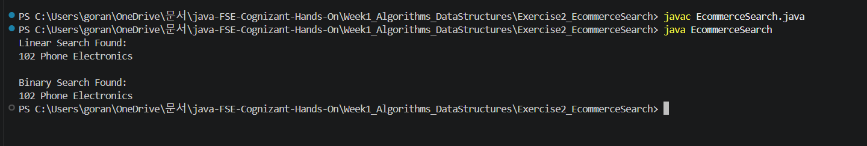
Result:
The product search functionality was implemented successfully using both Linear Search and Binary Search algorithms.

Exercise 7: Financial Forecasting
Objective:
To predict future financial values using recursion based on a fixed annual growth rate.
Source Code:
public class FinancialForecasting {
public static double forecast(double presentValue,double growthRate, int years) {
if (years == 0) {
return presentValue;
}
return forecast(presentValue, growthRate, years - 1)
* (1 + growthRate);
}
public static void main(String[] args) {
double presentValue = 10000;
double growthRate = 0.10;
int years = 5;
double futureValue =
forecast(presentValue, growthRate, years);
System.out.printf("Future Value after %d years = %.2f%n",years,futureValue);
}
}
Output:
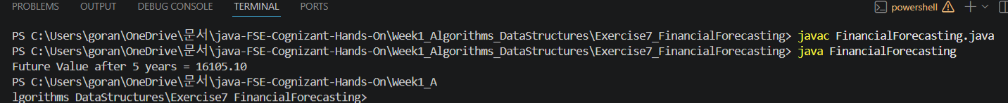
Result:
The future financial value was successfully calculated using recursion. The program demonstrates the concept of forecasting based on compound growth over multiple years.
Conclusion:
The Algorithms and Data Structures exercises were completed successfully. The E-commerce Search Function demonstrated searching techniques using Linear Search and Binary Search, while the Financial Forecasting exercise demonstrated recursion and growth prediction techniques.

