Week 1 – Design Patterns & Principles
Exercise 1: Implementing the Singleton Pattern
Objective:
To implement the Singleton Design Pattern in Java, ensuring that only one instance of a class is created and a global access point is provided to access that instance.
Source Code:
class Logger {
private static Logger instance;
private Logger() {
System.out.println("Logger Instance Created");
}
public static Logger getInstance() {
if (instance == null) {
instance = new Logger();
}
return instance;
}
public void log(String message) {
System.out.println("Log: " + message);
}
}
public class SingletonDemo {
public static void main(String[] args) {
Logger logger1 = Logger.getInstance();
Logger logger2 = Logger.getInstance();
logger1.log("Application Started");
logger2.log("Processing Data");

if (logger1 == logger2) {
System.out.println("Both objects are the same instance.");
}
}
}
Output:
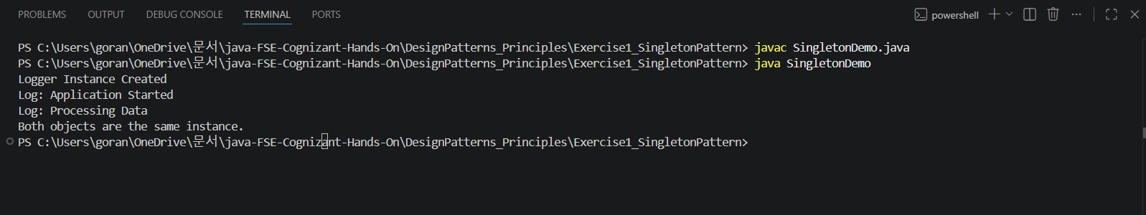
Result:
The Singleton Pattern was successfully implemented. Only one instance of the Logger class was created and shared throughout the application.

Exercise 2: Implementing the Factory Method Pattern
Objective:
To implement the Factory Method Design Pattern in Java, allowing object creation through a factory class without exposing the instantiation logic to the client.
Source Code:
Document.java
abstract class Document {
public abstract void open();
}
WordDocument.java
class WordDocument extends Document {
public void open() {
System.out.println("Opening Word Document");
}
}
PdfDocument.java
class PdfDocument extends Document {
public void open() {
System.out.println("Opening PDF Document");
}
}
ExcelDocument.java
class ExcelDocument extends Document {
public void open() {
System.out.println("Opening Excel Document");
}
}
FactoryDemo.java
class DocumentFactory {
public static Document createDocument(String type) {
if (type.equalsIgnoreCase("WORD")) {
return new WordDocument();
}
else if (type.equalsIgnoreCase("PDF")) {
return new PdfDocument();
}
else if (type.equalsIgnoreCase("EXCEL")) {
return new ExcelDocument();
}
return null;
}
}
public class FactoryDemo {
public static void main(String[] args) {
Document doc1 = DocumentFactory.createDocument("WORD");
doc1.open();
Document doc2 = DocumentFactory.createDocument("PDF");
doc2.open();
Document doc3 = DocumentFactory.createDocument("EXCEL");
doc3.open();
}
}
Output:
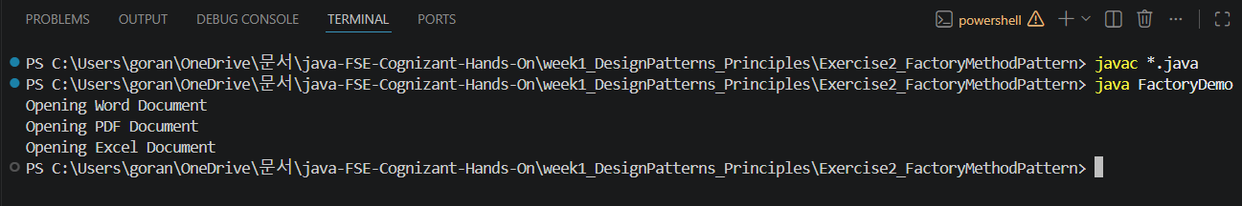
Result:
The Factory Method Pattern was successfully implemented. Different document objects were created through the factory class without directly instantiating the concrete classes.
Conclusion:
The Design Patterns and Principles exercises were completed successfully. The Singleton Pattern demonstrated controlled object creation with a single instance, while the Factory Method Pattern demonstrated object creation through a centralized factory mechanism, promoting loose coupling and maintainability.

