  - Circuit Overview

1.1.1 Brief Description

This Arduino circuit allows for the control of a DC motor through an Arduino using serial communication for ON/OFF control and analog input from a potentiometer for speed control. The 1K Ohm potentiometer is connected to the 5V pin at one end and grounded at the other, with its middle terminal connected to the A1 analog input pin of the Arduino. A TIP120 transistor is used, whose base is connected to the PWM (pulse-width modulation) output pin 5 of the Arduino through a 2.2K ohm resistor. The collector of the transistor is connected to a 9V DC power supply provided by a 9V AC/DC adaptor, and its emitter terminal is connected to one terminal of a 9V DC motor, whose other terminal is grounded. Output to the transistor base is provided by serial communication through the Arduino, whereby the output is LOW (motor is off) when ‘a’ is typed, but upon typing ‘b’, the motor is fed a voltage proportional to the adjustable input voltage read by pin A1, precisely reduced by a factor of 4 to account for the difference in the bit systems of the analog input and the PWM output of the Arduino, which are 10-bit and 8-bit systems, respectively.

1.1.2 List of Components

- Arduino Uno board

- 9V DC Motor

- TIP120 transistor

- 2,2K ohm resistor

- 1K Ohm potentiometer

- 9V AC/DC adapter

- Jumper wires

1.3 Fritzing Diagram
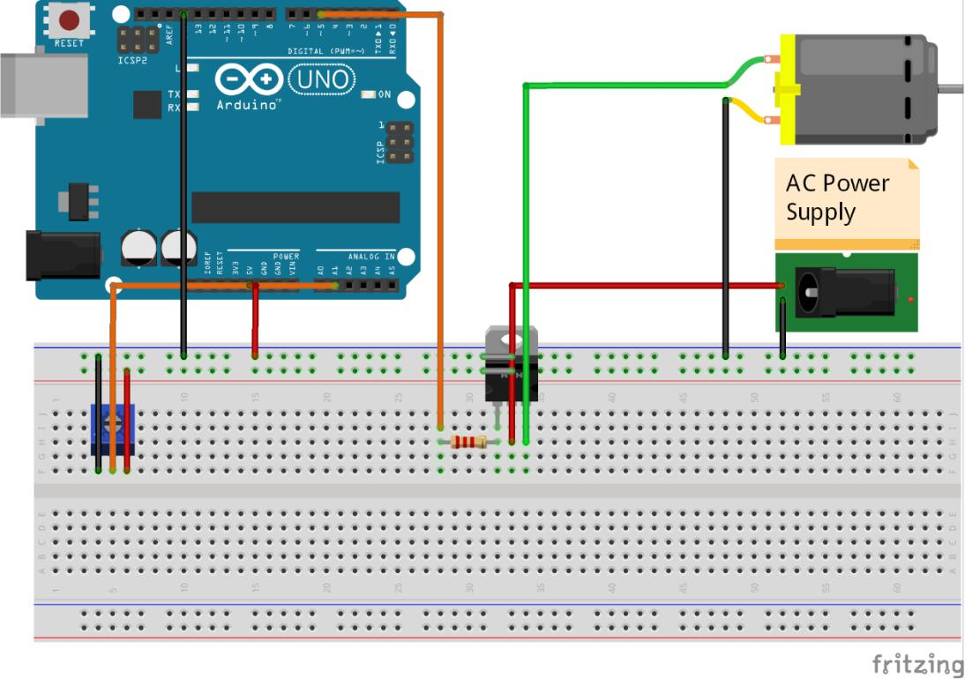

+9V AC/DC Adaptor

Figure 2: Fritzing Diagram

1.4 Circuit Photograph

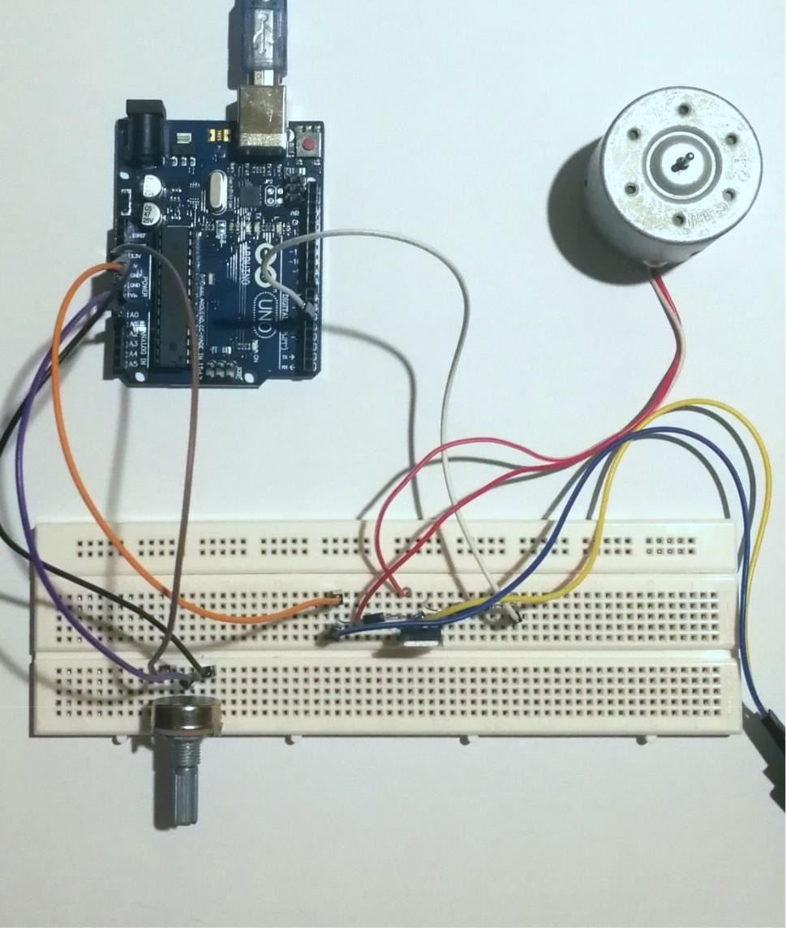

Figure 3: Circuit Photograph

1.2 Arduino Code
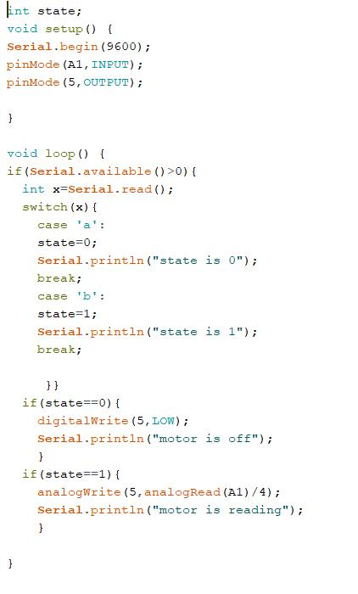

Figure 1: Screenshot of the Arduino Program

