Description Of the Circuit:

This circuit contains an Arduino UNO, motor, AC Adapter (9V), 2 push buttons, and an H-Bridge.

When pressing the first push button, the motor should reach its maximum speed within 2 seconds. After that, when we press the second push button, the motor should turn off within 2 seconds. However, if we press the first push button while the motor is on, or if we press the second one while the motor is off nothing should happen.

Code:

int onpush=13; //turns the motor on

int offpush=2; //turn the motor off

int motor=6;

int in1=8;// input 1

int in2=9;// input 2

int onpushstate;

int offpushstate;

int varout=0;

int y=0;

void setup() {

- put your setup code here, to run once: pinMode(onpush,INPUT); pinMode(offpush,INPUT); pinMode(motor,OUTPUT); pinMode(in1,OUTPUT); pinMode(in2,OUTPUT); Serial.begin(9600);

}

void loop() {

- put your main code here, to run repeatedly: onpushstate=digitalRead(onpush); offpushstate=digitalRead(offpush);
if(onpushstate==HIGH && y==0){

for( int i=0;i<=254;i++){ varout=varout+1; analogWrite(motor,varout); digitalWrite(in1,HIGH); digitalWrite(in2,LOW); delay(2000/255); Serial.println(varout);

}
y=1;
}
if(offpushstate==HIGH && y==1){
for(int i=254;i>=0;i--){ varout=varout-1; analogWrite(motor,varout); digitalWrite(in1,HIGH); digitalWrite(in2,LOW); delay(2000/255); Serial.println(varout);
}
y=0;
}
}
Circuit Picture:
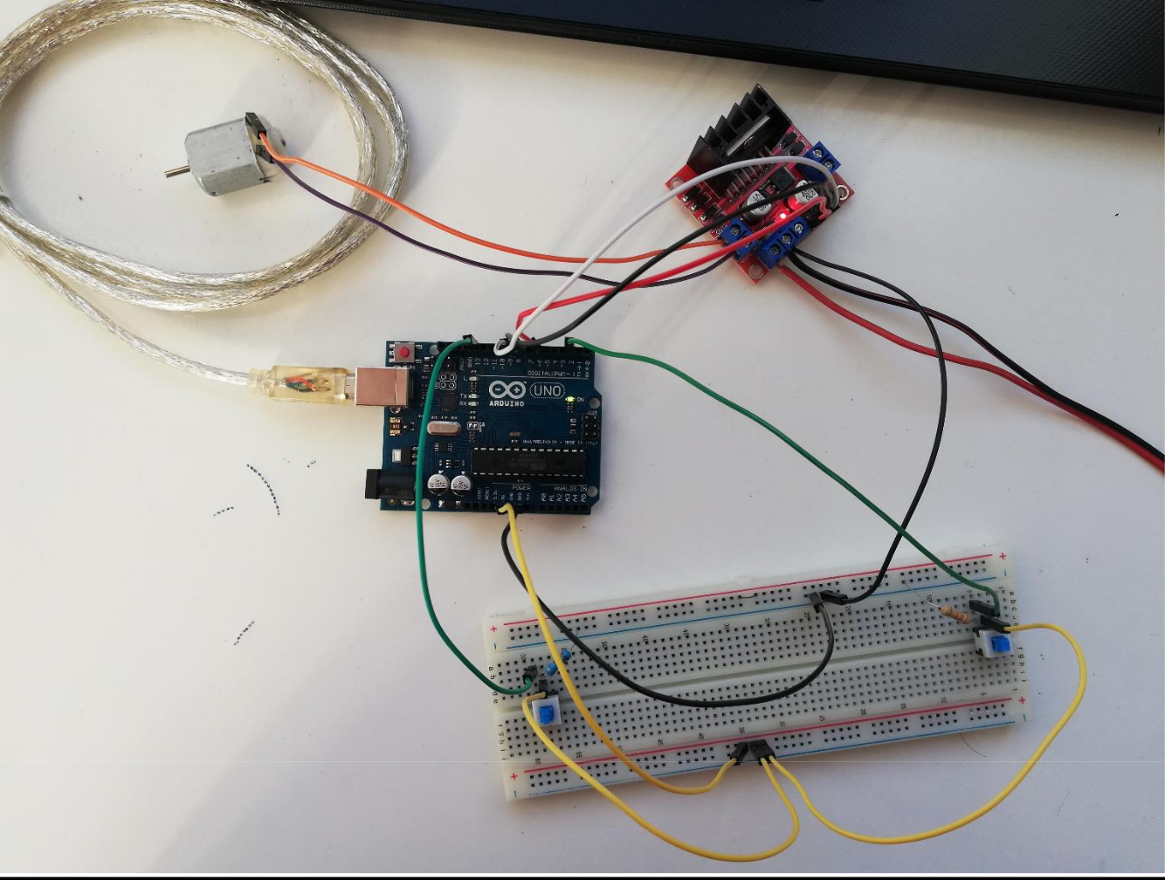

Circuit On Fritzing:
