

**MEDUSA**

Contents

I. List of Figures 3

II. List of Tables 3

III. Description 4

A. Overview 4

B. Purpose 4

C. Scope 4

D. Product Scenario 4

E. Stakeholders 5

1. Users of the applications 5

2. Other stakeholders 5

F. Mandated Constraints 6

1. Challenges 6

2. Possible Solutions 6

G. Relevant Facts and Assumptions 6

IV. Requirements 7

A. Product Use Cases 7

1. Use Case Diagram 7

2. Individual Product Use Cases 8

B. Functional Requirements 9

1. List of Functional Requirements 9

2. Priority List 10

C. Performance Requirements 10

1. Speed and Latency Requirements 10

2. Capacity Requirements 10

D. Dependability requirements 11

1. Availability Requirements 11

2. Reliability Requirements 11

E. Maintainability and Supportability Requirements 11

1. Adaptability Requirements 11

2. Longevity Requirements 11

3. Scalability or Extensibility Requirements 11

F. Security Requirements 12

1. Access Requirements 12

2. Integrity Requirements 12

3. Privacy Requirements 12

4. Audit Requirements 13

5. Immunity Requirements 13

G. Usability and Humanity Requirements 13

1. Ease of Use Requirements 13

2. Personalization and Internationalization Requirements 13

3. Understandability and Politeness Requirements 14

H. Look and Feel Requirements 14

1. Appearance Requirements 14

2. Style Requirements 14

I. Operational and Environmental Requirements 14

1. Requirements for Interfacing with Adjacent Systems 14

2. Release Requirements 14

J. Cultural and Political Requirements 14

1. Cultural Requirements 14

2. Political Requirements 14

K. Legal Requirements 15

1. Compliance Requirements 15

2. Standards Requirements 15

V. Selected Process Model 15

VI. Design 16

A. Diagrams: 16

1. Use Case Diagrams: 16

B. User Interface Design 18

1. Splash screen 18

2. Large background images 18

3. Swipe gestures 18

4. Short bio length 18

# List of Figures

Figure 1 Use case diagram 7

Figure 2 User use case 16

Figure 3 Sequence Diagram 17

# List of Tables

Table 1 Other stakeholders 5

# Description

## Overview

Medusa is an online geosocial networking and online dating application that allows users to anonymously swipe to like or dislike other profiles based on their photos, a small bio, and common interests. Once two users have "matched", they can exchange messages and get to know each other.

## Purpose

This application aims to ease the dating experience and enable different people all around the globe to connect and get to know each other so that it might hopefully lead to a relationship with common interests.

## Scope

The environment of the application is divided among:

* Guests: can access the application’s welcome and signing screens but aren’t allowed to start matching unless they register.
* Registered Users: can login through their accounts and start swiping and viewing other accounts.
* Administrators: should update the quality of the experience and add newly exclusive content.
* Application subsystems: should be available and work in real time updating data, feedback chat bots, account validation, advertisements, etc.

## Product Scenario

The user should sign up by entering the needed information into a series of pages to setup his/her profile. The user has the ability to choose from a variety of preferred methods for verification, including Gmail, Twitter, Facebook, etc. After that, he could login with full access of the application, where he can start viewing profiles and start swiping for a match. Once a match occurs, a new instance in the messaging tab appears so that the user could start chatting with who he/she matched. In case of an error or a bug occurring, the user can inform the admins about the problem by contacting them through the contact page available for registered users. Advertisements will appear when the user wants to use a premium feature, such as a super like or viewing available matches or undo a swipe he/she did.

## Stakeholders

### Users of the applications

* + - Username/category: All the people with internet access and interest.
    - User role: opens the application, views accounts of other users, swipes through the accounts, matches with other users to start a chat between them, gives reviews-feedback, few ads open when user is in the app.
    - Subject matter experience: User doesn’t need to have any previous knowledge, simply login and start swiping.
    - Technological experience: User should know how to use the phone and open applications.

### Other stakeholders

|  |  |  |
| --- | --- | --- |
| Role | ID | Knowledge needed |
| Sponsor | An investor | Initial income |
| Testers | Public/Friends | Beta Version |
| Business analysts | N/A | Statistical data about the app and the market |
| Technology experts | Admins-IT | Firewalls, security, etc. |
| System designers | Mobile applications developers | Front/back end |
| Marketing and advertisements | Open ads/google ads | Timed ads or one tap ads |
| Data sources | Online servers | Compatibility |

Table Other stakeholders

## Mandated Constraints

### Challenges

* + - The application is big and should be done in a short time.
    - The application has many subparts and needs external resources.
    - The application should satisfy its goal without affecting user’s privacy.
    - The application’s content should be trusted and updated frequently.
    - The application should be well advertised to attain maximum number of users.
    - The communication shall always be available between users and our servers.
    - The application shall be secure regarding message validation.
    - The application shall provide its services free of charge.
    - The application shall run on both IOS and Android effectively.

### Possible Solutions

* + - Finding fast and attainable methods.
    - updating the application on a timely basis to add more features and fix possible errors.
    - usage of off-the-shelf software
    - Gather a team of skilled programmers that can work and communicate smoothly.

## Relevant Facts and Assumptions

* Users may give faulty info.
* Data could be ambiguous.
* Copy-right strikes.
* Employees personal life problems
* Delay of production due to unknown factors

# Requirements

## Product Use Cases

Curiosity, convenience and boredom drive dating application downloads. People download dating applications because they are looking for a relationship or connection. Although people download dating apps for different reasons, they tend to be motivated to download by:

* Curiosity
* Convenience
* Boredom
* Loneliness
* Hope

### Use Case Diagram

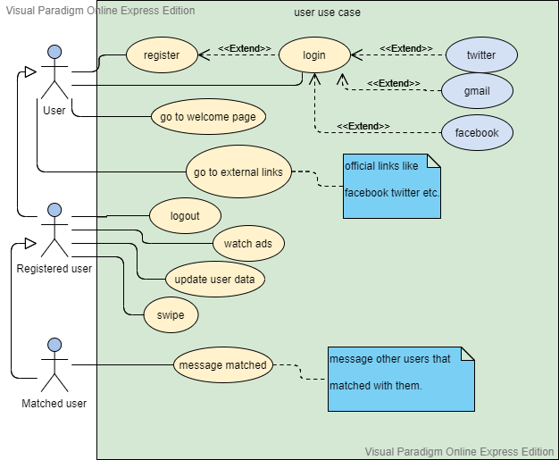

Figure Use case diagram

### Individual Product Use Cases

#### Use case name

Medusa.

#### Flow Of events

1. The user enters the application through the mobile phone.
2. The application displays a splash screen containing its logo.
3. The user can access the welcome page where he can navigate to either sign up or sign in.
4. The user creates an account, sets up the profile and logs in with it as a registered user to get the full privilege and service.
5. The user’s info is stored in our servers.
6. The user can start viewing and swiping through the previewed accounts until he gets a match.
7. The user can message the other user they matched with.
8. The application pops advertisements when the user wants access to a premium feature. it might be somewhat annoying to the user but it’s an important source of revenue to keep supporting the free content provided.
9. The user signs out from the application or can simply leave the application with the user still signed in.

#### Entry conditions

1. Username and password.
2. Email authentication.
3. Facebook authentication.
4. Twitter authentication.
5. Gmail authentication.

#### Exit condition

Logout.

## Functional Requirements

### List of Functional Requirements

#### Membership

* + Creating user profiles
  + Managing user profiles
  + Registration

#### Profile matching

* + Search the members’ database
  + Match the compatible profiles
  + Display the matching profiles

#### Managing Staff

* + Employees responsible for the development
  + Employees maintaining database
  + Customer assistance staff

#### Customer support

* + Helping with the membership form
  + Providing counselling
  + Listening to and providing solutions to customer complaints

#### Online dating

* + Provide online compatibility matching
  + Speed dating

#### Editing user profiles

* + Modification to user records by the user any number of times
  + Deletion of personal profile

#### Maintaining database

* + Creating a database containing user information
  + Updating the database
  + Deleting the profiles from the database who do not want to be a member anymore

#### Advertisement

* + Increase in online advertisements
  + Better graphical advertisements

### Priority List

#### Low

* + Advertisement
  + Editing user profiles

#### Medium

* + Maintaining database
  + Managing Staff
  + Membership

#### High

* + Online dating
  + Customer support
  + Profile matching

## Performance Requirements

### Speed and Latency Requirements

* Response time for answering the general query of the user should not be more than 10 seconds.
* At least 10 matches should be displayed while providing the matching list to the user.
* The members’ profiles should be made available on the website in no more than one day.
* The compatibility list should be handed over to the member within a day.

### Capacity Requirements

* The time spent downloading a video to be viewed shall be at most 7 seconds.
* The time spent downloading an image to be viewed shall be at most 4 seconds.

## Dependability requirements

### Availability Requirements

* The application shall deliver 100% of up time performance with utilization of at least 77%.
* The application shall not fail more than once per day.

### Reliability Requirements

* Necessary recovery options shall be available so that no data shall be lost or damaged in the event of a failure.

## Maintainability and Supportability Requirements

### Adaptability Requirements

* The application shall run on the web.
* The application shall run on both IOS and Android effectively.

### Longevity Requirements

* The application should operate within the maximum maintenance budget for a minimum of four years.

### Scalability or Extensibility Requirements

* The application shall be capable of processing all the transactions.
* The application should cope with the increase of up to twice the expected user rate since launch date.

## Security Requirements

### Access Requirements

* The application shall allow non-registered users to view the application’s sign and welcome pages and restrict access to the swiping screen.
* The application shall allow each user to obtain access to all of their own personal account information.
* The application shall not allow any user to access any account information of any other user.
* The application shall allow user service agents to automatically email a new user password to that user’s email address.

### Integrity Requirements

* The application shall prevent the unauthorized corruption of emails (and their attachments, if any) that it sends to customers and other external users.
* The application shall prevent the unauthorized corruption of data collected from users and other external users.
* The application shall prevent the unauthorized corruption of all communications passing through networks that are external to any protected data centers.

### Privacy Requirements

* The application shall not store any personal information about the users.
* The application shall not allow unauthorized individuals or programs access to any communications.
* The application shall not allow unauthorized individuals or programs access to any stored data.
* The application shall inform the users about any data collection done on their behalf.
* The application shall notify users of changes to its information policy.

### Audit Requirements

* Users shall agree on a list of terms and conditions as well as privacy policies before they can register.
* The application shall collect, organize, summarize, and regularly report the status of its security mechanisms including:
* Identification
* Authentication
* Authorization.
* Immunity.
* Privacy.
* Intrusion Detection.

### Immunity Requirements

* The application shall protect itself from infection by scanning all entered or downloaded data and software for known application viruses, worms, Trojan horses, and other similar harmful programs.
* The application shall disinfect any image or video found to contain a harmful program if disinfection is possible.
* The application shall notify the security administrator and the associated user if it detects a harmful program during a scan.
* the application shall daily update its definitions of known application viruses, worms, Trojan horses, and other similar harmful programs.

## Usability and Humanity Requirements

### Ease of Use Requirements

* The application shall be easy to use by teenagers and above.
* The application should provide a helping page to introduce the user about the different services provided.
* The application shall provide different swiping methods to control the swiping result.

### Personalization and Internationalization Requirements

* The application should provide users with options to change to local spelling or a certain desired language.
* The application should keep track of the user’s preference’s and provide a fitting swiping list.

### Understandability and Politeness Requirements

* The application shall use symbols and words that are naturally understandable by the user community.
* The application shall hide the details of its construction from the user.

## Look and Feel Requirements

### Appearance Requirements

* The application should attract all kind of audiences.
* The application should use colors that give a romantic vibe.

### Style Requirements

* The application design should have a professional look.
* The application design should be simple and user-friendly.
* The application design should give the vibe of love and compassion.

## Operational and Environmental Requirements

### Requirements for Interfacing with Adjacent Systems

* The application shall have a desktop version.
* The application shall support all new mobile releases.

### Release Requirements

* The maintenance releases will be offered to end users once a year.
* Each release shall not cause previous features to fail.

## Cultural and Political Requirements

### Cultural Requirements

* The application shall use American spelling by default.
* The application shall provide the ability to translate content to a different language.

### Political Requirements

* The application should not use any terms or icons that might possibly offend any religious party.

## Legal Requirements

### Compliance Requirements

* The application shall provide a list of privacy policies.
* The application shall include attribution that includes photography or any written content on the application.
* The application shall protect its content against copyright infringement by using symbols and notices of conditions of any reproduction of content.
* Personal information provided by the users should be kept confidential.

### Standards Requirements

* The application shall comply with the “General Data Protection Regulation” (GDPR).
* The application shall comply with the “California Consumer Privacy Act” (CCPA).
* The application should comply with rules and regulations of the Data Protection Act.
* The application developers shall be aware of the CAN-SPAM Act.

# Selected Process Model

We will be using the incremental process model because it is suitable for our circumstances and it provides the necessary conditions to deliver a reliable usable application in such an early notice. The perks of using this model includes generating working software quickly and early during the software life cycle, flexibility in which changing requirements and scope cost less and are less risky, easier testing and debugging and finally easier risk management.

# Design

## Diagrams:

### Use Case Diagrams:



Figure User use case

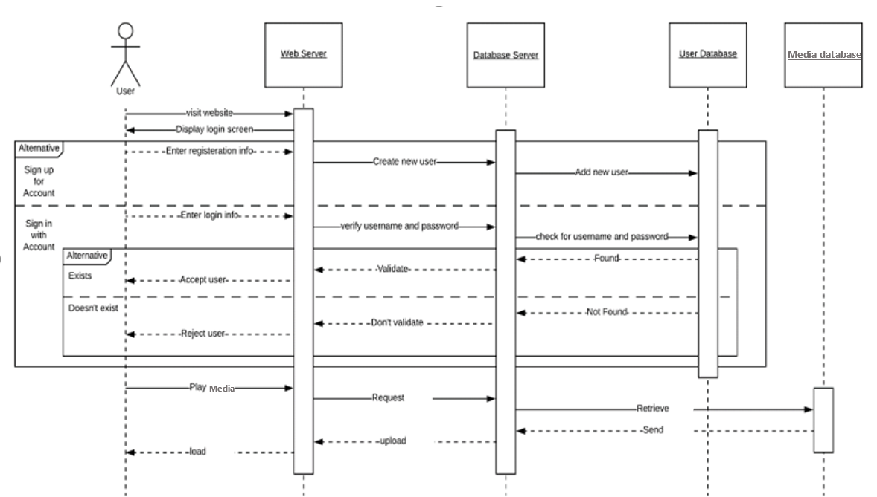

Figure Sequence Diagram

## User Interface Design

### Splash screen

A splash screen is also called a launch screen or startup screen that appears when a user opens a mobile application on their mobile devices. Not every mobile application has a splash screen feature but embedding a splash screen will help customers associate and build a long relationship with our brand. It will also help them recognize our brand whenever they see a logo or our app’s name.

### Large background images

Large photos and images play a huge role in creating attractive and interesting dating applications.

### Swipe gestures

The users can use swiping gestures in addition to the buttons available. Making the swiping progress more fun and graphical.

### Short bio length

The short bio length keeps everything in view at all times. It indirectly forces the users to be short and concise about describing their interests or selves making the reading process faster and less boring.