Technical Architecture & Functional Requirements Document
End-to-End Enterprise Carbon Accounting, Decarbonization Simulation & Climate Stress-Testing Application for Smallholder-Dominated Dairy Cooperatives

Target Sector: Agri-Food & Dairy Cooperative Enterprises | Compliance Frameworks: GHG Protocol, ISSB S2, EU CSRD
Horizon Target: 30% Carbon Reduction by 2030 | Analytical Engine: IPCC Tier 1/2 + THI Yield Modeling

1. Executive Summary & Problem Framing
Large-scale dairy cooperatives operate at an unprecedented nexus of commercial scale and structural operational fragmentation. A typical national cooperative processes tens of millions of liters of milk daily, sourced across a hyper-fragmented network of millions of smallholder farmers (each maintaining 2 to 5 animals). As international sustainability mandates (EU CSRD, ISSB S2) and capital markets enforce strict decarbonization targets, dairy enterprises face a dual imperative: they must commit to a verified 30% reduction in carbon intensity (kg CO₂e / kg milk) by 2030 while safeguarding raw milk supply against severe climate physical risks.
■ THE FRAGMENTATION CHALLENGE
Unlike Western industrial dairy setups where Scope 1 and Scope 2 dominate direct plant control, over 85% to 92% of total emissions in smallholder dairy networks reside in Scope 3 (Upstream Farm Sourcing). Measuring, modeling, and decarbonizing this fragmented supply chain forms the core technical requirement of this solution.

This document details the functional specification and quantitative architecture for an interactive Streamlit application. The application serves as an enterprise decision-support tool enabling executive teams, sustainability leads, and supply chain analysts to:
- Calculate baseline GHG emissions across Scope 1, Scope 2, and Scope 3 using India-calibrated IPCC Tier 1 and Tier 2 agricultural methodologies.
- Simulate decarbonization levers (e.g., ration balancing feed additives, village-level bulk milk cooler solarization, anaerobic digesters).
- Stress-test physical climate risks across three IPCC Shared Socioeconomic Pathways (SSPs), modeling Temperature-Humidity Index (THI) yield penalties and monsoon volatility.
- Optimize regional procurement by balancing climate-resilient regional milk productivity against inter-state transit logistics carbon trade-offs.

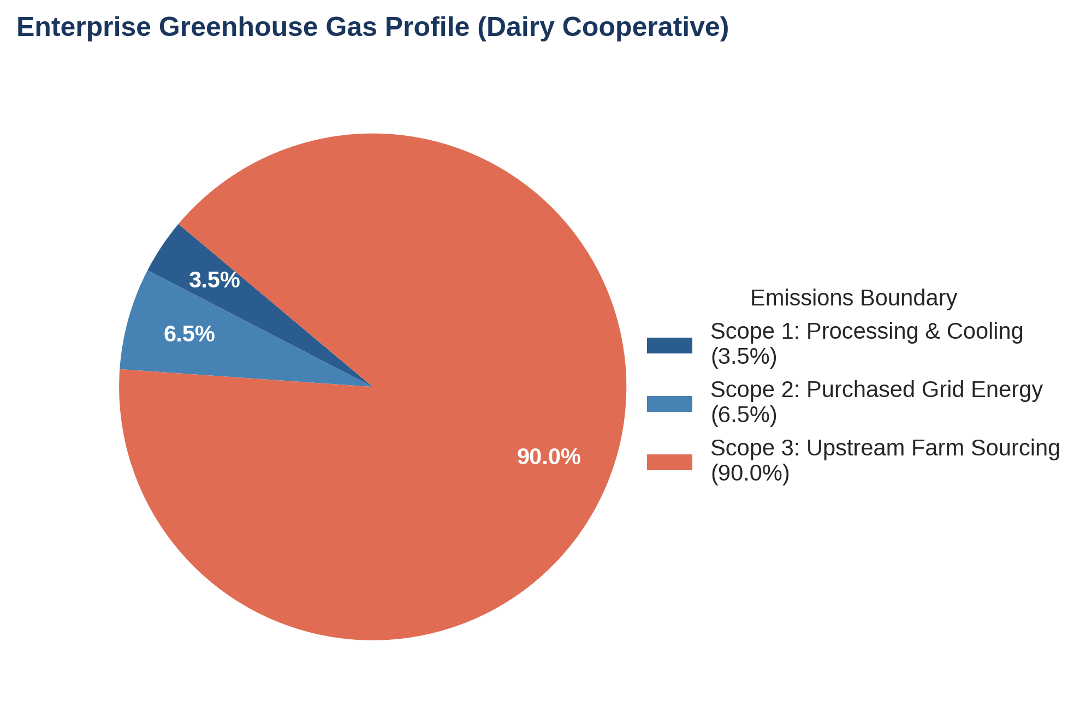
Figure 1: Enterprise GHG Footprint Breakdown highlighting Scope 3 dominance in smallholder cooperatives.
2. Framework Rules, Boundaries & Standard Constraints
To satisfy third-party auditability under the GHG Protocol Corporate Standard and Agriculture Guidance, the application's underlying mathematical engine operates within strict structural constraints:
2.1 Emissions Boundary Mapping
Emission Scope | Operational Activity | Primary Emission Gases & Drivers
Scope 1 (Direct) | Processing plant natural gas combustion, boiler operations, captive fleet diesel, emergency generator runs at chilling centers. | CO₂ (combustion), CH₄ (unburnt fuel), N₂O (thermal).
Scope 2 (Indirect) | Purchased electricity from State Electricity Boards (SEBs) for processing plants, central warehouses, and village Bulk Milk Coolers (BMCs). | CO₂e based on grid average emission factors (National Grid Mix: ~0.716 kg CO₂e/kWh).
Scope 3 (Upstream) | Enteric fermentation from cows and buffaloes, manure storage & management, fodder crop production (fertilizer N₂O), feed transport to village hubs. | CH₄ (enteric & manure), N₂O (fertilizers & manure management), CO₂ (land clearing/transport).

2.2 Mathematical Formulations & Standards
Emissions are calculated using standard IPCC 100-year Global Warming Potential (GWP) metrics (AR6 values: CH₄ = 28, N₂O = 265). The total carbon intensity metric is calculated dynamically as:
Carbon Intensity (kg CO₂e / kg milk) = [ Scope 1 + Scope 2 + Scope 3 Emissions (kg CO₂e) ] / [ Total Milk Procured (kg) ]
2.3 Sourcing Volume Balance Constraint
The system enforces a mass balance constraint. Total raw milk collected across all regional procurement zones must match total enterprise processing capacity:
∑ (Sourced Milk Volume_z) = Target Enterprise Production Volume
3. Regional Sourcing Architecture & Input Defaults
To reflect agro-climatic variations, the application categorizes milk procurement into three distinct geographic hubs. Each hub possesses unique herd compositions, fodder dependency, baseline carbon intensities, and physical climate vulnerabilities.
Procurement Zone | Agro-Climatic Profile | Herd Mix (Buffalo / Cross-bred / Indig.) | Baseline Intensity (kg CO₂e/kg)
Zone 1: Western Hub  (Gujarat / Rajasthan) | Semiarid to arid zone. High reliance on crop residue & dry fodder. Severe summer drought exposure. | 50% Buffalo / 35% Cross-bred / 15% Indigenous | 2.25 kg CO₂e / kg
Zone 2: Northern Belt  (Punjab / Haryana / UP) | Highly fertile alluvial plain. High cross-bred density. Extreme summer THI heatwaves (>75). | 35% Buffalo / 55% Cross-bred / 10% Indigenous | 1.98 kg CO₂e / kg
Zone 3: Southern / Central  (Karnataka / Maharashtra) | Moderate tropical climate, higher green fodder/pasture availability. Lower thermal extremes. | 40% Buffalo / 40% Cross-bred / 20% Indigenous | 2.10 kg CO₂e / kg

3.1 Built-in System Input Parameters (User Overridable)
The application pre-populates all analytical modules with validated industry default parameters:
Parameter Name | Default Value | Unit | Operational Context & Benchmark
Daily Processing Volume | 20,000,000 | Liters / day | Representative major regional dairy cooperative network.
Grid Power Carbon Factor | 0.716 | kg CO₂e / kWh | National electricity grid average emission intensity.
BMC Diesel Back-up Run | 0.08 | Liters / 100L milk | Accounting for rural grid outages during peak cooling periods.
Refrigerated Transit Tanker | 0.11 | kg CO₂e / ton-km | Primary milk movement from chilling hubs to central plants.
Baseline Scope 3 Intensity | 1.95 | kg CO₂e / kg milk | Weighted average smallholder baseline (enteric + manure + feed).
Target Carbon Reduction | 30.0 | % by 2030 | Aligned with Paris Agreement & ISSB corporate targets.

4. IPCC Physical Climate Risk Modeling Engine
A critical innovation of this application is the integration of physical climate risk stress-testing directly into carbon accounting. Rising ambient temperatures and unpredictable monsoons severely impact dairy productivity. The model incorporates a Temperature-Humidity Index (THI) penalty function:
■ THI HEAT STRESS MATHEMATICAL MECHANISM
THI = (1.8 × T + 32) - (0.55 - 0.0055 × RH) × (1.8 × T - 26)
When ambient THI exceeds 72, dairy animals enter heat stress. High-yielding cross-bred cows experience up to a 25% decline in daily milk yield. To maintain total cooperative production targets, farmers must maintain larger total herds, which paradoxically INCREASES overall Scope 3 carbon intensity.

The application evaluates three standard IPCC Shared Socioeconomic Pathways (SSPs) projected to the 2030–2040 horizon:
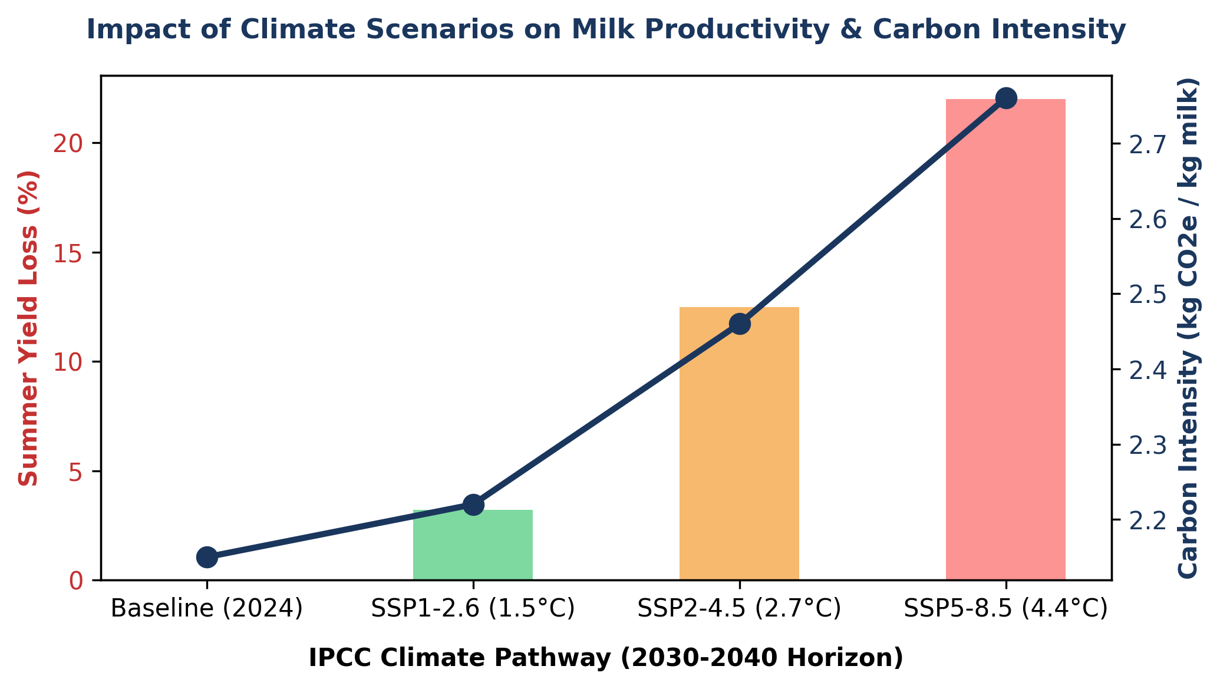
Figure 2: Impact of IPCC Climate Pathways on Milk Yield Penalties and Carbon Intensity Escalation.

IPCC Pathway | Physical Climate Conditions (2030-2040) | Modeled Impact on Dairy Operations
SSP1-2.6  (Low Warming +1.5°C) | Minor ambient temperature rise. Monsoons remain stable across Western and Northern belts. | Minimal heat stress yield loss (~3.2%). Carbon intensity increases slightly to 2.22 kg CO₂e/kg due to minor feed shifts.
SSP2-4.5  (Middle of Road +2.7°C) | Moderate THI heat stress (>75 THI) for 45+ summer days in Northern Belt. Frequent monsoon dry spells in West. | Significant yield drop in cross-bred stock (-12.5%). Fodder prices spike; carbon intensity rises to 2.46 kg CO₂e/kg.
SSP5-8.5  (High Warming +4.4°C) | Severe heatwaves across Indo-Gangetic plains. Acute drought in semiarid zones. Extended extreme THI periods. | Severe milk yield crash (-22.0%). Forces 15% regional sourcing reallocation to Southern zones to mitigate supply collapse.

5. Decarbonization Levers & Abatement Modeling
To achieve the targeted 30% reduction in carbon intensity by 2030 (dropping from ~2.15 down to 1.50 kg CO₂e / kg milk), users can dynamically adjust four primary mitigation levers within the application:
- Lever 1: Ration Balancing & Feed Additives (NDDB Model): Optimizing dietary protein/fiber ratios and introducing bypass fat/protein supplements reduces enteric methane emissions by 10% to 15% while improving milk yield per animal.
- Lever 2: Solarization of Village BMCs & Plants: Installing off-grid micro-solar units at village Bulk Milk Cooling centers eliminates diesel generator emissions (Scope 1) and cuts reliance on fossil-heavy grid power (Scope 2).
- Lever 3: Community Anaerobic Manure Digesters: Capturing methane from village animal dung for bio-CNG generation reduces Scope 3 manure management emissions by up to 60%.
- Lever 4: Dynamic Geographic Sourcing Optimization: Reallocating procurement shares away from extreme-heat Northern zones toward climate-resilient Southern/Central hubs. The model automatically balances reduced on-farm emissions against increased transit tanker fuel emissions (ton-km).
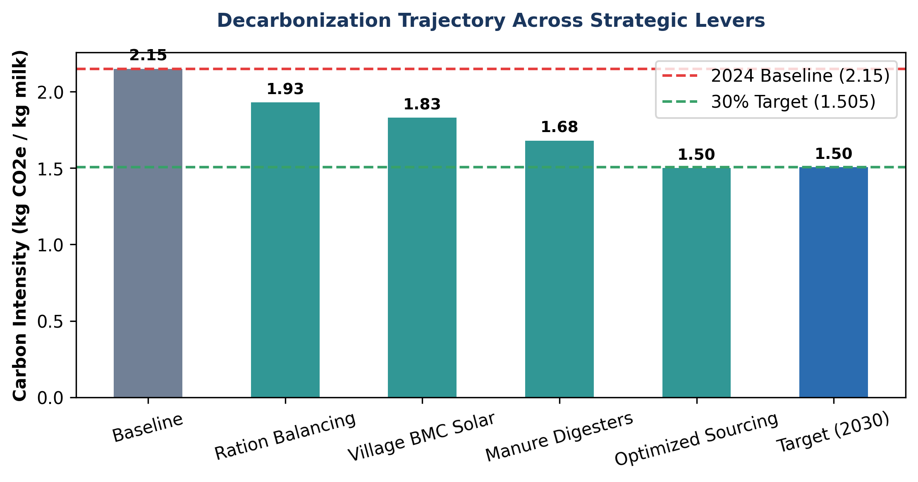
Figure 3: Cumulative Decarbonization Abatement Pathway demonstrating achievement of 2030 target.

6. Implementation Roadmap & Next Steps
With this complete functional requirement and architectural specification established, the next immediate step is to build the fully functional Streamlit application code. The python script will integrate NumPy/Pandas for vector math, Plotly for interactive chart rendering, and Streamlit for layout management.

Annexure
GHG Accounting & Climate Calculation Methodology
Technical Documentation for Scope 1, 2, 3 Footprinting, Mitigation Modeling, and IPCC Stress Testing
1. Executive Summary & Core Mass Balance
This document details the exact mathematical formulas, global emission factors, and logical steps used by the Dairy Enterprise Decarbonization & Risk Dashboard engine. All GHG accounting procedures follow the GHG Protocol Corporate Value Chain (Scope 3) Accounting Standard and IPCC Tier 1/2 Livestock Guidelines.
1.1 Raw Milk Procurement Mass Balance
To convert daily fluid volumetric throughput into annual mass equivalent:
$$M_{\text{annual}}=V_{\text{daily}}×365×ρ_{\text{milk}}$$
Where:
- $V_{\text{daily}}$ = Daily processing volume in liters (User Input)
- $365$ = Operational days per calendar year
- $ρ_{\text{milk}}$ = Density of raw milk ($≈1.03\text{ kg/L}$)
2. Baseline Greenhouse Gas Accounting Engine
2.1 Scope 1: Direct Combustion Emissions
Scope 1 accounts for direct diesel combustion in backup generators across rural Bulk Milk Cooling units (BMCs) and processing plant thermal heating.
$${\text{Scope 1 (kg CO}}_{2}\text{e)}=\left(M_{\text{annual}}×{\text{Diesel}}_{\text{Specific Cons}}\right)×{\text{EF}}_{\text{diesel}}$$
Where ${\text{Diesel}}_{\text{Specific Cons}}=0.005\text{ L/kg milk}$ and ${\text{EF}}_{\text{diesel}}=2.68{\text{ kg CO}}_{2}\text{e/L}$.
2.2 Scope 2: Indirect Electricity Emissions
Scope 2 measures grid power purchased for milk chilling, pasteurization, and packaging.
$${\text{Scope 2 (kg CO}}_{2}\text{e)}=\left(M_{\text{annual}}×{\text{Grid}}_{\text{Specific Cons}}\right)×{\text{EF}}_{\text{grid}}$$
Where ${\text{Grid}}_{\text{Specific Cons}}=0.04\text{ kWh/kg milk}$ and ${\text{EF}}_{\text{grid}}=0.716{\text{ kg CO}}_{2}\text{e/kWh}$ (Default).
2.3 Scope 3: Upstream Smallholder Farm & Transport Emissions
Scope 3 comprises farm-level biogenic methane (${\text{CH}}_{4}$), nitrous oxide (${\text{N}}_{2}\text{O}$), and transit logistics:
$$\text{Scope 3 Total}={\text{Scope 3}}_{\text{Farm}}+{\text{Scope 3}}_{\text{Transport}}$$
- Transport Logistics Formula:
$${\text{Scope 3}}_{\text{Transport}}{\text{ (kg CO}}_{2}\text{e)}=\sum{\left[\left(\frac{M_{\text{annual}}×{\text{Share}}_{z}}{1000}\right)×{\text{Distance}}_{z}×{\text{EF}}_{\text{transit}}\right]}$$
- On-Farm Livestock Formula (Tier 1/2 IPCC Method):
$${\text{Head Count}}_{\left(a,z\right)}=\frac{M_{\text{annual}}×{\text{Share}}_{z}×{\text{Share}}_{\text{animal}}}{{\text{Yield}}_{\left(\text{daily},a\right)}×365×ρ_{\text{milk}}}$$
$${\text{Scope 3}}_{\text{Farm}}{\text{ (kg CO}}_{2}\text{e)}=\sum{\text{Head Count}}×\left[\left({\text{EF}}_{\text{enteric}}+{\text{EF}}_{\text{manure}}\right)×{\text{GWP}}_{{\text{CH}}_{4}}+\left({\text{EF}}_{\text{feed}}×{\text{GWP}}_{{\text{N}}_{2}\text{O}}\right)\right]$$
2.4 Default Emission Factors & AR6 GWPs
Parameter / Gas | Value | Standard / Unit
Methane (${\text{CH}}_{4}$) GWP | 28.0 | IPCC AR6 (100-year horizon)
Nitrous Oxide (${\text{N}}_{2}\text{O}$) GWP | 265.0 | IPCC AR6 (100-year horizon)
Crossbred Cow Enteric ${\text{CH}}_{4}$ | 65.0 kg/head/yr | IPCC Tier 2 Regional Assessment
Buffalo Enteric ${\text{CH}}_{4}$ | 58.0 kg/head/yr | IPCC Tier 2 Regional Assessment
3. Decarbonization Lever Abatement Engine
The mitigation engine evaluates total carbon reduction across three operational intervention levers. Net abated emissions are subtracted from the baseline total to produce updated intensity metrics.
- Ration Balancing Savings:
$${\text{Abatement}}_{\text{Ration}}=\left({\text{Scope 3}}_{\text{Farm}}×0.75\right)×\left({\text{Adoption}}_{\text{Ration}}×0.15\right)$$
- Solar BMC Conversion Savings:
$${\text{Abatement}}_{\text{Solar}}=\left(\text{Scope 2}×0.60\right)×{\text{Adoption}}_{\text{Solar}}$$
- Community Manure Digester Savings:
$${\text{Abatement}}_{\text{Digester}}=\left({\text{Scope 3}}_{\text{Farm}}×0.15\right)×\left({\text{Adoption}}_{\text{Digester}}×0.60\right)$$
4. IPCC Physical Climate Risk & Heat Stress Engine
Heat stress reduces livestock feed intake and milk synthesis. To satisfy contract throughput, cooperatives must expand overall herd sizes, driving up baseline enteric methane emissions.
4.1 Temperature-Humidity Index (THI) & Yield Loss
$$\text{Weighted Yield Loss}=\sum{\left({\text{Yield Loss}}_{\text{Animal}}×{\text{Share}}_{\text{Animal}}×{\text{Share}}_{\text{Zone}}\right)}$$
4.2 Herd Expansion & Intensity Escalation
$$\text{Herd Expansion Penalty (\%)}=\left[\frac{\text{Weighted Yield Loss}}{1-\text{Weighted Yield Loss}}\right]×100$$
$$\text{Escalated Carbon Intensity}=\frac{\text{Scope 1}+\text{Scope 2}+\left(\text{Scope 3}×\left(1+\frac{\text{Penalty}}{100}\right)\right)}{M_{\text{annual}}}$$

Annex-2
1. Core Concept & The Enterprise Goal
- The Target: Your enterprise aims to achieve a 30% reduction in greenhouse gas (GHG) emissions per unit of milk by 2030.
- The Scale: Based on a daily procurement of 2 Million Liters of milk, the business processes approximately 2.06 Million kilograms per day ($2\text{M Liters}×1.03\text{ kg/L density}$), or ~751.8 Million kg annually.
- The Key Metric: Carbon Intensity, expressed as ${\text{kg CO}}_{2}\text{e / kg milk}$ (kilograms of carbon dioxide equivalent emitted to produce one kilogram of milk). Lowering this ratio is the central objective.
2. Plain-English Glossary of Key ESG Terms
- Mass Balance: Tracking the exact weight of raw materials (milk) moving through the business annually to establish an accurate baseline.
- ${\text{tCO}}_{2}\text{e}$ (Tonnes of Carbon Dioxide Equivalent): The standard "currency" of carbon accounting. It converts various heat-trapping gases (like methane and nitrous oxide) into the equivalent amount of ${\text{CO}}_{2}$ based on their Global Warming Potential (GWP):
  - $1\text{ kg of Methane }\left({\text{CH}}_{4}\right)=28{\text{ kg CO}}_{2}\text{e}$ (from cow burps & manure)
  - $1\text{ kg of Nitrous Oxide }\left({\text{N}}_{2}\text{O}\right)=265{\text{ kg CO}}_{2}\text{e}$ (from fertilizers & feed crops)
- The 3 Scopes (GHG Protocol Standard):
  - Scope 1 (Direct Operations): Diesel burned in backup generators at rural Bulk Milk Cooling (BMC) units and plant heating boilers ($∼0.7\%$ of total emissions).
  - Scope 2 (Purchased Energy): Grid electricity bought to power chilling plants, pasteurizers, and packaging machines ($∼1.5\%$ of total emissions).
  - Scope 3 (Upstream Value Chain): All indirect emissions from suppliers—primarily smallholder farm livestock burps, manure, feed crops, and milk transport tankers ($∼97.8\%$ of total emissions).
3. Baseline Footprint Breakdown (Per 1 kg of Milk)
Across your value chain, producing 1 kg of milk generates approximately $1.870{\text{ kg CO}}_{2}\text{e}$, broken down as follows:
- Scope 1 (Diesel): $0.0134{\text{ kg CO}}_{2}\text{e}$ ($0.005\text{ L diesel/kg}×2.68\text{ EF}$)
- Scope 2 (Grid Power): $0.0286{\text{ kg CO}}_{2}\text{e}$ ($0.04\text{ kWh/kg}×0.716\text{ EF}$)
- Scope 3 (Farm & Transport): $1.8280{\text{ kg CO}}_{2}\text{e}$
  - Collection Transport: $≈0.0120{\text{ kg CO}}_{2}\text{e}$ ($≈8,900{\text{ tCO}}_{2}\text{e/year}$ total, using insulated tankers traveling $100\text{--}120\text{ km}$).
  - On-Farm Livestock: $≈1.8160{\text{ kg CO}}_{2}\text{e}$ (burps, manure, feed).
Key Realization: Collection transport accounts for $<1\%$ of total emissions, while on-farm livestock operations drive nearly $98\%$ of the entire enterprise footprint.
4. Why Feed Management is the Single Primary Decarbonization Driver
Because Scope 3 dominates the footprint, cleaning up factories or trucks alone cannot achieve a 30% reduction. Feed management is the primary lever due to a biological mechanism called the Dilution of Maintenance Effect:
- How Methane is Made: Cows are ruminants. Microbes in their rumen ferment fibrous food, producing biogenic methane (${\text{CH}}_{4}$) that the cow burps out. Poor-quality feed causes inefficient digestion and excessive burping.
- Maintenance Overhead: Every cow requires a fixed amount of daily energy just to survive (keep its heart beating, maintain body temp). On low-quality feed, 70–80% of its energy goes to survival, leaving little for milk synthesis ($∼6\text{ L/day}$).
- The Dilution Effect: Precision Ration Balancing gives cows the optimal mix of protein, energy, and minerals. Daily milk yield per cow increases ($\text{e.g., from }6\text{ to }10\text{ Liters/day}$) without significantly increasing maintenance emissions.
- Herd Size Reduction: To fulfill a fixed milk contract (e.g., 10,000 Liters/day), higher individual animal yields mean you need substantially fewer total animals ($1,000\text{ cows}$ instead of $1,667\text{ cows}$). Fewer animals mean fewer burps, driving down total carbon intensity.
5. How the App Simulates Reductions (Tab 2 Levers)
To lower intensity from $1.870$ to $1.309{\text{ kg CO}}_{2}\text{e/kg}$ (a 30% reduction), the app combines three active intervention sliders:
- Ration Balancing & Additives: Abates up to 15% of enteric methane per participating farm by increasing milk yield per head and optimizing digestion.
- Solar BMC Conversion: Replaces 60% of Scope 1 diesel and Scope 2 grid electricity at village chilling units with rooftop solar PV.
- Community Manure Digesters: Captures 60% of manure-based methane emissions from participating farms, converting it into clean biogas.
6. Physical Climate Risk & Stress-Testing (Tab 3)
Finally, the app evaluates how future climate change affects your supply chain:
- Heat Stress (THI): Rising global temperatures increase heat stress on cattle, reducing feed intake and causing yield penalties.
- The Feedback Loop: To fulfill contracted milk processing volumes despite falling per-animal yields, cooperatives must expand overall herd sizes.
- The Penalty: Adding more animals increases total enteric methane, escalating your baseline carbon intensity—proving why early climate adaptation and decarbonization are essential for supply chain resilience.

