Read me

# Application Code :

High level the code is divided into following sections such as

* View
* ViewController
* Businesslogic
* Service
* Storage
* Supporting Files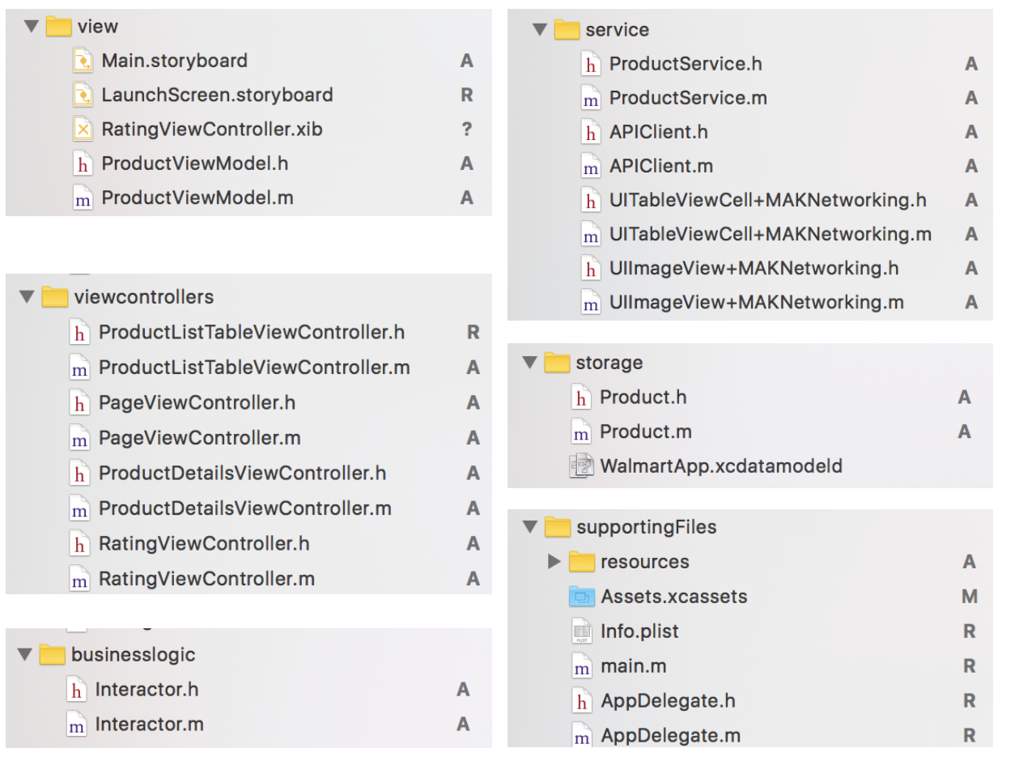

# Application Architecture :

The architecture for the application is a combination of ViewModels from MVVM and Interactor from VIPER Architecture.Reference : <https://www.objc.io/issues/13-architecture/>

For Customer created a Reusable Customer Rating Controller from scratch without using any framework.