**EV STATION**

**Database**

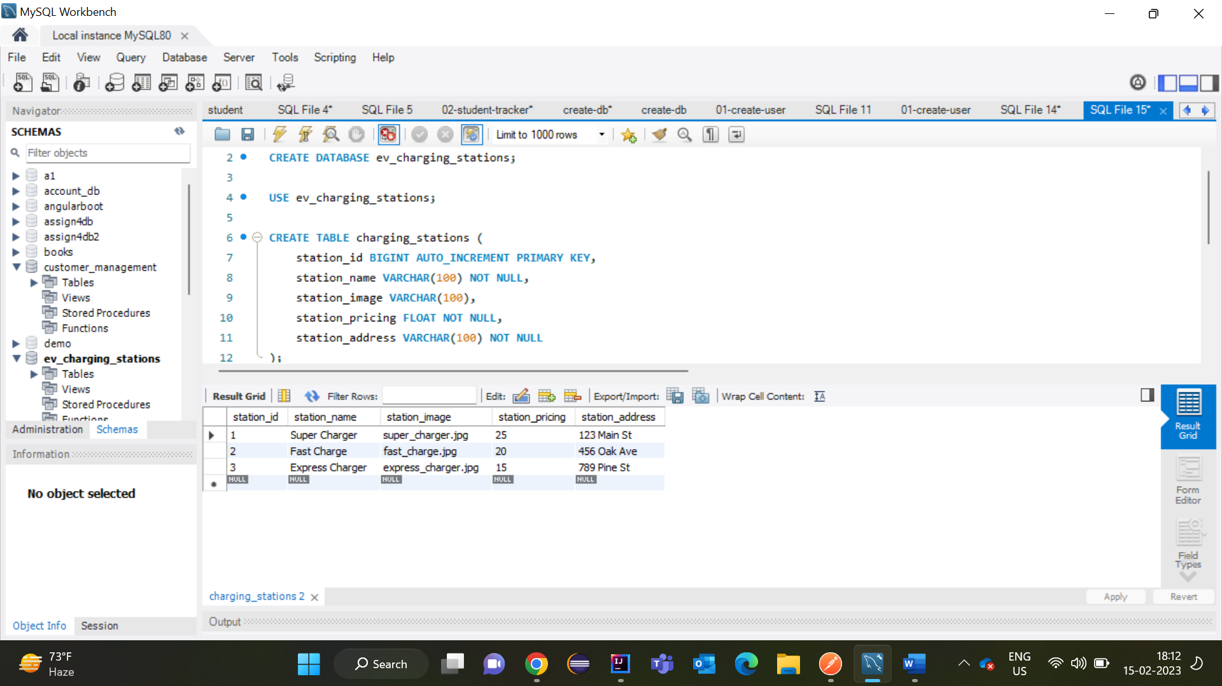

SPRING RUN

**GET ALL DATA**

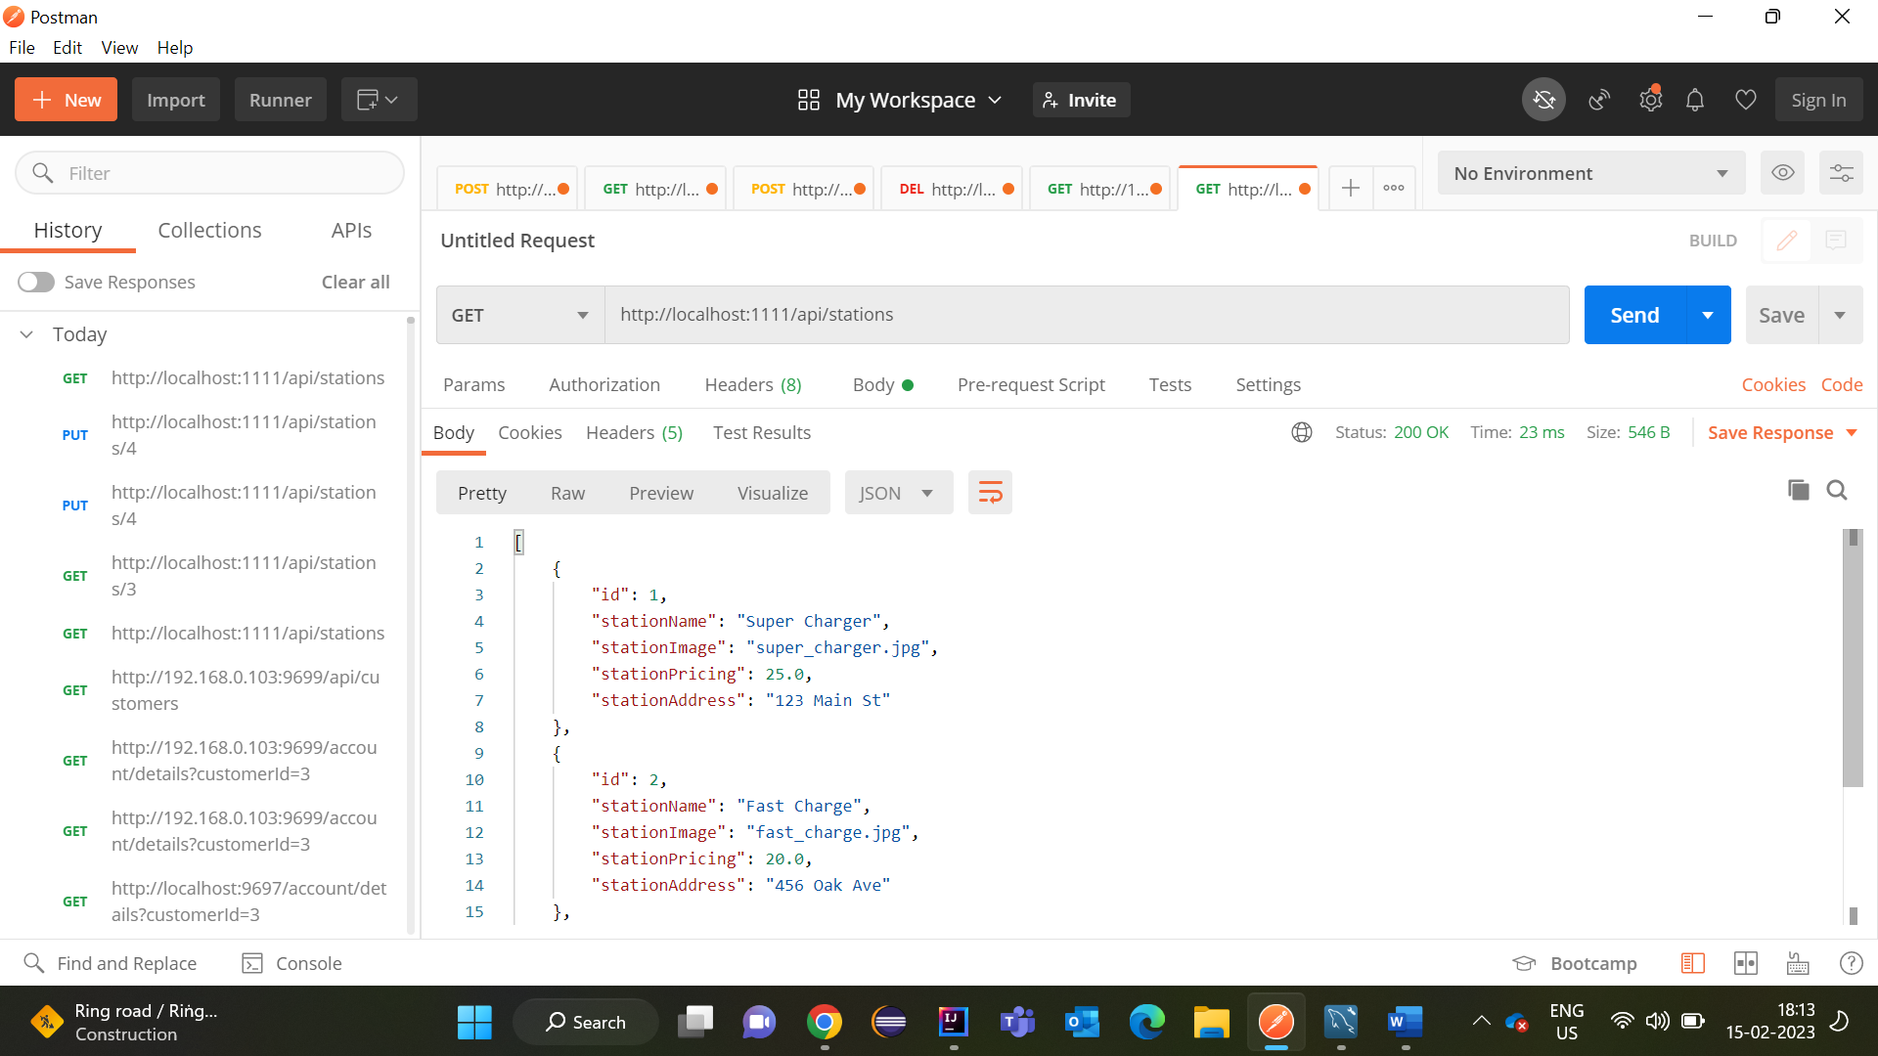

**GET DATA BY ID**

**CREATE**

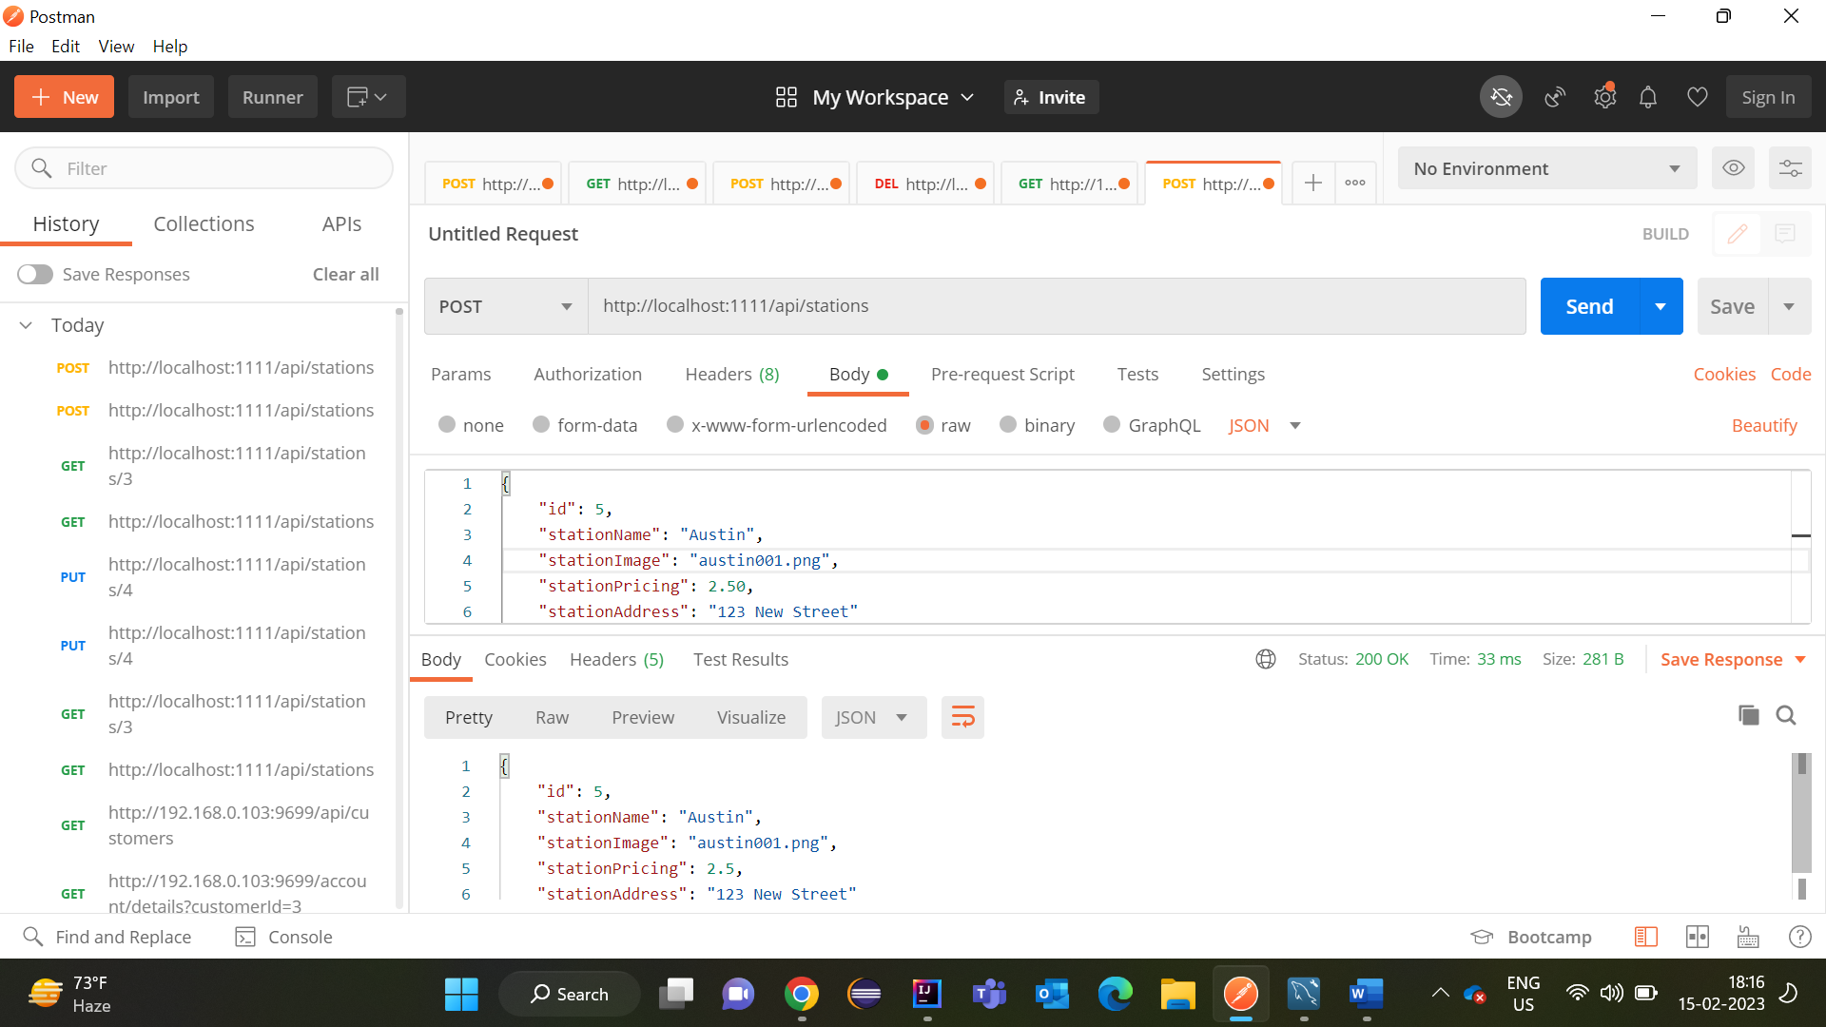

**PUT**

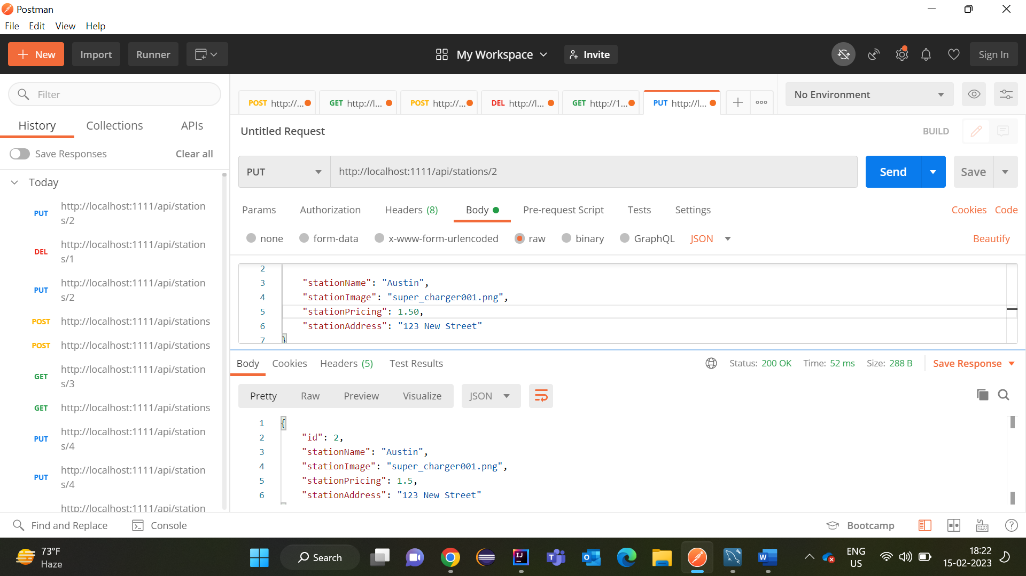

**DELETE**

