WEEK 3 – AUTOMATION TESTING AND FINAL ANALYSIS

1. Introduction
Week 3 focused on implementing automation testing to verify the core functionality of the SauceDemo web application. Automation testing helps reduce manual effort and increases testing efficiency by executing test cases automatically using scripts.
Automation testing was performed using Python and Selenium WebDriver, which allows interaction with web browsers programmatically.

2. Objective of Automation Testing
The main objectives of automation testing in this phase were:
- Automate repetitive test scenarios
- Reduce manual testing effort
- Verify important application functionalities automatically
- Demonstrate the use of Selenium for web testing
The automation scripts were created to test login functionality and product cart operations.

3. Tools and Technologies Used
Tool | Purpose
Python | Programming language used to write automation scripts
Selenium WebDriver | Framework used for browser automation
Google Chrome | Browser used for test execution
ChromeDriver | Driver that connects Selenium with Chrome browser

4. Automation Test Environment
Component | Description
Application Name | SauceDemo
Application URL | https://www.saucedemo.com
Operating System | Windows 11
Programming Language | Python
Automation Tool | Selenium WebDriver
Browser | Google Chrome

5. Automation Test Scenario
The following test scenarios were automated during Week 3:
Test Case ID | Test Scenario | Description
AT-01 | Login Automation | Automate login using valid credentials
AT-02 | Add Product to Cart | Automate adding product to cart
AT-03 | Remove Product from Cart | Automate removing product from cart

6. Selenium Automation Script

from selenium import webdriver
from selenium.webdriver.common.by import By
import time

driver = webdriver.Chrome()
driver.get("https://www.saucedemo.com/")
driver.maximize_window()

driver.find_element(By.ID, "user-name").send_keys("standard_user")
driver.find_element(By.ID, "password").send_keys("secret_sauce")
driver.find_element(By.ID, "login-button").click()

time.sleep(2)

driver.find_element(By.ID, "add-to-cart-sauce-labs-backpack").click()
print("Product added to cart")

time.sleep(2)
driver.find_element(By.ID, "remove-sauce-labs-backpack").click()
print("Product removed from cart")

time.sleep(2)

driver.quit()

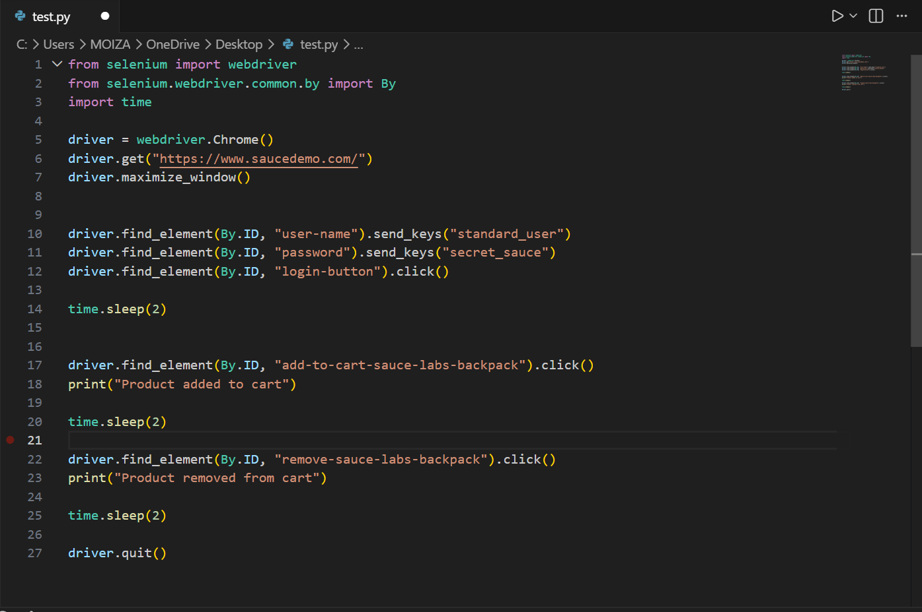

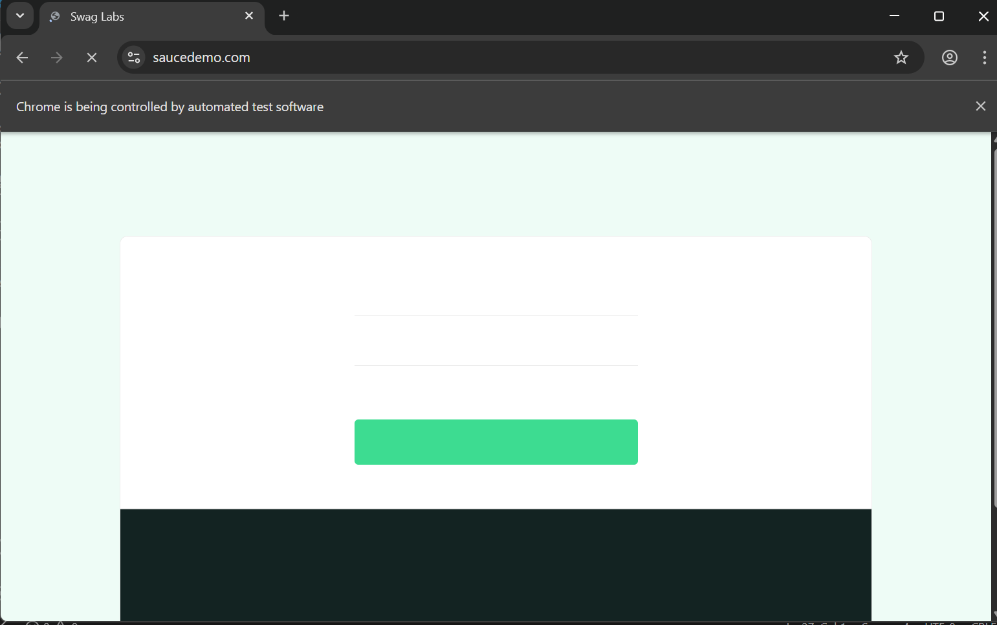

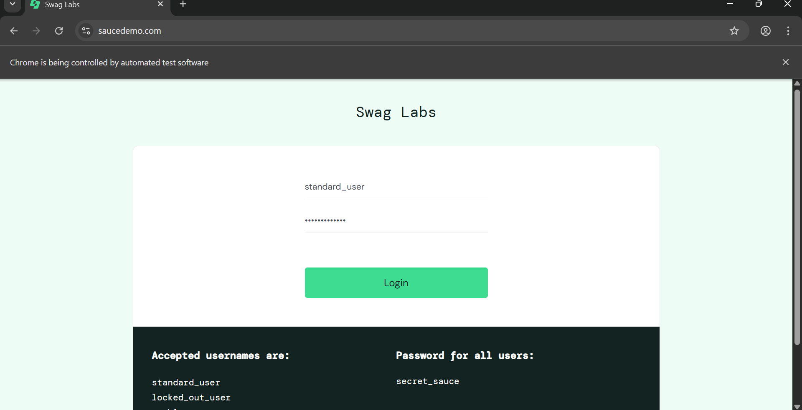

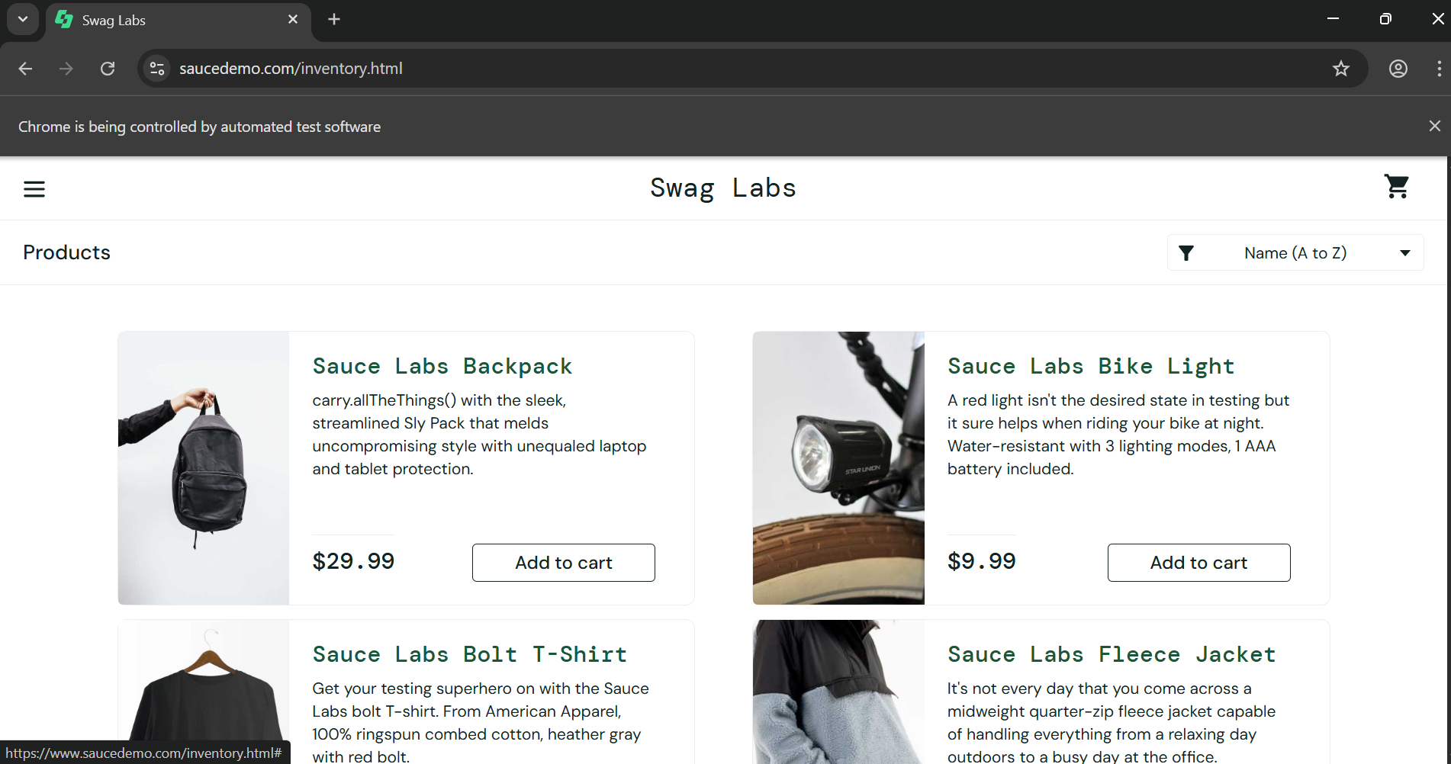
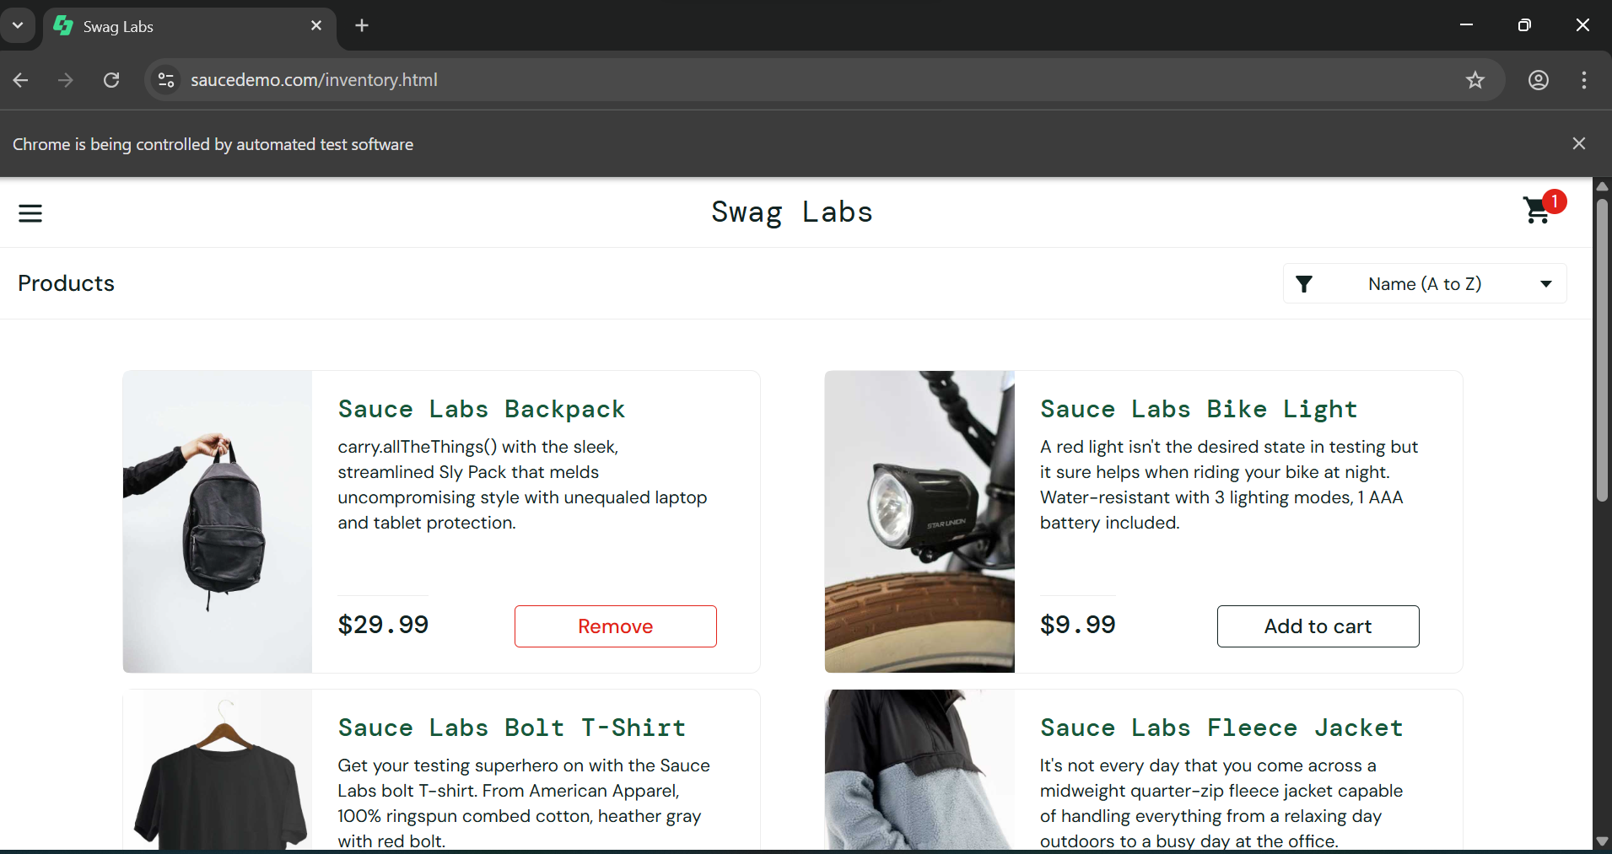

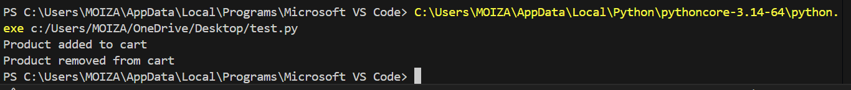

7. Explanation of Automation Script
The automation script performs the following actions:
- Launches the Chrome browser using Selenium WebDriver.
- Opens the SauceDemo website.
- Enters valid login credentials.
- Clicks the login button to access the product page.
- Adds a product to the shopping cart.
- Removes the product from the cart.
- Closes the browser after completing the test.

8. Test Execution Result
Test Scenario | Expected Result | Actual Result | Status
Login Automation | User logs into system successfully | Login successful | Pass
Add Product to Cart | Product added to cart | Product added successfully | Pass
Remove Product from Cart | Product removed from cart | Product removed successfully | Pass

9. Week 3 Summary
Activity | Status
Selenium Setup | Completed
Automation Script Development | Completed
Test Execution | Completed
Result Documentation | Completed

