SOFTWARE QUALITY ASSURANCE
PROJECT REPORT

Website Testing and Automation Project

Internship Organization
DevelopersHub Corporation

Team Lead
Faizan Khan

Internship Field
Software Quality Assurance

Tested Website
SauceDemo

Acknowledgement

First and foremost, I would like to express my sincere gratitude to DevelopersHub Corporation for providing me with the opportunity to complete my internship in the field of Software Quality Assurance. This internship allowed me to gain practical knowledge and hands-on experience in software testing, quality assurance practices, and automation testing techniques.
I would especially like to thank my team lead Faizan Khan for his continuous guidance, support, and mentorship throughout the internship period. His valuable feedback and professional insights helped me understand real-world testing processes and industry practices.
I would also like to thank my instructors and academic institution for providing me with the theoretical foundation of software engineering and testing principles that helped me successfully complete this project.
Finally, I appreciate all the online resources, documentation, and tutorials that assisted me in understanding testing tools such as Selenium and automation frameworks used in the industry.

TABLE OF CONTENT
Contents
1. Introduction 6
2. Overview of Software Testing 6
3. Website Overview 7
4. Project Objectives 7
5. Test Environment 8
6. WEEK 1 – MANUAL TESTING AND BUG REPORTING 8
6.1 Test Case Table 9
6.2 Bug Report Table: 10
7. WEEK 2 – TEST PLANNING AND ADVANCED TESTING 11
7.1 Test Plan 11
7.1.1 Objective 11
7.1.2 Scope of Testing 11
7.1.3 Out of Scope 12
7.1.4 Testing Strategy 12
7.2 Test Environment 13
7.3 Entry and Exit Criteria 13
7.4 Black Box Testing Techniques 14
7.4.1 Equivalence Partitioning 14
7.4.2 Boundary Value Analysis 14
7.5 Cross Browser Testing 15
7.6 Retesting of Bugs 15
8. Week 3 – Automation Testing 16
8.1 Tools and Technologies Used 16
8.2 Automation Test Environment 17
8.3 Automation Test Scenario 17
8.4 Selenium Automation Script 17
8.5 Explanation of Automation Script 22
8.6 Test Execution Result 23
9. Compatibility Report 24
9.1 Browsers Tested 24
9.2 Results 24
10. Performance Testing Report 25
10.1 Objective 25
10.2 Load Test Scenario 25
10.3 Observations 26
10.4 Graph Results 27
10.5 Summary Report 28
11. Security Testing Report 30
11.1 Introduction 30
11.2 Testing Approach 30
11.2.1 Automated Security Testing 30
11.2.2 Manual Security Testing 31
11.3 Summary of Vulnerabilities Identified 31
11.4 Manual Testing Findings 32
11.4.1 Input Validation 32
11.4.2 Cross-Site Scripting (XSS) 33
11.4.3 Authentication (Login/Logout) 33
11.4.4 Session Management 33
11.5 Risk Analysis 34
11.6 Recommendations 34
12 Vulnerability Report 36
12.1 Introduction 36
12.2 Security Testing Tools 36
12.3 Automated Security Testing 36
12.4 Manual Security Testing 43
13. CI/CD Workflow 47
13.1 How Selenium Scripts Run in the Pipeline 47
13.2 Trigger for Test Execution 47
13.3 Test Execution Flow in CI/CD Pipeline 48
13.4 Test Reports Generation 48
13.5 Benefits of CI/CD in Selenium Testing 49
14. GitHub Repository 50
14.1 GitHub Repository Link 50
15. Conclusion 51

1. Introduction
Software testing is one of the most critical phases in the software development lifecycle. The primary goal of testing is to ensure that software systems operate correctly and meet the requirements defined by stakeholders. In the field of Software Quality Assurance, testing activities are performed to detect errors, improve system reliability, and enhance overall product quality.
In modern software development, applications must perform efficiently and provide a smooth user experience. Any bugs or issues present in the system can negatively impact users and reduce trust in the product. Therefore, thorough testing is required before software is released to users.
This project focuses on performing manual and automated testing on the website SauceDemo. This website is widely used by students and professionals to practice software testing techniques.
The project is divided into three main phases:
- Manual testing and test case design
- Test planning and advanced testing techniques
- Automation testing using Selenium
Through these phases, different testing activities were performed to verify the functionality of the website and identify potential issues.

2. Overview of Software Testing
Software testing is the process of evaluating a system to determine whether it meets the specified requirements and functions correctly. Testing involves executing the system under controlled conditions and comparing the actual results with the expected results.
The main objectives of software testing include:
- Identifying defects in the system
- Ensuring the software meets requirements
- Improving system reliability and performance
- Enhancing user satisfaction
Testing can be performed using different approaches, such as manual testing and automation testing. Manual testing involves testers interacting with the system manually, while automation testing uses tools to execute tests automatically.
In this project, both manual and automation testing techniques were used to ensure comprehensive coverage of the application.

3. Website Overview
The website selected for this testing project is SauceDemo, which is a sample e-commerce platform designed for testing practice.
The website simulates a simple online shopping system where users can browse products, add items to a cart, and perform checkout operations. Since the website includes multiple features, it provides an excellent opportunity to test real-world e-commerce functionalities.
Key features of the website include:
- User login authentication
- Product catalog display
- Product sorting options
- Add to cart functionality
- Remove product from cart
- Checkout process
- User logout functionality
These features allow testers to evaluate different components of the system and verify whether they function as expected.

4. Project Objectives
The primary objective of this project is to perform systematic testing of the website and evaluate its functionality using different testing techniques.
The specific objectives of the project include:
- Verifying that the login system functions correctly
- Ensuring that products are displayed properly on the dashboard
- Testing the add-to-cart functionality
- Verifying the removal of products from the cart
- Testing the logout feature
- Identifying and documenting bugs
- Implementing automation testing using Selenium
By achieving these objectives, the project demonstrates the application of software testing techniques in a real-world scenario.

5. Test Environment
The test environment refers to the hardware, software, and tools used during testing.
Component | Details
Website | https://www.saucedemo.com
Operating System | Windows 11
Browser | Google Chrome
Testing Method | Manual and Automation
Automation Tool | Selenium
Programming Language | Python

The environment was configured to ensure that tests could be executed smoothly without compatibility issues.

6. WEEK 1 – MANUAL TESTING AND BUG REPORTING
During the first week of the project, manual testing was conducted to evaluate the functionality of the website.
Manual testing involves executing test cases manually without using automation tools. The tester interacts with the system as a user would and verifies whether the system behaves as expected.
The following modules were tested during this phase:
- Login functionality
- Product listing
- Add-to-cart feature
- Remove-from-cart feature
- Logout functionality
Each feature was tested multiple times to verify consistency and reliability.

6.1 Test Case Table
Test Case ID | Test Case Description | Preconditions | Steps | Expected Result | Actual Result | Status
TC-01 | Login with valid credentials | User is on login page | Enter valid username and password and click login | User should successfully login | User logged in successfully | Pass
TC-02 | Login with invalid credentials | User is on login page | Enter incorrect username/password | Error message should appear | Error message displayed | Pass
TC-03 | Login with empty fields | User is on login page | Click login without entering credentials | Error message should appear | Error message displayed | Pass
TC-04 | Add product to cart | User logged in | Click “Add to Cart” on product | Product should be added to cart | Product added successfully | Pass
TC-05 | Remove product from cart | Product added in cart | Click “Remove” button | Product should be removed | Product removed successfully | Pass
TC-06 | Apply product sorting | User logged in | Select sorting option (Price Low to High) | Products should be sorted correctly | Sorting applied but resets on refresh | Fail

6.2 Bug Report Table:
Using Google sheets for bug reporting.
https://docs.google.com/spreadsheets/d/1cUKviWTZ_QXOey7sG3KBUe9m8C3mngwtrtRizTpQ0NE/edit?usp=sharing
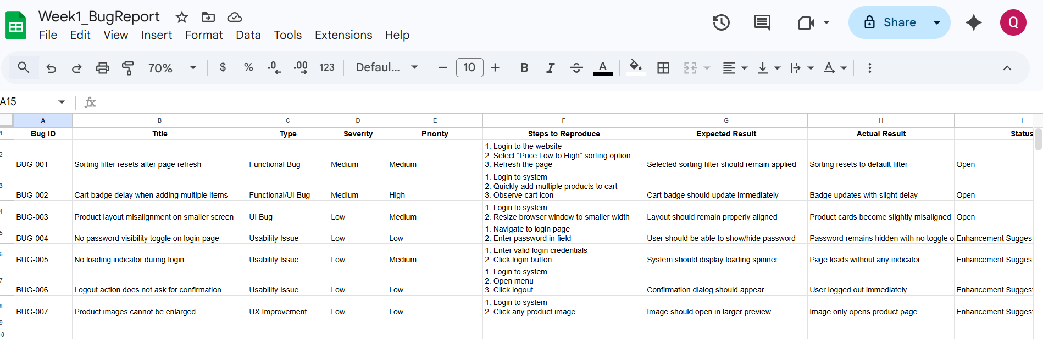

7. WEEK 2 – TEST PLANNING AND ADVANCED TESTING
During the second week, a test plan was developed to organize testing activities. A test plan outlines the testing approach, scope, and objectives.
The following testing techniques were applied during this phase:
- Functional testing
- Cross-browser testing
- Regression testing
- Retesting
These techniques helped ensure comprehensive testing of the application.

7.1 Test Plan

7.1.1 Objective
The objective of the test plan is to ensure that the main functionalities of the SauceDemo application operate correctly and meet the expected requirements. The test plan also helps organize the testing process, define responsibilities, and establish criteria for starting and ending testing activities.

7.1.2 Scope of Testing
The following features of the application were included in the testing scope:
- User login functionality
- Product listing page
- Product sorting functionality
- Add product to cart
- Remove product from cart
- Cart icon update
- Logout functionality
These modules were selected because they represent the core operations of an e-commerce system.

7.1.3 Out of Scope
The following areas were not included in testing during this project phase:
- Payment processing
- Order management
- Backend database validation

7.1.4 Testing Strategy
The following testing strategies were applied during Week 2:
Manual Testing
Manual testing was used to execute the prepared test cases and observe system behavior. The tester manually interacted with the user interface to verify functionality.
Black Box Testing
Black-box testing was used to verify application behavior without examining the internal source code. Testing focused on providing input and validating outputs.
Cross Browser Testing
The application was tested on multiple browsers to ensure compatibility and consistent behavior across different environments.
Retesting
Previously identified defects from Week 1 were retested to confirm whether the issues were resolved.

7.2 Test Environment
Component | Details
Application Name | SauceDemo
Application URL | https://www.saucedemo.com
Operating System | Windows 11
Browser 1 | Google Chrome
Browser 2 | Mozilla Firefox
Browser 3 | Microsoft Edge
Internet Connection | Stable broadband

7.3 Entry and Exit Criteria
Entry Criteria
Testing begins when the following conditions are satisfied:
- Application is accessible through the browser
- Test cases are prepared and reviewed
- Test environment is ready
Exit Criteria
Testing is considered complete when:
- All test cases are executed
- Defects are identified and documented
- Retesting of reported defects is performed

7.4 Black Box Testing Techniques

7.4.1 Equivalence Partitioning
Equivalence Partitioning divides inputs into groups that are expected to produce similar system behavior. Instead of testing all possible inputs, representative values from each group are tested.
Login Functionality
Test Category | Test Data | Expected Result
Valid credentials | standard_user / secret_sauce | Login successful
Invalid username | wrong_user / secret_sauce | Error message displayed
Invalid password | standard_user / wrong_password | Error message displayed
Empty fields | standard_user / wrong_password | Error message displayed

7.4.2 Boundary Value Analysis
Boundary Value Analysis focuses on testing values at the edges of acceptable input ranges.

Password Length Testing
Test Case | Input | Expected Result
Below boundary | Password length = 5 | Login fails
Boundary value | Password length = 6 | Login accepted
Above boundary | Password length = 7 | Login accepted

7.5 Cross Browser Testing
Cross-browser testing ensures that the application behaves consistently across different web browsers.
Testing was conducted using three commonly used browsers.
Browser | Result | Observation
Google Chrome | Pass | Application functions correctly
Mozilla Firefox | Pass | Minor UI alignment issue observed
Microsoft Edge | Pass | Slight delay noticed when clicking buttons

7.6 Retesting of Bugs
Retesting is performed to verify whether previously reported defects have been fixed. The same steps used to reproduce the defect are executed again.
Bug ID | Description | Previous Status | Current Status
BUG-001 | Sorting filter resets after refresh | Open | Still Open
BUG-002 | Cart badge delay when adding items | Open | Still Open
BUG-003 | UI misalignment on smaller screens | Open | Still Open
Since this is a demo testing environment, these issues were documented but not fixed during the project.

8. Week 3 – Automation Testing
Automation testing was implemented during the final phase of the project using Selenium with Python.
Automation testing allows testers to execute test cases automatically, which improves testing speed and efficiency.
Automation was performed for the following tasks:
- Login functionality
- Add product to cart
- Remove product from cart

8.1 Tools and Technologies Used
Tool | Purpose
Python | Programming language used to write automation scripts
Selenium WebDriver | Framework used for browser automation
Google Chrome | Browser used for test execution
ChromeDriver | Driver that connects Selenium with Chrome browser

8.2 Automation Test Environment
Component | Description
Application Name | SauceDemo
Application URL | https://www.saucedemo.com
Operating System | Windows 11
Programming Language | Python
Automation Tool | Selenium WebDriver
Browser | Google Chrome

8.3 Automation Test Scenario
The following test scenarios were automated during Week 3:
Test Case ID | Test Scenario | Description
AT-01 | Login Automation | Automate login using valid credentials
AT-02 | Add Product to Cart | Automate adding product to cart
AT-03 | Remove Product from Cart | Automate removing product from cart

8.4 Selenium Automation Script

from selenium import webdriver
from selenium.webdriver.common.by import By
import time

driver = webdriver.Chrome()
driver.get("https://www.saucedemo.com/")
driver.maximize_window()

driver.find_element(By.ID, "user-name").send_keys("standard_user")
driver.find_element(By.ID, "password").send_keys("secret_sauce")
driver.find_element(By.ID, "login-button").click()

time.sleep(2)

driver.find_element(By.ID, "add-to-cart-sauce-labs-backpack").click()
print("Product added to cart")

time.sleep(2)
driver.find_element(By.ID, "remove-sauce-labs-backpack").click()
print("Product removed from cart")

time.sleep(2)

driver.quit()

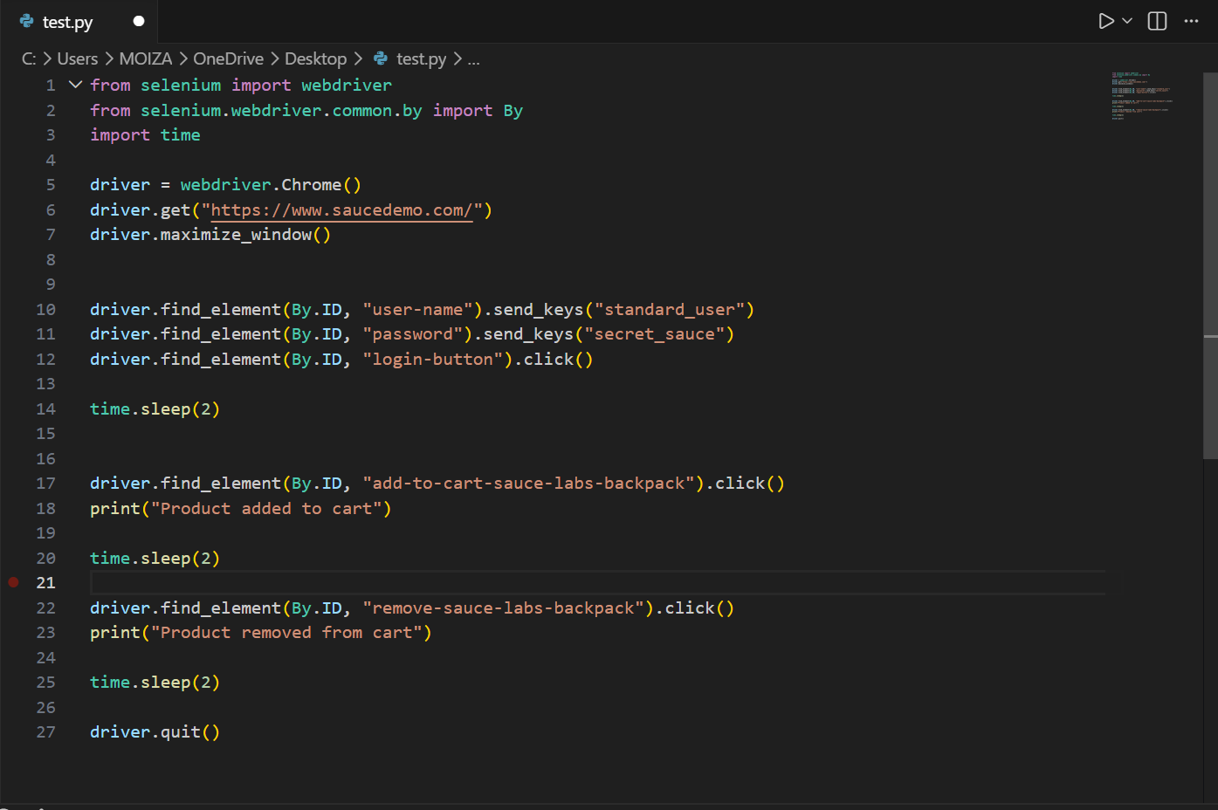

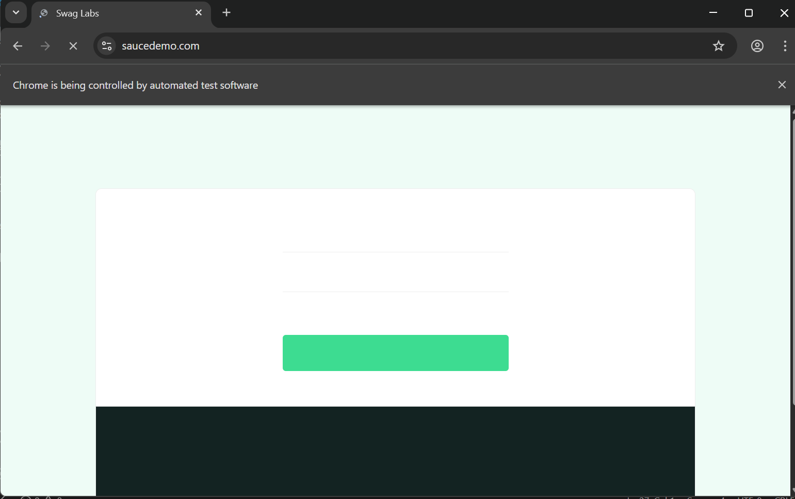

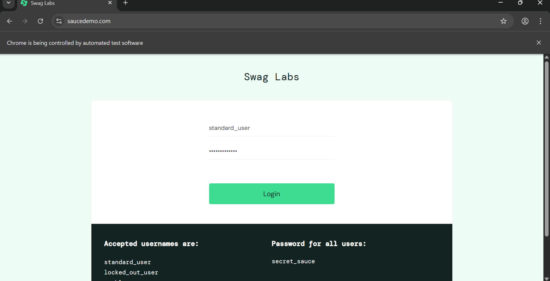

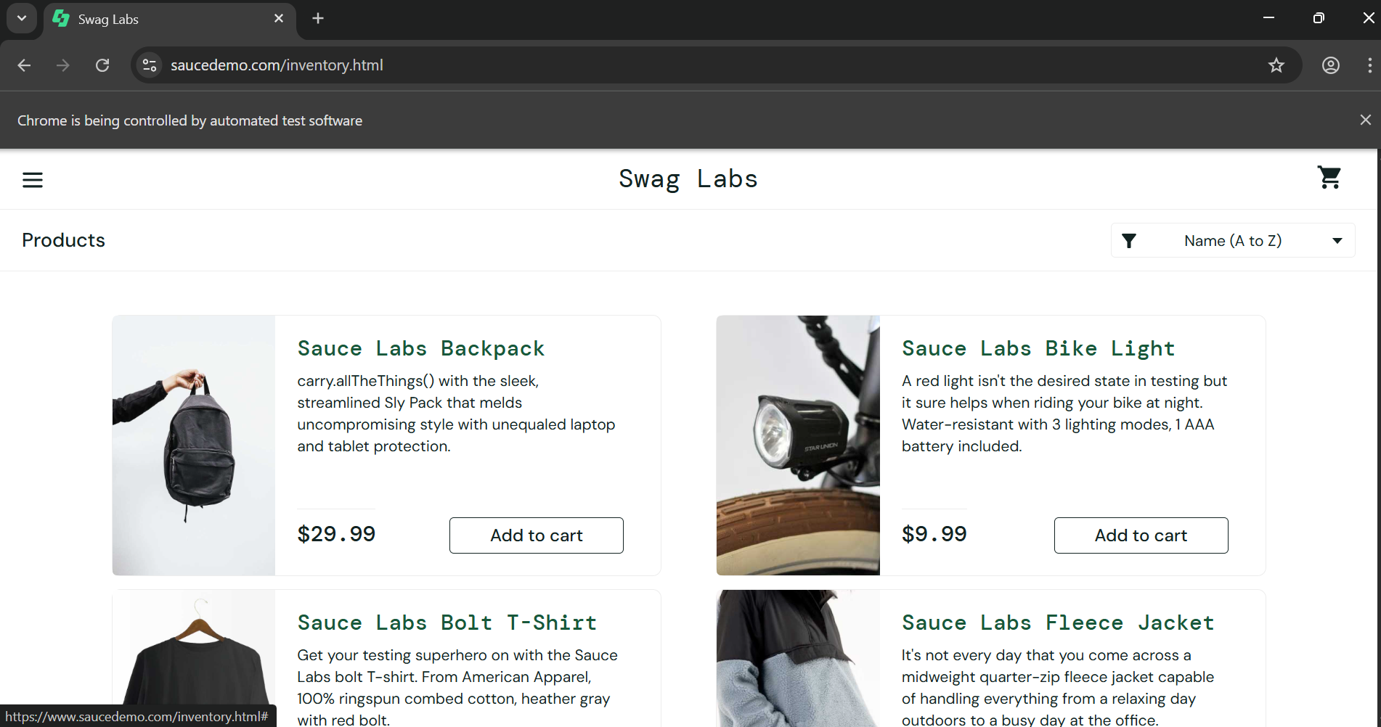
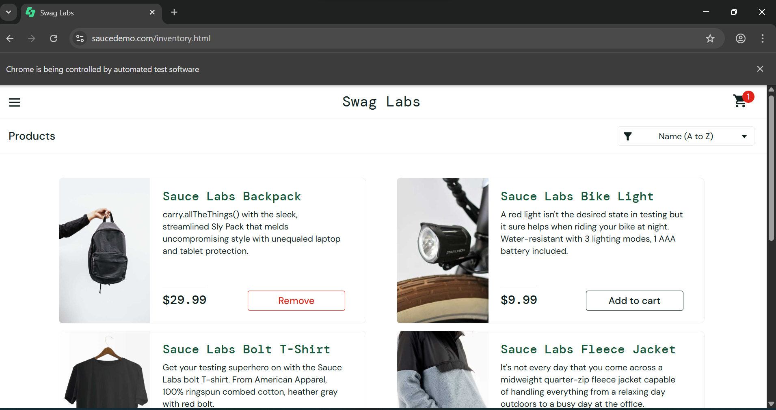



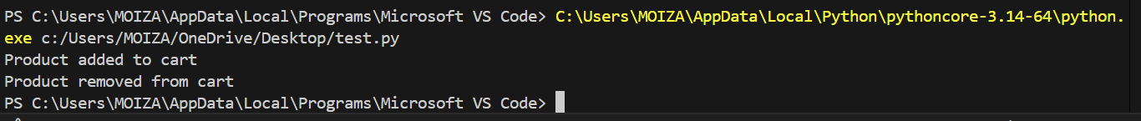

8.5 Explanation of Automation Script
The automation script performs the following actions:
- Launches the Chrome browser using Selenium WebDriver.
- Opens the SauceDemo website.
- Enters valid login credentials.
- Clicks the login button to access the product page.
- Adds a product to the shopping cart.
- Removes the product from the cart.
- Closes the browser after completing the test.

8.6 Test Execution Result
Test Scenario | Expected Result | Actual Result | Status
Login Automation | User logs into system successfully | Login successful | Pass
Add Product to Cart | Product added to cart | Product added successfully | Pass
Remove Product from Cart | Product removed from cart | Product removed successfully | Pass

9. Compatibility Report
Compatibility testing was performed across multiple browsers.

9.1 Browsers Tested
- Google Chrome
- Mozilla Firefox
- Microsoft Edge

9.2 Results
Browser | Result | Issue
Chrome | Pass | None
Firefox | Pass | Minor UI alignment issue
Edge | Pass | None

10. Performance Testing Report

10.1 Objective
The objective of this performance test was to evaluate the responsiveness and stability of the SauceDemo web application when accessed by multiple concurrent users.
Apache JMeter was used to simulate virtual users and analyze the system's behavior under load conditions.

10.2 Load Test Scenario
The load test simulated multiple users accessing the SauceDemo homepage simultaneously.
Test Parameter | Value
Virtual Users | 50
Ramp Up Time | 10 seconds
Loop Count | 5
Request Type | HTTP GET

Users were gradually introduced into the system to simulate real-world traffic conditions.
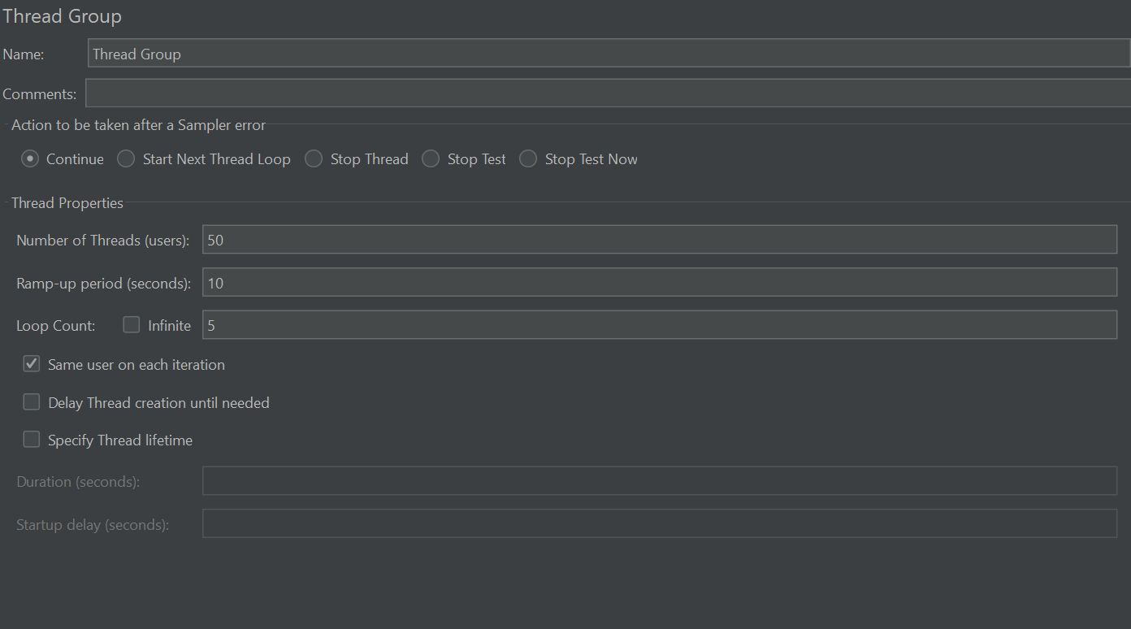
Figure 1: Thread Group Load Configuration

10.3 Observations
During the execution of the performance test, the system handled the simulated user load efficiently. The response time increased slightly as the number of concurrent users increased, which is expected during load testing.
The system remained stable throughout the testing process, and no major errors were observed.
The application responded successfully to user requests and maintained consistent performance.

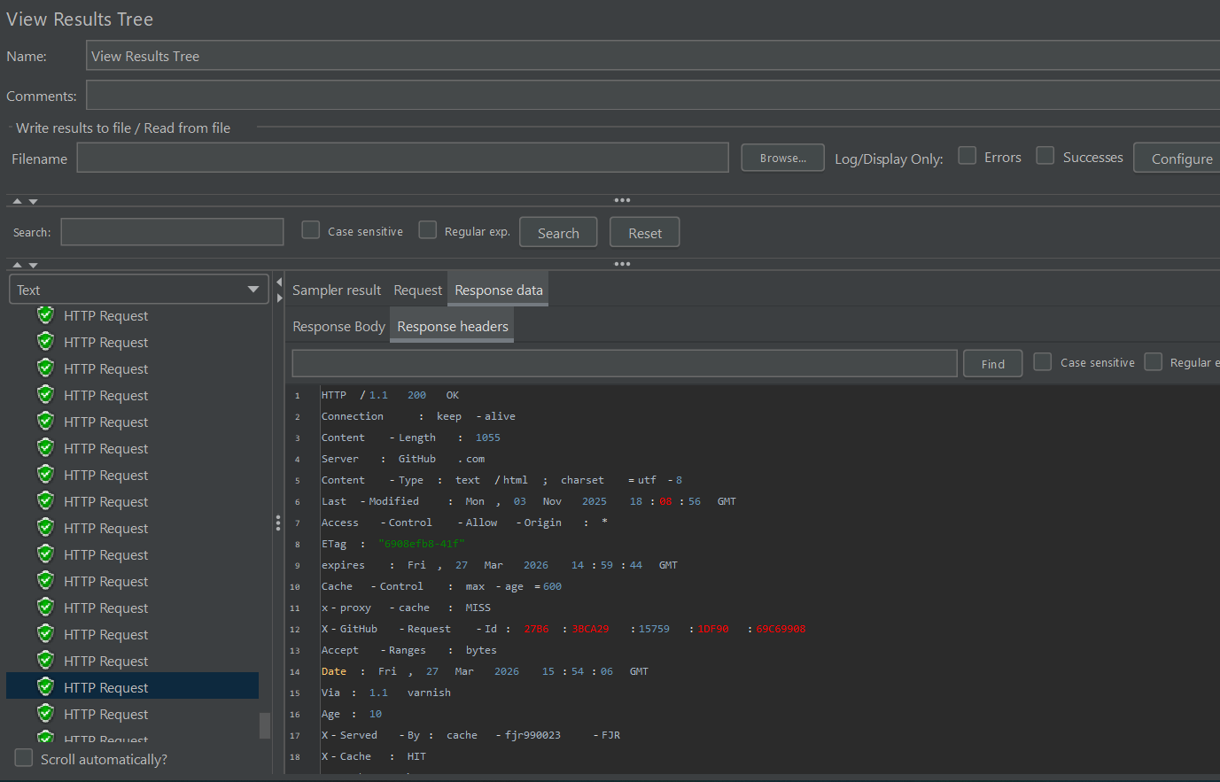
Figure 2: JMeter View Results Tree Output

10.4 Graph Results
The Graph Results listener in Apache JMeter displayed the response time behavior during the test execution.
The graph showed that response times gradually increased with the number of users but remained within acceptable limits.
The system did not show sudden spikes or performance degradation.
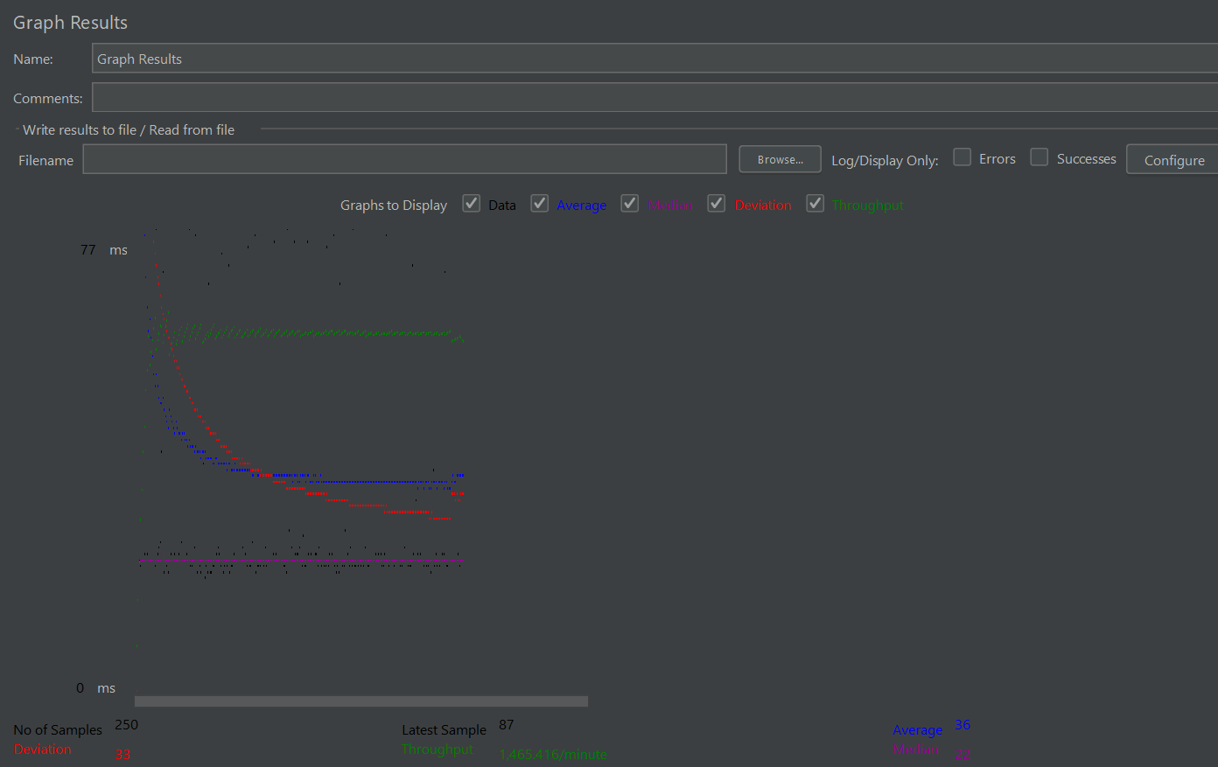
Figure 3: Response Time Graph from JMeter

10.5 Summary Report
The performance test generated a total of 250 samples, representing the number of requests sent to the server during the test execution. The average response time was 36 milliseconds, indicating that the application responded quickly to user requests.
The minimum response time recorded was 19 ms, while the maximum response time reached 308 ms during peak load conditions. The standard deviation of 33.2 ms indicates moderate variation in response times during the test.
The error rate remained at 0.00%, meaning all requests were successfully processed by the server. The throughput was 24.42 requests per second, which represents the number of requests handled by the system per second during the test.
Label | # Samples | Average Response Time (ms) | Min (ms) | Max (ms) | Std. Dev. | Error % | Thoughput | Received KB/sec | Sent KB/sec | Avg. Bytes
HTTP Request | 250 | 36 | 19 | 308 | 33.2 | 0.00% | 24.42 requests/sec | 40.49 | 2.84 | 1697.6
TOTAL | 250 | 36 | 19 | 308 | 33.2 | 0.00% | 24.42 requests/sec | 40.49 | 2.84 | 1697.6
Additionally, the system received 40.49 KB of data per second and sent 2.84 KB per second, with an average response size of 1697.6 bytes per request.

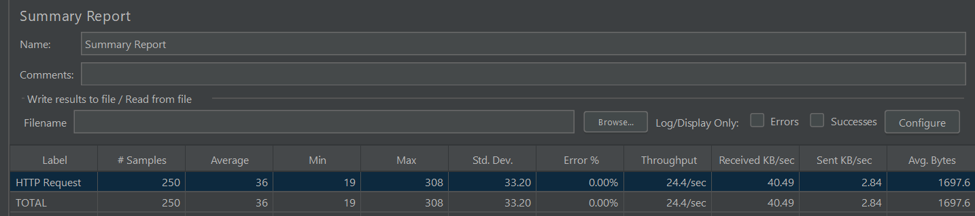
Figure 4: JMeter Summary Report

11. Security Testing Report

11.1 Introduction
Security testing was conducted to evaluate the robustness and reliability of the web application against potential security threats and vulnerabilities. The primary objective of this phase was to identify weaknesses that could compromise the confidentiality, integrity, and availability of the system.
The testing process focused on identifying issues related to improper input validation, cross-site scripting (XSS), session management, authentication mechanisms, and missing security configurations. Both automated and manual testing approaches were utilized to ensure comprehensive coverage of potential security risks.
Automated vulnerability scanning was performed using OWASP ZAP, while manual testing was conducted on the SauceDemo application.

11.2 Testing Approach
The security testing strategy consisted of two main components:

11.2.1 Automated Security Testing
Automated testing was conducted using OWASP ZAP to identify common web application vulnerabilities.
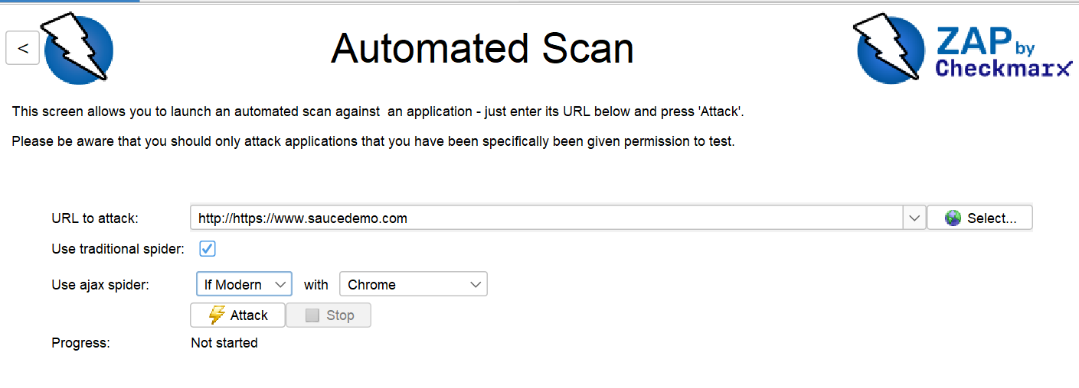
Figure 1: OWASP ZAP Automated Scan Interface
The tool performed spider scanning and active scanning to detect issues such as:
- Missing HTTP security headers
- Cross-domain misconfigurations
- Information disclosure vulnerabilities
- Weak security configurations
The automated scan provided a quick overview of security weaknesses present in the application.

11.2.2 Manual Security Testing
Manual testing was performed to validate application behavior against real-world attack scenarios. The following aspects were tested:
- Input validation mechanisms
- Cross-Site Scripting (XSS) protection
- Login and logout functionality
- Session timeout and session management
Manual testing ensured that the application was not only secure in configuration but also resistant to practical attack techniques.

11.3 Summary of Vulnerabilities Identified
The automated scan detected a total of 11 alerts, categorized into different severity levels:
- Medium Severity Issues: Related to missing critical security headers
- Low Severity Issues: Related to configuration weaknesses
- Informational Alerts: General observations and best practice recommendations
Key Vulnerabilities Identified
- Content Security Policy (CSP) Header Not Set
- Cross-Domain Misconfiguration
- Missing Anti-Clickjacking Header
- Subresource Integrity Attribute Missing
- Strict-Transport-Security Header Not Set
- X-Content-Type-Options Header Missing
- Information Disclosure – Suspicious Comments
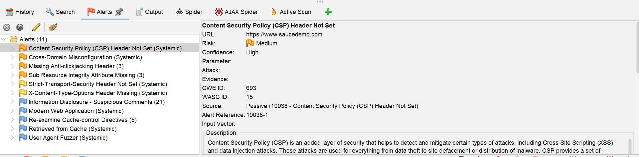
Figure 2: OWASP ZAP Alerts Panel Showing Detected Vulnerabilities
Most of these vulnerabilities were related to missing HTTP security headers, which are essential for protecting web applications against modern security threats.

11.4 Manual Testing Findings
Manual testing revealed the following observations:

11.4.1 Input Validation
The application successfully handled malicious inputs such as script tags and SQL-like queries. Invalid inputs were rejected, and appropriate error messages were displayed.
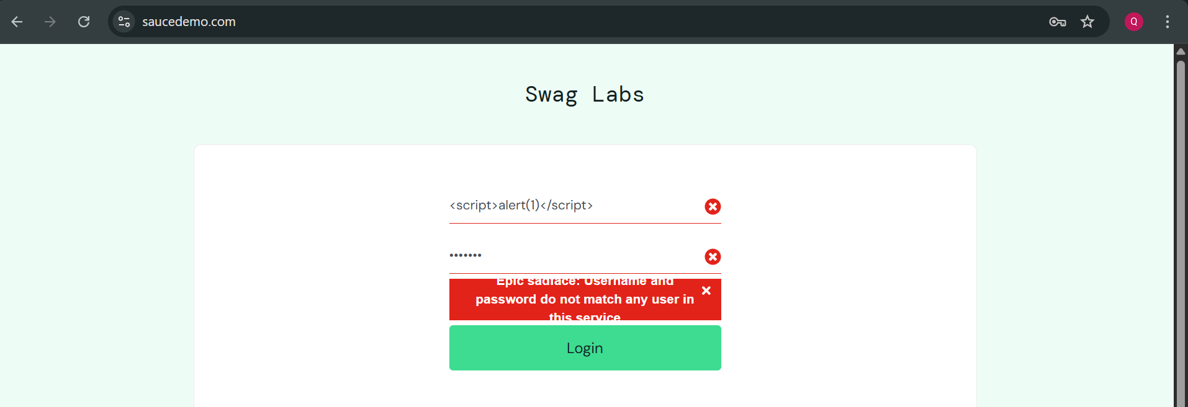
Figure 3: Input Validation Test (Invalid Script Input)

11.4.2 Cross-Site Scripting (XSS)
Basic XSS payloads were tested on input fields. The application did not execute injected scripts, indicating protection against simple XSS attacks.
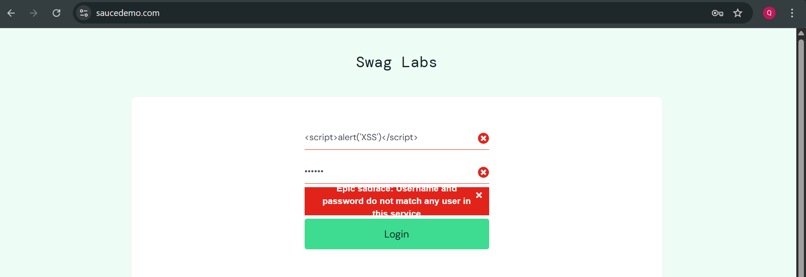
Figure 4: Cross-Site Scripting (XSS)

11.4.3 Authentication (Login/Logout)
The login functionality worked correctly with valid credentials. After logout, users were not able to access restricted pages using the browser back button, ensuring proper session termination.
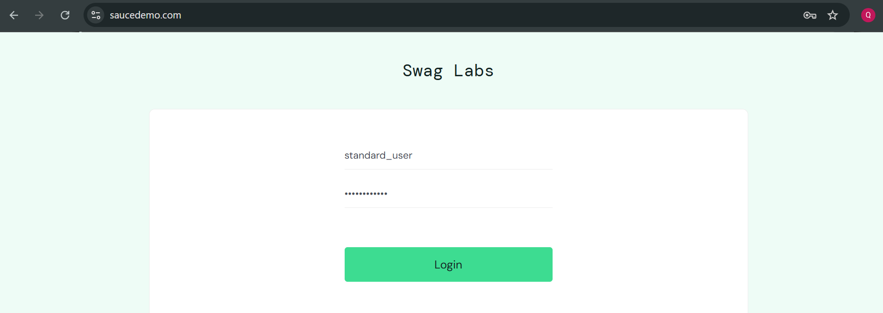
Figure 5: Authentication Login

11.4.4 Session Management
The application session remained active after a period of inactivity. This indicates a lack of strict session timeout policies, which could pose a security risk in real-world scenarios.
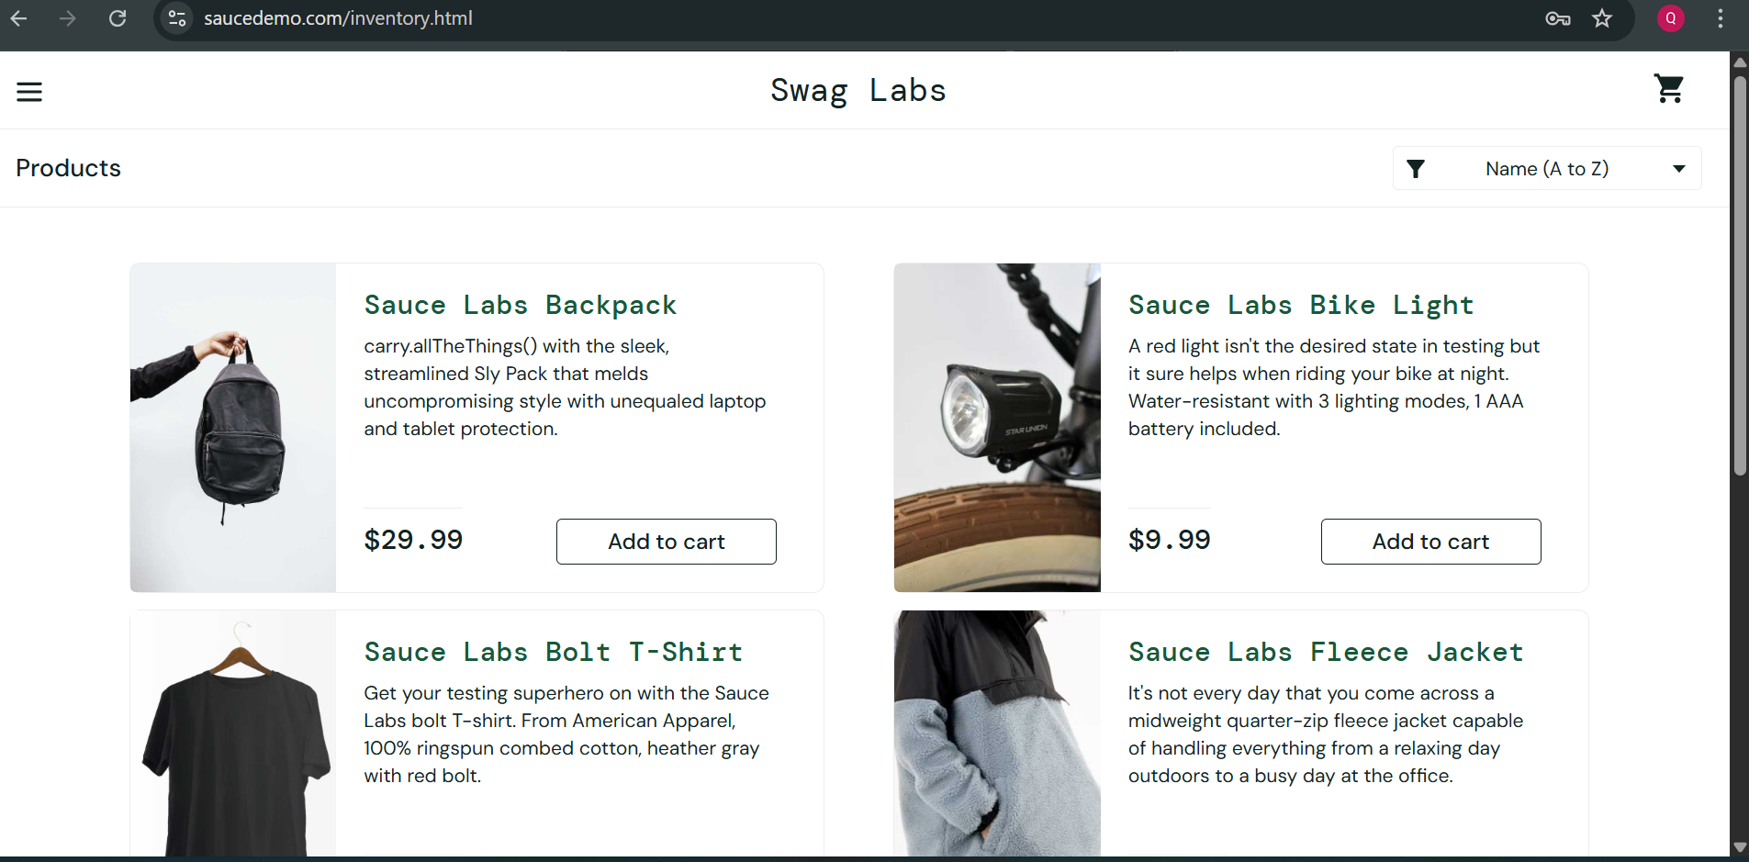
Figure 6: Session Management

11.5 Risk Analysis
The overall risk level of the application is considered Low to Medium based on the findings.
- No High or Critical vulnerabilities were detected
- Most issues were related to configuration and security headers
- Manual testing confirmed that core functionalities are secure
However, the absence of proper security headers and session timeout mechanisms could expose the application to potential risks if deployed in a production environment.

11.6 Recommendations
To improve the security posture of the application, the following recommendations are suggested:
- Implement Content Security Policy (CSP) to prevent XSS attacks
- Add X-Frame-Options header to protect against clickjacking
- Enable Strict-Transport-Security (HSTS) to enforce secure communication
- Include X-Content-Type-Options header to prevent MIME-type sniffing
- Apply Subresource Integrity (SRI) for external resources
- Configure proper CORS policies to avoid cross-domain vulnerabilities
- Implement automatic session timeout for inactive users
- Remove unnecessary comments from source code to prevent information leakage

12 Vulnerability Report

12.1 Introduction
Security testing was performed to identify vulnerabilities in the web application. The testing focused on detecting potential security weaknesses such as improper input validation, cross-site scripting attempts, authentication issues, and missing security configurations.
Both automated security scanning and manual testing techniques were used during this phase. Automated scanning was performed using OWASP ZAP, while manual testing was conducted on the SauceDemo login functionality.

12.2 Security Testing Tools
The following tool was used during the security testing phase:
OWASP ZAP
OWASP ZAP is an open-source security testing tool designed to find vulnerabilities in web applications. It performs automated scans to detect common web security issues such as missing security headers, cross-domain misconfigurations, and information disclosure.
The tool was configured to scan the SauceDemo website and generate vulnerability alerts.

12.3 Automated Security Testing
After scanning the SauceDemo application using OWASP ZAP, several vulnerabilities were detected.
Vulnerability ID: VULN-01
Description
Content Security Policy (CSP) Header Not Set. The application does not define a Content Security Policy header to control which resources the browser is allowed to load.
Severity
Medium

Steps to Reproduce
- Open OWASP ZAP.
- Enter the target URL of the SauceDemo website.
- Start the automated scan.
- Navigate to the Alerts section.
- Locate the alert titled Content Security Policy Header Not Set.
Evidence
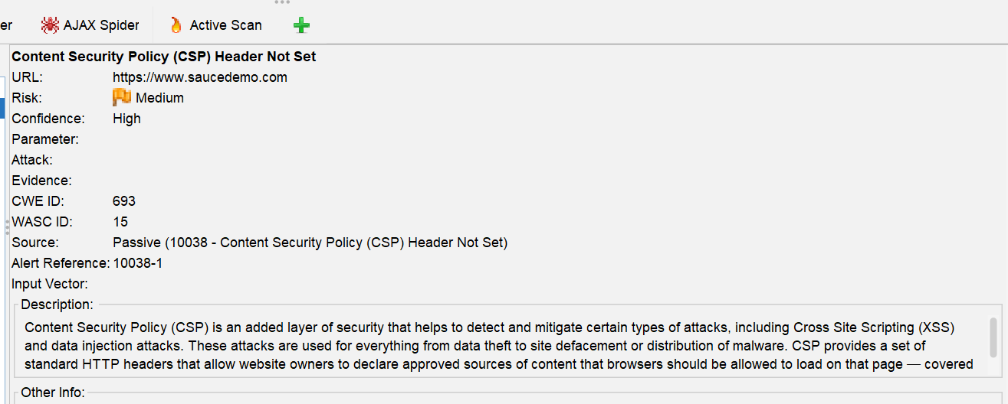
Suggested Fix
Configure the server to include a Content-Security-Policy HTTP header to restrict resource loading.

Vulnerability ID: VULN-02
Description
Cross-Domain Misconfiguration. Improper cross-domain configuration may allow external domains to access application resources.
Severity
Medium

Steps to Reproduce
Run the OWASP ZAP scan and review the alert Cross Domain Misconfiguration.
Evidence
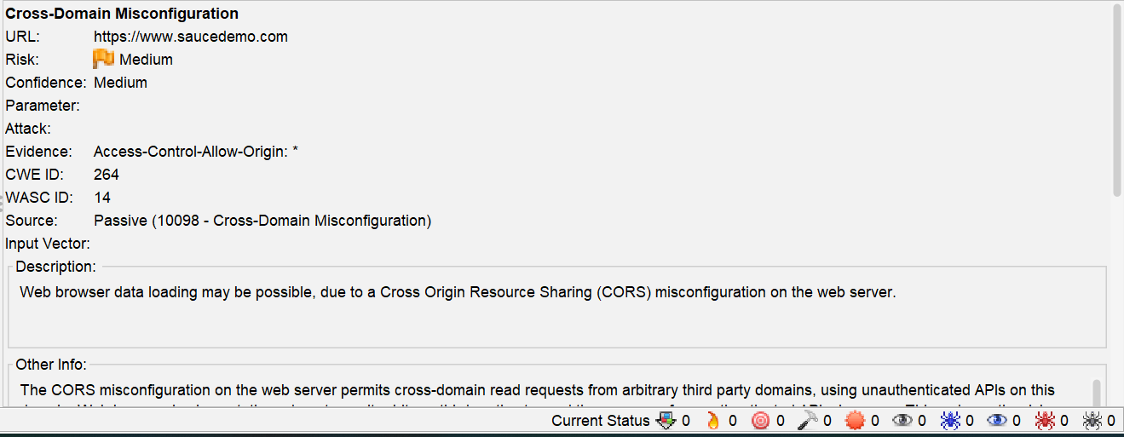
Suggested Fix
Restrict cross-origin requests and configure a proper CORS policy.

Vulnerability ID: VULN-03
Description
Missing Anti-Clickjacking Header. The application does not include the X-Frame-Options header which protects against clickjacking attacks.
Severity
Medium
Steps to Reproduce
Run the automated scan in OWASP ZAP and observe the alert titled Missing Anti-Clickjacking Header.

Evidence
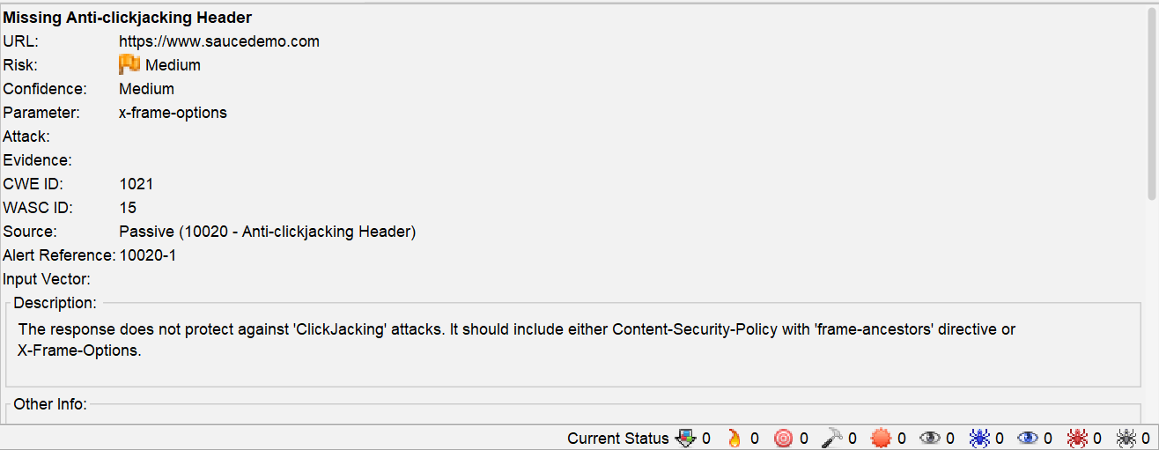
Suggested Fix
Add the following header in the server configuration:
X-Frame-Options: SAMEORIGIN

Vulnerability ID: VULN-04
Description
The scan detected that external resources such as JavaScript or CSS files are loaded without using a Sub Resource Integrity (SRI) attribute.
Subresource Integrity allows browsers to verify that files fetched from external sources have not been tampered with. Without this attribute, if a third-party resource is compromised, malicious code could be executed in the user's browser.
Severity
Medium
Steps to Reproduce
Run the automated scan in OWASP ZAP and observe the alert “Sub Resource Integrity Attribute Missing.”

Evidence
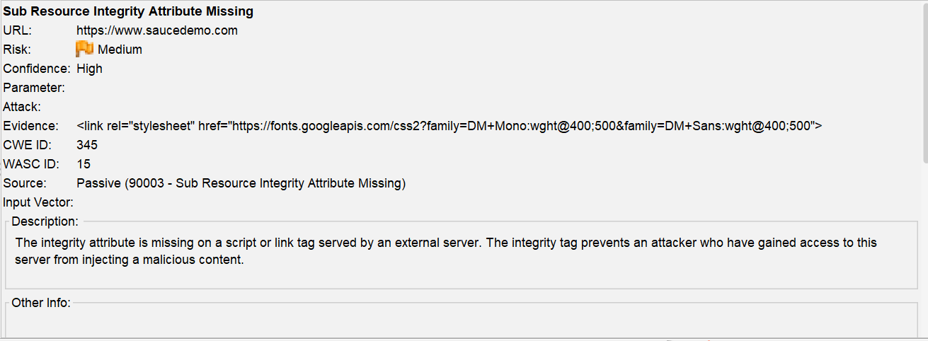Suggested Fix
Developers should include the integrity attribute when loading external scripts or stylesheets.

Vulnerability ID: VULN-05
Description
The Strict-Transport-Security (HSTS) header is not set in the server response. Without this header, browsers may allow connections over HTTP, which can expose users to man-in-the-middle attacks.
Severity
Low
Steps to Reproduce
- Perform a scan using OWASP ZAP.
- Review the alert titled Strict-Transport-Security Header Not Set.

Evidence
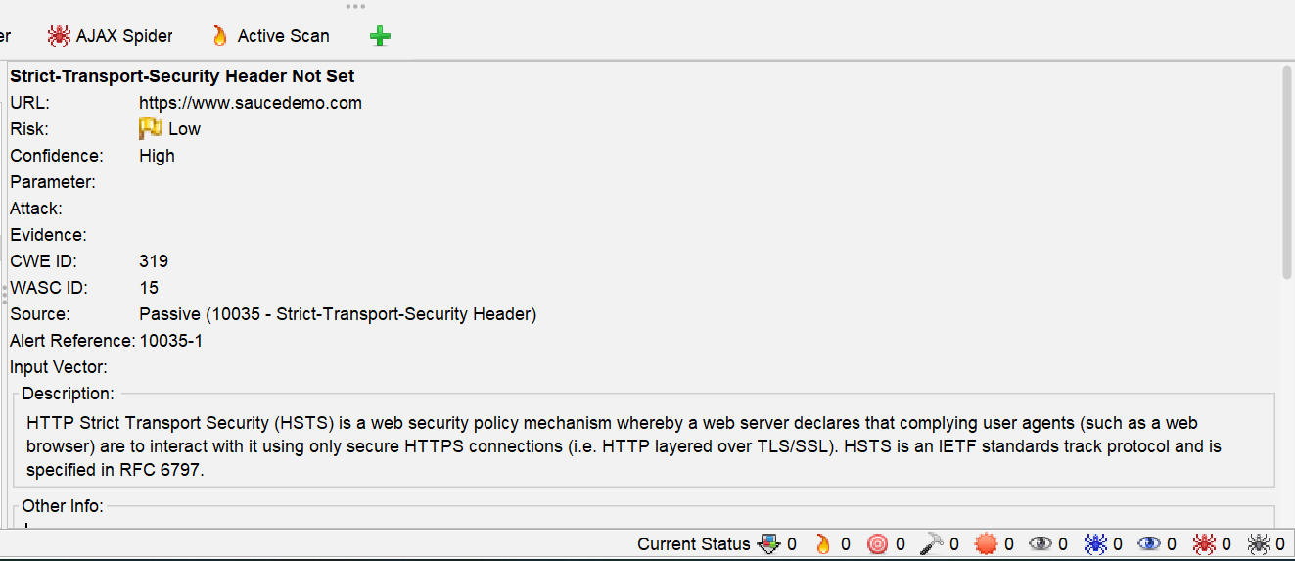
Suggested Fix
Ensure that your web server, application server, load balancer, etc. is configured to enforce Strict-Transport-Security.

Vulnerability ID: VULN-06
Description
X-Content-Type-Options Header Missing. Without this header, browsers may attempt to interpret files as a different content type.
Severity
low
Steps to Reproduce
Run the automated scan and locate the alert X-Content-Type-Options Header Missing.

Evidence
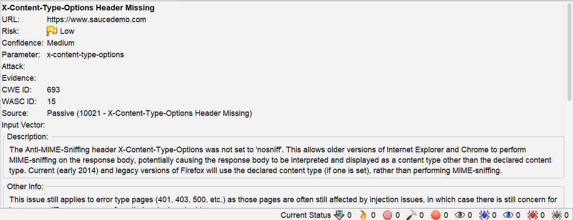
Suggested Fix
X-Content-Type-Options: nosniff

Vulnerability ID: VULN-07
Description
Information Disclosure – Suspicious Comments. The source code contains comments that may reveal internal information about the system.
Severity
Informational
Steps to Reproduce
- Perform a scan using OWASP ZAP.
- Review the alert titled Information Disclosure - Suspicious Comments.

Evidence
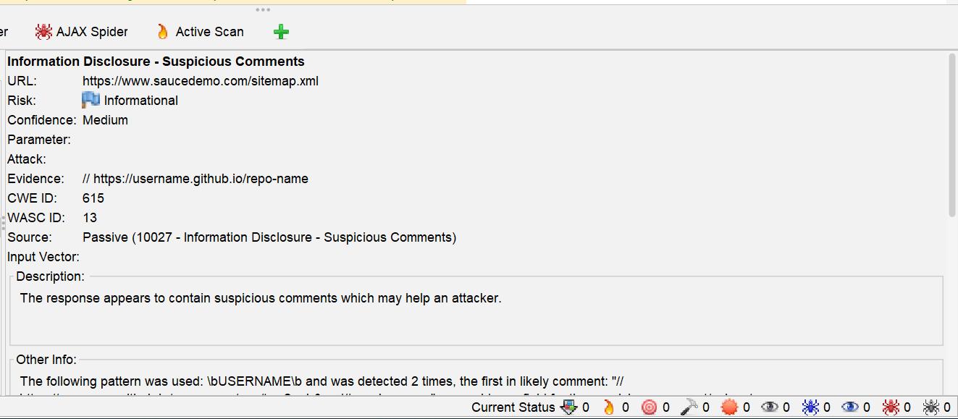
Suggested Fix
Remove all comments that return information that may help an attacker and fix any underlying problems they refer to.

12.4 Manual Security Testing
In addition to automated scanning, manual security testing was conducted to verify the application's behavior against common attack techniques.

Vulnerability ID: MAN-01
Description
Weak Input Validation Testing.
The login form was tested with invalid and malicious inputs to evaluate whether the system properly validates user input.
Severity
Low
Steps to Reproduce
Username
<script>alert(1)</script>
Password
test123
Submit the login form.
Evidence

Suggested Fix
Implement strict input validation and sanitization on user inputs.

Vulnerability ID: MAN-02
Description
Cross-Site Scripting (XSS) Testing.
The login input field was tested with a basic XSS payload.
Severity
Low
Steps to Reproduce
Username
<script>alert('XSS')</script>
Password
123456
Click Login.

Evidence
Suggested Fix
Continue implementing output encoding and input validation to prevent XSS attacks.

Vulnerability ID: MAN-03
Description
Session Timeout Behavior.
The application session remained active after a long period of inactivity.
Severity
Low
Steps to Reproduce
- Login using valid credentials.
Username
standard_user
Password
secret_sauce
- Leave the session idle for 10–15 minutes.
- Attempt to access another page.

Evidence


Suggested Fix
Implement automatic session timeout after a defined inactivity period.

13. CI/CD Workflow
In this project, a Continuous Integration and Continuous Deployment (CI/CD) pipeline is designed to automate the execution of Selenium test scripts for the SauceDemo application. The pipeline ensures that every change in the codebase is automatically tested, improving software quality and reducing manual effort.
The CI/CD process is implemented using GitHub Actions.

13.1 How Selenium Scripts Run in the Pipeline
In the CI/CD pipeline, Selenium automation scripts are executed automatically whenever new code is pushed to the repository.
The execution process is as follows:
- Developer pushes code to the GitHub repository.
- GitHub Actions workflow is triggered automatically.
- A virtual machine environment is created (Ubuntu runner).
- Required dependencies such as Python and Selenium are installed.
- Selenium test scripts are executed in a browser environment.
- Test cases validate application functionality such as login, product selection, and cart operations.
- Execution results are captured and displayed in the workflow logs.
This ensures that every update is tested without manual intervention.

13.2 Trigger for Test Execution
The CI/CD pipeline is triggered automatically under the following conditions:
Push Trigger
- When new code is pushed to the main branch, the pipeline starts automatically.
Pull Request Trigger (Optional Enhancement)
- When a pull request is created, tests can also be executed before merging code.
Manual Trigger
- The pipeline can also be run manually from the GitHub Actions tab if required.
This ensures continuous validation of the application at every change.

13.3 Test Execution Flow in CI/CD Pipeline
The pipeline follows these main stages:
Stage 1: Code Checkout
The latest project code is downloaded from the repository.
Stage 2: Environment Setup
A virtual machine is prepared, and Python is installed.
Stage 3: Dependency Installation
Required libraries such as Selenium and PyTest are installed.
Stage 4: Test Execution
Selenium test scripts are executed to validate:
- Login functionality
- Product selection
- Cart operations
Stage 5: Result Collection
Test execution results are captured from logs.

13.4 Test Reports Generation
After test execution, results are generated automatically by the CI/CD pipeline.
The test reports include:
1 Console Logs
- Shows step-by-step execution of test cases
- Displays pass/fail status of each test
2 GitHub Actions Summary
- Displays overall workflow status (Success/Failure)
- Provides execution time and logs
3 Artifacts
- Test reports can be saved as downloadable files for documentation

13.5 Benefits of CI/CD in Selenium Testing
Implementing CI/CD with Selenium provides the following benefits:
- Automated test execution on every code change
- Early detection of defects
- Reduced manual testing effort
- Faster feedback to developers
- Improved software reliability and quality

14. GitHub Repository
The complete Software Quality Assurance (SQA) project has been hosted on GitHub for version control, collaboration, and CI/CD integration. The repository contains all project artifacts including test plans, test cases, automation scripts, performance testing files, security testing reports, and CI/CD pipeline configuration.
The project is organized in a structured manner to ensure easy navigation and maintainability. GitHub also enables continuous integration and automated testing using GitHub Actions, which executes test scripts whenever changes are pushed to the repository.

14.1 GitHub Repository Link
The project repository can be accessed at the following link:
https://github.com/makmania2022-creator/SauceDemo_QA_Project

15. Conclusion
This project provided valuable experience in performing both manual and automated testing on the SauceDemo platform. Through this project, various software testing techniques were applied to verify system functionality and identify potential defects.
Manual testing helped validate the system's core features, while automation testing using Selenium significantly improved testing efficiency and reduced manual effort.
Overall, the project enhanced my understanding of Software Quality Assurance concepts, including test case design, bug reporting, test planning, and automation testing. These skills are essential for ensuring the delivery of reliable and high-quality software systems.

