Software Requirements Specification
for
Task Management System

Prepared by: Makmot Kabira Johnson, Armand Shematsi, Chemutai Marvis, Bbale Daniel Bwanika
Department of Networks
11th June, 2026
Table of Contents
1. Introduction 3
1.1 Purpose 3
1.2 Intended Audience and Reading Suggestions 3
1.3 Product Scope 4
2. Overall Description 5
2.1 Product Perspective 5
Figure 1: System Architecture 6
2.2 Product Functions 6
2.3 User Classes and Characteristics 7
Figure 2: Use Case Diagram 9
2.5 Design and Implementation Constraints 10
2.6 User Documentation 11
2.7 Assumptions and Dependencies 11
3. External Interface Requirements 12
3.1 User Interfaces 12
3.2 Hardware Interfaces 14
3.3 Software Interfaces 14
3.4 Communications Interfaces 15
4. System Features 15
4.1 Task Management 15
Table 1: Use Case UC1 – Create and Assign Task: Stimulus/Response Sequence 16
Table 2: SRS Detail – Create and Assign Task 17
Table 3: Use Case UC2 – Update Task Status: Stimulus/Response Sequence 18
Table 4: SRS Detail – Update Task Status 19
4.2 Progress Tracking 20
Table 5: Use Case UC3 – View Intern Progress: Stimulus/Response Sequence 20
Table 6: SRS Detail – View Intern Progress 22
4.3 Report and Submission Management 23
Table 7: Use Case UC4 – Submit Report: Stimulus/Response Sequence 23
Table 8: SRS Detail – Report and Submission Management 25
Table 9: Use Case UC5 – Review Submitted Report: Stimulus/Response Sequence 26
Table 10: SRS Detail – Review Submitted Report 27
4.4 Performance Metrics and Analytics 28
Table 11: Use Case UC7 – View Analytics Dashboard: Stimulus/Response Sequence 28
Table 12: SRS Detail – Performance Metrics and Analytics 30
4.5 Machine Learning Engagement Monitoring 31
Table 13: Use Case UC8 – Generate Engagement Score and Risk Alerts: Stimulus/Response Sequence 32
Table 14: SRS Detail – Machine Learning Engagement Monitoring 34
4.6 Supervisor Comment and Feedback System 35
Table 15: Use Case UC6 – Add Comment to Intern Report: Stimulus/Response Sequence 35
Table 16: SRS Detail – Supervisor Comment and Feedback System 38
5. Non-Functional Requirements 39
5.1 Performance Requirements 39
5.2 Security Requirements 40
5.3 Reliability and Availability 40
5.4 Usability Requirements 40
5.5 Maintainability 40
5.6 Data Privacy and Compliance 41
Figure 3: Entity-Relationship Diagram 41
6. References 42
Appendix A: Glossary 42
Table 17: Glossary of Terms 42
Appendix B: Use Case Summary 44
Table 18: Use Case Summary 44

1. Introduction

1.1 Purpose
This document defines the Software Requirements Specification (SRS) for the Task Management System. The system is designed to digitize and streamline the supervision of interns within an organization by enabling supervisors to assign tasks, monitor daily and weekly progress, collect reports and submissions, aggregate performance metrics and leverage machine learning to track intern engagement. It also provides supervisors with a structured mechanism to leave feedback and comments on intern-submitted reports.

This document covers the full scope of the application, its functional requirements, non-functional requirements, external interface requirements and system constraints.

1.2 Intended Audience and Reading Suggestions
This document is intended to be read by the following parties:

- Project Managers and Development Team: Must become thoroughly familiar with all functional and non-functional requirements, particularly Sections 4 and 5, to ensure accurate implementation.
- Testers and QA Team: Should focus on Section 4 (System Features) and Section 5 (Non-Functional Requirements) to develop meaningful and comprehensive test cases.
- Marketing and Product Staff: Should review Section 1.4 (Product Scope) and Section 3 (External Interface Requirements) to understand product features for communication purposes.
- Organizational Stakeholders: Should review Sections 1 and 2 to understand the goals, benefits, and constraints of the system.
- Documentation Writers: Should review all sections to produce accurate user manuals and in-app guides.

It is recommended that all readers start with Sections 1 and 2 before moving into the more technical sections.

1.3 Product Scope
The Task Management System is a web-based platform designed to replace manual, spreadsheet-driven intern supervision workflows. It brings together supervisors and interns in a single, organized digital environment where tasks can be assigned, progress tracked, reports submitted and reviewed, and performance trends automatically analyzed.

1.3.1 Goals
- To provide supervisors with a centralized digital workspace to manage all intern-related activities.
- To give interns a clear, structured view of their assignments, deadlines, and expectations.
- To automate performance tracking and reduce the administrative burden on supervisors.
- To identify disengaged or struggling interns early through machine learning, enabling timely intervention.
- To maintain a complete and auditable record of intern activities, report submissions, and supervisor feedback.

1.3.2 Objectives
Main Objective
To build a reliable, scalable, and user-friendly intern management platform that uses automation and machine learning to improve intern supervision outcomes.
Other Objectives:

- To collect and analyze requirements for the Intern Management System.
- To design a relational data model and system architecture suitable for multi-user, role-based access.
- To implement the system based on the approved design and requirements.
- To test the system thoroughly with both supervisors and interns before deployment.

1.3.3 Benefits
- Supervisors gain a real-time overview of each intern's workload and progress without manual follow-ups.
- Interns receive structured feedback through annotated report comments, improving their professional development.
- Management gains access to aggregated analytics dashboards showing cohort-level performance trends.
- The machine learning engine flags at-risk interns automatically, allowing proactive support.
- All intern records, task histories, and submitted reports are stored securely in one place, reducing the risk of data loss.

2. Overall Description

2.1 Product Perspective
The Task Management System is a modern, standalone web application designed to replace the manual, spreadsheet-based tracking of interns. The system is organized into three main architectural components that work together:

- The Web Dashboard: The primary interface that users log into to fill out forms, view charts, manage tasks, submit reports, and interact with the system's features. It is accessible via standard web browsers on any device.

- The Database (Filing Cabinet): A structured, secure relational SQL database that stores all intern profiles, task assignments, report submissions, performance logs, and activity history. It ensures referential integrity so that no record is accidentally lost, overwritten, or disassociated.

- The Machine Learning Engine (Smart Assistant): A background processing module that continuously reads intern activity logs to identify behavioral patterns. If an intern's login frequency drops significantly or task completion falls below a defined threshold, the engine automatically flags that intern as "at risk" and surfaces the alert on the supervisor's dashboard.
System Architecture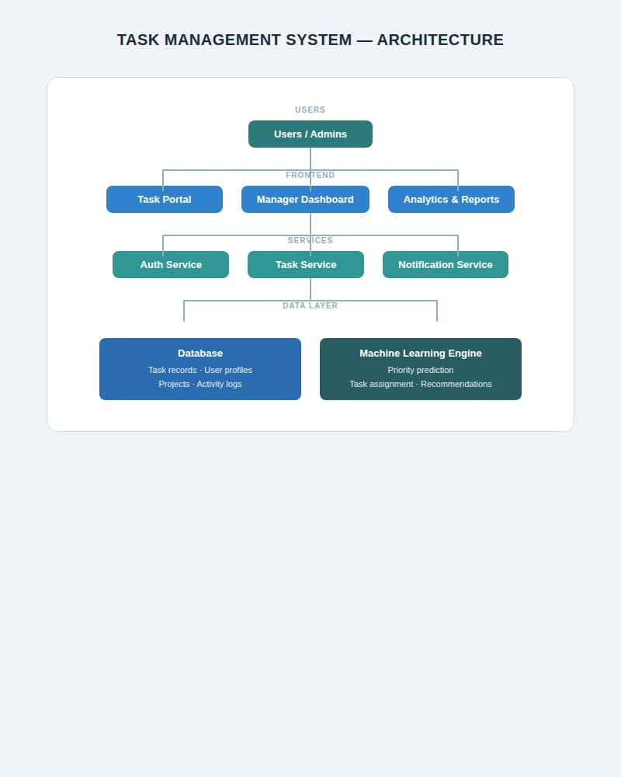
Figure 1: System Architecture

2.1.1 Site Adaptation Requirements
The system must be deployable on standard web hosting infrastructure or cloud platforms (e.g., AWS, Digital Ocean or a local on-premise server). It must support multi-user configurations where multiple supervisors and interns can operate simultaneously without data crossover. The interface must be fully responsive and usable on desktop browsers, laptops, tablets, and smartphones.

2.2 Product Functions
The Task Management System is built around four core functional areas:

- Task Assignment and distribution: Supervisors are provided with a digital dashboard to create tasks, divide these tasks into subtasks and assign them to specific interns, and set distinct deadlines for these tasks. This eliminates reliance on scattered email threads or informal communication channels.

- Progress Tracking and work submission: Interns can update their task status (e.g., To-Do, In Progress, Completed) at any time. Supervisors can view a real-time board showing the progress of every intern in their group, filtered by day or week. To prevent interns from falsely marking status as completed or under review, the system strictly requires proof of work by directly uploading the weekly report file onto the platform.

- ML-Driven Performance Analytics and Monitoring: The system quietly gathers raw operational statistics as they happen such as task completion dates, missed deadlines and system login times. The ML engine processes these metrics to compile clean summary totals (total tasks completed vs. late submissions) and calculates an overall engagement score for each intern. The system then takes these scores and generates clear charts and automated alert lists on the supervisor’s control panel, allowing them to instantly identify high-performing individuals and flag interns who are falling behind and need immediate support.

- Supervisor Comment and Feedback System: Supervisors can leave annotated comments directly on submitted intern reports. Interns receive notifications when new comments are added and can view all feedback from within their dashboard.

2.3 User Classes and Characteristics
The platform enforces role-based access control across three distinct user classes:

2.3.1 System Administrator
The System Administrator holds the highest privilege level. Their responsibilities include provisioning supervisor accounts, onboarding new interns into the system, managing user roles, configuring system-level settings, and ensuring the health and uptime of the application. Administrators are expected to have technical proficiency in web-based systems.
2.3.2 Supervisor
Supervisors are the primary power users of the platform. They use the system daily to create and assign tasks, review submitted intern reports, leave comments and feedback on reports, monitor progress through visual dashboards, and respond to automated ML-generated engagement alerts. Supervisors are expected to be proficient with standard web applications but do not require technical training.

2.3.3 Intern
Interns interact with the system through a simplified personal workspace. They can view their assigned tasks, update task statuses, submit daily logs and weekly reports, and read supervisor feedback on their submissions. Interns cannot access other interns' profiles, data, or managerial analytics views. Basic web browsing skills are sufficient for an intern to use the system.
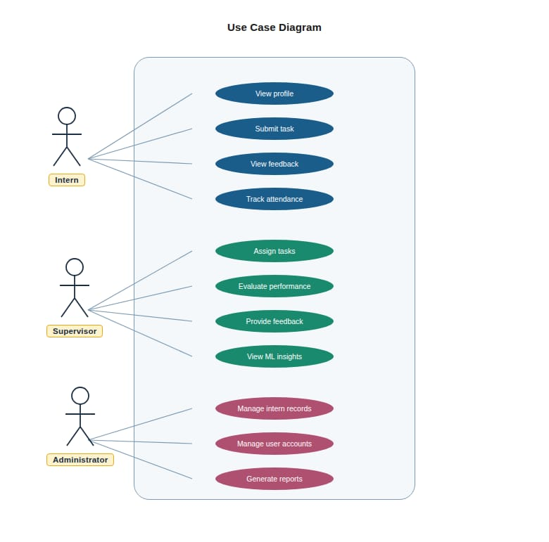
Figure 2: Use Case Diagram
supervisor
2.4 Operating Environment
The Intern Management System will operate within a distributed multi-tier client-server environment and must function correctly under the following configuration:

- Server Side: A Linux-based web server running Python (Django or Flask) with a relational MySQL database and a background ML processing worker (Python with scikit-learn and pandas).
- Client Side: Any modern web browser (Google Chrome, Mozilla Firefox, Microsoft Edge, Safari) on desktops, laptops, tablets, or smartphones.
- Network: Requires a stable internet connection for real-time communication between client and server. A minimum bandwidth of 5 Mbps is recommended for a smooth experience.
- Operating Systems: Compatible with Windows, macOS, Linux, Android, and iOS on the client side.

2.5 Design and Implementation Constraints
- Database Constraints: The system must use a relational SQL database (MySQL). All data entities, interns, tasks, reports, and metrics are tightly interdependent, and a relational schema ensures referential integrity. A task record, for example, must always be linked to a valid intern in the system.

- ML Performance Boundary: The machine learning engine must run as an isolated background process, completely separate from the main web application codebase. Heavy computational operations (e.g., model training, engagement score recalculation) must not block or slow down the user-facing dashboard. Asynchronous task queues (e.g., Celery with Redis) should be used for this purpose.

- Hardware Limitations: The platform must be lightweight and performant on standard office hardware. Client devices are assumed to have at minimum a dual-core processor, 4 GB RAM, and a modern browser. The server should be provisioned with at least 4 vCPUs and 8 GB RAM to handle concurrent users comfortably.

- Data Privacy and Regulatory Compliance: Because the system stores personally identifiable information (names, email addresses, phone numbers, work performance data), it must comply strictly with Uganda's Data Protection and Privacy Act. This includes implementing access controls, data encryption at rest and in transit (HTTPS/TLS), and providing mechanisms for data deletion upon request.

- Role Boundary Enforcement: The system must enforce strict privilege boundaries at the API level, not just the UI level. An intern must never be able to access another intern's data or any supervisor-level analytics, regardless of how they access the system.

2.6 User Documentation
The following documentation will be delivered alongside the software:

- In-App Quick Guides:

  - For Interns: A simple visual guide (accessible from the dashboard) explaining how to view assigned tasks, update task statuses, and upload weekly reports.
  - For Supervisors: A contextual walkthrough explaining how to create and assign tasks, interpret dashboard analytics, read ML-generated engagement risk alerts, and leave comments on intern reports.

- System Administration Manual: A comprehensive guide covering user provisioning, role management, database setup, and system configuration for technical administrators.

- Deployment and Setup Guide: A step-by-step technical manual explaining how to install the application, configure the SQL database, set up the ML background worker, and deploy to a hosting environment.

2.7 Assumptions and Dependencies

2.7.1 Assumptions
- All supervisors and interns using the platform are assumed to have baseline familiarity with web browsers and standard online forms; no specialized technical training will be required for day-to-day use.
- The organization implementing the system will provide and maintain adequate computing hardware and a stable internet connection for all users.
- Supervisors are assumed to have sufficient familiarity with their interns' work to provide meaningful written feedback through the comment system.
- Intern data entered into the system is assumed to be accurate and up-to-date; the system does not independently verify personal information beyond email confirmation.

2.7.2 Dependencies
- Internet Connectivity: The system depends on a stable and continuous internet connection. Without it, interns cannot submit reports, and supervisors cannot monitor dashboards in real time.
- Database Availability: The entire system depends on the continuous health of the MySQL database server. If the database becomes unavailable, all user profiles, tasks, reports, and analytics records will be inaccessible until it is restored.
- Python ML Libraries: The engagement monitoring engine depends on the stability and availability of Python scientific libraries, specifically pandas for data processing and scikit-learn for behavioral modeling. Updates to these libraries must be tested before deployment.
- Email Service Provider: Features such as account verification, supervisor notifications, and intern report feedback alerts depend on a functioning email delivery service (e.g., SMTP via SendGrid or a similar provider).

3. External Interface Requirements

3.1 User Interfaces
The Intern Management System will have the following primary interface screens:

- Login / Registration Page: The entry point for all users. Existing users log in using their registered email and password. New interns are provisioned by the system administrator, who then sends them a registration link via email. The interface includes fields for email address and password, a "Forgot Password" link, and clear error messaging for incorrect credentials.

- Intern Dashboard: Upon login, an intern is presented with their personal dashboard displaying:

- A list of all currently assigned tasks, organized by status: To-Do, In Progress, and Completed.
- A report submission panel where the intern can type a daily log or upload a weekly progress report (PDF or DOCX).
- A notifications panel showing new supervisor comments on recent submissions.
- A simple summary card showing their current engagement score and task completion rate.

- Supervisor Dashboard: Upon login, a supervisor sees:
- An overview panel showing all interns under their supervision with color-coded status indicators (green = on track, amber = moderate risk, red = high risk).
- A task management panel for creating, editing, assigning, and tracking tasks.
- A report review panel listing all recent intern submissions, with the ability to open each report and leave inline comments.
- An analytics section featuring visual charts generated from aggregated performance data.
- An ML alert panel listing interns currently flagged as disengaged.

- Report Review and Comment Interface: When a supervisor opens an intern's submitted report, they see the full report text or an embedded document viewer. A comment input panel appears on the right-hand side (or below on mobile), allowing the supervisor to type feedback and submit it. All existing comments on that report are listed in chronological order. The intern receives a notification when a new comment is posted.

- System Administrator Panel: A back-end management interface for creating and managing user accounts, assigning roles, configuring system settings, and viewing system health metrics.

All interfaces must be fully responsive for mobile and tablet viewports. The UI should follow accessible design principles (WCAG 2.1 AA compliance is recommended).

3.2 Hardware Interfaces
The Intern Management System is a web-based platform and therefore has no direct hardware interface dependencies. It is compatible with any device capable of running a modern web browser. The recommended minimum client hardware specifications are:

- Processor: Dual-core, 1.6 GHz or higher
- RAM: 4 GB or more
- Display: Any screen with a minimum resolution of 1024 × 768
- Network: Broadband internet connection (minimum 5 Mbps)

The recommended minimum server specifications are:

- Processor: 4 vCPUs (2.4 GHz or higher)
- RAM: 8 GB
- Storage: 80 GB SSD (scalable based on report and media storage needs)
- Operating System: Ubuntu Server 22.04 LTS or equivalent

3.3 Software Interfaces
The system will interface with the following external software components:

- MySQL Database Management System: All application data, user profiles, task records, report submissions, performance metrics and activity logs will be stored in a relational MySQL database. The system will use an ORM (e.g., Django ORM) to interact with the database.
- Python ML Libraries (scikit-learn, pandas, NumPy): Used by the background ML engine to process activity logs, calculate engagement scores, and generate risk flags.
- Email Delivery Service (SMTP / SendGrid API): Used for sending account verification emails, password reset links and supervisor comment notifications to interns.
- File Storage: Intern report uploads (PDF, DOCX) will be stored in a structured file storage system (local filesystem or cloud object storage such as AWS S3).
- Web Framework: The application will be developed using a Python-based web framework (Django or Flask) with a RESTful API architecture. The frontend will be built using HTML5, CSS3, and a JavaScript framework (e.g., React or Vue.js).

3.4 Communications Interfaces
- The system shall send an automatic email verification link to a new user's registered email address during account setup.
- The system shall send an email notification to an intern when a supervisor posts a comment on one of their submitted reports.
- The system shall send automated email alerts to supervisors when the ML engine flags an intern as disengaged or at risk.
- All data communication between the client and server shall be encrypted using HTTPS (TLS 1.2 or higher).
- The system shall use RESTful API communication between the frontend client and the backend server, with all responses formatted in JSON.

4. System Features

4.1 Task Management

4.1.1 Create and Assign Task

4.1.1.1 Description and Priority
This feature allows a supervisor to create a new task, define its title, description, deadline, and priority level, and assign it to one or more interns. Once a task is assigned, the intern receives an in-app notification and can see the task in their dashboard. This is a high priority feature, it is the foundational workflow of the entire system.

4.1.1.2 Stimulus/Response Sequences
Table 1: Use Case UC1 – Create and Assign Task: Stimulus/Response Sequence
Field | Details
Use Case Name | Create and Assign Task
Use Case ID | UC1
Priority | High
Actor(s) | Supervisor, System
Description | A supervisor creates a new task and assigns it to one or more interns.
Preconditions | The supervisor is logged into the system. At least one intern exists in the system.
Normal Flow of Events | 1. The supervisor navigates to the Task Management panel.  2. The supervisor clicks "Create New Task." 3. The supervisor fills in the task title, description, deadline, and priority. 4. The supervisor selects one or more interns to assign the task to. 5. The supervisor clicks "Assign Task." 6. The system saves the task and links it to the selected intern(s). 7. The system sends an in-app notification to each assigned intern. 8. The task appears in each intern's To-Do list.
Post Conditions | The task is saved in the database and visible on both the supervisor's tracking view and the assigned intern(s)' dashboard.
Alternative Flows | Flow 1: If the supervisor submits the form with required fields missing (title or deadline), the system displays an inline validation error and does not save the task.

4.1.1.3 Functional Requirements
- The system shall allow a supervisor to create a new task with a title, description, deadline, and priority level.
- The system shall allow a supervisor to assign a task to one or more interns.
- The system shall notify each assigned intern via in-app notification upon task assignment.
- The system shall display assigned tasks in the intern's personal task list immediately after assignment.
- The system shall validate that all required task fields are completed before saving.

SRS For Create and Assign Task
Table 2: SRS Detail – Create and Assign Task
Category | Requirement | Input | Output | Business Rule
Functional | The system shall allow a supervisor to create a new task with a title, description, deadline, and priority level | Task title, description, deadline (date), priority level (e.g. High/Medium/Low) | Saved task record in the database | Title and deadline are mandatory fields; task cannot be saved without them
Functional | The system shall allow a supervisor to assign a task to one or more interns | Selected intern(s) from existing user list | Task linked to selected intern(s) in the database | At least one intern must exist in the system before assignment can occur
Notification | The system shall notify each assigned intern via in-app notification upon task assignment | Completed task assignment action | In-app notification delivered to each assigned intern | Notification must be triggered immediately upon task save
Display | The system shall display assigned tasks in the intern's personal task list immediately after assignment | Task assignment record | Task visible in intern's To-Do list | Task must appear without requiring a page refresh
Validation | The system shall validate that all required task fields are completed before saving | Form submission with all fields | Inline validation error if title or deadline is missing; task saved if all required fields are present | System shall not persist any task record that is missing required fields

4.1.2 Update Task Status

4.1.2.1 Description and Priority
This feature allows an intern to update the status of an assigned task to reflect their current progress. Supervisors can see these updates in real time on their dashboard. This is a high priority feature.

4.1.2.2 Stimulus/Response Sequences
Table 3: Use Case UC2 – Update Task Status: Stimulus/Response Sequence
Field | Details
Use Case Name | Update Task Status
Use Case ID | UC2
Priority | High
Actor(s) | Intern, System
Description | An intern updates the status of an assigned task.
Preconditions | The intern is logged in and has at least one task assigned to them.
Normal Flow of Events | 1. The intern opens their task list. 2. The intern selects a task. 3. The intern changes the status to In Progress or Completed. 4. The system saves the updated status with a timestamp. 5. The supervisor's dashboard reflects the change in real time.
Post Conditions | The task status is updated in the database and reflected on the supervisor's dashboard.
Alternative Flows | None.

4.1.2.3 Functional Requirements
- The system shall allow an intern to update the status of their assigned tasks to To-Do, In Progress, or Completed.
- The system shall record a timestamp for every status change.
- The system shall reflect task status updates on the supervisor's tracking dashboard without requiring a full-page refresh.

SRS for Update Task Status
Table 4: SRS Detail – Update Task Status
Category | Requirement | Input | Output | Business Rule
Functional | The system shall allow an intern to update the status of their assigned tasks | Selected task; new status value (To-Do, In Progress, or Completed) | Updated status saved in the database | Only interns assigned to the task may update its status
Audit | The system shall record a timestamp for every status change | Status update action by intern | Timestamp stored alongside the updated status record | Timestamps must be recorded for all three status values
Real-Time Display | The system shall reflect task status updates on the supervisor's tracking dashboard without requiring a full page refresh | Status change event | Supervisor dashboard updated in real time | Update must propagate to the supervisor view without a manual page reload

4.2 Progress Tracking

4.2.1 View Intern Progress

4.2.1.1 Description and Priority
This feature allows a supervisor to view the real-time progress of all interns under their supervision. The dashboard presents a Kanban-style or table-based view showing tasks grouped by status and filterable by date. This is a high priority feature.

4.2.1.2 Stimulus/Response Sequences
Table 5: Use Case UC3 – View Intern Progress: Stimulus/Response Sequence
Field | Details
Use Case Name | View Intern Progress
Use Case ID | UC3
Priority | High
Actor(s) | Supervisor, System
Description | A supervisor reviews the current task progress of all interns they supervise.
Preconditions | The supervisor is logged in and has interns assigned to them with active tasks.
Normal Flow of Events | 1. The supervisor opens the Progress Tracking panel from their dashboard. 2. The system displays all interns and their associated task statuses organized by status column. 3. The supervisor can filter by date range (daily or weekly) or by individual intern. 4. The supervisor clicks on a specific intern to view a detailed breakdown of their tasks.
Post Conditions | The supervisor has a current, accurate view of all intern task progress.
Alternative Flows | Flow 1: If no tasks have been assigned yet, the system displays a prompt encouraging the supervisor to create and assign tasks.

4.2.1.3 Functional Requirements
- The system shall display all tasks for all interns under a supervisor's supervision, grouped by their current status.
- The system shall allow the supervisor to filter progress views by date range (daily/weekly) and by individual intern.
- The system shall allow the supervisor to drill down into a specific intern's full task history.

SRS to View Intern Progress
Table 6: SRS Detail – View Intern Progress
Category | Requirement | Input | Output | Business Rule
Display | The system shall display all tasks for all interns under a supervisor's supervision, grouped by their current status | Supervisor login session | Kanban-style or table-based view of tasks grouped by status column | Only interns directly supervised by the logged-in supervisor are shown
Filtering | The system shall allow the supervisor to filter progress views by date range and by individual intern | Filter parameters (date range: daily/weekly; intern selection) | Filtered task list matching the selected criteria | Both filter types (date and intern) must be independently operable
Drill-Down | The system shall allow the supervisor to drill down into a specific intern's full task history | Supervisor click on a specific intern | Detailed view of all tasks assigned to and completed by that intern | Task history must include all statuses and timestamps
Empty State | The system shall display a prompt encouraging the supervisor to create tasks if no tasks have been assigned yet | No task records found for the supervisor's interns | Empty-state message with prompt to create and assign tasks | Prompt is shown only when zero tasks exist for the supervisor's interns

4.3 Report and Submission Management

4.3.1 Submit Report

4.3.1.1 Description and Priority
This feature allows an intern to submit a daily log or weekly progress report through the system. Reports can be typed directly into a text editor within the platform or uploaded as a file (PDF or DOCX). This is a high priority feature.

4.3.1.2 Stimulus/Response Sequences
Table 7: Use Case UC4 – Submit Report: Stimulus/Response Sequence
Field | Details
Use Case Name | Submit Report
Use Case ID | UC4
Priority | High
Actor(s) | Intern, System
Description | An intern submits a progress report to their supervisor through the platform.
Preconditions | The intern is logged in. A reporting period is active.
Normal Flow of Events | 1. The intern navigates to the Report Submission panel. 2. The intern selects the report type (daily log or weekly report). 3. The intern either types their report into the text editor or uploads a file (PDF/DOCX). 4. The intern clicks "Submit." 5. The system validates the submission and saves it to the database. 6. The system sends a notification to the supervisor indicating a new report has been submitted. 7. The intern's submission history is updated.
Post Conditions | The report is stored in the system and is visible to the assigned supervisor.
Alternative Flows | Flow 1: If the intern submits an empty report or an unsupported file type, the system displays a validation error and does not save the submission.

4.3.1.3 Functional Requirements
- The system shall allow an intern to submit a typed daily log or weekly progress report through an in-app text editor.
- The system shall allow an intern to upload a report as a PDF or DOCX file.
- The system shall validate uploaded file types and reject unsupported formats with a descriptive error message.
- The system shall notify the supervisor when a new report is submitted by one of their interns.
- The system shall maintain a full submission history for each intern, accessible to both the intern and their supervisor.

SRS For Report and Submission Management
Table 8: SRS Detail – Report and Submission Management
Category | Requirement | Input | Output | Business Rule
Functional | The system shall allow an intern to submit a typed daily log or weekly progress report through an in-app text editor | Report type selection (daily log or weekly report); typed report content | Report saved to the database and linked to the intern | A reporting period must be active; empty reports shall not be saved
File Upload | The system shall allow an intern to upload a report as a PDF or DOCX file | Uploaded file (PDF or DOCX) | File stored in the system and linked to the intern's submission record | Only PDF and DOCX formats are accepted
Validation | The system shall validate uploaded file types and reject unsupported formats with a descriptive error message | File upload attempt with unsupported format | Descriptive validation error message; file not saved | Validation error must clearly indicate which file types are accepted
Notification | The system shall notify the supervisor when a new report is submitted by one of their interns | Completed report submission | In-app notification sent to the assigned supervisor | Notification must trigger immediately upon successful submission
History | The system shall maintain a full submission history for each intern, accessible to both the intern and their supervisor | All past report submissions by the intern | Chronological submission history visible to intern and supervisor | Both the intern and their supervisor must have read access to the full history

4.3.2 Review Submitted Report

4.3.2.1 Description and Priority
This feature allows a supervisor to open, read, and review a submitted intern report from within the platform. It is a high priority feature and is a prerequisite for the comment feature (UC6).

4.3.2.2 Stimulus/Response Sequences
Table 9: Use Case UC5 – Review Submitted Report: Stimulus/Response Sequence
Field | Details
Use Case Name | Review Submitted Report
Use Case ID | UC5
Priority | High
Actor(s) | Supervisor, System
Description | A supervisor opens and reads a report submitted by an intern.
Preconditions | The supervisor is logged in. At least one intern has submitted a report.
Normal Flow of Events | 1. The supervisor opens the Report Review panel. 2. The system displays a list of recent submissions with intern name, submission date, and report type. 3. The supervisor selects a report to open. 4. The system renders the report content in the review interface. 5. The supervisor reads the report and may proceed to leave comments.
Post Conditions | The supervisor has reviewed the report and can proceed to provide feedback.
Alternative Flows | None.

4.3.2.3 Functional Requirements
- The system shall display a list of all submitted reports for all interns under a supervisor's supervision, sorted by most recent.
- The system shall allow a supervisor to open and read any submitted report in full within the platform.
- The system shall display uploaded file reports using an embedded document viewer or provide a clearly labelled download link.

SRS For Review Submitted Report
Table 10: SRS Detail – Review Submitted Report
Category | Requirement | Input | Output | Business Rule
Display | The system shall display a list of all submitted reports for all interns under a supervisor's supervision, sorted by most recent | Supervisor login session | Paginated or scrollable list showing intern name, submission date, and report type | Only reports from the supervisor's own interns are shown
Viewing | The system shall allow a supervisor to open and read any submitted report in full within the platform | Supervisor selection of a report from the list | Full report content rendered in the review interface | Report content must be readable without leaving the platform
File Reports | The system shall display uploaded file reports using an embedded document viewer or provide a clearly labelled download link | Report record with an attached PDF or DOCX file | Embedded document viewer or download link rendered in the review interface | Both display methods (embedded viewer and download link) are acceptable; file must be clearly accessible

4.4 Performance Metrics and Analytics

4.4.1 View Analytics Dashboard

4.4.1.1 Description and Priority
This feature provides a supervisor with an auto-generated analytics dashboard showing aggregated performance metrics for all their interns. The dashboard includes visual charts, summary statistics, and comparison views. This is a high priority feature.

4.4.1.2 Stimulus/Response Sequences
Table 11: Use Case UC7 – View Analytics Dashboard: Stimulus/Response Sequence
Field | Details
Use Case Name | View Analytics Dashboard
Use Case ID | UC7
Priority | High
Actor(s) | Supervisor, System
Description | A supervisor views an automatically generated analytics dashboard showing aggregated intern performance data.
Preconditions | The supervisor is logged in. Sufficient task and submission data exists in the system.
Normal Flow of Events | 1. The supervisor navigates to the Analytics section. 2. The system retrieves and aggregates all relevant performance data for the supervisor's interns. 3. The system renders visual charts including: task completion rate (bar chart), submission frequency (line graph), on-time vs. late submissions (pie chart), and engagement score trends (line graph). 4. The supervisor can filter the view by individual intern or by date range.
Post Conditions | The supervisor has a clear visual summary of both cohort-level and individual intern performance.
Alternative Flows | Flow 1: If insufficient data exists (e.g., no tasks have been assigned yet), the system displays a message explaining that analytics will populate as activity accumulates.

4.4.1.3 Functional Requirements
- The system shall automatically aggregate task completion data, submission history, and engagement logs into summary performance metrics.
- The system shall render a visual analytics dashboard containing at minimum: task completion rates, report submission frequency, on-time vs. late submission ratios, and engagement score trends.
- The system shall allow the supervisor to filter analytics views by individual intern and date range.
- The system shall refresh analytics data at regular intervals (minimum every 24 hours) or on demand when the supervisor requests a manual refresh.

SRS For Performance Metrics and Analytics
Table 12: SRS Detail – Performance Metrics and Analytics
Category | Requirement | Input | Output | Business Rule
Aggregation | The system shall automatically aggregate task completion data, submission history, and engagement logs into summary performance metrics | Task records, submission records, and engagement logs for the supervisor's interns | Aggregated performance metrics available for dashboard rendering | Aggregation must cover all interns under the supervisor's supervision
Visualization | The system shall render a visual analytics dashboard containing at minimum: task completion rates, report submission frequency, on-time vs. late submission ratios, and engagement score trends | Aggregated performance metrics | Dashboard with bar chart (task completion), line graph (submission frequency), pie chart (on-time vs. late), and line graph (engagement trends) | All four chart types are mandatory for the dashboard to be considered complete
Filtering | The system shall allow the supervisor to filter analytics views by individual intern and date range | Filter parameters (intern selection; date range) | Filtered analytics view scoped to selected intern or period | Both filter types must be independently operable
Refresh | The system shall refresh analytics data at regular intervals or on demand | Scheduled timer (minimum every 24 hours) or manual refresh request from supervisor | Updated analytics data rendered on the dashboard | Automatic refresh must occur at least once every 24 hours; supervisor may also trigger a manual refresh at any time
Empty State | If insufficient data exists, the system shall display an explanatory message | No task or submission data found | Message informing the supervisor that analytics will populate as activity accumulates | No charts or metrics should be displayed when data is insufficient; message must be shown instead

4.5 Machine Learning Engagement Monitoring

4.5.1 Generate Engagement Score and Risk Alerts

4.5.1.1 Description and Priority
This feature describes the background ML engine that monitors intern behavioral patterns — including login frequency, task update frequency, and report submission timeliness — and calculates a continuous Engagement Score for each intern. When a score drops below a configurable threshold, the system flags the intern as "at risk" and adds them to the supervisor's alert list. This is a high priority feature.

4.5.1.2 Stimulus/Response Sequences
Table 13: Use Case UC8 – Generate Engagement Score and Risk Alerts: Stimulus/Response Sequence
Field | Details
Use Case Name | Generate Engagement Score and Risk Alerts
Use Case ID | UC8
Priority | High
Actor(s) | System (ML Engine), Supervisor
Description | The ML engine analyzes intern activity data, calculates engagement scores, and surfaces at-risk flags on the supervisor's dashboard.
Preconditions | At least two weeks of intern activity data (logins, task updates, report submissions) have been collected.
Normal Flow of Events | 1. The ML engine runs as a scheduled background job (e.g., nightly). 2. It reads activity logs from the database for each intern. 3. It calculates an Engagement Score (0–100) based on weighted behavioral features including login frequency, task update recency, and submission timeliness. 4. Interns scoring below the configured risk threshold (default: 40) are flagged as "at risk." 5. The supervisor's dashboard displays updated engagement scores and the current at-risk alert list. 6. An email alert is sent to the supervisor for each newly flagged intern.
Post Conditions | Engagement scores are updated in the database. At-risk interns are surfaced prominently on the supervisor's dashboard.
Alternative Flows | Flow 1: If an intern has insufficient activity history (less than two weeks of data), the system displays "Insufficient data" instead of a score and does not generate a risk flag for that intern.

4.5.1.3 Functional Requirements
- The system shall include a background ML process that calculates an Engagement Score (0–100) for each intern based on login frequency, task update frequency, and report submission patterns.
- The system shall flag interns whose Engagement Score falls below a configurable threshold (default: 40) as "at risk."
- The system shall display current engagement scores and at-risk flags on the supervisor's analytics dashboard.
- The system shall send an email notification to the supervisor when an intern is newly flagged as at risk.
- The ML engine shall run as an isolated background process and shall not degrade the performance of the live web application.
- The system shall display "Insufficient data" for interns with less than two weeks of activity history, without generating a risk flag for those interns.

SRS For Machine Learning Engagement Monitoring
Table 14: SRS Detail – Machine Learning Engagement Monitoring
Category | Requirement | Input | Output | Business Rule
Score Calculation | The system shall include a background ML process that calculates an Engagement Score (0–100) for each intern | Login frequency logs, task update frequency logs, report submission timeliness records | Engagement Score (0–100) per intern stored in the database | Score must be calculated using weighted behavioral features; exact weighting is configurable
Risk Flagging | The system shall flag interns whose Engagement Score falls below a configurable threshold as "at risk" | Calculated Engagement Score; configured risk threshold (default: 40) | "At risk" flag applied to the intern's profile | Default threshold is 40; threshold must be configurable by the supervisor or system admin
Dashboard Display | The system shall display current engagement scores and at-risk flags on the supervisor's analytics dashboard | Stored engagement scores and at-risk flags | Engagement scores and prominently surfaced at-risk alerts on the supervisor's dashboard | Scores and flags must be visible without additional navigation
Email Notification | The system shall send an email notification to the supervisor when an intern is newly flagged as at risk | Newly generated "at risk" flag for an intern | Email notification sent to the assigned supervisor | Notification is sent only when an intern is newly flagged, not on every score recalculation
Isolation | The ML engine shall run as an isolated background process and shall not degrade the performance of the live web application | Scheduled background job trigger (e.g. nightly) | Updated scores and flags written to the database | The ML engine must be decoupled from the web application process
Insufficient Data | The system shall display "Insufficient data" for interns with less than two weeks of activity history, without generating a risk flag | Intern activity log with less than two weeks of data | "Insufficient data" label displayed instead of a score; no risk flag generate | Two weeks of activity data is the minimum required to calculate a score or generate a flag

4.6 Supervisor Comment and Feedback System

4.6.1 Add Comment to Intern Report

4.6.1.1 Description and Priority
After reviewing an intern's submitted report, a supervisor can write and post written comments or feedback directly on that report within the platform. The intern is notified of the new comment and can read it from their own dashboard. This is a high priority feature as it closes the feedback loop between supervisor and intern and directly supports professional development.

4.6.1.2 Stimulus/Response Sequences
Table 15: Use Case UC6 – Add Comment to Intern Report: Stimulus/Response Sequence
Field | Details
Use Case Name | Add Comment to Intern Report
Use Case ID | UC6
Priority | High
Actor(s) | Supervisor, System, Intern
Description | A supervisor reads an intern's submitted report and posts a comment or piece of feedback on it. The intern is notified and can view the comment.
Preconditions | The supervisor is logged in. The intern has submitted a report. The supervisor has opened the report in the review interface (UC5).
Normal Flow of Events | 1. The supervisor opens a submitted intern report in the Review interface (see UC5). 2. The supervisor types their feedback or comment in the comment input panel. 3. The supervisor clicks "Post Comment." 4. The system saves the comment, associating it with the specific report, the supervisor's user profile, and the current timestamp. 5. The system sends an in-app notification to the intern. 6. The system optionally sends an email notification to the intern. 7. The intern logs in and sees the notification indicator on their dashboard. 8. The intern opens the relevant report and reads the supervisor's comment.
Post Conditions | The comment is saved in the database and is associated with the report. The intern has been notified and can view the feedback.
Alternative Flows | Flow 1: If the supervisor attempts to post an empty comment, the system displays a validation warning and does not save it. Flow 2: If the notification email fails to deliver, the in-app notification still appears for the intern and the system logs the email delivery failure.

4.6.1.3 Functional Requirements
- The system shall allow a supervisor to post a written comment on any submitted intern report.
- Each comment shall be associated with the specific report, the supervisor's user profile, and a creation timestamp.
- The system shall support multiple comments from the same or different supervisors on a single report.
- The system shall send an in-app notification to the intern when a new comment is posted on their report.
- The system shall optionally send an email notification to the intern when a new comment is posted.
- The system shall display all comments on a report in chronological order, each showing the commenter's name, timestamp, and comment text.
- The system shall prevent empty comments from being saved and display a descriptive validation error.
- The system shall allow a supervisor to edit or delete their own previously posted comments, with the edit timestamp recorded.

SRS For Supervisor Comment and Feedback System
Table 16: SRS Detail – Supervisor Comment and Feedback System
Category | Requirement | Input | Output | Business Rule
Functional | The system shall allow a supervisor to post a written comment on any submitted intern report | Typed comment text; report ID; supervisor user session | Comment saved and associated with the report | Supervisor must have the report open in the review interface (UC5) before posting
Metadata | Each comment shall be associated with the specific report, the supervisor's user profile, and a creation timestamp | Comment submission action | Stored comment record containing report ID, supervisor ID, and creation timestamp | All three associations (report, supervisor, timestamp) are mandatory on every comment record
Multiple Comments | The system shall support multiple comments from the same or different supervisors on a single report | Multiple comment submissions on one report | All comments stored and displayed on the report | No limit on the number of comments per report
Intern Notification | The system shall send an in-app notification to the intern when a new comment is posted on their report | New comment saved event | In-app notification delivered to the intern | Notification must trigger immediately upon comment save
Optional Email | The system shall optionally send an email notification to the intern when a new comment is posted | New comment saved event; intern email address | Email notification sent to the intern if email notifications are enabled | If email delivery fails, the in-app notification must still appear and the failure must be logged
Chronological Display | The system shall display all comments on a report in chronological order, each showing the commenter's name, timestamp, and comment text | All comments associated with a report | Ordered comment thread displaying commenter name, timestamp, and comment body | Oldest comments appear first; each comment must display all three fields
Validation | The system shall prevent empty comments from being saved and display a descriptive validation error | Empty comment form submission | Validation error message; comment not saved | Whitespace-only input must also be treated as empty
Edit and Delete | The system shall allow a supervisor to edit or delete their own previously posted comments, with the edit timestamp recorded | Edit or delete action on an existing comment; supervisor user session | Updated comment with edit timestamp recorded, or comment removed | Supervisors may only edit or delete comments they authored; edit timestamp must be recorded on every modification

5. Non-Functional Requirements

5.1 Performance Requirements
- The system shall load any dashboard page within 3 seconds under normal network conditions (10 Mbps or higher) for up to 100 concurrent users.
- Report submission and task status updates shall be processed and confirmed to the user within 2 seconds.
- The ML background engine shall complete its scheduled engagement score recalculation within 10 minutes for a dataset of up to 500 interns.

5.2 Security Requirements
- All data in transit between the client and server shall be encrypted using TLS 1.2 or higher (HTTPS).
- All user passwords shall be stored as salted cryptographic hashes (e.g., bcrypt). Plaintext passwords shall never be stored or logged.
- The system shall implement role-based access control (RBAC) enforced at the API level, preventing any user from accessing data outside their authorized scope.
- The system shall log all login attempts — including failed attempts — with timestamps and IP addresses.
- User sessions shall expire after 30 minutes of inactivity, requiring re-authentication.

5.3 Reliability and Availability
- The system shall target an uptime of 99.5% or higher during business hours The system shall perform automated database backups at least once every 24 hours, with backup data retained for a minimum of 30 days.
- In the event of an ML engine failure, the main web application shall continue to function normally without any degradation to task management, reporting, or commenting features.

5.4 Usability Requirements
- A new intern user shall be able to submit their first report and update a task status within 10 minutes of first login, without requiring external guidance.
- All UI interfaces shall be fully responsive and usable on screen widths as narrow as 375px (standard smartphone viewport).
- The system shall follow WCAG 2.1 Level AA accessibility guidelines for color contrast, keyboard navigation, and screen reader compatibility.

5.5 Maintainability
- The codebase shall follow a modular architecture, clearly separating the web application layer, database layer, and ML engine into distinct, independently deployable components.
- All API endpoints shall be documented using an OpenAPI (Swagger) specification and kept up-to-date with each release.

5.6 Data Privacy and Compliance
- The system shall comply fully with Uganda's Data Protection and Privacy Act (2019), including implementing mechanisms for data access requests and data deletion upon user departure or request.
- Personal data (names, email addresses, phone numbers, performance records) shall not be shared with any third-party service without explicit consent, except where legally required.

Entity-Relationship Diagram
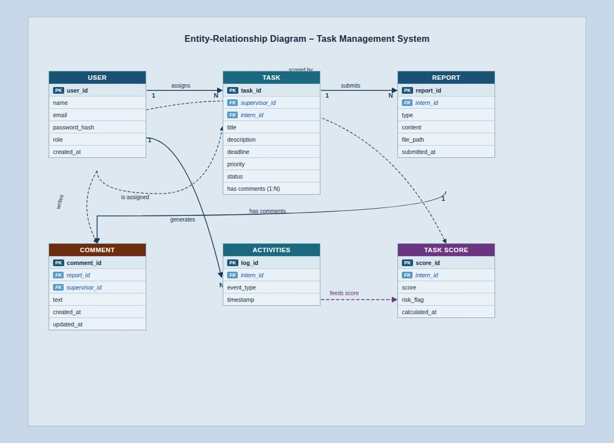
Figure 3: Entity-Relationship Diagram

6. References
- Uganda Data Protection and Privacy Act, 2019.
- IEEE Std 830-1998, IEEE Recommended Practice for Software Requirements Specifications.
- Scikit-learn Documentation — https://scikit-learn.org/stable/documentation.html
- Django REST Framework Documentation — https://www.django-rest-framework.org/
- Concept paper for the Intern Management System (internal document).

Appendix A: Glossary
Table 17: Glossary of Terms
Term | Definition
API | Application Programming Interface, a set of protocols that allow software systems to communicate.
CRUD | Create, Read, Update, Delete, the four basic operations performed on data records.
Engagement Score | A numerical value (0–100) calculated by the ML engine to represent how actively an intern is engaging with the system based on their behavioral patterns.
GB | Gigabyte
HTTPS | Hypertext Transfer Protocol Secure — the encrypted web communication protocol.
Intern | A user of the system who is undergoing a supervised internship program within the organization.
JSON | JavaScript Object Notation — a lightweight data interchange format used in API responses.
Kanban | A visual workflow management method displaying tasks organized in columns by status.
ML | Machine Learning — a method of data analysis that automates building analytical models from patterns in data.
MySQL | My Structured Query Language — an open-source relational database management system.
ORM | Object-Relational Mapper — a tool that converts database records into programming language objects.
RBAC | Role-Based Access Control — a method of restricting system access based on the roles assigned to individual users.
REQ | Requirement
REST | Representational State Transfer — an architectural style for building web APIs.
SRS | Software Requirements Specification
Supervisor | A user of the system responsible for managing, assigning tasks to, and reviewing the work of interns.
TLS | Transport Layer Security — a cryptographic protocol for securing network communications.
UC | Use Case
WCAG | Web Content Accessibility Guidelines — international standards for making web content accessible.

Appendix B: Use Case Summary
The following use cases are defined in this document and should be represented in the system use case diagram:

Table 18: Use Case Summary
Use Case ID | Use Case Name | Primary Actor | Priority
UC1 | Create and Assign Task | Supervisor | High
UC2 | Update Task Status | Intern | High
UC3 | View Intern Progress | Supervisor | High
UC4 | Submit Report | Intern | High
UC5 | Review Submitted Report | Supervisor | High
UC6 | Add Comment to Intern Report | Supervisor | High
UC7 | View Analytics Dashboard | Supervisor | High
UC8 | Generate Engagement Score and Risk Alerts | System (ML Engine) | High

Actor Descriptions:

- Intern: Interacts with UC2 and UC4. Can view their own task list, notifications, and report feedback comments.
- Supervisor: Interacts with UC1, UC3, UC5, UC6, and UC7. Receives dashboard outputs from UC8.
- System (ML Engine): Automatically triggers UC8 on a scheduled basis; outputs are surfaced to the Supervisor via the dashboard and email alerts.
- System Administrator: Manages user accounts, role assignments, and system configuration. Operates outside the functional UCs above but is a recognized system actor.

End of Document — Intern Management System SRS

