Architecture   
of the Example Machine

[Aka VizMachine]

* The machine has 16 general-purpose registers with numbers from 0 to F.
* Each register has a width of one Byte.
* Any distinct register within the instructions is referenced by 4 Bits. (0000 corresponds to register 0, 0100 to register 4, 1111 to register F ...)
* The machine utilizes a Main Memory of 256 Bytes.
* Each memory cell (one Byte) is accessed using an address ranging from 0 to 255(00 to FF hexadecimal).
* Floating-point values are represented as followed: (from most significant bit downwards): 1 Bit prefix (+/-), 3 Bit Exponent, 4 Bit Mantissa.
* Each machine instruction has a length of 2 Byte and consists of an Op-Code with 4 Bit and an operand-field of 12 Bits.
* The following description uses the letters R, S, T within the operand for a hexadecimal number, which points to the number of a register.
* The letters X and Y within the operand point to hexadecimal numbers, which do not represent registers. These represent a hexadecimal value or an address in the memory between 00 and FF.

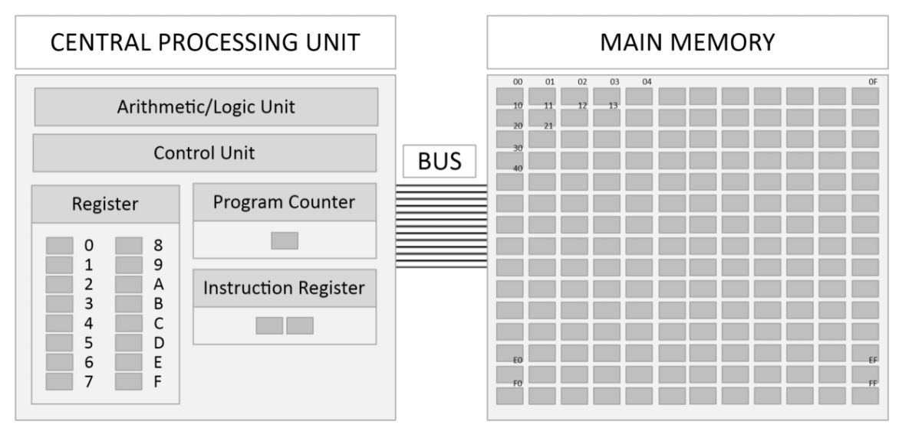

|  |  |  |
| --- | --- | --- |
| **Op-code** | **Operand** | **Description** |
| 1 | RXY | LOAD register R with data from memory cell with address XY.  (Register/Memory Direct Addressing) |
| 2 | RXY | LOAD register R with value of (Bit-pattern) XY. (Immediate Value) |
| 3 | RXY | STORE data from register R in memory cell with address XY. |
| 4 | 0RS | MOVE data from register R to register S. |
| 5 | RST | ADD data from register S and register T (Two Complement Interpretation), saving the result to register R. |
| 6 | RST | ADD data from register S and register T (Floating-Point Interpretation), saving the result to register R. |
| 7 | RST | OR of Bit pattern from register S and register T, saving the result to register R. |
| 8 | RST | AND of Bit pattern from register S and register T, saving the result to register R. |
| 9 | RST | XOR of Bit pattern from register S and register T, saving the result to register R. |
| A | R0X | ROTATE the Bit pattern in register R one Bit to the right, X-times. |
| B | RXY | JUMP to instruction in memory cell with the address XY, if the data in register R is equal to the data in register 0. |
| C | 000 | HALT. |

**Additional Operations**

|  |  |  |
| --- | --- | --- |
| **Op-code** | **Operand** | **Description** |
| D | XYZ | WAIT in milliseconds defined by XYZhex value. |
| E | RST | WRITE data from register R in memory cell with address given in register T.  (Register Indirect) |