The plot showing every single dog rating from January 2016 to May 2019. The sheer volume of 1669 ratings over 41 months can make the chart hard to sniff out. The median dog rating is 12/10, while the single most common rating is also 12/10. As per to obtain the first plot we filtered out the rating that seemed to be outliers i.e. ratings over 25. The reason of choosing 25 as a threshold doesn’t have any statistical importance, we are just not willing to throw away more data than necessary.

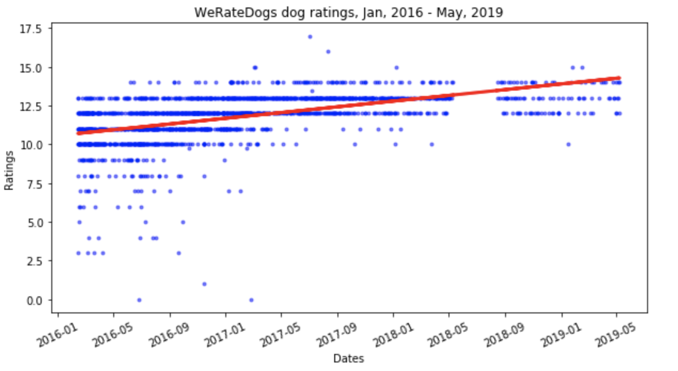

The plot below plots average rating out of 10 (red) and average ratings of 10 or higher (green). As it is show that ratings given out by WeRateDogs eventually become superlative i.e. most of the dogs start getting 10+ ratings. Also, to obtain the graph below, the tweets were segmented into red and green sections and then I computed the mean of each section by grouping by year and month.

