PHASE 7: DEPLOYMENT AND USER DOCUMENTATION

7.1 Introduction
This phase describes how the Learning Management System (LMS) is deployed and used. The system is a C++17 offline console application that uses SQLite for data storage.
The deployment documents include a UML deployment diagram, an installation guide for the school technician, user manuals for the four roles and release notes for version 1.0. The system runs on a school computer and does not require an internet connection during normal operation.

7.2 UML Deployment Diagram
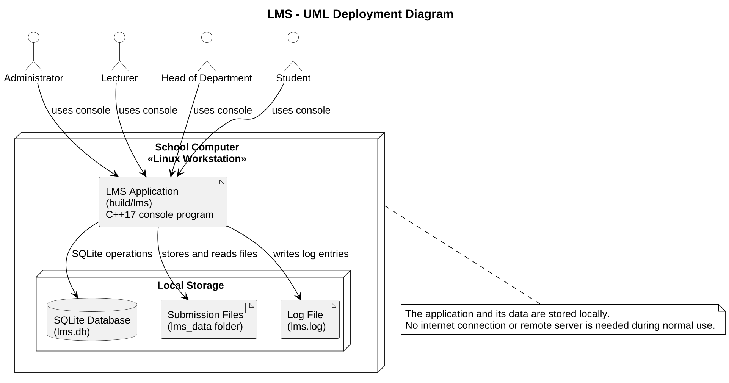
The deployment diagram shows the school computer and the software and data stored on it.
Figure 7.1: UML Deployment Diagram of the LMS
The LMS application runs on the school computer. Users interact with it through the console according to their assigned roles. The application stores records in the local SQLite database (lms.db), saves submitted work in a local folder (lms_data) and writes system logs to a file (lms.log).
By default, these files and folders are created in the directory from which the application is started. Their locations can be changed using the --db, --data and --log command-line options.
The diagram represents the current offline deployment. It does not include a web server or a remote database server.

7.3 Installation Guide
This guide is intended for the school technician responsible for installing and preparing the LMS.

7.3.1 System Requirements
Requirement | Purpose
Linux operating system | Runs the application
C++17 compiler | Compiles the source code
CMake | Configures the build
SQLite development files | Provides database support
libsodium development files | Supports password hashing
GoogleTest | Builds and runs automated tests
pkg-config | Helps locate required development libraries
Git | Downloads the project source code
The computer must have enough storage for the application, database and uploaded submissions. File permissions should also protect the stored information from unauthorised access.

7.3.2 Installation Steps
Step 1: Install the required packages.
On a Debian-based Linux system, open the terminal and run:
sudo apt update
sudo apt install build-essential cmake git pkg-config libsqlite3-dev libsodium-dev libgtest-dev
Step 2: Download the project.
Clone the project repository and enter its directory:
git clone https://github.com/makoakhotso-oss/CS4433-MODERATED-LMS-PROJECT.git
cd CS4433-MODERATED-LMS-PROJECT
Step 3: Configure the project.
Run the following command to prepare the build directory:
cmake -S . -B build
Step 4: Build the application.
Compile the source code and create the application and test executables:
cmake --build build -j2
Step 5: Run the application.
Start the LMS using:
./build/lms
On the first run with an empty database, the application prompts the user to create the first Administrator account. The Administrator can then create other users, departments, courses and enrolments.
The --seed-demo option can be used to populate an empty database with demonstration data. This option is intended for testing and should not be used for the school's real database.
Step 6: Check the installation.
Run the automated tests to verify that the application is working correctly:
cd build
ctest --output-on-failure
The tests should complete without failures before the installation is accepted.
Internet access is required to clone the repository unless the project source code has already been provided. After installation, the LMS can operate without an internet connection.

7.3.3 Initial System Setup
After installation, the technician or Administrator should complete the following steps:
- Create the first Administrator account.
- Log in using the Administrator account.
- Create the required departments.
- Create lecturer and student accounts.
- Create courses and assign lecturers.
- Enrol students in their respective courses.
- Check that each user can log in using their own account.
The technician should ensure that the application, database and submission folder have suitable access permissions to protect school information.

7.3.4 Backup and Maintenance
The database and submitted files contain important school records. The technician should follow these maintenance practices:
- Back up the SQLite database regularly.
- Back up the uploaded submission files.
- Keep backups in a secure location separate from the working computer.
- Restrict access to the database and submission folder.
- Test backups regularly to confirm that they can be restored.
- Do not delete or replace the database file while the application is running.

7.4 User Manuals
The LMS provides separate menus for its four user roles: Administrator, Lecturer, Head of Department (HoD) and Student. After logging in, each user selects an operation using its menu number.

7.4.1 Administrator User Manual
Purpose: The Administrator manages users, departments, courses, lecturer assignments and student enrolments.
Main operations:
- Start the LMS and log in as the Administrator.
- Select Create user to add lecturers, students and other users.
- Select Update user to change a user's details, role or department.
- Select Activate / deactivate user to stop or restore an account.
- Select Reset a user's password when a user forgets their password.
- Select Create department and Create course to set up the school structure.
- Select Assign lecturer to course to assign lecturers.
- Select Enrol student in course or Remove student from course to manage enrolments.
- Select List students of a course to check student enrolments.
- Log out when finished.
Important: Only create accounts for authorised school users and keep account details secure.

7.4.2 Lecturer User Manual
Purpose: The Lecturer manages courses, assignments, individual extensions, submissions and marking.
Main operations:
- Start the LMS and log in as a Lecturer.
- Select My courses and assignments to view assigned courses and their assignments.
- Select Create assignment and enter the title, instructions, deadline and maximum mark.
- Select Students of a course to view enrolled students.
- Select Grant an individual extension when a student needs additional time.
- Select View submissions and mark to open the latest submission and enter the mark and feedback.
- Select Send marks for moderation when marking is complete.
- Select Mark change history to review changes made to marks.
- Log out when finished.
Important: Check the assignment deadline and maximum mark before creating an assignment. Students cannot view marks until the HoD has approved and released them. Lecturers can also create and rename their own courses.

7.4.3 Head of Department User Manual
Purpose: The HoD reviews marks submitted by lecturers and makes moderation decisions for courses within their department.
Main operations:
- Start the LMS and log in as the HoD.
- Select Department courses and assignments to view the department's courses.
- Select Review marks of an assignment to view submitted marks and feedback.
- Select Approve and release marks when the marks are acceptable.
- Select Return marks for correction when changes are required, and provide a reason.
- Select Mark change history to review changes made to marks.
- Log out when finished.
Important: The HoD can only moderate courses within their own department. Approving marks also releases them to students.

7.4.4 Student User Manual
Purpose: Students use the LMS to view courses and assignments, submit work and access released marks.
Main operations:
- Start the LMS and log in as a Student.
- Select My courses and then My assignments to view assignment instructions and deadlines.
- Select Submit or resubmit an assignment and provide the file path. An optional comment can also be added.
- Select My submissions for an assignment to view previous submission attempts.
- Resubmit work only when permitted by the applicable deadline.
- Select My released marks and feedback to view marks after they have been approved and released.
- Log out when finished.
Important: Students should submit their work before the deadline. Submissions made up to three days late receive a penalty of 10% of the available mark for each day late. A first submission made more than three days late is saved with a zero mark. Late resubmissions are refused. Marks are visible only after moderation and release.

7.5 Release Notes
Product: Learning Management System (LMS)
Release version: 1.0 (Initial Release)
Platform: Linux
Technology: C++17, SQLite, CMake and libsodium

7.5.1 Features Included
The version 1.0 release includes the following features:
- User login and role-based access control.
- Administrator management of users and departments.
- Course creation and student enrolment.
- Assignment creation and deadline management.
- Student submission and resubmission, with submission attempts retained.
- Individual deadline extensions.
- Automatic late penalty calculation.
- Lecturer marking and feedback.
- HoD moderation and release of marks.
- Mark change history through an audit log.
- Local SQLite database storage.
- Password hashing using Argon2id.

7.5.2 Known Limitations
The following limitations apply to version 1.0:
- The application uses a console interface rather than a graphical or web interface.
- The application operates offline and does not support remote access.
- Whole-class deadline extensions (CR1) are not included.
- Student resubmission after a moderation rejection is not implemented.
- The SQLite database file is not encrypted.

7.5.3 Installation and Upgrade Information
The application is built using CMake and requires a C++17 compiler, SQLite development files and libsodium development files.
For a new installation, follow the instructions in Section 7.3. Before replacing an existing installation with a newer version, back up the database and submission files to prevent the loss of school records.

7.5.4 Release Identification
The initial release is identified by the Git tag v1.0, which marks the source code for version 1.0.
Release evidence: The project was tagged v1.0 and published as the initial GitHub release.
GitHub Release: https://github.com/makoakhotso-oss/CS4433-MODERATED-LMS-PROJECT/releases/tag/v1.0

7.6 Conclusion
This phase provides the information required to install, configure and use the LMS. The deployment diagram illustrates the offline setup, while the installation guide explains how to build and run the application.
The user manuals describe the main operations available to the Administrator, Lecturer, HoD and Student. The release notes document the features and known limitations of version 1.0.

