DRS4 Evaluation Board
User’s Manual

Board Revision 2.0
as of March 2009
Last revised: August 3, 2009

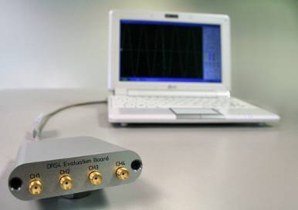

Stefan Ritt
Paul Scherrer Institute
CH-5232 Villigen PSI
Switzerland

Email: stefan.ritt@psi.ch
Phone: +41 56 310 3728
Revision History
Date | Modification
2 March 09 | Initial Revision
27 April 09 | Mention input range, added timing calibration description
3 Aug. 09 | Added LED description

Table of Contents
Revision History 2
Table of Contents 3
1. Introduction 4
1.1. Board description 4
1.2. Firmware Description 5
2. Installation 7
2.1. Windows XP 7
2.2. Linux 9
3. Development Hints 16
3.1. Power Supply 16
3.2. Analog Input 17
3.3. Control Voltages 17
3.4. ADC Clock 17
4. DRS4 Evaluation Board Schematics 18
5. DRS4 Evaluation Board Bill of Materials 24

Introduction
The DRS4 chip, which has been designed at the Paul Scherrer Institute, Switzerland by Stefan Ritt and Roberto Dinapoli is a Switched Capacitor Array (SCA) capable of digitizing eight channels at sampling speeds up to 5 GSPS. This chip is available through the PSI technology transfer program for other institutes and organizations. In order to simplify the design process to integrate the DRS4 chip into custom electronics, an evaluation board has been designed, which demonstrates the basic operation of the chip. It has SMA connectors for four input channels CH1 to CH4, an USB 2.0 connector and a LEMO trigger input (Figure 1). The board is powered through the USB port and contains an on-board trigger logic. It comes with MS Windows® and Linux drivers and two application programs. It is basically equivalent to a four channel 5 GSPS digital oscilloscope.
This manual describes the software installation, the usage of the application programs, and gives hints for developers seeking to build new electronics around the DRS4 chip.

Board description
Since the DRS4 chip has differential inputs, the board uses four transformers (ADT1-1WT from Mini-Circuits®) to converted the 50-Ohm terminated single ended inputs into differential signals. The transformers are followed by analog switches (ADG936 form Analog Devices®). These switches allow the multiplexing of the DRS4 inputs between the input connectors and a reference voltage generated by the on-board 16-bit DAC for calibration purposes. The four analog inputs ar AC coupled and have a input range of 1 V peak-to-peak. The absolute maximum input voltage range is -0.5V to +2.8V. The DRS4 is read out with a 14-bit ADC (AD9245 from Analog Devices®) and a FPGA (Xilinx® Spartan 3). The USB connection is implemented with a micro controller (Cypress® CY2C68013A). The high speed modus of the USB 2.0 bus allows for data transfer rates of more than 20 MB/sec.
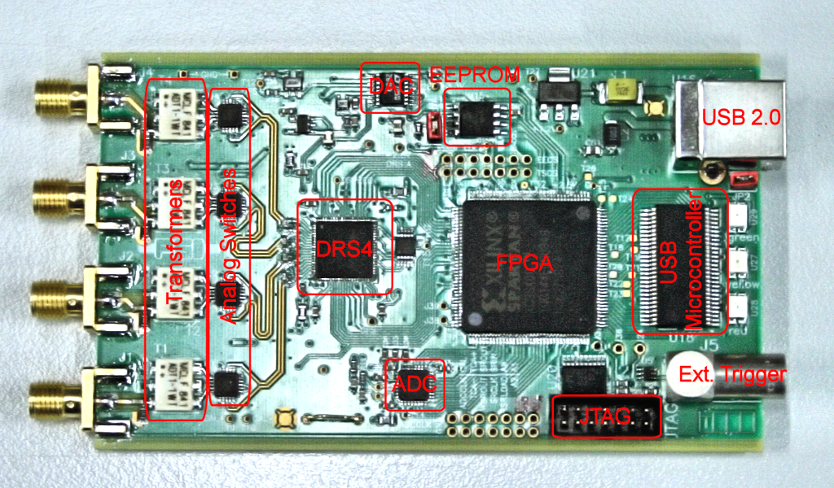
Figure 1: Picture of the DRS4 Evaluation Board with different components
For trigger purposes, a 50 Ω terminated TTL compatible input is implemented (Lemo connector). Since the input is 50 Ω terminated, care has to be taken that the trigger source is able to drive at least 2.2 V into 50 Ω.
A on-board discriminator with programmable level allows for self triggering on any of the four input channels. An 1 MBit EEPROM (25LC1025 from Microchip®) is used to store the board serial number and calibration information. Two 14-pin headers carry all important logical signals which allow easy debugging with a logic analyzer or oscilloscope. A JTAG adapter can be used to update the FPGA firmware through a Xilinx® Platform Cable Adapter.
The specifications of the board inputs is summarized in following table:
Analog inputs  Termination  Input range  Maximum allowed input voltage | 50 Ω  1 V p-p  -0.5 V to +2.8 V | AC coupled
Trigger input  Termination  Maximum allowed input voltage  High Level Input Voltage | 50 Ω  -0.5 V to +5.5 V  2.2 V (max) | 5 V TTL compatible

LEDs
The DRS4 evaluation board is equipped with four LEDs. They are operated by the micro controller and the FPGA and have following meaning:
LED | Meaning
Green | This LED becomes green when the on-board micro-controller booted successfully. If this LED stays dark, there is either no power or the micro-controller lost it’s program, which requires a re-programming of the EEPROM.
Yellow | When the on-board FPGA boots correctly this LED becomes lit. If it stays dark, it might be that the FPGA program was lost and requires re-programming. After booting, this LED indicates the board status. If lit, the DRS4 chip is active and sampling data. If stopped by software or a trigger, this LED turns off. A special pulse stretcher ensures that even in high trigger rate environments this LED does not flash with more than ~10Hz so the blinking can still be seen by eye.
Red | When lit, this LED indicates a error condition

Firmware Description
Both the Windows and the Linux distribution contain a subdirectory “firmware” which contains the FPGA and Microcontroller firmware for the DRS4 Evaluation Board. The FPGA firmware is written in pure VHDL, thus making it easy to port it to other FPGA devices such as Altera® or Lattice®. Only a few Xilinx® basic components such as clock managers and I/O blocks have been instantiated and must be adapted when another FPGA manufacturer than Xilinx® is chosen. The FPGA source code is contained in several files with following contents:
src/drs4_eval1.vhd | Top level entity. Routing of clock signals, global reset signal, LEDs and LEMO input
src/drs4_eval1_app.vhd | Main file containing state machines for DRS4 readout, serial interface to DAC, EEPROM and temperature sensor, trigger logic and reference clock generation
src/usb_dpram.vhd | Instantiates block ram for waveform storage
src/usb_racc.vhd | Interface to CY2C68013A microcontroller in slave FIFO mode. Implements a set of status and control registers through which the main application can be controlled
src/usr_clocks.vhd | Generates 66 MHz, 132 MHz, 264 MHz and a phase shifted 66 MHz clock out of the 33 MHz quartz input frequency via the Xilinx® Digital Clock Managers (DCM)
ucf/drs4_eval1.ucf | Constraint file. Assigns package pins and defines clock constraints
3s400/drs4_eval1.ise | Xilinx® ISE 9.2i project file
3s400/drs4_eval1.bit | Compiled firmware image directly for Spartan 3s400 FPGA
3s400/drs4_eval1.mcs | Compiled firmware image for FPGA EEPROM XCF02S
3s400/drs4_eval1.ipf | Xilinx® Impact project file to program FPGA via download cable

The firmware for the USB microcontroller from Cypress® is written in C and must be compiled with the Keil® 8051 C compiler. It contains the standard include and library files from the Cypress EZ-USB® development kit plus some DRS specific files:
CY7C68013A/drs_eval.c | Main micro controller firmware file
CY7C68013A/dscr.a51 | USB descriptor tables
CY7C68013A/drs_eval.hex | Compiled firmware file (Intel HEX format)
CY7C68013A/drs_eval1.iic | Compiled firmware file (For Cypress EZ-USB Console download)
CY7C68014A/* | Remaining files are standard files from EZ-USB development kit

The FPGA firmware implements a set of control and status registers, through which the DRS4 can be controlled and read out. The mapping of the control registers is as follows:
# | Ofs. | Bit | Name | Comment
0 | 0x00 | 0 | start_trig | Write a "1" to start the domino wave
0 | 0x00 | 1 | reinit_trig | Write a "1" to stop & reset the DRS chip
0 | 0x00 | 2 | soft_trig | Write a "1" to stop the DRS chip & read the data to RAM
0 | 0x00 | 3 | eeprom_write_trig | Write contents of RAM into EEPROM (32kB page)
0 | 0x00 | 4 | eeprom_read_trig | Read contents of EEPROM into RAM (32kB page)
0 | 0x02 | 18 | led | 1=on, 0=blinks once at beginning of DRS chip readout
0 | 0x02 | 19 | tcal_en | Switch on (1) / off (0) 264 MHz calib. sig. for DRS chips
0 | 0x02 | 20 | tcal_source | System clock (0) or separate quartz (1) clock source
0 | 0x02 | 21 | transp_mode | 1=send DRS inputs to outputs ("transparent mode")
0 | 0x02 | 22 | enable_trigger1 | Write a "1" to enable external trigger (LEMO)
0 | 0x02 | 23 | readout_mode | 0:start from first bin, 1:start from domino stop
0 | 0x02 | 24 | neg_trigger | 1=trigger on high to low transition
0 | 0x02 | 25 | acalib | Write "1" to enable amplitude calibration
0 | 0x02 | 27 | dactive | 0:stop domino wave during readout, 1:keep it running
0 | 0x02 | 28 | standby | 1: put chip in standby mode
0 | 0x02 | 29 | trigger_source1 | Analog trigger source bits CH1-CH4
0 | 0x02 | 30 | trigger_source2 | Analog trigger source bits CH1-CH4
0 | 0x02 | 31 | enable_trigger2 | Write a “1” to enable analog trigger
1 | 0x04 | 31..16 | DAC0 | Set DAC 0 (=A, ROFS)
1 | 0x06 | 15..0 | DAC1 | Set DAC 1 (=B, CMOFS)
2 | 0x08 | 31..16 | DAC2 | Set DAC 2 (=C, CAL-)
2 | 0x0A | 15..0 | DAC3 | Set DAC 3 (=D, CAL+)
3 | 0x0C | 31..16 | DAC4 | Set DAC 4 (=E, BIAS)
3 | 0x0E | 15..0 | DAC5 | Set DAC 5 (=F, TLEVEL)
4 | 0x10 | 31..16 | DAC6 | Set DAC 6 (=G, O-OFS)
4 | 0x12 | 15..0 | DAC7 | Set DAC 7 (=H, -)
5 | 0x14 | 31..24 | configuration | Bit0: DMODE, Bit1: PLLEN, Bit2: WSRLOOP
5 | 0x14 | 23..16 | channel_config | 1=1x8k,0x11=2x4k,0x33=4x2k,0xFF=8x1k
5 | 0x16 | 7..4 | first_chn | First channel address to read out (0..9)
5 | 0x16 | 3..0 | last_chn | Last channel address to read out (1..9)
6 | 0x18 | 31..16 | trigger_delay | Trigger delay in ticks of roughly 0.56 ns
6 | 0x1A | 15..0 | sampling_freq | Sampling frequency in ticks (=1024/f_{samp}*0.120-2)
7 | 0x1C | 31..16 | zero_supp_thresh | Not yet implemented
8 | 0x1E | 15..0 | eeprom_page | Page number for EEPROM communication

While the mapping of the status registers is like this:
# | Ofs. | Bits | Name | Comment
0 | 0x00 | 31..16 | board_magic | 0xC0DE, Magic number for DRS board identification
0 | 0x02 | 15..8 | board_type | 5 for DRS4 USB Evaluation Board 1.1
0 | 0x02 | 7..0 | drs_type | 4 for DRS4
1 | 0x04 | 0 | running | "1" while domino wave running or readout in progress
2 | 0x08 | 31..16 | stop_cell | position of cell where sampling stopped at last trigger
8 | 0x20 | 31..16 | temperature | temperature in 0.0625 deg. C units
9 | 0x24 | 31..16 | serial_cmc | Serial number CMC board
9 | 0x26 | 15..0 | version_fw | firmware version (SVN revision)

All registers are implemented as 32-bit registers, so they can be mapped easily into some VME address space for example if one decides to build a VME board containing the DRS4.

Installation

Windows XP
Under MS Windows® it is important to install the necessary driver before connection the DRS4 Evaluation Board with the PC. The current distribution can be downloaded from http://drs.web.psi.ch/download . The Windows version contains a single program drs-xx.exe (where xx is the version) which can be executed to install the driver, applications, documentation and source code. Executing this file starts the installer:
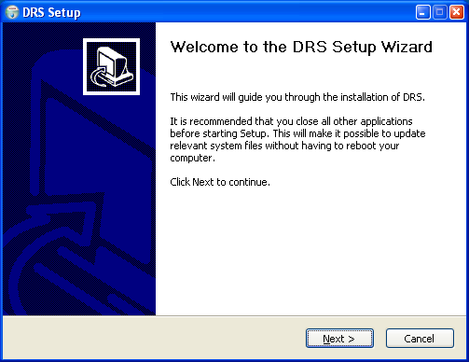
You can select which components to be installed:
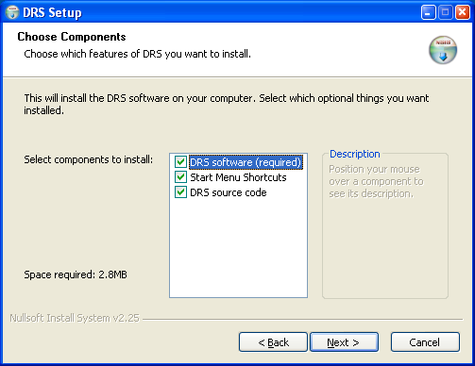
Then you can select the installation directory:
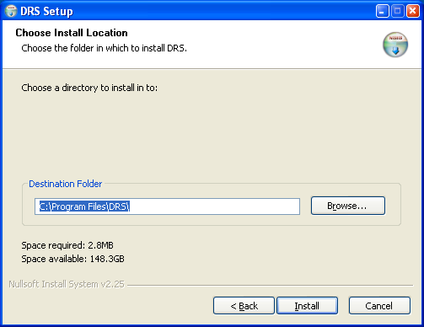
After the installer has finished, you can connect the DRS4 Evaluation Board to the Computer:
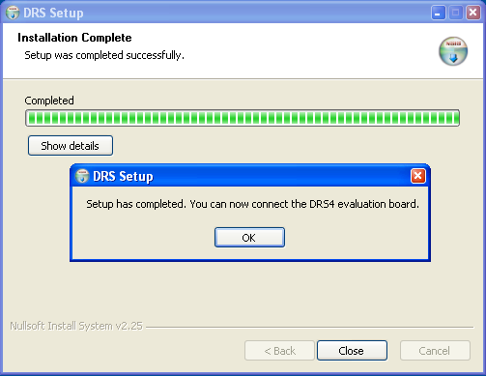
Now you will see the “Found New Hardware” dialog:
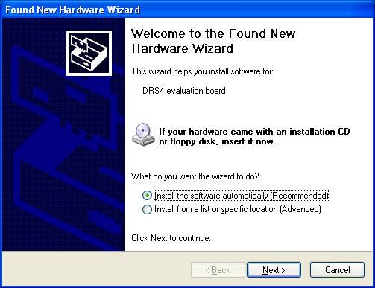
Where you can click “Install the software automatically” and then click “Next”.
After successful installation of the driver, you will see the following window:
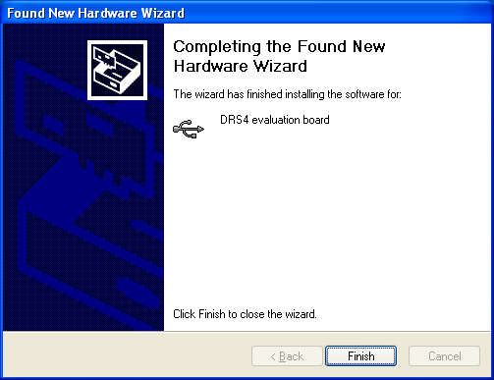
And a new group in your Start Menu:
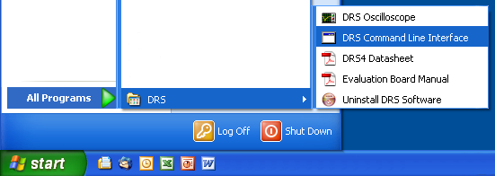
The software comes with two applications, a command line interface and an oscilloscope. These applications are explained in section 3.

Linux
The drivers and applications are distributed for Linux in source code and must be compiled on each system. First untar the tar ball:
[/usr/local]$ tar -xzvf drs-1.0.tar.gz
drs-1.0/
drs-1.0/doc/
drs-1.0/doc/DRS4_rev06.pdf
drs-1.0/doc/manual.pdf
drs-1.0/include/
drs-1.0/include/ConfigDialog.h
drs-1.0/include/DOFrame.h
drs-1.0/include/DOScreen.h
. . .
Then change the directory and do a „make“. Note that to compile the oscilloscope application it is necessary to have the wxWidgets package version 2.8.9 or later installed. You can obtain this package in source form from http://www.wxwidgets.org/downloads/. If this package is present, you can change to the drs directory and issue a make:
[/usr/local]$ cd drs-1.0
[/usr/local/drs-1.0]$ make
g++ -g -O2 -Wall -Wuninitialized -fno-strict-aliasing -Iinclude -DOS_LINUX -DHAVE_LIBUSB -c src/musbstd.c
g++ -g -O2 -Wall -Wuninitialized -fno-strict-aliasing -Iinclude -DOS_LINUX -DHAVE_LIBUSB -c src/mxml.c
. . .
Now you can connect the DRS4 board to the PC. On systems where the “lsusb” tool is installed, one should be able to find the DRS4 evaluation board after connecting it with following command:
[/usr/local/drs-1.0]$ /sbin/lsusb -d 04b4:1175 –v
Bus 005 Device 005: ID 04b4:1175 Cypress Semiconductor Corp.
Device Descriptor:
bLength 18
bDescriptorType 1
bcdUSB 2.00
bDeviceClass 0 (Defined at Interface level)
bDeviceSubClass 0
bDeviceProtocol 1
bMaxPacketSize0 64
idVendor 0x04b4 Cypress Semiconductor Corp.
idProduct 0x1175
bcdDevice 0.01
iManufacturer 1 S. Ritt PSI
iProduct 2 DRS4 Evaluation Board
iSerial 3 REV1
bNumConfigurations 1
Configuration Descriptor:
bLength 9
bDescriptorType 2
wTotalLength 46
bNumInterfaces 1
bConfigurationValue 1
iConfiguration 0
bmAttributes 0x80
MaxPower 500mA
. . .
If the board is correctly recognized, one can access it with the command line program. Under most Linux distributions however, only the “root” user can directly access USB devices. Some systems can be configured to allow non-root access via the “udev” system, but the exact instructions vary from distribution to distribution and can therefore not be given here.

If the command line program works, the oscilloscope application “drsosc” can be started. It will open a X window and show exactly the same functionality as its Windows counterpart:
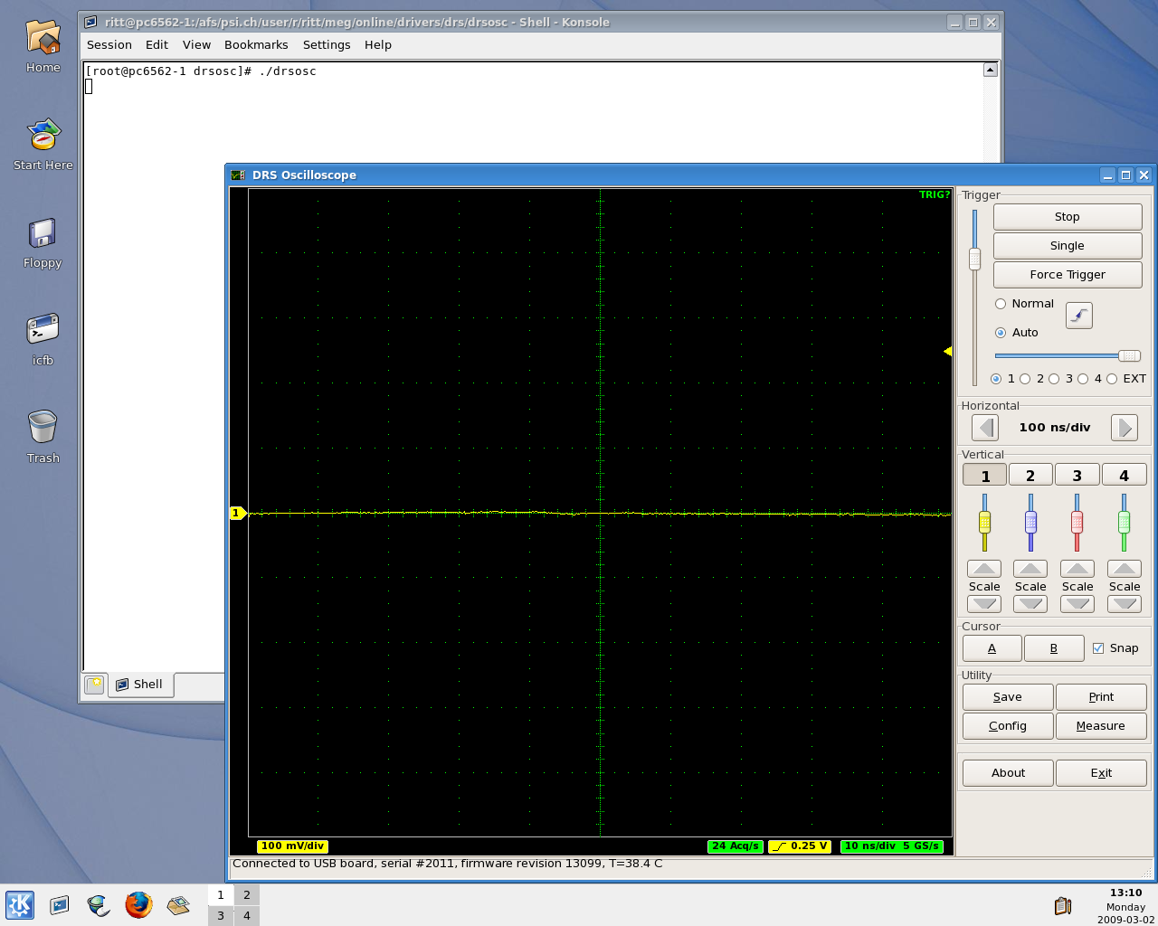

Running the Board

Command line Interface “drscl”
Clicking on „DRS Command Line Interface“ (Windows) or entering “drscl” (Linux) will start a simple application which connects to the DRS4 Evaluation Board. If it finds the board, it displays the board serial number and the firmware revision as on the following screen shot:
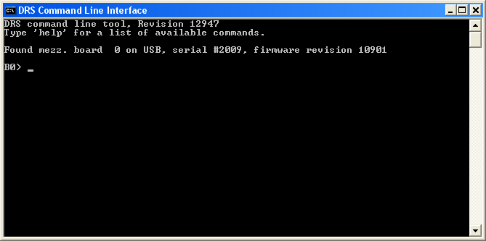
Now you are ready to issue your first command “info” which shows some more information, like the current board temperature. The temperature sensor is on the bottom side just below the DRS4 chip. If you keep issuing “info” commands and touch that sensor with your finger, you should see the temperature increase.
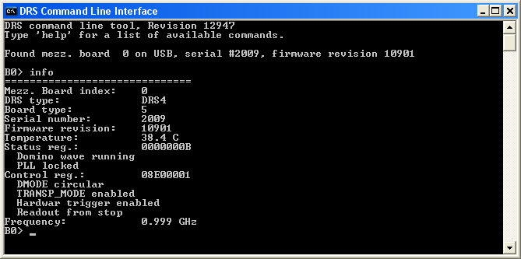
Oscilloscope application
The second application is an oscilloscope-like program, which connects to the DRS4 board and works pretty much like a normal oscilloscope. You can select the trigger mode, trigger level and trigger source. On Rev. 1.1 of the DRS4 evaluation board, only CH1 can be selected as trigger source. You enable a channel by clicking on the number “1” to “4”. There are two cursors and a few utilities.
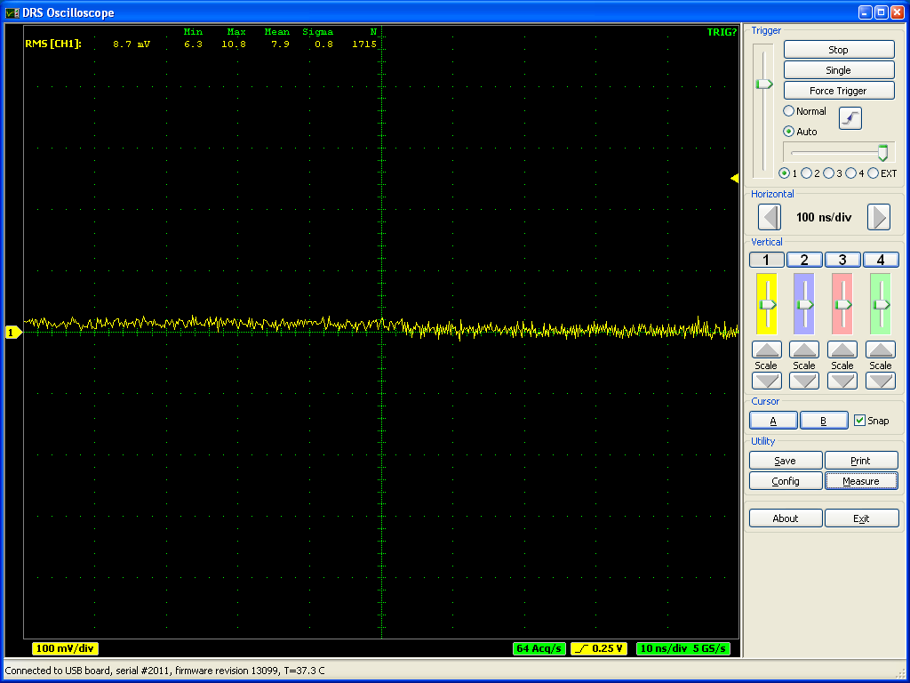
The picture above shows an un-calibrated evaluation board, which shows a noise level of about 8 mV RMS. After offset and gain calibrations, the noise level is reduced significantly:
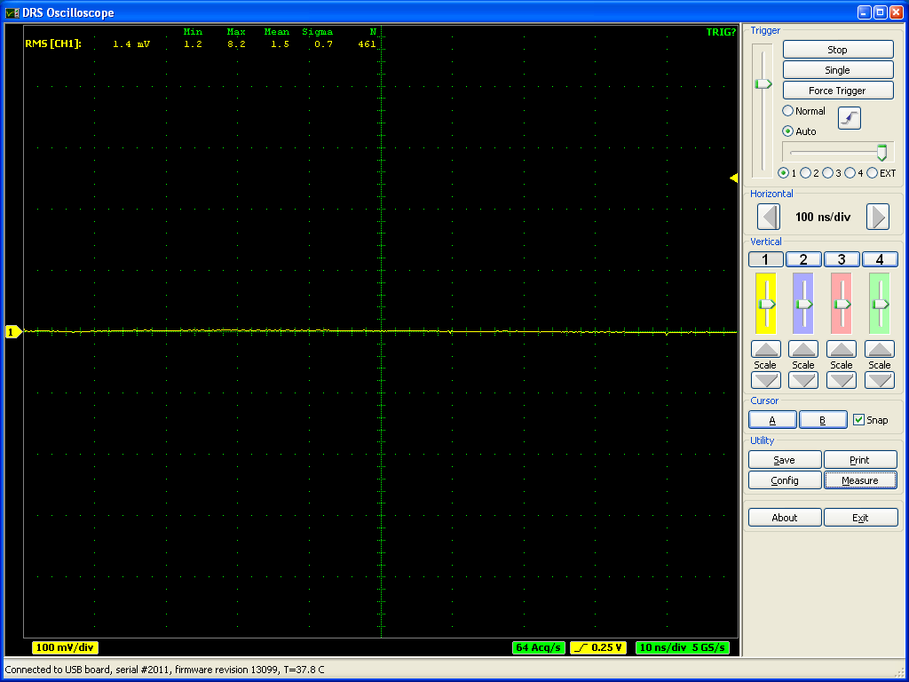
The evaluation board Rev. 2.0 still shows some small random spikes originating probably from the USB interface. It is expected that future versions will improve this and reduce the noise level further.
The DRS4 evaluation board is shipped pre-calibrated in amplitude and time. This calibration can be turned on or off using the check boxes “Display calibrated waveforms” and “Display timing calibrated waveforms” in the “Config” Dialog:
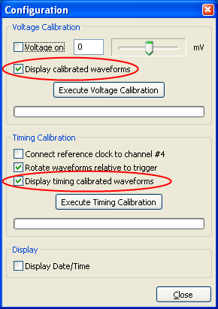
The calibration can be re-done any time by clicking on the “Execute Voltage Calibration” and “Execute Timing Calibration” buttons. For the voltage calibration, the inputs are switched to a calibration voltage generated by a DAC. Three calibration points (-0.4V, 0V, +0.4V) are taken and an offset and gain is evaluation. For the timing calibration, a 240 MHz clock is sampled in one channel and the deviation from the expected period to the measured period is used to determine the effective width of each cell.
This calibration data both for voltage and timing is then stored in the EEPROM on the evaluation board, from where it is obtained each time the oscilloscope is started.
For test purposes, an internal 60 MHz reference clock signal can be connected to channel #4 via the “Config” menu. To do so, activate channel #4, then select the “Config” menu and click on “Connect reference clock to channel #4”:
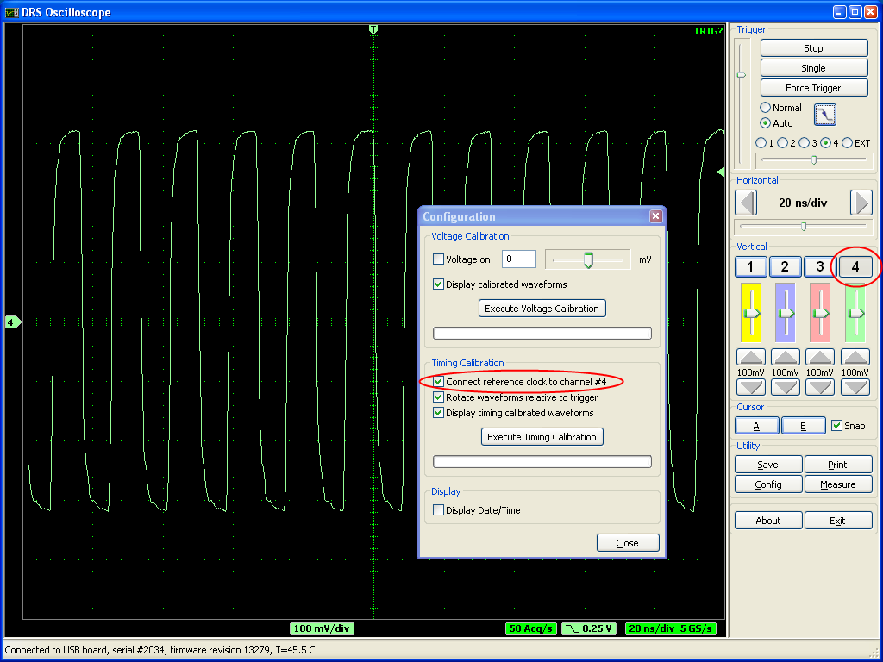
The effect of the timing calibration can be tested by turning the timing calibration on and off via the “Display timing calibrated waveforms” check box.
You can save a waveform in an ASCII and a binary format by pressing the “Save” button. After you open a file, each trigger will write the waveform of the active channel(s) to that file. When you are continuously running, the file will grow very quickly. If the file has the extension “.xml” it will be written in ASCII form using XML encoding, otherwise a raw binary file will be written with following contents:
Byte | Contents
0 (LSB)  1 (MSB) | First cell first channel 16-bit value (0 = -0.5 V, 65535 = +0.5V)
2 (LSB)  3 (MSB) | Second cell first channel 16-bit value
…
2048 (LSB) | First cell second channel 16-bit value

Development Hints
The idea behind the evaluation board is to make first steps in using the DRS4 chip, but then develop your own custom electronics around the chip. The first thing to do there is to study carefully the DRS4 data sheet, which can be obtained from http://drs.web.psi.ch/datasheets. Then have a look at the DRS4 Evaluation Board Reference Design, which schematics is supplied at the end of this document. When you start to design your own electronics, there are however some important points, which are not necessarily obvious from the data sheet or from the reference design. These points together with some design tips are explained in this section.

Power Supply
As with any analog design, the quality of the power supply is very important, since it has an influence of the noise level measured by the DRS4 chip. Low noise linear regulators together with the usual decoupling capacitors are recommended for all power supplies. The analog power supply AV_{DD} powers only the domino circuit of the DRS4 chip and directly influences the jitter of the sampling frequency. Long term variations in this power supply (seconds…) are regulated by the on-chip PLL, but high frequency noise in the MHz region leads directly to an increase of the PLL jitter. Therefore the evaluation board contains two separate 2.5V linear regulators for the DRS4 chip, one for the AV_{DD} power and one for the DV_{DD} power. Although the DV_{DD} power is called “digital power”, it powers also the analog output buffers of the DRS4 chip and needs the same good quality than the AV_{DD} power in order to minimize the noise of the board.
The DRS4 chip also contains two grounds AGND and DGND. They can be either routed separately on the board and be connected at the power source, or they can be directly connected to an overall dedicated ground plane of the PCB. Tests have been shown that the latter choice gives slightly less noise.
The bottom of the QFN76 package of the DRS4 has an exposed paddle connected to the internal DGND. It is recommended that this paddle is matched by a PCB pad of similar size connected to analog ground to achieve the best electrical and thermal performance of the DRS4. The copper plane should have several vias to achieve a good heat dissipation to flow through the PCB as shown in Figure 2:
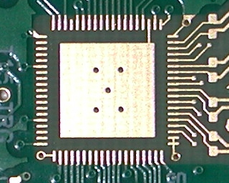
Figure 2: PCB pad under the DRS4 chip
These vias should be solder-filled or plugged. The maximum power dissipation of the DRS4 chip is not critical (350 mW), but an improved thermal stability helps the performance of any analog chip. To maximize the coverage and adhesion between the DRS4 and the PCB, the copper plane could be partitioned into several uniform sections, providing several tie points during the reflow process.

Analog Input
If non-differential signals should be digitized with the DRS4 chip, they must be converted into differential signals for the DRS4 inputs. The simplest solution is to connect the IN- inputs to AGND and to connect the signals directly to the IN+ inputs. This method has however the disadvantage that the crosstalk and noise immunity of the DRS4 chip are worsened. The evaluation board uses passive transformers ADT1-1WT from Mini-Circuits® for this purpose. While this is a good solution to reduce the power consumption of the board, such that it can be powered from the USB power (500 mA @ 5V), it has the disadvantage that it reduces the analog bandwidth of the system to about 200 MHz (-3 dB). The reason for this is the dynamic capacitive load of the DRS4 inputs, which must be driven by the signal source. Since the input impedance of the DRS4 becomes very small at high frequencies, the signal height drops if only driven passively. Better performance is achieved with active differential drivers. Tests have been made with the THS4513 from Texas Instruments® giving a bandwidth of 450 MHz and the ADA4937 from Analog Devices® giving 700 MHz. A small bypass capacitor (1pF) in the feedback loop of the buffer adds a high frequency pole, which shows up as a peak in the response function, but then pushes the bandwidth to 750 MHz. The peaking can be reduced by adding a series resistor of a few Ohm between the buffer output and the DRS4 input.
The usual design rules like proper termination and matched impedance PCB traces apply as in any high frequency analog design.

Control Voltages
The DRS4 chip requires certain control voltages: ROFS, O-OFS and BIAS. The latter two are generated internally with some default voltage, but can be “overwritten” by an external low impedance source. It is recommended to connect these lines to an external 16-bit DAC, so that the DRS4 input range can be fine-tuned on a board-by-board basis, to compensate for chip variations. The ROFS signal should be driven by a high speed low noise buffer. If this signal would be directly connected to the DAC output, the signal height would change slightly during the chip readout and the measurement would show a varying baseline level.

ADC Clock
There is a very strict relation between the DRS4 output shift register clock SRCLK and the ADC clock (see DRS4 data sheet WAVEFORM READOUT). In order to reduce the noise due to aperture jitter, the phase shift between these two clocks must be fixed and contain very small jitter (~10ps). The easiest way to generate this phase shift is to use the digital clock managers (DCM) in the FPGA, as it is done on the evaluation board Rev. 1.1. Since the DCMs have however an inherent phase jitter of ~150ps, this introduces some noise in form of a baseline variation when sampling a DC signal in the order of up to a few mV. If this becomes a problem, it is recommended to generate the phase shift between these two clocks with a low jitter delay circuit.

DRS4 Evaluation Board Schematics
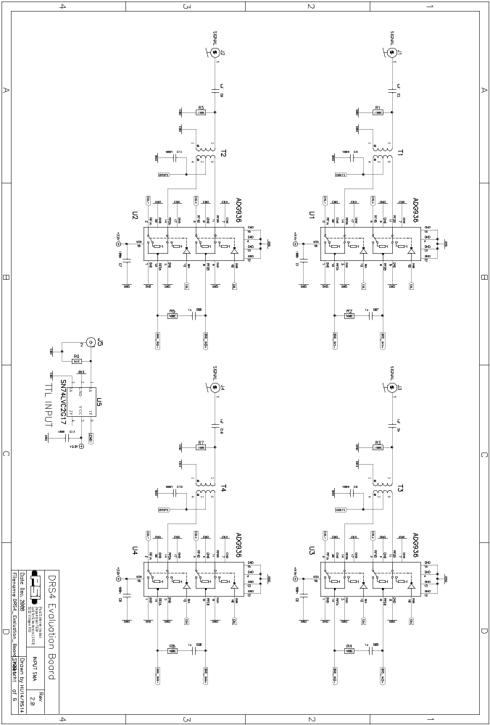
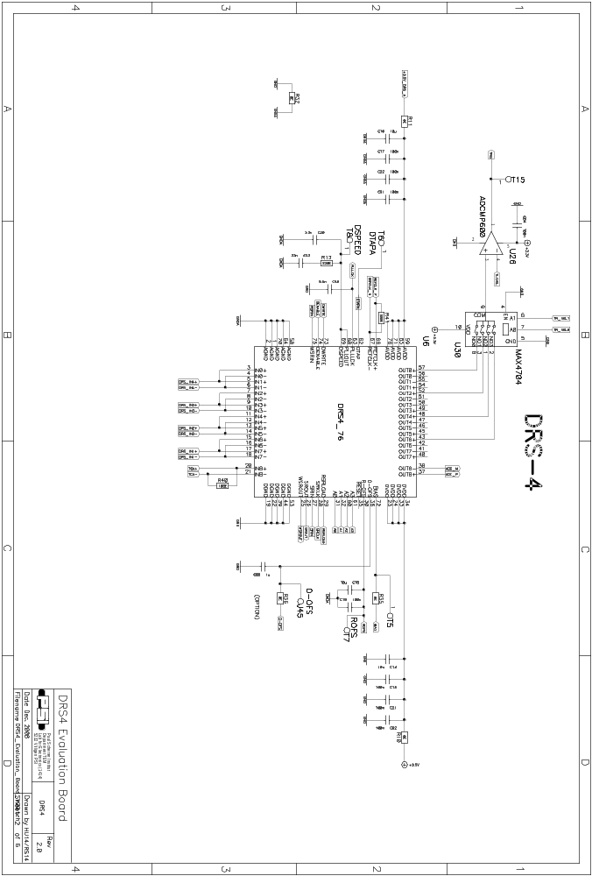
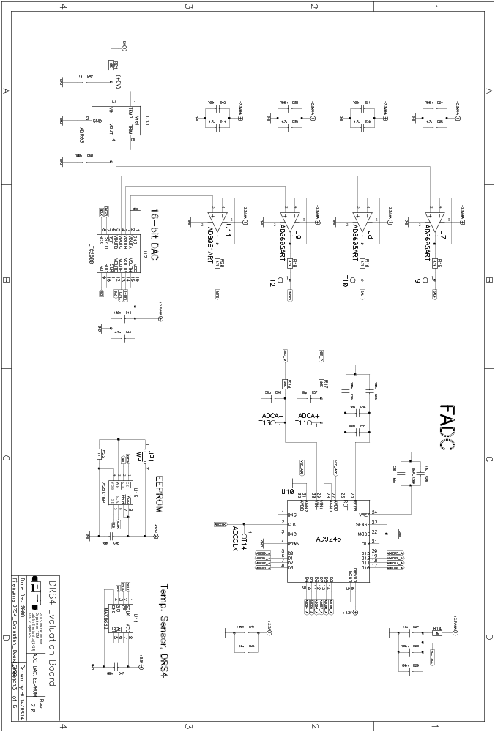
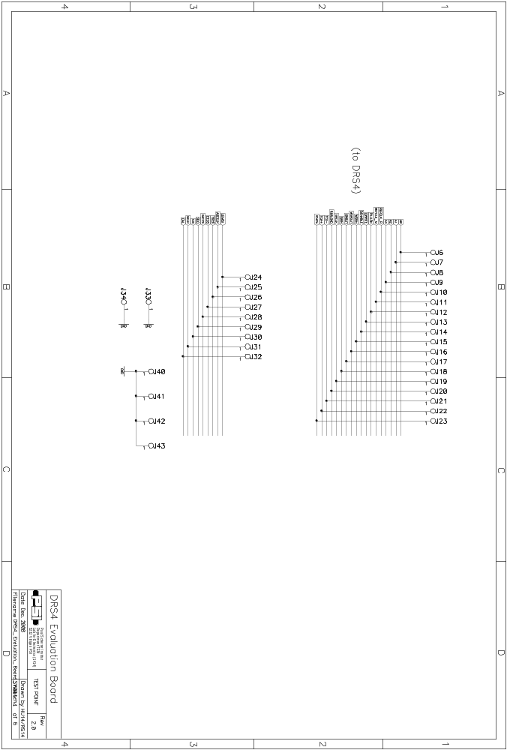
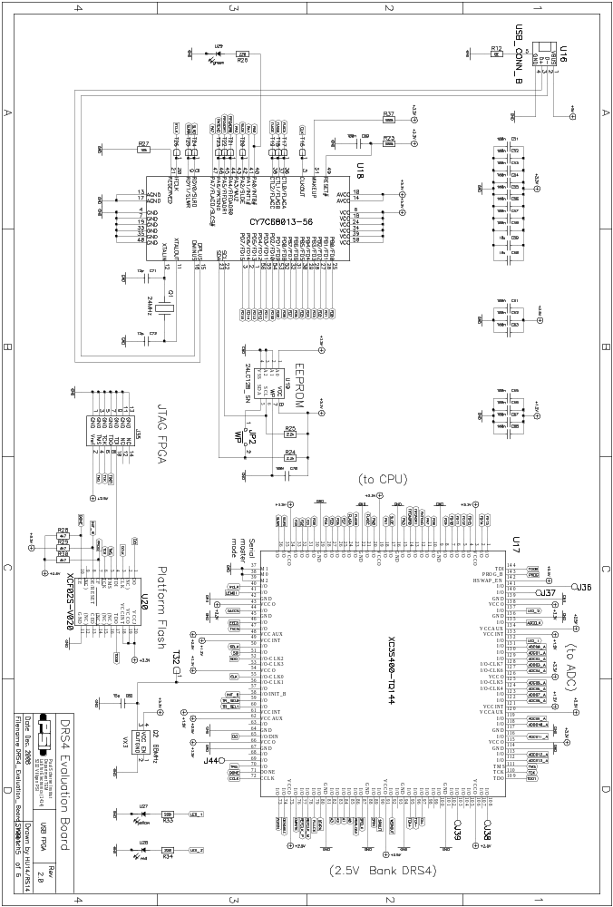
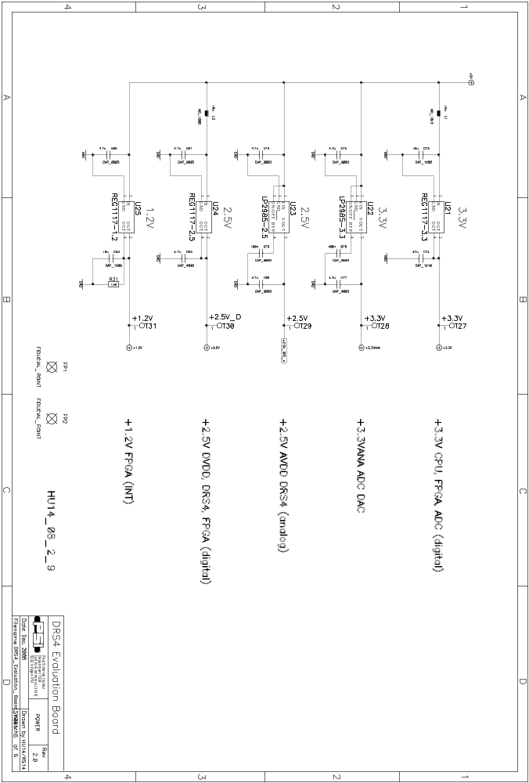

DRS4 Evaluation Board Bill of Materials
Count | ComponentName | RefDes | PatternName | Value | Description | Producer
1 | 24LC128_SN | U19 | SO-G8 |  | EEPROM 16kx8 | MICROCHIP
1 | 44.021.0547 | J5 | CONN_PSI2 |  | Lemo 00 90° | Lemo
1 | AT45DB161D | U15 | SO-8-SM | 16Mbit | Data-Flash | ATMEL
1 | AD8061ART | U11 | SOT23-5 |  | Amplifier | ANALOG DEVICES
3 | AD8605ART | U7 | SOT23-5 |  | Amplifier | ANALOG DEVICES
 | AD8605ART | U8 | SOT23-5 |  | Amplifier | ANALOG DEVICES
 | AD8605ART | U9 | SOT23-5 |  | Amplifier | ANALOG DEVICES
1 | AD9245 | U10 | LFCSP_VQ_32 |  | ADC | ANALOG DEVICES
1 | ADCMP600 | U26 | SOT23-5 |  | Comparator | ANALOG DEVICES
4 | ADG936 | U1 | PQFP-N20 |  |  | ANALOG DEVICES
 | ADG936 | U2 | PQFP-N20 |  |  | ANALOG DEVICES
 | ADG936 | U3 | PQFP-N20 |  |  | ANALOG DEVICES
 | ADG936 | U4 | PQFP-N20 |  |  | ANALOG DEVICES
1 | ADR03 | U13 | SC70-5 | 2.5V |  | ANALOG DEVICES
4 | CAP_0402 | C87 | 0402 | 1u | Capacitor
 | CAP_0402 | C88 | 0403 | 1u | Capacitor
 | CAP_0402 | C89 | 0404 | 1u | Capacitor
 | CAP_0402 | C90 | 0405 | 1u | Capacitor
6 | CAP_0603 | C49 | 0603 | 1u | Capacitor
 | CAP_0603 | C86 | 0603 | 1u | Capacitor
 | CAP_0603 | C3 | 0603 | 1u | Capacitor
 | CAP_0603 | C9 | 0603 | 1u | Capacitor
 | CAP_0603 | C10 | 0603 | 1u | Capacitor
 | CAP_0603 | C4 | 0603 | 1u | Capacitor
1 | CAP_0603 | C20 | 0603 | 3.3n | Capacitor
1 | CAP_0603 | C98 | 0603 | 5.6n | Capacitor
2 | CAP_0603 | C71 | 0603 | 12p | Capacitor
 | CAP_0603 | C72 | 0603 | 12p | Capacitor
1 | CAP_0603 | C82 | 0603 | 15p | Capacitor
1 | CAP_0603 | C23 | 0603 | 33n | Capacitor
2 | CAP_0603 | C37 | 0603 | 56p | Capacitor
 | CAP_0603 | C40 | 0603 | 56p | Capacitor
50 | CAP_0603 | C1 | 0603 | 100n | Capacitor
 | CAP_0603 | C2 | 0603 | 100n | Capacitor
 | CAP_0603 | C5 | 0603 | 100n | Capacitor
 | CAP_0603 | C6 | 0603 | 100n | Capacitor
 | CAP_0603 | C7 | 0603 | 100n | Capacitor
 | CAP_0603 | C8 | 0603 | 100n | Capacitor
 | CAP_0603 | C11 | 0603 | 100n | Capacitor
 | CAP_0603 | C12 | 0603 | 100n | Capacitor
 | CAP_0603 | C13 | 0603 | 100n | Capacitor
 | CAP_0603 | C15 | 0603 | 100n | Capacitor
 | CAP_0603 | C17 | 0603 | 100n | Capacitor
 | CAP_0603 | C19 | 0603 | 100n | Capacitor
 | CAP_0603 | C21 | 0603 | 100n | Capacitor
 | CAP_0603 | C22 | 0603 | 100n | Capacitor
 | CAP_0603 | C24 | 0603 | 100n | Capacitor
 | CAP_0603 | C28 | 0603 | 100n | Capacitor
 | CAP_0603 | C29 | 0603 | 100n | Capacitor
 | CAP_0603 | C30 | 0603 | 100n | Capacitor
 | CAP_0603 | C31 | 0603 | 100n | Capacitor
 | CAP_0603 | C33 | 0603 | 100n | Capacitor
 | CAP_0603 | C35 | 0603 | 100n | Capacitor
 | CAP_0603 | C36 | 0603 | 100n | Capacitor
 | CAP_0603 | C38 | 0603 | 100n | Capacitor
 | CAP_0603 | C41 | 0603 | 100n | Capacitor
 | CAP_0603 | C43 | 0603 | 100n | Capacitor
 | CAP_0603 | C45 | 0603 | 100n | Capacitor
 | CAP_0603 | C47 | 0603 | 100n | Capacitor
 | CAP_0603 | C48 | 0603 | 100n | Capacitor
 | CAP_0603 | C50 | 0603 | 100n | Capacitor
 | CAP_0603 | C51 | 0603 | 100n | Capacitor
 | CAP_0603 | C52 | 0603 | 100n | Capacitor
 | CAP_0603 | C53 | 0603 | 100n | Capacitor
 | CAP_0603 | C54 | 0603 | 100n | Capacitor
 | CAP_0603 | C55 | 0603 | 100n | Capacitor
 | CAP_0603 | C56 | 0603 | 100n | Capacitor
 | CAP_0603 | C57 | 0603 | 100n | Capacitor
 | CAP_0603 | C58 | 0603 | 100n | Capacitor
 | CAP_0603 | C61 | 0603 | 100n | Capacitor
 | CAP_0603 | C62 | 0603 | 100n | Capacitor
 | CAP_0603 | C63 | 0603 | 100n | Capacitor
 | CAP_0603 | C64 | 0603 | 100n | Capacitor
 | CAP_0603 | C65 | 0603 | 100n | Capacitor
 | CAP_0603 | C66 | 0603 | 100n | Capacitor
 | CAP_0603 | C67 | 0603 | 100n | Capacitor
 | CAP_0603 | C68 | 0603 | 100n | Capacitor
 | CAP_0603 | C70 | 0603 | 100n | Capacitor
 | CAP_0603 | C76 | 0603 | 100n | Capacitor
 | CAP_0603 | C79 | 0603 | 100n | Capacitor
 | CAP_0603 | C91 | 0603 | 100n | Capacitor
 | CAP_0603 | C92 | 0603 | 100n | Capacitor
12 | CAP_0805 | C25 | 0805 | 4.7u | Capacitor
 | CAP_0805 | C32 | 0805 | 4.7u | Capacitor
 | CAP_0805 | C39 | 0805 | 4.7u | Capacitor
 | CAP_0805 | C44 | 0805 | 4.7u | Capacitor
 | CAP_0805 | C46 | 0805 | 4.7u | Capacitor
 | CAP_0805 | C75 | 0805 | 4.7u | Capacitor
 | CAP_0805 | C77 | 0805 | 4.7u | Capacitor
 | CAP_0805 | C78 | 0805 | 4.7u | Capacitor
 | CAP_0805 | C80 | 0805 | 4.7u | Capacitor
 | CAP_0805 | C81 | 0805 | 4.7u | Capacitor
 | CAP_0805 | C83 | 0805 | 4.7u | Capacitor
 | CAP_0805 | C85 | 0805 | 4.7u | Capacitor
11 | CAP_1206 | C14 | 1206 | 10u | Capacitor
 | CAP_1206 | C16 | 1206 | 10u | Capacitor
 | CAP_1206 | C18 | 1206 | 10u | Capacitor
 | CAP_1206 | C26 | 1206 | 10u | Capacitor
 | CAP_1206 | C27 | 1206 | 10u | Capacitor
 | CAP_1206 | C34 | 1206 | 10u | Capacitor
 | CAP_1206 | C42 | 1206 | 10u | Capacitor
 | CAP_1206 | C59 | 1206 | 10u | Capacitor
 | CAP_1206 | C60 | 1206 | 10u | Capacitor
 | CAP_1206 | C73 | 1206 | 10u | Capacitor
 | CAP_1206 | C84 | 1206 | 10u | Capacitor
1 | CAP_1206 | C69 | 1206 | 100n | Capacitor
1 | CAP_1210 | C74 | 1210 | 47u | Capacitor
1 | CONN_MOLEX | J35 | DIL14P_2MM |  | JTAG | MOLEX
1 | CY7C68013-56 | U18 | SSO-G56 |  | UP | CYPRESS
1 | DRS4_76 | U6 | QFN-76 |  | DRS4 | PSI
1 | IND_1008 | L2 | 1008 | 10u | Inductor | EPCOS
1 | IND_1812 | L1 | 1812 | 10u | Inductor | EPCOS
2 | JMP2MM | JP1 | TP50MIL | ~WP | Jumper
 | JMP2MM | JP2 | TP50MIL | ~WP | Jumper
1 | LED_PLCC-4 | U29 | PLCC-4 | green |  | AVAGO
1 | LED_PLCC-4 | U28 | PLCC-4 | red |  | AVAGO
1 | LED_PLCC-4 | U27 | PLCC-4 | yellow |  | AVAGO
1 | LP2985-2.5 | U23 | SOT23-5 |  | 150mA Low Dropout | National
1 | LP2985-3.3 | U22 | SOT23-5 |  | 150mA Low Dropout | National
1 | LTC2600 | U12 | SSOP16 |  | DAC | LINEAR
1 | MAX4704 | U30 | MSOP-10 |  | MUX | MAXIM
1 | MAX6662 | U14 | SO-G8 |  |  | MAXIM
1 | QUARZ_NKS7 | Q1 | QUARZ_NKS7 | 24MHz | JXS75-12-30/30
1 | REG1117-1.2 | U25 | SOT223 |  | 800mA Low Dropout
1 | REG1117-2.5 | U24 | SOT223 |  | 800mA Low Dropout
1 | REG1117-3.3 | U21 | SOT223 |  | 800mA Low Dropout
4 | RES_0402 | R2 | 0402 | 100E | Resistor
 | RES_0402 | R4 | 0402 | 100E | Resistor
 | RES_0402 | R6 | 0402 | 100E | Resistor
 | RES_0402 | R8 | 0402 | 100E | Resistor
1 | RES_0603 | R35 | 0603 | 0E | Resistor
1 | RES_0603 | R22 | 0603 | 1k | Resistor
2 | RES_0603 | R24 | 0603 | 2.2k | Resistor
 | RES_0603 | R25 | 0603 | 2.2k | Resistor
3 | RES_0603 | R28 | 0603 | 4k7 | Resistor
 | RES_0603 | R29 | 0603 | 4k7 | Resistor
 | RES_0603 | R30 | 0603 | 4k7 | Resistor
4 | RES_0603 | R15 | 0603 | 4.7E | Resistor
 | RES_0603 | R16 | 0603 | 4.7E | Resistor
 | RES_0603 | R18 | 0603 | 4.7E | Resistor
 | RES_0603 | R20 | 0603 | 4.7E | Resistor
1 | RES_0603 | R21 | 0603 | 10E | Resistor
1 | RES_0603 | R27 | 0603 | 10k | Resistor
2 | RES_0603 | R17 | 0603 | 22E | Resistor
 | RES_0603 | R19 | 0603 | 22E | Resistor
2 | RES_0603 | R40 | 0603 | 100E | Resistor
 | RES_0603 | R41 | 0603 | 100E | Resistor
2 | RES_0603 | R23 | 0603 | 100k | Resistor
 | RES_0603 | R37 | 0603 | 100k | Resistor
4 | RES_0603 | R1 | 0603 | 150E | Resistor
 | RES_0603 | R3 | 0603 | 150E | Resistor
 | RES_0603 | R5 | 0603 | 150E | Resistor
 | RES_0603 | R7 | 0603 | 150E | Resistor
4 | RES_0603 | R26 | 0603 | 220E | Resistor
 | RES_0603 | R33 | 0603 | 220E | Resistor
 | RES_0603 | R34 | 0603 | 220E | Resistor
 | RES_0603 | R13 | 0603 | 220E | Resistor
2 | RES_0805 | R10 | 0805 | 0E | Resistor
 | RES_0805 | R11 | 0805 | 0E | Resistor
4 | RES_0805 | R12 | 0805 | 0E | Resistor
 | RES_0805 | R14 | 0805 | 0E | Resistor
 | RES_0805 | R32 | 0805 | 0E | Resistor
 | RES_0805 | R36 | 0805 | 0E | Resistor
1 | RES_1206 | R9 | 1206 | 51E | Resistor
1 | RES_1206 | R31 | 1206 | 120E | Resistor
4 | RF-TRAFO | T1 | RF-TRAFO | 75Ohm |  | Mini-Circuits
 | RF-TRAFO | T2 | RF-TRAFO | 75Ohm |  | Mini-Circuits
 | RF-TRAFO | T3 | RF-TRAFO | 75Ohm |  | Mini-Circuits
 | RF-TRAFO | T4 | RF-TRAFO | 75Ohm |  | Mini-Circuits
4 | SMA_SMD | J1 | SMA_SMD |  | SMA Connector | Johnson
 | SMA_SMD_S | J2 | SMA_SMD |  | SMA Connector | Johnson
 | SMA_SMD_S | J3 | SMA_SMD |  | SMA Connector | Johnson
 | SMA_SMD_S | J4 | SMA_SMD |  | SMA Connector | Johnson
1 | SN74LVC2G17 | U5 | SC-70 |  | Dual schmitt-trigger | TI
1 | USB_CONN_B | U16 | USB_CONN_B |  |  | Lumberg
1 | Oszillator VX3 | Q2 | VX3 | 66MHz | Oszillator VX3
1 | XC3S400-TQ144 | U17 | TQFP144 |  | FPGA | XILINX
1 | XCF02S-V020 | U20 | TSSOP20 |  | EEPROM | XILINX

