Lab 01 – Building a Virtual Development Test Lab

Executive Summary:

This lab was executed to set up a virtual environment on a personal computer in preparation for future labs. This private virtual environment will be used for testing virtual machines and hypervisor settings in the proceeding labs

The virtual environment built consists of one Windows Server 2019 virtual machine (VM), one Windows 10 VM and one Ubuntu VM. There was a private address range set up for the devices to communicate with each other. The Windows Server is a DHCP server that is in control of the address range for the clients. The three Virtual Machines are contained within the VMware Workstation environment that is providing the network resources, memory, CPU, disk and other resources for the environment. Private address range was created by the VMware Workstation Hypervisor. All theresources used and assigned to the Virtual Machines are controlled by this this hypervisor.

The Active Directory Domain (testlab.local) was manually created and configured on the Windows Server 2019 Virtual Machine. This domain manages the Domain Services for this isolated network. For Windows Server 2019 Virtual Machine to assign IP addresses to the two client Virtual machines, A DHCP configuration was performed. Two domain users were set up for the domain so we could validate settings and access levels. A file share was set up in the domain and which was made to be accessed by windows client.

Below is a network topology including the devices, network connection, ip addresses, domain details and credential information used to set up this lab

1. Hypervisor (VMware Workstation 10 PRO) Installation

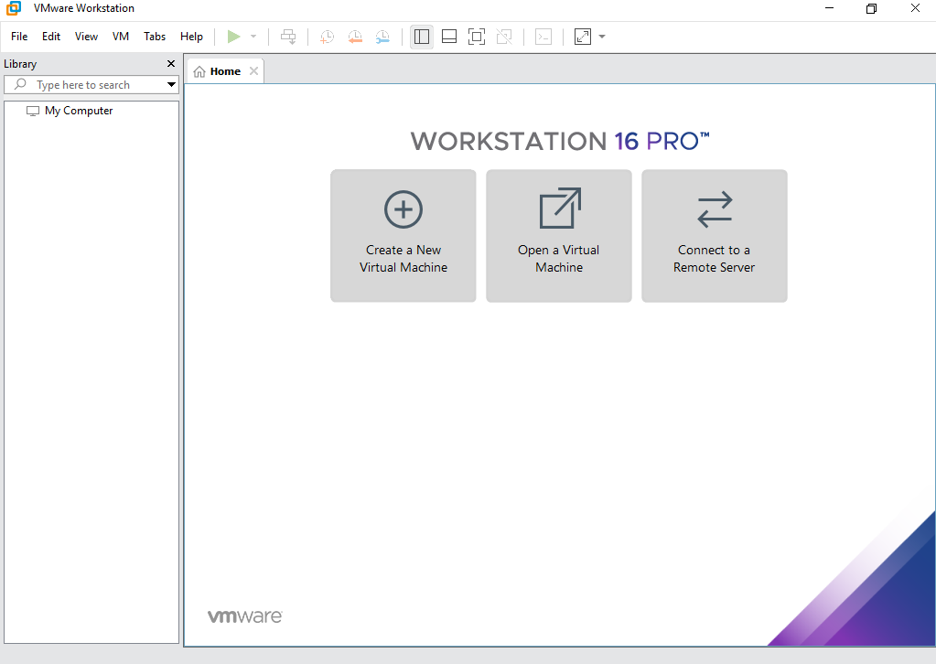

The above screen capture shows VMware Workstation hypervisor initial successful installation on my personal computer.

1. VMware Workstation Configuration

The Ubuntu image file was downloaded from the official ubuntu download page and saved on the local storage of my personal computer. The same process applied to Windows 10 and the Windows Server 2019 Image files which were downloaded from Microsoft Azure Portal after creating a Microsoft account

**Your Screenshot of windows server 2019, windows 10 or 11 client, and Ubuntu 20 client iso image files**

**My screenshot as an example**

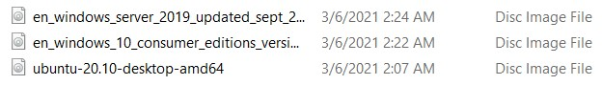

The above operating system image files were used within the Hypervisor portal in building this lab.

I imported these into my Hypervisor and then began the image configuration and install Requirement 1)

1. Installation of Windows Server 2019

After loading the VMware Workstation and checking that “*new virtual option”* is selected, default settings were accepted and certain hardware specific value modifications were made. The screen was prompted with the option to install the guest OS from the optical disk. The Ubuntu ISO image file was selected and loaded into the VMware Workstation. The user name and password were set and the virtual machine name was set. The selected configurations were displayed for approval before the installation process was initialized. After installation, Windows server 2019 was powered on and the virtual network for the lab was setup. The Windows Server 2019 was updated as the last step of the installation process

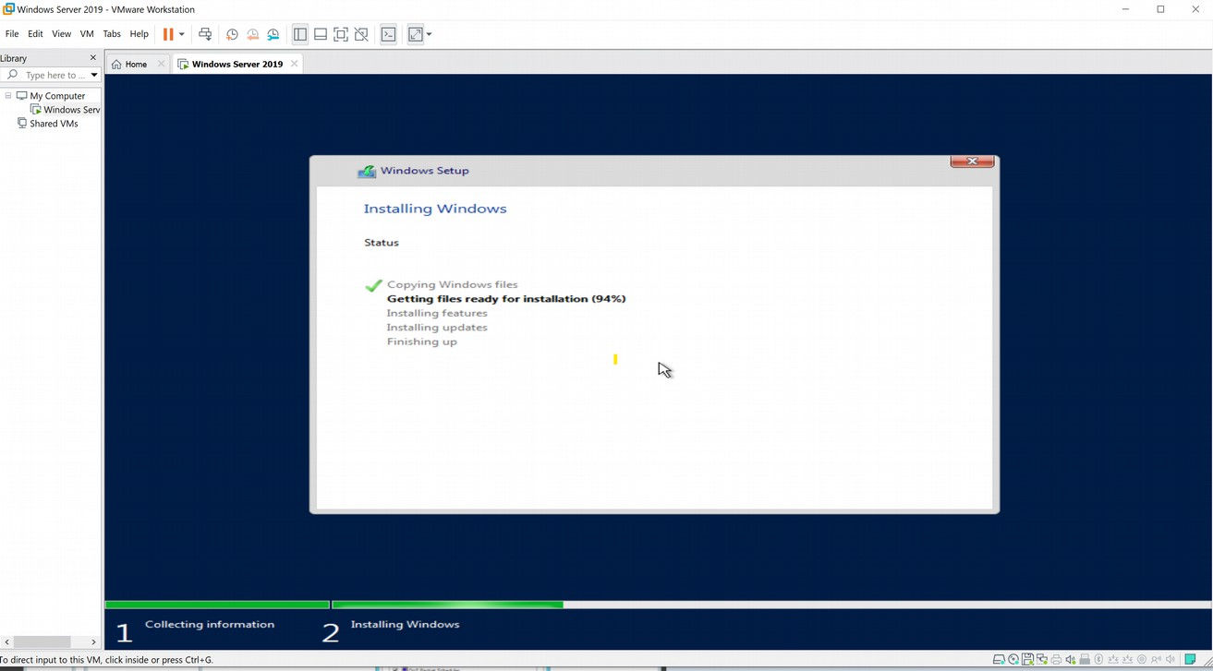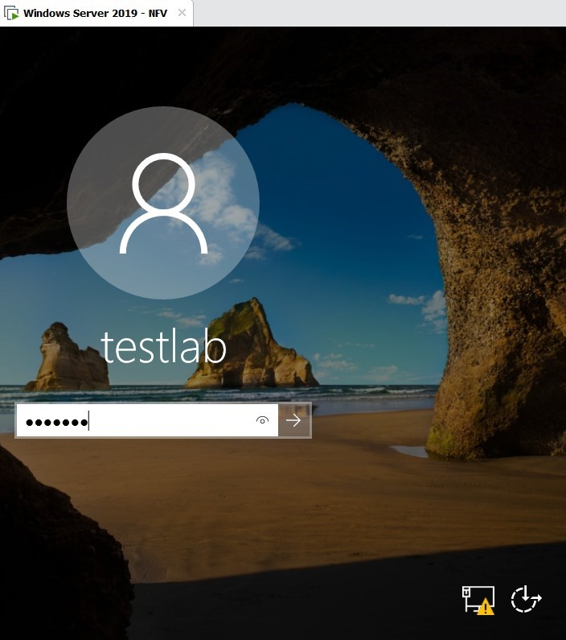

To find the hostname, IP address and physical address of Windows Server 2019, *ipconfig* command was used in the command line interface. This command also helped to troubleshoot the Virtual Machine for the network related issues.

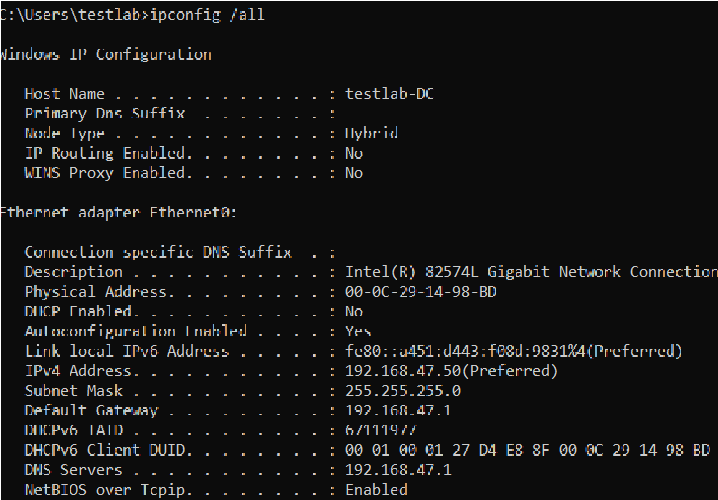

1. Configuration of Windows Active Directory and the Domain Controller

The Active Directory Server was installed and accessed using administrative credentials so that we can make changes. Roles and other features were added and enabled. The roles were selected and installed on the server including the Active Directory Domain Services which elevated the server to a domain controller

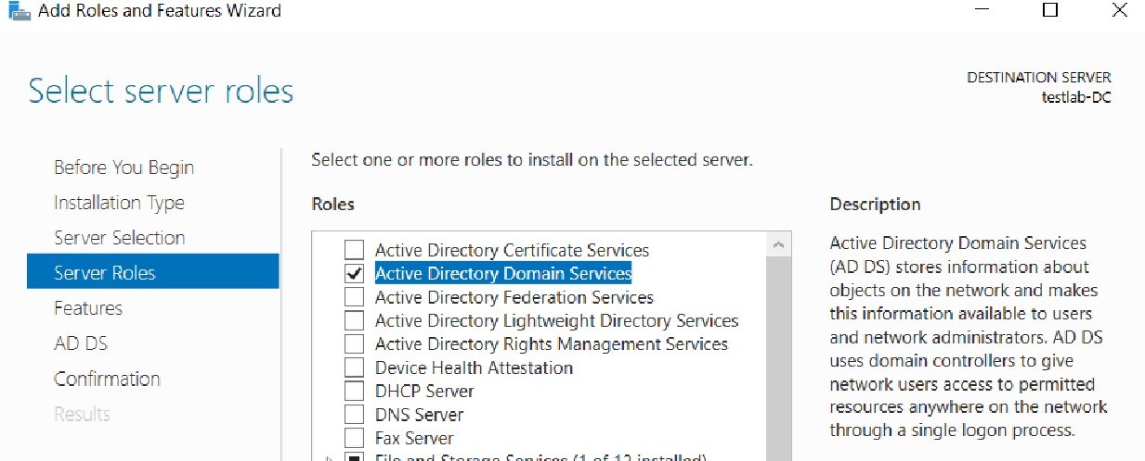

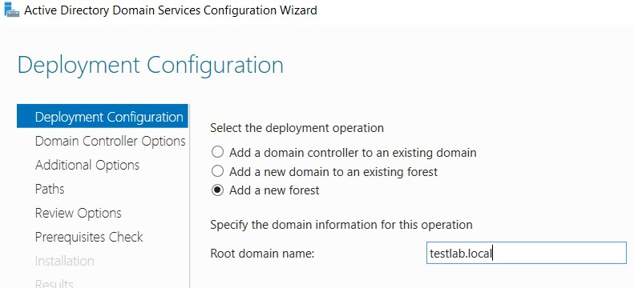

The successful execution of the above steps and configurations lead to a successful implementation of the DNS and Active Directory Services.

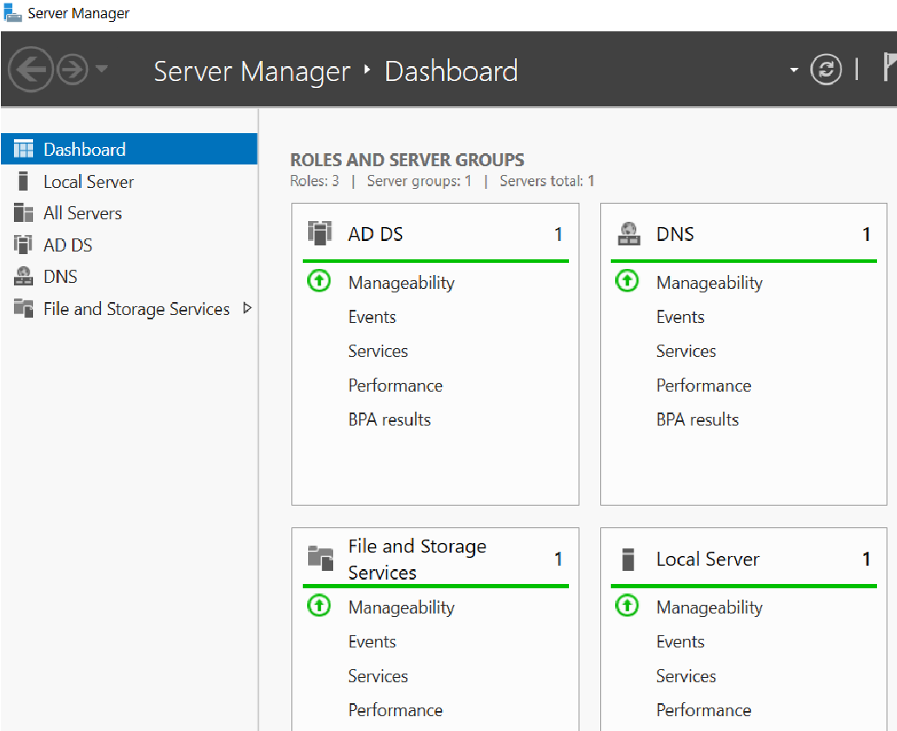

1. Windows 10 Client Installation

Windows 10 was installed as a guest operating system in a new virtual machine under VMware Workstation. The installation was done using the easy install method with a Windows 10 ISO image. The username and the password for the guest operating system was applied in the process.

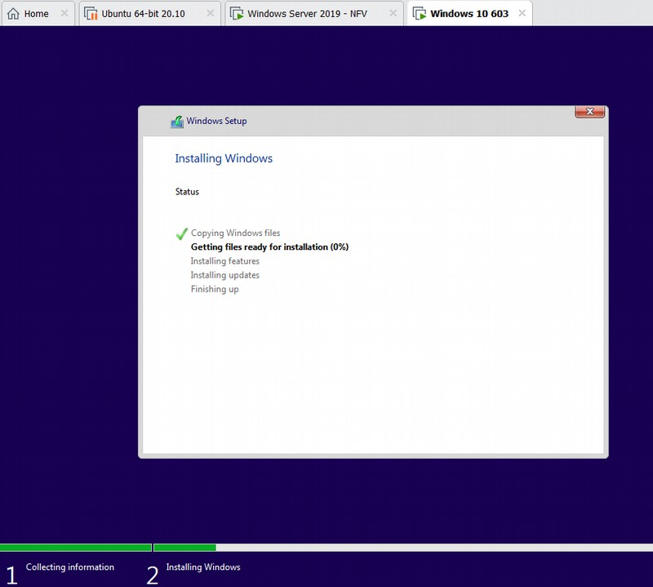

A reservation was created on a DHCP server running on Windows Server 2019 for the Windows 10. A new entry was created manually on the DHCP server to reserve the IP address of windows 10 client

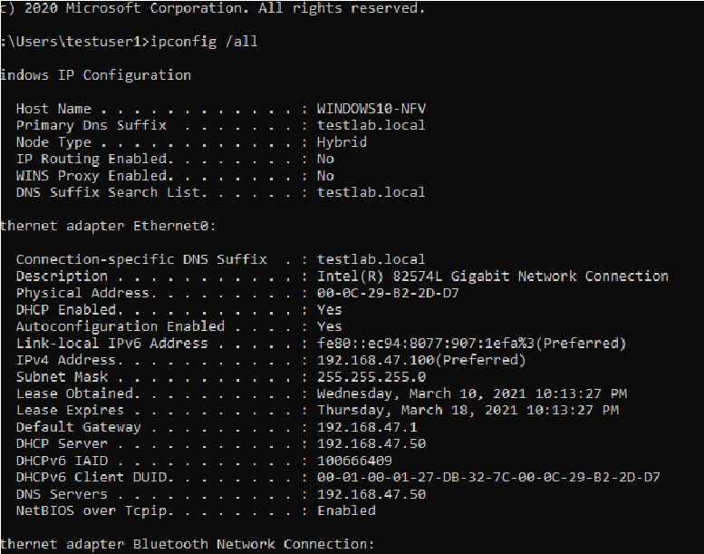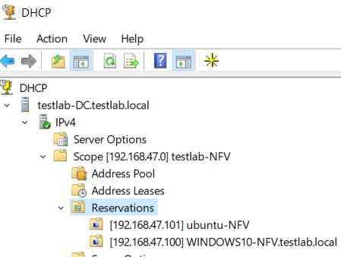

To ensure that all devices are able to communicate with all the devices and to check if they are connected, a ping command was used. The ping was used to send some packets to Windows Server 2019 and Ubuntu client and the reply was returned confirming that the devices are connected and they can communicate with each other.

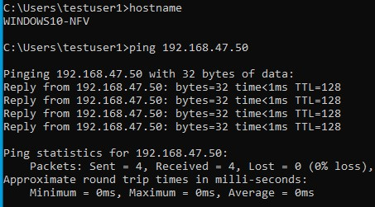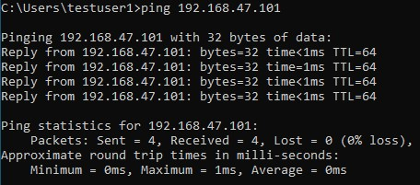

1. Ubuntu Client Installation

As we already downloaded the free Ubuntu Desktop version 20.10 ISO image, the next step is to burn it on the optical disk before starting the installation process. The installation process was identical to that one of Windows operating system

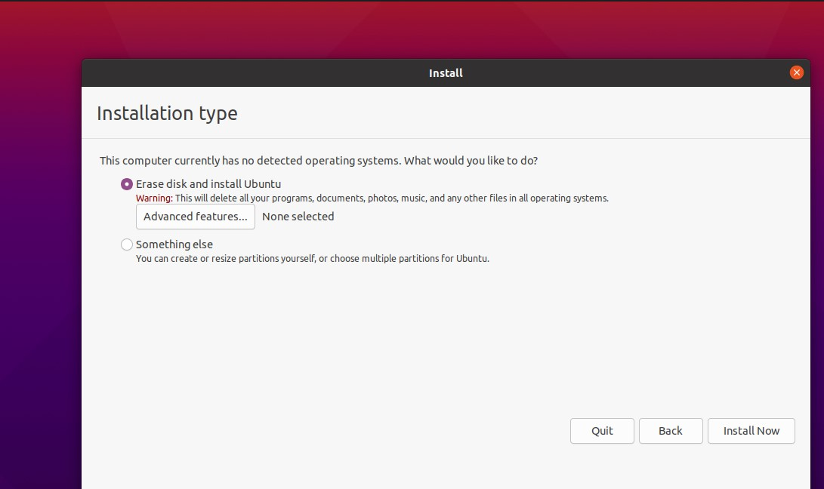

The IP address for the newly installed Ubuntu was set based on DHCP assignment from the Windows Server. This allows Ubuntu to remain connected to Windows Server 2018 and can also communicate to Windows 10 client through the server

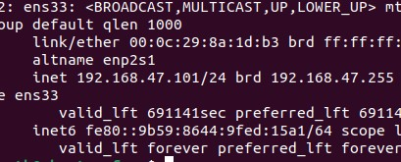

The ping command issued from the Ubuntu terminal confirmed that the virtual machine was sending the packets and receiving replies. Ubuntu’s hostname was assigned using a UNIX command *hostnamectl.* In the terminal screen captures below it is evidenced that the Ubuntu client virtual machine was able to communicate with both Windows Server 2019 and Windows 10 client. This shows that the lab was well configured to allow the deices to send packets to each other through the network.

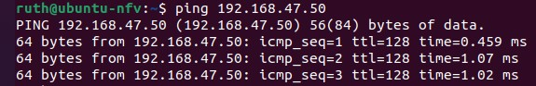

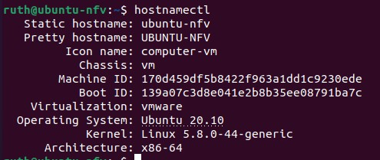

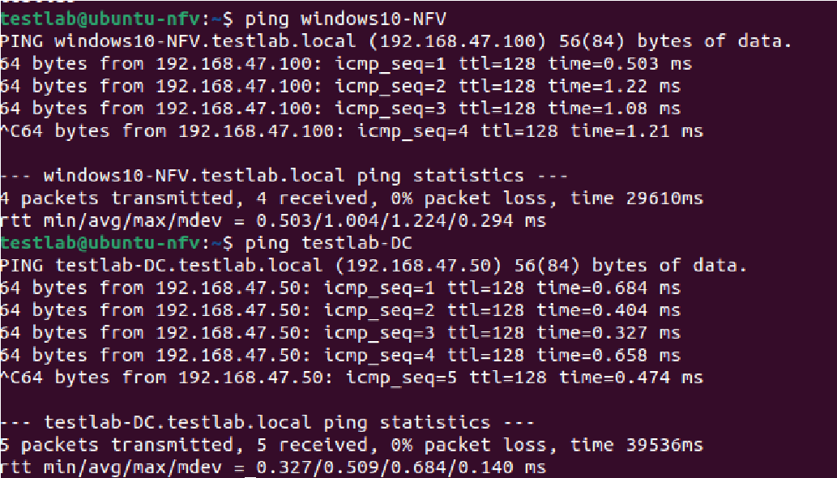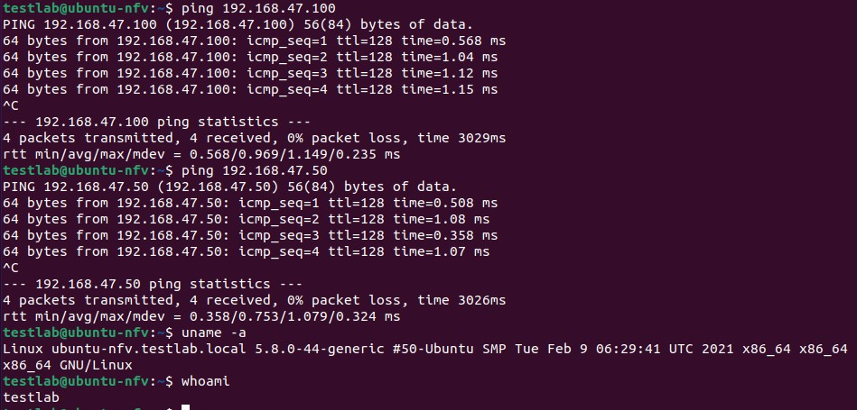

In the end I verified my settings were now correct

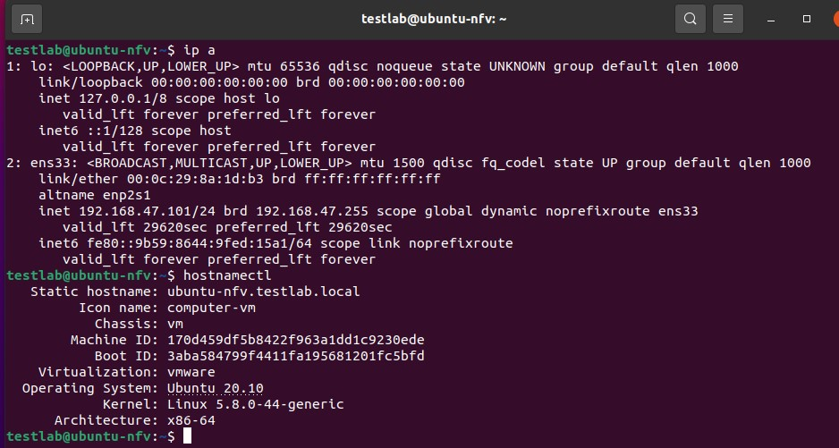

Conclusion:

Installing and configuring the hypervisor (VMware Workstation) and using it to create the virtual environment with three interconnected devices was the focus of this lab. The operating system installed in the VMware Workstation were; Windows Server 2019, Windows 10 client, and Ubuntu version 20.10 client. In this lab, experience on how to set up the domain controller in Windows Server 2019 was gained. The devices were configured to communicate to each other through a virtual environment. Setting up this lab had many setbacks as this was the first experience installing and using the hypervisor. Choosing between which hypervisor was best for this lab was also a challenge. For the first time configuring the Domain server settings and assigning the IP addresses was not a simple task. The main challenge for this lab was installing and configuring the network settings on Ubuntu client. Since it is a UNIX system, it heavily relies on terminal commands to get the tasks done like connecting to domain. After passing through all the challenges, the lab was successfully set up with all the resources required for the devices installed to communicate with each other. Generally, this was a great lab with hands on experience as for the beginners.