Homework_3 - Computer Network

张家成 2017013564

**Q1：We made a distinction between the forwarding function and the routing function performed in the network layer. What are the key differences between routing and forwarding?**

**A1： 转发是数据包从路由器的输入链路到相应的输出链路，路由是确定源和目的地之间的端到端路由**。

**Q2：Consider a datagram network using 8-bit host addresses. Suppose a router uses longest prefix matching and has the following forwarding table:**

|  |  |
| --- | --- |
| **Prefix Match** | **Interface** |
| **00** | **0** |
| **010** | **1** |
| **011** | **2** |
| **10** | **2** |
| **11** | **3** |

**For each of the four interfaces, give the associated range of destination host addresses and the number of addresses in the range.**

**A2：**

|  |  |  |
| --- | --- | --- |
| **Destination Address Range** | | **Interface** |
| **00000000** | **00111111** | **0** |
| **01000000** | **01011111** | **1** |
| **01100000** | **01111111** | **2** |
| **10000000** | **10111111** | **2** |
| **11000000** | **11111111** | **3** |

**接口0的地址数 26 = 64**

**接口1的地址数 25 = 32**

**接口2的地址数 25+26 = 96**

**接口3的地址数 26 = 64**

**Q3：Consider the topology shown in the Figure. Denote the three subnets with hosts (starting clockwise at 12:00) as Networks A, B, and C. Denote the subnets without hosts as Networks D, E, and F.**

**a. Assign network addresses to each of these six subnets, with the following constraints: All addresses must be allocated from 214.97.254/23; Subnet A should have enough addresses to support 250 interfaces; Subnet B should have enough addresses to support 120 interfaces; and Subnet C should have enough addresses to support 120 interfaces. Of course, subnets D, E and F should each be able to support two interfaces. For each subnet, the assignment should take the form a.b.c.d/x or a.b.c.d/x – e.f.g.h/y.**

**b. Using your answer to part (a), provide the forwarding tables (using longest prefix matching) for each of the three routers.**

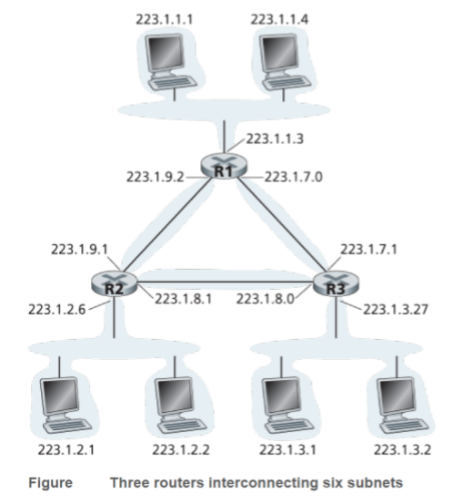

**A3：**

**a：**

**SubnetA : the subnet with hosts and R1**

**SubnetB : the subnet with hosts and R3**

**SubnetC : the subnet with hosts and R2**

**SubnetD : the subnet with R1 and R3**

**SubnetE : the subnet with R3 and R2**

**SubnetF : the subnet with R2 and R1**

**Assign the IP addresses to the six subnets as follows:**

|  |  |  |
| --- | --- | --- |
| **Subnet** | **IP address** | **Num of available address** |
| **A** | **214.97.255/24** | **254 (2 for special purpose)** |
| **B** | **217.97.254.0/25-217.97.254.0/29** | **128-8=120** |
| **C** | **214.97.254.128/25** | **128** |
| **D** | **214.97.254.0/31** | **2** |
| **E** | **214.97.254.2/31** | **2** |
| **F** | **214.97.254.4/30** | **4** |

**Router 1**

|  |
| --- |
| **11010110 01100001 11111111 SubnetA** |
| **11010110 01100001 11111110 0000000 SubnetD** |
| **11010110 01100001 11111110 000001 SubnetF** |

**Router 2**

|  |
| --- |
| **11010110 01100001 11111110 0 SubnetB** |
| **11010110 01100001 11111110 0000000 SubnetD** |
| **11010110 01100001 11111110 0000001 SubnetE** |

**Router 3**

|  |
| --- |
| **11010110 01100001 11111110 1 SubnetC** |
| **11010110 01100001 11111110 0000001 SubnetE** |
| **11010110 01100001 11111110 000001 SubnetF** |

**Q4：Consider sending a 2400-byte datagram into a link that has an MTU of 700 bytes. Suppose the original datagram is stamped with the identification number 422. How many fragments are generated? What are the values in the various fields in the IP datagram(s) generated related to fragmentation?**

**A4： 数据区的最大存储限制是680字节（20字节被用来当作IP数据报头）。因此数据碎片个数是（2400-20）/680 = 4。每个碎片将有422的标识。前三个片段的大小为700 字节，但最后一个片段的大小为360字节。4个片段的偏移量为0，85，170，255。前3个片段的flag=1，表示还有数据;最后一个片段flag=0，表示后面没有数据。**

**Q5：How does generalized forwarding differ from destination-based forwarding?**

**A5：**

**基于地址的转发：仅基于目的IP地址的转发**

**广义转发：基于任何报文头部值的转发**