Homework_4 - Computer Network

张家成 2017013564

**Q1：Consider the network shown below, and assume that each node initially knows the costs to each of its neighbors. Consider the distance-vector algorithm and show the distance table entries at node z.**

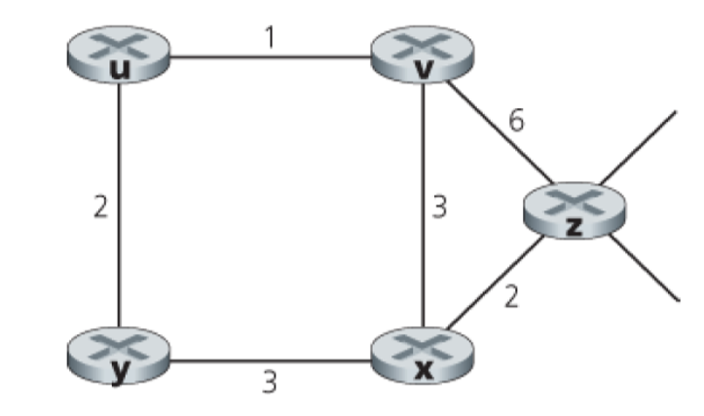

**A1：**

**初始状态**

|  |  |  |  |  |  |  |
| --- | --- | --- | --- | --- | --- | --- |
| Cost | | | | | | |
| From |  | u | v | x | y | z |
| v | ∞ | ∞ | ∞ | ∞ | ∞ |
| x | ∞ | ∞ | ∞ | ∞ | ∞ |
| z | ∞ | 6 | 2 | ∞ | 0 |

**V, X, Z互通路由表**

|  |  |  |  |  |  |  |
| --- | --- | --- | --- | --- | --- | --- |
| Cost | | | | | | |
| From |  | u | v | x | y | z |
| v | 1 | 0 | 3 | ∞ | 6 |
| x | ∞ | 3 | 0 | 3 | 2 |
| z | 7 | 5 | 2 | 5 | 0 |

**U,Y, V, X互通路由表,更新发至Z**

|  |  |  |  |  |  |  |
| --- | --- | --- | --- | --- | --- | --- |
| Cost | | | | | | |
| From |  | u | v | x | y | z |
| v | 1 | 0 | 3 | 3 | 5 |
| x | 4 | 3 | 0 | 3 | 2 |
| z | 6 | 5 | 2 | 5 | 0 |

**Q2：What are some of the possible services that a link-layer protocol can offer to the network layer? Which of these link-layer services have corresponding services in IP? In TCP?**

**A2： link-access, framing, reliable delivery between adjacent nodes, flow control, error detection and correction, half-duplex and full-duplex**

**Service provided for IP : link-access, framing, error detection**

**Service provided for TCP : link-access, framing, reliable delivery between adjacent nodes, error detection and correction, half-duplex and full-duplex**

**Q3：Suppose nodes A, B, and C each attach to the same broadcast LAN (through their adapters). If A sends thousands of IP datagrams to B with each encapsulating frame addressed to the MAC address of B, will C’s adapter process these frames? If so, will C’s adapter pass the IP datagrams in these frames to the network layer C? How would your answers change if A sends frames with the MAC broadcast address?**

**A3：不会。C适配器会检查帧中的MAC地址，发现和自己的MAC地址不同，便不会提取出封装的数据报。如果A使用特殊的广播地址FF-FF-FF-FF-FF-FF，C适配器便会接受这些数据吧，并上传至网络层。**

**Q4：Suppose the information content of a packet is the bit pattern 1110 0110 1001 1101 and an even parity scheme is being used. What would the value of the field containing the parity bits be for the case of a two-dimensional parity scheme? Your answer should be such that a minimum length checksum field is used.**

**A4：**

|  |  |  |  |  |
| --- | --- | --- | --- | --- |
| **1** | **1** | **1** | **0** | **1** |
| **0** | **1** | **1** | **0** | **0** |
| **1** | **0** | **0** | **1** | **0** |
| **1** | **1** | **0** | **1** | **1** |
| **1** | **1** | **0** | **0** | **0** |

**Q5：Consider a broadcast channel with N nodes and a transmission rate of R bps. Suppose the broadcast channel uses polling (with an additional polling node) for multiple access. Suppose the amount of time from when a node completes transmission until the subsequent node is permitted to transmit (that is, the polling delay) is dpoll. Suppose that within a polling round, a given node is allowed to transmit at most Q bits. What is the maximum throughput of the broadcast channel?**

**A5：**

**一次轮询的时间：T=N(Q/R+dpoll)**

**吞吐量：throughout = NQ/T=NQ/(N(Q/R+dpoll))=Q/(Q/R+dpoll)**

**Q6：Suppose nodes A and B are on the same 10 Mbps broadcast channel, and the propagation delay between the two nodes is 325 bit times. Suppose CSMA/CD and Ethernet packets are used for this broadcast channel. Suppose node A begins transmitting a frame and, before it finishes, node B begins transmitting a frame. Can A finish transmitting before it detects that B has transmitted? Why or why not? If the answer is yes, then A incorrectly believes that its frame was successfully transmitted without a collision. Hint: Suppose at time t = 0 bits, A begins transmitting a frame. In the worst case, A transmits a minimum-sized frame of 512 + 64 bit times. So A would finish transmitting the frame at t = 512 + 64 bit times. Thus, the answer is no, if B’s signal reaches A before bit time t = 512 + 64 bits. In the worst case, when does B’s signal reach A?**

**A6： 假设t=0时，A开始传输，t=576时，A停止传输。A要在传输之后才探测到B的传输，在最坏情况下，B在A传输的第一个比特到达时就开始传输，此时t=324，当t=325+324=649时，B完成传输，576>649，因此A此时已经完成了它的传输，认为自己传输的帧没有冲突的传输到了B。**