SQL Hands on:

Schema:

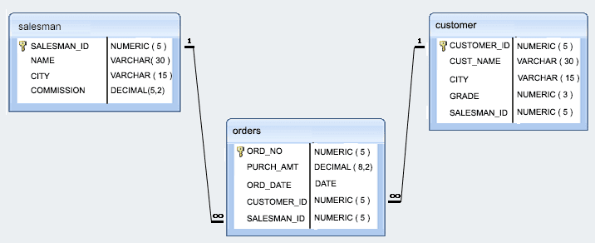

*Sample table*: salesman

salesman_id | name | city | commission

-------------+------------+----------+------------

5001 | James Hoog | New York | 0.15

5002 | Nail Knite | Paris | 0.13

5005 | Pit Alex | London | 0.11

5006 | Mc Lyon | Paris | 0.14

5007 | Paul Adam | Rome | 0.13

5003 | Lauson Hen | San Jose | 0.12

*Sample table*: orders

ord_no purch_amt ord_date customer_id salesman_id

---------- ---------- ---------- ----------- -----------

70001 150.5 2012-10-05 3005 5002

70009 270.65 2012-09-10 3001 5005

70002 65.26 2012-10-05 3002 5001

70004 110.5 2012-08-17 3009 5003

70007 948.5 2012-09-10 3005 5002

70005 2400.6 2012-07-27 3007 5001

70008 5760 2012-09-10 3002 5001

70010 1983.43 2012-10-10 3004 5006

70003 2480.4 2012-10-10 3009 5003

70012 250.45 2012-06-27 3008 5002

70011 75.29 2012-08-17 3003 5007

70013 3045.6 2012-04-25 3002 5001

*Sample table*: customer

customer_id | cust_name | city | grade | salesman_id

-------------+----------------+------------+-------+-------------

3002 | Nick Rimando | New York | 100 | 5001

3007 | Brad Davis | New York | 200 | 5001

3005 | Graham Zusi | California | 200 | 5002

3008 | Julian Green | London | 300 | 5002

3004 | Fabian Johnson | Paris | 300 | 5006

3009 | Geoff Cameron | Berlin | 100 | 5003

3003 | Jozy Altidor | Moscow | 200 | 5007

3001 | Brad Guzan | London | | 5005

1. Write a query to display the columns in a specific order like order date, salesman id, order number and purchase amount from for all the orders
2. write a SQL query to find the unique salespeople ID. Return salesman_id.
3. write a SQL query to find the salespeople who lives in the City of 'Paris'. Return salesperson's name, city
4. write a SQL query to find the orders, which are delivered by a salesperson of ID. 5001. Return ord_no, ord_date, purch_amt
5. write a SQL query to find all the customers in ‘New York’ city who have a grade value above 100. Return customer_id, cust_name, city, grade, and salesman_id.
6. write a SQL query to find the details of those salespeople whose commissions range from 0.10 to0.12. Return salesman_id, name, city, and commission
7. write a SQL query to calculate total purchase amount of all orders. Return total purchase amount.
8. write a SQL query to calculate average purchase amount of all orders. Return average purchase amount.
9. write a SQL query to count the number of unique salespeople. Return number of salespeople.
10. write a SQL query to find the highest purchase amount ordered by each customer. Return customer ID, maximum purchase amount
11. write a SQL query to find the highest purchase amount ordered by each customer on a particular date. Return, order date and highest purchase amoun
12. write a SQL query to find the highest purchase amount on '2012-08-17' by each salesperson. Return salesperson ID, purchase amount.
13. write a SQL query to find the salesperson and customer who belongs to same city. Return Salesman, cust_name and city.
14. write a SQL query to find those orders where order amount exists between 500 and 2000. Return ord_no, purch_amt, cust_name, city
15. write a SQL query to find those salespersons who received a commission from the company more than 12%. Return Customer Name, customer city, Salesman, commission
16. write a SQL query to display the cust_name, customer city, grade, Salesman, salesman city. The result should be ordered by ascending on customer_id.
17. 1. write a SQL query to find all the orders issued by the salesman 'Paul Adam'. Return ord_no, purch_amt, ord_date, customer_id and salesman_id
18. 2. write a SQL query to find all the orders, which are generated by those salespeople, who live in the city of London.Return ord_no, purch_amt, ord_date, customer_id, salesman_id.
19. 3. write a SQL query to find the orders generated by the salespeople who works for customers whose id is 3007. Return ord_no, purch_amt, ord_date, customer_id, salesman_id. A customer can works only with a salespeople
20. 4. write a SQL query to find the order values greater than the average order value of 10th October 2012. Return ord_no, purch_amt, ord_date, customer_id, salesman_id.
21. 5. write a SQL query to find all the orders generated in New York city. Return ord_no, purch_amt, ord_date, customer_id and salesman_id
22. 6. write a SQL query to find the salespeople who had more than one customer. Return salesman_id and name
23. 7. write a SQL query to find those orders, which are higher than average amount of the orders. Return ord_no, purch_amt, ord_date, customer_id and salesman_id
24. 8. Write a query to find the sums of the amounts from the orders table, grouped by date, eliminating all those dates where the sum was not at least 1000.00 above the maximum order amount for that date
25. 9. Write a query to extract all data from the customer table if and only if one or more of the customers in the customer table are located in London.
26. 10. write a SQL query to find the salespeople who deal multiple customers. Return salesman_id, name, city and commission