Assignment 08

Timothy Quintana

IT FDN 110A

December 08, 2020

Assignment 08 dealing with Classes was tough and insightful at the same time. As always time constraints have held me from fully immersing myself into the assignment but nonetheless I made an attempt. My first attempt didn’t go as expected, I tried to reread the listings to try to get it working. Most of the product class worked but the rest of the code faltered so I read Randal’s code and was able to get everything working.   
  
I had some issues with the Product class after looking at Randal’s code but it was a good learning opportunity that allowed me to read the debugger, search for errors and make modifications as needed  
  
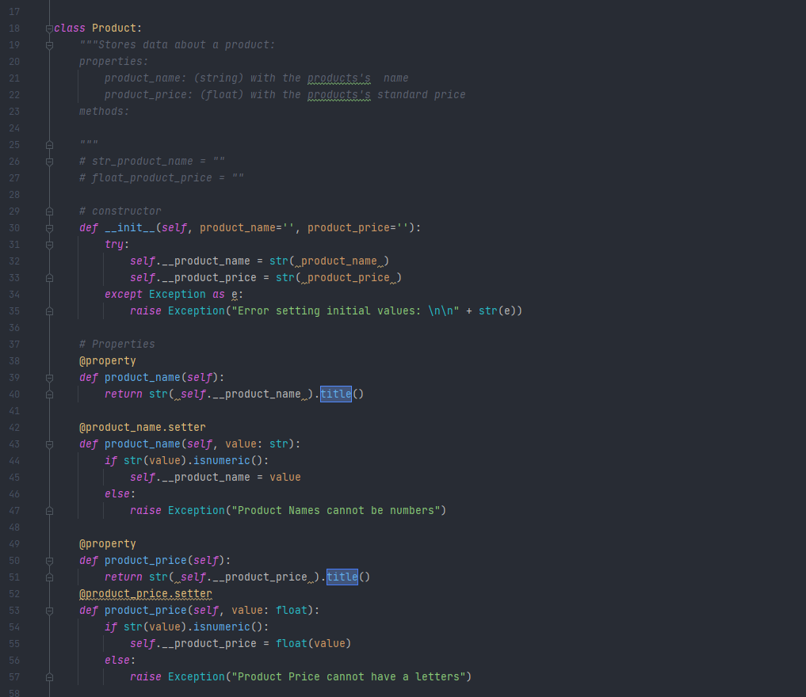

Here is an example of one of the errors that I was getting:  
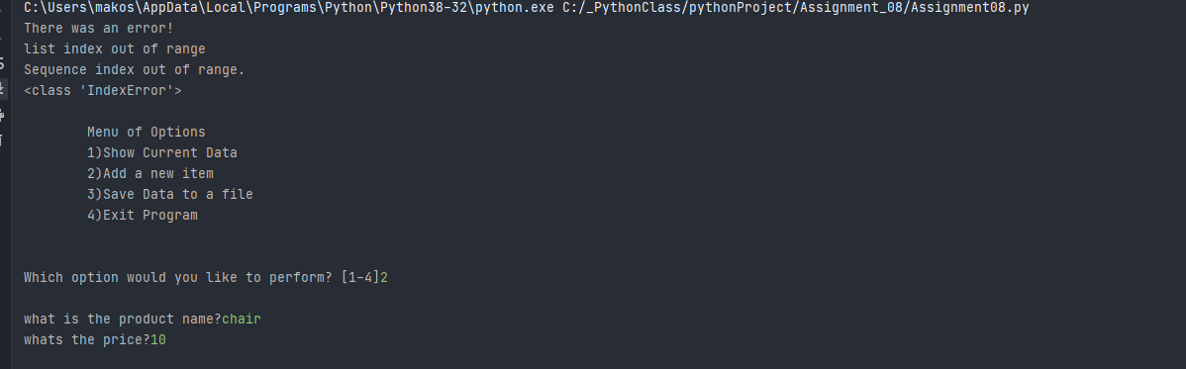

In addition, I had classes and variable misnamed or spelled wrong, str/float issues and finally was able to get it all working. This was a tough assignment but I hope to get through it all and finish this class.

Starting the program:  
  
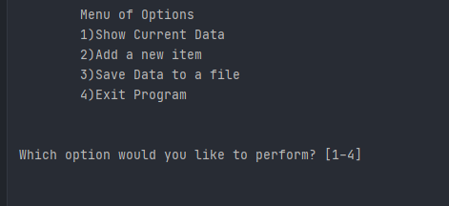

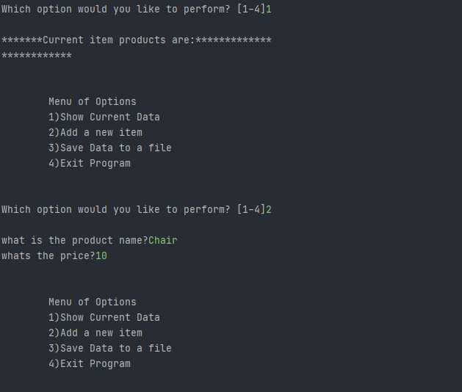

Select 3 to Save the Data:

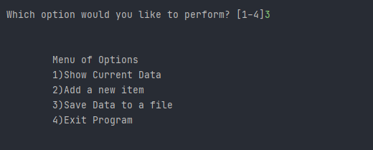

Showing the Data:  
