**JDK 1.8 - 64 bit**:

**Uninstall the existing Java**: Ignore If they don’t exist.

Open Control panel and uninstall the below highlighted softwares.

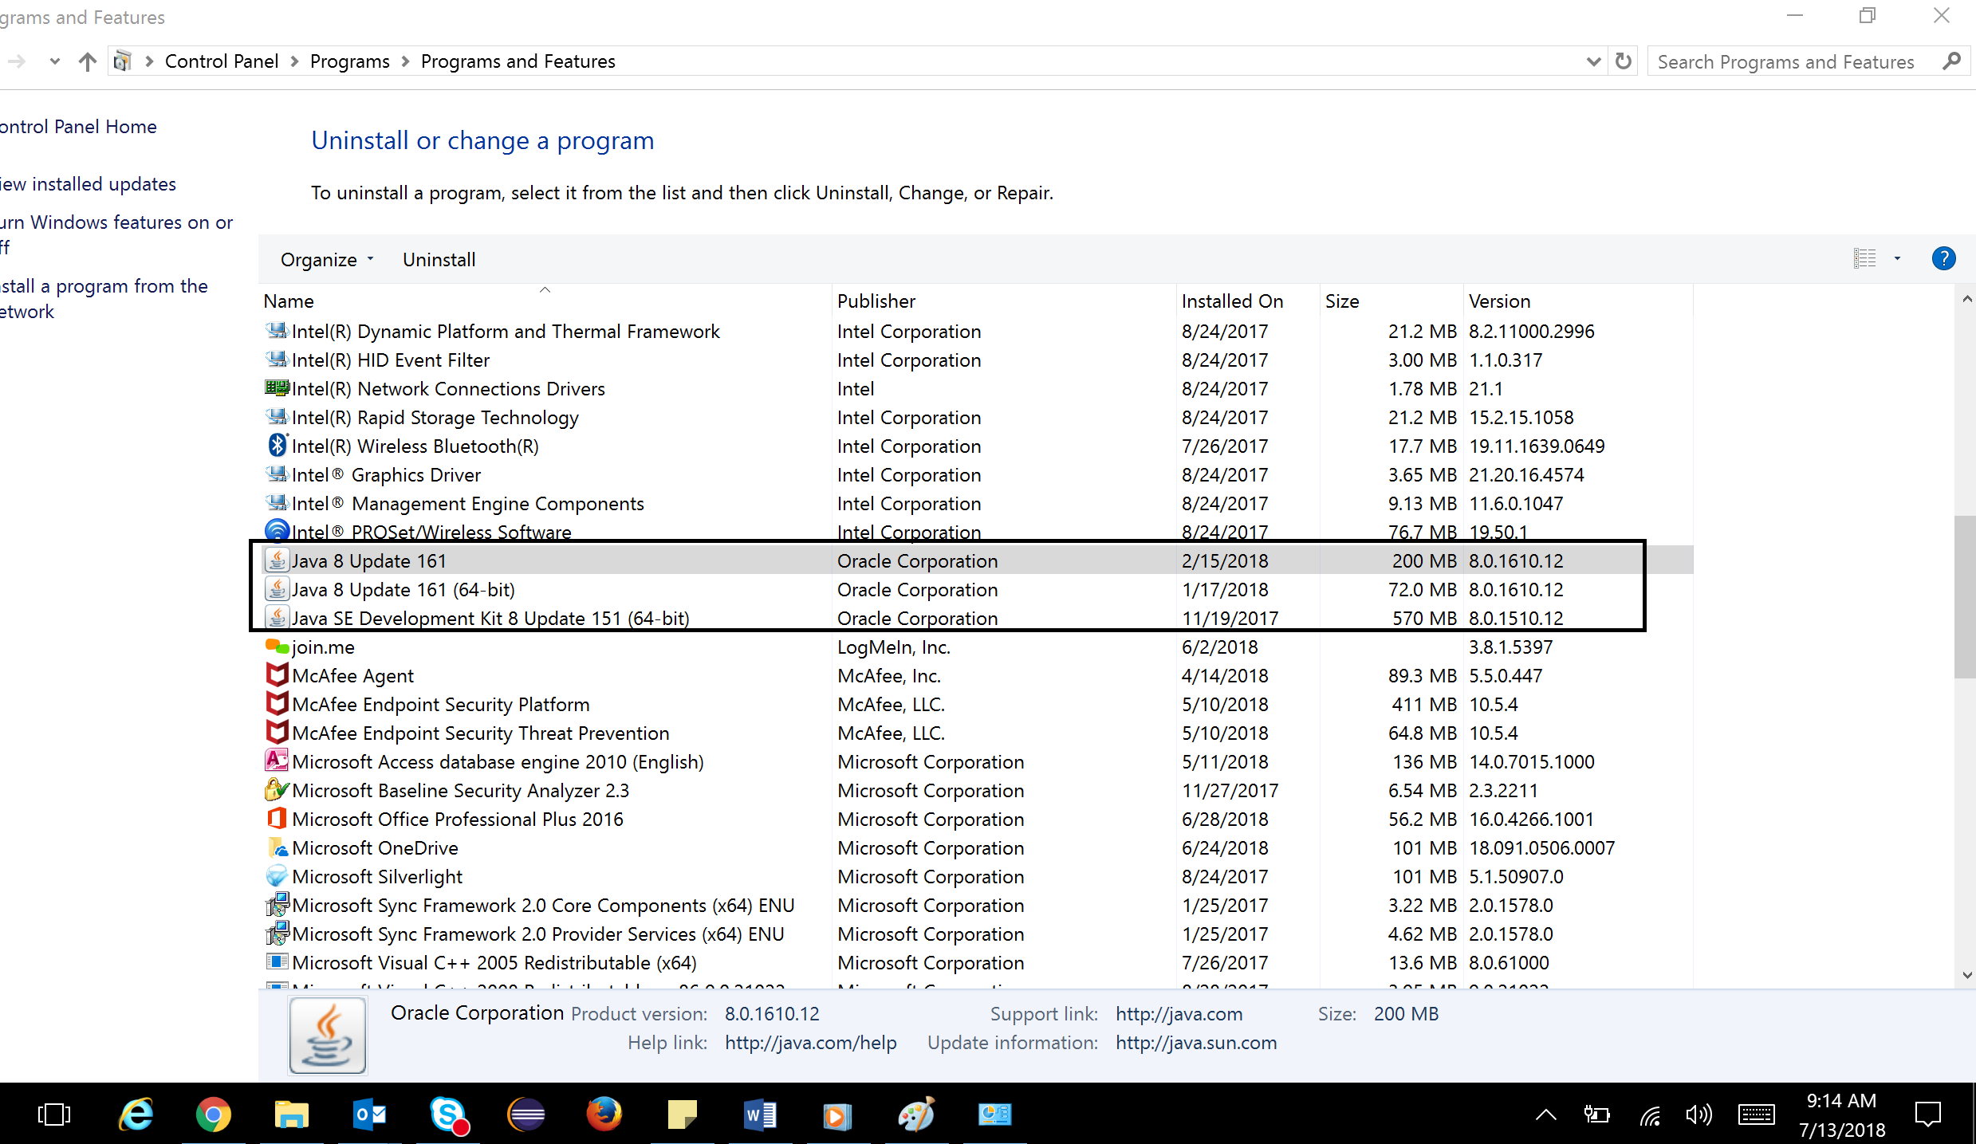

* Open below link:

<https://www.oracle.com/technetwork/java/javase/downloads/jdk8-downloads-2133151.html>

* Click on Accept Licese Agreement

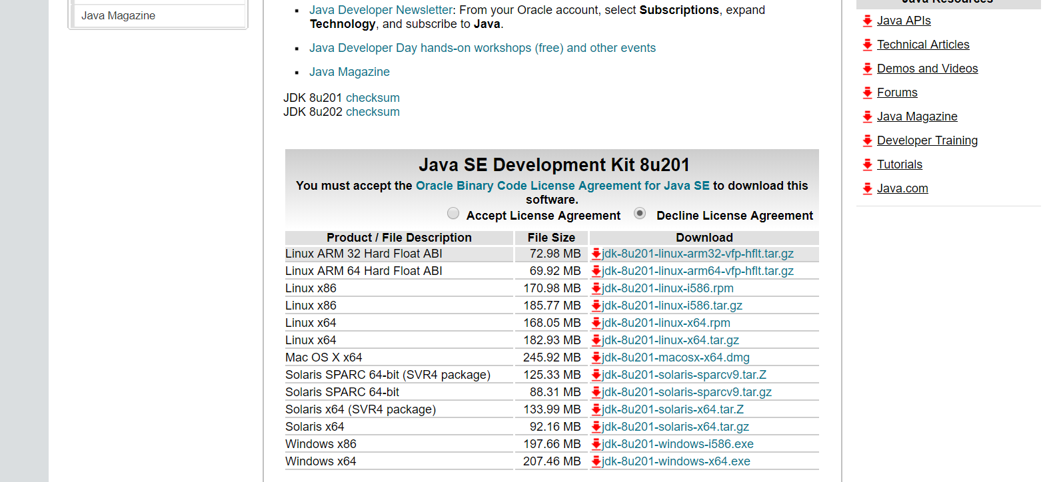

* Click on below highlighted link to download 64 bit

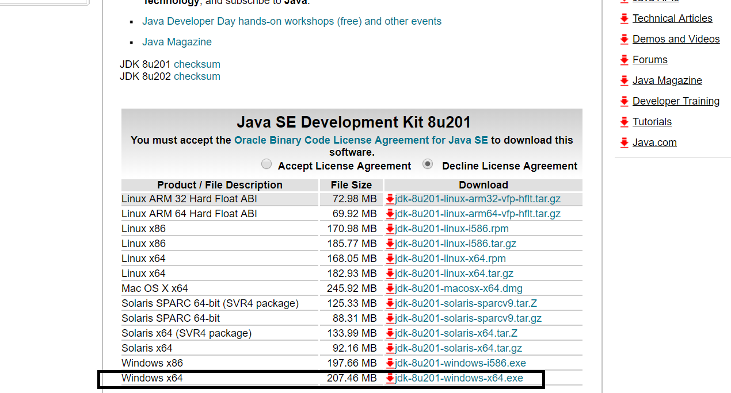

* Once downloaded, install it by clicking on Next button with default options only.

**Eclipse IDE – NEON – 64 bit**

* Open below link:

<https://www.eclipse.org/downloads/packages/release/photon/m7>

* Click on below highlighted 64 bit link

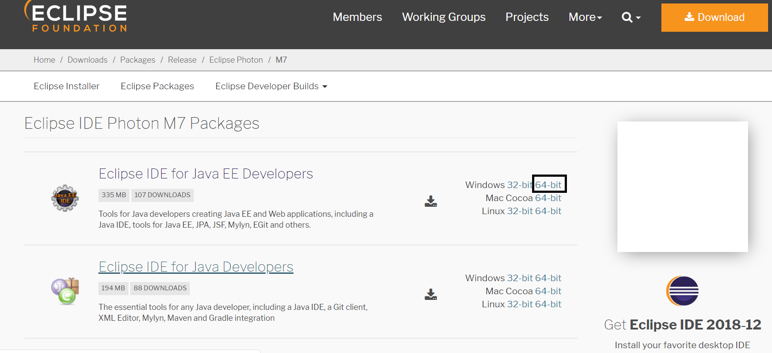

* After Download and unzip it.

**You may download NEON version of Eclipse IDE as well. Ensure to download the latest version.**

**Selenium Stand Alone Jar**:

* Open below link:

<http://docs.seleniumhq.org/download/>

* Click on below highlighted link

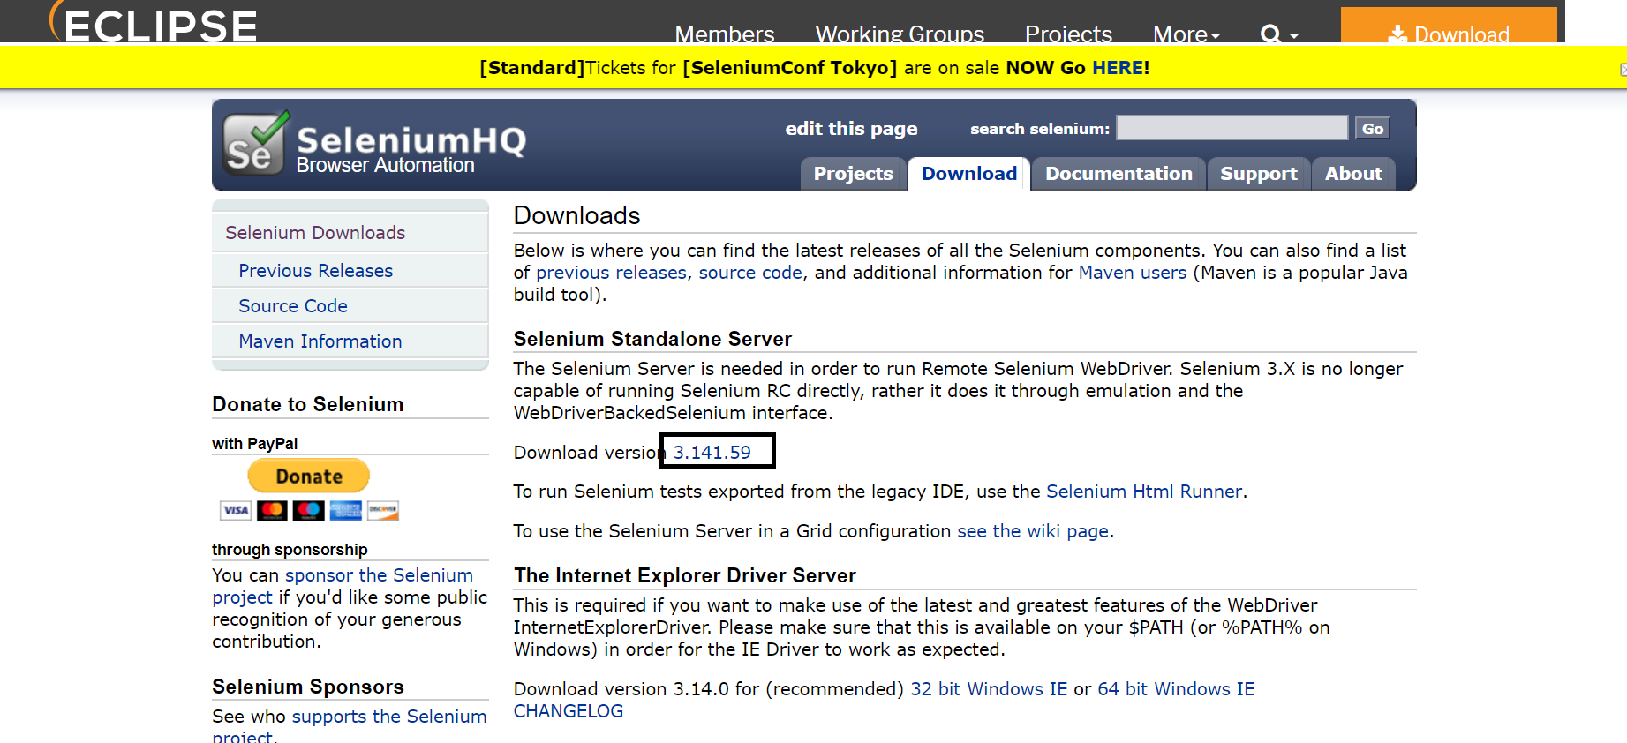

**Google Chrome Driver**:

* In the same link: <http://docs.seleniumhq.org/download/>
* Click on below highlighted link

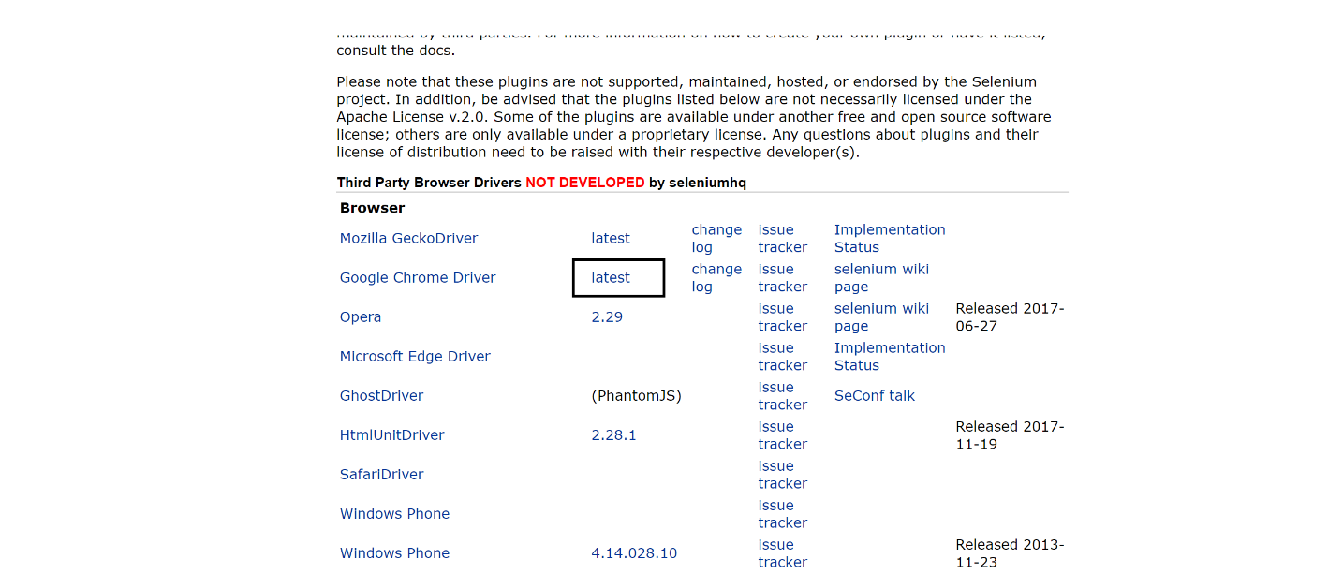

* Click on below highlighted link to download chrome for windows.

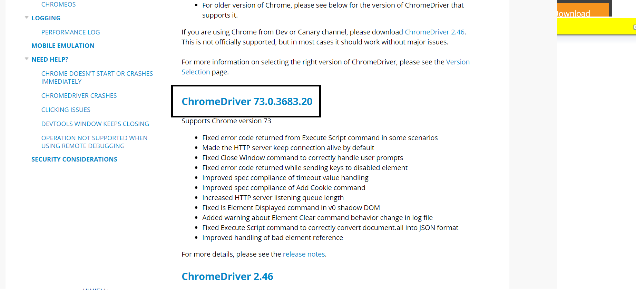

* And then Click on the below highlighted link

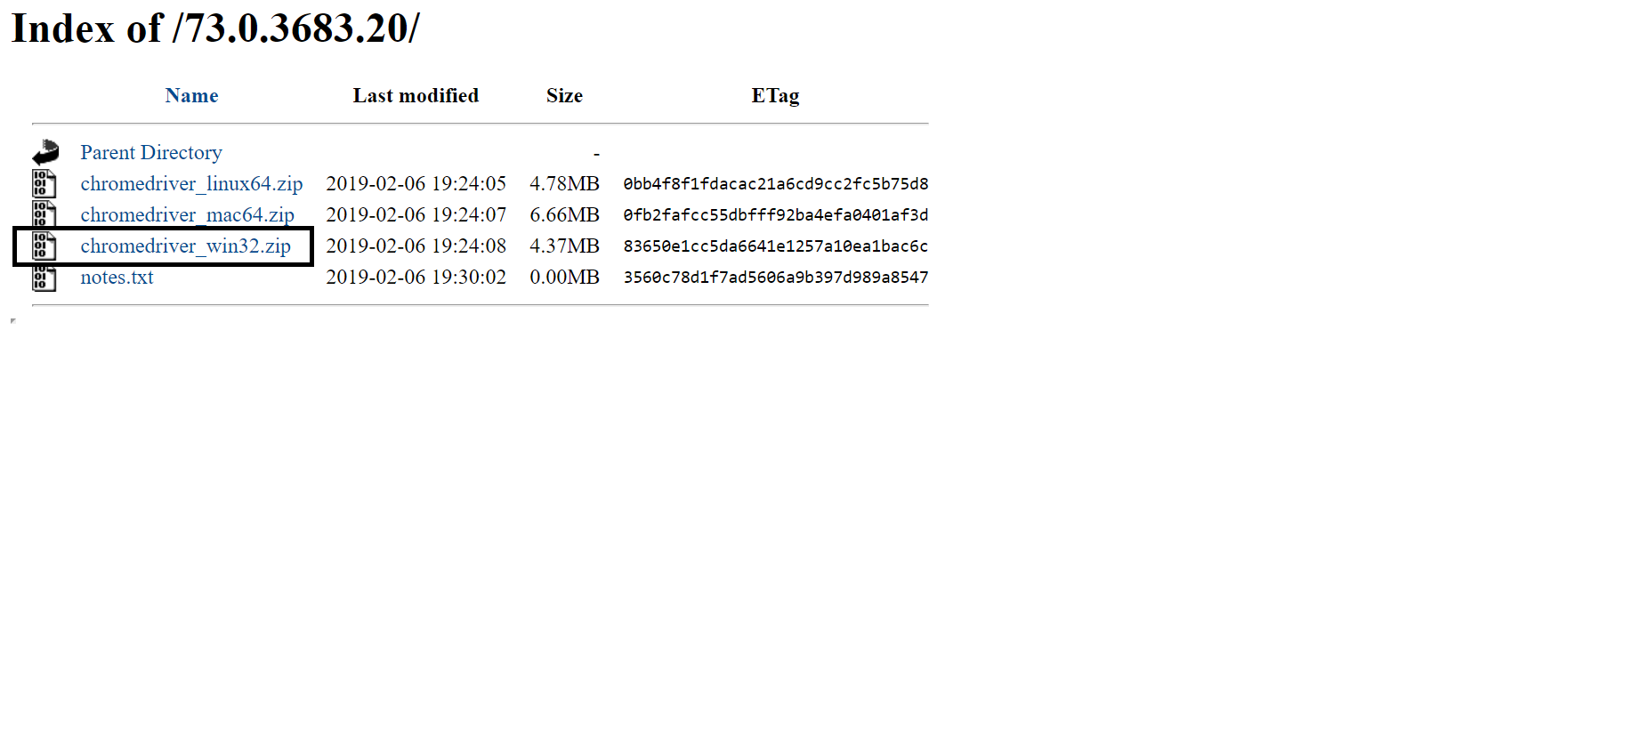 **Firefox Driver**:

* Click on below highlighted link

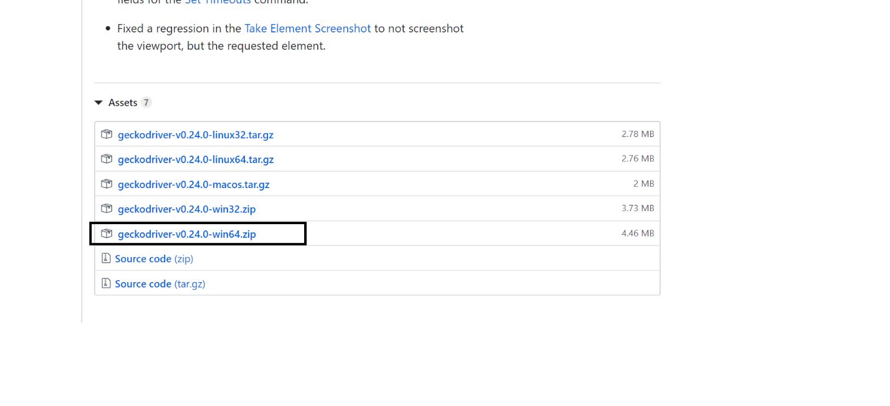

* And then Click on the below highlighted link

