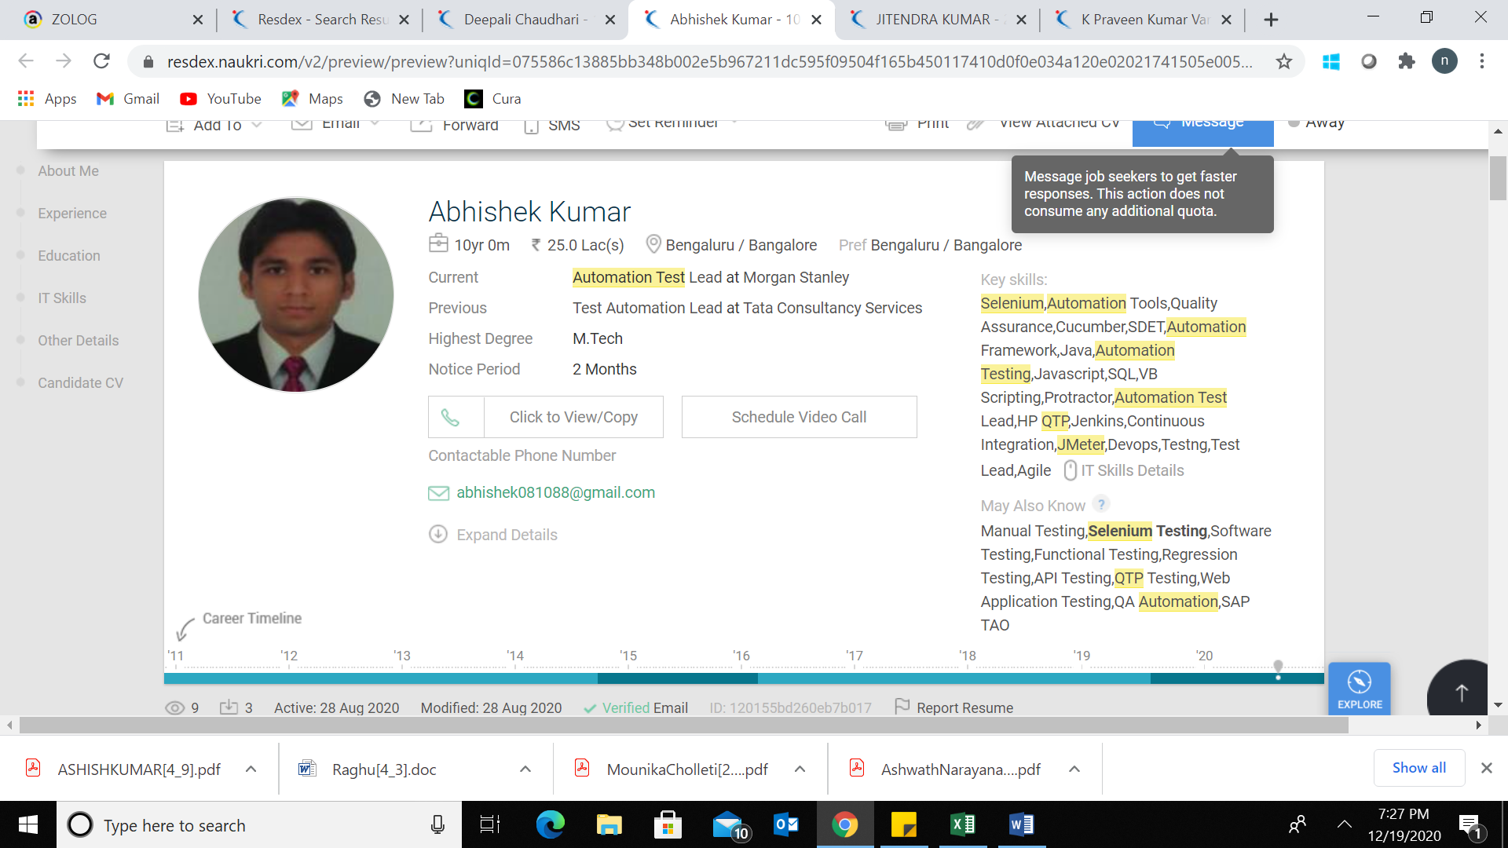

10 yrs of exp in Automation Testing using UFT/QTP ,Selenium and Protractor | CICD integration using jenkins | Performance testing using JMeter | Automation of app hosted on cloud

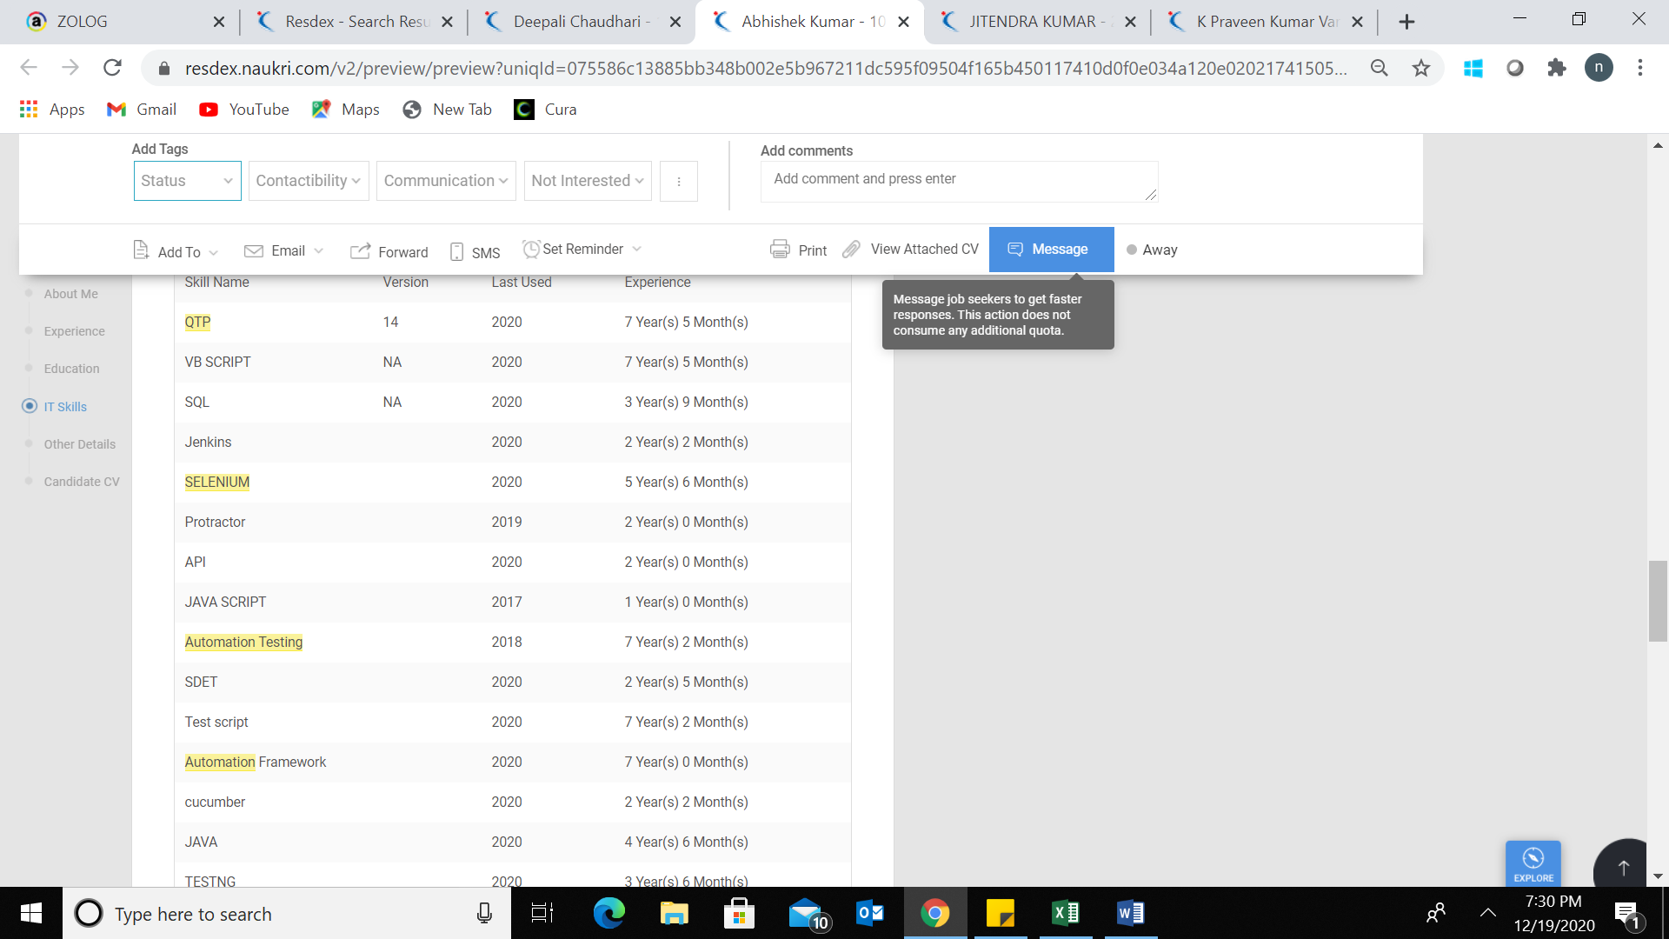

**SDET**

Seeking a challenging and rewarding opportunity in the industry which is more in line with my academic background and which effectively utilizes my analytical and technical skills.

C:\Users\nbanu\AppData\Local\Microsoft\Windows\INetCache\Content.MSO\3B3F83AA.tmp

**PROFILE**

**♦**         Technically competent and result oriented professional, **offering 9.7 years of experience**, **currently working as SDET with Morgan Stanley.**

**♦**         Experience in **Automating Mainframe, Web, Window and SAP based applications using UFT/Selenium and Angular JS based application using Protractor-NodeJs**

**♦**         **Experience in automating REST API services.**

**♦**         **Experience in Automating application hosted on cloud**

**♦**         **Good knowledge on Microsoft Azure fundamentals**

**♦**         **Experience in doing performance testing using JMeter**

**♦**         Comprehensive domain grasp across all functional areas with expertise in **Quality Assuranceand Software Testing Life cycle(STLC),** managing requirement gathering process and **User Acceptance Testing**, and conducted other project related activities.

**♦**         **Good analytical, troubleshooting**and leadership skills with ability to create and sustain high work tempo

**Projects Handled**

**Core Processing |  Role-SDET | Duration-4.2 years**

The project involves Core Services QA Automation Team for performing automation testing, enforcing quality for various applications under Wealth Management Domain for Morgan Stanley and writing high quality test suites for automating various test scenarios across multiple touch points

**Tools Used: ALM, UF/QTP, JMeter, Selenium,Protractor/NodeJS**

**Main responsibilities:**

**♦**         Automating Web(Angular/Non Angular) based **applications using Protractor(NodeJS) and Selenium(Cucumber framework).**

**♦**         **Leading a team** of 5 associates to ensure on-time and quality.

**♦**         Worked in complete STLC ( Software Testing Life Cycle) process.

**♦**         Automation of **REST API** services

**♦**         **Automation of application hosted on cloud**

**♦**         **Creating pipelines in Azure dashboard**

**♦**         **CICD integration using Jenkins.**

**♦**         **Performance testing** using JMeter

**♦**         Design and execute test scenarios by using best methods and techniques.

**♦**         Direct interaction with client to discuss issues faced while testing.

