**Project Mobile Application**

**App “Car rental”**

**Prepared by**

**1.5804062660125 Mr.Yodchai Thammakesorn**

**2.5804062660273 Mr.Chirathip Chantrawichaikun**

**Architecture**

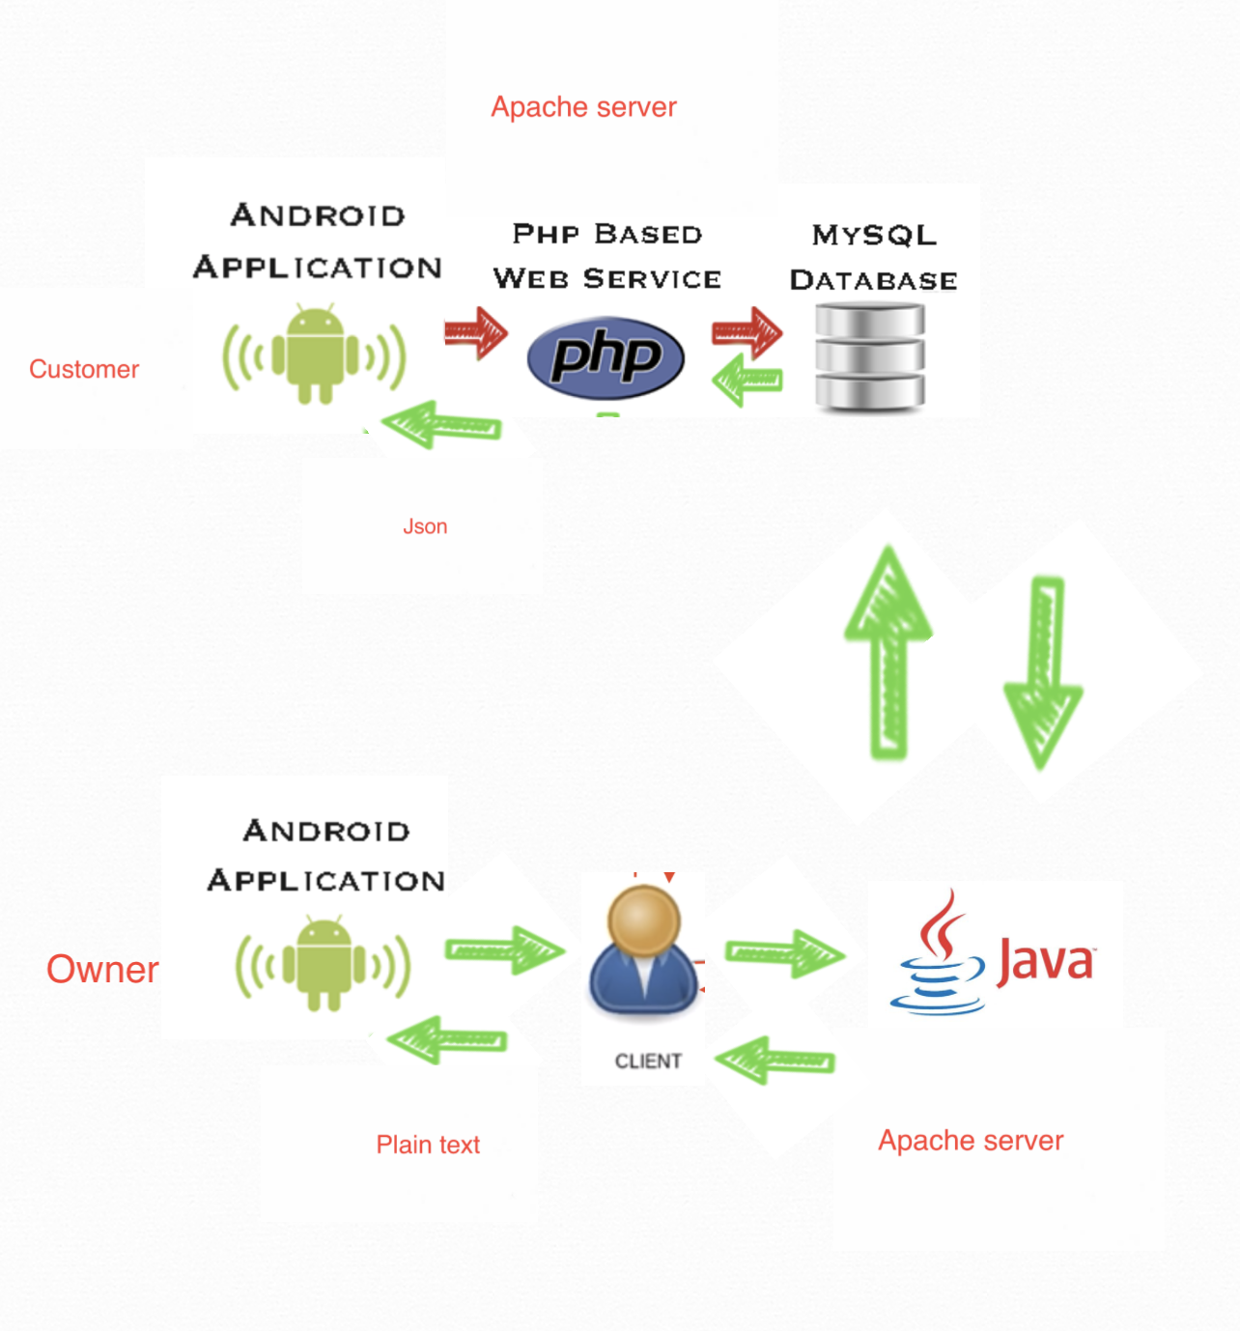

**DATABASE**

**Car**

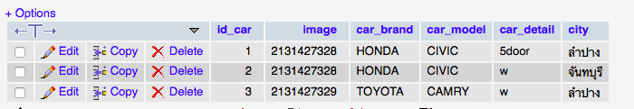

**Order**

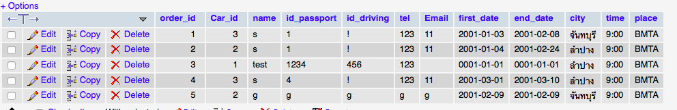

**Activity diagram**

**Customer**

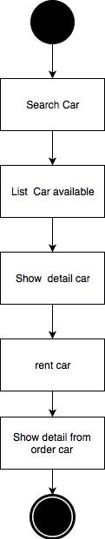

**Owner**

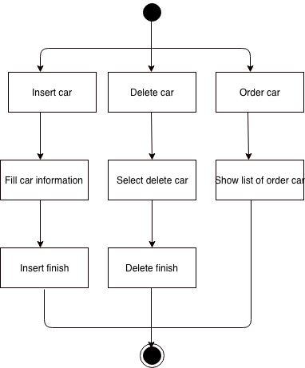

**UI**

**Customer**

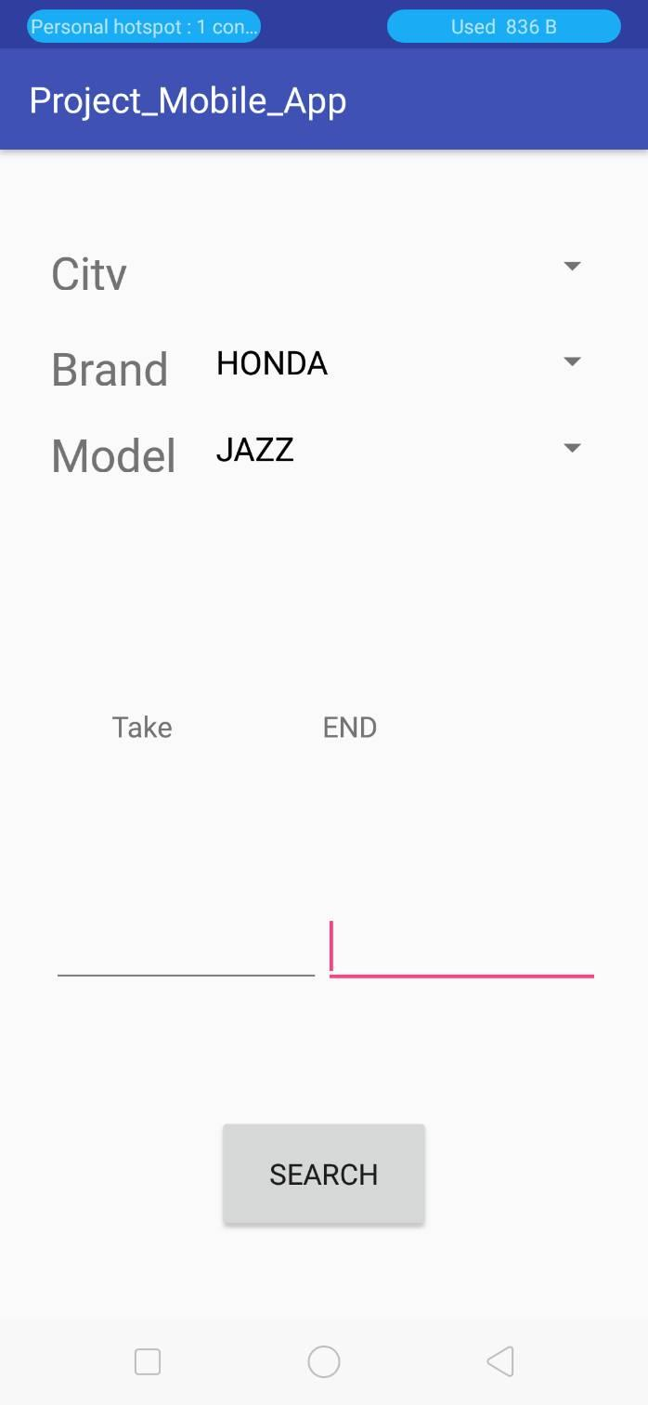

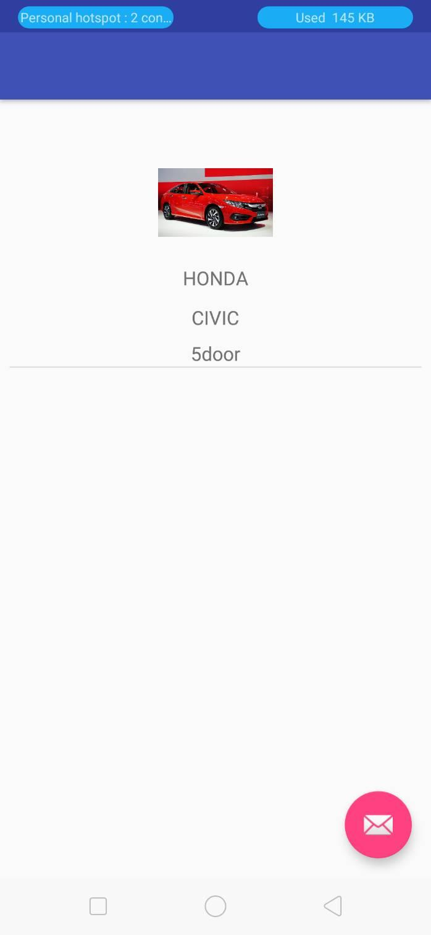

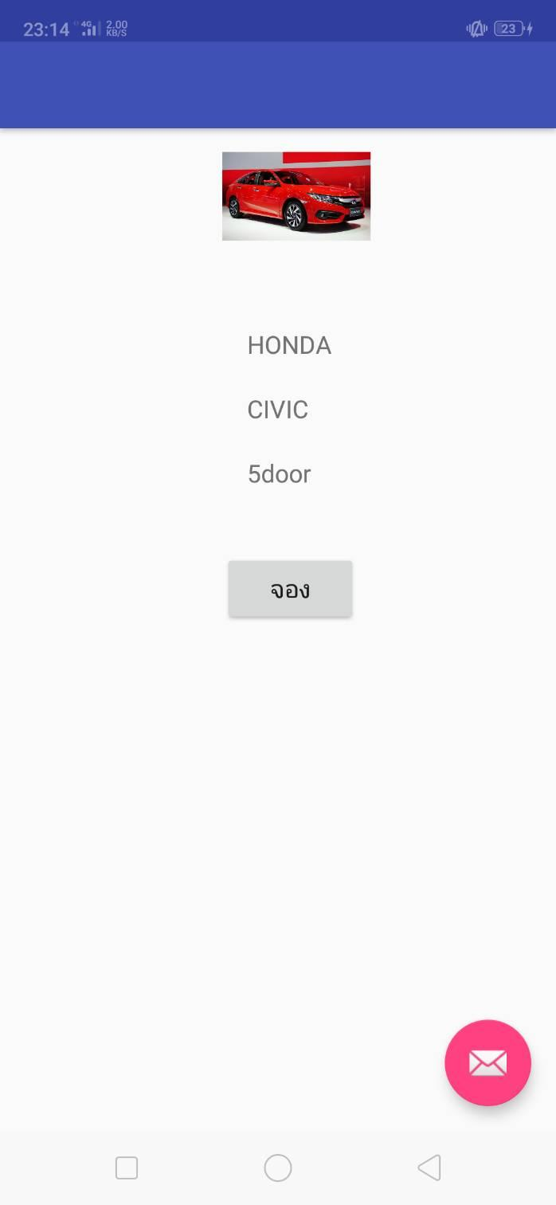

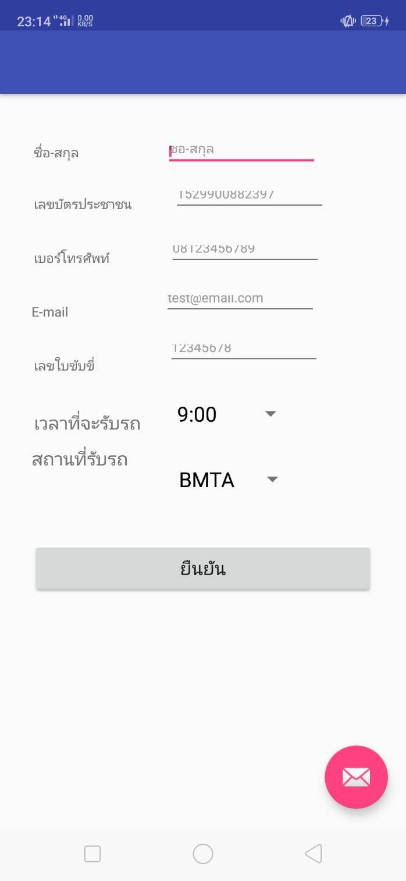

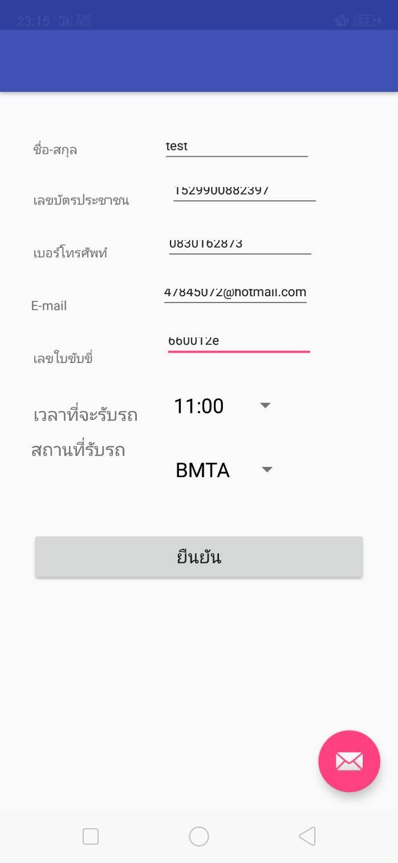

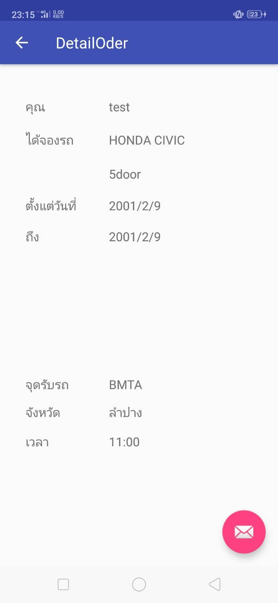

**Code PHP SELECT data from DB and return json array**

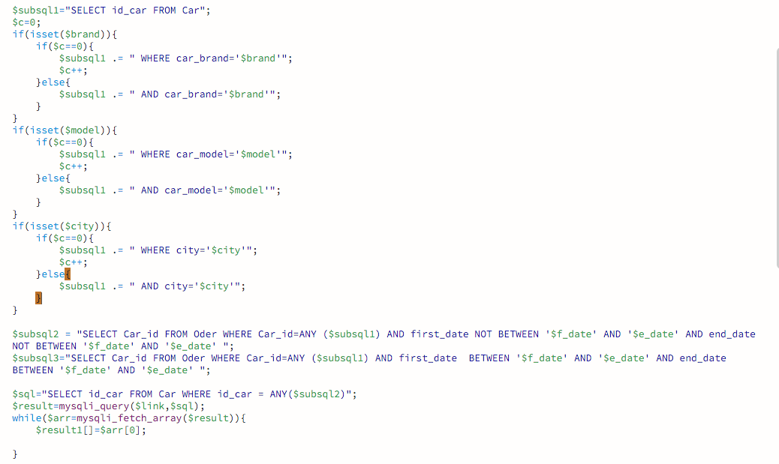

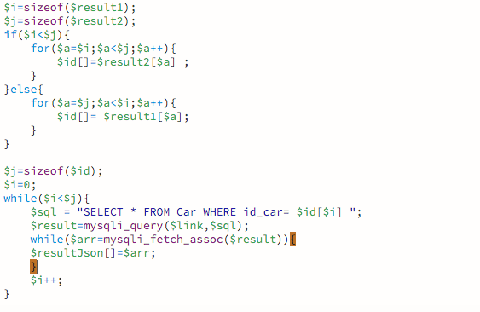

**Data to response form PHP**

[{"id_car":"3","image":"2131427329","car_brand":"TOYOTA","car_model":"CAMRY","car_detail":"w","city":"\u0e25\u0e33\u0e1b\u0e32\u0e07"},{"id_car":"2","image":"2131427328","car_brand":"HONDA","car_model":"CIVIC","car_detail":"w","city":"\u0e08\u0e31\u0e19\u0e17\u0e1a\u0e38\u0e23\u0e35"},{"id_car":"1","image":"2131427328","car_brand":"HONDA","car_model":"CIVIC","car_detail":"5door","city":"\u0e25\u0e33\u0e1b\u0e32\u0e07"}]

Validate Json From JSONLint

[{

"id_car": "3",

"image": "2131427329",

"car_brand": "TOYOTA",

"car_model": "CAMRY",

"car_detail": "w",

"city": "\u0e25\u0e33\u0e1b\u0e32\u0e07"

}, {

"id_car": "2",

"image": "2131427328",

"car_brand": "HONDA",

"car_model": "CIVIC",

"car_detail": "w",

"city": "\u0e08\u0e31\u0e19\u0e17\u0e1a\u0e38\u0e23\u0e35"

}, {

"id_car": "1",

"image": "2131427328",

"car_brand": "HONDA",

"car_model": "CIVIC",

"car_detail": "5door",

"city": "\u0e25\u0e33\u0e1b\u0e32\u0e07"

}]

**Code PHP Insert Order from DB and return id order**

**Code JsonArrayRequest**

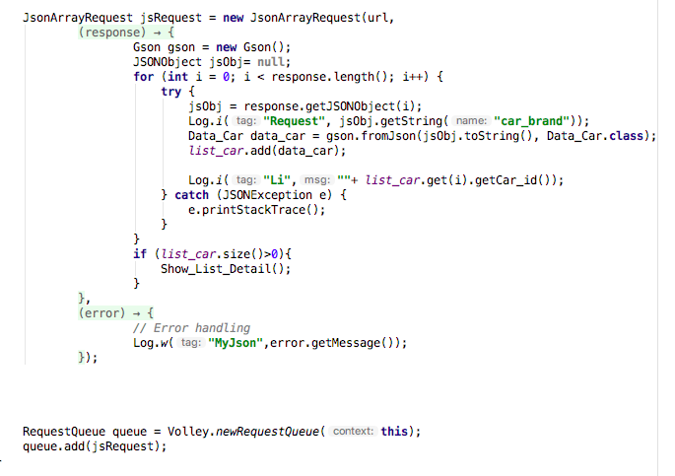

**Code String Request**

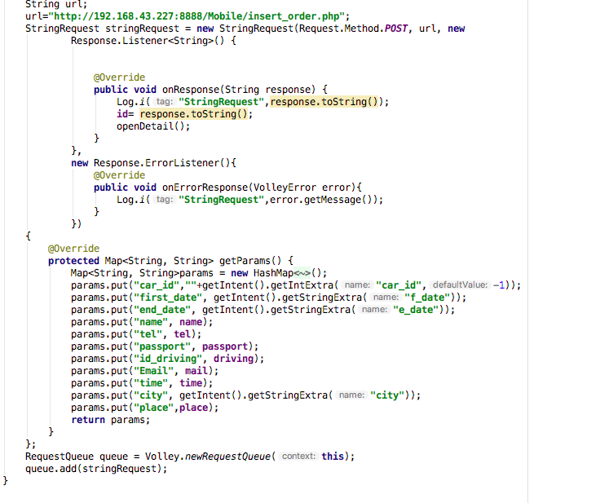

**POJO**

|  |
| --- |
| **Data_Car** |
| * **Int id_car,image** * **String city** * **String car_model** * **String car_brand** * **String car_detail** |
| **+ int getcar_id()**  **+ int getimage()**  **+ string getcar_model()**  **+ String getcar_brand()**  **+ String getcar_detail()**  **+ String getcity()**  **+ void setcar_id(int id_car)**  **+ void setimage(int image)**  **+ void setcar_model(String car_model)**  **+ void setcar_brand(String car_brand)**  **+ void setcar_detail(String car_detail)**  **+ void setcity(String city)** |

**Code POJO**

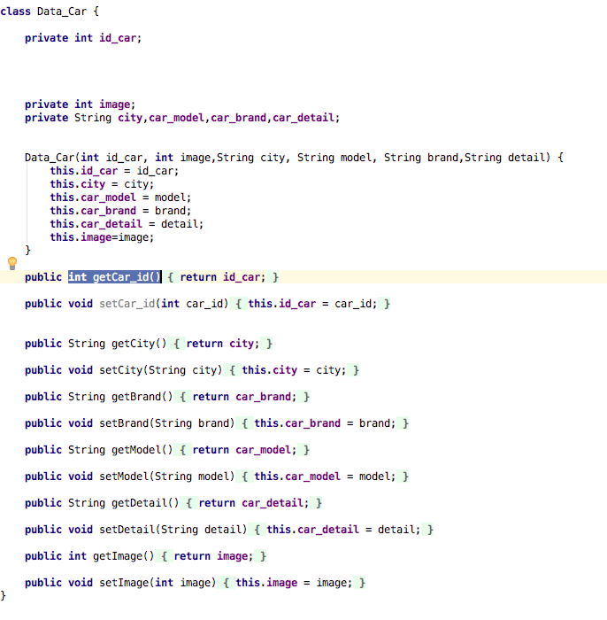

**Owner**

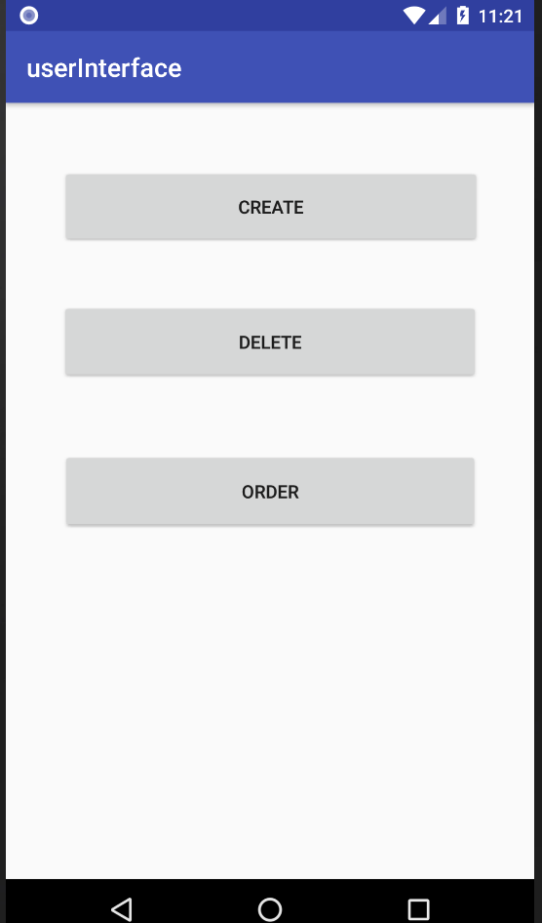

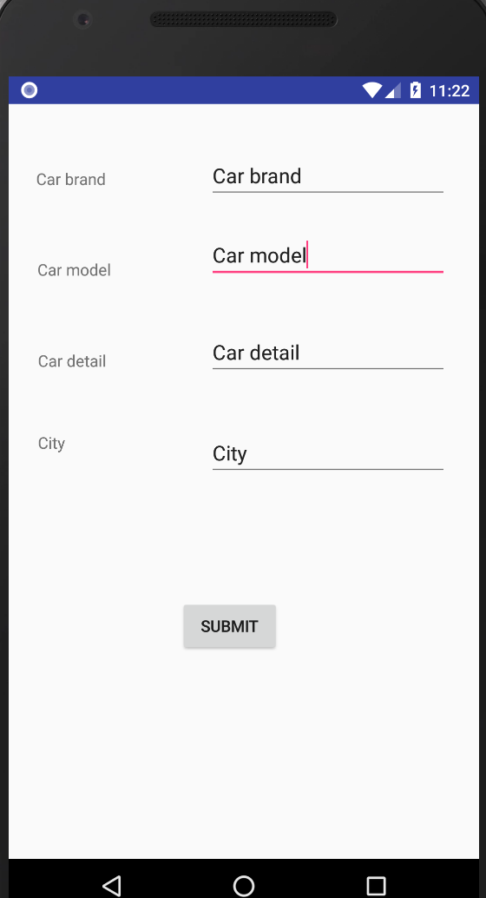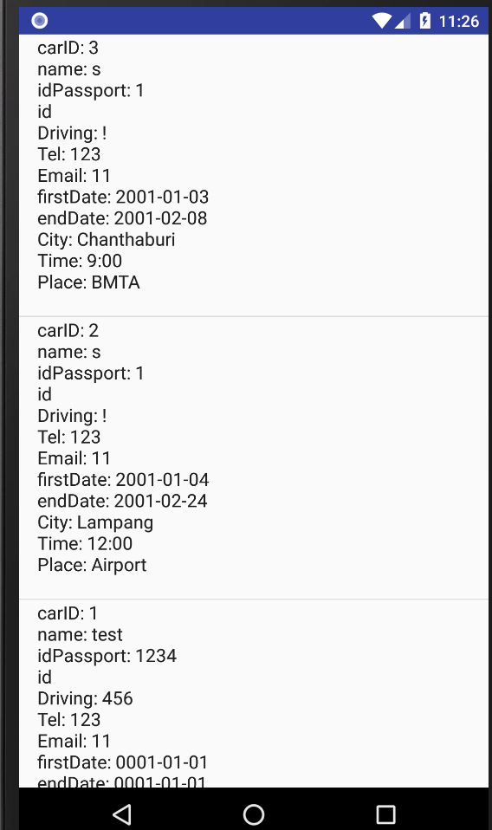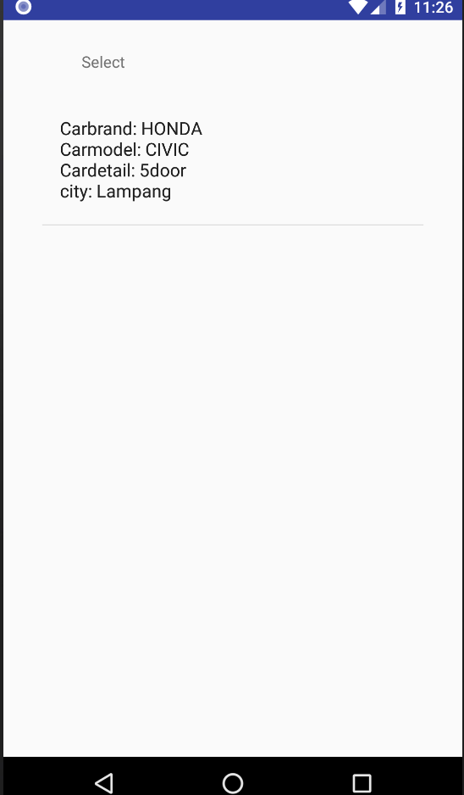

**Code on android app**

**-code insert car to DB**

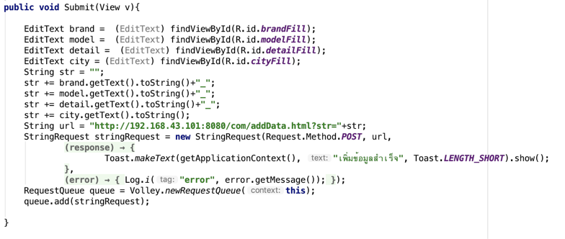

**-code delete car from DB**

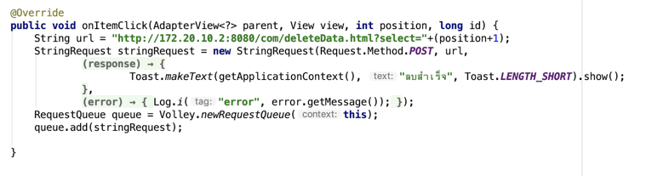

**Code on servlet(server side)**

**-code delete when receive request**

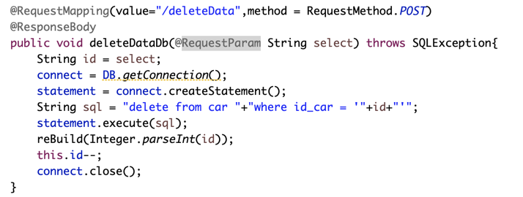

**-code show data when receive request and return value**

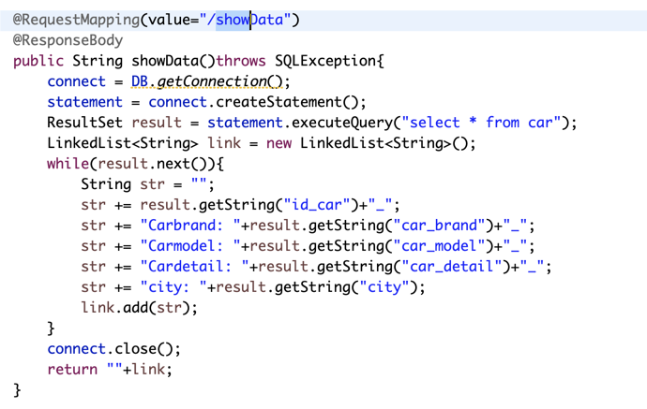

**-code of jdbc (Java Database Connectivity)**

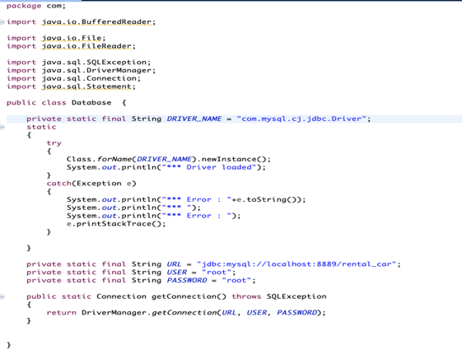

**Data from server side when send back to android application**

**[1_Carbrand: HONDA_Carmodel: CIVIC_Cardetail: 5door_city: Lampang, 2_Carbrand: HONDA_Carmodel: CIVIC_Cardetail: w_city: Chanthaburi, 3_Carbrand: TOYOTA_Carmodel: CAMRY_Cardetail: w_city: Lampang, 4_Carbrand: Car brand_Carmodel: Car detail_Cardetail: Car model_city: City]**

**How to transfer this data**

**-from this code data’ll change to**

**String arr[] = response.split(",");**

**String temp[] = arr[0].split("\\[");**

**arr[0] = temp[temp.length-1];**

**temp = arr[arr.length-1].split("\\]");**

**arr[arr.length-1] = temp[0];**

**-From string value it ‘ll split it to store in array and one index per one table from DB**

**1_Carbrand: HONDA_Carmodel: CIVIC_Cardetail: 5door_city: Lampang, 2_Carbrand: HONDA_Carmodel: CIVIC_Cardetail: w_city: Chanthaburi, 3_Carbrand: TOYOTA_Carmodel: CAMRY_Cardetail: w_city: Lampang, 4_Carbrand: Car brand_Carmodel: Car detail_Cardetail: Car model_city: City**