# CS370 – ASSIGNMENT #5

## NAME: Kostiantyn Makrasnov

**GRADE:**

|  |  |  |
| --- | --- | --- |
| **CATEGORY** | **POINTS** |  |
| EX05_01 |  | 30 |
| EX05_02 |  | 30 |
| EX05_03 |  | 40 |
|  |  |  |
| **TOTAL** |  | 100 |

## EXERCISES:

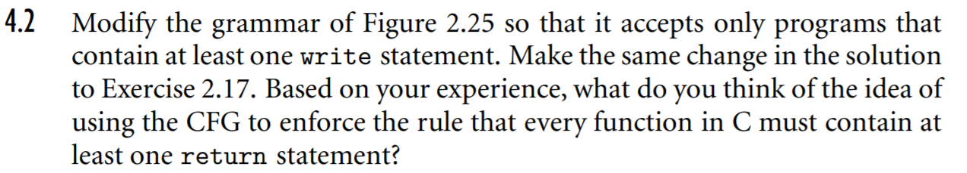**EX05_01 –** Complete Exercise 4.2, page 210

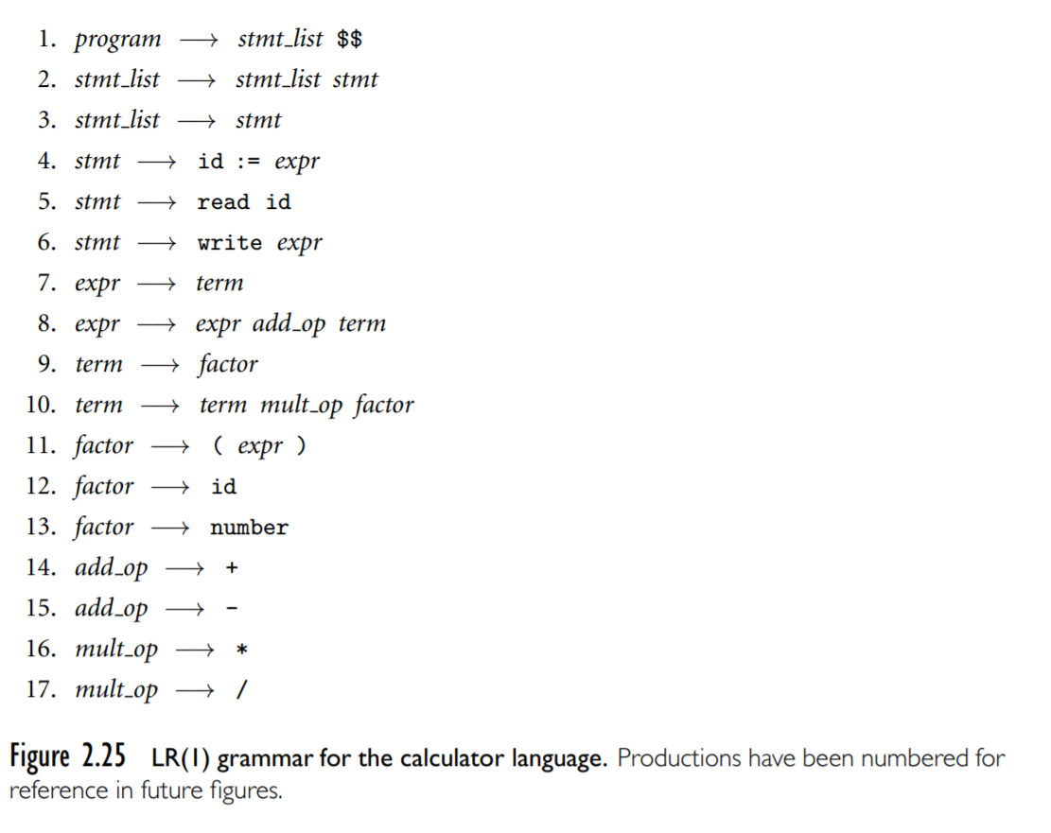

*1. program* 🡪 *stmt_list wrt_stmt stmt_list* **$$**

*6. wrt_stmt* 🡪 **write** *expr*

*3. stmt_list* 🡪 *Ꜫ*

**New Rules**

*2. stmt_list* 🡪 *stmt_list wrt_stmt* **|** *stmt_list stmt*

**This will force a write statement,**

**but it will be outside of the if and while constructs**

*25. compare_op* 🡪 **== | < = | >= | != | < | >**

*23. logic_op* 🡪 **or | and**

*24. logic_stmt* 🡪 *factor compare_op factor*

*20. condition* 🡪 *condition_tail* *logic_stmt*

*21. condition_tail* 🡪 *condition_tail* *logic_stmt logic_op*

*22. condition_tail* 🡪 *Ꜫ*

*19. stmt* 🡪 **while** *condition* **do** *stmt_list* **od**

*18. stmt* 🡪 **if** *condition* **then** *stmt_list* **fi**



*6. wrt_stmt* 🡪 **write** *expr*

*3. stmt_list* 🡪 *Ꜫ*

**New Rules**

*2. stmt_list* 🡪 *stmt_list wrt_stmt* **|** *stmt_list stmt*

*1. program* 🡪 *stmt_list wrt_stmt stmt_list* **$$**

**Part C:** Based on my experience I don’t think using a CFG is a good way to enforce for every function to have at least one return statement in C. This is because inside a function there are infinite ways to place in control structures and various statements would make it incredibly hard (if not impossible) for any CFG to both allow for all valid function control flows and still enforce the one return statement rule. The fact that a return statement is required to occur only once further complicates the requirement because are infinite cases where a return statement can be present in one scope but not another and the function could still be valid. Without selections, loops and other programming constructs the rule could be easily implemented as in part A of this exercise.

**EX05_02 –** Complete Exercise 4.7, page 211

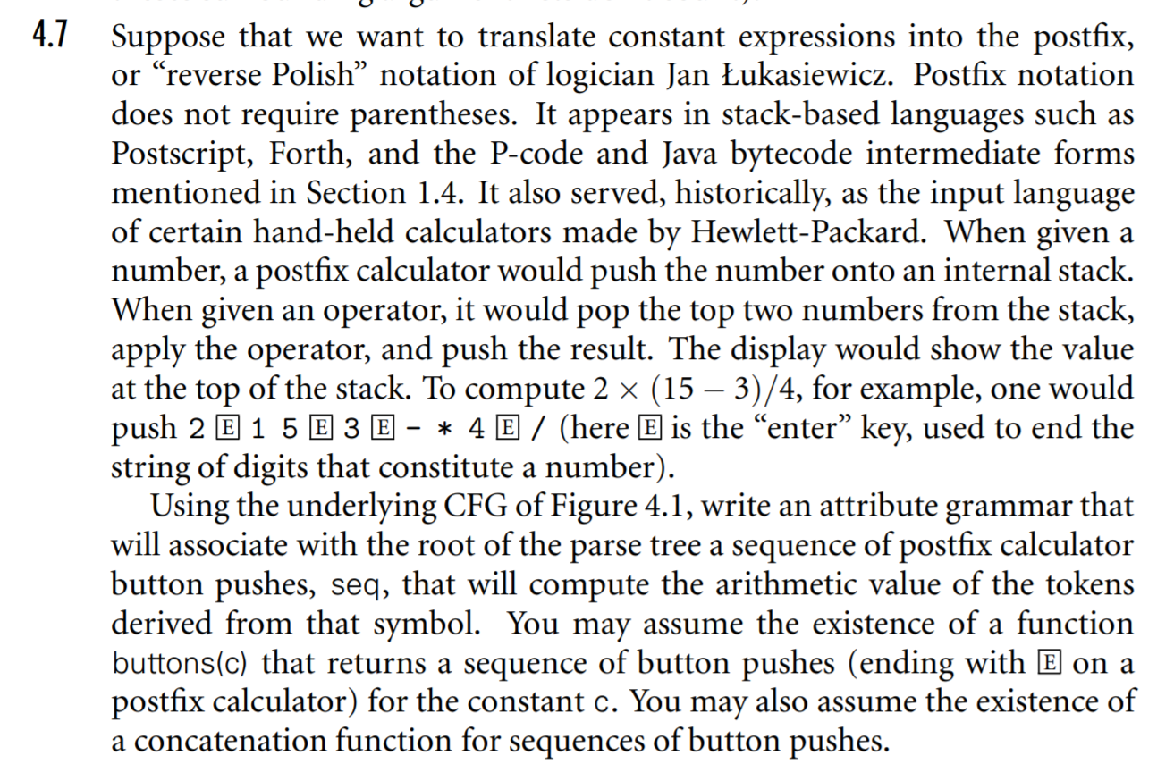

**EX05_03 –** Complete Exercise 4.10, page 211-212

