# CS370 – ASSIGNMENT #11

## NAME: Kostiantyn Makrasnov

**GRADE:**

|  |  |  |
| --- | --- | --- |
| **CATEGORY** | **POINTS** |  |
| EX11_01 |  | 100 |
|  |  |  |
| **TOTAL** |  | 100 |

## EXERCISES:

**EX11_01 –** Write a Prolog program that solves one of the logic puzzles given (from <http://www.puzzlersparadise.com>). Hint: you can go to the web sites to see the grids. They may help you in setting up your lists.

**A Day of Car Racing** (<http://www.puzzles.com/Projects/LogicProblems/DayOfCarRacing.htm>).

Larry and four friends went to the racetrack to witness the big car race held this past weekend. Five different contenders sped their way around the track to victory, or defeat. The race ended with no major crashes and an exciting dead heat to the finish line. The five friends had such a good time, they made arrangements right on the spot to return the following month for the next big race. Determine the first and last name of each driver in the race, the sponsor for each race car, and in what position each driver ended the race.

1. The driver sponsored by Flash Automotive finished the race in third place.
2. Howard, who wasn’t sponsored by Crank Motor Oil, didn’t finish the race in fifth place.
3. Ryan, whose last name wasn’t Right, wasn’t sponsored by NAPA Auto Parts.
4. Barry Straight wasn’t sponsored by Fleet Bodyworks.
5. The driver sponsored by Crank Motor Oil placed one position higher than Sydney, whose last name wasn’t Element.
6. Mr. Chariot, whose first name wasn’t Adam, finished in first place.
7. Howard placed one position lower than Mr. Right.
8. NAPA Auto Parts sponsored the driver who finished in fourth place, which wasn’t Barry.
9. The five drivers, in no particular order, are Adam, the second place driver, the driver sponsored by Tredco Tires, Mr. Right, and Mr. Rafe.

**Output:** (first name, last name, sponsor, place in race)

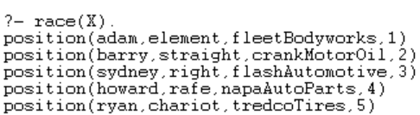

**Code:**

See the file .\raceFinal.pl

OR

Screenshot on the next page

**Screenshot of solution to the race problem:**

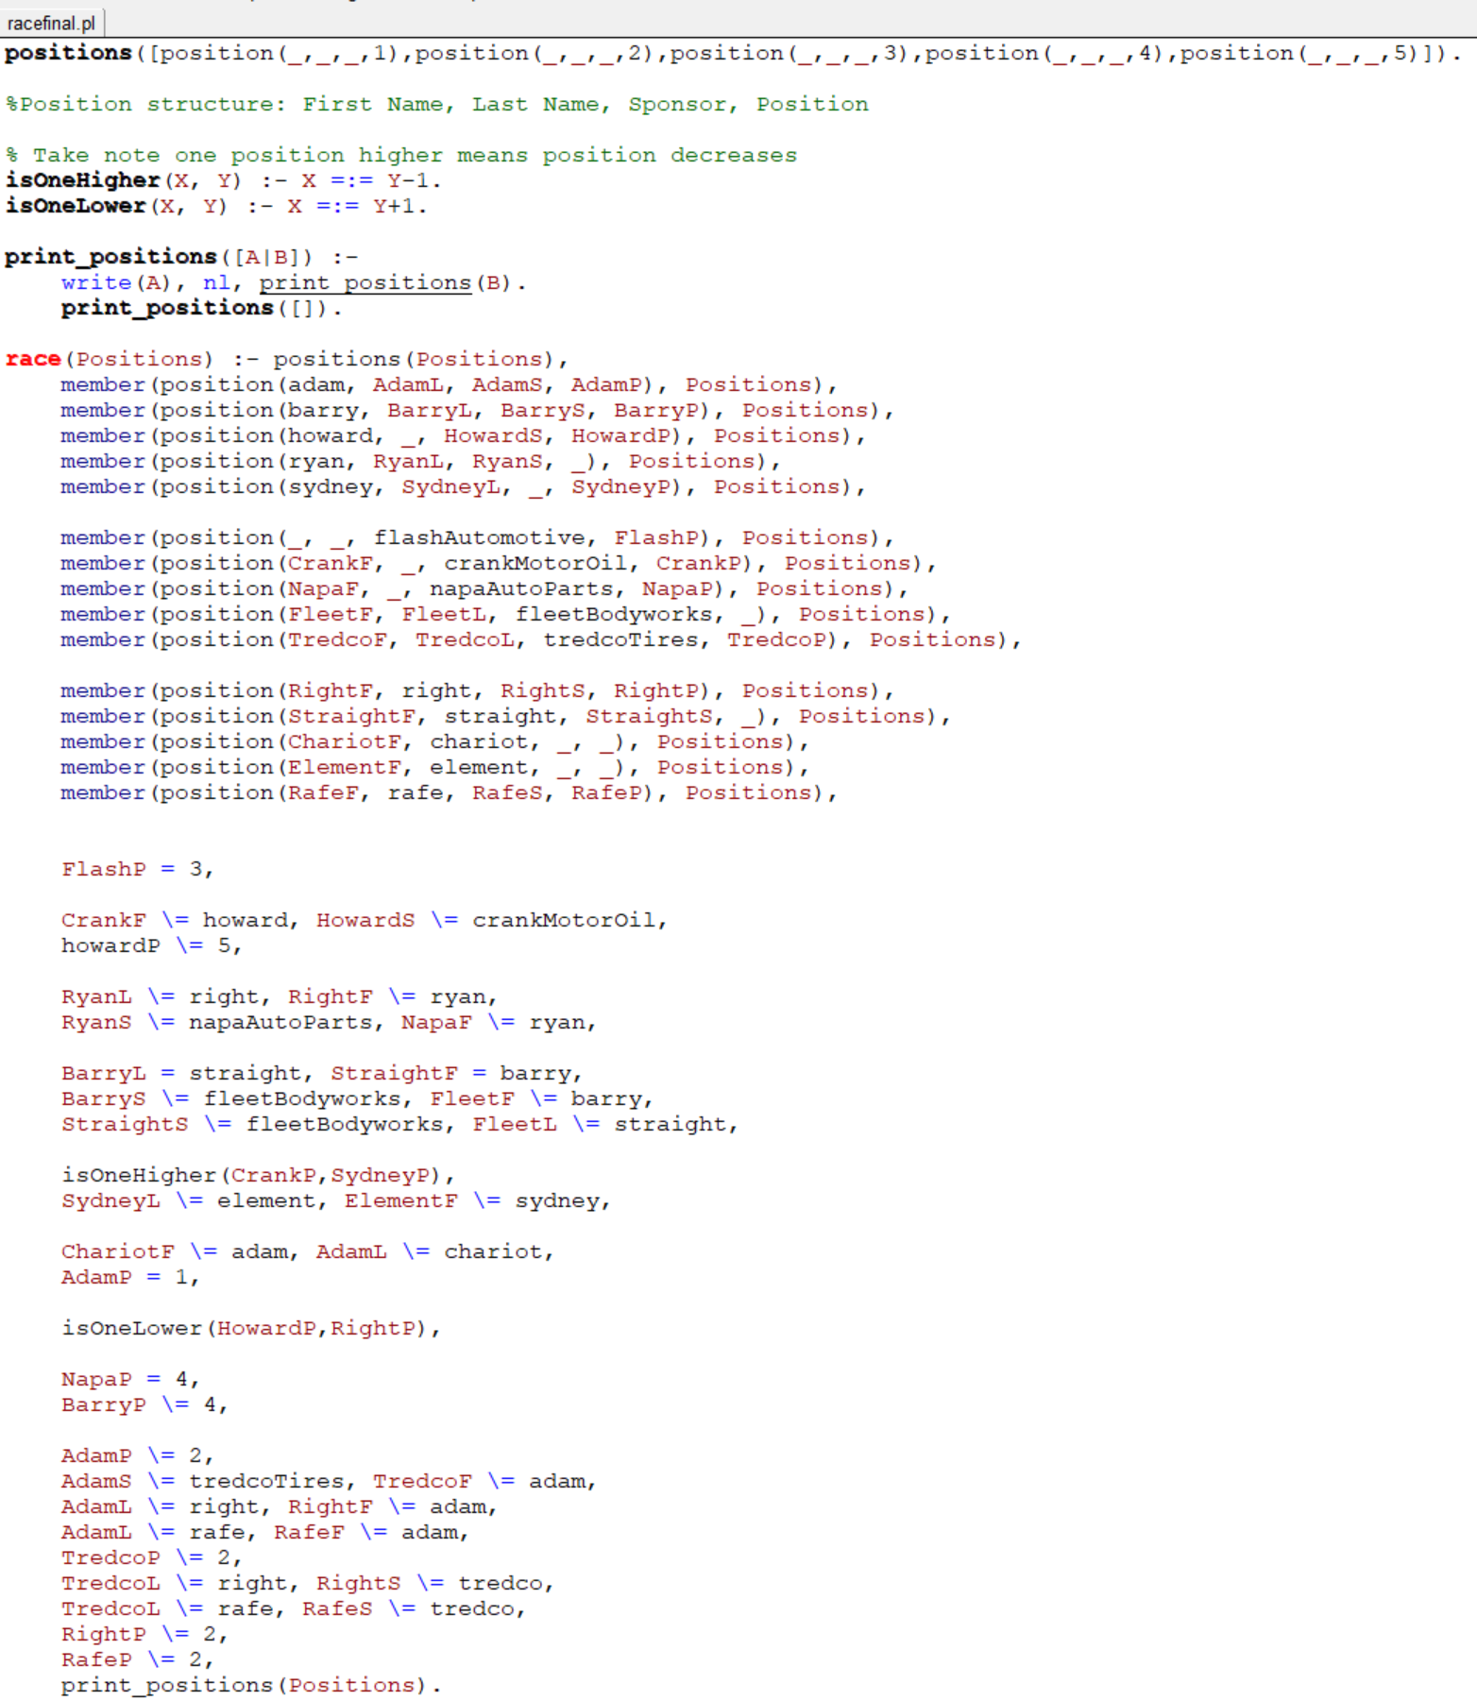

**Friday Night Bowling** (<http://www.puzzles.com/Projects/LogicProblems/FridayNightBowling.htm>)

Four couples bowl every Friday night in the Millersville Couples-Only bowling league. They’re about halfway through the first half of the winter season, and competition is starting to get fierce for placement. Each night, the couples bowl three games and can win up to 8 points for the night. Last Friday, all four couples moved up in the league ranks, though none of the couples played each other this week. Determine the first names of each couple, the number of points they won on Friday night, and each couple’s team name.

1. Steve didn’t win all 8 points. The Red Dogs team won 2 points for the night.
2. The Bowling Aces won two more points than Larry’s team.
3. Mike’s team won four points more than Linda’s team, but Linda’s team didn’t score the least amount of points.
4. The team that won 6 points was Just4Fun. Wanda wasn’t on the team called No Pressure.
5. Steve’s team won 4 points. Donna wasn’t on the Bowling Aces.
6. Tom and Sara were on the same team, but it wasn’t the Red Dogs.