# CS370 – ASSIGNMENT #8

## NAME: Kostiantyn Makrasnov

**GRADE:**

|  |  |  |
| --- | --- | --- |
| **CATEGORY** | **POINTS** |  |
| EX08_01 |  | 100 |
|  |  |  |
| **TOTAL** |  | 100 |

## EXERCISES:

**EX08_01 –** Use Perl to implement a web crawler. Your web crawler should store email addresses that are found during the crawl.

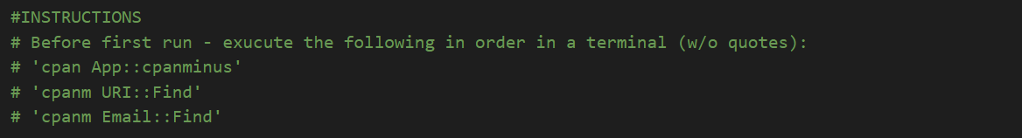

* Visit web sites using the HTTP::Request and LWP::UserAgent modules

Done

* Parse the HTML response using regular expressions, looking for email addresses and URLs

This part was complete (it’s in the comments)! But I’ve opted to use some more advanced packages to get a more accurate output.

* Store the email addresses in an email file (or an email table in a database)

Done

* Store the URLs in a URL file (or a URL table in a database)

Done

* Use the URL file to get the next URL to crawl

Done

* You will need to put some starting URLs in the URL file to get the crawler started

Done