How to make an influenza dataset using the 2025 Virus Evolution Lab pipeline

NCBI Virus
Downloading Data
- Before downloading any data, make sure that your “Downloads” directory is completely clean! There should be no files in there except for the ones we will download here.
- Go to the NCBI Virus webpage.
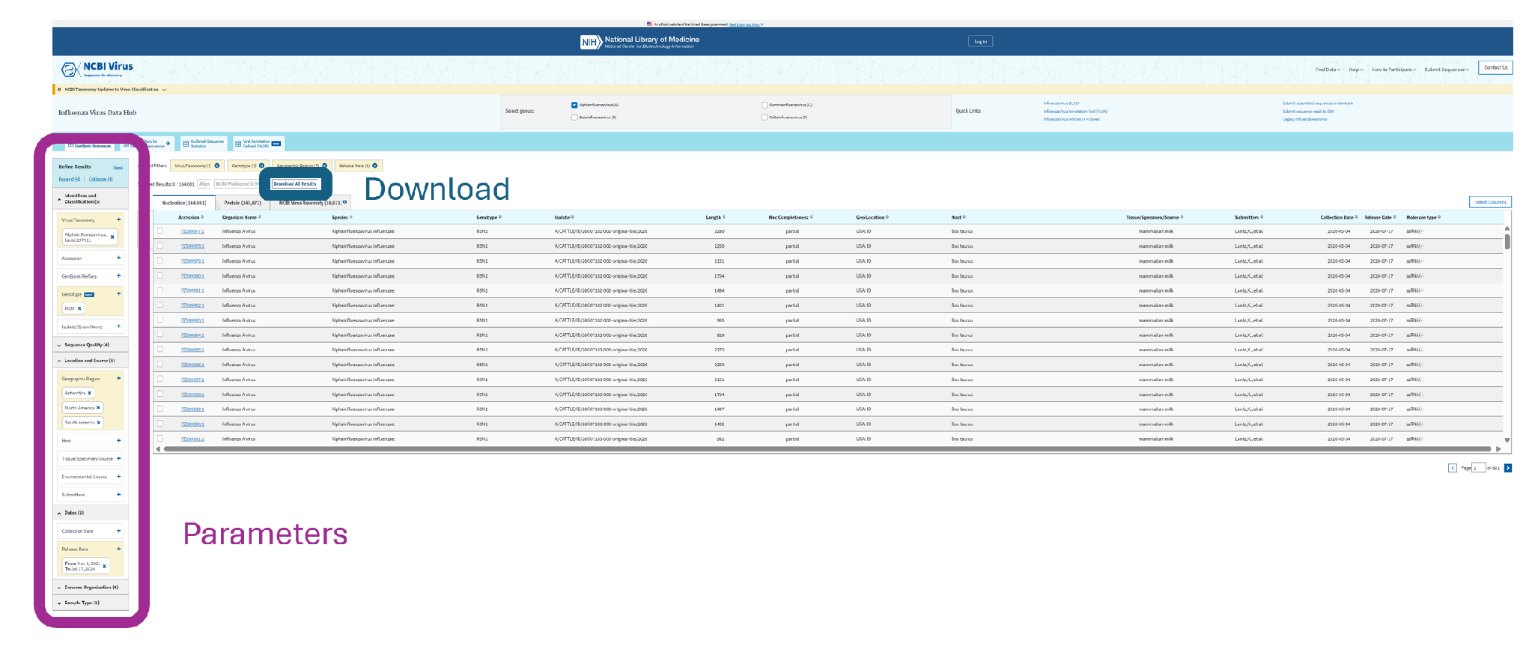
  - On the left side of the page, you will see various options under “Refine Results”. Select the following options:
    - Identifiers and Classification
      - Virus/taxonomy: Alphainfluenzavirus
      - Genotype: H5N*
        - (This is actually serotype, NCBI Virus does not have true flu genotypes.)
    - Location and Source
      - Geographic Region: Antarctica, North America, South America
        - Each time you add a continent, you will need to click the plus sign next to “Geographic Region” -- otherwise NCBI Virus may delete your previous selection.
    - Dates
      - Under “Release Date” (NOT “Collection Date”), type:
        - From: 11/1/2021
        - To: [the most recent completed Friday]
          - E.g. if today is Friday, 7/24/2026, since the day isn’t finished, type the previous Friday, 7/17/2026. Under no circumstances choose the current date, because then you will not know later if other submissions were made by the end of the day.
  - At the top of the page, select “Download All Results”. You will then need to download two types of results – FASTA files, and metadata.
    - FASTA files
      - Select Data Type: Sequence Data (FASTA Format): Nucleotide
      - Select Records: Download All Records
      - Select FASTA Definition Line: Use Default
      - Download
    - Metadata
      - Select Data Type: Results Table: CSV Format
      - Select Records: Download All Records
      - Select Columns to Include in Results Set: Select All, with Version
      - Download
Running the Jupyter notebook
- Clone the maksiaev/Avian_Flu repository to your local machine.
- In the maksiaev/Avian_Flu repository, there is a Jupyter notebook named “Step1_avian_Flu_NCBI_Virus_v6.ipynb”. Navigate to this notebook.
- In the “Input” and “Paths” cells, change the variables to what you need. An example is listed below, and each cell has specific instructions on how to format these variables.
  - The variables to change are:
    - Locations (string)
    - Serotypes (list)
    - Genotypes (list)
    - Start date (string)
    - End date (string)
  - The paths you need to change are:
    - Home: parent directory to Avian Flu Files and maksiaev/Avian_Flu
    - Avian Flu Files: parent directory to “NCBI_Virus” and subdirectories “Downloads saved”, “Temp files”, and “Complete files”
    - Downloads: Wherever in your local machine downloads from the web are saved
    - Downloads saved: Subdirectory of “NCBI_Virus” -- where downloads from the web are moved
    - Temp files: Subdirectory of “NCBI_Virus” -- where temporary files are housed
    - Complete files: Subdirectory of “NCBI_Virus” -- complete files for next steps
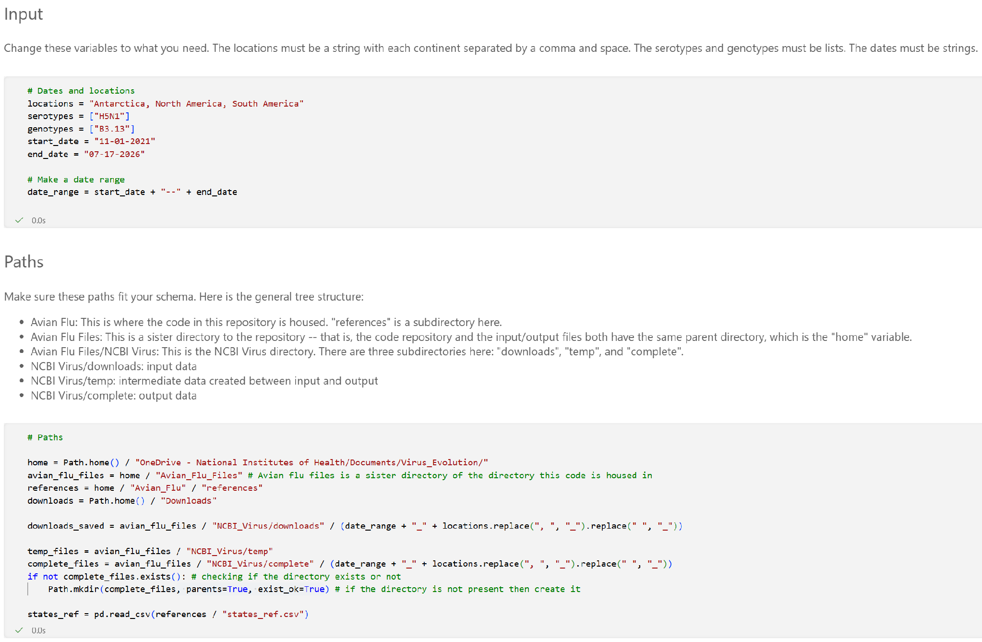
  - Note: The directory tree mentioned in the “Paths” cell should ultimately look like this:
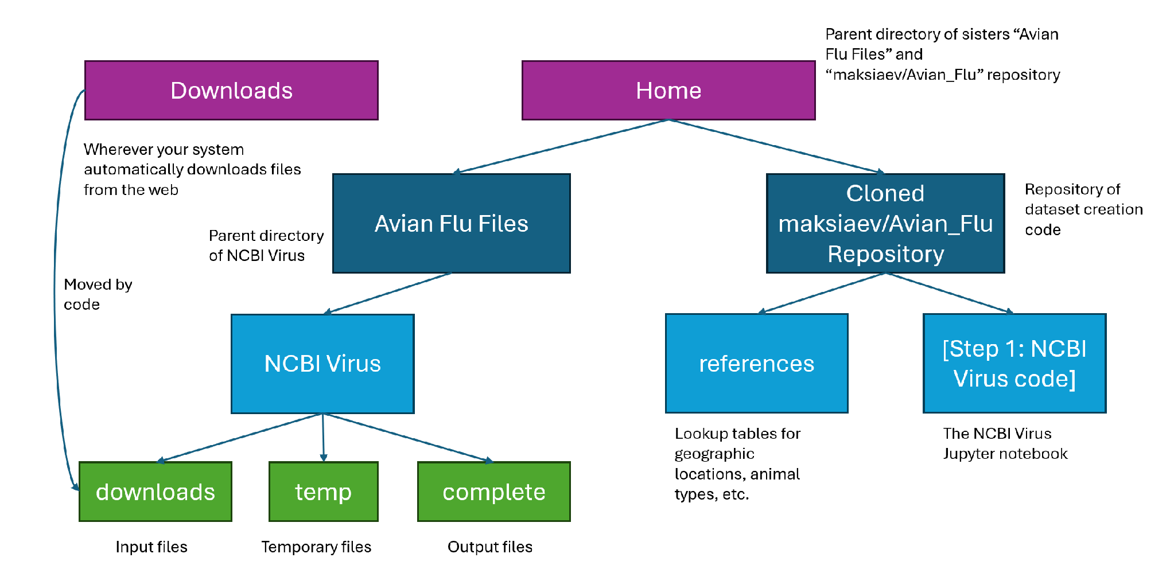
- Run the notebook until you are stopped by the “Re-Labeling Using GenoFlu” section.
Running GenoFlu
- You should have eight temporary output files in the “NCBI/temp/segments_[date range]/” directory.
- On Windows, use the program Windows SCP.
  - When using Windows SCP, you will need to log into BioWulf. Use the settings displayed in the below screenshot:
    - File protocol: SFTP
    - Host name: helix.nih.gov
    - Port number: 22
    - Username: [your NIH username]
    - Do not put anything in the password field. Windows SCP will prompt you once you need to put in the password.
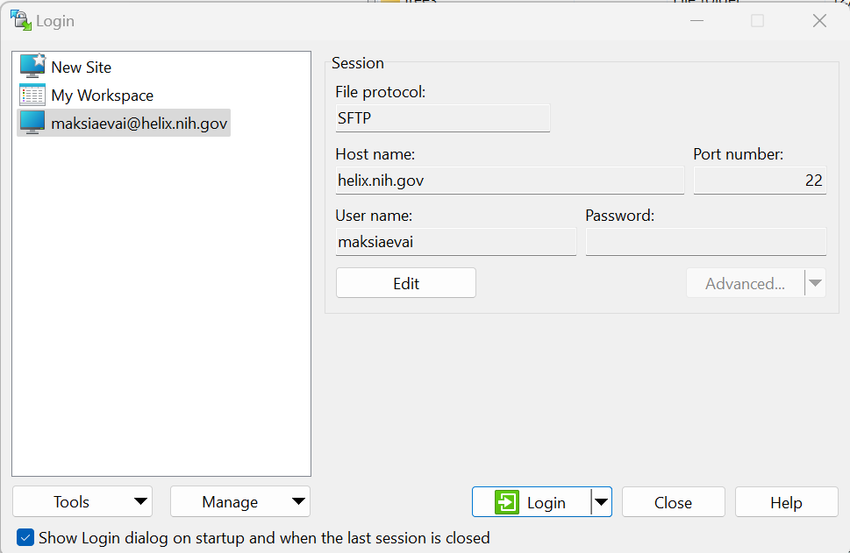
    - Once logged in, you will also need to make sure that you are in your “data” directory, NOT your “home” directory. By default, you will land into the “home” directory.
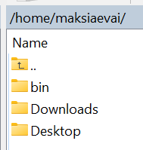
      - Go to the root directory
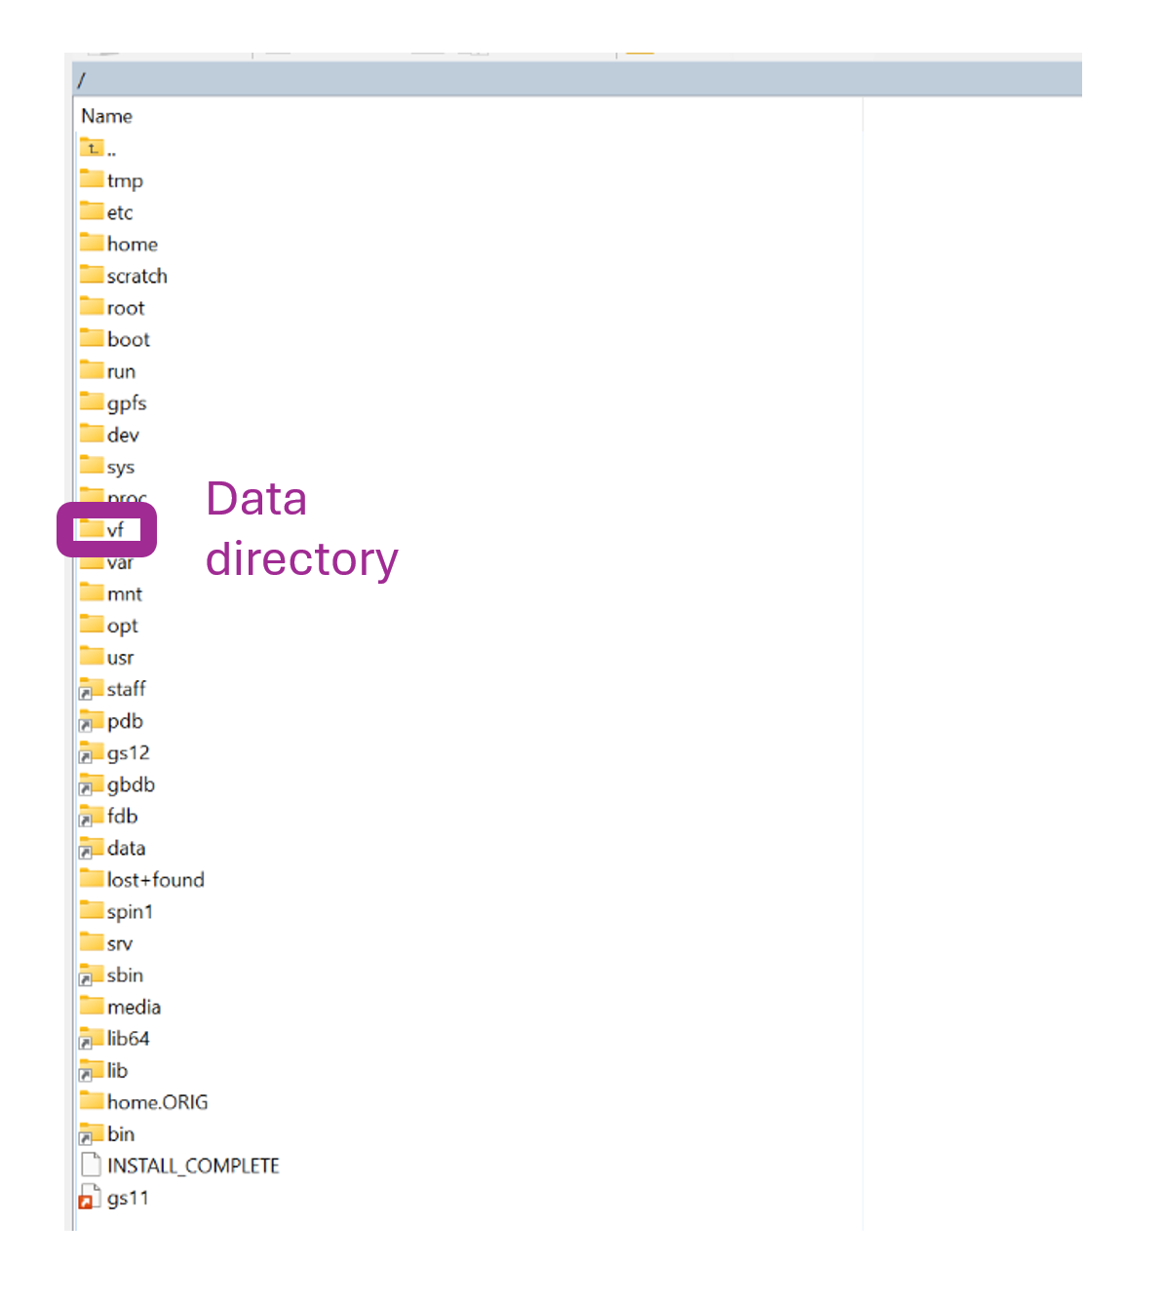
      - Choose the “vf” folder > Users > your NIH username
        - Then you will be in the “data” directory.
  - Using Windows SCP, navigate to your NCBI temp file directory (on your local machine), and copy the directory to within your data directory in BioWulf.
    - It is recommended to create a parent directory in your data directory to house all files for your parameters (date range, locations) and copy your NCBI temp file directory to be a subdirectory of this parent directory.
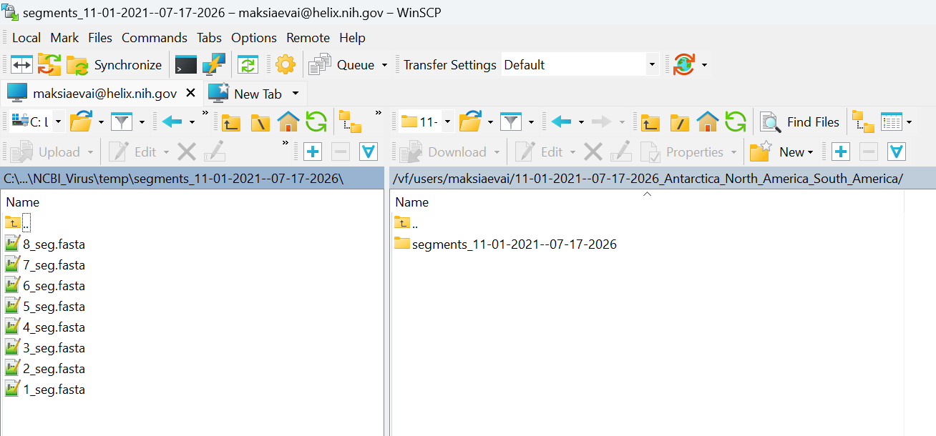
    - Now you will have access to your files via the Biowulf terminal.
- Log into BioWulf via the terminal.
  - On Windows: PowerShell
    - Input: ssh [your NIH username]@biowulf.nih.gov
      - Enter password
    - Input: cd ../../data/[your NIH username]
      - This is a similar step to Windows SCP – you'll need to go to the root directory, then data, then your username. You start in the home directory by default. You do not need to type “vf” anywhere in this step.
    - Navigate to your files’ directory.
- Run GenoFLU-Multi.
  - Prerequisites:
    - One file per segment of NCBI sequences (eight files total)
      - See step "Running the Jupyter Notebook” in this section.
    - Access to conda in BioWulf
    - Access to a conda environment containing GenoFlu in BioWulf
      - To create the conda environment:
        - Input: mamba create -c conda-forge -c bioconda -n genoflu genoflu
          - Must be “mamba” and not “conda” because BioWulf uses the mamba installation wrapper.
    - Cloned Moncla lab GenoFLU-multi repository
      - This repository must be cloned as a sister directory to the parent directory containing the directory of the eight NCBI segment FASTA files (aunt directory?).
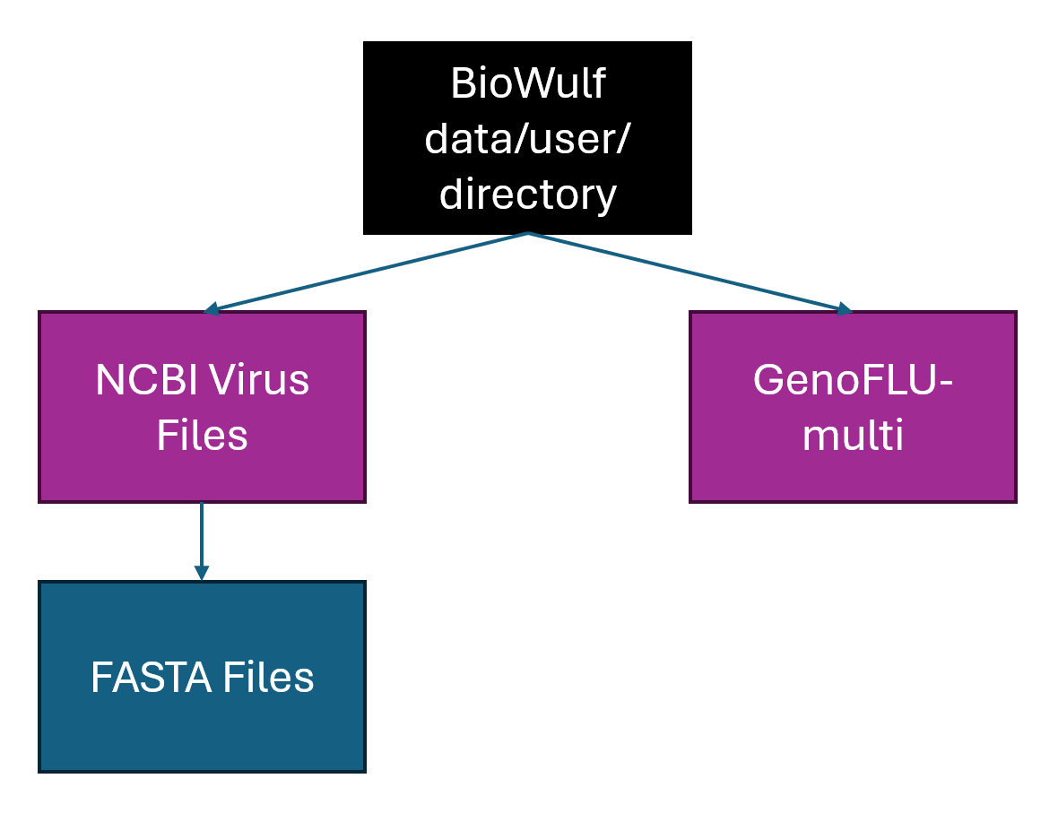
  - With conda installed on BioWulf, assuming prerequisites:
    - Input: sinteractive
      - You must do this step, otherwise BioWulf will kill the job.
    - Input: source myconda
    - Input: conda activate genoflu
    - Input: cd GenoFLU-multi
    - Input: python bin/genoflu-multi.py -f <FASTA_directory>
      - FASTA directory should be “../[parameter parent directory]/[files directory]”
        - In this example, the directory is “../11-01-2021—07-17-2026_Antarctica_North_America_South_America/segments_11-01-2021—07-17-2026/”
  - After genoflu runs, in your FASTA directory there should be two subdirectories created with output: “results”, and “temp”.
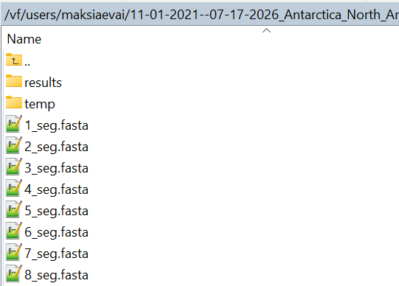
    - There should be a file called “results.tsv” in the “results” subdirectory. Take this file and move it to your local machine, in whichever directory your downloaded NCBI Virus files are housed.
      - For this example, that directory is “NCBI_Virus/downloads/11-01-2021—07-17-2026_Antarctica_North_America_South_America/”, containing the sequences.fasta, sequences.csv, and now results.tsv.
Run code and check animals
- After running genoflu and getting the output, continue running the cells in the “Step 1: NCBI Virus” Jupyter notebook.
- After the code stops at the animal check cell, look at the output below the cell with the title “After running the below code, STOP TO CHECK if any new animals appear”.
  - Look at the list in the output labeled “New animals to add to reference:”. If the list is empty, go to section “Running the rest of NCBI Virus code”. Otherwise, follow these steps:
- In the maksiaev/Avian_Flu repository, navigate to the “references” directory and find the file “animals_ref_to_sort.csv”.
    - In “animals_ref_to_sort.csv” there will be a column called “New”, populated with some new values to sort into the rest of the columns.
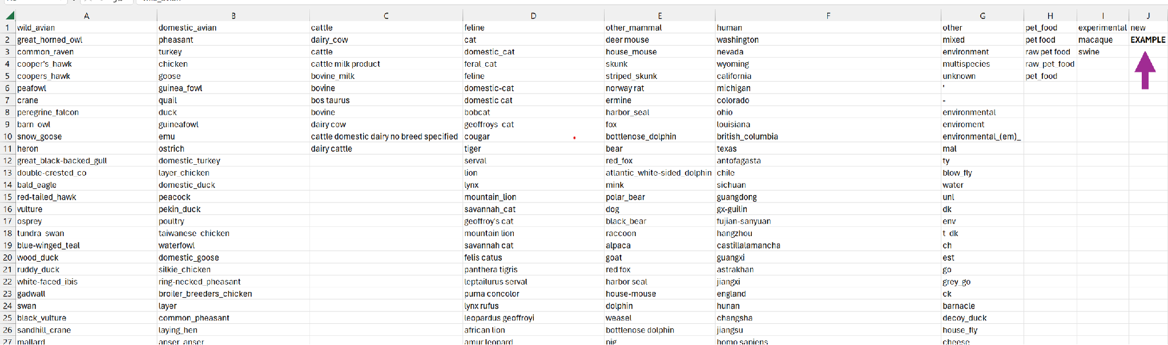
    - Determine what category each animal belongs to and cut and paste the animal from “New” to the column with that category.
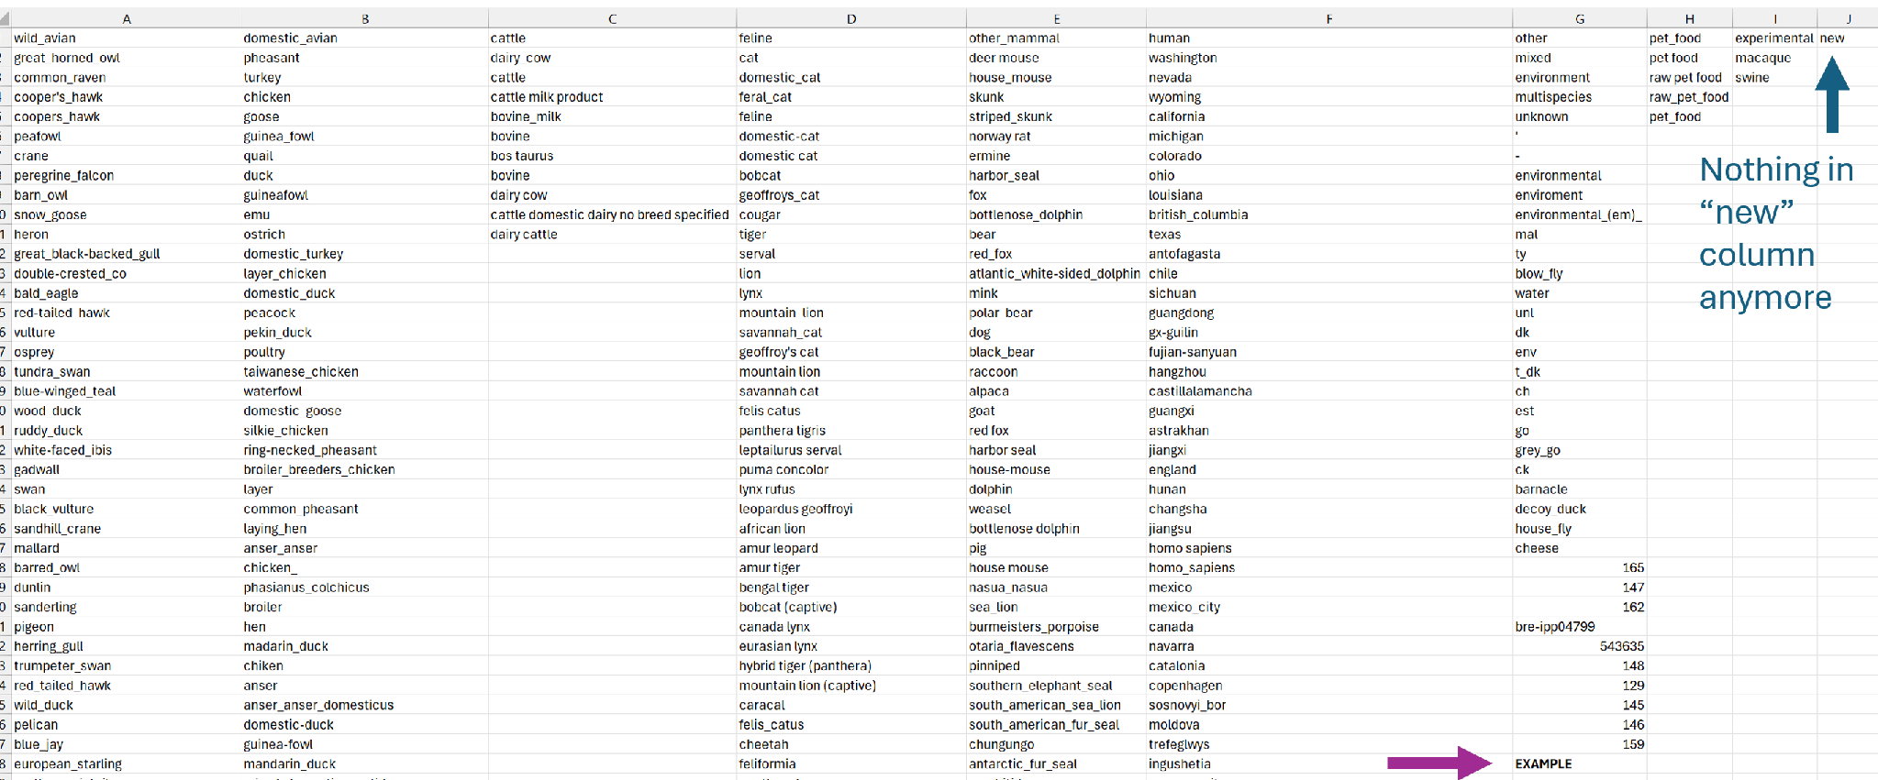
    - Save the file as “animals_ref.csv”, overwriting the previous version.
      - If you want, you can save the previous version as a differently named file before doing this.
    - Continue running code.
Running the rest of NCBI Virus code
- Run the rest of the cells. Once the code stops running, you should have several complete FASTA files in your “NCBI_Virus/complete” directory.
  - There should be 8 * [number of genotypes you wanted] files, one per segment per genotype. For example, if you wanted genotypes D1.1 and B3.13, you should have 16 resulting FASTA files.

Andersen Lab
Downloading Data
- If you have not done so already, fork the avian-influenza GitHub by the Andersen Lab.
  - Every time before you start running the code, make sure to sync your fork and pull the repository to update it on your local machine.
Running the Jupyter Notebook
- In the maksiaev/Avian_Flu repository, there is a Jupyter notebook named “Step2_avian_Flu_Andersen_v6.ipynb”. Navigate to this notebook.
  - In the “Inputs and Paths” cell, change the inputs and paths to what you need. An example is listed below:
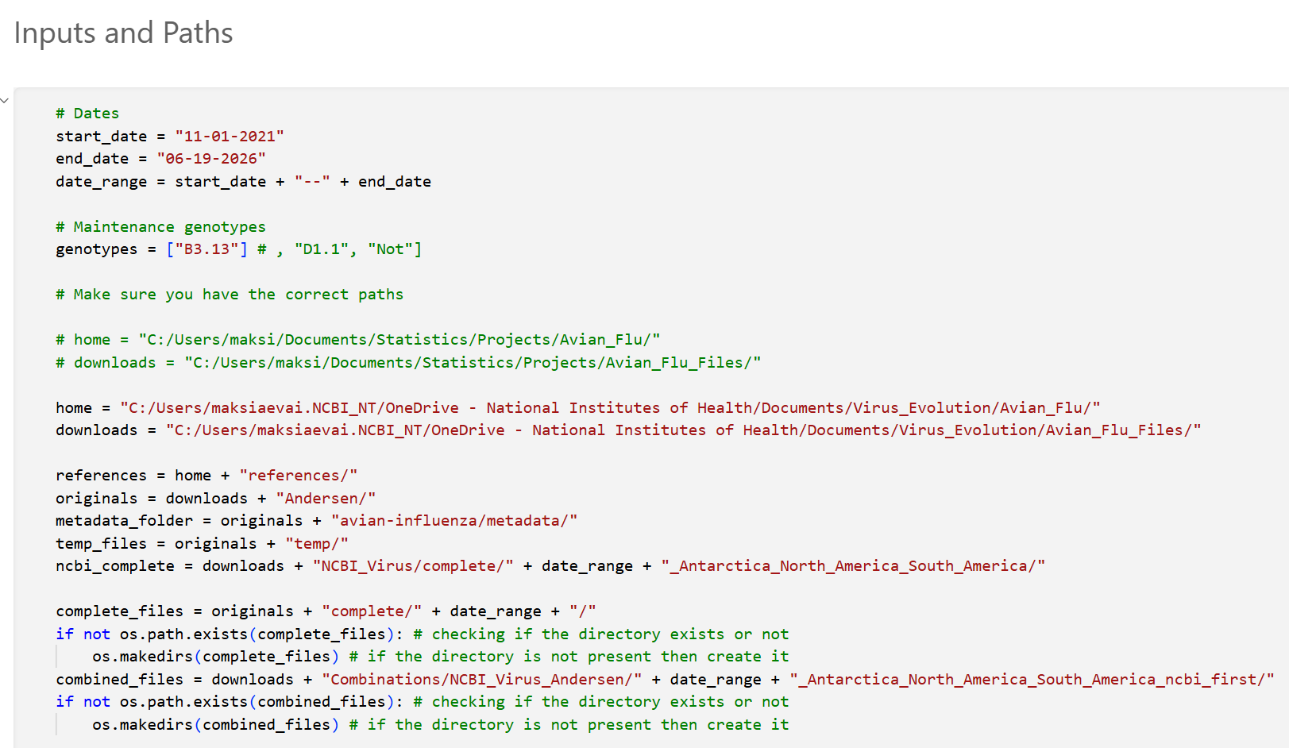
    - These are the inputs you will need:
      - Start date (string)
      - End date (string)
      - Genotypes (list)
    - These are the paths you will need to change:
      - Home: maksiaev/Avian_Flu repository
      - Downloads: Parent directory of NCBI Virus directory and Andersen Lab files directory (which itself is a parent directory of Andersen Lab’s avian-influenza forked repository)
      - Originals: Parent directory of the avian-influenza forked repository, Andersen temporary files, and Andersen completed files.
      - Temp files: Subdirectory in “Originals” repository, houses temporary files
      - NCBI Complete: Completed NCBI Virus files from the previous step; subdirectory of NCBI directory in “Downloads” directory.
      - Complete files: Completed Andersen FASTA files relabeled; subdirectory in Andersen Lab files directory (NOT the forked repository).
      - Combined files: Subdirectory within “Downloads” directory containing the combined NCBI Virus and Andersen relabeled FASTA files.
  - Below is a file tree diagram to help visualize the paths you will need.
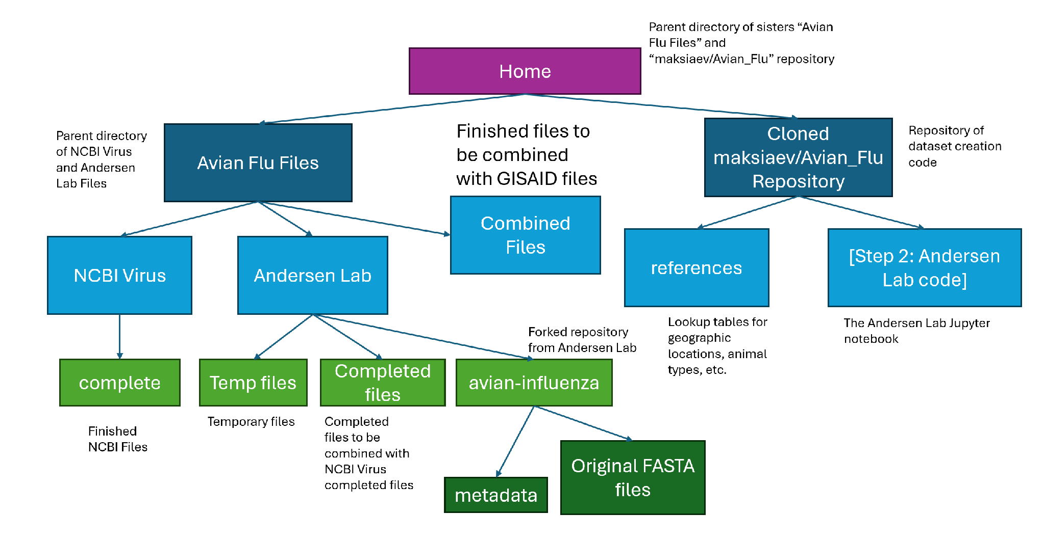
Run the code and check animals
- Run the code until it stops at “Get host type”. Check if any new animals have been flagged in the output after “New animals to add to reference.” If the list is empty, continue.
  - Otherwise, follow the same instructions as this part in the NCBI Virus section.
- Run the code to the end.

GISAID
Downloading Data
- Before downloading any data, make sure that your “Downloads” directory is completely clean! There should be no files in there except for the ones we will download here.
- Go to the GISAID webpage.
  - Log in.
  - Navigate to the EpiFlu page.
  - Navigate to “Search & Browse”.
    - You should see this page:
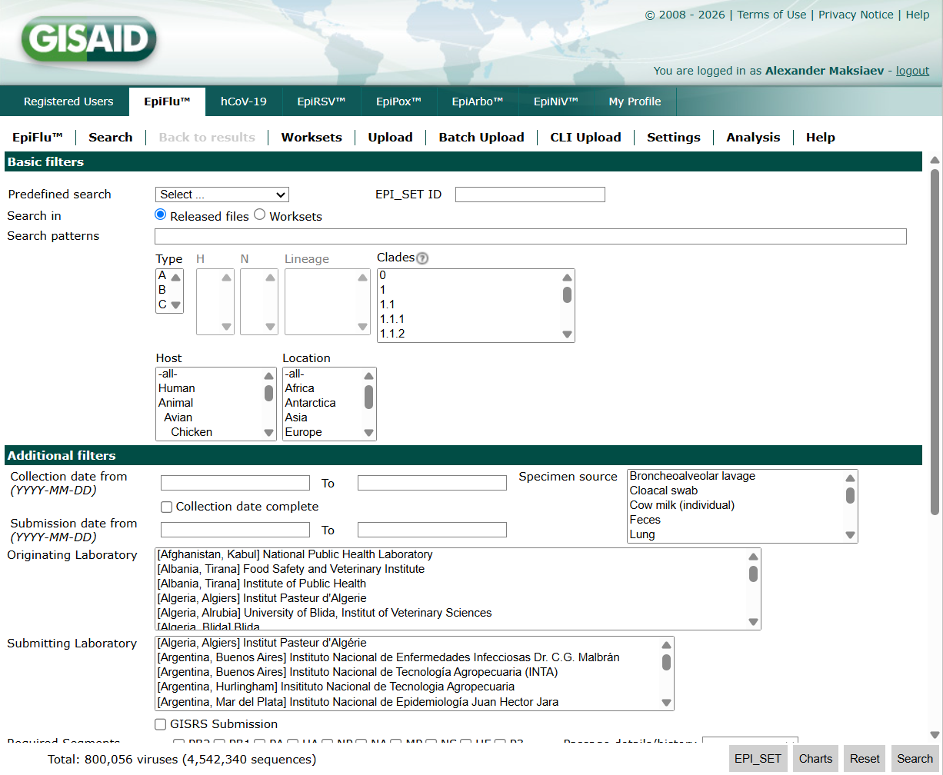
    - Select or type in the parameters you need:
      - Type: A
      - H: 5 (or whatever your case needs)
      - N: 1 (or whatever your case needs)
        - If searching for H5Nx, leave N blank.
        - If searching for HxNx, leave both H and N blank.
      - Clades: 2.3.4.4b (or whatever your case needs)
        - You should then see options for genotypes, but typically none will be chosen because it’s often desired to also have “unknown” genotypes in the dataset.
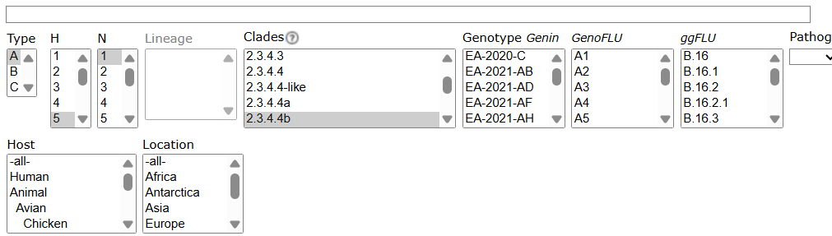
      - Location: (whatever continents you need – you may need to click “CTRL” to select multiple for one dataset.)
      - Required segments: All except HE and P3.
      - Submission date from: [whatever dates you need]
        - NOTE: If your date range spans from at or before 11/1/2021 to after 12/31/2025 (or if the total number of viruses needed exceeds 20,000), you will need to download data in batches based on date. For example, assuming your date range is 11/1/2021 -- 7/17/2026:
          - Batch 1: 11/1/2021 -- 12/31/2025
            - DO NOT skip downloading previous data. Sometimes data is changed or updated, and so datasets must be re-downloaded each time.
          - Batch 2: 1/1/2026 -- 7/17/2026
  - Press “Search”. You should see a page that looks like this:
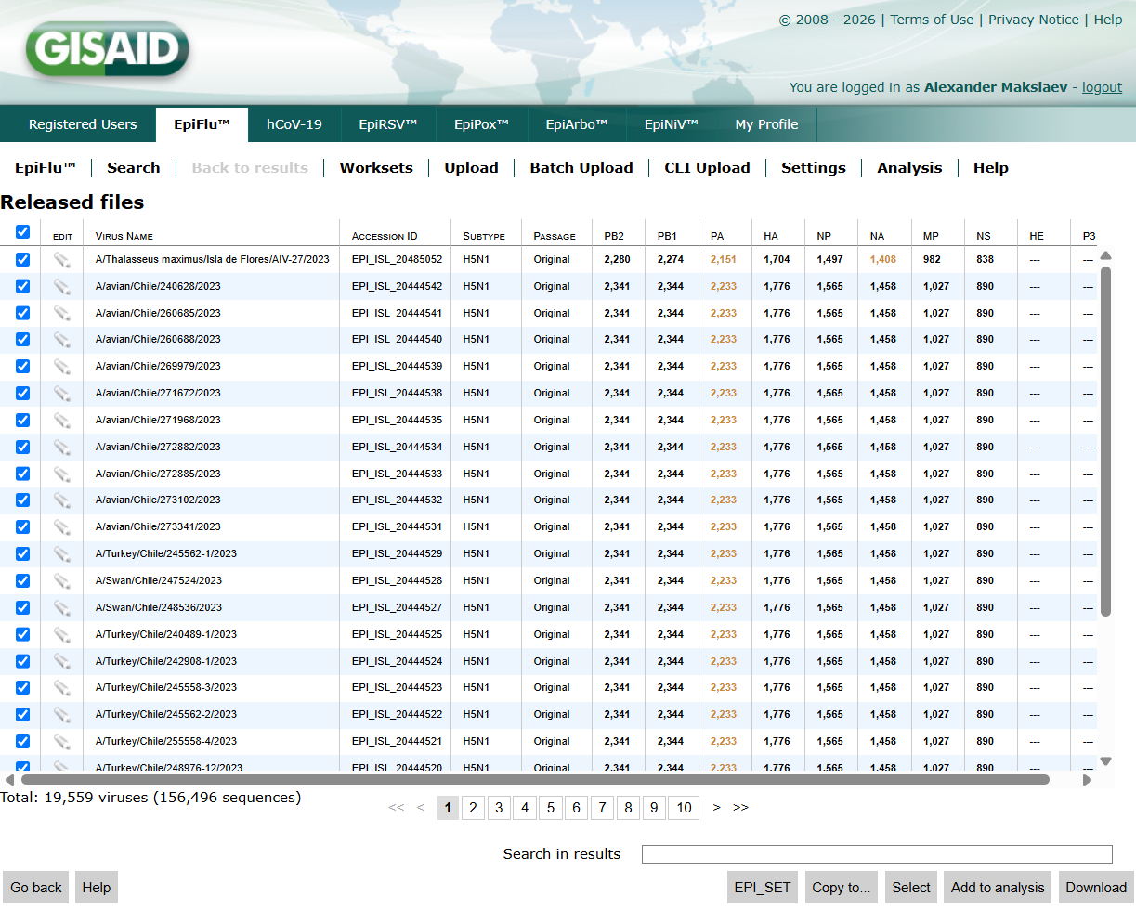
    - Select all sequences by pressing the “select all” box (it should be above the first listed virus. In the above screenshot, the sequences are already selected.)
    - Click “Download” at the bottom.
      - If you are prompted with a message talking about a “temporary publishing embargo”, click “Yes, I agree” and continue downloading. The sequences under embargo will be removed by the code.
  - Download metadata and FASTA files.
    - Metadata selections:
      - “Isolates as XLS (virus metadata only)”
      - Date format: YYYY-MM-DD
      - Download.
    - FASTA files:
      - “Sequences (DNA) as FASTA”
        - DNA: all (except HE and P3)
        - FASTA Header: Isolate ID | Isolate name | Type | Segment | Collection date
        - Date format: YYYY-MM-DD
        - Select “Replace spaces with underscores in FASTA header”
        - Select “Remove spaces before and after values in FASTA header”
      - Download.
Running the Jupyter Notebook
- In the maksiaev/Avian_Flu repository, there is a Jupyter notebook named “Step3_avian_Flu_GISAID_v6.ipynb”. Navigate to this notebook.
  - In the “Inputs and Paths” cell, change the inputs and paths to what you need. An example is listed below:
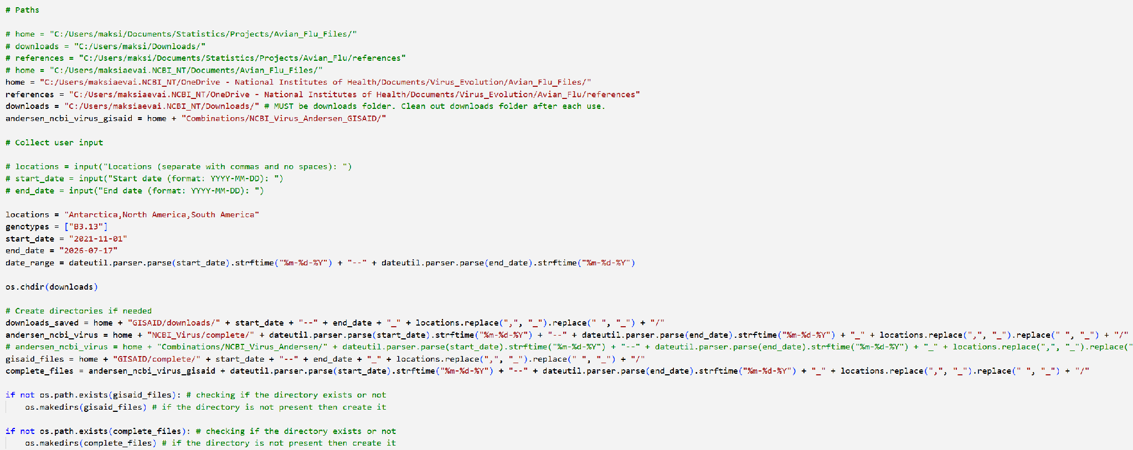
    - These are the inputs you will need:
      - Locations (string)
      - Start date (string)
      - End date (string)
      - Genotypes (list)
    - These are the paths you will need to change:
      - Home: Parent directory of GISAID directory, NCBI Virus directory, and Andersen Lab files directory.
      - References: References subdirectory in maksiaev/Avian_Flu repository.
      - Downloads: Whichever directory on your local machine houses downloads straight from the internet.
      - Andersen NCBI Virus GISAID: Directory containing the final combined dataset. This should be a subdirectory in Home.
  - Below is a file tree diagram to help visualize the paths you will need.
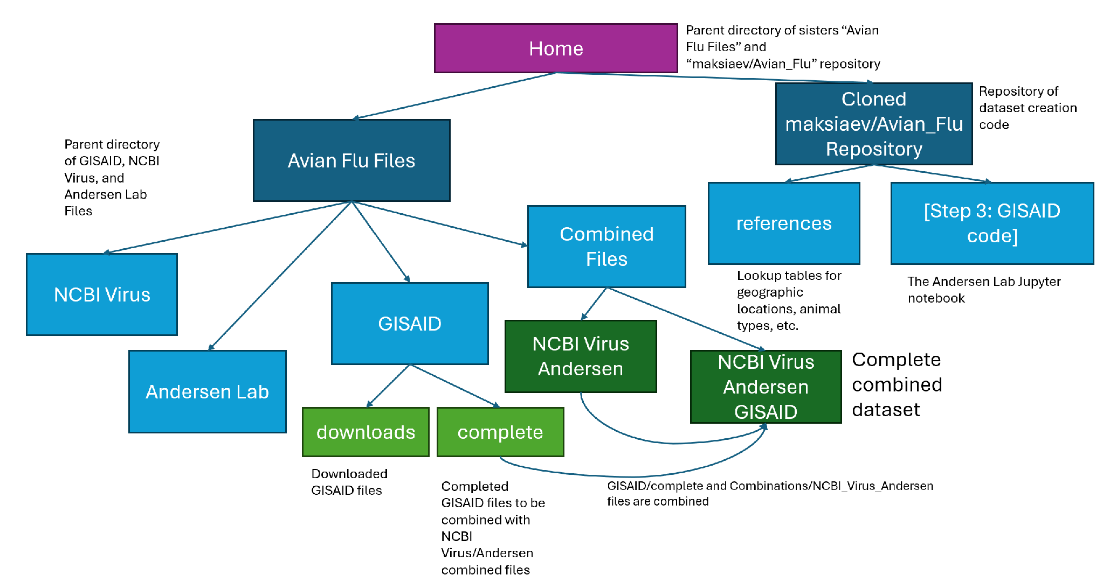Run the code and check animals
- Run the code until it stops at “Get host type”. Check if any new animals have been flagged in the output after “New animals to add to reference.” If the list is empty, continue.
  - Otherwise, follow the same instructions as this part in the NCBI Virus section.
- Run the code to the end.
- Double-check your final dataset to see if anything is missing or incorrect in your sequences (common points of error: locations, host types, dates)
Your dataset is now finished! The dataset ready to be aligned, trimmed, and tree’d should be in: Home/Avian Flu Files/Combined Files/NCBI_Virus_Andersen_GISAID/[date range and locations folder]. See above diagram for the directory tree as reference.

How to make an alignment using MAFFT in BioWulf

Windows SCP
- Make sure that you have your dataset and swarm file ready. The dataset should be comprised of multiples of 8 FASTA files: each corresponding to 1 of the 8 flu segments, multiplied by how many genotypes you are analyzing (e.g. if you are aligning datasets for Influenza A H5N1 B3.13 and D1.1, you will need 2 (B3.13, D1.1) * 8 (PB2, PB1, PA, HA, NP, NA, MP, NS) = 16 FASTA files.
  - The FASTA files need to have headers corresponding to sequences.
    - For example, the file contents should look like this (but with longer sequences):
>example_label_header
ATGCGTAAAGC
  - You will also need a swarm file to run MAFFT with.
    - For example, the file itself should be named [something].swarm, and the contents should look like this:
mafft --thread 4 file_PB2.fasta > file_PB2_aln.fasta
mafft --thread 4 file_PB1.fasta > file_PB1_aln.fasta
mafft --thread 4 file_PA.fasta > file_PA_aln.fasta
mafft --thread 4 file_HA.fasta > file_HA_aln.fasta
mafft --thread 4 file_NP.fasta > file_NP_aln.fasta
mafft --thread 4 file_NA.fasta > file_NA_aln.fasta
mafft --thread 4 file_MP.fasta > file_MP_aln.fasta
mafft --thread 4 file_NS.fasta > file_NS_aln.fasta
    - You can technically name your input and output files anything you want. However, they CANNOT be the same name. Make sure you choose something distinctive so that you can identify what is the input file and what is the output file.
    - This file must be in LF end-of-line sequence, not CRLF. Notepad typically is in CRLF, so I recommend changing the settings in VS Code and writing this file in there.
    - One swarm file per genotype is recommended.
- Transfer your dataset to BioWulf
  - On Windows, use the program Windows SCP.
    - Drag your files into your BioWulf data directory on Windows SCP.
      - For further instructions on how to do this, refer to section “How to make an influenza dataset using the 2025 Nelson Lab pipeline / NCBI Virus / Running GenoFlu”.
      - Make sure that your files (dataset and bash scripts) are in the SAME directory.

BioWulf
- Log into BioWulf via the terminal. For further instructions on how to do this, refer to section “How to make an influenza dataset using the 2025 Nelson Lab pipeline / NCBI Virus / Running GenoFlu”.
  - Navigate to your files’ directory
  - Input into the terminal: sinteractive
    - This is an interactive session in BioWulf. You will need this, otherwise MAFFT will not run.
  - Input: set –e
    - “Starting a bash script with set -e will tell bash to stop executing a script if a command fails and signal failure with a non-zero exit code which will be reflected as a FAILED state in SLURM.”
  - Input: module load mafft
  - Input: swarm [your swarm file name].swarm
  - Check job status by inputting “sjobs” into the terminal.
Your alignments should be ready in a few minutes. You should have one alignment file for each input file you gave – for influenza, this means each genotype you align should have 8 files per segment.

How to trim an alignment using AliView

Non-spliced segments (PB2, PB1, PA, HA, NP, NA)
- Open one of the aligned FASTA files into AliView.
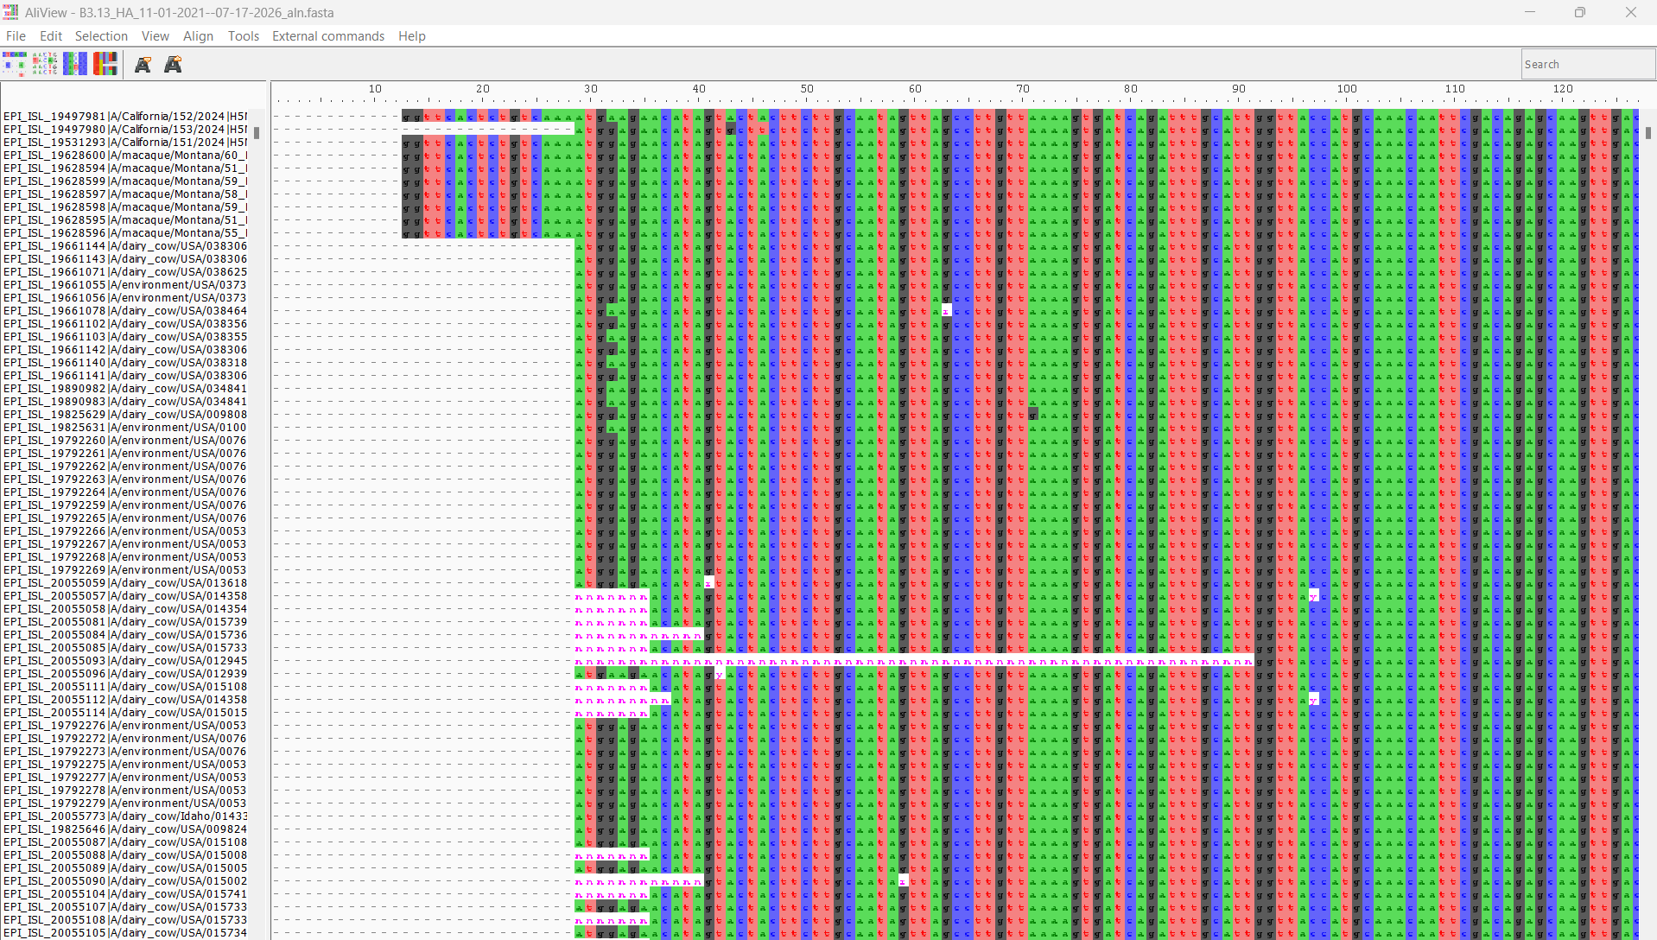
- Click the “translate nucleotide sequences to amino acids” button at the top.
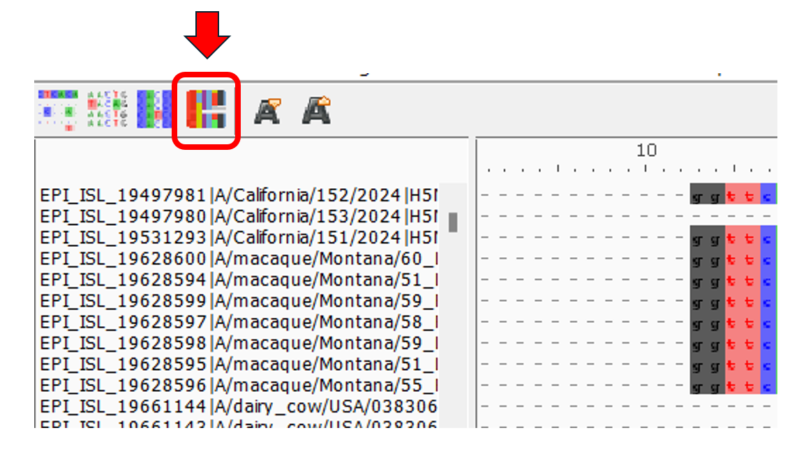
  - You should now see the sequences as amino acids.
- You will need to trim the sequences to the start and stop codons.
  - Start codons are on the left of the sequence in dark blue, and will always be labeled “ATG”.
  - Stop codons are on the right of the sequence in black, and may be labeled “TAG”, “TAA”, or “TGA”.
- I recommend beginning with start codons and ending with stop codons. This means going from left to right in AliView.
- Sometimes start codons and stop codons may not be obvious. For example, in this HA segment, you will need to search for the “ATG” start codon and trim up to the first “A”.
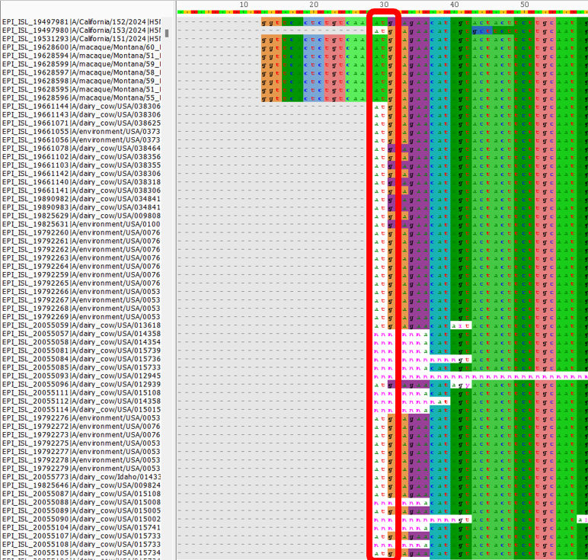
  - To trim, select all the columns that are to the left of the start codon.
    - Then, delete them. If you get a prompt asking if you’re sure, press the affirmative button.
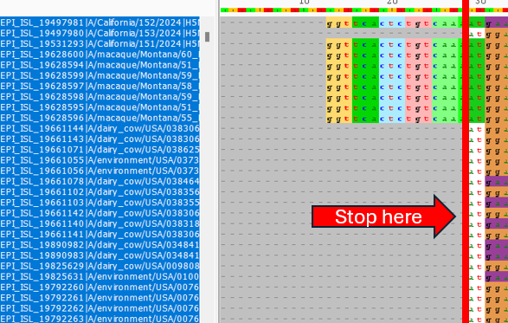
  - After trimming, the start codon should be at the beginning of the sequence and visibly dark blue.
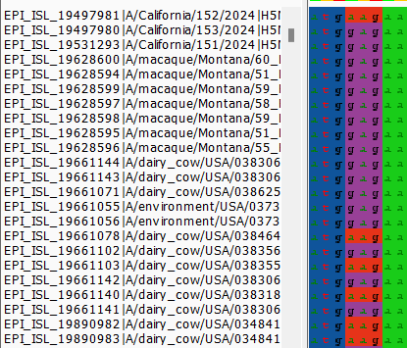
- Scroll to the right until you see any black stop codon.
  - The black stop codon should be close to the end of the sequence. If there are multiple, the “correct” one is the leftmost one.
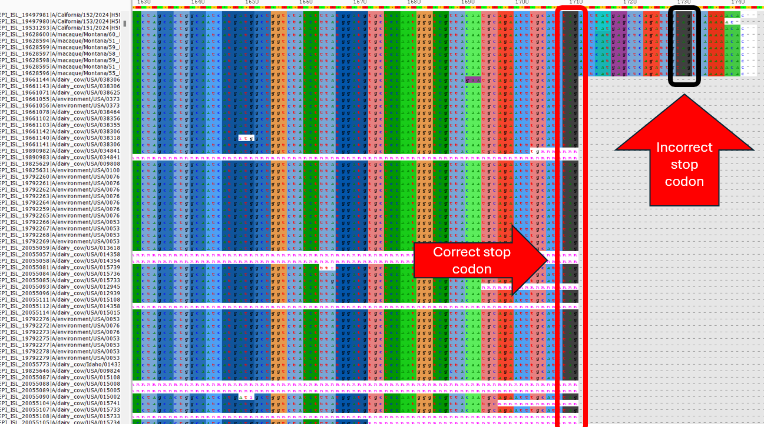
  - Sometimes, there will be black stop codons in the middle of the sequence, not close to the end at all. This typically happens when there are significant insertions or deletions in the sequence affecting the alignment. In these cases, you must introduce gaps to make the “false stop” codons disappear.
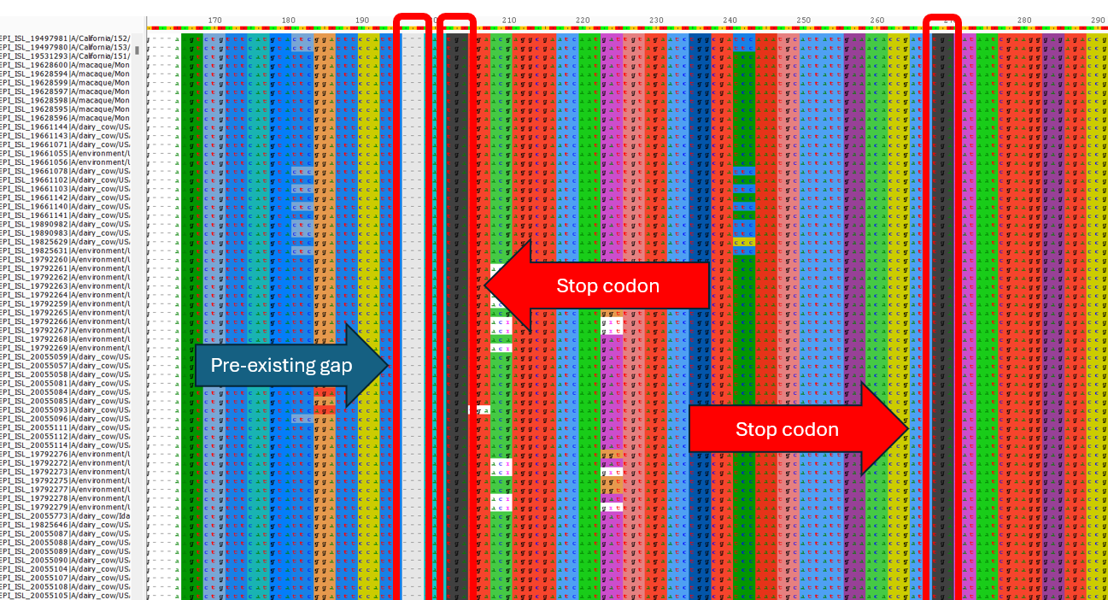
    - To introduce a gap, select the column in the pre-existing gap before the nucleotide where you want to introduce the gap. Press the spacebar to introduce the gap.
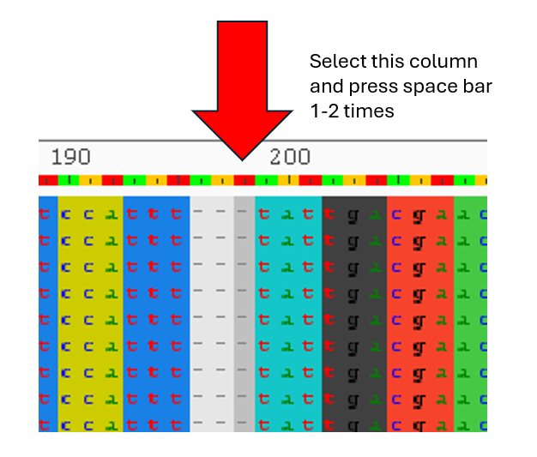
    - Sometimes you may need to introduce two gaps to make the “false stop” codon disappear. However, three gaps would be unnecessary, as it would revert the codons to their original configuration.
    - Occasionally, there will be multiple “false stop” codons. If they all do not disappear in the introduction of one or two gaps, introduce the gaps that make the next “false stop” codon as far away as possible, then continue to the next “false stop” codon and repeat the process until the only stop codon left is the true one at the end.
  - Trim the remaining parts of the sequence to the right of the final stop codon. This is similar to the start codon trimming, except the sequence sections to be deleted are to the right of the stop codon, not the left.
- Save the file under a different name from the original. Typically what I do is attach the number corresponding to the segment at the beginning of the name, then “_trim” to the end of the name before the extension.
  - E.g. “4-B3.13_HA_11-01-2021--07-17-2026_aln_trim.fasta”
    - Even if you name it something else, make sure that however you name the files, they alphabetically/numerically are in the same order as the proper segment order.
      - PB2, PB1, PA, HA, NP, NA, MP, NS is the proper segment order. Since the alphabetical order is different, what I do is put a number at the beginning of each file name – e.g. 1-[PB2_file].fasta, 2-[PB1_file].fasta, 3-[PA_file].fasta, etc.

MP
- Begin trimming as in the “non-spliced segments” section.
- Scroll to the middle of the sequence, around nucleotide #750. In this section, there should be a stop codon.
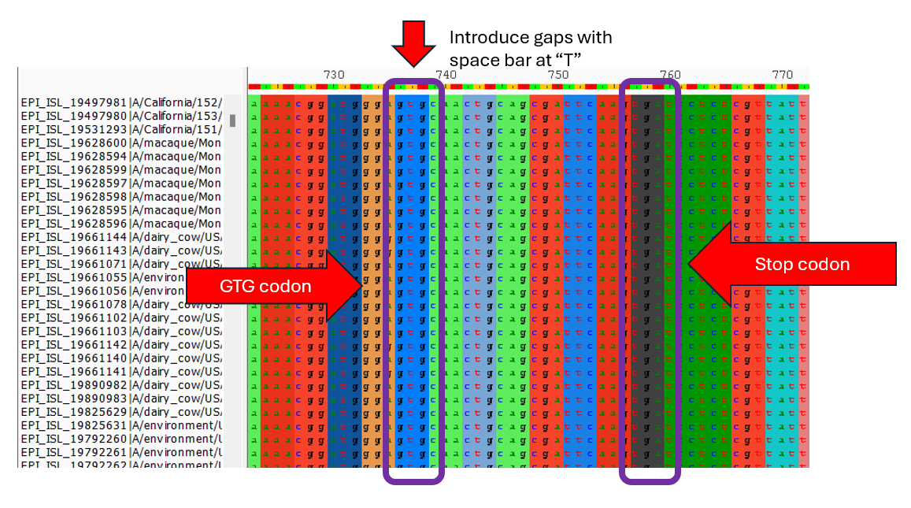
  - To the left of the stop codon a few codons back, find the first “GTG” codon before the stop codon. It should be light blue.
  - Select the column corresponding to the “T” in “GTG” and introduce two gaps.
- There should only be one stop codon left at the end. Trim the sequences to the right of this stop codon and save your file under a different name, as described in “Non-spliced segments”.

NS
- This is another spliced segment, so the process will be similar to MP.
- Begin trimming as in the “non-spliced segments” section.
- Scroll to the middle of the sequence, around nucleotide #700. In this section, there should be a stop codon.
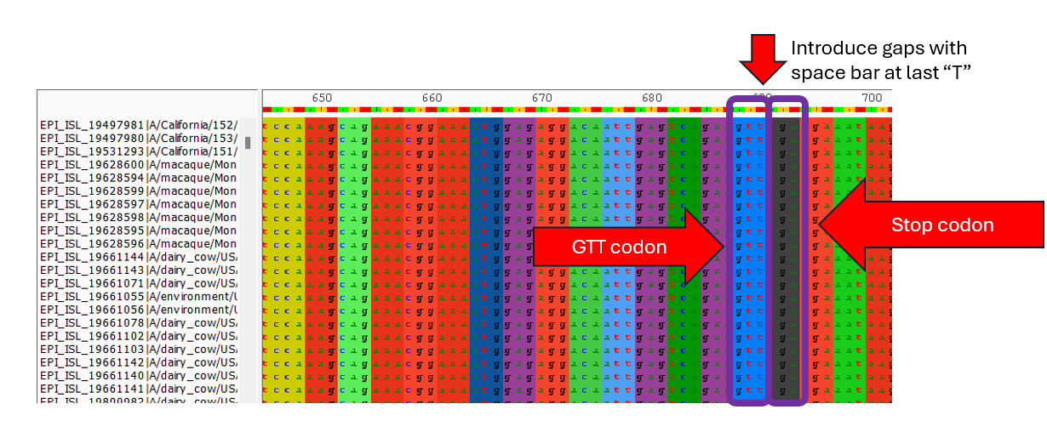
  - To the immediate left of the stop codon, there is a “GTT” codon. It should be light blue.
  - Select the column corresponding to the last “T” in “GTT” and introduce two gaps.
- There should be only one stop codon left at the end. Trim the sequences to the right of this stop codon and save your file under a different name, as described in “Non-spliced segments”.

How to concatenate trimmed alignments
- To concatenate trimmed alignments, in the maksiaev/Avian_Flu repository there is a Jupyter notebook called “concatenator_v2.ipynb”. First, find this file.
- Next, change the variables “genotype” and “input_path” to suit your use case. Example:
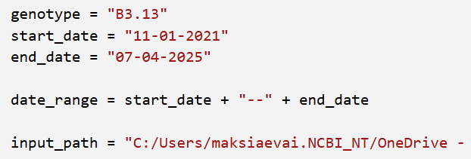
  - The “input path” should be the directory where your trimmed aligned datasets are housed. Make sure there are only 8 files in the directory. This may mean you might have to separate different genotypes into different directories.
    - Your files must also be in an order by name that is the same order as the proper segment order.
      - PB2, PB1, PA, HA, NP, NA, MP, NS is the proper segment order. If these are out of order in your file system (e.g. alphabetically), the concatenation will produce the wrong result.
  - “start date”, “end date”, and “date range” may be useful if you named directories using the date range. Otherwise, there’s no need for it necessarily.
- Run the notebook. The result should be an output file in the same directory as your input path, named “[genotype]_concat_[number of sequences].fasta”.

How to build a tree using IQTree2 in BioWulf
- To build a tree, you must have a concatenated, trimmed, aligned FASTA file. There should be one file per genotype.
- In the maksiaev/Avian_Flu repository there is a directory called “bash” containing bash scripts. Navigate to this directory and select the “B3.13_iqtree.sh”, regardless of which genotype you plan to use to make a tree.
  - The script should look like this:
#!/bin/bash
#SBATCH --job-name="all B3.13 iqtree"
#SBATCH --mail-type=BEGIN,END,FAIL
#SBATCH --mail-user="alexander.maksiaev@nih.gov"
##################################################
######################

module load iqtree
iqtree2 -s B3.13_concat_5336.fasta -m GTR+G -bb 1000 -nt AUTO

######################
date +"%Y-%m-%d %H:%M"

  - Change the following in the script:
    - “all B3.13 iqtree”: Should be your genotype (unless it indeed is B3.13).
    - --mail-type: Should be your email.
    - “B3.13_concat_5336.fasta”: Should be the name of your file.
- Open Windows SCP (if using Windows) and move the bash script and final FASTA file to your BioWulf directory.
- In the BioWulf terminal, log in, navigate to your directory, and input the following:
  - Input: sinteractive
  - Input: sbatch –mem=64g –time=128:00:00 [name of your bash script]
    - Memory should be at least 32 gigabytes, but I put 64 just to be safe.
    - The tree will not take 128 hours to run, but it’s good to have a long time just to be safe.
- The tree should take several hours to run. However, a preliminary tree without bootstrap will be available in a few minutes, as a treefile.
All done!

