DoNeMP – Module 2 Home Task 1

1. Implement following DB:

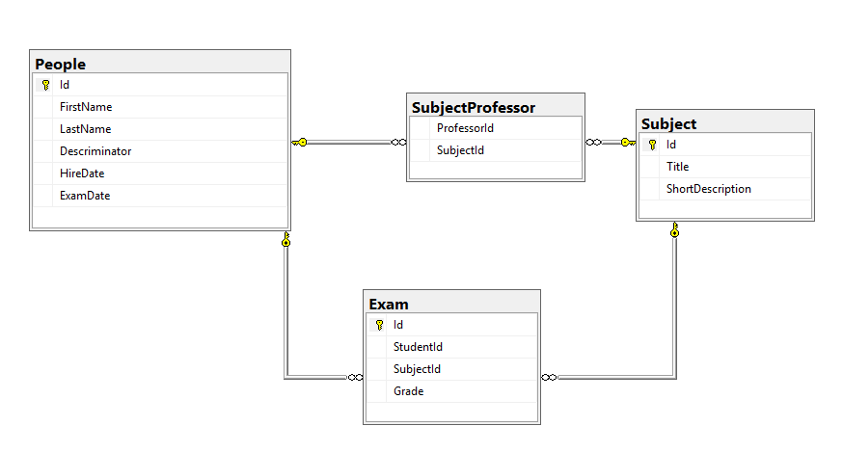

1. Implement CRUD operations to be able:  
   a. Add Student, who passed some exams

b. Add Professor, who handles some subjects

c. Update Student’s grade for given subject

d. Delete student

Feel free to choose Connected or Disconnected approach od ADO.Net

1. Prepare file with data to fill DB. You should use 500 students, 50 professors and 5 subjects. Each Professor handles all the subjects. Each Student has to pass exam for each subject.
2. Using your Data Access Layer, you should make some operations and measure the time they run.  
   a. Insert all the data to your db

b. Perform 500 selects on table People by Id

c. Choose subject and update it’s grades for all the students whose name starts with “A”

d. Perform 500 deletions on table People by Id

1. Save your results to \*.excel file

Criteria:

0 points – requirements doesn’t meet completely

4 points – works as expected

1 extra point – implementation with respect to SQL injections.

1 extra points – implementation with respect to transient faults.