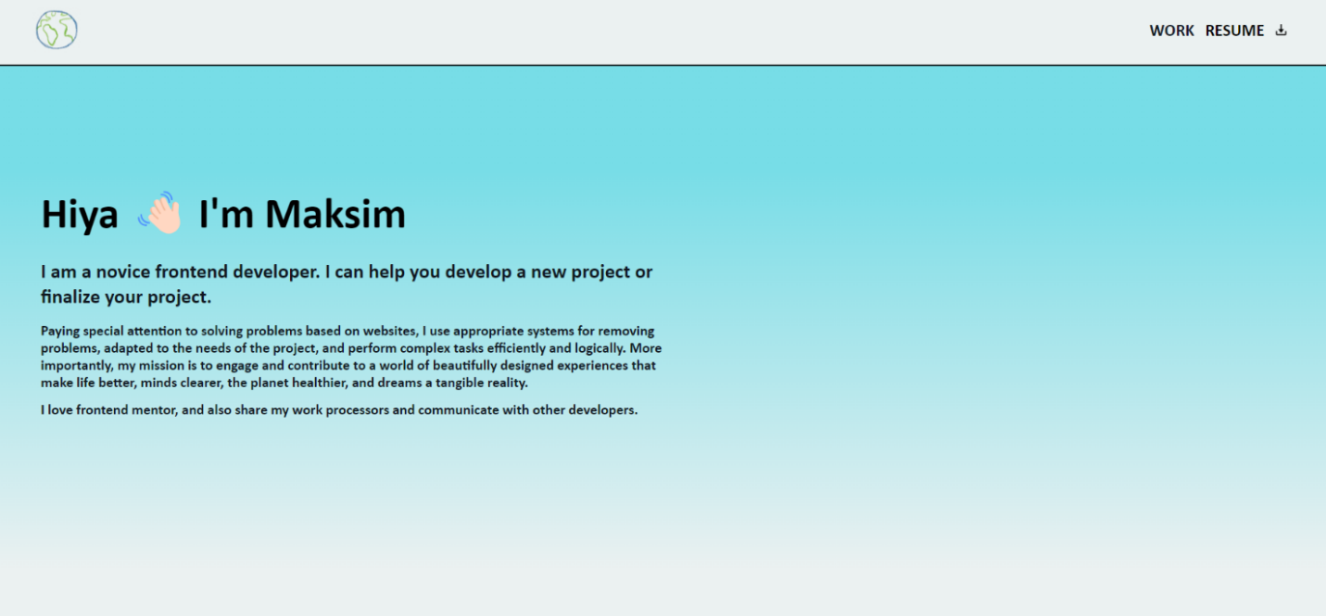

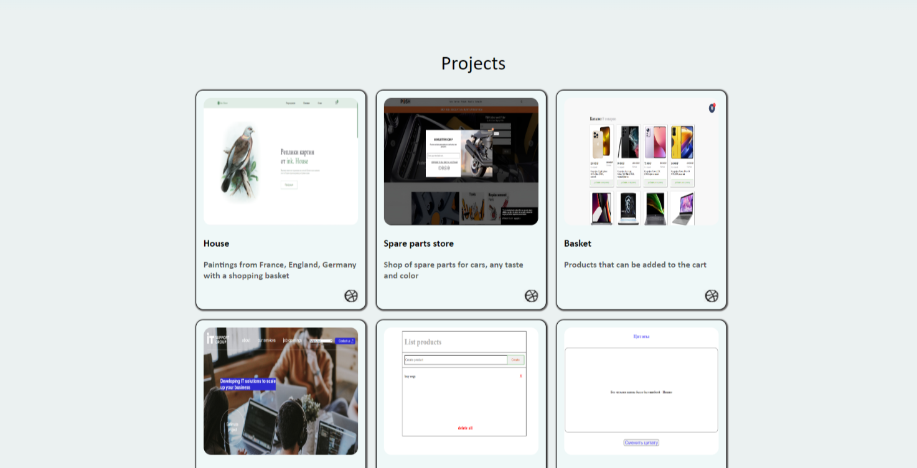

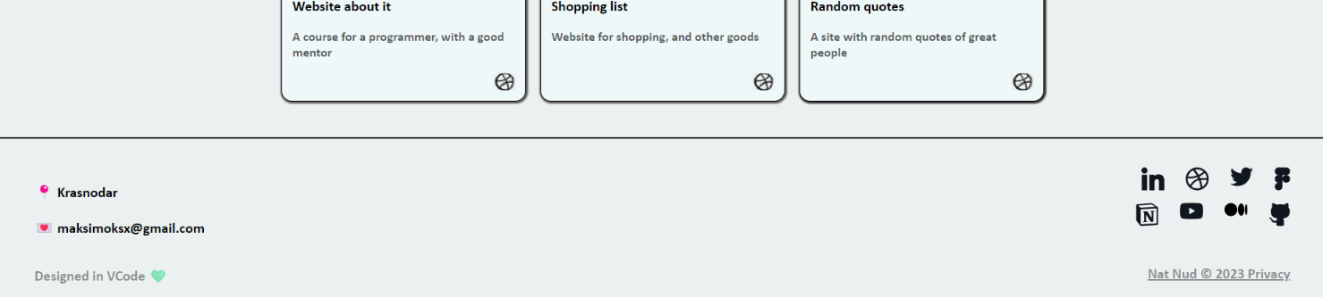

Ссылки на страницы:

<https://maksimka241e.github.io/House/build/index.html>

<https://maksimka241e.github.io/auto-parts/build/>

<https://maksimka241e.github.io/basket/build/index.html>

<https://maksimka241e.github.io/servis-it/build/index.html>

<https://maksimka241e.github.io/list-Product/>

<https://maksimka241e.github.io/random-quotes/случайные%20цитаты/index.html>