# Grest

|  |  |  |  |  |
| --- | --- | --- | --- | --- |
| Talex Maxim  Maksim Superfin | +972587754748 |  |  | taimax13@gmail.com  maxym.superfin@gmail.com |

GIP Launch

Groupon improved product (app)

Table of Contents

1. Grest 0
2. Executive Summary 2
3. Product 2

The market

OUR Clients

Competitors

Keys to Success (Risk and opportunity)

management team

Brife Profit estimation for 3 years

# Executive Summary

Grest is a new IT software company which is looking for the smart solutions which are not yet in the market. We are providing the best and creative solutions on the market. We are outside the box thinkers. Our solutions are wide ranged from the mobile apps for the daily life up to the corporate analytics.

# Product

We are launching new app -GIP (Groupon improved product) for the android and IOS platform. GIP will trigger certain improvements of Groupon app. GIP is more efficient and provides a better visualization of the service or product client is interested in. Based on 2-steps survey, user will receive overview of all possible places for him to visit based on his preferences. GIP – will economies time and money for our users!

## The market

We define our market as a large user-based software which will have the impact over the globe. Furthermore, we are seen us as on the same stage as Facebook or Google!

## OUR Clients

Active users all over the globe, who are valued time and money!

## Competitors

We are competing directly with Groupon app. Our product superior because of clear navigation system and high visualization of all deals by chosen topic.

## Keys to Success (Risk and opportunity)

We are making our competitor as our partner and by so we are putting us in a position where we can benefit from the Groupon by receiving a fare commission.

## management team

The team lead by Chief Executive Officer Talex Maxim who has 12 years of experience in launching new products and implementing new technologies, MBA in banking and retail industry. The technical support and solutions provided by Chief Executive Officer Maksim Superfin with 16 years of experience within hi-tech industry as a software engineer and software architect builder.

## Brife Profit estimation for 3 years

In 3 years’ time we are planning to subscribe 80% of Groupon users, as well as attract new customers. Our profit prognoses based on Groupon statistic and estimated like this in USD:

Global revenue of Groupn 3,119 mln * 80% * 15%= 374,5 mln.

We are looking for the initial investments amount of 750 000 USD; the project will provide ROI – 180% annually.

Attachments

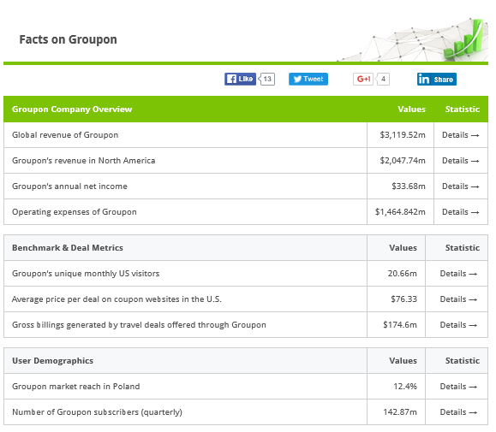 http://www.statista.com/topics/824/groupon/

|  |  |
| --- | --- |
|  |  |