OFDM MATLAB PROJECT 2


OFDM
Orthogonal frequency division multiplexing (OFDM) is now over 30 years old and belongs to a class of modulation schemes called multi-carrier (MC). The modulation and demodulation process is generally performed using an FFT and IFFT pair as motivated in Figure1. The transmission of N symbols begins with interpreting each symbol to be transmitted as a complex number that collectively define an N-sample set of complex valued symbols. The complex array is presented to an N-point IFFT which converts the symbol array into an N-sample complex time-series. The complex time-series is transmitted and decoded by an FFT located at the receiver which converts the complex time-series back into an array of N complex symbols.
N Symbols
X₀

X_{N-1}
N complex
numbers
Parallel to Serial Buffer

N pt.
IFFT
C^{N}↔C^{N}
Time-
series
Serial to Parallel Buffer
N Symbols
X₀
…
X_{N-1}
Modulation by f₀
Demodulation by f₀
⊕

N pt.
FFT
C^{N}↔C^{N}

Noise
Figure 1: Basic ODFM modulator/demodulator.
The OFDM strategy also includes a number of innovations including cyclic prefixing that insures the periodicity of an FFT transformed signal.

MATLAB PROJECT #2
You are part of an engineering team developing a 64 channel (64-point IFFT/FFT) QPSK OFDM-class solution (see QPSK constellation in Figure 2). You are to test your proposed solution using MATLAB studies. Using MATLAB’s randn Gaussian noise function, create a 2⁶x2⁶ matrix of 2-bit random QPSK symbols { 1+j0, 0+j1, -1+j0, 0-j0}.
[-1+j0]
[1+j0]
[01]₂
[0+j1]
[01]

[0+j1]
[01]

[10]₂]
[01]

[10]₂
[00]₂ ₂₂]
[01]

Figure 2: QPSK constellation (complex value and binary value).
[01]

Data will be read from the 2⁶x2⁶ symbol matrix 2⁶ symbols at a time, processed by a 64-point IFFT and FFT in a channel containing additive noise in accordance with OFDM solution shown in Figure 3, then analyze (symbol error rate determination).
Study four SNR cases for the OFDM system shown in Figure 3. Adjust the signal to noise ratio (SNR) measured at the input of the receiver to be (no noise), 25dB, 15dB, and 5 dB (verify your SNR calculations). Finally compute the symbol error rate (BER) by interpreting symbol errors in the context of the decoding of the received constellation (see Figure 3):
2¹²-symbols,
compute symbol error rate
2¹²-symbols
Block
Decomposition
2⁶x2⁶ (2¹²)
64-symbol/block
64-sample
IFFT
C^{64⇒} C⁶⁴
Parallel
to serial
converter
Additive WGN
Serial to
parallel
converter
64-sample
FFT
C^{64⇒} C⁶⁴
Block to Decomposition
2⁶x2⁶ (2¹²)

s_{i}
64-symbol/block
SNR determination
Figure 3: OFDM Simulator
Analyze the system under four SNR conditions computing the symbol error rate for each SNR case. Remember that the noise must also be complex. Assume that all signals are transmitted across a lossless (flat) delay-less channel. This assumption eliminates the need for cyclic prefixing and data re-synchronization. An example of a possible outcome is shown below.
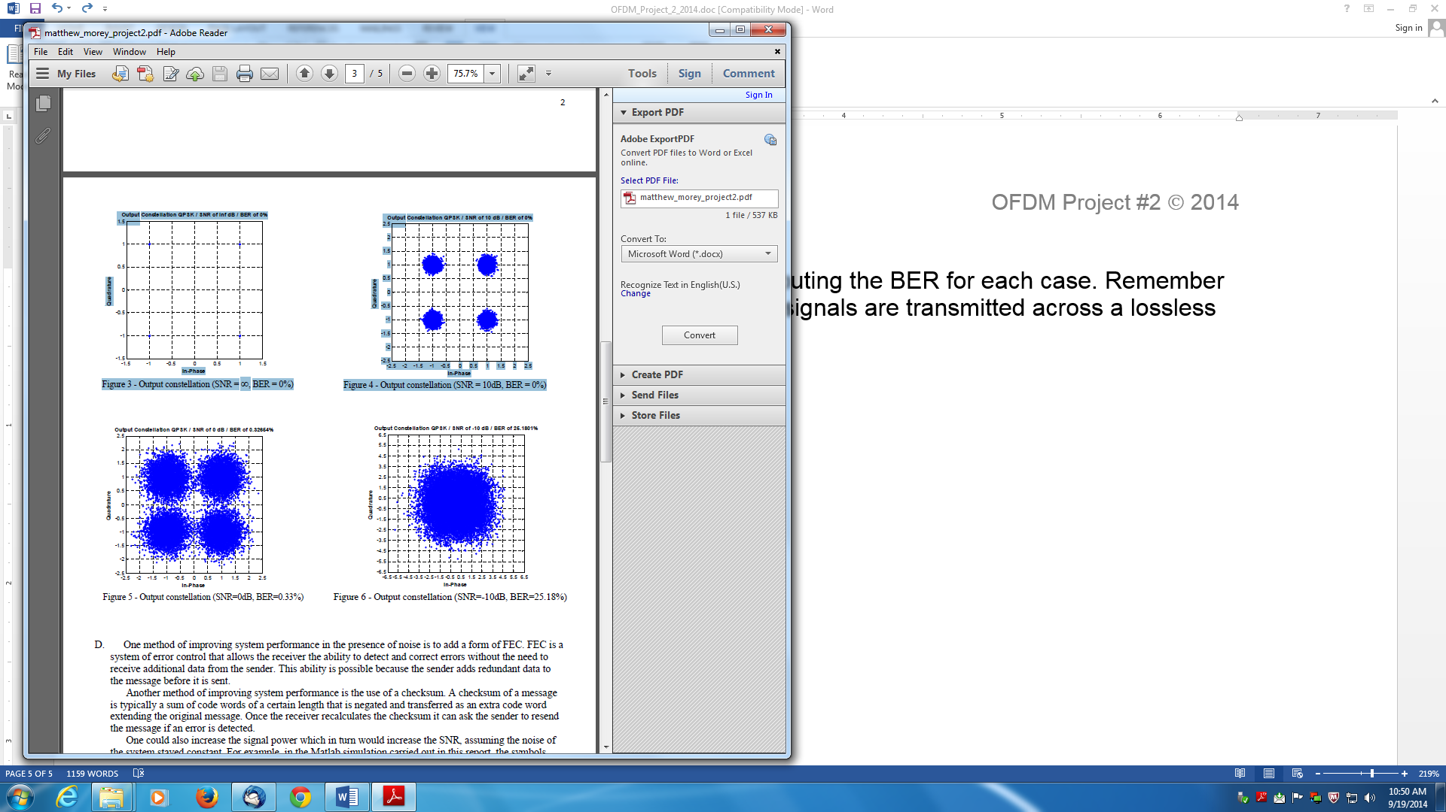

Project #2 due June 15, 2014.
Format: Same as Project #1

