Rasterization
Maksim Levental
CAP 4730
February 21, 2014

Introduction

Rasterization is the logical converse of ray-tracing. Instead of having an implicit representation of the scene, an object's explicit representations are used – triangle primitives who vertices are explicitly record. Then instead of shooting rays of “light” from the screen to the object in 3-space the pixels in the viewing plan are computed. This is done by representing vertices as 4 vectors and projecting down using matrices. Real depth values and other attributes are also stored and later used during the rasterization process. After projecting the vertices to screen space Bresenham's algorithm is used to trace out and color in the outline of each triangle. Then scanline conversion is used to fill in the outline of the triangles. Color, shading, and depth values are computed at each pixel by interpolation between certain points – between vertices for the lines and between scanline edges for the interior.

READ THE LAST SECTION “BASIC OPERATION” FIRST!!!

Basic Program Structure

The RGB array passed to glDrawPixel is image[IMAGE_HEIGHT][IMAGE_WIDTH][3]. static GLfloat light_src[3] = {-1.,0.,3.} static GLfloat eye_location[3] = {0.,0, translation} define the vectors to the light source from the model and to the “eye”.

Triangulation

For the purposes of rasterization models have an explicit presentation in terms of vertices, generated by 3D packages like Maya or Blender. These files are then loaded into renderers, e.g. Nate Robins Smooth, and “triangulated”. This means that edges between vertices are declared, normals to those triangles are computed, and vertex normals are also computed. Surface properties, like reflectance, and color, are stored in texture files and then associated with the triangle data structure. Note in Nate Robins code the GLMgroup data structure stores information about surface texture. To make things simpler I edited his GLMtriangle data structure to also store the index of its own texture in the GLMmodel textures array. The first function addMaterialToAllTriangles() run in raster() “links” each triangle to its texture (stores the array index in model->materials that belongs to that triangel).

Rasterization - raster()

Each triangle is first plotted to a framebuffer as discussed below, stored in double framebuffer[IMAGE_WIDTH][IMAGE_HEIGHT][1+1+3]. Using swapImageAndFrameBuffer() the depth value at each entry, framebuffer[y][x][1], is compared against the same entry in zbuffer. If the z-value stored in zbuffer is greater than that stored in framebuffer then the framebuffer atttribute values are written to the final image.

Plotting triangles - plotTriangleToFrameBuffer(GLMtriangle* triangle)

First the OpenGL state matrices for the projection matrix and model view matrix, I.e the configuration of the model in the 3-space and the parameters for projecting that model down to screen space, are fetched. These will be used in gluProject to compute the screen coordinates of each vertices in each triangle. These will be then be stored in winX, winY, winZ, where winZ is a misnomer and just stores the depth value. Along with storing the screen space coordinates of each vertex the normal at each vertex is stored in vertnormals[]. This is used for Goraud shading. As mentioned before I have changed the code so that each triangle primitive can index into the texture array in the model – the fetched material is stored in triangleMaterial. Then the outline of the triangle is traced out using bresenham(). The first 6 arguments are the endpoint screen space vertices of the line and the depth values, the 7th and 8th arguments are the vertex normals at each end, and the ninth argument is the material. bresenham() uses the two normals to interpolate. If flat%2==1, ie if flat shading is desired, then the triangle (facet) normal is passed to both arguments and the interpolation has no effect. This is slow. It would have been better for bresenham() not to do any interpolation whatsoever in the flat shading case but I chose to do it this way to make implementation of both Goraud and flat easier. If flat%2 == 0 then Goraud shading is done and the vertex normals are actually used effectively in shader(). Finally scanlineTriangleToFrameBuffer() is run to fill in the outlines. It is discussed below.

Bresenham - bresenham()

The algorithm
This implementation of Bresenham's algorithm, even underneath all of the interpolation, is a little different. It is based on http://en.wikipedia.org/wiki/Bresenham's_line_algorithm#Simplification. The way it works is using an implicit representation of the line of the form

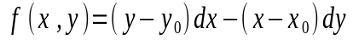
Inside err is stored 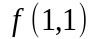. This is so we can easily test the points a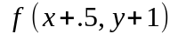nd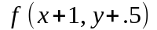. By test I mean we test 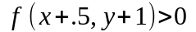and 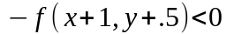. To wit

But by construction 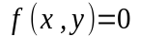, because we start the plot of the line at 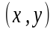. So finally the test for whether we plot (x+.5,y+1) is

This is the condition we test to see whether to advance x. The argument is subtle for this is in fact the correct condition for x. It is because

where 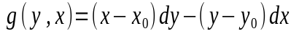, the implicit representation of the line with the axes flipped. So 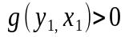implies 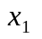is above the line which by contrapositive implies that when 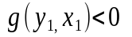 then x is below the line and that is the condition we are interested in for our simplified Bresenham's. But as mentioned before 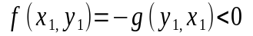is the test using 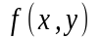instead of 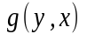. The second conditional is obvious.

Shading - shader()

To make shading work we approximate the vector from the eye and the light source to some point on the line, for use in computing dot products inside shader(). To be able to do this we recover the original vertices associated with the screen space endpoints of the line using glUnProject. This is slow and uncessary but easier. It would have been more efficient to simply use the vector that emanates from the “eye” and intersects the viewing plane, which is simply the screen space coordinates shifted. But glUnProject is conceptually easier. If flat shading is used then the point that we “look from” and “light see light from” is the midpoint of the the line connecting the vertices. It is as good an approximation as any. If Goraud shading is used then the normals at each vertex are used so it makes sense to compute a lookFrom and lightFrom vector for each vertex seperately. shader() uses the same algorithms, Blinn-Phong, as in the ray tracer assignment. The only difference is that a color is calculated as function of normal, vector to “eye”, and vector to light source. All of these are passed in. It stores RGB values in color1 and color2 to be used for interpolation in the main body of the Bresenham loop. The algorithm also marks “filled in” points in framebuffer[y][x][0] for later use in scanlineTriangleToFrameBuffer().

Interpolation

The proper interpolation parameter on the line, for the attributes is a function of the distance traversed on the line. Alpha is distance along the line. Source is here http://citeseerx.ist.psu.edu/viewdoc/download?doi=10.1.1.3.211&rep=rep1&type=pdf . This is calculated using calculateBeta() and then used to interpolate the depth values between the vertices, and the color values.

Scan-lining

scanlineTriangleToFrameBuffer() is a fairly ugly hack. First the bounding box of the triangle is computed. This bounding box is actually expanded in the loops (miny-1, maxy+1,minx-1,maxx+1) so as to not miss any pixels. The algorithm sweeps from left to right along each y and records delta “height”. Not that inside bresenham() for every point that is colored in, framebuffer[y][x][0] is set to 1. scanlineTriangleToFrameBuffer() then, when sweeping along, looks for “hills” that look like this

where each peak has height 1. It records the pixel right before the hill and the pixel the hill is on. This is abs(abs(framebuffer[y][x+1][0] - framebuffer[y][x][0]) - 1) < .0001, which says if framebuffer[y][x+1][0] – framebuffer[y][x][0]) == 1 then record x, crossings[crossing][0] = x, and x+1 crossings[crossing][1] = x+1. The .0001 is for floating point error. crossings[][] is the collection of crossings and the crossing index tells you which crossing you're at. If crossing==4 (observe the picture above) then you have a scanline bounded by two lines in a triangle. Otherwise you don't. If crossing does in fact equal 4 then color and depth is interpolated between the two edges of the scanline similarly to how it's done in bresenham().

Basic operation

To compile run 'make release'. The executable will be in bin/Release . On immediate load Nate Robins version of smooth loads. All functionality remains. To switch to my version press 'y'. By default my models are shaded using Goraud shading. To flat shade run the executable with the argument flat I.e $./rasterizer flat . You will still have to switch to my rasterizer by pressing 'y' but they will now be flat shaded. There is a loader bar in the console that tells you the progress of the rasterization. When rotating a model the behavior in my rasterizer is that of rotating the camera about the model, instead of rotating the model in the 3-space. This is why the lit part of the model disappears from view and then reappears.

Miscellaneous

Several changes were made to Nate Robins code. As mentioned earlier GLMTriangle now stores the index to the textures array. Also the methods glmDot, glmCross, glmNormalize were moved to the header file glm.h so that they were accessible in smooth.cpp. Also in glmNormalize a divide by zero error had to be caught and returned from. Also in smooth.cpp glmScalarMultiple and glmSum had to be implemented for use in shader and other places.

Progress Journal

Triangle outlines
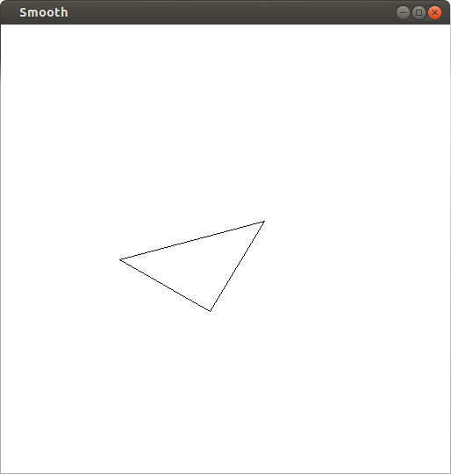
Wireframe
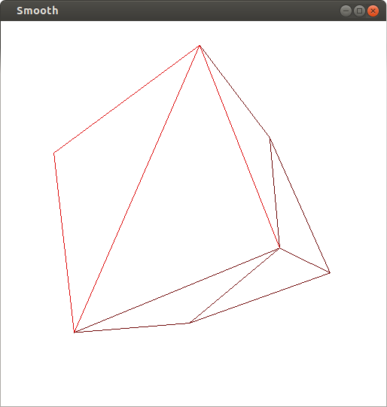
Flat shading
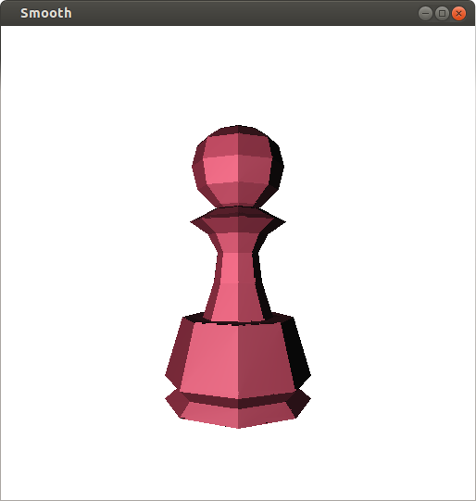
Goraud shading
