Rasterization
Maksim Levental
CAP 4730
February 21, 2014

Introduction

Rasterization is the logical converse of ray-tracing. Instead of having an implicit representation of the scene objects explicit representations are used – triangle primitives who vertices are explicitly record. Then instead of shooting rays of “light” from the screen to the object in 3-space the pixels in the viewing plan are computed. This is done by representing vertices as 4 vectors and projecting down using matrices. Real depth values and other attributes are also stored and later used during the rasterization process. After projecting the vertices to screen space Bresenham's algorithm is used to trace out and color in the outline of each triangle. Then scanline conversion is used to fill in the outline of the triangles. Color, shading, and depth values are computed at each pixel by interpolation between certain points – between vertices for the lines and between scanline edges for the interior.

Basic operation

On immediate load Nate Robins version of smooth loads. All functionality remains. To switch to my version press 'y'. To switch between flat shading and Goraud shading press 'f'.

Basic Structure

The RGB array passed to glDrawPixel is image[IMAGE_HEIGHT][IMAGE_WIDTH][3]. static GLfloat light_src[3] = {-1.,0.,3.} static GLfloat eye_location[3] = {0.,0, translation} define the vector the light source and to the “eye”.

Triangulation

For the purposes of rasterization models have an explicit presentation in terms of vertices, generated by 3D packages like Maya or Blender. These files are then loaded into renderers, Nate Robins Smooth, and “triangulated”. This means that edges between vertices are declared, normals to those triangles are computed and vertex normals are also computed. Surface properties, like reflectance, and color are stored in texture files and then associated with the triangle data structure. Note in Nate Robins code the GLMGroup data structure stores information about surface texture. To make things simpler I edited his GLMTriangle data structure to also store the index of its own texture in the GLMModel textures array. Then the first function addMaterialToAllTriangles() run in raster() links each triangle to its texture.

Rasterization

Each triangle is first plotted to framebuffer as discussed below, stored in double framebuffer[IMAGE_WIDTH][IMAGE_HEIGHT][1+1+3]. Using swapImageAndFrameBuffer() the depth value at each entry, framebuffer[y][x][1], is the comapred against the same entry in zbuffer. If the z-value stored in zbuffer is greater than that stored in framebuffer then the framebuffer atttribute values are written to the final image.

Plotting triangles

First the OpenGL state matrices for the projection matrix and model view matrix, I.e the configuration of the model in the 3-space and the parameters for projecting that model down to screen space, are fetched. These will be used in gluProject to compute the screen coordinates of each vertices in each triangle. These will be then be stored in winX, winY, winZ, where winZ is a misnomer and just stores the depth value. Along with storing the screen space coordinates of each vertex the normal at each vertex is stored in vertnormals[]. This is used for Goraud shading. As mentioned before I have changed the code so that each triangle primitive can index into the texture array in the model – the fetched material is stored in triangleMaterial. Then the outline of the triangle is traced out using bresenham. The first 6 arguments are the endpoint screen space vertices of the line and the depth values, the 7th and 8th arguments are the vertex normals at each end, and the ninth argument is the material. Bresenham() uses the two normals to interpolate If flat == 0, ie if flat shading is desired then the triangle (facet) normal is passed to both arguments and then the interpolation has no effect. This is slow. It would have been better for bresenham() not to do any interpolation whatsoever in the flat shading case but I chose to do it this way to make implementation of both Goraud and flat easier. If flat != 0 then Goraud shading is done and the vertex normals are effectively. Finally scanlineTriangleToFrameBuffer() is run to fill in the outlines. It is discussed below.

Bresenham

The algorithm
This implementation of Bresenham's algorithm, even underneath all of the interpolation, is a little different. It is based on http://en.wikipedia.org/wiki/Bresenham's_line_algorithm#Simplification. The way it works is using and implicit representation of the line of the form

Inside err is stored 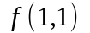. This is so we can easily test the points a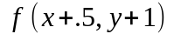nd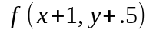. By test I mean we test 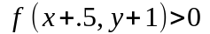and 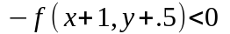. To wit

But by construction 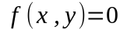, because we start the plot of the line at 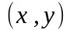. So finally the test for whether we plot (x+.5,y+1) is

This the condition we test to see whether to advance x because

where the implicit representation of the line with the axes flipped. So 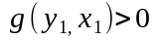implies 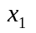is above the line which by contrapositive implies 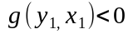is below the line and that is the condition we are interested in for this simplified Bresenham's. But as mentioned before 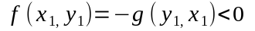is the test using 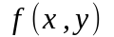instead of 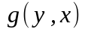. The second conditional is obvious.

Shading
To make shading work we approximate the vector from the eye and the light source to some point on the line, for use in computing dot products inside shader(). To be able to do this we recover the original vertices associated with the screen space endpoints of the line using glUnProject. If flat shading is used then that point is the midpoint of the the line connecting the vertices. If Goraud shading is used then the normals at each vertex are used so it makes sense to compute a lookFrom and lightFrom vector for each vertex seperately. Shader is discussed below but store RGB values in color1 and color2 to be used for interpolation in the main body of the Bresenham loop. The algorithm also marks “filled in” points in framebuffer[y][x][0] for later use in scanlineTriangleToFrameBuffer.

Interpolation

The proper interpolation parameter on the line, for the attributes is a function of the distance traversed on the line. Alpha is distance along the line. Source is here http://citeseerx.ist.psu.edu/viewdoc/download?doi=10.1.1.3.211&rep=rep1&type=pdf . This is calculated using calculateBeta and then used to interpolate the depth values between the vertices, and the color values.

Shader

Shader uses the same algorithms, Blinn-Phong, as in the ray tracer assignment. The only difference is that a color is calculated as function of normal, vector to “eye”, and vector to light source. All of these are passed in.

Scan-lining

scanlineTriangleToFrameBuffer is a fairly ugly hack. First the bounding box of the triangle is computed. This bounding box is actually expanded in the loops (miny-1, maxy+1,minx-1,maxx+1) so as to not miss any pixels. The algorithm sweeps from left to right along each y and records delta “height”. Inside Bresenham for every point that is colored in framebuffer[y][x][0] is set to 1. scanline then when sweeping along looks for “hills” that look like this

where each peak has height 1. It records the pixel right before the hill and the pixel the hill is on. This is abs(abs(framebuffer[y][x+1][0] - framebuffer[y][x][0]) - 1) < .0001, which says if framebuffer[y][x+1][0] – framebuffer[y][x][0]) == 1 then record x, crossings[crossing][0] = x, and x+1 crossings[crossing][1] = x+1. Crossings is the collection of crossings and the crossings index tells you which crossing you're at. If you see 4 crossings (observe the picture above) then you have a scanline bounded by two lines in a triangle. Otherwise you don't. If crossings does in fact equal 4 then color and depth is interpolated between the two edges of the scanline similarly to how it's done in Bresenham.

Miscellaneous

Several changes were made to Nate Robins code. As mentioned earlier GLMTriangle now stores the index to the textures array. Also the methods glmDot, glmCross, glmNormalize were moved to the header file glm.h so that they were accessible in smooth_mine.cpp. Also in glmNormalize a divide by zero error had to caught and returned from. Also in smooth_mine.cpp glmScalarMultiple and glmSum had to be implemented for use in shader and other places.

Progress

Triangle outlines
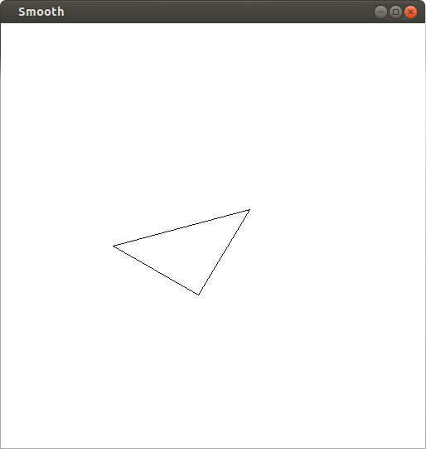
Wireframe
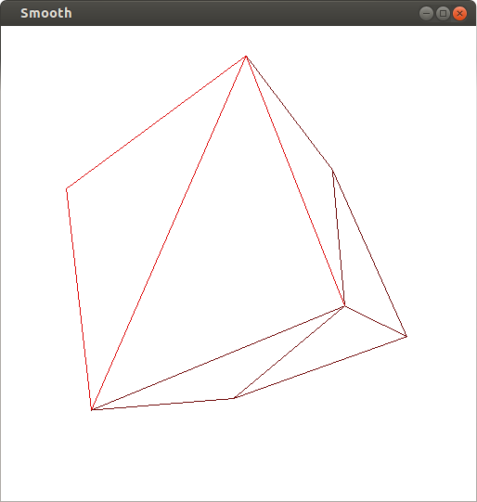
Flat shading
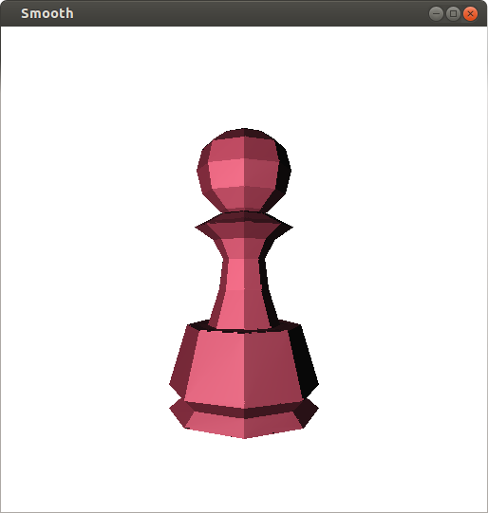
Goraud shading
