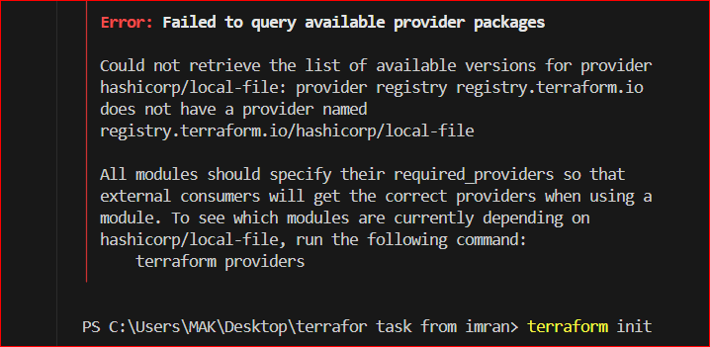

Solution is that we need to add provider block for local file and also using local-file instead of local_file