Dynamics PyMOL Plugin Manual
v. 1.0.0

University of Gdansk
Laboratory of Biomolecular Systems Simulation
Table of Content:

1. Introduction 3
2. Requirements and Installation 4
2.1. Requirements 4
2.2. Installation 4
3. Instruction 5
3.1. Molecule 5
3.2. Force Field and Water Model 8
3.3. Configuration 9
3.4. Restraints 10
3.5. Jobs 11
3.6. Command line 12
3.7. Additional Buttons 12
4. Standalone Application 14
4.1. pyDynamics-gui 14
4.2. pyDynamics 14
5. Changelog 15
6. Copyright 16
1. Introduction

PyMOL is powerful and easy to use open source tool for viewing and manipulating molecules. Thanks to its API capabilities it can be extended by developing third party plugins in high level programing language Python. This project is focused on developing plugin for PyMOL, which add molecular dynamics simulation feature. It is meant to be easy to use. The plugin uses GROMACS tools as a back-end. Project is developed as a open source and as such create full open source stack together with PyMOL and GROMACS. Because GROMACS can compile easily only on Unix like systems, the plugin also keep compatibility only with those. No Windows port is expected. Plugin is developed and maintained by Laboratory of Biomolecular Systems Simulation at University of Gdansk.
2. Requirements and Installation

2.1. Requirements

The plugin should work on all variety of Unix like systems. Most of the test are performed on Ubuntu Linux, which is treated as a reference platform. To work properly plugin require Bash, Python with TkInter, Tix, PyMOL, GROMACS and X-Window system for GUI. To satisfy those requirements on Ubuntu do following command:
sudo apt-get install python-tk python-pmw tix pymol gromacs

2.2. Installation

There are two ways to install plugin. If you are Ubuntu user, than you can just add repository and install package:
sudo add-apt-repository ppa:tomaszm/dynamics
sudo apt-get update
sudo apt-get install dynamics-pymol-plugin
All required libraries will be downloaded as a dependencies. Supported versions of Ubuntu are latest stable and latest LTS.
The second way for all other platforms or Ubuntu as well is to install plugin directly from its GitHub repository:
https://github.com/tomaszmakarewicz/Dynamics
You can download latest master snapshot by command:
git clone git://github.com/tomaszmakarewicz/Dynamics.git
Than run PyMOL as a root. On the top Menu choose Plugin->Manage Plugins->Install... Than choose dynamics.py file. After installation restart PyMOL with normal user privilege.
3. Instruction

Dynamics PyMOL plugin is meant to be as easy to use as it is possible. As an input it takes PDB molecule model. As an output it creates PDB multimodel molecule, which could be easily stored and viewed. After starting PyMOL load PDB file for which molecular dynamics simulation needs to be performed. If you want some specific atoms to restraints just select them on displayed molecule model. Now all you need to do is to click on top Menu->Plugin->dynamics and plugin menu should open. All available options are described in this chapter.

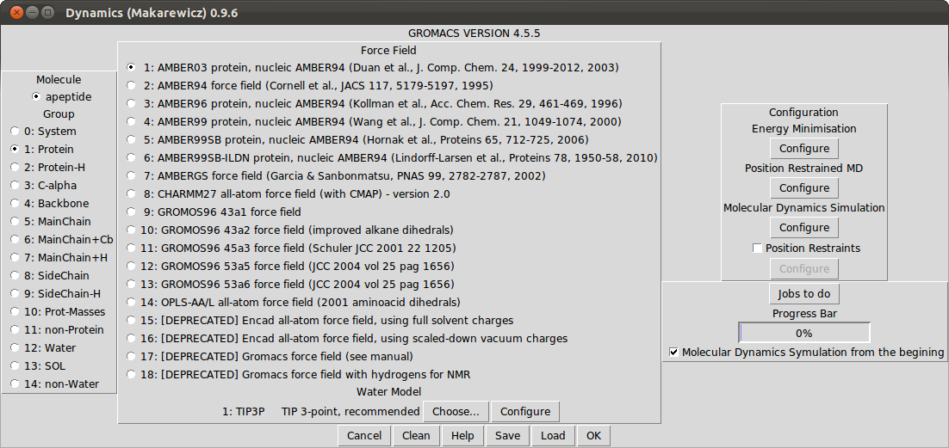
Picture 1.

3.1. Molecule

There are three columns in the plugin menu. The left one is used to choose molecule for dynamics simulation. If you have loaded any molecule in PyMOL the list of those should appear. Chose one, for which you want perform simulation.

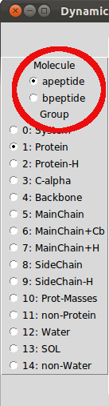
Picture 2.

If you haven't loaded any molecule in PyMOL. The Browse button should appear. You can use it to select PDB file for molecular dynamics simulation.

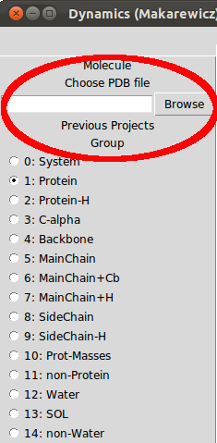
Picture 3.

If you have earlier perform any simulations using this plugin, the additional list should appear. It will allow you to select any of previous molecules.
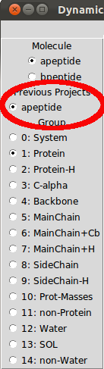
Picture 4.

The last list in this column determine which part of molecule should be displayed as a final result. It does not affect any calculations. The default selection is whole Protein, as it is suggested by GROMACS.

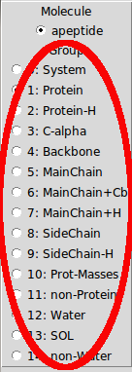
Picture 5.

3.2. Force Field and Water Model

The middle column is focused on force fields and water models for molecular dynamics simulation. The first radiobuttons list allows you to choose force fields provided by GROMACS tool. Note that not all force fields can perform full molecular dynamics simulation for given molecule.

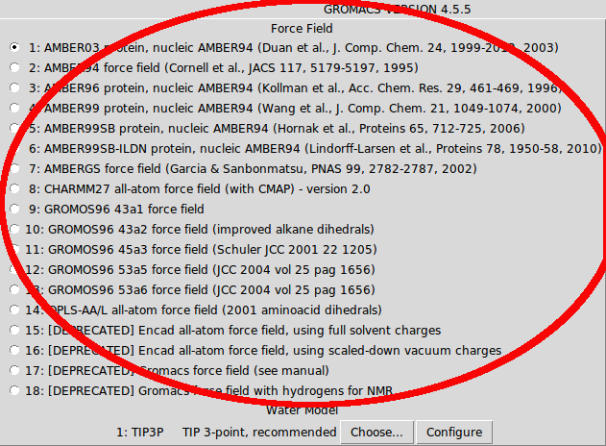
Picture 6.

Below force field there is a label with default water model for chosen force field. You can change it by clicking Choose... button. Note that every force field may have different available list of water models.

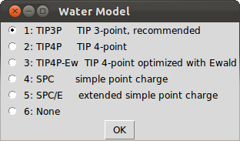
Picture 7.

Next to the Choose... button there is a Configure button, which allows you to customise water box details. Here you can change shape of the box, water density which is given in g/L unit. You can also determine here size of the water box, which is given in multiple of molecule size.

3.3. Configuration

The right column of plugin menu is devoted for advanced configuration. The first configuration options are for Energy Minimalisation. This step is performed after adding molecule to water box. Some atoms in that system may collide. The purpose is to move water atoms a bit, so dynamics simulation will not started in very inconvenient energy state.
The second option is for Progression Restrained MD. This step keep molecule fix, while allow water molecules to moves. It will make water to fill any holes created by Energy Minimalisation.
The third option is for final Molecular Dynamics Simulation.
To get exact info about available options look at GROMACS configuration MDP files options:
http://manual.gromacs.org/current/online/mdp_opt.html
If you want to use your own MDP files instead of available configuration options just paste your files to ~/.dynamics/ directory. File names are respectively em.mdp, pr.mdp, md.mdp.

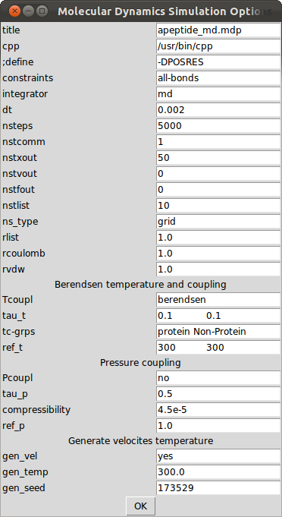
Picture 8.

3.4. Restraints

In the right column there is checkbox for Position Restraints. After clicking it, the Configure button will become active. After clicking button you will get the list of proposed parts of molecules to be restraints. Every list of the atoms contain atoms IDs, which are assigned to them in PDB file. The last options show atoms selected in PyMOL. You can choose one of the available list and modify which atoms should be restrained. Those atoms will get big energy penalty for every move while performing molecular dynamics simulation, so they will stay fixed and only not selected atoms will get proper molecular dynamics simulation.

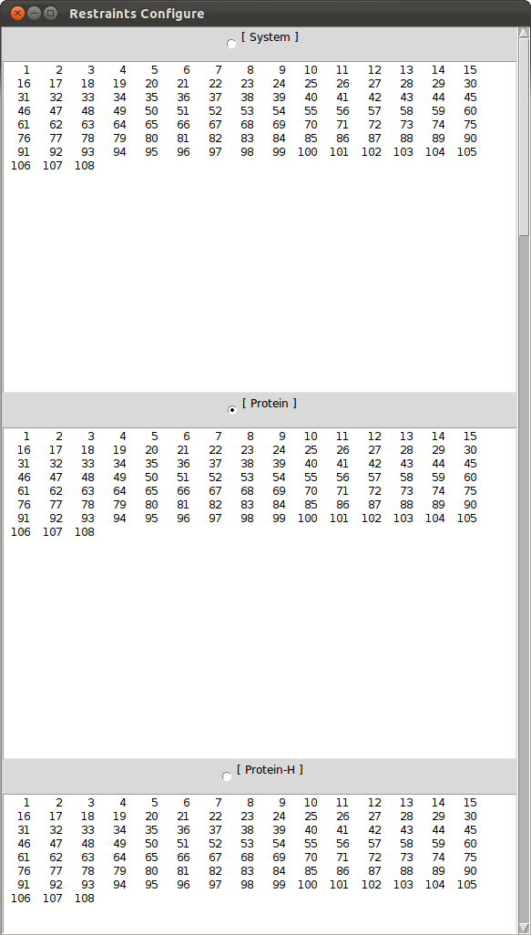
Picture 9.

3.5. Jobs

Not all of molecular dynamics calculation need to be done at once. In the right column at the bottom, you can click Jobs to do button. You will then get list of available jobs. Select those, which you want to do. After calculation you can save results and finish work on other machine or resume work on the same computer later. To resume work in the main menu select molecule in left column from list Previous Projects and uncheck box Molecular Dynamics Simulation from the beginning in the right column.

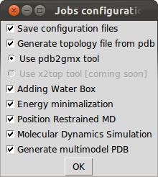
Picture 10.

3.6. Command line

There is command line interface for Dynamics PyMOL Plugin, which allows you to use the plugin directly from the PyMOL shell. At the moment this option is unfortunately depreciated.

3.7. Additional buttons

In the main menu on the bottom there are six buttons. From the left. Cancel button will exit the plugin. Clean button will remove all temporary plugin files including previous project files. Help button will display brief help information. Save button will allow you to save your molecule with all settings and any previous work as at tar.bz2 archive. Load button will allow you to load previously saved tar.bz2 archive. OK button will take you to next window, in which you will perform molecular dynamics simulation.

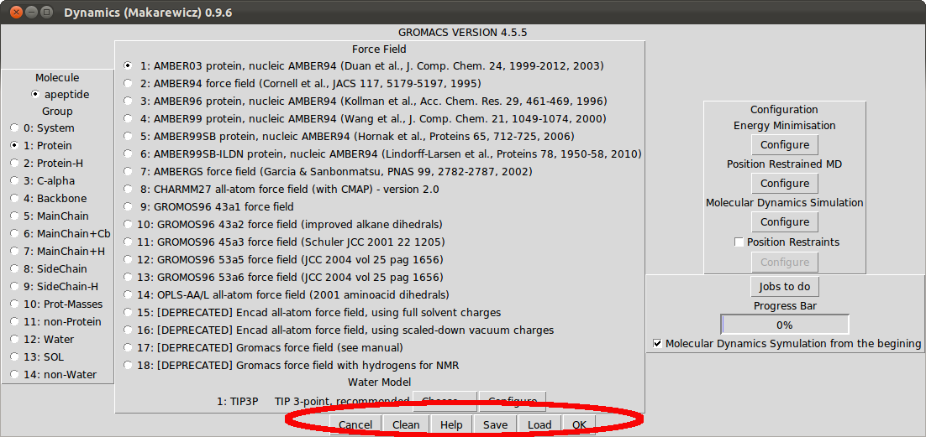
Picture 11.

In the next menu there are 4 buttons. From the left. EXIT button will quit plugin. SAVE button will allow you to save current project with its progress and settings as a tar.bz archive. STOP button will suspend calculations, while START button will resume or start counting.

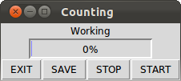
Picture 12.
4. Standalone Application

It is possible to use dynamics-pymol-plugin outside PyMOL environment, as a separate application. The project to allow that is called pyDynamics. It won’t give you ability to view results and some other options will be restricted, as they are internal PyMOL features. But it will allow you to do all the calculation even without graphic environment. To install pyDynamics on Ubuntu do:
sudo add-apt-repository ppa:tomaszm/dynamics
sudo apt-get update
sudo apt-get install pydynamics
On other systems you can download latest master snapshot:
git clone git://github.com/tomaszmakarewicz/Dynamics.git
And use pydynamics-gui.py as a normal Python scripts for GUI interface or pydynamics.py for command line interface. Remember that pyDynamics require dynamics-pymol-plugin to be installed or to be in the same directory as a pyDynamics script to run.

4.1. pyDynamics-gui

After installation this program can be found in Menu->Programs->Education. It also can be called from command line:
pydynamics-gui
This variant of application offers the same graphic interface as known from Dynamics PyMOL Plugin. One of the most worthy difference is that after dynamics simulation is finished it will not show molecule multimodel in PyMOL, but offer window to save multimodel pdb file. This application could also be used to input all settings and save file for non GUI pyDynamics.

4.2. pyDynamics

This application does not require graphic environment to run and can be called from command line:
pydynamics
It is designed with servers in mind. As a input it takes Dynamics PyMOL Plugin saved tar.bz archive files. It run all operations set in settings and as a output gives multimodel pdb file.
Example of how to use program:
pydynamics /home/user/aprotein_saved.tar.bz /home/user/aprotein_multimodel.pdb
First argument after pydynamics command is path to saved Dynamics PyMOL Plugin project (which could be for example uploaded to a server). The second argument is path to which output multimodel pdb file will be saved.
5. Changelog

What's new in 1.0.0:
- initial release

Known issues:
- command line interface is depreciated
6. Copyright

This software (including its Debian packaging) is available to you under the terms of the GPL-3, see "/usr/share/common-licenses/GPL-3".
Software is created and maintained by Laboratory of Biomolecular Systems Simulation at University of Gdansk.
Contributors:
- Tomasz Makarewicz (tomaszm@biotech.ug.edu.pl)

