**Technika Mikroprocesorowa**

**Sprawozdanie z Laboratorium 3**

**Maksym Pervov, grupa 4.7/13**

1. Zadanie 1

Disassembly:

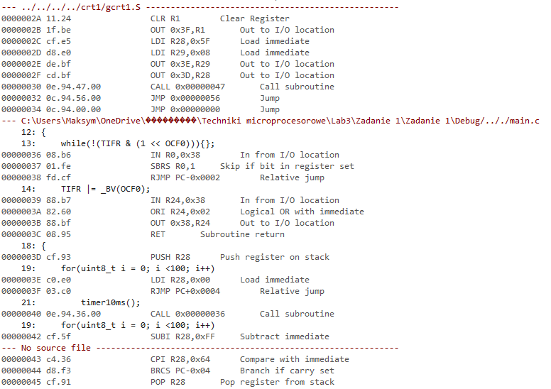

Source code:

/*

* Zadanie 1.c

*

* Created: 05.05.2022 12:27:24

* Author : mpervov

*/

# define *F_CPU* 1000000UL

# include <avr/io.h>

# include <util/delay.h>

void timer10ms()

{

while(!(TIFR & (1 << OCF0))){};

TIFR |= _BV(OCF0);

}

void czas_1s()

{

for(*uint8_t* i = 0; i <100; i++)

{

timer10ms();

}

}

int main(void)

{

OCR0 = 40;

DDRA = 0x01;

PORTA = 0x00;

TCCR0 |= _BV(CS02) | _BV(WGM01);

while (1)

{

PORTA ^= _BV(PA0);

czas_1s();

}

}