**Technika Mikroprocesorowa**

**Sprawozdanie z Laboratorium 4**

**Odróbiono 07.06.2022 o, mgr inż. Patryk Panas**

**Maksym Pervov, grupa 4.7/13**

1. Zadanie 1

Disassembly:

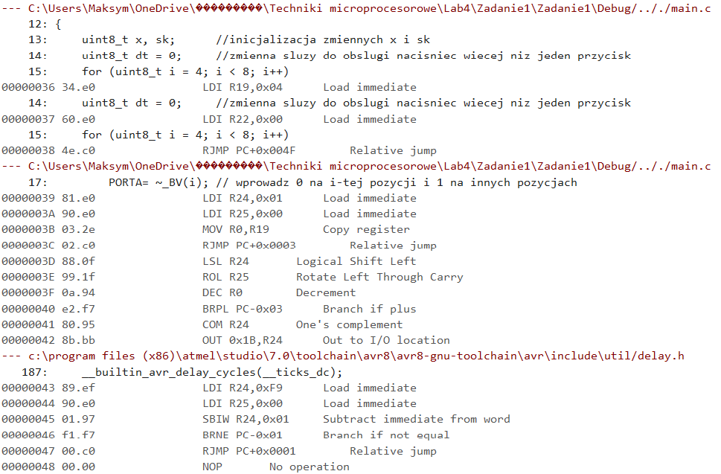

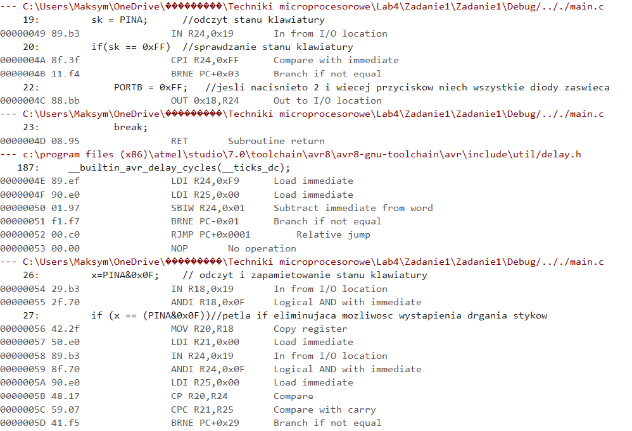

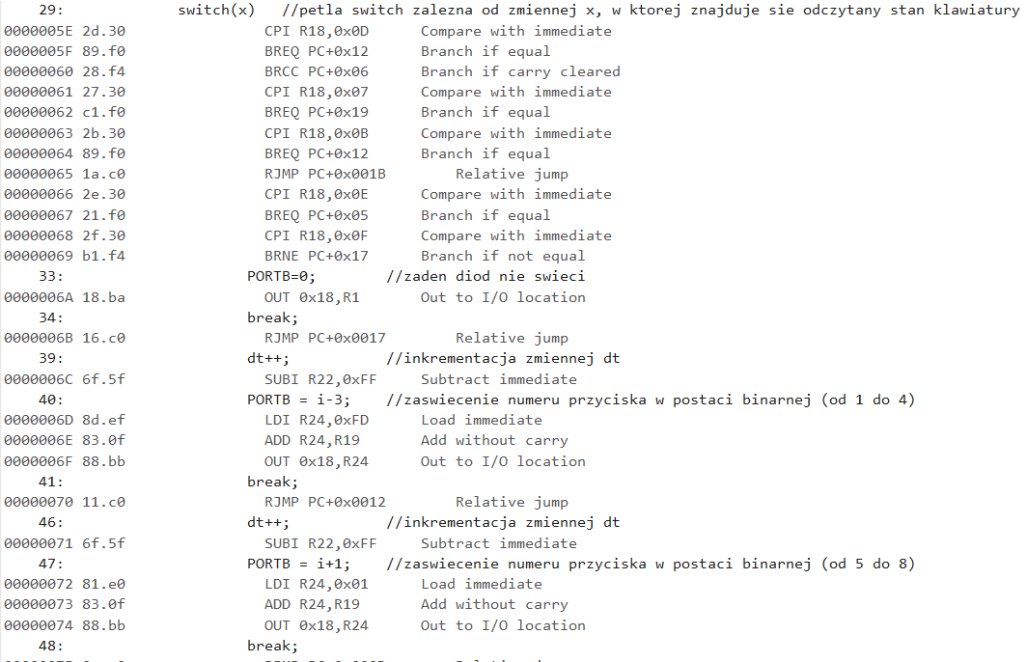

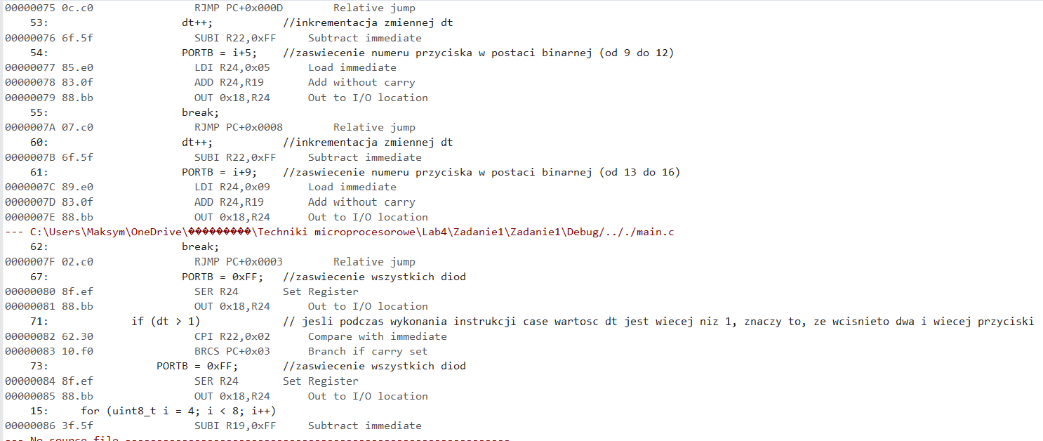

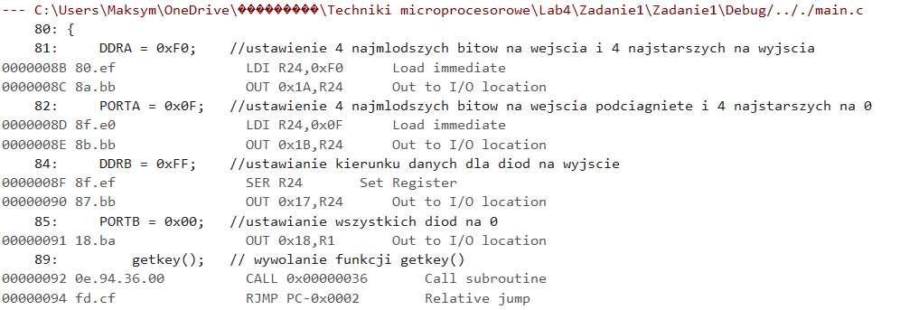

Source code:

#define *F_CPU* 1000000UL

#include <avr/io.h>

#include <util/delay.h>

void getkey()

{

*uint8_t* x, sk; //inicjalizacja zmiennych x i sk

*uint8_t* dt = 0; //zmienna sluzy do obslugi nacisniec wiecej niz jeden

przycisk

for (*uint8_t* i = 4; i < 8; i++)

{

PORTA= ~_BV(i); // wprowadz 0 na i-tej pozycji i 1 na innych pozycjach

*_delay_ms*(1); //opoznienie co 1 ms

sk = PINA; //odczyt stanu klawiatury

if(sk == 0xFF) //sprawdzanie stanu klawiatury

{

PORTB = 0xFF; //jesli nacisnieto 2 i wiecej przyciskow niech

wszystkie diody zaswieca

break;

}

*_delay_ms*(1); //opoznienie co 1 ms

x=PINA&0x0F; // odczyt i zapamietowanie stanu klawiatury

if (x == (PINA&0x0F))//petla if eliminujaca mozliwosc wystapienia drgania

stykow

{

switch(x) //petla switch zalezna od zmiennej x, w ktorej znajduje

sie odczytany stan klawiatury

{

case 0b00001111: //jesli zaden przycisk nie jest wcisniety

{

PORTB=0; //zaden diod nie swieci

break;

}

case 0b00001110: //jesli wcisnieto przycisk z wiersza 1

{

dt++; //inkrementacja zmiennej dt

PORTB = i-3; //zaswiecenie numeru przyciska w postaci

binarnej (od 1 do 4)

break;

}

case 0b00001101: //jesli wcisnieto przycisk z wiersza 2

{

dt++; //inkrementacja zmiennej dt

PORTB = i+1; //zaswiecenie numeru przyciska w postaci

binarnej (od 5 do 8)

break;

}

case 0b00001011: //jesli wcisnieto przycisk z wiersza 3

{

dt++; //inkrementacja zmiennej dt

PORTB = i+5; //zaswiecenie numeru przyciska w postaci

binarnej (od 9 do 12)

break;

}

case 0b00000111: //jesli wcisnieto przycisk z wiersza 4

{

dt++; //inkrementacja zmiennej dt

PORTB = i+9; //zaswiecenie numeru przyciska w postaci

binarnej (od 13 do 16)

break;

}

default: //jesli zadna instrukcja nie byla

wykonana, znaczy to, ze wcisnieto dwa i

wiecej przyciski

{

PORTB = 0xFF; //zaswiecenie wszystkich diod

break;

}

}

if (dt > 1) // jesli podczas wykonania instrukcji case

wartosc dt jest wiecej niz 1, znaczy to, ze wcisnieto dwa i wiecej przyciski

{

PORTB = 0xFF; //zaswiecenie wszystkich diod

}

}

}

}

int main(void)

{

DDRA = 0xF0; //ustawienie 4 najmlodszych bitow na wejscia i 4 najstarszych

na wyjscia

PORTA = 0x0F; //ustawienie 4 najmlodszych bitow na wejscia podciagniete i 4 najstarszych na 0

DDRB = 0xFF; //ustawianie kierunku danych dla diod na wyjscie

PORTB = 0x00; //ustawianie wszystkich diod na 0

while (1)

{

getkey(); // wywolanie funkcji getkey()

}

}

1. Zadanie 2

Disassembly

--- C:\Users\Maksym\OneDrive\���������\Techniki microprocesorowe\Lab4\Zadanie2\Zadanie2\Debug/.././main.c

7: uint8_t przycisk(uint8_t port, uint8_t pin) {

8: uint8_t i = 1;

9: if (port == PINA) {i=0;}

0000003E 99.b3 IN R25,0x19 In from I/O location

0000003F 98.17 CP R25,R24 Compare

00000040 11.f0 BREQ PC+0x03 Branch if equal

--- C:\Users\Maksym\OneDrive\���������\Techniki microprocesorowe\Lab4\Zadanie2\Zadanie2\Debug/.././main.c

8: uint8_t i = 1;

00000041 e1.e0 LDI R30,0x01 Load immediate

00000042 01.c0 RJMP PC+0x0002 Relative jump

9: if (port == PINA) {i=0;}

00000043 e0.e0 LDI R30,0x00 Load immediate

10: if (port & (1 << pin)) {

00000044 90.e0 LDI R25,0x00 Load immediate

00000045 06.2e MOV R0,R22 Copy register

00000046 02.c0 RJMP PC+0x0003 Relative jump

00000047 95.95 ASR R25 Arithmetic shift right

00000048 87.95 ROR R24 Rotate right through carry

00000049 0a.94 DEC R0 Decrement

0000004A e2.f7 BRPL PC-0x03 Branch if plus

0000004B 80.ff SBRS R24,0 Skip if bit in register set

0000004C 15.c0 RJMP PC+0x0016 Relative jump

11: if (!(state[i] & (1 << pin))) {

0000004D f0.e0 LDI R31,0x00 Load immediate

0000004E e0.5a SUBI R30,0xA0 Subtract immediate

0000004F ff.4f SBCI R31,0xFF Subtract immediate with carry

00000050 80.81 LDD R24,Z+0 Load indirect with displacement

00000051 90.e0 LDI R25,0x00 Load immediate

00000052 02.c0 RJMP PC+0x0003 Relative jump

00000053 95.95 ASR R25 Arithmetic shift right

00000054 87.95 ROR R24 Rotate right through carry

00000055 6a.95 DEC R22 Decrement

00000056 e2.f7 BRPL PC-0x03 Branch if plus

00000057 80.fd SBRC R24,0 Skip if bit in register cleared

00000058 08.c0 RJMP PC+0x0009 Relative jump

--- c:\program files (x86)\atmel\studio\7.0\toolchain\avr8\avr8-gnu-toolchain\avr\include\util/delay.h

187: __builtin_avr_delay_cycles(__ticks_dc);

00000059 83.ec LDI R24,0xC3 Load immediate

0000005A 99.e0 LDI R25,0x09 Load immediate

0000005B 01.97 SBIW R24,0x01 Subtract immediate from word

0000005C f1.f7 BRNE PC-0x01 Branch if not equal

0000005D 00.c0 RJMP PC+0x0001 Relative jump

0000005E 00.00 NOP No operation

--- C:\Users\Maksym\OneDrive\���������\Techniki microprocesorowe\Lab4\Zadanie2\Zadanie2\Debug/.././main.c

14: return 1;

0000005F 81.e0 LDI R24,0x01 Load immediate

00000060 08.95 RET Subroutine return

21: }

00000061 08.95 RET Subroutine return

19: return 0;

00000062 80.e0 LDI R24,0x00 Load immediate

21: }

00000063 08.95 RET Subroutine return

--- C:\Users\Maksym\OneDrive\���������\Techniki microprocesorowe\Lab4\Zadanie2\Zadanie2\Debug/.././main.c

49: int main(void) {

00000064 ef.92 PUSH R14 Push register on stack

00000065 ff.92 PUSH R15 Push register on stack

00000066 1f.93 PUSH R17 Push register on stack

00000067 cf.93 PUSH R28 Push register on stack

00000068 df.93 PUSH R29 Push register on stack

51: DDRA = 0x00;

00000069 1a.ba OUT 0x1A,R1 Out to I/O location

52: DDRB = 0xff;

0000006A 8f.ef SER R24 Set Register

0000006B 87.bb OUT 0x17,R24 Out to I/O location

53: DDRC = 0xff;

0000006C 84.bb OUT 0x14,R24 Out to I/O location

54: DDRD = 0x00;

0000006D 11.ba OUT 0x11,R1 Out to I/O location

55: PORTA = 0xff;

0000006E 8b.bb OUT 0x1B,R24 Out to I/O location

56: PORTD = 0xff;

0000006F 82.bb OUT 0x12,R24 Out to I/O location

57: PORTB = 0;

00000070 18.ba OUT 0x18,R1 Out to I/O location

58: PORTC = 0;

00000071 15.ba OUT 0x15,R1 Out to I/O location

60: j=0;k=0;state[0]=0;state[1]=0;

00000072 e0.e6 LDI R30,0x60 Load immediate

00000073 f0.e0 LDI R31,0x00 Load immediate

00000074 10.82 STD Z+0,R1 Store indirect with displacement

00000075 11.82 STD Z+1,R1 Store indirect with displacement

00000076 10.e0 LDI R17,0x00 Load immediate

00000077 d0.e0 LDI R29,0x00 Load immediate

61: while (j<2) {

00000078 2c.c0 RJMP PC+0x002D Relative jump

62: wyswietl(count[j]); //pokaz wprowadzana liczbe

00000079 ed.2e MOV R14,R29 Copy register

0000007A f1.2c MOV R15,R1 Copy register

63: for (i=0;i<8;i++) // odczytanie liczby

0000007B c0.e0 LDI R28,0x00 Load immediate

0000007C 15.c0 RJMP PC+0x0016 Relative jump

64: if ( (przycisk( &PINA, i)) && k<4 ) {

0000007D 6c.2f MOV R22,R28 Copy register

0000007E 89.e3 LDI R24,0x39 Load immediate

0000007F 0e.94.3e.00 CALL 0x0000003E Call subroutine

00000081 88.23 TST R24 Test for Zero or Minus

00000082 71.f0 BREQ PC+0x0F Branch if equal

--- No source file -------------------------------------------------------------

00000083 14.30 CPI R17,0x04 Compare with immediate

00000084 60.f4 BRCC PC+0x0D Branch if carry cleared

--- C:\Users\Maksym\OneDrive\���������\Techniki microprocesorowe\Lab4\Zadanie2\Zadanie2\Debug/.././main.c

65: count[j]= (count[j] * 10) + i;

00000085 f7.01 MOVW R30,R14 Copy register pair

00000086 ee.59 SUBI R30,0x9E Subtract immediate

00000087 ff.4f SBCI R31,0xFF Subtract immediate with carry

00000088 80.81 LDD R24,Z+0 Load indirect with displacement

00000089 88.0f LSL R24 Logical Shift Left

0000008A 98.2f MOV R25,R24 Copy register

0000008B 99.0f LSL R25 Logical Shift Left

0000008C 99.0f LSL R25 Logical Shift Left

0000008D 89.0f ADD R24,R25 Add without carry

0000008E 8c.0f ADD R24,R28 Add without carry

0000008F 80.83 STD Z+0,R24 Store indirect with displacement

66: k++;

00000090 1f.5f SUBI R17,0xFF Subtract immediate

63: for (i=0;i<8;i++) // odczytanie liczby

00000091 cf.5f SUBI R28,0xFF Subtract immediate

--- No source file -------------------------------------------------------------

00000092 c8.30 CPI R28,0x08 Compare with immediate

00000093 48.f3 BRCS PC-0x16 Branch if carry set

00000094 c0.e0 LDI R28,0x00 Load immediate

00000095 0d.c0 RJMP PC+0x000E Relative jump

00000096 6c.2f MOV R22,R28 Copy register

00000097 80.e3 LDI R24,0x30 Load immediate

00000098 0e.94.3e.00 CALL 0x0000003E Call subroutine

0000009A 88.23 TST R24 Test for Zero or Minus

0000009B 31.f0 BREQ PC+0x07 Branch if equal

0000009C d1.11 CPSE R29,R1 Compare, skip if equal

0000009D 02.c0 RJMP PC+0x0003 Relative jump

0000009E c0.93.64.00 STS 0x0064,R28 Store direct to data space

000000A0 df.5f SUBI R29,0xFF Subtract immediate

000000A1 10.e0 LDI R17,0x00 Load immediate

000000A2 cf.5f SUBI R28,0xFF Subtract immediate

000000A3 c8.30 CPI R28,0x08 Compare with immediate

000000A4 88.f3 BRCS PC-0x0E Branch if carry set

000000A5 d2.30 CPI R29,0x02 Compare with immediate

000000A6 90.f2 BRCS PC-0x2D Branch if carry set

000000A7 80.91.64.00 LDS R24,0x0064 Load direct from data space

--- C:\Users\Maksym\OneDrive\���������\Techniki microprocesorowe\Lab4\Zadanie2\Zadanie2\Debug/.././main.c

75: switch(j) {

000000A9 82.30 CPI R24,0x02 Compare with immediate

000000AA c9.f0 BREQ PC+0x1A Branch if equal

000000AB 28.f4 BRCC PC+0x06 Branch if carry cleared

000000AC 88.23 TST R24 Test for Zero or Minus

000000AD 41.f0 BREQ PC+0x09 Branch if equal

000000AE 81.30 CPI R24,0x01 Compare with immediate

000000AF 69.f0 BREQ PC+0x0E Branch if equal

000000B0 30.c0 RJMP PC+0x0031 Relative jump

000000B1 83.30 CPI R24,0x03 Compare with immediate

000000B2 d1.f0 BREQ PC+0x1B Branch if equal

000000B3 84.30 CPI R24,0x04 Compare with immediate

000000B4 29.f1 BREQ PC+0x26 Branch if equal

000000B5 2b.c0 RJMP PC+0x002C Relative jump

77: count[2]=count[0]+count[1];

000000B6 e2.e6 LDI R30,0x62 Load immediate

000000B7 f0.e0 LDI R31,0x00 Load immediate

000000B8 90.81 LDD R25,Z+0 Load indirect with displacement

000000B9 81.81 LDD R24,Z+1 Load indirect with displacement

000000BA 89.0f ADD R24,R25 Add without carry

000000BB 82.83 STD Z+2,R24 Store indirect with displacement

78: break;

000000BC 24.c0 RJMP PC+0x0025 Relative jump

80: count[2]=count[0]-count[1];

000000BD e2.e6 LDI R30,0x62 Load immediate

000000BE f0.e0 LDI R31,0x00 Load immediate

000000BF 80.81 LDD R24,Z+0 Load indirect with displacement

000000C0 91.81 LDD R25,Z+1 Load indirect with displacement

000000C1 89.1b SUB R24,R25 Subtract without carry

000000C2 82.83 STD Z+2,R24 Store indirect with displacement

81: break;

000000C3 1d.c0 RJMP PC+0x001E Relative jump

83: count[2]=count[0]*count[1];

000000C4 e2.e6 LDI R30,0x62 Load immediate

000000C5 f0.e0 LDI R31,0x00 Load immediate

000000C6 80.81 LDD R24,Z+0 Load indirect with displacement

000000C7 91.81 LDD R25,Z+1 Load indirect with displacement

000000C8 89.9f MUL R24,R25 Multiply unsigned

000000C9 80.2d MOV R24,R0 Copy register

000000CA 11.24 CLR R1 Clear Register

000000CB 82.83 STD Z+2,R24 Store indirect with displacement

--- C:\Users\Maksym\OneDrive\���������\Techniki microprocesorowe\Lab4\Zadanie2\Zadanie2\Debug/.././main.c

84: break;

000000CC 14.c0 RJMP PC+0x0015 Relative jump

86: count[2]=(count[0]*10)/count[1];

000000CD e2.e6 LDI R30,0x62 Load immediate

000000CE f0.e0 LDI R31,0x00 Load immediate

000000CF 80.81 LDD R24,Z+0 Load indirect with displacement

000000D0 2a.e0 LDI R18,0x0A Load immediate

000000D1 82.9f MUL R24,R18 Multiply unsigned

000000D2 c0.01 MOVW R24,R0 Copy register pair

000000D3 11.24 CLR R1 Clear Register

000000D4 61.81 LDD R22,Z+1 Load indirect with displacement

000000D5 70.e0 LDI R23,0x00 Load immediate

000000D6 0e.94.e9.00 CALL 0x000000E9 Call subroutine

000000D8 62.83 STD Z+2,R22 Store indirect with displacement

87: break;

000000D9 07.c0 RJMP PC+0x0008 Relative jump

89: if(count[1]=count[0]){

000000DA e2.e6 LDI R30,0x62 Load immediate

000000DB f0.e0 LDI R31,0x00 Load immediate

000000DC 80.81 LDD R24,Z+0 Load indirect with displacement

000000DD 81.83 STD Z+1,R24 Store indirect with displacement

000000DE 81.11 CPSE R24,R1 Compare, skip if equal

90: count[2]=count[1];

000000DF 80.93.64.00 STS 0x0064,R24 Store direct to data space

102: }

000000E1 80.e0 LDI R24,0x00 Load immediate

000000E2 90.e0 LDI R25,0x00 Load immediate

000000E3 df.91 POP R29 Pop register from stack

000000E4 cf.91 POP R28 Pop register from stack

000000E5 1f.91 POP R17 Pop register from stack

000000E6 ff.90 POP R15 Pop register from stack

000000E7 ef.90 POP R14 Pop register from stack

000000E8 08.95 RET Subroutine return

Source code:

#include <avr/io.h>

#include <util/delay.h>

#include <inttypes.h>

*uint8_t* count[3];//tablica liczb do operacji

*uint8_t* state[2];

*uint8_t* przycisk(*uint8_t* port, *uint8_t* pin) {

*uint8_t* i = 1;

if (port == PINA) {i=0;}

if (port & (1 << pin)) {

if (!(state[i] & (1 << pin))) {

*_delay_ms*(10);

return 1;

}

}

else

{

return 0;

}

}

*uint8_t* znaki(*uint8_t* znaczek) {

/* przetwarzanie uint8 do 7LED */

switch(znaczek) {

case 0 : return 0x3F;

case 1 : return 0x06;

case 2 : return 0x5B;

case 3 : return 0x4F;

case 4 : return 0x66;

case 5 : return 0x6D;

case 6 : return 0x7D;

case 7 : return 0x07;

case 8 : return 0x7F;

case 9 : return 0x6F;

default: return 0xAA;

}

return 0xAA;

}

void wyswietl(*uint8_t* num) {//fukcja do wyswietlanie na 7LED

*uint8_t* led[4];

if (num <= 9999) {

led[3]=num/1000;//ustalanie na 1 kolumnie

led[2]=(num%1000)/100;//ustalanie na 1,2 kolumnie

led[1]=(num%100)/10;// ustalanie na 1,2,3 kolumnie

led[0]=num%10;//ustalanie na 1,2,3,4 kolumnie

}

}

int main(void) {

//deklaracja portow A,B,C,D

DDRA = 0x00;

DDRB = 0xff;

DDRC = 0xff;

DDRD = 0x00;

PORTA = 0xff;

PORTD = 0xff;

PORTB = 0;

PORTC = 0;

*uint8_t* i,j,k;

j=0;k=0;state[0]=0;state[1]=0;

while (j<2) {

wyswietl(count[j]); //pokaz wprowadzana liczbe

for (i=0;i<8;i++) // odczytanie liczby

if ( (przycisk( &PINA, i)) && k<4 ) {

count[j]= (count[j] * 10) + i;

k++;

}

for (i=0;i<8;i++) //odczytujemy operacje dla liczb

if (przycisk( &PIND, i)) {

if (!j) count[2]=i;

j++;k=0;

}

}

j=count[2];

switch(j) {

case 0: // dodawanie

count[2]=count[0]+count[1];

break;

case 1: // odejmowanie

count[2]=count[0]-count[1];

break;

case 2: // mnozenie

count[2]=count[0]*count[1];

break;

case 3: // dzielenie

count[2]=(count[0]*10)/count[1];

break;

case 4: //czy jest rowne

if(count[1]=count[0]){

count[2]=count[1];

}

else

{

break;

}

}

while(1)

{

wyswietl(count[2]);//wyswietlamy wynik

return 0;

}

}