**Abstract**

The information system for communication with alumni includes one of many ways how university can keep tracking with its alumni. Alumni means the graduates or, more broadly, former students of an institution. Universities all around the world have thousands of alumni. Many of the universities does not have a system to manage alumni information. It is important to manage the information’s of all alumni and keep tracking the former students along with the fresh graduates. The university often organize events, also provides various opportunities for the former students that help all the alumni to maintain connection with the university. The Alumni Management System proposed to manage the information’s of all former students of the university efficiently so that it can keep a connection with all the alumni. Managing alumni information’s by using the existing system would be more time consuming. The other student management system of the university has specific tasks to accomplish and mostly deals with the current students. So introducing a new system is a great idea that will keep a track of alumni. The aim of this project is to build an online Alumni Management System that will keep a track of all the updated information’s of University graduates. This project regarded to complete in two phases. The initial phase will be the creation of simple system to use to capture data from current final year students before the end term. The second phase of development will extend the functionality of the system to allow past alumni to register. The project manages the fresh as well as old graduate students who register with their respective information. The system will have a notification service to notify the alumni about upcoming events. The system will collect actual information of former students. Most importantly, the system will categorize all the alumni according to their major’s and their graduation year. The system will allow graduates to communicate with each other.

**Keywords:** Alumni, Management system, Maintain connection, Tracking, system, former students.

**TABLE OF CONTENT**

**CHAPTER CONTENT PAGE**

**1 INTRODUCTION 4**

1.1 Introduction 4

1.2 Objective 4

1.3 Scope of the Study 5

1.4 Justification of the Study 5

**2 LITERATURE REVIEW 6**

2.1 Background of Study 6

2.2 Related Work 6

2.2.1 Independent University Alumni System 6

2.2.2 Techno Developers Group 7

(Alumni Management System)

2.2.3 Alumni Tracking System 8

2.2.4 Northern University Bangladesh 9

Alumni System

2.2.5 AlmaHub 10

**3 METHODOLOGY 12**

3.1 Introduction 12

3.2 RAD Phases 13

3.3 Justification of Choosing RAD 15

**4 ANALYSIS, DESIGN AND DEVELOPMENT 16**

4.1 Requirement Analysis 16

4.2 System Design 16

4.2.1 System Flow Chart 17

4.2.2 Use-Case Diagram 19

4.2.3 Sequence Diagram 21

4.3 Development 24

4.3.1 Language- PHP, JavaScript, HTML, Css 24

4.3.2 Tool – Vs Code 25

4.3.3 Database- MySql 26

**5 PROJECT DESCRIPTION 27**

5.1 Problem Definition 27

5.2 Project Overview 27

5.3 Module Description 28

5.4 Snapshot of project 28

**6 CONCLUSION 36**

6.1 Conclusion 36

6.2 Limitations 36

6.3 Future Work 36

**Chapter 1 Introduction**

* 1. **Introduction**

Alumni management is one of the thrust areas considered focal to institutional development mostly in developing countries. A strong alumni system plays a vital role in reaping enormous benefits for student-student networks as well as institution-student networks (CAMS-Adrita, 2019).

The best resource any University can have is the Alumni Management System. Alumni are the former students of the university that represents the university in the real world (Bander Ali, 2017). The "Alumni Management System" for the students will be an incorporated web application to oversee alumni information. The proposed framework is a web application that permits previous students to keep an association with the university and with alumni.

The alumni network is significant in the advancement of the institution in light of their immense potential that benefits both the Institution and the students. Many advantages for are being an alumni from a University. A portion of the advantages is keeping an individual illuminate on the occasions coordinated by the University. Another advantage is that data concerning a previous student can be received effectively and different individuals from the alumni located without much stress. The alumni will be able to communicate with each other.

* 1. **Objective**

The objectives of this project are:

1. To build a system that will be able to manage alumni data and provide easy access to the same.
2. To reduce pressure of other student management system that deals with the current student.
3. To provide user-friendly interface.
4. Quick data retrieval and large amount of data storing.
5. To allow former students and fresh graduates communicate with each other.

To allow the alumni keep a connection with the university

* 1. **Scope of the Study**

The System is a web-based application framework, which can go about as an intuitive medium between the old students and the University. A web-based is an online application that assists the Institution to track its alumni and maintaining up to date information. Simultaneously it assists the graduates to stay connected with the university and other alumni. This system developed to facilitate the former students of the university. There are various features in the system that will help the alumni in various ways. User will be able to register, login, check for event notification, check gallery and search for other alumni. The system can be fully utilized by the user to build connectivity with other alumni and the university. Alumni and fresh graduates will be able to post jobs and apply jobs if available. Moreover, this system can bring various opportunities to its users.

* 1. **Justification of Study**

There are many robust systems for managing alumni data. The existing systems has very few features to help the alumni. Many of the systems do not have a proper registration and login feature, while the other systems studied not maintained well and have less data security. The proposed system has user register function, with better data security and many other features that allows users to remain up to date with regular events also to build a connection with other alumni.

**Chapter 2 Literature Review**

**2.1 Background of the Study**

To develop a new system it is necessary to study the existing system that are working in the market to know their draw backs and introduce solutions to overcome the problems which are faces by existing system. For this purpose, some of the existing systems that currently work with the alumni have been studied and explored. The systems that have been studied are IUB Alumni System, TDG Alumni System, NUB Alumni System, and AlmaHub. The systems that are used in other university has many limitations. Many of the systems do not have proper alumni registering feature and have lack of data security. All the related systems are given below with the advantages and limitations.

**2.2 Related Work**

**2.2.1 Independent University Alumni System**

Independent University (IUB) is a famous private University in Bangladesh that is located in Bashundhara R/A, Dhaka, Bangladesh. It was established in 1993 by the Private University Act, 1992 [1]. Like every other university it has an alumni system that enables students to know about the alumni. The admin posts here the notable alumni and students can browse and see their information. There is a heap of students added in data.

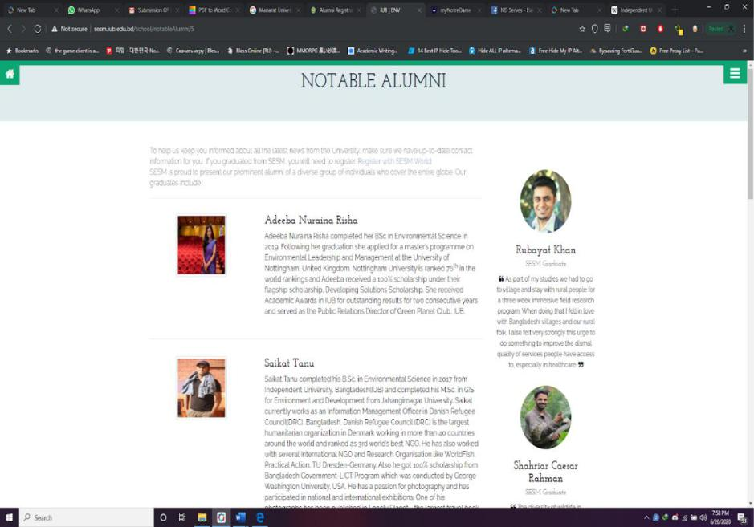**Screenshot:**

**Figure 2.1**

Name of notable alumni with the achievements are mentioned here so that the fresh graduates get motivated.

**Pros:**

* Well-designed system and accurate user interface.
* Notable alumni are mentioned which greatly helps to motivate current students.
* Linked with main homepage.
* Greatly helps getting introduced with each other.

**Limitations:**

* Not a pure database system. It can be said as directories.
* User Login system is not provided.
* Only Notable students, not every alumni data inserted.
* Privacy and security of information are weak.
* Lack of activity, news portal and social networking.

**2.2.2 Techno Developers Group (Alumni Management System)**

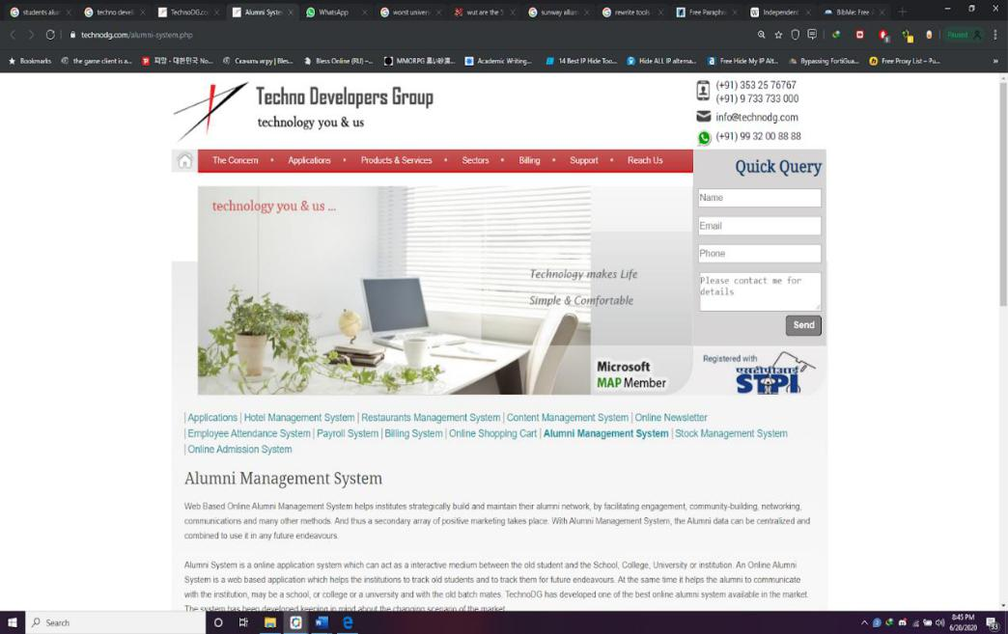Techno Developers Group has web based online Alumni system that helps institutes, strategically build and maintain their alumni network, by facilitating engagement, community-building, networking, communications and many other methods [2]. Their Alumni System is fully online based and interactive medium between alumni students and the institute. This system tracks the old students and keeps database of their current and thus letting institutes know the student’s information. At the same time, it enables alumni to communicate with the institute and old batch mates.

**Screenshot:**

**Figure 2.2**

**Pros:**

* Online based Alumni system made by experts.
* It has Admin/Moderator approval option.
* It has facilities as if registering alumni can edit text, images.
* Form mail-based communication method between the alumni.
* Admin option to edit/delete/register new alumni.
* Admin option to send common mailer to all alumni.

**Limitations:**

* As a group of experts created, it and they are admin. It has a security issue of leaking out information to individuals.
* Admin can change anything as their will, thus lack of having data privacy.
* Institutes information may leak, or a hacker issue might rise as it is an outsourced web application.

**2.2.3 Alumni Tracking System**

The project primarily aims to replace current tracking procedures of college graduates and provide alumni data to college faculties. Alumni information will be stored in the database of the server which will be accessible through a web portal to the faculty in charge of the college. A platform must exist where all the alumni can easily update their profile, have persistent storage of student data and can be easily accessed by college. Alumni mentorship programs can help alumni to suggest mentorship programs for students. Aim of our project is to develop an android application which will be useful to track all the alumni by their social media account information using web API's.Alumni to alumni messaging facility is provided through GCM (Google Cloud Messaging) technology. One of the main ways to identify what are the demands to be met is creating a manner to manage information of its alumni. Web App Module the Web App Authority will able the create the new application authority and new users, the web app authority users will only be the college faculties will be able to create users, access the alumni information and notify about certain seminar.

**2.2.4 Northern University Bangladesh Alumni System**

Northern University of Bangladesh keeping in step with the rapidly increasing demand for higher education, the Government of the People’s Republic of Bangladesh passed the Private Universities Act in 1992 which has been revised and replaced by Private University Act 2010. Presently Northern University Bangladesh (NUB) has 5 Faculties situated within the Dhaka Metropolitan city with its Permanent Campus near Haji camp at Ashkona, Dakshin Khan. This is one of the well-known universities of Bangladesh. Alumni system of this University is called “NUB alumni association”. Northern University Bangladesh Alumni Association (NUBAA) started its journey in the year 2009. During the passage of time the NUBAA has been enriched with experience and attained with a tradition. NUBAA aims to deliver its most effective relationship among Alumnus. It will arrange programs anywhere in Bangladesh. The objective of the website was made, it was acquired.

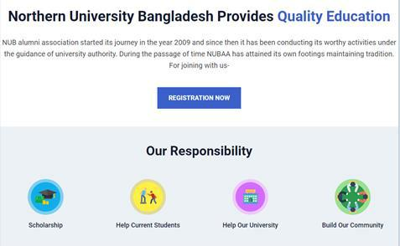**Screenshot:**

**Figure 2.3**

**Pros:**

* Greatly helps getting introduced with each other
* It enables end users to save time, finding established students.
* Notable alumni are mentioned which helps to motivate current students.
* Linked with the main homepage.

**Limitation:**

* Technologically not so well maintained
* Not a pure database system
* Login system not provided
* Lack of activity, news portal and social networking
* Privacy and security of information are very weak
* Have just a member list, not students list there

**2.2.5 AlmaHub**

AlmuHub is an online application system that builds an engaging, online alumni community on web and Mobile. Their goal is to simplify the task of building and maintaining lifelong relationships amongst Alumnus. The website they developed is so well furnished and attractive and so well made. The designing user interfaces are good to see. The admins and students post here the notable alumni and students can browse and see their information. There is a heap of students added in data.

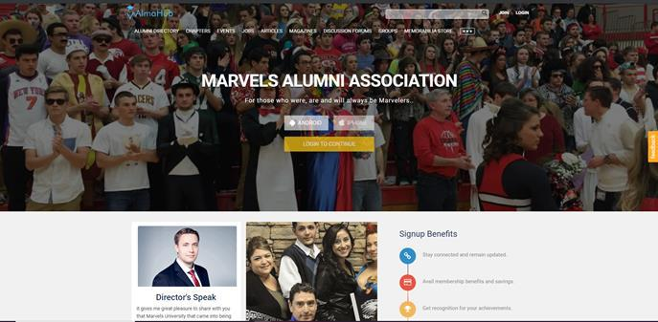**Screenshot:**

**Figure 2.4**

**Pros:**

* Well maintained database system
* Event management
* Member Accounts and Directories
* Membership Management
* Users Community and Portal
* Well managed website and system

**Limitations:**

* Pay to use monthly subscription system
* Students and teacher’s login systems are not provided
* Not very safe to be used for an organization and person as data can be stolen

**Chapter 3 Methodology**

**3.1 Introduction**

This chapter describes systematic method applied to develop the project. The flow chart below depicts flow of this chapter.

RAD Model

Phases of RAD

Justification of RAD

The chosen SDLC model for developing the system is RAD (Rapid Application Development). RAD: Rapid Application Development (RAD) is a form of agile software development methodology that prioritizes rapid prototype releases and iterations. Unlike the waterfall method, RAD emphasizes the use of software and user feedback over strict planning and requirements recording (capterra, 2019).

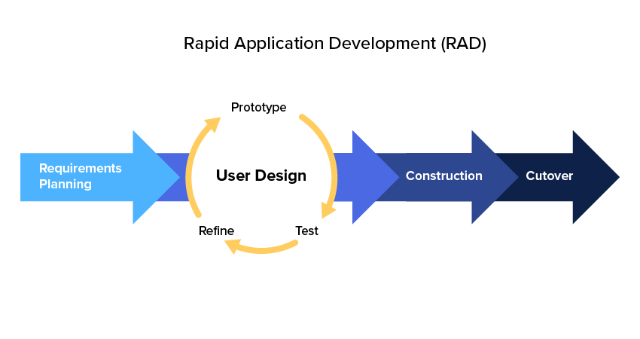

**3.2 RAD (Rapid Application Development) Phases**

**3.2.1 Requirement Planning**

This phase is equivalent to a project-scoping meeting ([lucidChart](https://www.lucidchart.com/blog/rapid-application-development-methodology)). Although, comparing to other methodologies the planning phase is condensed, this is a critical step for the building a successful project. During this stage, a preliminary study and research been conducted on other existing systems and a survey carried out to determine the goals and expectations for the project.

**3.2.2 User Design**

After scoping the project, it was time to build out the user design through various prototype iterations. This is the phase where user and developer work hand in hand ([lucidChart](https://www.lucidchart.com/blog/rapid-application-development-methodology)).. A prototype of the system been built in this phase. The designed prototype evaluated by the users.

**Product Evaluation Questions**

Does the interface look understandable?

Do you like the interface?

As per the video are all the modules working?

Does the system looks user friendly?

Would you like to use the system?

Used legible font?

User friendly system?

Navigation to pages is smooth?

Used appropriate colors?

Interface Design?

Organized information compilation?

**3.2.3 Rapid construction**

This is the phase where the prototypes and beta systems from the design phase taken to convert into the working model ([lucidChart](https://www.lucidchart.com/blog/rapid-application-development-methodology)).. As the majority of the problems and changes addressed during the thorough iterative design phase, it was right time to construct the final working model more quickly. A final working model of the project constructed in this phase.

**3.2.4 Cutover**

This is the implementation phase where the finished product goes to launch. This phase includes data conversion, testing and changeover to the new system, as well as user training. A final changes are made in this phase while looking for the bugs in the system ([lucidChart)](https://www.lucidchart.com/blog/rapid-application-development-methodology)..

**3.3 Justification of choosing RAD methodology**

The traditional SDLC follows a rigid process models with high emphasis on requirement analysis and gathering before the coding starts. It puts pressure on the customer to sign off the requirements before the project starts and the customer does not get the feel of the product, as there is no working build available for a long time.

The customer may need some changes after he gets to see the software. However, the change process is quite rigid and it may not be feasible to incorporate major changes in the product in the traditional SDLC.

The RAD model focuses on iterative and incremental delivery of working models to the customer. This results in rapid delivery to the customer and customer involvement during the complete development cycle of product reducing the risk of non-conformance with the actual user requirements. RAD model enables rapid delivery as it reduces the overall development time due to the reusability of the components and parallel development. RAD works well only if high skilled engineers are available and the customer is also committed to achieve the targeted prototype in the given period. If there is, commitment lacking on either side the model may fail (tutorialspoint, n.d).

**Chapter 4 Analysis, Design and Development**

**4.1 Requirement Analysis**

**Supportive Operating Systems:**

The supported Operating Systems for client include:

* Windows 7 onwards
* Linux

**Software Requirement:**

The Software Requirement in this project include:

* Apache
* PhpMyAdmin
* Google Chrome, Edge, Mozilla FireFox etc

**Hardware Requirement:**

Recommended PC specification for developing this system

* Processor: Intel Core i5 (2.00 Ghz and above)
* RAM: 4 GB
* Graphics Processing Unit (GPU): NVIDIA GTX (240 and above) or ATI REDON (5770 and above)
* Hard Disk: 500 GB

**4.2 System Design**

Systems design is the process of defining elements of a system like modules, architecture, components and their interfaces and data for a system based on the specified requirements. It is the process of defining, developing and designing systems, which satisfies the specific needs.

**4.2.1 System Flow Chart**

**Alumni**

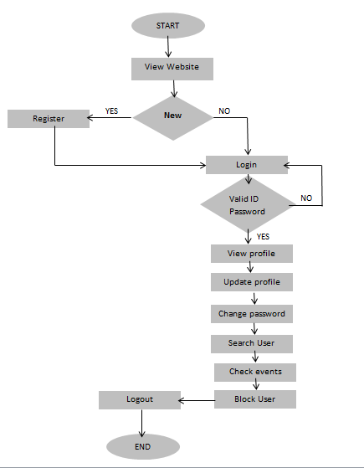

**Admin**

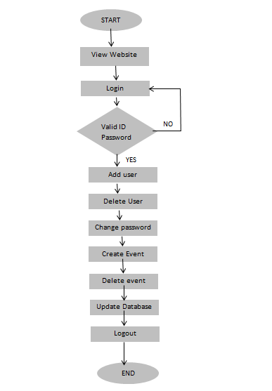

**4.2.2 Use-Case Diagram**

**Admin**

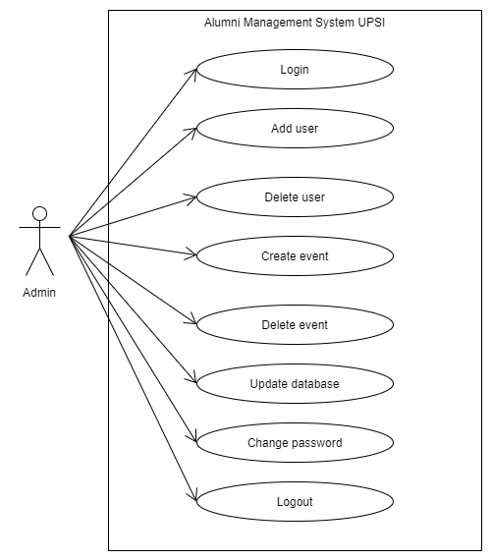

**Admin has the following tasks**

* Login
* Add user
* Delete user
* Create event
* Delete event
* Change password
* Logout

**Alumni**

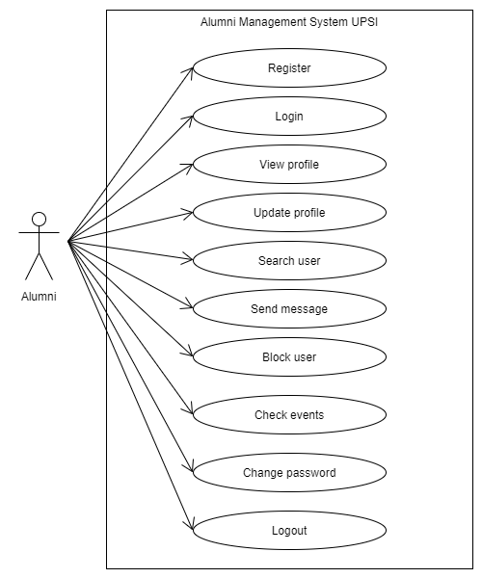

**Alumni has the following powers**

* Registration
* Login
* Update profile
* Search user
* Check event
* Logout

**4.2.3 Sequence Diagram**

**Admin**

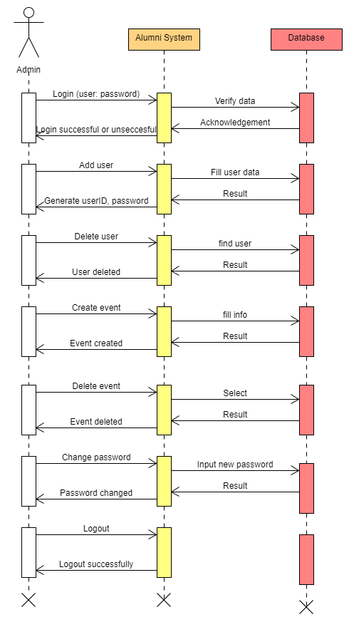

-The admin enters the id and password

-The information will be validated

It enables the admin to manage the database, change database if required, and then show the results

-Can add users

-Can delete users

-Can update database

-Can create event

-Can delete event

-And change password

**Alumni**

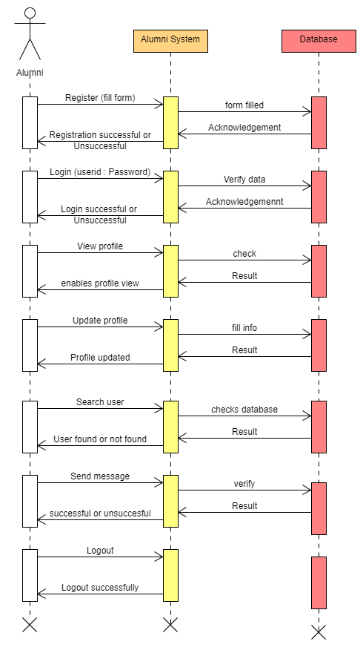

-Alumni can register in the system. Register user can use the system using email and password.

**4.3 Development**

**4.3.1 Language– PHP, JavaScript, HTML, Css**

**PHP**

PHP is a general-purpose scripting language geared toward web development. Danish-Canadian programmer Rasmus Ledorf originally created it in 1994. The PHP Group now produces the PHP reference implementation. PHP originally stood for Personal Home Page, but it now stands for Hypertext Preprocessor (Wikipedia).

**JavaScript**

JavaScript is a programming language that is one of the core technologies of the World Wide Web, alongside HTML and CSS. Over 97% of websites use JavaScript on the client side for web page behavior, often incorporating third-party libraries. All major web browsers have a dedicated JavaScript engine to execute the code on users' devices. JavaScript is a high-level, often just in time-compiled language that conforms to the ECMAScript standard. It has dynamic typing, prototype-based object-orientation, and first-class functions. It is multi-paradigm, supporting event-driven, functional, and imperative programming styles. It has application programming interfaces (APIs) for working with text, dates, regular expressions, standard data structures, and the Document Object Model (DOM) (Wikipedia).

**HTML**

The HyperText Markup Language or HTML is the standard markup language for documents designed to be displayed in a web browser. It can be assisted by technologies such as Cascading Style Sheets (CSS) and scripting languages such as JavaScript. Web browsers receive HTML documents from a web server or from local storage and render the documents into multimedia web pages. HTML describes the structure of a web page semantically and originally included cues for the appearance of the document.HTML elements are the building blocks of HTML pages (Wikipedia).

**CSS**

Cascading Style Sheets (CSS) is a style sheet language used for describing the presentation of a document written in a markup language such as HTML. CSS is a cornerstone technology of the World Wide Web, alongside HTML and JavaScript. CSS is designed to enable the separation of presentation and content, including layout, colors, and fonts. This separation can improve content accessibility; provide more flexibility and control in the specification of presentation characteristics; enable multiple web pages to share formatting by specifying the relevant CSS in a separate .css file, which reduces complexity and repetition in the structural content; and enable the .css file to be cached to improve the page load speed between the pages that share the file and its formatting (Wikipedia).

**4.3.2 Tool – VS Code**

Visual Studio Code, also commonly referred to as VS Code, is a source-code editor made by Microsoft for Windows, Linux and macOS. Features include support for debugging, syntax highlighting, intelligent code completion, snippets, code refactoring, and embedded Git.

Users can change the theme, keyboard shortcuts, preferences, and install extensions that add additional functionality. Visual Studio Code was first announced on April 29, 2015, by Microsoft at the 2015 Build conference. A preview build was released shortly thereafter. On November 18, 2015, the source of Visual Studio Code was released under the MIT License, and made available on GitHub. Extension support was also announced (Wikipedia).

**4.3.3 Database – MySql**

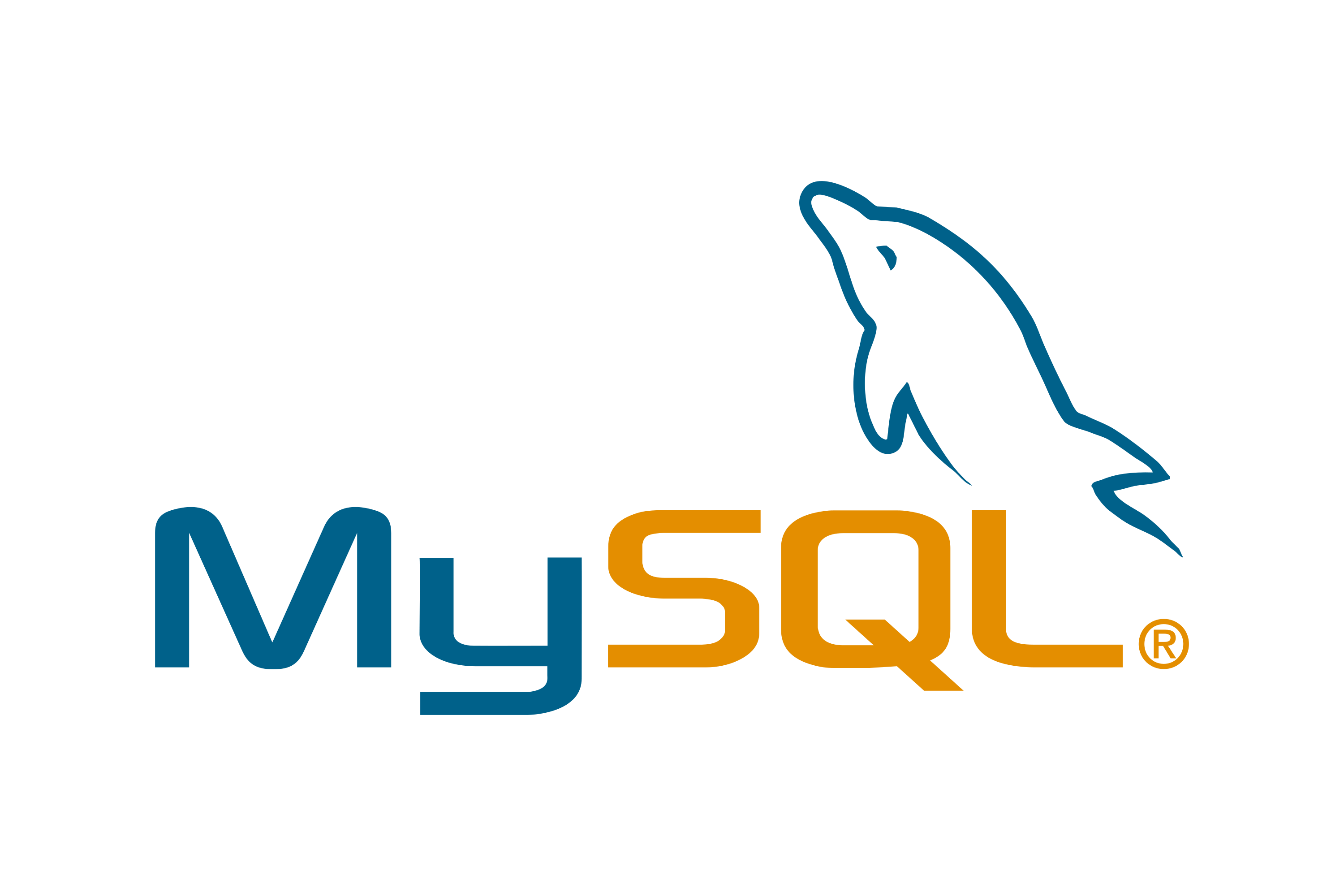MySQL is an open-source relational database management system (RDBMS). Its name is a combination of "My", the name of co-founder Michael Widenius's daughter, and "SQL", the abbreviation for Structured Query Language. A relational database organizes data into one or more data tables in which data types may be related to each other; these relations help structure the data. SQL is a language programmers use to create, modify and extract data from the relational database, as well as control user access to the database.

**Chapter 5 Project Description**

**5.1 Problem Definition**

There is a developed applications used in the university. This project is to develop a web-based system that will work with a broader database. The existing web-based system/portal of university deals with the current students only. It will become complicated if the university wants to use the existing system to manage the alumni information.

Retrieving detail and accurate information about the alumni and engaging with all the alumni together in a single platform is not an easy task if a University does not have a proper platform. To manage the alumni information efficiently there should be a system dedicated to the alumnus.

The problems are:

* The university needs a proper medium to manage alumni information’s efficiently.
* Sometimes the announcement or information about event does not get to the right person at the right time.
* Most of the Time University does not have the updated information’s of alumni.

**5.2 Project Overview**

**“Alumni Management System”** designed to manage the information’s of all alumni and keep tracking the former students along with the fresh graduates. As we know alumni are the one who represent the university in real world. It is important to keep a track of all alumni.

The System will allow it is users to communicate with each other. All the former students will be able to know and share their views and ideas through the platform. An Alumni Management system is an asset for any institution around the world. The university and the alumni can maintain their connection with each other through the system.

**5.3 Module Description**

**Registration Module:** In this module, the user can register onto the system. The GUI is made attractive with the help of css, Javascript is used for validating the input fields that will be feeded by the user.

**Login Module:** In this module, the registered user can login onto the system using email and password.

**Event Module:** In this module, user can check upcoming event information and details of event.

**Gallery Module:** This module displays event photos.

**Job Module:** This module displays the jobs posted by user.

**Alumni Module:** This module displays information of registered alumni.

**5.4 Snapshots of the project**

**Home Page**

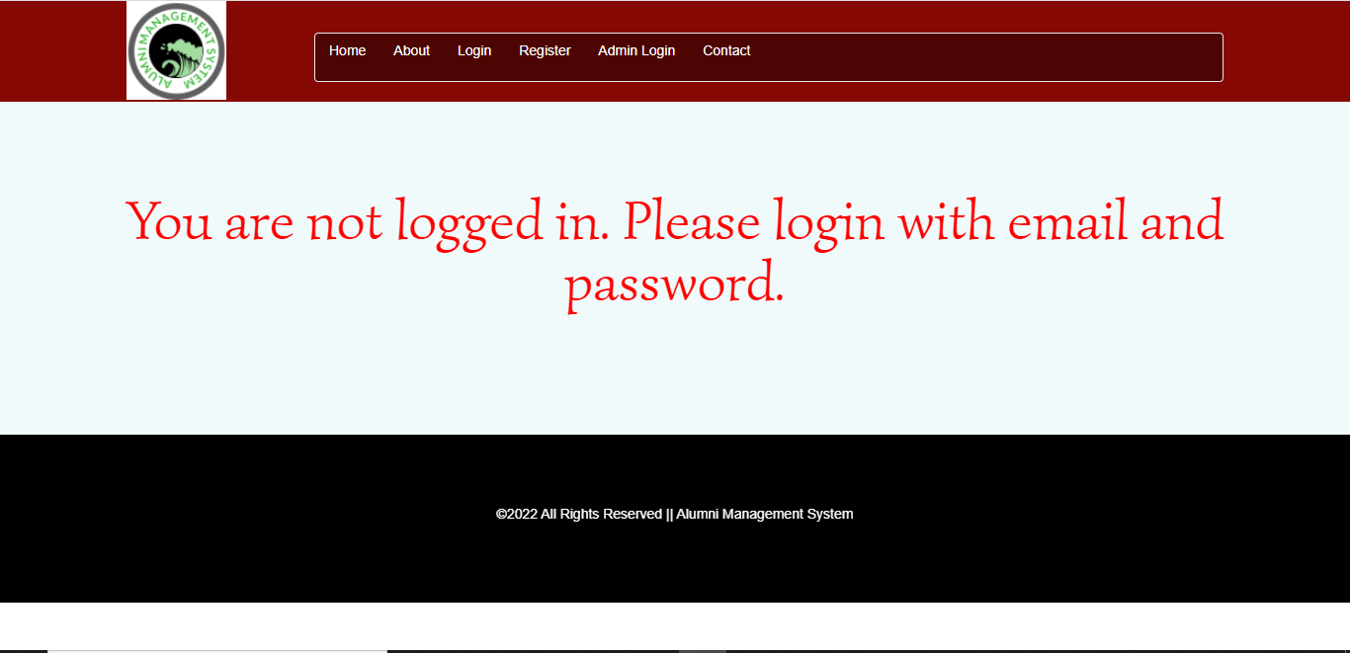

**About Page**

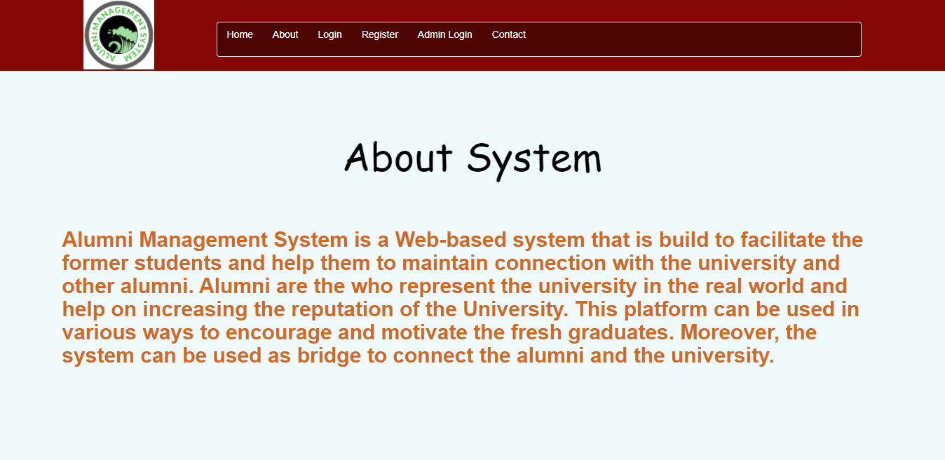

**Login Page**

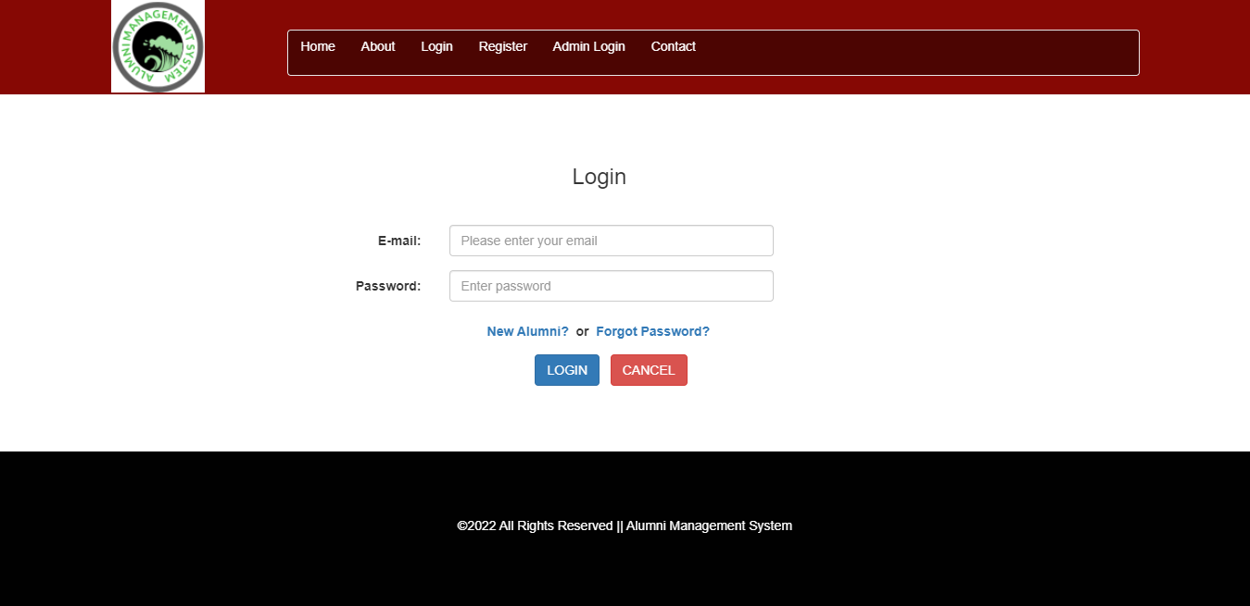

**Registration Page**

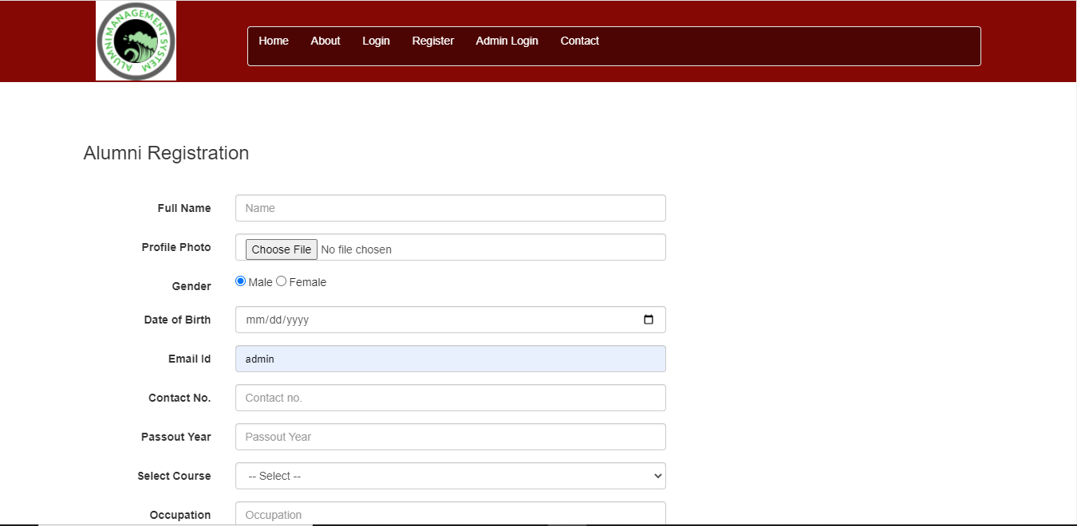

**Feedback Page**

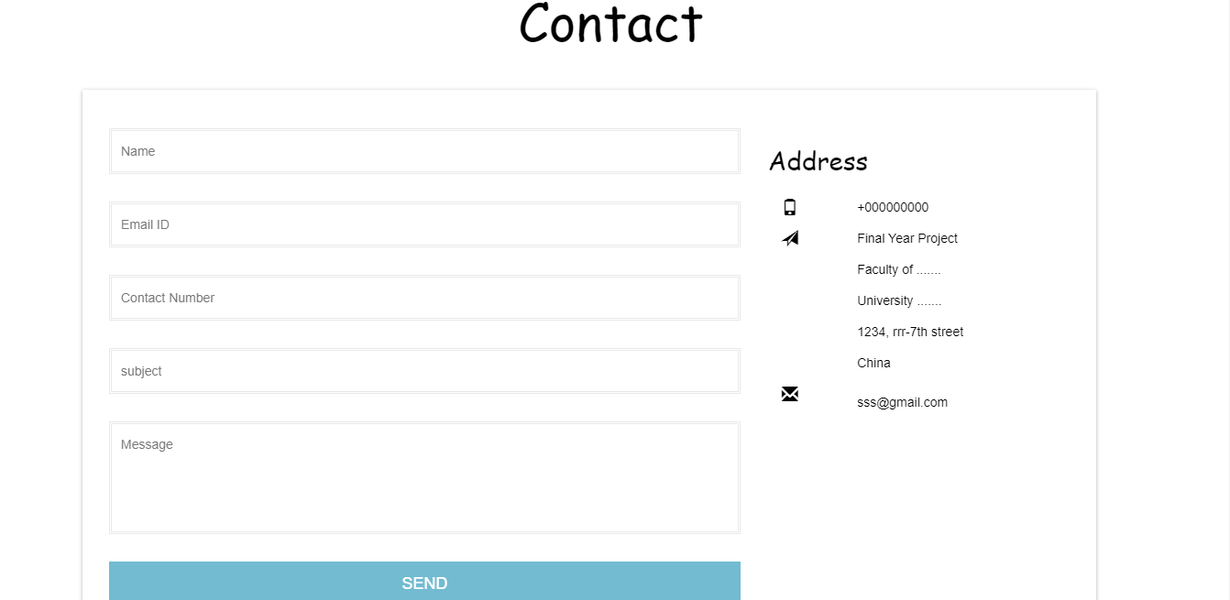

**Alumni Home Page**

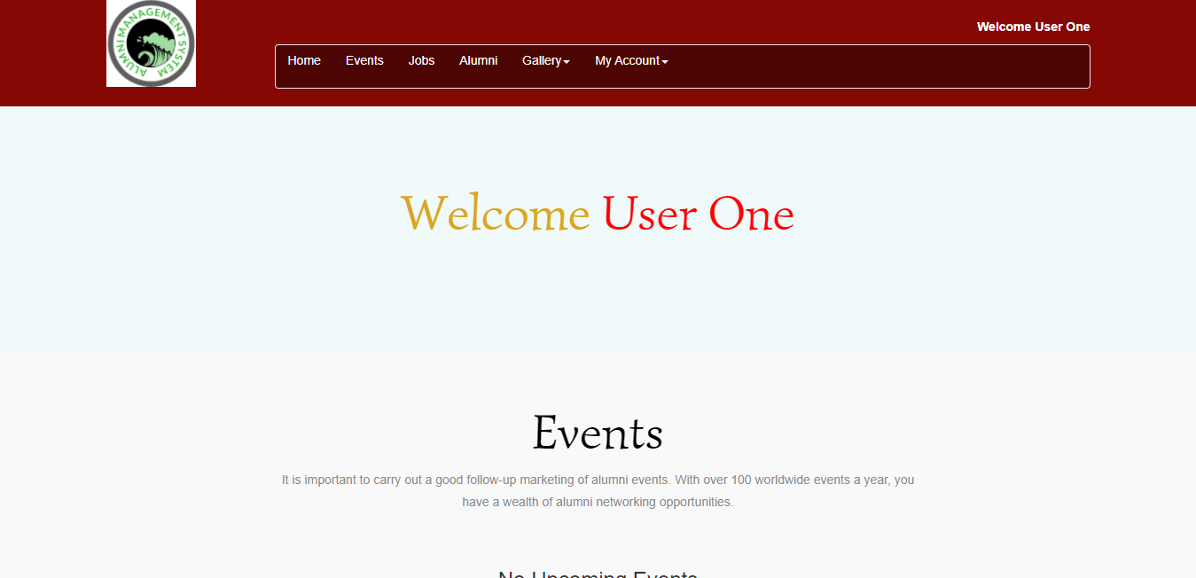

**Events Page**

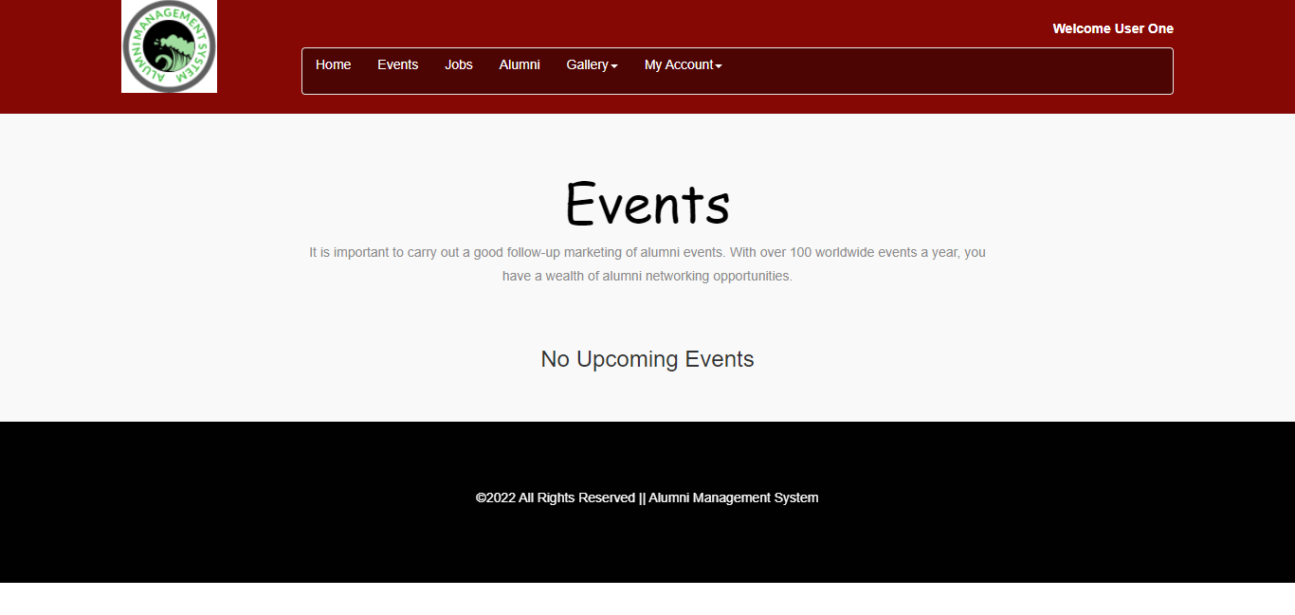

**Job Page**

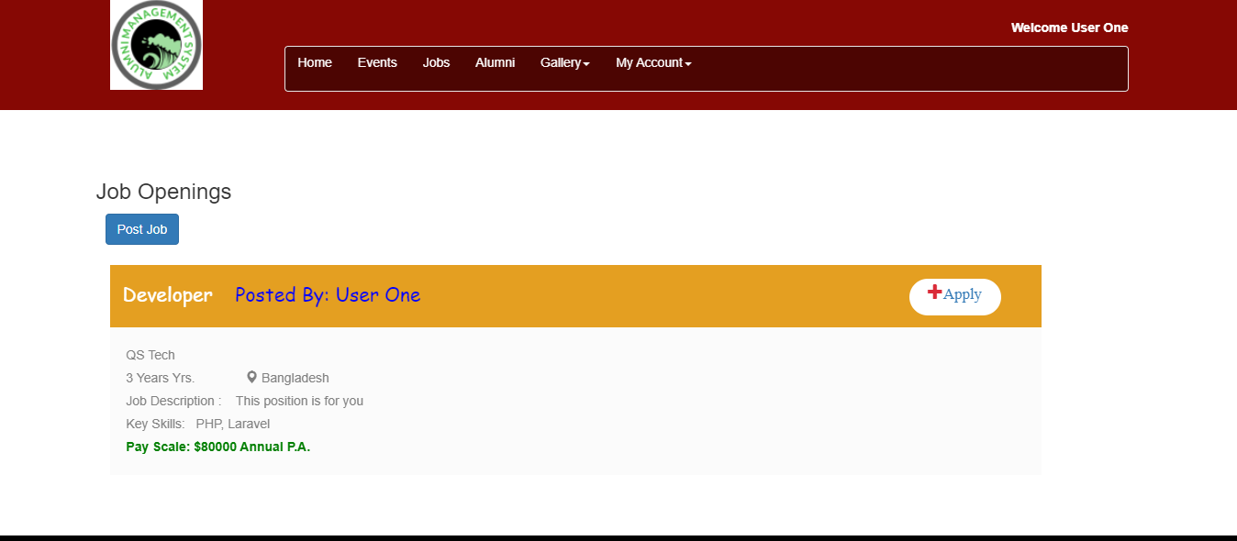

**Job Apply Modal**

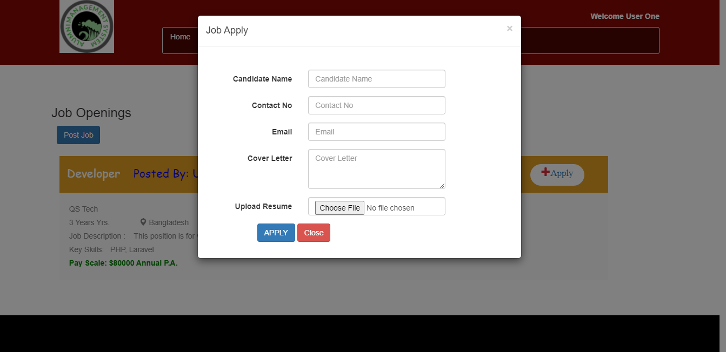

**Registered Alumni Info**

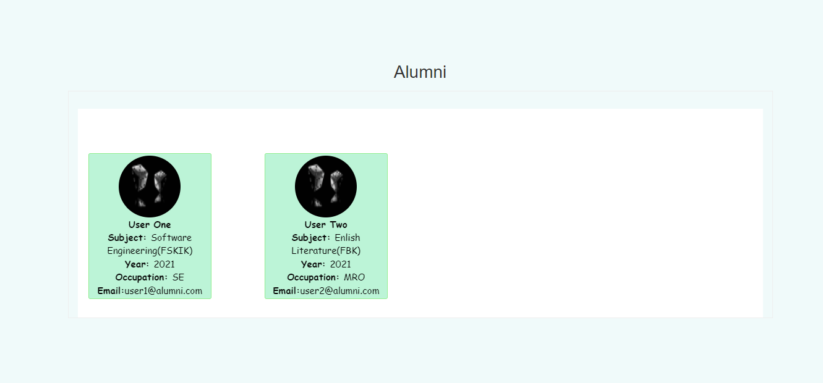

**New Admin Page**

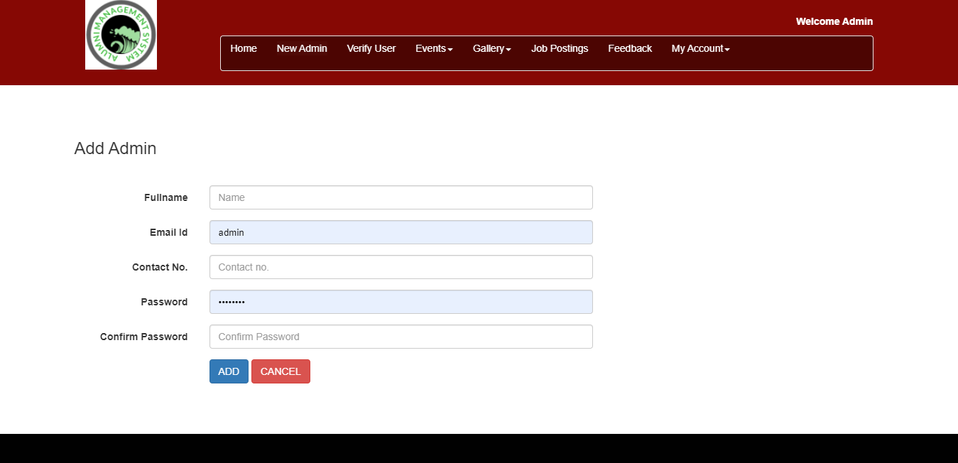

**Verify Alumni Page**

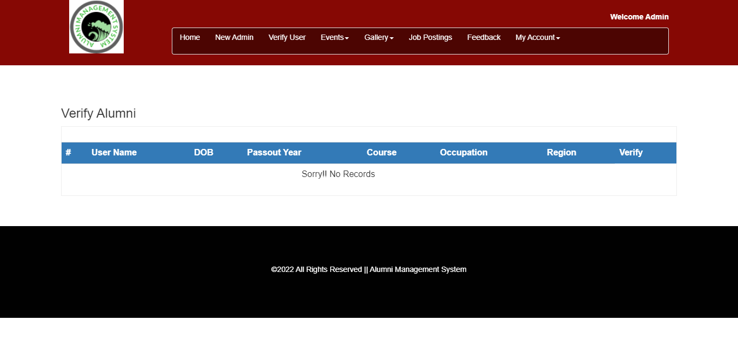

**Add Event Page**

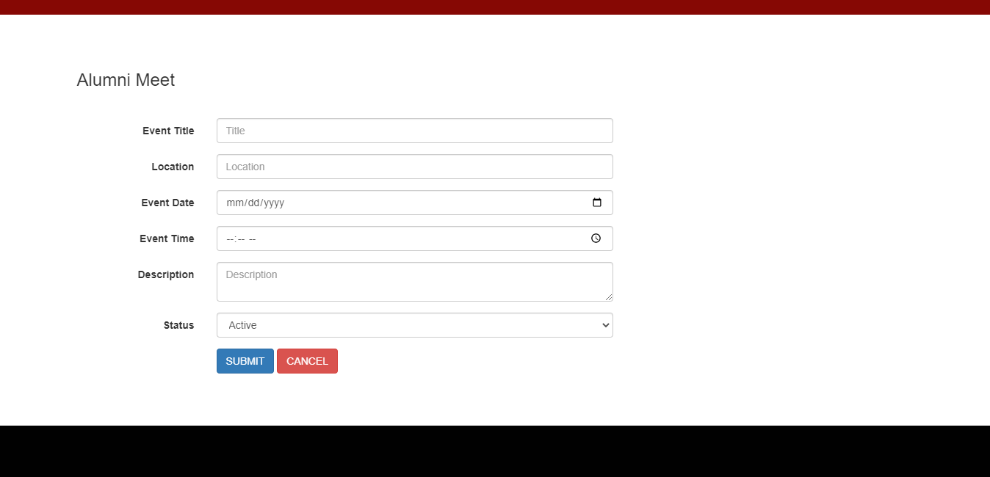

**Job Posting Page**

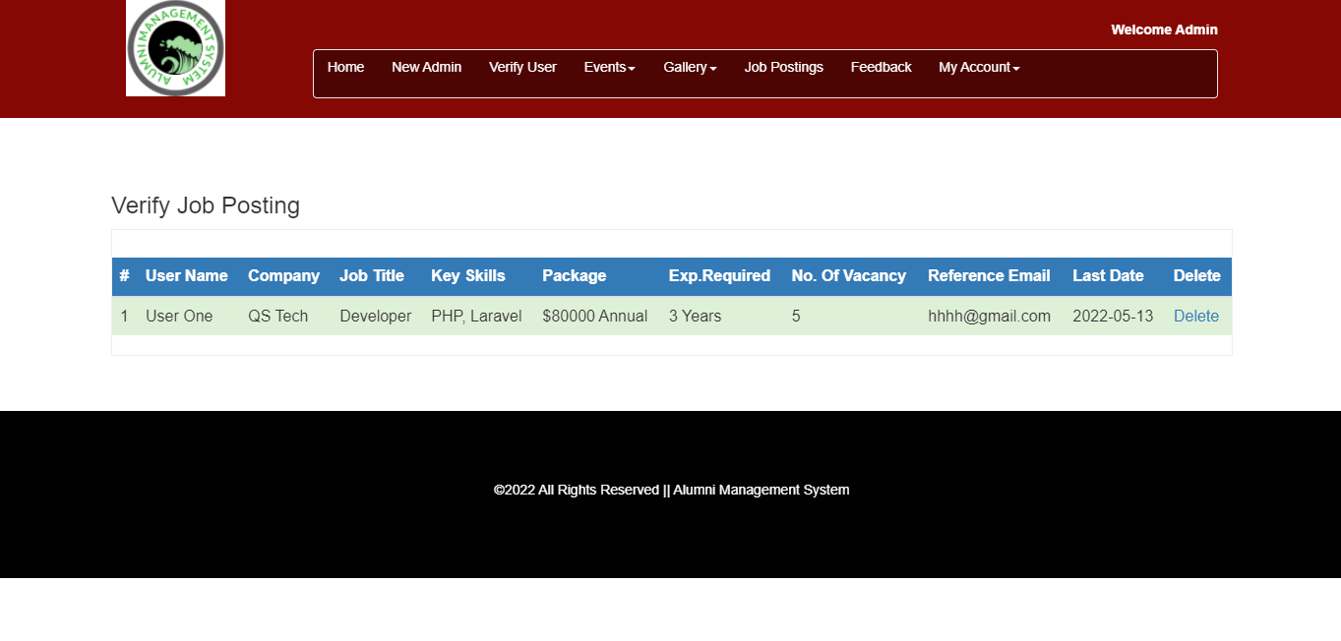

**Alumni Feedback page**

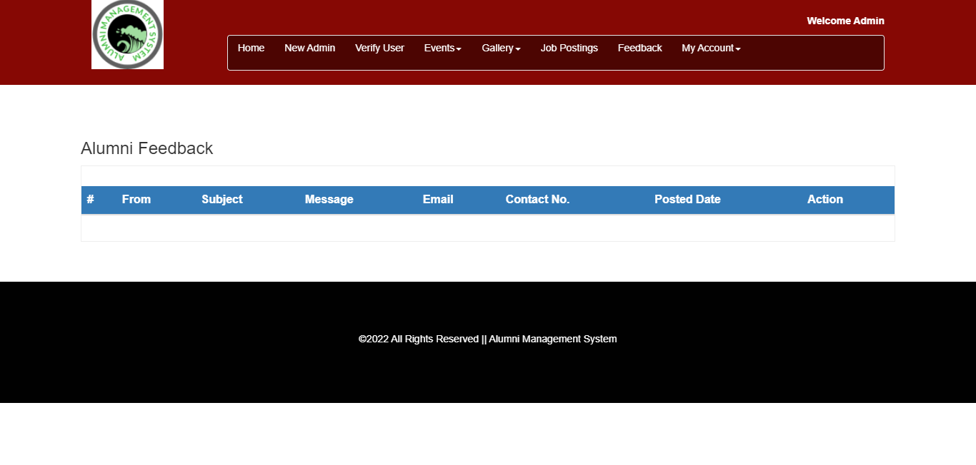

**Chapter 6 Conclusion**

**6.1 Conclusion**

Finally, the Alumni Management System that has been developed to accomplish the project

scope and fulfill the project objectives. This developed system will be able to help the alumni

in many ways. The main focus of the developed system is to create a bridge between alumni

to alumni and alumni to university to share benefits. In addition, the system will help the

university authority to collect alumni data more easily and quickly. Vulnerability in the new

developed system is expected to be improved so that this system become perfect and

complete development.

**6.2 Limitation**

The Alumni Management System is limited to alumni who are in Bangladesh. In order to use

the system user always have to maintain internet connection. Alumni in remote areas can’t

access to the system without internet connection. The automated mailer integration is not

working well as per it should be.

**6.3 Future Work**

According to some suggestions from the evaluation phase some of visual aspects of the

system that mean the interface need to be improved in future. As this system is only for those

who are in Bangladesh it will be extended for internationals or for those who are outside

Bangladesh. The most important thing that can be mentioned here is, this web-based system will

be implemented as mobile application in near future.