**Software Requirements Specification**

**for**

**Online Notice Board Software**

**Version 0.0**

**Prepared by Maksudur Rahman**

**Jahangirnagar University**

**May 4, 2018**

***Software Requirements Specification for Online Notice Board Software*** ***Page ii***

**Table of Contents**

**Table of Contents** **ii**

**Revision History** **iiii**

**1. Introduction** **1**

1.1 Purpose 1

1.2 Document Conventions 1

1.3 Intended Audience and Reading Suggestions 1

1.4 Product Scope 1

1.5 References 2

**2. Overall Description** **3**

2.1 Product Perspective 3

2.2 Product Functions 3

2.3 User Classes and Characteristics 7

2.4 Operating Environment 8

2.5 Design and Implementation Constraints 8

2.6 User Documentation 8

2.7 Assumptions and Dependencies 9

**3. External Interface Requirements** **10**

3.1 User Interfaces 10

3.2 Hardware Interfaces 18

3.3 Software Interfaces 19

3.4 Communications Interfaces 19

**4. System Features** **19**

4.1 Graph Visualization 19

4.2 Graph Layout 22

4.3 Graph Metrics 23

4.4 Filters 24

4.5 Data Table 25

4.6 Dynamic Graphs 28

4.7 Graph Export 29

***Software Requirements Specification for Online Notice Board Software*** ***Page iii***

**5. Other Nonfunctional Requirements** **30**

5.1 Performance Requirements 30

5.2 Safety Requirements 30

5.3 Security Requirements 30

5.4 Software Quality Attributes 30

**Glossary** **31**

**Revision History**

|  |  |  |  |  |  |
| --- | --- | --- | --- | --- | --- |
| **Name** | **Date** | | | **Version** |  |
|  | |  |  | |  |  |
| Online Notice Board Software | |  | May | | 0.0 Alpha |  |
|  | |  | 2018 | |  |

***Software Requirements Specification for Online Notice Board Software*** ***Page 1***

**1. Introduction**

**1.1 Purpose**

This is Online Notice board of Computer Science And Engineering department of Jahangirnaagar University .In this software ,Show all notice about department and varsity issue, and I also want to manage all information about this department .For which students ,teachers and interested people can be informed many important information.

**1.2 Document Conventions**

This Document was created based on the IEEE template for System Requirement Specification Documents.

**1.3 Intended Audience and Reading Suggestions**

Typical Users, such as students, who want to use online notice board software for analyzing networks (Social networks, Social Media networks, Semantic networks etc.)

Advanced/Professional Users, such as engineers or researchers, who want to use online notice board software for more demanding graph analysis.

Programmers who are interested in working on the project by further developing it or fix existing bugs.

**1.4 Product Scope**

***Online Notice Board Software*** is a tool that people can use to analyze their any information and valuable notice. Users can use it to represent their data as a graph and interact with them. They can alter the layout of the notices and information of it, to understand their future work in a better way and discover hidden aspects about it, such as patterns or faults during data sourcing.

***Software Requirements Specification for Online Notice Board Software*** ***Page 2***

This is a software for [Exploratory Data Analysis,](http://en.wikipedia.org/wiki/Exploratory_data_analysis) a paradigm appeared in the [Visual](http://en.wikipedia.org/wiki/Visual_Analytics) [Analytics](http://en.wikipedia.org/wiki/Visual_Analytics) field of research.

**1.5 References**

JU CSE’s website:

[https://](https://gephi.org/)www.juniv.edu[/](https://gephi.org/)

JU CSE’s GitHub page:

[https://github.com/](https://github.com/gephi)rotnocse

IEEE Template for System Requirement Specification Documents:

<https://goo.gl/nsUFwy>

GNU General Public License version 3:

<http://www.gnu.org/licenses/gpl.html>

CDDL Common Development and Distribution License:

<https://opensource.org/licenses/CDDL-1.0>

***Software Requirements Specification for Online Notice Board Software*** ***Page 3***

**2. Overall Description**

**2.1 Product Perspective**

The software named online noticeboard for CSE dept is specified for the information about the CSE dept of Jahangirnagar University.User of the software can be benifitted by knowing different info such as 1.About admission system 2.Exam system 3.Current stuff info 4.Exam routine

5.Current student’s result 6.info about officials 7.Date of different seminer etc

The goal of this software is maintain info about dept ,so that people capable of knowing all info easily at their’s own place without shipping.

**2.2 Product Functions**

File:

New Project: Creation of a new project

Open: Loads an existing project or a file of one of the supported graph formats

Open Recent: Loads one of the displayed, recently opened files.

Close Project: Closes the currently open project.

Properties: Displays some properties of the project (such as the title) which can be edited.

Import Spreadsheet: Loads a CSV file (edges table or nodes table).

Import Database -> Edges List: Loads the edges of a graph from a Database (MySQL, SQLite, PostgreSQL)

Generate -> Dynamic Graph Example: Creates a Dynamic Graph from scratch.

Generate -> Multi-Graph Example: Creates a Multi-Graph from scratch.

Generate -> Random Graph: Creates a Random type of graph from scratch.

Save: Saves the project without changing its name or directory.

***Software Requirements Specification for Online Notice Board Software*** ***Page 4***

Save as: Saves the project and gives the user the ability to change its name or directory.

Export -> Graph file: Exports the current project’s graph in one of the supported file formats

Export -> SVG/PNG/PDF file: Exports a screenshot of the current project’s graph in one of the available formats (SVG, PNG or PDF).

Exit: online notice board software shuts down

Workspace:

New: Creates a new workspace.

Delete: Deletes the current workspace.

Rename: Renames the current workspace

Tools:

Plugins: Here the user can change his plugin settings (update already installed plugins, install new plugins etc.).

Options: Here the user can change some of Online Notice Board Software settings (key bindings etc.).

Language: Changes the language to one of the languages displayed.

Online docs and support: Redirects the user to <https://gephi.org/users/support/>

Window:

Context

Data Table: Displays the Data Table tab.

Filters: Displays the Filters tab.

Graph: Displays the Graph tab.

Layout: Displays the Layout tab.

Output: Displays the Output-Log tab.

Preview: Displays the Preview tab.

Preview Settings: Displays the Preview Settings tab.

Appearance: Displays the Appearance tab.

***Software Requirements Specification for Online Notice Board Software*** ***Page 5***

Welcome: Displays the Welcome window.

Statistics: Displays the statistics tab.

Timeline: Displays the timeline tab.

Configure Window: Here the user can select one of the available display options for the currently selected tab.

Close Window: Closes the currently selected tab

Document Group -> New Document Group: Creates a new Document Group.

Document Group -> Manage: Selects or removes one of the existing Document Groups.

Help

Check for Updates: Displays the plugins that can be updated to newer versions

About: Displays the logo of online notice board software, which licenses are being used, the product version and other info.

Main Pages:

Overview: Displays the Overview page, which by default includes the tabs: Appearance, Layout, Graph, Context, Filters, Statistics and Queries.

Data Laboratory: Displays the Data Laboratory page, which by default includes the tab Data Table.

Preview: Displays the Preview page, which by default includes the tabs: Preview and Preview Settings.

Overview:

Appearance: Here the user can change the color of the edges/nodes. He can choose one color for all the edges/nodes or choose multiple colors, according to the values of a certain attribute.

Layout: Here the user can change the layout of the graph by using one of the available layouts.

***Software Requirements Specification for Online Notice Board Software*** ***Page 6***

Graph: Here the user can interact directly with the graph itself, by dragging nodes, zooming in or out etc.

Context: Displays the number of nodes and edges and the type of the graph.

Filters: Here the user can choose which filters to apply on the graph. (the filters are being applied by drag and drop on to the “Queries” tab).

Statistics: Here the user can choose which of the graph statistics will be calculated (by pressing on the button “Run” of the desired statistic).

Queries: This is the module where filters are being placed.

Data Laboratory :

Nodes: Displays the Nodes table

Edges: Displays the Edges table

Configuration: Preferences about how the data is presented.

Add node: Creates a new node and adds it to the graph.

Add edge: Creates a new edge between two existing nodes of the graph

Search/Replace: Stand Search/Replace functionality.

Import Spreadsheet: Opens a dialog to load a csv file (edges or nodes table)

Export Table: Exports the table as a csv file, the user can choose which attributes will be included in the file.

More Actions -> Clear Graph: All nodes and edges of the graph will be deleted.

More Actions -> Clear Edges: All edges of the graph will be deleted.

More Actions -> Detect and merge node duplicates: Removes node duplicates by merging them into one node.

More Actions -> Manage Dynamic Column Estimators:

Filter: Used to find all the rows of the table that contain a specific value at an attribute selected by the user.

Add column: Adds a new attribute to the table (edges/nodes)

Merge columns: Combines the selected columns into one. The merge strategy must be selected by the user.

***Software Requirements Specification for Online Notice Board Software*** ***Page 7***

Delete column: Removes all the values of a column and the column itself from the table.

Clear column: For every row sets the selected column empty.

Copy data to other column: For every row the value of the target column becomes identical to the value of the source column.

Fill column with a value: For every row the value of the selected column is set to the specified one.

Duplicate a column: Creates a duplicate of the selected column.

Create a boolean column from regex match: Creates a new boolean column, the value of which depends on whether the value of the selected existing column matches a regular expression or not. The regular expression must be specified by the user.

Create column with list of regex matching groups: Creates a new column. For every

row the value of this column is a list about how the value of the selected existing column matches with the user’s regular expression.

Convert column to dynamic: Converts the selected static column into a dynamic one.

Preview

Preview Settings: Here the user can configure rendering settings.

Preview Ratio: When set under 100% a partial graph is displayed.

Refresh: Applies changes made by the user.

Preview: After changes have been applied, the updated graph will be shown here.

**2.3 User Classes and Characteristics**

Typical Users, such as students, who want to use online notice board software for analyzing networks (Social networks, Social Media networks, Semantic networks etc.)

***Software Requirements Specification for Online Notice Board Software*** ***Page 8***

Advanced/Professional Users, such as engineers or researchers, who want to use online notice board software for more demanding graph analysis.

Programmers who are interested in working on the project by further developing it or fix existing bugs

**2.4 Operating Environment**

Windows 2000 Windows XP Windows Vista Windows 7

Windows 8 Windows 10 Mac OS X Linux

**2.5 Design and Implementation Constraints**

online notice board software is developed in Java, it uses OpenGL for its visualization engine and has been built on top of the NetBeans Platform. It uses a modular design where every feature is wrapped into a separate module and the modules depend on each other through well-written APIs. There are several APIs available to make plugin development easy.

**2.6 User Documentation**

There is a quick start guide available on the website of online notice board software:

<https://gephi.org/users/quick-start/>

***Software Requirements Specification for Online Notice Board Software*** ***Page 9***

There are two other official tutorials, one for visualization:

<https://gephi.org/users/tutorial-visualization/>

And one for layouts:

<https://gephi.org/users/tutorial-layouts/>

In this page: <https://gephi.org/users/>users can find every available tutorial including tutorials made by the community, video tutorials, the official tutorials mentioned above, non-English tutorials etc.

Additional help and information can be found at Online Notice Board Software wiki:

<https://github.com/gephi/gephi/wiki>

**2.7 Assumptions and Dependencies**

online notice board software is developed in Java and therefore requires Java to be installed on the user’s system. The latest stable version of online notice board software requires Java version 7 or higher. This applies to Windows and Linux users. On Mac OS X, Java is bundles with the application.

***Software Requirements Specification for Online Notice Board Software*** ***Page 10***

**3. External Interface Requirements**

**3.1 User Interfaces**

1. Online Notice Board Software Welcome Screen:

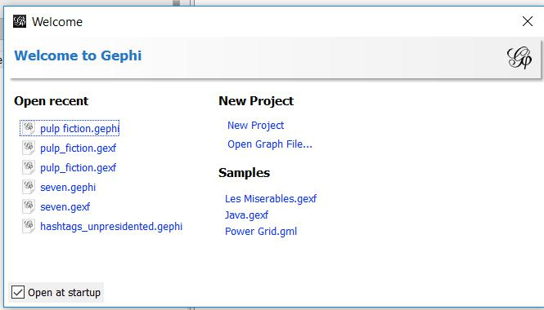

1. Online Notice Board Software Main Screen:

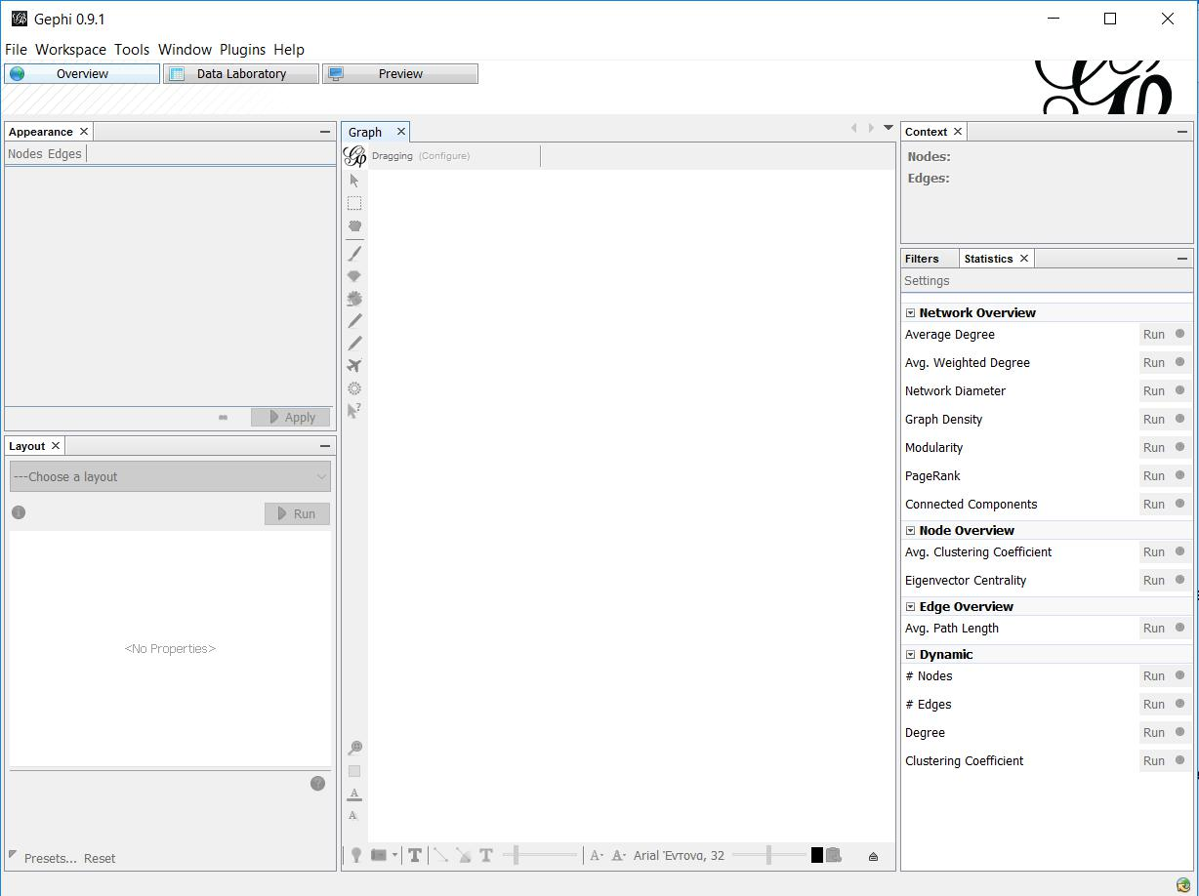***Software Requirements Specification for Online Notice Board Software*** ***Page 11***

3. Import Graph (CSV file)

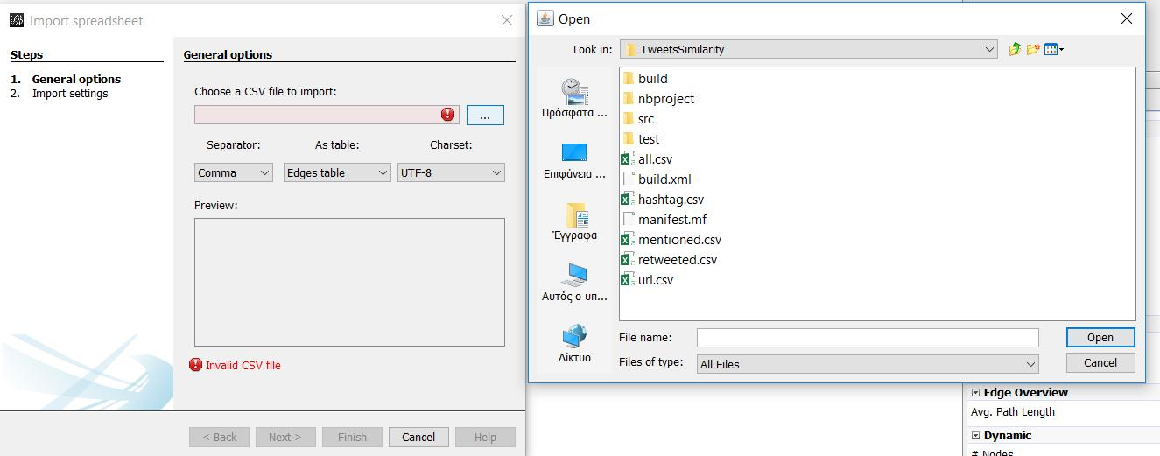

4. Open Graph (all supported file formats)

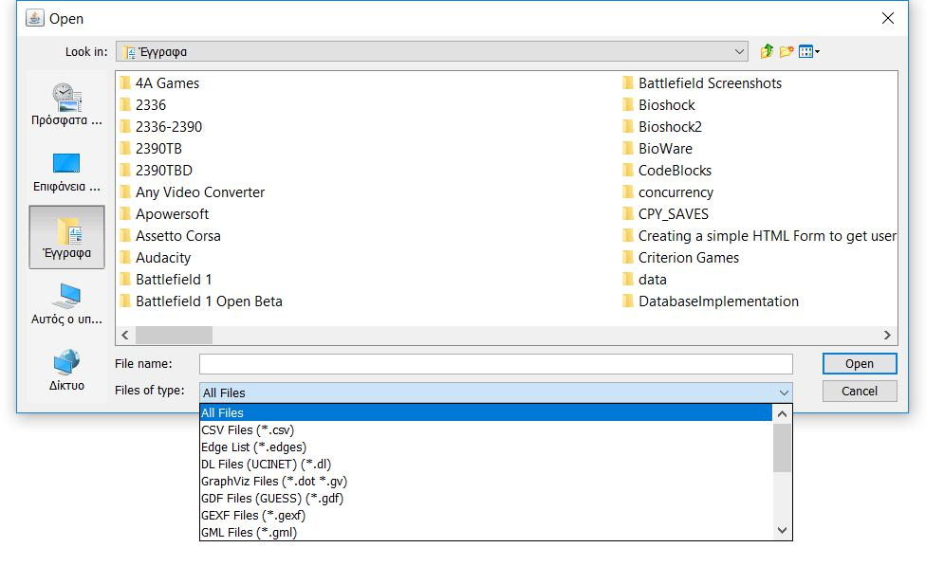***Software Requirements Specification for Online Notice Board Software*** ***Page 12***

1. Overview of the Graph. Left side buttons, from top to bottom: direct selection (select only one node/edge), rectangle selection (select part of the graph ), Drag ( drag a node using the mouse), Painter ( color nodes by clicking on them), Sizer ( change size of nodes by clicking on them and dragging the mouse vertically), Brush ( colors the selected node and its nearest neighbour), Node Pencil ( create new node where mouse is clicked), Edge Pencil (create new edge by clicking first on source node and then on target node), Shortest Path ( display the shortest path between two clicked nodes), Heat Map ( Set color intensity on a node neighbourhood, based on the distance from the clicked node), Edit (Click on a node to edit its attributes), Center on Graph, Reset Colors ( remove color from every edge and node), Reset Label Colors( remove color from every label), Reset Label Visible( make labels invisible).

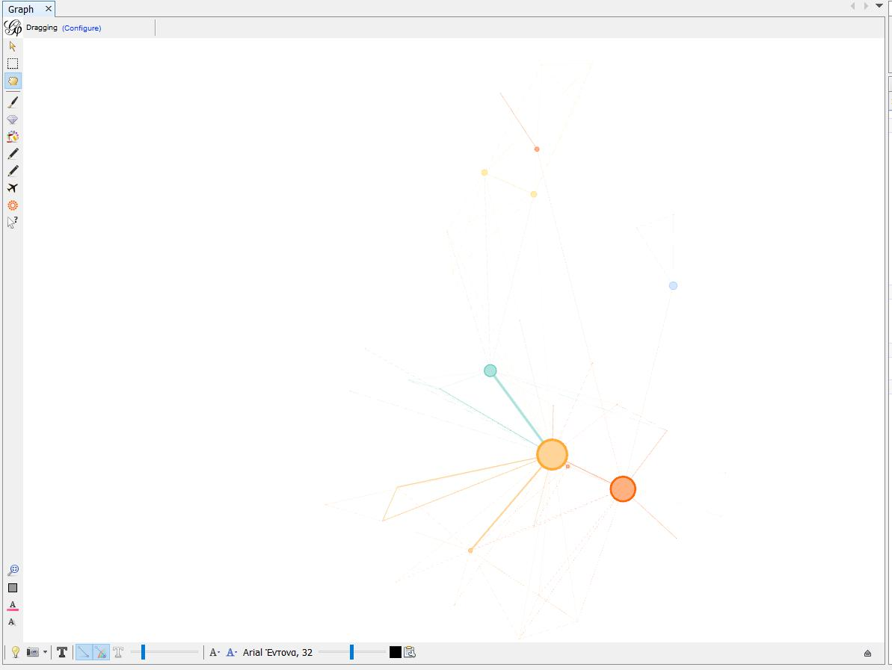

Bottom buttons, from left to right: Background color (left click to switch between black and white, right click to choose color), Take Screenshot, Show Node Labels, Show Edges, Edges have source node color, Show Edge labels, Edge Weight Scale, Size Mode( Fixed, Scaled or Node size) Color Mode( Unique, Object or Text), Font, Font

***Software Requirements Specification for Online Notice Board Software*** ***Page 13***

size scale, Default color, Attributes (choose which attributes are displayed on graph overview)

6. Change Graph Layout

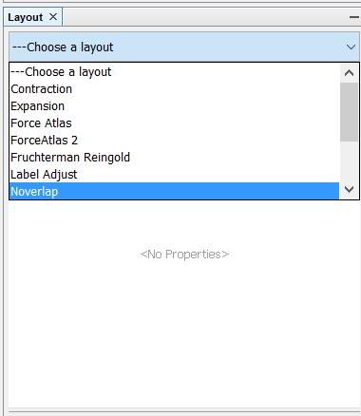

1. Change Node/Edge Colour (Unique applies the exact same colour to all nodes/edges. Attribute changes the colour of each node/edge according to its value of the selected attribute)

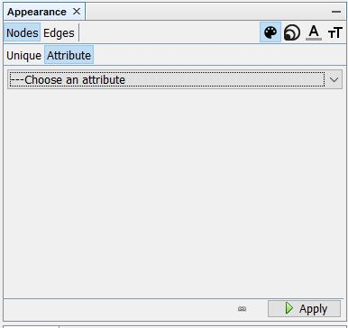

***Software Requirements Specification for Online Notice Board Software*** ***Page 14***

1. Apply Filters Create filters that can hide nodes and edges ( that do not comply with the filter’s settings) To apply a filter drag it from the “Filters” module to the “Queries” module and press the “Filter” button on the bottom right side. Filter settings can be modified.

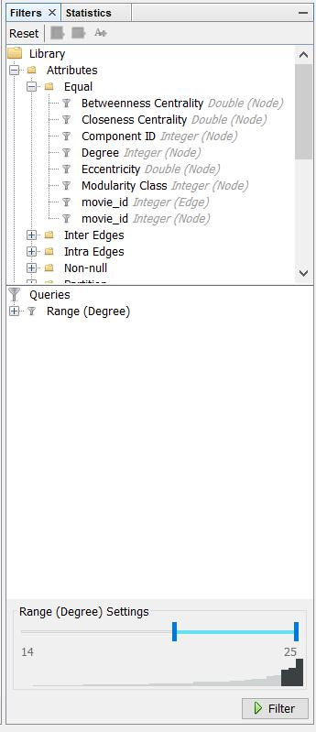

***Software Requirements Specification for Online Notice Board Software*** ***Page 15***

9. Calculate Graph Metrics

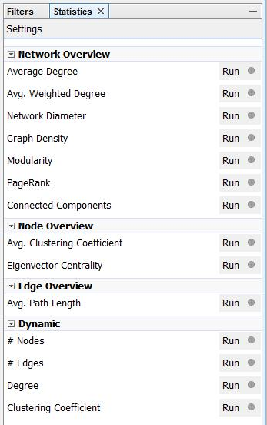

10. Data Laboratory

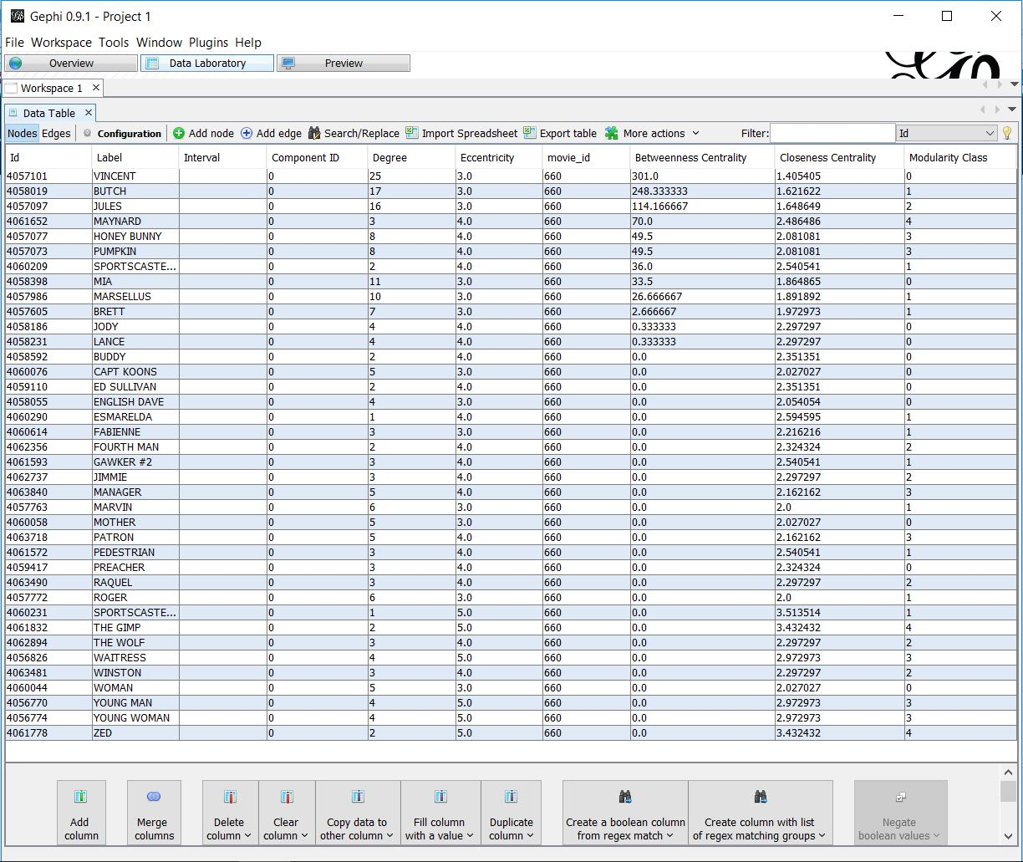

***Software Requirements Specification for Online Notice Board Software*** ***Page 16***

1. Edit Node (either use the “Edit” button and click on the Node in the Overview screen or left click on the Node in the Data Laboratory screen)

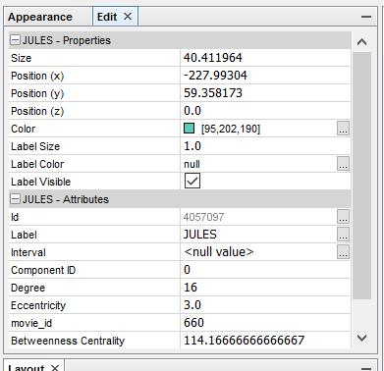

12. Preview Graph

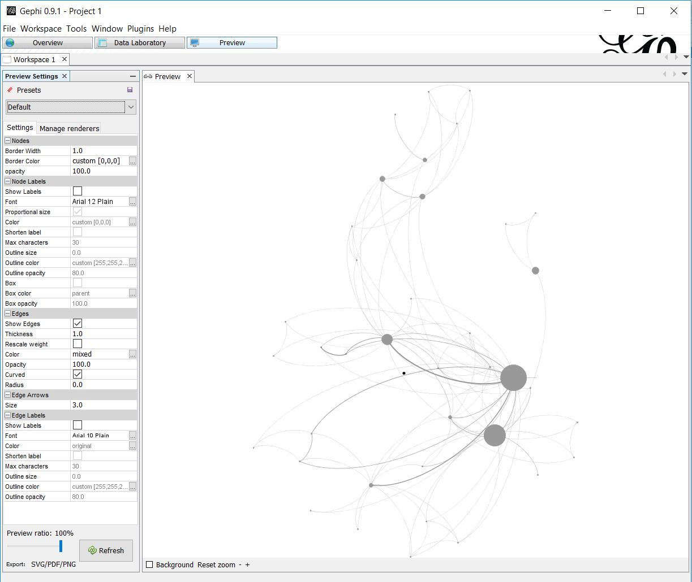

***Software Requirements Specification for Online Notice Board Software*** ***Page 17***

13. Manage Plugins

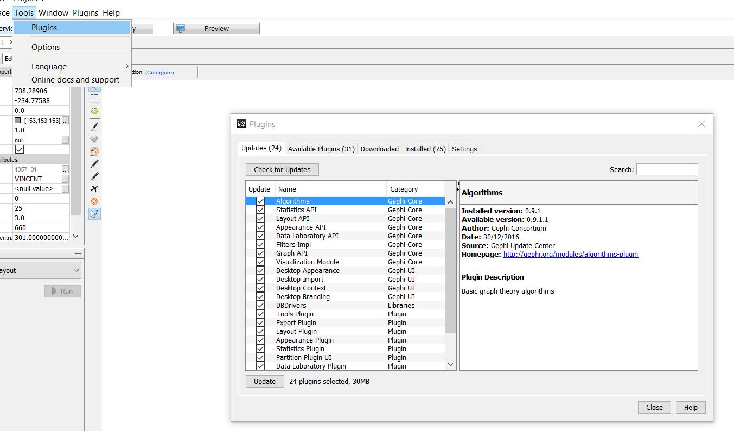

14. Export Graph

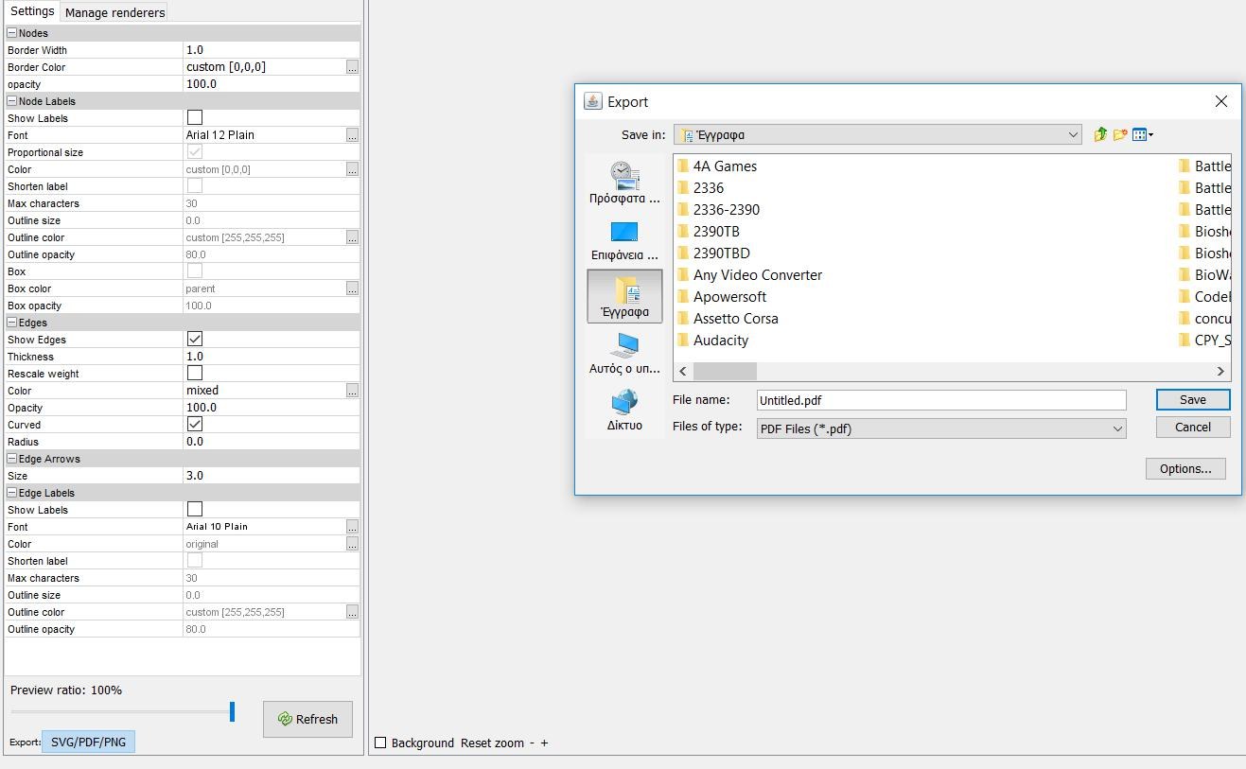***Software Requirements Specification for Online Notice Board Software*** ***Page 18***

15. Help -> About

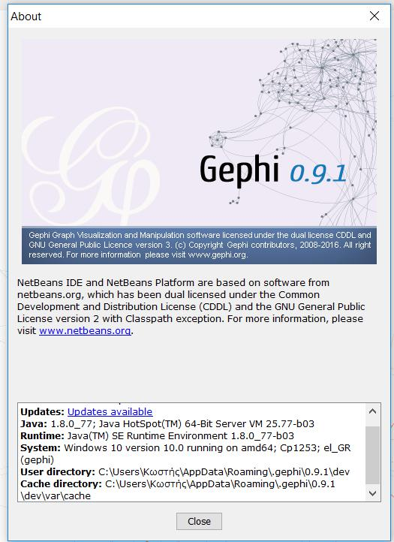

**3.2 Hardware Interfaces**

The minimum hardware requirements of online notice board software are a 500 Megahertz CPU and 128 megabytes of RAM. Also, because online notice board software uses an OpenGL 3D engine to speed up graph visualization, a compatible graphics card is required. A system with these specifications can handle a Network of approximately 1000 edges and nodes. For bigger networks, additional memory is required (<https://gephi.org/users/requirements/>).

***Software Requirements Specification for Online Notice Board Software*** ***Page 19***

**3.3 Software Interfaces**

online notice board software requires Java to be installed on the system, more specifically Java version 7 or 8 for its latest release. Additional information can be found on section 2.7 of this document.

online notice board software can be connected with a MySQL, SQLite or PostgreSQL database to import a graph edge list.

**3.4 Communications Interfaces**

online notice board software requires an internet connection to install new plugins, update already installed ones and update some of its components (APIs, modules etc.).

**4. System Features**

This section demonstrates Online Notice Board Software most prominent features and explains how they can be used and the results they will give back to the user.

**4.1 Graph Visualization**

Users can directly interact with the graph by clicking on nodes to drag them, edit their attributes or color, add new nodes and edges, display shortest paths between nodes, make node labels visible/invisible etc.

Users can also use the appearance module to change the color of nodes. They can use the same color for the entire graph or use the values of a specific attribute as a reference point.

***Software Requirements Specification for Online Notice Board Software*** ***Page 20***

Example of changing the color of nodes based on one of their attributes (modularity class):

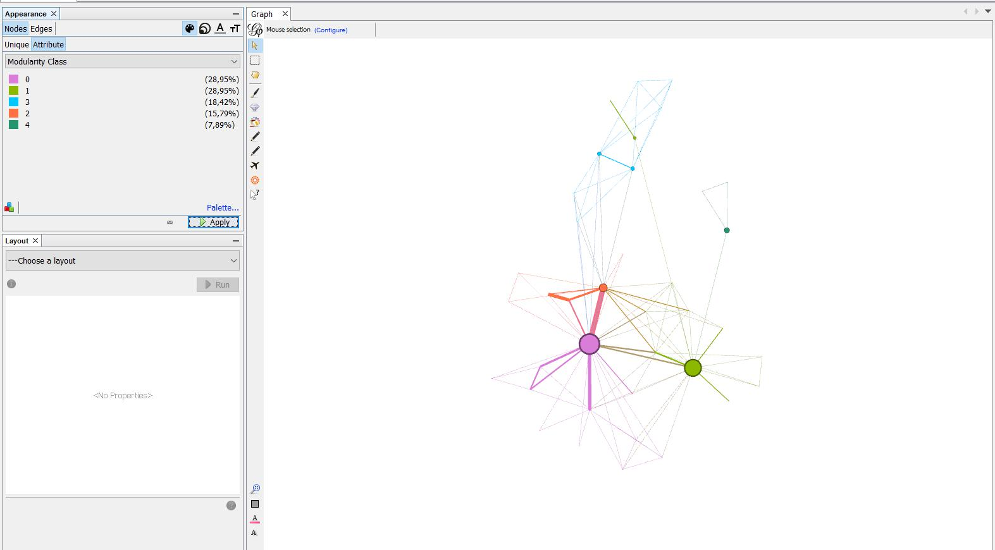

Example of making node labels visible (using the Show Node Labels – T button ):

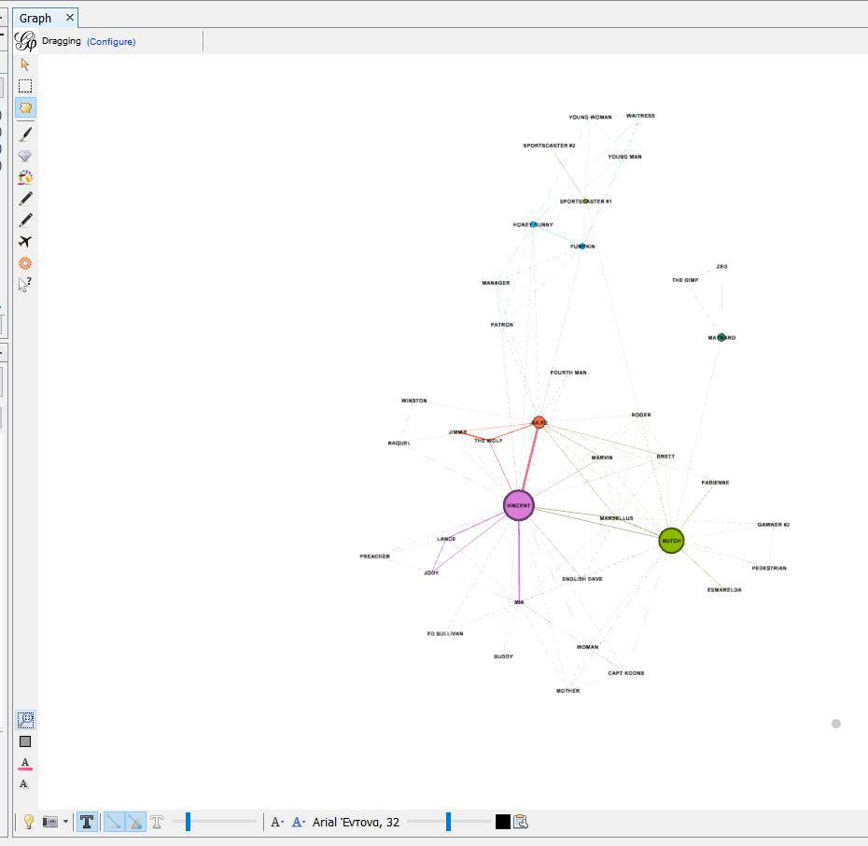***Software Requirements Specification for Online Notice Board Software*** ***Page 21***

Example of chancing the color of only one node( Vincent) using mouse selection:

(The user has to press the “Painter” button first, on the left side of the screen, then choose color, on the top of the screen, and finally click on the desired node)

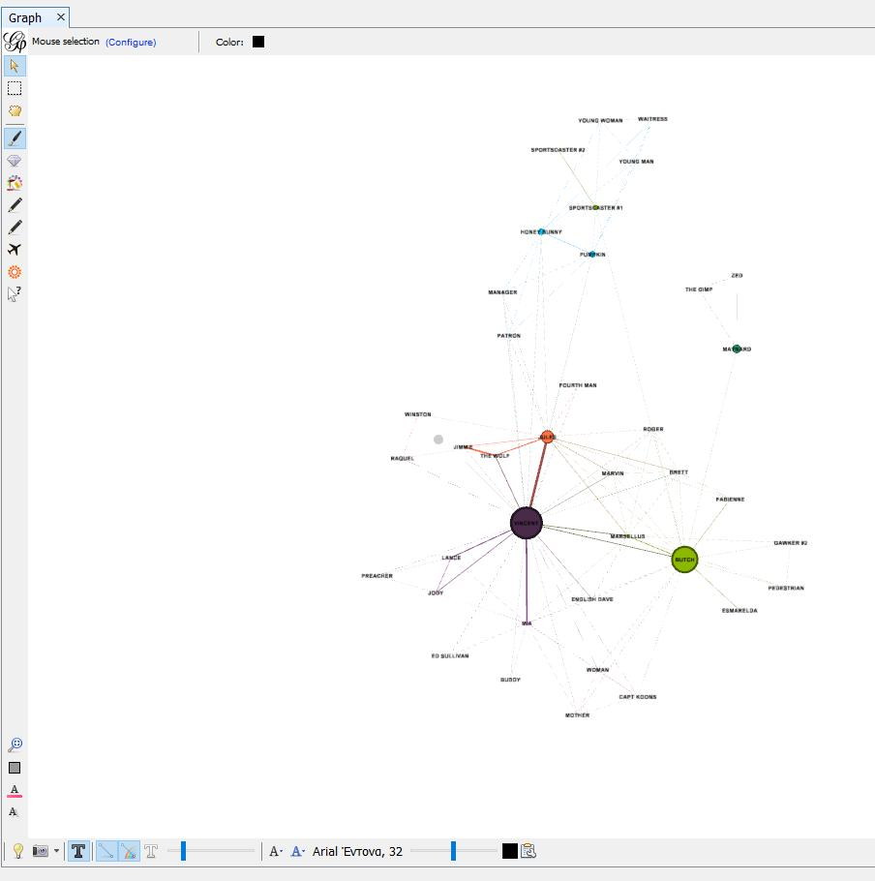

Example of Node Dragging (by pressing the ”Drag” button on the left side of the screen) :

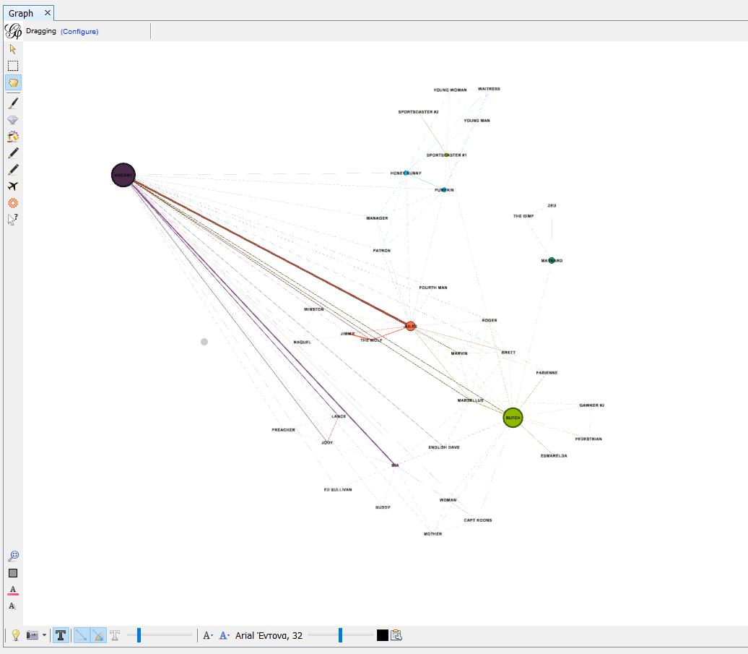***Software Requirements Specification for Online Notice Board Software*** ***Page 22***

**4.2 Graph Layout**

online notice board software provides the following layout algorithms: Contraction, Expansion, Force Atlas, Force Atlas 2, Fruchterman Reingold, Label Adjust, OpenOrd, Random Layout, Rotate, Yifan Hu and Yifan Hu Proportional.

Example of applying a Layout algorithm to a graph:

The graph, before changing the Layout:

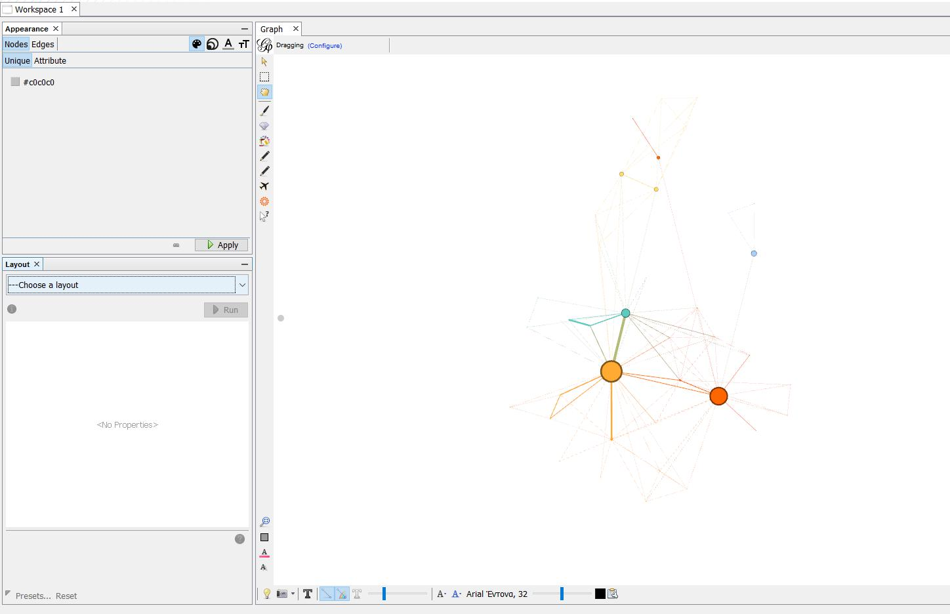***Software Requirements Specification for Online Notice Board Software*** ***Page 23***

The graph, after applying the layout “Yifan Hu”:

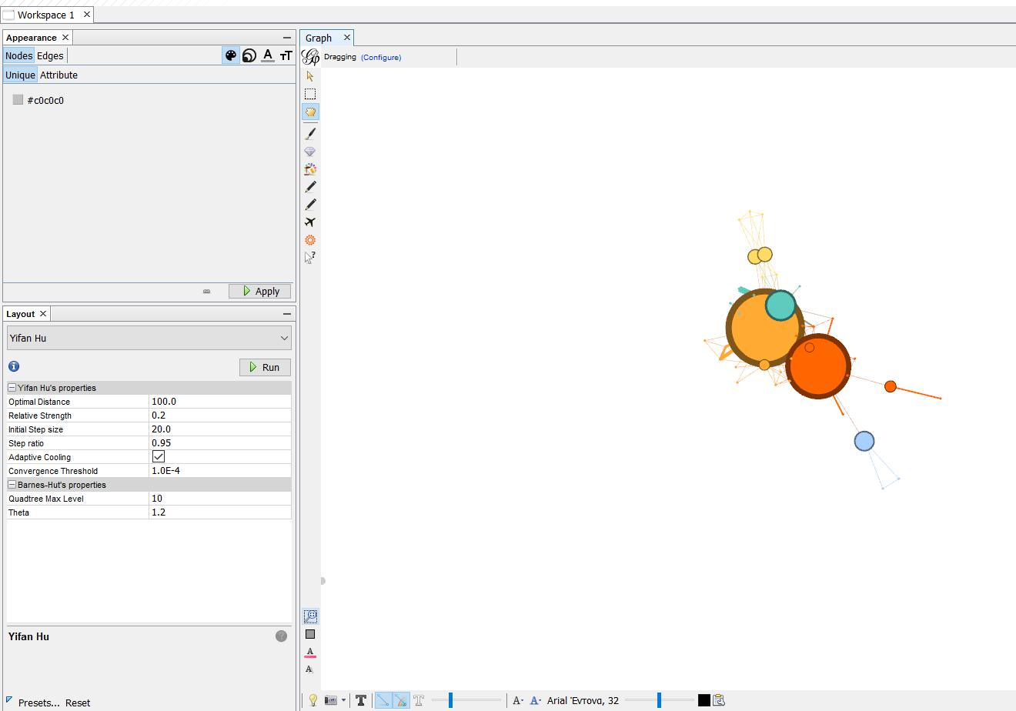

**4.3 Graph Metrics**

online notice board software provides the following Graph metrics:

Network Overview: Average Degree, Average Weighted Degree, Network Diameter, Graph Density, Modularity, PageRank, Connected Components Node Overview: Average Clustering Coefficient, Eigenvector Centrality

Edge Overview: Average Path Length

Dynamic: #Nodes, #Edges, Degree, Clustering Coefficient

***Software Requirements Specification for Online Notice Board Software*** ***Page 24***

Example of calculating the “Average Degree” of the graph:

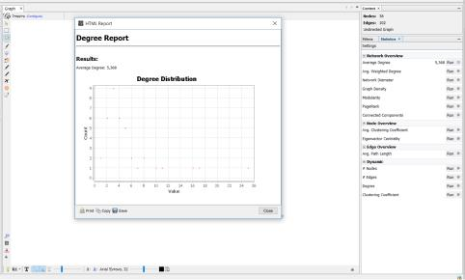

The graph which represents the distribution of the Average Degree can be printed,copied or saved.

**4.4 Filters**

Το apply a filter the user must select it and drag it to the “Queries” module.

Example of applying a filter which removes every node that has a degree outside of the range [2,25], in other words it removes every leaf node.

On the bottom right side of the screen there is the Stop/Filter button which removes/applies the selected Filters. In the context module, we can see the number and percentage of the nodes and edges that did not get removed by the filter.

***Software Requirements Specification for Online Notice Board Software*** ***Page 25***

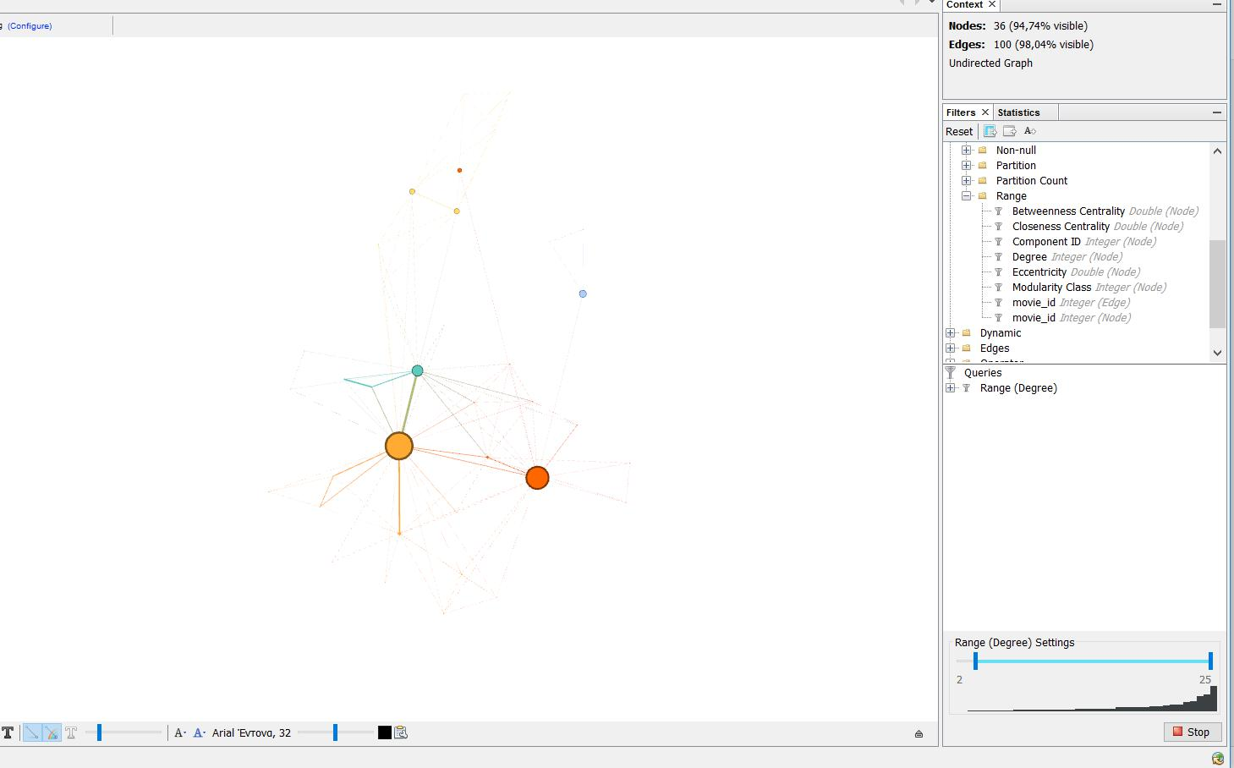

**4.5 Data Table**

Here the data of the graph is presented in two tables, one for nodes and one for edges and can be edited by the user. This is the Nodes table, the user can change to

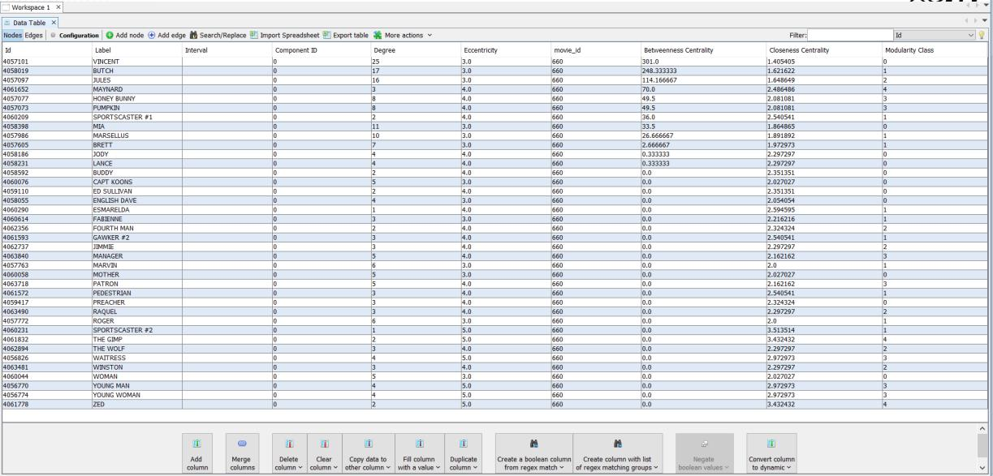***Software Requirements Specification for Online Notice Board Software*** ***Page 26***

the edges table by pressing the “Edges” button on the top left hand side of the screen. The user can add new nodes/edges, edit existing ones, merge columns, create duplicates of columns etc.

Example of adding a new Edge to the graph (by pressing the “Add edge” button):

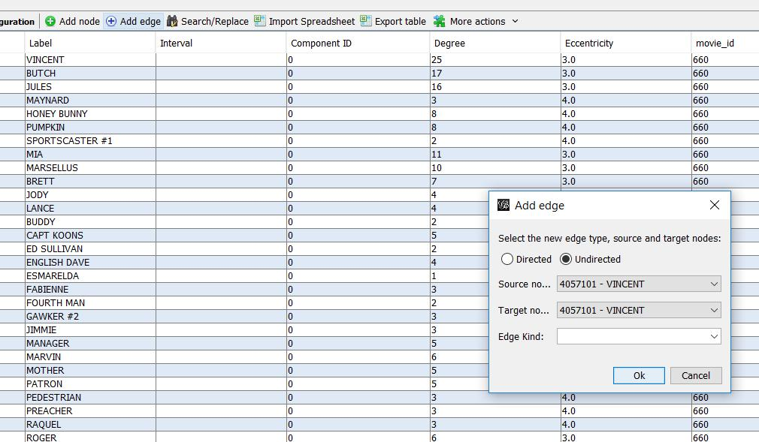

Example of merging two columns into one:

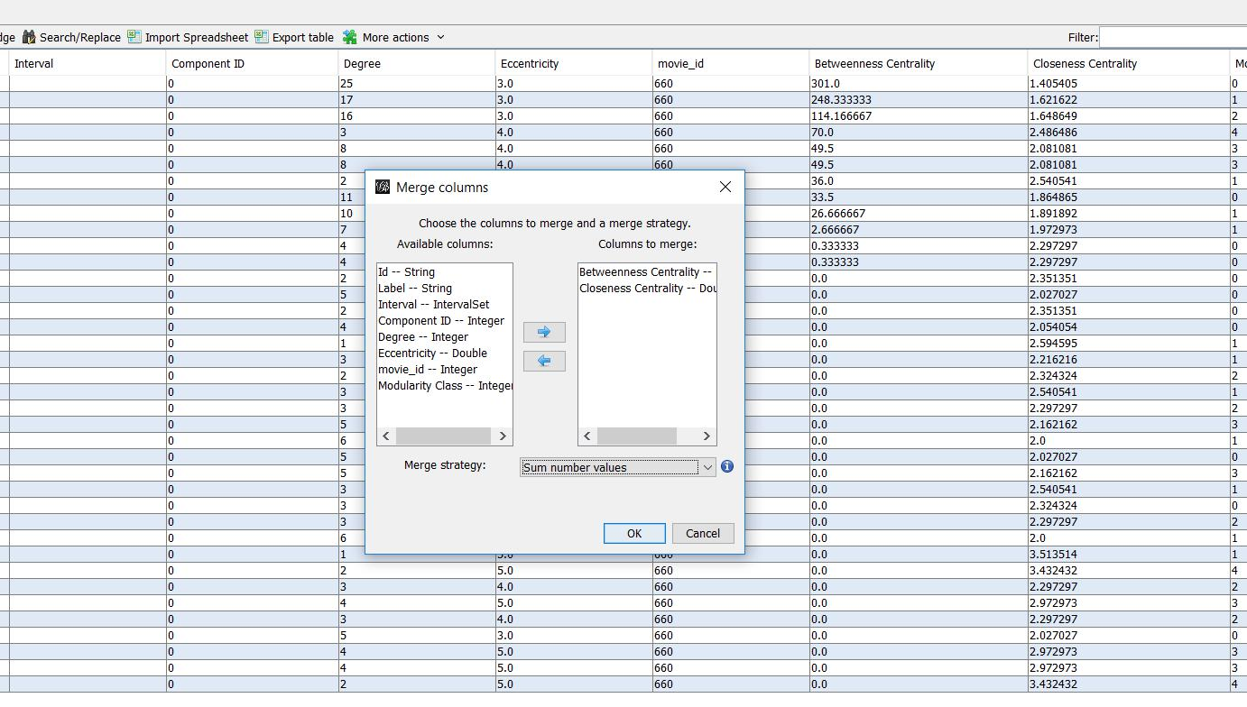***Software Requirements Specification for Online Notice Board Software*** ***Page 27***

Choosing the new column’s title:

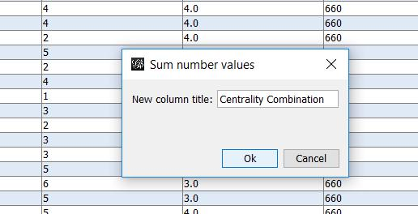

The new column (last one from the left) in the table:

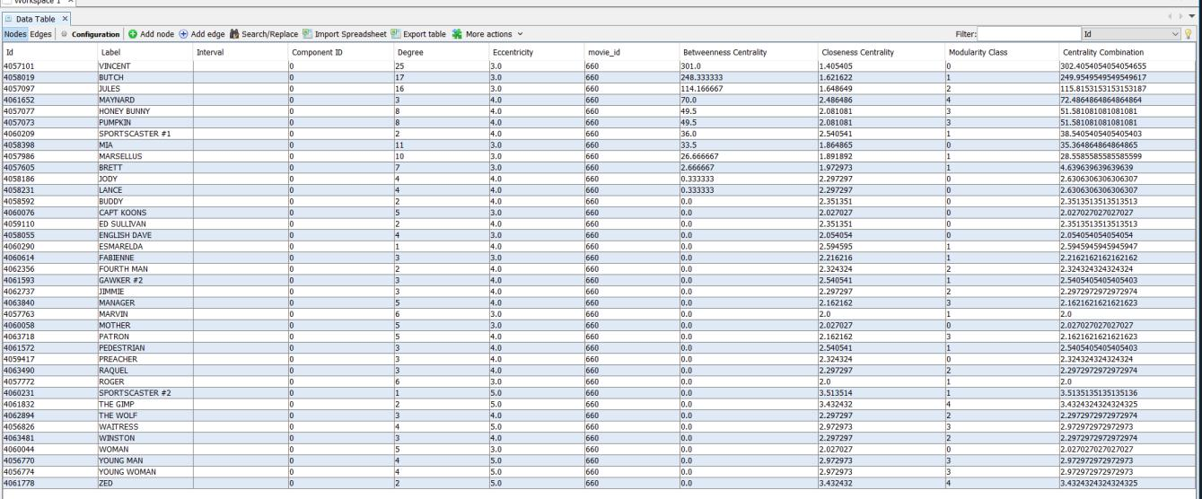***Software Requirements Specification for Online Notice Board Software*** ***Page 28***

**4.6 Dynamic Graphs**

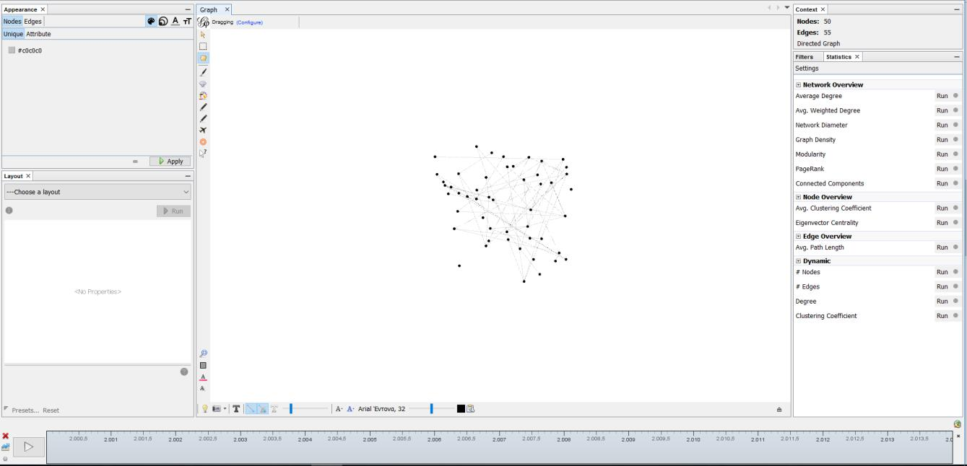

On the bottom side of the page we have the timeline bar, which can be used to demonstrate how the graph has changed at each timestamp. The user can select custom time intervals.

We can see in the data laboratory the appearance of the attribute Timestamp, which represents the time, and also the different values of the attribute score for every timestamp. online notice board software also provides special metrics for dynamic graphs (for more information refer to section 4.3)

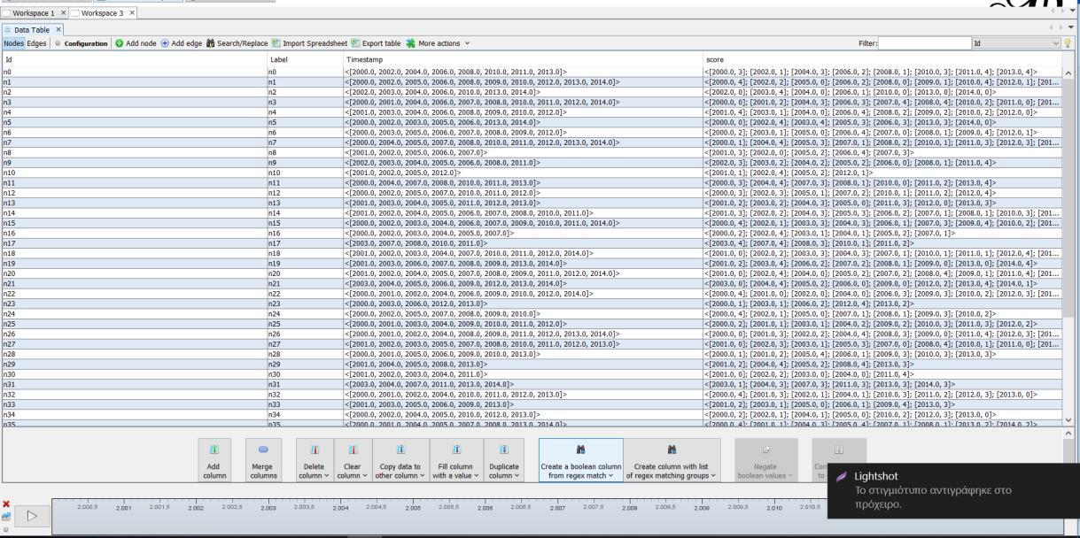***Software Requirements Specification for Online Notice Board Software*** ***Page 29***

**4.7 Graph Export**

The user can export the graph, either via the main toolbar

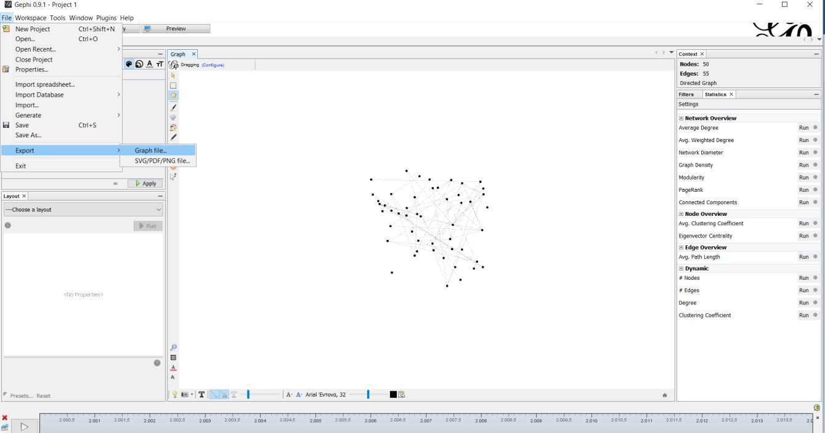

Or via the preview page:

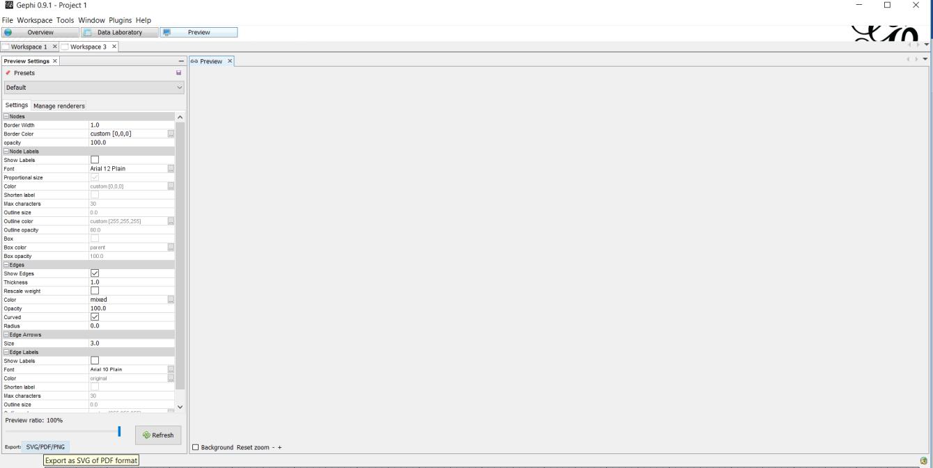

The available output file formats are: SVG PDF and PNG (just for the graph it self) and also every supported graph format (such as gexf , which also includes the graph data)

***Software Requirements Specification for Online Notice Board Software*** ***Page 30***

**5. Other Nonfunctional Requirements**

**5.1 Performance Requirements**

online notice board software requires a system with at least a 500 megahertz CPU and 128 megabytes of RAM and an OPENGL 1.2 compatible graphics card. However, these requirements can support effectively graphs of up to 1000 nodes and edges. Performance depends on the graph size and as a result, the system requirements for bigger graphs are more demanding. (precise figures: <https://gephi.org/users/requirements/>)

**5.2 Safety Requirements**

To ensure that no one of Online Notice Board Software users loses any data while using online notice board software (due to a crash or a bug of some kind) the developer team updates online notice board software regularly. There is a bug tracker available where users can report any bugs they have encountered so that the developers can fix it in the next release.

**5.3 Security Requirements**

online notice board software does not have any security requirements and thus any type of user can use it without any additional privileges.

**5.4 Software Quality Attributes**

online notice board software provides the users with both simple and advanced features. Due to its well designed and easy to use interface it can be used by both experts and typical users. However, users must already have a basic knowledge of graphs before using it.

***Software Requirements Specification for Online Notice Board Software*** ***Page 31***

**Glossary**

References: [**https://en.wikipedia.org/wiki/Main_Page**](https://en.wikipedia.org/wiki/Main_Page)

Graph: a system of nodes connected in pairs by edges. Often subdivided

into [directed graphs](https://en.wikipedia.org/wiki/Directed_graph) or [undirected graphs](https://en.wikipedia.org/wiki/Undirected_graph) according to whether the edges have an orientation or not. [Mixed graphs](https://en.wikipedia.org/wiki/Mixed_graph) include both types of edges.

Node: A node is (together with edges) one of the two basic units out of which graphs are constructed. Nodes of graphs are often considered to be atomic objects, with no internal structure.

Edge: An edge is (together with vertices) one of the two basic units out of which graphs are constructed. Each edge has two (or in hypergraphs, more) vertices to which it is attached, called its endpoints. Edges may be directed or undirected; undirected edges are also called lines and directed edges are also called arcs or arrows. In an undirected [simple graph,](https://en.wikipedia.org/wiki/Simple_graph) an edge may be represented as the set of its vertices, and in a directed simple graph it may be represented as an ordered pair of its vertices. An edge that connects vertices *x* and *y* is sometimes written *xy*.

Degree: the degree of a node of a [graph](https://en.wikipedia.org/wiki/Graph_(discrete_mathematics)) is the number of [edges](https://en.wikipedia.org/wiki/Edge_(graph_theory)) [incident](https://en.wikipedia.org/wiki/Incidence_(graph_theory)) to the node.

Weight: A graph structure can be extended by assigning a weight to each edge of the graph. Graphs with weights, or [weighted graphs,](https://en.wikipedia.org/wiki/Weighted_graph) are used to represent structures in which pairwise connections have some numerical values. For example, if a graph represents a road network, the weights could represent the length of each road.

Network(graph) Diameter: The diameter of a graph is the length of the shortest path between the most distanced nodes.

Graph Density: graph density is the ratio of the number of edges and the number of possible edges.

***Software Requirements Specification for Online Notice Board Software*** ***Page 32***

Modularity: Modularity is one measure of the structure of [networks](https://en.wikipedia.org/wiki/Complex_network) or [graphs.](https://en.wikipedia.org/wiki/Graph_(discrete_mathematics)) It

was designed to measure the strength of division of a network into modules (also called groups, clusters or communities).

PageRank is an [algorithm](https://en.wikipedia.org/wiki/Algorithm) used by [Google Search](https://en.wikipedia.org/wiki/Google_Search) to rank websites in their search engine results. Because the web is represented as a graph when PageRank is applied to it, it can be applied to every graph.

Connected component: a connected component (or just component) of

an [undirected graph](https://en.wikipedia.org/wiki/Undirected_graph) is a [subgraph](https://en.wikipedia.org/wiki/Subgraph_(graph_theory)) in which any two [vertices](https://en.wikipedia.org/wiki/Vertex_(graph_theory)) are [connected](https://en.wikipedia.org/wiki/Connected_graph) to each other by [paths,](https://en.wikipedia.org/wiki/Path_(graph_theory)) and which is connected to no additional vertices in the supergraph.

Clustering coefficient: clustering coefficient is a measure of the degree to which nodes in a graph tend to cluster together.

Centrality: In [graph theory](https://en.wikipedia.org/wiki/Graph_theory) and [network analysis,](https://en.wikipedia.org/wiki/Network_theory) indicators of centrality identify the most important [vertices](https://en.wikipedia.org/wiki/Vertex_(graph_theory)) within a graph.

Closeness Centrality: In a [connected](https://en.wikipedia.org/wiki/Connected_component_(graph_theory)) [graph,](https://en.wikipedia.org/wiki/Graph_(discrete_mathematics)) the closeness

centrality (or closeness) of a node is a measure of [centrality](https://en.wikipedia.org/wiki/Centrality) in a [network,](https://en.wikipedia.org/wiki/Graph_(discrete_mathematics)) calculated as the sum of the length of the [shortest paths](https://en.wikipedia.org/wiki/Shortest_path_problem) between the node and all other nodes in the graph. Thus, the more central a node is, the closer it is to all other nodes.

Betweenness Centrality: In [graph theory,](https://en.wikipedia.org/wiki/Graph_theory) betweenness centrality is a measure of [centrality](https://en.wikipedia.org/wiki/Centrality) in a [graph](https://en.wikipedia.org/wiki/Graph_(discrete_mathematics)) based on [shortest paths.](https://en.wikipedia.org/wiki/Shortest_path_problem) For every pair of vertices in a graph, there exists a shortest [path](https://en.wikipedia.org/wiki/Vertex_(graph_theory)) between the vertices such that either the number of edges that the path passes through (for [undirected graphs)](https://en.wikipedia.org/wiki/Undirected_graph) or the sum of the weights of the edges (for [directed graphs)](https://en.wikipedia.org/wiki/Directed_graph) is minimized. The betweenness centrality for each [vertex](https://en.wikipedia.org/wiki/Vertex_(graph_theory)) is the number of these shortest paths that pass through the vertex.

Dynamic Graph: An update on a graph is an operation that inserts or deletes edges or vertices of the graph or changes attributes associated with edges or vertices, such as cost or color. A dynamic graph is a graph that is subject to a sequence of updates.

***Software Requirements Specification for online notice board software*** ***Page 33***