

CAR SHARING SERVICE
Logical Data Model
Logical Model Preparation
Subject Area | Car Sharing Service
DBMS | PostgreSQL
Number of Tables | 16
Normalization Goal | Third Normal Form (3NF)
Contents
1. Business Description 3
1.1. The Benefits of Implementing a Database. Project Vision 3
2. Model Description 4
2.1. Definitions & Acronyms 4
2.2. Logical Scheme 5
2.3. Objects 7
Normalization Summary 16
Final Conclusion 16

1. Business Description

1.1. The Benefits of Implementing a Database. Project Vision
The Car Sharing Service is a platform that allows customers to reserve and use vehicles for short-term transportation. The system manages customer information, driver licenses, vehicle categories, parking locations, reservations, trips, pricing plans, payments, maintenance activities, and vehicle features.
The main objective of the database is to provide a reliable and consistent way to store and manage all information required for the operation of the service.
Business Problems and Database Solutions
Without a structured database, the business may experience duplicated customer information, inconsistent vehicle statuses, overlapping reservations, incomplete payment records, and difficulties tracking vehicle maintenance.
The proposed relational database addresses these problems through normalized tables, primary keys, foreign keys, unique constraints, and business validation rules.
Data Integrity and Consistency
Primary keys uniquely identify records, while foreign keys establish relationships between related entities. Unique constraints prevent duplicate email addresses, phone numbers, vehicle registration plates, VINs, and other unique identifiers.
Additional validation rules should ensure that reservation end times occur after start times, monetary amounts are non-negative, and vehicle measurements remain within valid ranges.
Traceability and Historical Data
The VehicleStatusHistory table records vehicle status changes over time. The MaintenanceRecord table preserves maintenance events, including their descriptions, costs, and completion status. The Payment table allows multiple payment attempts to be recorded for a trip.
These structures improve traceability and support operational analysis.
Scalability
The model separates customers, vehicles, reservations, trips, payments, and maintenance records into independent entities. New vehicle categories, parking zones, pricing plans, and vehicle features can be added without redesigning the entire database.
The model can also be extended with additional payment providers, discounts, insurance policies, trip fees, and customer loyalty programs.
Project Vision
The vision is to create a reliable, maintainable, and scalable database that supports the complete vehicle-sharing process, from vehicle reservation to trip completion and payment processing.

2. Model Description
The logical data model contains 15 tables. Each table represents a specific business entity or relationship. The model uses surrogate primary keys for most entities and a composite primary key for the vehicle-feature assignment table.
The database is designed according to relational modeling principles and aims to satisfy Third Normal Form (3NF).

2.1. Definitions & Acronyms
Term | Definition
PK | Primary Key — uniquely identifies a record.
FK | Foreign Key — references a record in another table.
1NF | First Normal Form — attributes contain atomic values, without repeating groups.
2NF | Second Normal Form — the table is in 1NF and non-key attributes depend on the entire candidate key.
3NF | Third Normal Form — the table is in 2NF and has no inappropriate transitive dependencies of non-key attributes on a key.
ERD | Entity Relationship Diagram — a graphical representation of entities and their relationships.
VIN | Vehicle Identification Number — a unique identifier assigned to a vehicle.
M:N | Many-to-many relationship.
Cardinality | The number of records that can participate in a relationship.
Reservation | A customer's request to use a particular vehicle during a specified time interval.
Trip | The actual use of a vehicle following a reservation.
Pricing Plan | A set of pricing terms used for a reservation.
Vehicle Feature | A characteristic or capability associated with a vehicle.
Referential Integrity | The principle that foreign-key references must point to valid records or be NULL where permitted.
DBMS | Database Management System.

2.2. Logical Scheme
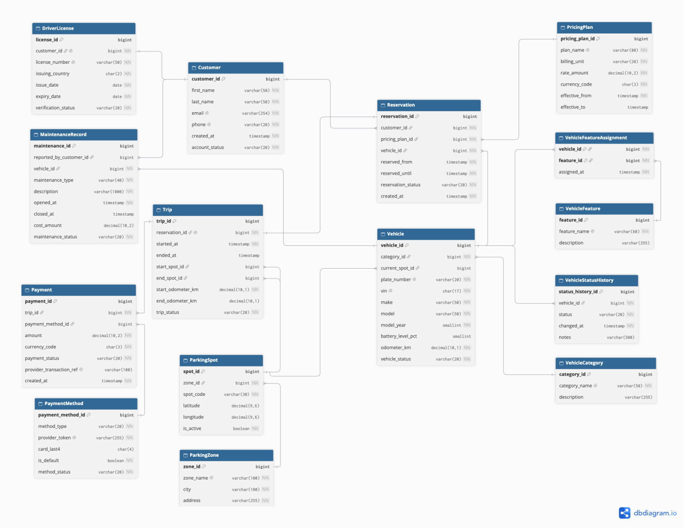

The logical scheme contains the following entities:
- Customer
- DriverLicense
- VehicleCategory
- ParkingZone
- ParkingSpot
- Vehicle
- VehicleStatusHistory
- PricingPlan
- Reservation
- Trip
- PaymentMethod
- Payment
- MaintenanceRecord
- VehicleFeature
- VehicleFeatureAssignment
Main Relationships
- One customer can have zero or one driver-license record.
- One vehicle category can classify multiple vehicles.
- One parking zone can contain multiple parking spots.
- One parking spot can be referenced as the current location of multiple vehicles over time.
- One vehicle can have multiple status-history records.
- One customer can create multiple reservations.
- One vehicle can be included in multiple reservations over time.
- One pricing plan can be used by multiple reservations.
- One reservation can produce zero or one trip.
- One trip can have multiple payment records.
- One payment method can be referenced by multiple payments.
- One vehicle can have multiple maintenance records.
- One customer can optionally be identified as the reporter of a maintenance issue.
- Vehicles and vehicle features have a many-to-many relationship resolved through VehicleFeatureAssignment.
Modeling Decision
One of the most important modeling decisions was resolving the many-to-many relationship between vehicles and features. A vehicle may have several features, and the same feature may be available in several vehicles. The junction table VehicleFeatureAssignment resolves this relationship using the composite primary key (vehicle_id, feature_id).
Another important decision was separating reservations from trips. A reservation represents planned vehicle usage, while a trip represents actual usage. This separation allows the system to retain planned and actual timestamps independently.
Potential Data Anomalies Prevented
- Duplicate records: Unique constraints prevent duplicate customer emails, phone numbers, vehicle registration plates, VINs, and feature names.
- Invalid references: Foreign keys prevent reservations from referencing nonexistent customers, vehicles, or pricing plans.
- Duplicate feature assignments: The composite primary key in VehicleFeatureAssignment prevents the same feature from being assigned to the same vehicle more than once.
- Loss of status history: VehicleStatusHistory retains historical status changes rather than requiring the current status to be the only stored record.
- Inconsistent pricing information: PricingPlan stores pricing information separately from reservations, reducing repeated plan definitions.
Scalability and Future Changes
The model supports adding new vehicle categories, parking locations, features, and pricing plans. These changes can be introduced by inserting new records rather than redesigning existing tables.
If the business introduces multiple payment providers, complex pricing rules, discounts, insurance, or customer subscriptions, additional related tables may be required.
The most likely areas to change are pricing, payment processing, trip billing, and reservation management because these processes often become more complex as a service grows.
Business Rules Requiring Additional Validation
The logical model defines the relationships and basic constraints, but some business rules require additional database or application-level enforcement:
- A reservation must end after it starts.
- Confirmed reservations for the same vehicle must not overlap.
- A driver must have a valid and verified license before starting a trip.
- A vehicle undergoing maintenance must not be available for reservation.
- Monetary amounts and maintenance costs must not be negative.
- An ended trip must have an end timestamp and a valid end odometer reading.
- Pricing-plan end dates, when provided, must be later than their start dates.

These rules should be implemented through appropriate SQL constraints, database exclusion constraints, triggers, or transactional application logic.

2.3. Objects
The following sections describe all 15 tables in the logical model. For each table, the field definitions, keys, normalization rationale, and example records should be documented.

Table 1: Customer
Purpose: Stores customer account information.
Why separate: Customer details should not be repeated in every reservation or trip.
Normalization: The table is designed for 3NF because customer attributes depend on customer_id. Email and phone are separately constrained to be unique.

Field name | Field description | Data type
customer_id | PK; customer identifier | BIGINT
first_name | Customer's first name | VARCHAR(50)
last_name | Customer's last name | VARCHAR(50)
email | Unique email address | VARCHAR(254)
phone | Unique contact number | VARCHAR(20)
created_at | Account creation timestamp | TIMESTAMP
account_status | Current account status | VARCHAR(20)
Example data
customer_id | first_name | last_name | email
1 | Ali | Karimov | ali@example.com
2 | Madina | Usmanova | madina@example.com

Table 2: DriverLicense
Purpose: Stores driver-license details and verification status.
Why separate: License information has its own lifecycle and verification process and should not be duplicated in customer records.
Normalization: Designed for 3NF. customer_id is both an FK and UNIQUE, so each customer can have at most one license record in this model.

Field name | Field description | Data type
license_id | PK; license record identifier | BIGINT
customer_id | FK to Customer; unique | BIGINT
license_number | Unique license number | VARCHAR(50)
issuing_country | Issuing country code | CHAR(2)
issue_date | License issue date | DATE
expiry_date | License expiry date | DATE
verification_status | Verification result | VARCHAR(20)
Example data
license_id | customer_id | license_number | verification_status
1 | 1 | UZ123456 | verified
2 | 2 | UZ789012 | pending

Table 3: VehicleCategory
Purpose: Defines vehicle categories.
Why separate: Category names and descriptions should be maintained once and referenced by vehicles.
Normalization: Designed for 3NF because category attributes depend on category_id.

Field name | Field description | Data type
category_id | PK; category identifier | BIGINT
category_name | Unique category name | VARCHAR(50)
description | Category description | VARCHAR(255)
Example data
category_id | category_name | description
1 | Economy | Economical city cars
2 | Electric | Battery-powered vehicles

Table 4: ParkingZone
Purpose: Stores service-area or parking-zone information.
Why separate: A zone can contain many parking spots, and its location details should not be repeated in each spot.
Normalization: Designed for 3NF because zone attributes depend on zone_id.

Field name | Field description | Data type
zone_id | PK; zone identifier | BIGINT
zone_name | Unique zone name | VARCHAR(100)
city | City containing the zone | VARCHAR(100)
address | General zone address | VARCHAR(255)
Example data
zone_id | zone_name | city | address
1 | Central Zone | Tashkent | Amir Temur Avenue
2 | Airport Zone | Tashkent | Airport Terminal

Table 5: ParkingSpot
Purpose: Represents an individual parking spot.
Why separate: A zone contains multiple spots, and each spot has its own code, coordinates, and active status.
Normalization: Designed for 3NF. zone_id is an FK, and (zone_id, spot_code) is unique.

Field name | Field description | Data type
spot_id | PK; parking spot identifier | BIGINT
zone_id | FK to ParkingZone | BIGINT
spot_code | Spot code within the zone | VARCHAR(30)
latitude | Geographic latitude | DECIMAL(9,6)
longitude | Geographic longitude | DECIMAL(9,6)
is_active | Whether the spot is active | BOOLEAN
Example data
spot_id | zone_id | spot_code | is_active
1 | 1 | C-001 | true
2 | 1 | C-002 | true

Table 6: Vehicle
Purpose: Stores vehicle identification, technical details, location, and current status.
Why separate: Vehicle details are independent of reservations, trips, and payments.
Normalization: Designed for 3NF. Category information is stored in VehicleCategory, and parking-zone information is stored in separate location tables.

Field name | Field description | Data type
vehicle_id | PK; vehicle identifier | BIGINT
category_id | FK to VehicleCategory | BIGINT
current_spot_id | Optional FK to ParkingSpot | BIGINT
plate_number | Unique registration plate | VARCHAR(20)
vin | Unique vehicle identification number | CHAR(17)
make | Manufacturer | VARCHAR(50)
model | Vehicle model | VARCHAR(50)
model_year | Manufacturing/model year | SMALLINT
battery_level_pct | Optional battery level, 0–100 | SMALLINT
odometer_km | Current odometer reading | DECIMAL(10,1)
vehicle_status | Current vehicle status | VARCHAR(20)
Example data
vehicle_id | category_id | plate_number | make | model
1 | 1 | 01A123AA | Chevrolet | Cobalt
2 | 2 | 01B456BB | BYD | Dolphin

Table 7: VehicleStatusHistory
Purpose: Stores historical vehicle status changes.
Why separate: The current status in Vehicle does not provide a complete history of previous statuses.
Normalization: Designed for 3NF. Each status-history record depends on its own primary key and references a vehicle through vehicle_id.

Field name | Field description | Data type
status_history_id | PK; history record identifier | BIGINT
vehicle_id | FK to Vehicle | BIGINT
status | Recorded vehicle status | VARCHAR(20)
changed_at | Date and time of change | TIMESTAMP
notes | Optional notes | VARCHAR(500)
Example data
status_history_id | vehicle_id | status | changed_at
1 | 1 | available | 2026-10-01 09:00
2 | 1 | reserved | 2026-10-01 10:00

Table 8: PricingPlan
Purpose: Stores pricing-plan names, rates, currencies, and effective periods.
Why separate: Pricing rules should not be repeated in every reservation.
Normalization: Designed for 3NF. Each pricing attribute depends on pricing_plan_id.

Field name | Field description | Data type
pricing_plan_id | PK; pricing-plan identifier | BIGINT
plan_name | Unique pricing-plan name | VARCHAR(80)
billing_unit | Minute, hour, or day | VARCHAR(20)
rate_amount | Rate per billing unit | DECIMAL(10,2)
currency_code | Currency code | CHAR(3)
effective_from | Plan start timestamp | TIMESTAMP
effective_to | Optional plan end timestamp | TIMESTAMP
Example data
pricing_plan_id | plan_name | billing_unit | rate_amount | currency_code
1 | Standard Hourly | hour | 50000.00 | UZS
2 | Economy Minute | minute | 1000.00 | UZS

Table 9: Reservation
Purpose: Records planned vehicle usage by customers.
Why separate: A reservation is a planned event, whereas a trip represents actual vehicle use.
Normalization: Designed for 3NF. Customer, vehicle, and pricing-plan details are referenced through FKs instead of being copied into the reservation.

Field name | Field description | Data type
reservation_id | PK; reservation identifier | BIGINT
customer_id | FK to Customer | BIGINT
pricing_plan_id | FK to PricingPlan | BIGINT
vehicle_id | FK to Vehicle | BIGINT
reserved_from | Planned start timestamp | TIMESTAMP
reserved_until | Planned end timestamp | TIMESTAMP
reservation_status | Reservation status | VARCHAR(20)
created_at | Reservation creation timestamp | TIMESTAMP
Example data
reservation_id | customer_id | vehicle_id | reservation_status
1 | 1 | 1 | confirmed
2 | 2 | 2 | pending

Table 10: Trip
Purpose: Records actual vehicle usage.
Why separate: Actual start/end times, locations, and odometer readings may differ from the planned reservation.
Normalization: Designed for 3NF. reservation_id is a unique FK, allowing at most one trip per reservation.

Field name | Field description | Data type
trip_id | PK; trip identifier | BIGINT
reservation_id | Unique FK to Reservation | BIGINT
started_at | Actual trip start | TIMESTAMP
ended_at | Optional actual trip end | TIMESTAMP
start_spot_id | Optional FK to ParkingSpot | BIGINT
end_spot_id | Optional FK to ParkingSpot | BIGINT
start_odometer_km | Odometer at trip start | DECIMAL(10,1)
end_odometer_km | Optional odometer at trip end | DECIMAL(10,1)
trip_status | Trip status | VARCHAR(20)
Example data
trip_id | reservation_id | started_at | trip_status
1 | 1 | 2026-10-01 10:05 | completed
2 | 2 | 2026-10-02 14:00 | ongoing

Table 11: PaymentMethod
Purpose: Stores payment-method details and payment-provider tokens.
Why separate: Payment instruments and their provider tokens should be stored separately from individual payment transactions.
Normalization: Designed for 3NF. Each attribute describes the payment-method record identified by payment_method_id.

Field name | Field description | Data type
payment_method_id | PK; payment-method identifier | BIGINT
method_type | Type of payment method | VARCHAR(20)
provider_token | Unique payment-provider token | VARCHAR(255)
card_last4 | Optional last four card digits | CHAR(4)
is_default | Default-method indicator | BOOLEAN
method_status | Payment-method status | VARCHAR(20)
Example data
payment_method_id | method_type | card_last4 | method_status
1 | card | 1234 | active
2 | wallet | NULL | active

Table 12: Payment
Purpose: Records payment transactions and their processing status.
Why separate: One trip may have multiple payment records, such as retries or refunds.
Normalization: Designed for 3NF. Trip and payment-method information is referenced through foreign keys.

Field name | Field description | Data type
payment_id | PK; payment identifier | BIGINT
trip_id | FK to Trip | BIGINT
payment_method_id | Optional FK to PaymentMethod | BIGINT
amount | Payment amount | DECIMAL(10,2)
currency_code | Currency code | CHAR(3)
payment_status | Payment processing status | VARCHAR(20)
provider_transaction_ref | Optional unique provider reference | VARCHAR(100)
created_at | Payment creation timestamp | TIMESTAMP
Example data
payment_id | trip_id | amount | payment_status
1 | 1 | 50000.00 | paid
2 | 2 | 25000.00 | pending

Table 13: MaintenanceRecord
Purpose: Records vehicle maintenance, repairs, cleaning, inspections, and reported issues.
Why separate: A vehicle can have multiple maintenance events, each with its own dates, description, cost, and status.
Normalization: Designed for 3NF. Vehicle and reporting-customer information is referenced through foreign keys.

Field name | Field description | Data type
maintenance_id | PK; maintenance identifier | BIGINT
reported_by_customer_id | Optional FK to Customer | BIGINT
vehicle_id | FK to Vehicle | BIGINT
maintenance_type | Type of maintenance | VARCHAR(40)
description | Description of the issue or work | VARCHAR(1000)
opened_at | Maintenance start timestamp | TIMESTAMP
closed_at | Optional completion timestamp | TIMESTAMP
cost_amount | Optional maintenance cost | DECIMAL(10,2)
maintenance_status | Maintenance status | VARCHAR(20)
Example data
maintenance_id | vehicle_id | maintenance_type | maintenance_status
1 | 1 | inspection | completed
2 | 2 | repair | in_progress

Table 14: VehicleFeature
Purpose: Defines vehicle features, such as GPS, automatic transmission, or a child seat.
Why separate: Feature names and descriptions should be maintained once and reused across vehicles.
Normalization: Designed for 3NF. Feature attributes depend on feature_id, and feature_name is unique.

Field name | Field description | Data type
feature_id | PK; feature identifier | BIGINT
feature_name | Unique feature name | VARCHAR(60)
description | Optional feature description | VARCHAR(255)
Example data
feature_id | feature_name | description
1 | GPS | Navigation system
2 | Child Seat | Child safety seat

Table 15: VehicleFeatureAssignment
Purpose: Connects vehicles to their available features.
Why separate: It resolves the many-to-many relationship between vehicles and features.
Normalization: Designed for 3NF. The composite primary key (vehicle_id, feature_id) prevents duplicate assignments. Both columns are foreign keys, and assigned_at describes the assignment identified by the complete composite key.

Field name | Field description | Data type
vehicle_id | Composite PK; FK to Vehicle | BIGINT
feature_id | Composite PK; FK to VehicleFeature | BIGINT
assigned_at | Assignment timestamp | TIMESTAMP
Example data
vehicle_id | feature_id | assigned_at
1 | 1 | 2026-10-01 09:00
1 | 2 | 2026-10-01 09:05

2. Normalization Summary
The model is designed to meet 3NF principles.
- First Normal Form (1NF): Each field stores a single value. Repeating lists of vehicle features are not stored inside the Vehicle table.
- Second Normal Form (2NF): Non-key attributes depend on the complete primary key. In VehicleFeatureAssignment, assigned_at describes the specific vehicle-feature pair.
- Third Normal Form (3NF): Entity-specific attributes are stored in their appropriate tables. Vehicle category details are separated from Vehicle; parking-zone details are separated from ParkingSpot; and pricing-plan details are separated from Reservation.

The model uses primary keys, foreign keys, unique constraints, and recommended validation rules to improve data integrity.

3. Final Conclusion
The Car Sharing Service logical data model provides a structured foundation for managing customers, driver licenses, vehicles, parking infrastructure, reservations, trips, pricing plans, payment records, maintenance, and vehicle features.
Its normalized structure reduces unnecessary duplication, supports traceability, and allows new business capabilities to be introduced with limited changes to the existing schema.

