İSTANBUL NİŞANTAŞI UNIVERSITY
FACULTY OF ENGINEERING ARCHITECTURE
SOFTWARE ENGINEERING DEPARTMENT

GRADUATION PROJECT REPORT

AI-Powered Contract Analysis System: Risk Detection and Legal Precedent Retrieval for Turkish Contracts with Corrective RAG

ID NO Oğuzhan TUĞAY
ID NO Maksut AKGÜN
ID NO Eren YÜKSEL

DEPARTMENT: SOFTWARE ENGINEERING
PROJECT ADVISOR: Sibel BORAN, Ph.D.
COURSE NAME / CODE: GRADUATION PROJECT / ESOF433
ACADEMIC YEAR / SEMESTER: 2026-2027 / FALL
PRESENTATION DATE: DECEMBER 25, 2026

FOREWARD
This report presents the graduation project carried out in the Software Engineering Department of İstanbul Nişantaşı University during the 2026-2027 Fall semester. The project grew out of a simple observation: most people in Türkiye sign rental, service and employment contracts without having them read by a lawyer, and only discover an unfair or unlawful clause when a dispute has already started. We wanted to build a tool that gives such people an affordable first check of their contract, explains the risks in plain language and points to the court decisions and statutes that support each warning.
Building the system taught us far more than we expected about combining large language models with deterministic software, about the limits of what a language model should be trusted with in a legal setting, and about designing software that degrades honestly when an external service fails. Some of these lessons came from events outside our control, such as the shutdown of a free public service we depended on, and we describe them openly in this report.
We would like to thank our advisor, Sibel BORAN, Ph.D., for her guidance, patience and constructive criticism throughout the project, and the faculty members of the Software Engineering Department for the knowledge they shared with us over four years. We also thank the developers of the open-source Yargı MCP server, whose work made access to Turkish court decisions possible, and our families for their constant support.

Oğuzhan TUĞAY
Maksut AKGÜN
Eren YÜKSEL
Undergraduate Students at Software Engineering Department

ABSTRACT
Contracts are signed every day by people who cannot afford a legal review, and the Turkish legal system contains mandatory limits, such as the cap on lease deposits or on the duration of a non-compete covenant, that ordinary readers do not know. This project presents an AI-powered contract analysis system for Turkish contracts. A user uploads a contract as PDF, DOCX or a scanned image, states which side of the contract they are on, and receives a plain-language summary, clause-by-clause risk findings with severity and recommendations, a 0-100 risk score, Turkish court decisions that support each risk, statutory limit checks, a list of missing protective clauses, a corrected version of the contract that can be downloaded as a Word document, and a chat interface for asking questions about the analysed contract.
The backend is built with FastAPI and orchestrated as a LangGraph state graph. Risk classification is performed by a large language model (Gemma 3 27B through the Gemini API) in clause batches, while legally sensitive decisions are delegated to deterministic code: statutory limits of the Turkish Code of Obligations and the Labour Act are checked by rules that receive only extracted facts from the model, statute references come from a curated and verified table, and the risk score is computed by a noisy-OR aggregation that replaced an earlier saturating formula. Court decisions are retrieved from the Yargı MCP server over the Model Context Protocol inside a Corrective Retrieval-Augmented Generation (CRAG) loop that grades every retrieved decision and rewrites the query up to two times when no relevant decision is found. Every fallback is reported to the user as a limitation, so the system never degrades silently.
The report describes the problem, the related literature on legal NLP and retrieval-augmented generation, the design and implementation of the system, the risk management of the project, including an external service shutdown that actually happened, and a frank discussion of limitations. Functional checks performed offline with a rule-based analyzer are reported, and a quantitative evaluation protocol on an annotated set of real contracts is defined; its results will be presented at the defence. The system is positioned as a first check that helps users ask better questions, not as a replacement for a lawyer.
Keywords: contract analysis, legal NLP, retrieval-augmented generation, corrective RAG, LangGraph, Model Context Protocol, large language models, Turkish law, risk scoring.

TABLE OF CONTENTS
1. INTRODUCTION 1
2. PURPOSE OF THE PROJECT 3
2.1. PROBLEM DEFINITION 3
2.2. TARGET USERS 4
2.3. OBJECTIVES 4
2.4. SCOPE 5
3. LITERATURE 6
4. METHODS 8
4.1. DESIGN 8
4.2. CODE 13
4.3. RISK MANAGEMENT 15
5. DISCUSSION 17
6. CONCLUSION 20
REFERENCES 21

LIST OF FIGURES

FIGURE 2.1.1 Upload screen with contract type and party selection
FIGURE 4.1.1 System architecture
FIGURE 4.1.2 LangGraph analysis pipeline with the Corrective RAG loop and its conditional edges
FIGURE 4.1.3 Report view with risk score, statutory checks and court decisions
FIGURE 5.1.1 Old and new risk scores for selected finding profiles

LIST OF TABLES

TABLE 4.1.1 Canonical risk categories
TABLE 4.1.2 Statutory rules and their legal basis
TABLE 4.1.3 Technology stack
TABLE 4.3.1 Work Package
TABLE 5.1.1 Old and new risk score for selected finding profiles (computed with law_rag.risk)

1. INTRODUCTION
A contract is the most common legal document an ordinary person signs. Renting a flat, hiring a freelance developer or starting a new job all involve a written agreement that decides who pays, who carries the risk and what happens when something goes wrong. The weaker party usually receives a ready-made text prepared by the other side and signs it after a quick reading. A legal review would reveal one-sided termination rights, excessive penalties, deposits above the statutory limit or an eviction undertaking signed together with the lease, but such a review costs time and money that many people, students and small businesses do not have.
Turkish law protects the weaker party in several of these situations through mandatory provisions. The Turkish Code of Obligations (TBK) limits a residential lease deposit to three months of rent (m.342), restricts rent increases at renewal to the twelve-month average change of the consumer price index (m.344), forbids penalty clauses and acceleration of future rent for late payment against the tenant (m.346), makes an eviction undertaking given when the lease is signed unenforceable (m.352) and limits a non-compete covenant to two years except in special circumstances (m.445) [14]. The Labour Act limits the probation period to two months (m.15) and sets minimum notice periods by seniority (m.17) [15]. A layperson rarely knows that these rules exist.
Large language models (LLMs) can now read long Turkish documents and explain them in plain language, so it is tempting to ask a chatbot whether a contract is fair. Legal question answering, however, is an area in which LLMs are known to hallucinate: studies of general-purpose models and of commercial legal research tools found invented case law, wrong article numbers and confident but unsupported conclusions [10][11]. A tool that cites the wrong article or a non-existent decision gives false confidence and is worse than no tool at all.
This project addresses both sides of the problem. We built a web application in which a user uploads a Turkish contract as PDF, DOCX or a scan, states which side of the contract they are on, and receives a plain-language summary, clause-by-clause risk findings with severity and recommendations, a 0-100 risk score, statutory limit checks, missing protective clauses, court decisions that support each risk, a corrected version of the contract as a Word document, and a chat in which follow-up questions are answered from the analysed contract. The LLM is used for what it does well, namely reading clauses, recognising risk patterns, extracting facts and writing explanations, while every legally load-bearing decision is delegated to deterministic, verifiable code: statutory limits are checked by rules verified against mevzuat.gov.tr, article numbers come only from a curated table, and the risk score is a documented formula.
Court decisions of Yargıtay, Danıştay and the Personal Data Protection Authority (KVKK) are retrieved through the Yargı MCP server in a Corrective Retrieval-Augmented Generation (CRAG) loop [2]: each finding produces a search query, the returned decisions are graded as relevant, ambiguous or irrelevant, and the query is rewritten at most twice when nothing relevant is found. The loop is implemented as a LangGraph state graph with conditional edges [17], and the retrieval history of every finding is returned to the user.
The system is positioned as an affordable first check, not as legal advice and not as a replacement for a lawyer. This shapes many design decisions: every fallback and uncertainty is reported as a limitation, findings that cannot be decided automatically are marked as needing review, and the fact that contract text is sent to a model provider is disclosed. Section 2 states the purpose of the project, Section 3 reviews the literature, Section 4 describes the design, the implementation and the risk management, Section 5 discusses results, the evaluation protocol and limitations, and Section 6 concludes.

2. PURPOSE OF THE PROJECT
The purpose of the project is to design and implement a web-based system that helps non-lawyers understand the risks of a Turkish contract before they sign it, with explanations grounded in statutes and real court decisions rather than in the unsupported output of a language model.

2.1. PROBLEM DEFINITION
The problem has three parts. There is an access problem: legal review is expensive relative to the value of most everyday contracts, so leases, freelance agreements and employment contracts are usually signed without review. There is a knowledge problem: the mandatory rules that protect the weaker party are scattered across several codes, so a clause that is plainly unlawful to a lawyer looks normal to a tenant or a new employee. And there is a trust problem with the obvious technological answer: chatbots explain contracts fluently but invent citations, do not show which decisions support their claims and answer differently each time [10][11]. A useful system must locate each risky clause, explain why it is risky from the user's side, distinguish an unfavourable clause from one that violates a mandatory limit, support its warnings with verifiable sources, propose corrections, and be honest about what it could not do.
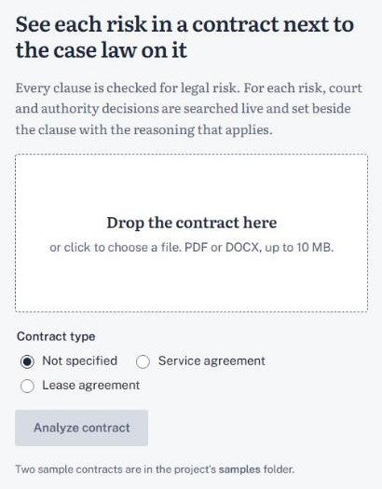
FIGURE 2.1.1 Upload screen with contract type and party selection

2.2. TARGET USERS
The primary users are individuals and small organisations who sign standard contracts without legal support: tenants and small landlords, freelancers and their clients, small businesses buying services, and employees reviewing a job offer. Lawyers and law students may use the system as a fast first pass. The interface and all generated explanations are in Turkish, because the contracts and legal sources are Turkish.

2.3. OBJECTIVES
- Accept contracts as PDF, DOCX or scanned PDF or photo, using OCR by a vision model when there is no text layer.
- Split the contract into clauses by rules and classify the risks of every clause with an LLM, without truncating long contracts.
- Take the user's side into account, so that a clause that harms only the other party does not raise the user's score.
- Check mandatory statutory limits with deterministic code, with the LLM only extracting the facts the rules need.
- Detect missing protective clauses and attach verified statute references; never let the LLM be the source of an article number.
- Retrieve, grade and trace supporting court decisions in a Corrective RAG loop over the Yargı MCP server.
- Compute a bounded, interpretable 0-100 risk score that does not saturate.
- Suggest clause rewrites, export a corrected contract as DOCX, and answer questions about the contract with cited sources.
- Report every fallback to the user and persist no contract on the server.
From the user's point of view the workflow is short. The user opens the web interface, uploads the contract, selects the contract type and their role, and starts the analysis. The report first shows the summary and the risk score with its level, then the risky clauses with explanations and recommendations, the statutory checks that passed or failed, the missing clauses, the supporting court decisions and the suggested rewrites. The corrected contract can be downloaded as a Word document, and a chat panel answers follow-up questions about the same contract. Every limitation that affected the analysis is listed next to the score, so the user can judge how much to rely on it.

2.4. SCOPE
The system covers lease, service and employment contracts in depth and handles other contracts with general risk categories. The statutory rules cover the most frequent mandatory limits of these types and are not a complete codification of Turkish contract law. The system does not give legal advice; it prepares the user for a conversation with a professional or helps them decide that one is needed. From a software engineering perspective, the project also aimed to structure an LLM application as an explicit state graph whose steps can be tested in isolation, to keep a rule-based analyzer that runs offline as both fallback and evaluation baseline, and to define an evaluation protocol that measures the contribution of each component.

3. LITERATURE
Contract review datasets. Contract review is a long-standing target of natural language processing because it is repetitive, expensive and largely about recognising known clause types. CUAD by Hendrycks et al. [4] contains more than 500 commercial contracts annotated by experts with 41 clause categories, such as governing law, non-compete and uncapped liability, and frames review as extractive question answering; its category list influenced our taxonomy, adapted to Turkish lease, service and employment contracts. LEDGAR by Tuggener et al. [8] is a large corpus of provisions from contracts filed with the US SEC, labelled for multi-label clause classification, and shows the long-tail distribution of clause types. ContractNLI by Koreeda and Manning [6] treats review as document-level natural language inference with evidence spans; its emphasis on evidence is reflected in our design, where every finding is tied to a clause and every chat answer must cite its sources.
Unfair clause detection and legal language models. CLAUDETTE by Lippi et al. [9] detects potentially unfair clauses in online terms of service under EU consumer law, with categories such as unilateral termination, limitation of liability and jurisdiction, several of which correspond to our categories. LEGAL-BERT by Chalkidis et al. [7] showed that pretraining on legal corpora improves legal classification over a general model. LegalBench by Guha et al. [5], a benchmark of 162 legal reasoning tasks, found that LLMs do relatively well at classification and interpretation but are weaker at applying a precise legal rule, which motivated our decision to keep statutory rule application in deterministic code. Almost all of these resources concern English and US or EU law; to our knowledge there is no public clause-level annotated dataset of Turkish contracts, which is why we rely on a general multilingual model, keep a rule-based baseline and are building a small annotated evaluation set.
Retrieval-augmented generation. RAG, introduced by Lewis et al. [1], conditions a generator on documents retrieved at query time, reducing reliance on memorised knowledge, allowing the knowledge source to be updated and making evidence visible, all of which matter in law. Standard RAG assumes that retrieved documents are relevant. Corrective RAG by Yan et al. [2] adds a retrieval evaluator that classifies retrieval as correct, ambiguous or incorrect and, depending on the verdict, refines the documents, searches again with a rewritten query, or combines both. Our loop adopts this three-way grading at the level of each court decision, with query rewriting as the corrective action on the official decision sources and a bounded number of rewrites. Self-RAG by Asai et al. [3] trains a model to decide when to retrieve and to critique relevance and support with reflection tokens; we do not train a model but follow the same principle by storing an explicit grade and reason with every decision.
Hallucination in legal AI. Dahl et al. [11] found high hallucination rates of widely used LLMs on questions about US case law, acceptance of false premises and poor calibration of confidence. Magesh et al. [10] found that commercial legal research tools built on RAG hallucinate less than general chatbots but still give incorrect or misgrounded answers, for example citing a real case that does not support the claim. These findings led to three design decisions: the model is never the source of an article number, retrieved decisions are graded before they are shown, and the model's self-reported confidence is treated as an uncalibrated signal.
Rank fusion and probabilistic aggregation. Reciprocal rank fusion by Cormack, Clarke and Buettcher [12] merges ranked lists by summing 1/(k + rank) without score normalisation and outperformed more complex fusion methods; our chat combines dense and lexical rankings this way. The noisy-OR model described by Pearl [13] assumes that each cause independently produces an effect with some probability, so the probability of the effect is one minus the product of (1 - p_i); it is monotone, bounded and needs one parameter per cause, and our risk score uses exactly this aggregation.
Tools. LangGraph [17] builds stateful LLM applications as graphs of nodes over a shared state, with conditional edges that make loops explicit and testable. The Model Context Protocol [18] is a JSON-RPC 2.0 based protocol through which applications discover and call tools of external servers, such as the court decision searches of the Yargı MCP server. FastAPI [19] is a Python web framework based on type hints and pydantic models, and the Gemini API [20] serves the open-weight Gemma 3 27B model and an embeddings endpoint. In summary, the literature provides English clause datasets [4][6][8][9], evidence that LLMs are weak at precise rule application and prone to legal hallucination [5][10][11], and retrieval methods that ground and correct generation [1][2][3]; what is missing for Turkish users is an end-to-end system that combines these ideas transparently, which this project provides.

4. METHODS
The system was developed iteratively in five work packages: the core pipeline and Corrective RAG loop, the legal features, chat and OCR, evaluation tooling, and testing with frontend integration. This section describes the design (4.1), the implementation (4.2) and the risk management (4.3).

4.1. DESIGN
Architecture. The system follows a client-server architecture (Figure 4.1.1). The React frontend lets the user upload a contract, choose the contract type and their side, read the report, download the corrected contract and chat. It talks to a FastAPI backend over HTTPS with JSON. The backend validates the upload (10 MB limit by default), extracts the text with pypdf or python-docx, or by OCR for scans, and runs the analysis as a LangGraph state graph compiled per request. Two external services are used: the Gemini API hosts the language model (gemma-3-27b-it) and the embeddings endpoint, and the Yargı MCP server gives access to decisions of Yargıtay, Danıştay and KVKK. Everything that must be exact, namely segmentation, statutory checks, statute references, checklists, the score and the export, is deterministic Python code. The backend persists nothing: uploads live only in request memory and chat indexes in an in-memory session store with a time-to-live. Both external clients are defined by Python protocols with offline fake implementations, so the whole system can run without network access.
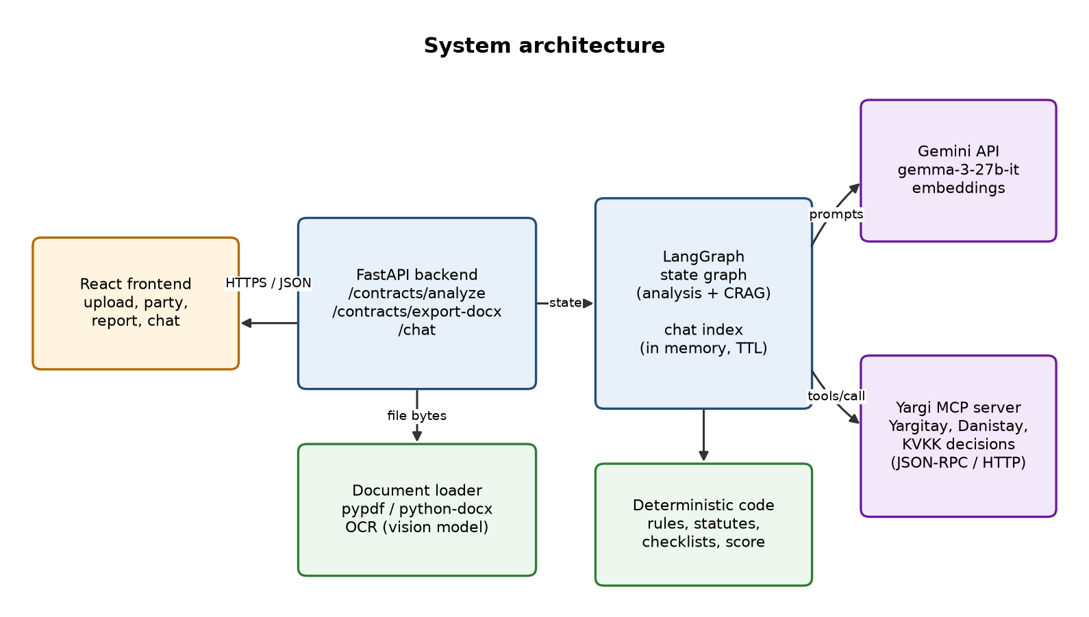
FIGURE 4.1.1 System architecture
Pipeline. The analysis is a LangGraph StateGraph over a pydantic state that holds the text, clauses, findings, statutory checks, missing clauses, rewrites, retrieval traces, candidate and selected decisions, the score and the accumulated limitations (Figure 4.1.2). segment_clauses splits the text; classify_risks obtains findings; check_statutes runs the statutory rules, attaches statute references and applies the party perspective; score_contract computes the score; build_legal_queries, retrieve_yargi_decisions, grade_decisions and rewrite_queries form the Corrective RAG loop; select_decisions picks decisions to report; detect_missing_clauses and suggest_rewrites follow; compose_report assembles the result. The score is computed before retrieval so that a failure of the court decision service can never change it.
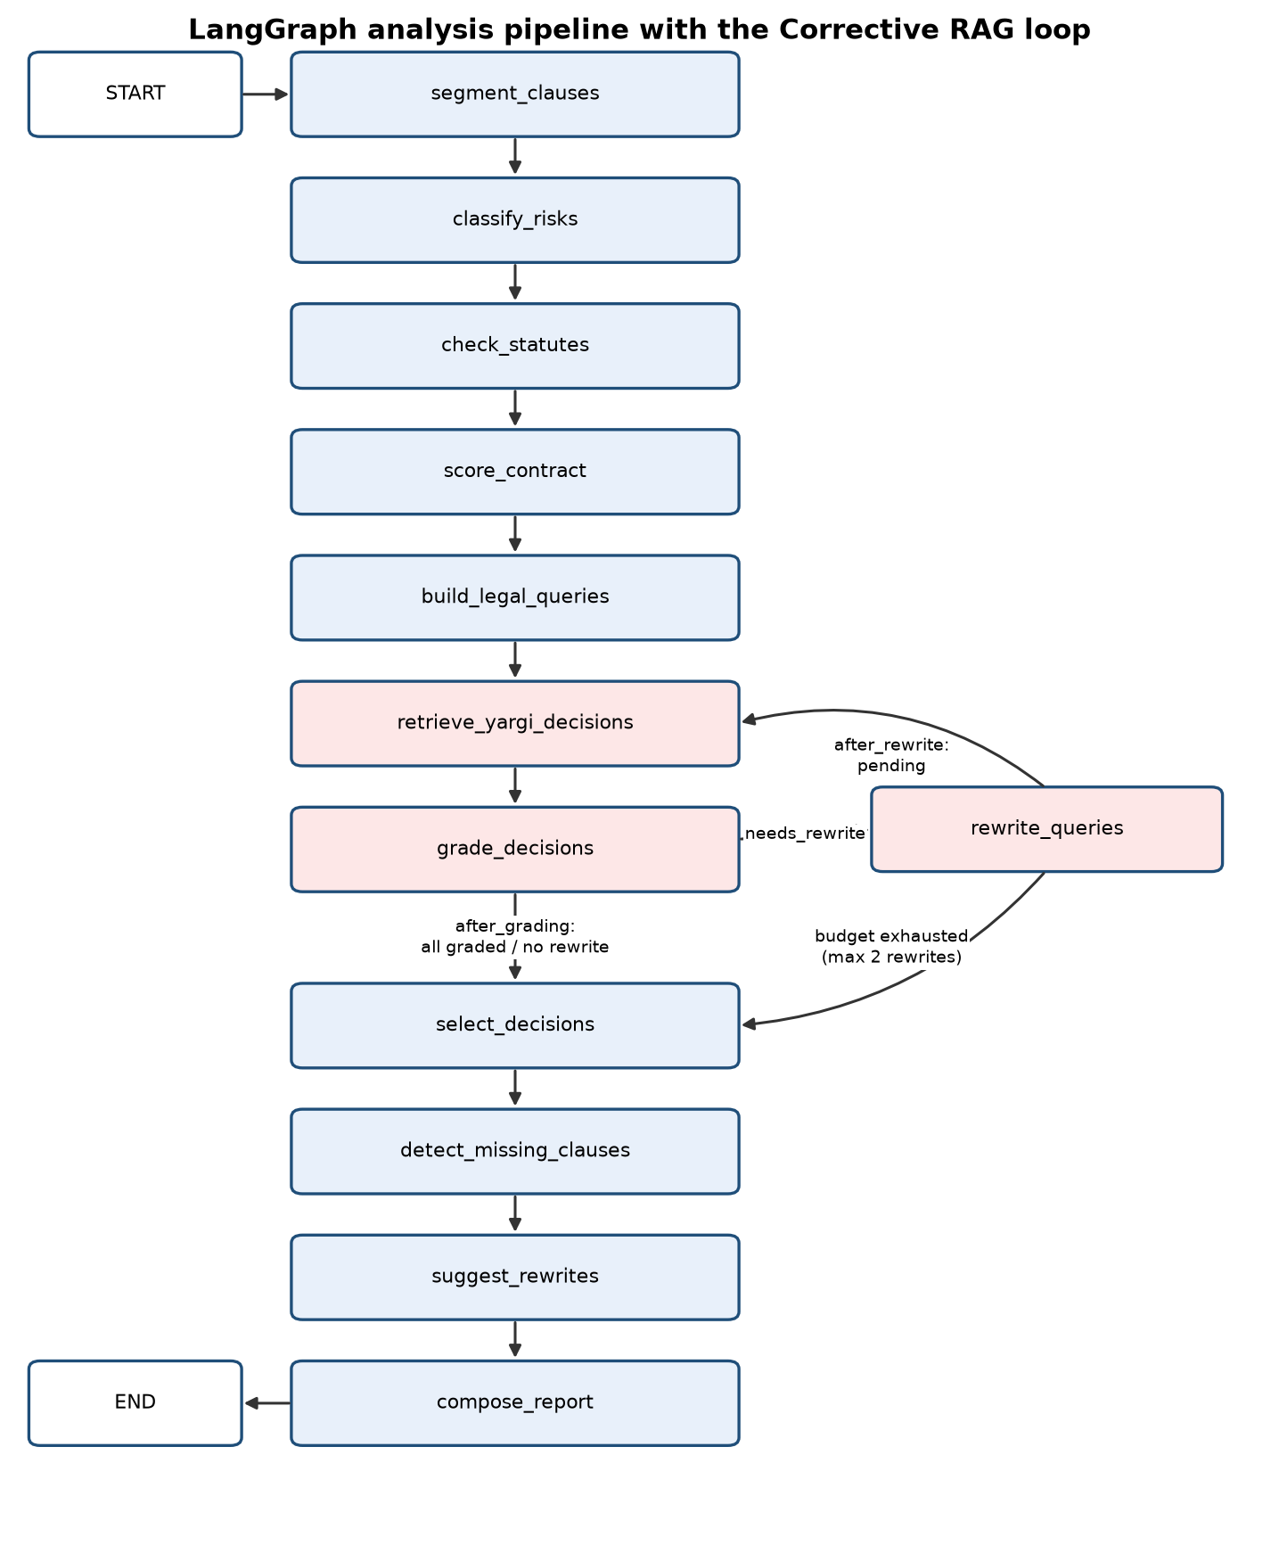
FIGURE 4.1.2 LangGraph analysis pipeline with the Corrective RAG loop and its conditional edges
Segmentation and risk classification. Clauses are found by rules that recognise "MADDE 5" and "Madde 1 -" headings, numbered headings such as "1." and "1)", sub-numbering such as "5.1", and fall back to paragraphs; stable clause identifiers are what findings, checks, rewrites and chat citations refer to. The LLM classifies risks in clause batches of about 6,000 characters, so long contracts are analysed completely rather than truncated. It returns JSON findings with category, severity, explanation, recommendation, confidence, clause and disadvantaged party, parsed tolerantly: surrounding text is stripped and malformed items are skipped instead of failing the batch. Categories come from a single source of truth that defines 17 canonical categories with Turkish labels, aliases, relevance terms for grading and fallback search queries (Table 4.1.1). A rule-based analyzer that detects the same categories with Turkish patterns serves both as the offline fallback for every LLM step and as the evaluation baseline. No fallback is silent: each one adds a limitation to the report, which the frontend displays next to the score.
TABLE 4.1.1 Canonical risk categories
Contract area | Categories
Lease | deposit_forfeiture, rent_increase, eviction_undertaking, unlawful_entry, cash_payment, penalty_clause
Employment | probation_period, non_compete, termination, data_protection, intellectual_property
Service and general | liability, payment_interest, force_majeure, intellectual_property, data_protection, termination
Procedure | jurisdiction, dispute_resolution
Other | general_risk

Party perspective. Each contract type defines two roles (tenant and landlord, client and provider, employee and employer). The user selects their role and the model states which party each finding disadvantages. Findings that hurt only the other party remain visible but are excluded from the score; without a role the analysis is neutral.
Statutory checks and statute grounding. The model, or the rule-based extractor as fallback, only extracts facts such as rent, deposit, rent increase, probation, notice periods and non-compete duration, each linked to its clause. Deterministic rules compare these facts with the limits in Table 4.1.2 and return ok, violation, needs_review or not_applicable. A violation becomes a finding with confidence 1.0 and the verified legal basis, merged with any LLM finding on the same clause and category. needs_review is used when the law depends on facts the text does not give: lease limits apply to residential and roofed workplace leases (TBK m.339), and the rent increase cap depends on the CPI figure published monthly by TÜİK, which is a configuration setting and is never guessed. Statute references come from a curated table with law number, article, summary and mevzuat.gov.tr link, covering the Code of Obligations, the Labour Act, the Code of Civil Procedure, the Personal Data Protection Law [16] and the Law on Intellectual and Artistic Works. The LLM is never the source of an article number, and a rewrite that cites a statute is rejected and replaced by a template.
TABLE 4.1.2 Statutory rules and their legal basis
Rule | Check | Legal basis
lease_deposit_cap | Deposit at most three months' rent | TBK m.342
lease_rent_increase_cap | Renewal increase not above twelve-month average CPI change | TBK m.344
lease_penalty_acceleration | No penalty or acceleration for late rent | TBK m.346
lease_eviction_undertaking_date | Eviction undertaking not given at signing | TBK m.352/1
employment_probation_cap | Probation at most two months | İş Kanunu m.15
employment_notice_minimum | Notice at least 2/4/6/8 weeks by seniority | İş Kanunu m.17
employment_non_compete_cap | Non-compete at most two years (special cases aside) | TBK m.445

Corrective RAG. For each finding the model writes a short Turkish search query, with a per-category fallback. Retrieval searches the Yargı MCP server for findings whose status is pending, using the KVKK search for data protection findings and the unified Yargıtay/Danıştay search otherwise; searches are cached per run and missing decision texts are fetched within a budget. Grading applies a keyword pre-filter, then the LLM grades each decision as relevant, ambiguous or irrelevant with a reason; if the LLM is disabled or fails, a keyword grader is used and a limitation is recorded. A finding without a relevant decision is sent by the conditional edge after_grading to rewrite_queries, which rewrites the query using feedback on why the previous attempt failed; after_rewrite returns to retrieval or, when two rewrites have been spent, proceeds to selection. Selection prefers relevant decisions, falls back to a labelled ambiguous one, never repeats a decision across findings and caps the total. Each finding carries a retrieval trace of its queries and of the grade counts of each attempt.
Risk score. The first formula was max(average, highest) + min(20, 4 x (n - 1)) over severity weights 15, 35, 65 and 85 times confidence, capped at 100. It saturated (one critical plus four findings of any severity reached 100), its density bonus had no interpretation, and it ignored the severity of additional findings. The current score uses noisy-OR aggregation [13]: each applicable finding is an independent chance of a dispute or loss with p_i = w(severity) x confidence, where w is 0.10, 0.25, 0.45 and 0.70 for low, medium, high and critical, and score = 100 x (1 - product of (1 - p_i)), with levels at 25, 50 and 75. The score is monotone (a finding never lowers it), bounded, free of arbitrary bonuses and interpretable as the probability that at least one risk materialises under the independence assumption. The weights still need calibration on labelled data; Section 5 compares the two formulas.
Missing clauses, rewrites and export. Per-type checklists list protective topics, such as the handling of the deposit in a lease or liability limits in a service contract, with importance, protected party, keywords and a suggested clause; missing topics are reported but do not affect the score. For risky clauses the model proposes balanced Turkish rewrites, validated and otherwise replaced by templates. The export endpoint builds a Word document of the corrected contract with python-docx and an appendix table listing every change with the original and new text and the related risk.
Chat. After analysis, the report is split into chunks (clauses, findings, statute references, statutory checks and decisions), each with an identifier, and indexed in memory for the session. Retrieval is hybrid: a dense ranking from Gemini embeddings and a lexical ranking on Turkish-normalised text, in which case and Turkish characters are folded, combined with reciprocal rank fusion [12]. When nothing relevant is retrieved, a fixed reply states that the question is not covered by this contract, without calling the model. Otherwise the model answers only from the retrieved chunks and must cite chunk identifiers, which are validated against the retrieved set.
OCR and report. Scanned PDFs and photos are rendered to images and transcribed page by page by the vision-capable model with a faithful-transcription prompt and a page cap; the report notes that OCR was used. The analysis endpoint returns a ContractReport whose fields are the summary, score and level, contract type and party, clauses, findings, recommended actions, statutory checks, missing clauses, rewrites, related decisions, retrieval trace and limitations (Figure 4.1.3).
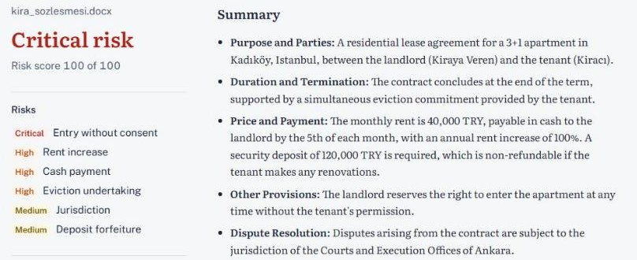
FIGURE 4.1.3 Report view with risk score, statutory checks and court decisions
TABLE 4.1.3 Technology stack
Layer | Technology | Role
Frontend | React | Upload, party selection, report, DOCX download, chat
API | FastAPI | Endpoints, validation, multipart upload [19]
Orchestration | LangGraph | State graph with conditional edges [17]
Language model | Gemini API, gemma-3-27b-it, embeddings | Classification, extraction, grading, rewriting, OCR, chat [20]
Court decisions | Yargı MCP server, httpx | Yargıtay, Danıştay, KVKK decisions over MCP [18]
Documents and data | pypdf, python-docx, pydantic | Text extraction, export, state and report schema
Tooling | uv, pytest | Dependencies and offline testing

4.2. CODE
Modules. The backend is the Python package law_rag, managed with uv. api.py defines the FastAPI endpoints; document_loader.py extracts text; segmentation.py splits clauses; graph.py and graph_steps.py hold the LangGraph nodes and edges; llm.py, llm_steps.py and prompts.py implement the Gemini analyzer, its call gate, tolerant parsing and prompt builders; fake_analyzer.py is the rule-based analyzer; categories.py and contract_types.py hold the category and role vocabularies; facts.py, statutory_rules.py and statutes.py implement fact extraction, rules and curated references; missing_clauses.py and rewrites.py the checklists and templates; crag.py and yargi_client.py the retrieval helpers and MCP client; risk.py the score; export_docx.py the export; models.py and config.py the pydantic models and settings; the chat and OCR modules the chunk index, hybrid retrieval and page transcription. All tunable behaviour is read from environment variables through pydantic-settings, including the model name, the Yargı MCP URL, whether to use the remote or fake Yargı client, the upload limit, LLM concurrency and minimum call interval, clause batch size, whether the LLM grader is used, the maximum number of rewrites (2), switches for the optional steps and the CPI figure for TBK m.344.
Score function. The whole aggregation is visible in a few lines; the legacy formula is kept in the same module so that both can be computed on the same findings.
SEVERITY_PROBABILITY = {"low": 0.10, "medium": 0.25, "high": 0.45, "critical": 0.70}

def calculate_risk_score(findings: list[RiskFinding]) -> int:
if not findings:
return 0
survival = prod(
1.0 - SEVERITY_PROBABILITY[finding.severity] * finding.confidence
for finding in findings
)
return max(0, min(100, round(100 * (1.0 - survival))))

Conditional edge. The CRAG loop is driven only by the retrieval status of each finding (pending, retrieved, relevant, needs_rewrite, exhausted or failed). Because a finding is marked exhausted when its rewrite budget is spent, the loop terminates regardless of the model's behaviour.
def after_grading(state: ContractAnalysisState) -> str:
if any(trace.status == "needs_rewrite" for trace in state.retrieval.values()):
return "rewrite_queries"
return "select_decisions"

workflow.add_conditional_edges(
"grade_decisions", after_grading,
{"rewrite_queries": "rewrite_queries", "select_decisions": "select_decisions"},
)

Statutory rule. Rules are small pure functions registered with their category, severity and legal basis; the user-facing explanations (elided here) are Turkish.
def _non_compete(rule, facts, _cpi):
fact = facts.get("non_compete_years")
limit = "Özel durumlar dışında en çok 2 yıl"
if fact is None:
return rule.result("not_applicable", "...", limit=limit)
years = float(fact.value)
status = "ok" if years <= 2 else "violation"
return rule.result(status, "...", fact=fact, value=f"{years} yıl", limit=limit)

Prompts and MCP client. Prompts are built by functions in prompts.py and follow fixed principles: plain JSON output with an exact shape (Gemma is not assumed to support a JSON mode), closed vocabularies taken from the single source of truth, one narrow task per prompt, no article numbers from the model, an explicit user role, English instructions with Turkish user-facing output, and bounded lengths. The remote Yargı client speaks MCP over HTTP with JSON-RPC 2.0 [18]: it sends initialize with protocol version 2025-06-18, keeps the Mcp-Session-Id header, sends notifications/initialized, lists the tools and calls search tools such as search_bedesten_unified and search_kvkk_decisions with tools/call, mapping JSON or server-sent-event responses to decision models.
Error handling and fallbacks. LLM calls pass through a call gate that bounds concurrency with a semaphore and spaces call starts, keeping the system within free-tier limits. When a call fails or returns unusable output, the step falls back to the rule-based analyzer, a template or keyword grading, and a warning is recorded. After each node the graph merges these warnings, without duplicates, into the report's limitations, together with retrieval failures, capped decision lists, decisions without text, ambiguous-only evidence, checks that need review and OCR use. The user therefore always receives a report and always knows what degraded.
Configuration over code. A recurring implementation principle was to make every external dependency and every tunable threshold a setting rather than a constant. This allowed the team to develop against fakes, to switch optional LLM steps off when the free-tier quota was low, to provide the CPI figure for the rent increase check without a code change, and, as described in Section 4.3, to react to the shutdown of the hosted court decision endpoint by changing a single value. Settings are validated by pydantic at start-up, so an invalid value, such as a negative number of rewrites, fails immediately instead of producing a wrong analysis later.
Testing. Tests use pytest and run fully offline with fake implementations of the external services. They cover the risk score and its thresholds (for example, that a single critical finding no longer forces the score to 100), clause segmentation, category normalisation, query building and prompt compactness with a monkeypatched model, the MCP client with stubbed JSON-RPC responses, and the full graph with fake clients, including decision selection and relevance filtering. The CRAG loop was also exercised in scripted scenarios with the fake client (Section 5).

4.3. RISK MANAGEMENT
Project risks were identified at the start of the semester, reviewed at weekly meetings and tied to work packages (Table 4.3.1).
TABLE 4.3.1 Work Package
Work Package No | THE MOST IMPORTANT RISKS | RISK MANAGEMENT (Plan B)
WP1: Core pipeline and CRAG loop | Free hosted Yargı MCP endpoint becomes unavailable (materialised); LLM rate limits and outages; irrelevant decisions shown | Endpoint is a configuration value; client behind a protocol with an offline fake; self-host the open-source server or use the successor service; call gate and rule-based fallback; grading with keyword fallback; limitations reported
WP2: Legal features (party, statutory checks, missing clauses, rewrites, statutes) | Hallucinated article numbers; wrong statutory facts; wrong CPI value | Curated statute table verified on mevzuat.gov.tr; LLM never the source of article numbers; rewrites citing statutes rejected; needs_review when undecidable; CPI as a setting
WP3: Chat and OCR | Ungrounded chat answers; OCR errors; cost of long scans | Hybrid retrieval with validated chunk citations; fixed "not covered" reply; page cap; OCR use reported
WP4: Evaluation | No public labelled Turkish contract dataset; annotation delays | In-house set of 20-30 contracts; rule-based baseline; protocol fixed in advance; results at the defence
WP5: Testing and frontend integration | Integration delays; tests depending on paid or unstable services; schedule | Offline fakes for all external services; fake-mode API for frontend work; optional steps behind switches

A risk that materialised. Court decisions were initially retrieved from a free hosted instance of the Yargı MCP server at yargimcp.surucu.dev. During the project the operator shut this free endpoint down and moved the service to a paid offering. The impact was limited by earlier design decisions: the endpoint is a configuration value, so pointing the system elsewhere needs no code change; the client sits behind a protocol with an offline fake, so development, frontend integration and tests continued, and the pipeline reported missing decisions as a limitation instead of failing; and the server is open source, so it can be self-hosted, the alternative being the operator's successor service. The lesson was that every external dependency, even a free and apparently stable one, needs an interface and a fallback.
Other risks. LLM rate limits and outages are handled by the call gate, clause batching, switches for optional steps and the rule-based fallback. Hallucinated legal citations [10][11] are addressed by the curated statute table, graded decisions and validated chat citations. Wrong statutory facts are guarded against by writing each rule from the official text and returning needs_review when the law depends on facts the contract does not give. OCR errors are mitigated by page-wise faithful transcription, a page cap and a limitation telling the user to double-check amounts. The privacy of contract text is protected by persisting nothing and by disclosing that text is sent to the model provider, in line with the Personal Data Protection Law [16]. The schedule risk was managed by ordering work packages so that an end-to-end system existed early and later features could be switched off.

5. DISCUSSION
This section reports only results we computed deterministically and functional checks performed offline, defines the evaluation protocol whose results will be presented at the defence, and discusses limitations. No accuracy, latency or cost figures are reported because they have not yet been measured.
Behaviour of the risk score. Because the score is a deterministic function of the findings, it can be studied exactly. Table 5.1.1 lists the old and new score, computed by importing the system's risk module, for finding profiles we defined (confidence 1.0 unless stated), and Figure 5.1.1 plots them.
TABLE 5.1.1 Old and new risk score for selected finding profiles (computed with law_rag.risk)
Finding profile | Findings | Old score (level) | New score (level)
1 low | 1 | 15 (low) | 10 (low)
2 low | 2 | 19 (low) | 19 (low)
1 medium | 1 | 35 (medium) | 25 (medium)
3 medium | 3 | 43 (medium) | 58 (high)
6 medium | 6 | 55 (high) | 82 (critical)
1 high | 1 | 65 (high) | 45 (medium)
1 high + 2 low | 3 | 73 (high) | 55 (high)
2 high | 2 | 69 (high) | 70 (high)
1 critical | 1 | 85 (high) | 70 (high)
1 critical (conf 0.6) | 1 | 51 (high) | 42 (medium)
1 critical + 3 high | 4 | 97 (critical) | 95 (critical)
1 critical + 4 low | 5 | 100 (critical) | 80 (critical)
1 critical + 5 high | 6 | 100 (critical) | 98 (critical)
10 low | 10 | 35 (medium) | 65 (high)

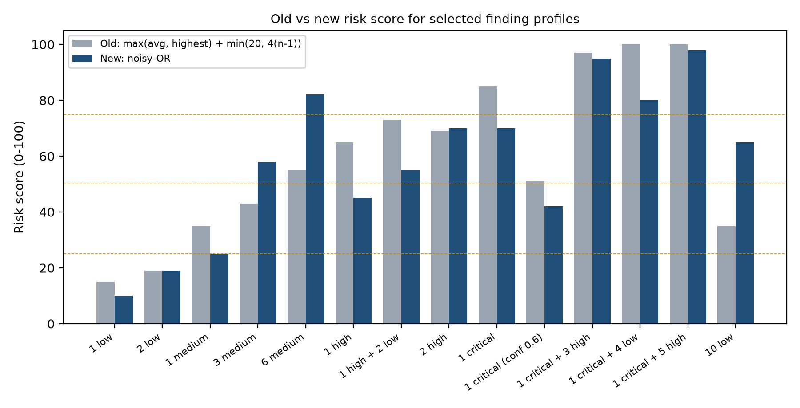
FIGURE 5.1.1 Old and new risk scores for selected finding profiles
Under the old formula, one critical plus four low findings and one critical plus five high findings both scored 100; the new formula separates them (80 and 98). The old formula rated one critical finding at 85 but six medium findings at only 55, while the new one gives 70 and 82, reflecting that many moderate risks together can be as serious as one severe risk. Ten low findings move from 35 to 65; whether this is the right magnitude is precisely what calibration must decide. The new score also responds smoothly to confidence: a critical finding with confidence 0.6 scores 42 instead of 70.
Functional checks. The pipeline was run end to end offline with the rule-based analyzer and the fake Yargı client on sample contracts written by the team. These are functional checks, not accuracy measurements. On a sample lease, the neutral and tenant perspectives scored 91 (critical) with four findings, while the landlord perspective scored 40 (medium) because three findings did not apply to that side. A nine-clause sample with eight findings scored 99, close to but below 100. For a lease with a fixed percentage increase, the rent increase check returned needs_review without a CPI figure and became a violation once the figure was set below the agreed percentage. An employment sample with a three-month probation, a one-week notice period and a five-year non-compete produced violations of İş Kanunu m.15, m.17 and TBK m.445. The CRAG loop was exercised in three scripted scenarios: relevant on the first query, relevant after one rewrite, and exhausted after two rewrites, the last reported as a limitation; in each case the trace recorded every query and grade count.
Evaluation protocol. To measure quality rather than mechanics, the protocol was fixed before running it. The evaluation set consists of 20 to 30 real, anonymised Turkish lease, service and employment contracts annotated at clause level with category, severity and disadvantaged party. The experiments are: precision, recall and F1 of clause-level risk detection for the LLM analyzer against the rule-based baseline; the proportion of reported decisions judged relevant by a human with keyword-only versus LLM grading, and the effect of rewriting; dense versus lexical versus hybrid retrieval for chat, with the share of answers whose citations are all valid; score stability over repeated runs; and the agreement of the old and new score with the annotators' risk ranking. Annotation is in progress, and the quantitative results will be presented at the defence.
Limitations. The LLM is non-deterministic, so the same contract can yield slightly different findings; the deterministic parts reduce but do not remove this. Self-reported confidence is uncalibrated, and models are often overconfident [11]; since the score multiplies weights by confidence, miscalibration propagates into it. The severity weights and thresholds are design choices not yet fitted to labelled data, and the independence assumption of noisy-OR does not hold exactly. Seven statutory rules cover frequent, clear-cut limits only; consumer law and exceptions requiring legal judgement are not encoded. The system depends on the Gemini API and the Yargı MCP server, as the shutdown in Section 4.3 showed; fallbacks keep it usable but less informative. Poor scans can produce OCR errors in the amounts and durations the rules rely on. Although nothing is stored on our side, contract text is sent to the model provider; a self-hosted open-weight model would remove this at the cost of hardware. Finally, the system is not legal advice: it can miss risks or misjudge them, and important decisions should be taken with a lawyer.
Comparison with a general chatbot. The design choices can be read as answers to the weaknesses of asking a general chatbot the same question. A chatbot sees the contract as one block of text; our system segments it and ties every statement to a clause identifier. A chatbot may state a statutory limit from memory; our system computes it with a rule whose legal basis is a verified reference, and defers with needs_review when the contract does not contain the necessary facts. A chatbot may cite a decision that does not exist or does not support the claim; our system only shows decisions returned by the official sources, each with a grade, a reason and the query that found it. A chatbot gives no indication of what went wrong; our system lists every fallback. These differences are qualitative and do not by themselves show that the system finds more risks; that question is what the evaluation protocol is designed to answer.
Lessons learned. Reliability in a sensitive domain came more from architecture than from prompts. Making the pipeline an explicit graph made steps testable with fakes and retries bounded by construction; deciding which outputs the model may produce removed whole classes of hallucination; reporting every fallback turned external failures into visible information; and replacing the first score formula taught us to treat even simple heuristics as models whose properties must be checked.

6. CONCLUSION
The project set out to give people who sign Turkish contracts without legal support an affordable first check grounded in the law. The system accepts a contract as PDF, DOCX or scan, analyses it clause by clause from the user's side, checks mandatory limits of the Code of Obligations and the Labour Act with deterministic rules, attaches verified statute references, retrieves and grades court decisions in a Corrective RAG loop over the Yargı MCP server, computes an interpretable noisy-OR score, lists missing clauses, proposes rewrites, exports a corrected contract, and answers questions with cited sources.
Its main contribution is an architecture that divides work between a language model and deterministic code according to what each can be trusted with, expressed as a LangGraph state graph that is testable offline and reports every fallback. Functional checks confirmed that the party perspective, the statutory rules, the score and the retrieval loop behave as designed, and the formula comparison showed that the new score removes the saturation of the old one. The quantitative evaluation is in progress and will be presented at the defence. Future work includes calibrating the score on the annotated set, extending the statutory rules to consumer contracts, self-hosting the court decision server, evaluating a locally running open-weight model to remove the privacy limitation, and a usability study with tenants, freelancers and employees.

REFERENCES
1. Lewis, P., Perez, E., Piktus, A., et al. "Retrieval-Augmented Generation for Knowledge-Intensive NLP Tasks", 2020, Advances in Neural Information Processing Systems (NeurIPS), vol. 33.
2. Yan, S.-Q., Gu, J.-C., Zhu, Y., Ling, Z.-H. "Corrective Retrieval Augmented Generation", 2024, arXiv preprint arXiv:2401.15884.
3. Asai, A., Wu, Z., Wang, Y., Sil, A., Hajishirzi, H. "Self-RAG: Learning to Retrieve, Generate, and Critique through Self-Reflection", 2024, International Conference on Learning Representations (ICLR), arXiv:2310.11511.
4. Hendrycks, D., Burns, C., Chen, A., Ball, S. "CUAD: An Expert-Annotated NLP Dataset for Legal Contract Review", 2021, NeurIPS Datasets and Benchmarks Track, arXiv:2103.06268.
5. Guha, N., Nyarko, J., Ho, D. E., et al. "LegalBench: A Collaboratively Built Benchmark for Measuring Legal Reasoning in Large Language Models", 2023, NeurIPS Datasets and Benchmarks Track, arXiv:2308.11462.
6. Koreeda, Y., Manning, C. D. "ContractNLI: A Dataset for Document-level Natural Language Inference for Contracts", 2021, Findings of the Association for Computational Linguistics: EMNLP 2021.
7. Chalkidis, I., Fergadiotis, M., Malakasiotis, P., Aletras, N., Androutsopoulos, I. "LEGAL-BERT: The Muppets straight out of Law School", 2020, Findings of the Association for Computational Linguistics: EMNLP 2020.
8. Tuggener, D., von Däniken, P., Peetz, T., Cieliebak, M. "LEDGAR: A Large-Scale Multi-label Corpus for Text Classification of Legal Provisions in Contracts", 2020, Proceedings of the 12th Language Resources and Evaluation Conference (LREC).
9. Lippi, M., Pałka, P., Contissa, G., Lagioia, F., Micklitz, H.-W., Sartor, G., Torroni, P. "CLAUDETTE: an automated detector of potentially unfair clauses in online terms of service", 2019, Artificial Intelligence and Law, 27(2).
10. Magesh, V., Surani, F., Dahl, M., Suzgun, M., Manning, C. D., Ho, D. E. "Hallucination-Free? Assessing the Reliability of Leading AI Legal Research Tools", 2024, arXiv preprint arXiv:2405.20362.
11. Dahl, M., Magesh, V., Suzgun, M., Ho, D. E. "Large Legal Fictions: Profiling Legal Hallucinations in Large Language Models", 2024, Journal of Legal Analysis, 16(1), arXiv:2401.01301.
12. Cormack, G. V., Clarke, C. L. A., Buettcher, S. "Reciprocal Rank Fusion Outperforms Condorcet and Individual Rank Learning Methods", 2009, Proceedings of the 32nd International ACM SIGIR Conference.
13. Pearl, J. "Probabilistic Reasoning in Intelligent Systems: Networks of Plausible Inference", 1988, Morgan Kaufmann, San Mateo, CA.
14. Türkiye Cumhuriyeti. "Türk Borçlar Kanunu, Kanun No. 6098", 2011, Resmî Gazete No. 27836, https://www.mevzuat.gov.tr.
15. Türkiye Cumhuriyeti. "İş Kanunu, Kanun No. 4857", 2003, Resmî Gazete No. 25134, https://www.mevzuat.gov.tr.
16. Türkiye Cumhuriyeti. "Kişisel Verilerin Korunması Kanunu, Kanun No. 6698", 2016, Resmî Gazete No. 29677, https://www.mevzuat.gov.tr.
17. LangChain, Inc. "LangGraph Documentation", 2026, official documentation, https://langchain-ai.github.io/langgraph/.
18. Anthropic and contributors. "Model Context Protocol Specification (revision 2025-06-18)", 2025, official specification, https://modelcontextprotocol.io/specification.
19. Ramírez, S. "FastAPI Documentation", 2026, official documentation, https://fastapi.tiangolo.com.
20. Google. "Gemini API Documentation and Gemma 3 Model Card", 2025-2026, official documentation, https://ai.google.dev.

