Lab 6: Java and Object Oriented Programming
Event Registration Console Application
Name: Мақсұтхан Әділ Group: IT-3 2501 DS

1. Purpose
The purpose of this work is to build a Java console application that manages event registrations using objects. The program uses a Registration class with private fields, a constructor and getters, an ArrayList in RegistrationManager for storage, and a Scanner-based menu in Main. Input is validated, and invalid input is handled without stopping the program.

2. Program structure
- Registration – holds id, fullName, email, studentGroup and eventTitle in private fields; has a constructor, getters and toString().
- RegistrationManager – owns the ArrayList<Registration>; validates and adds records, assigns IDs from a counter that never decreases, shows all, finds and deletes by ID, filters by event.
- Main – reads keyboard input with Scanner, runs the menu loop and catches NumberFormatException; it only calls methods of RegistrationManager.

3. Console screenshots
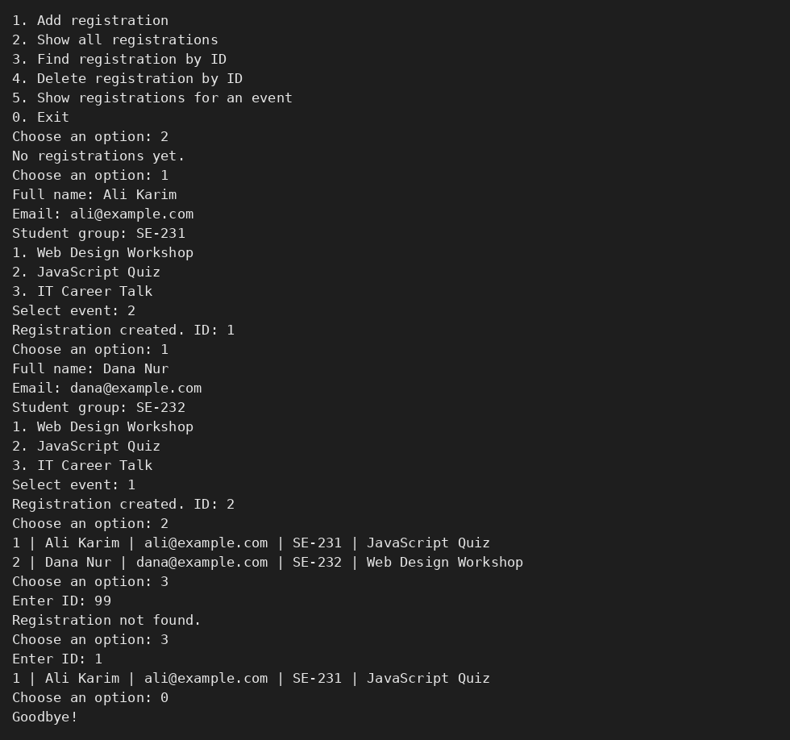
Figure 1. Empty list message, two valid registrations with different IDs, search for existing and missing ID, filter by event.
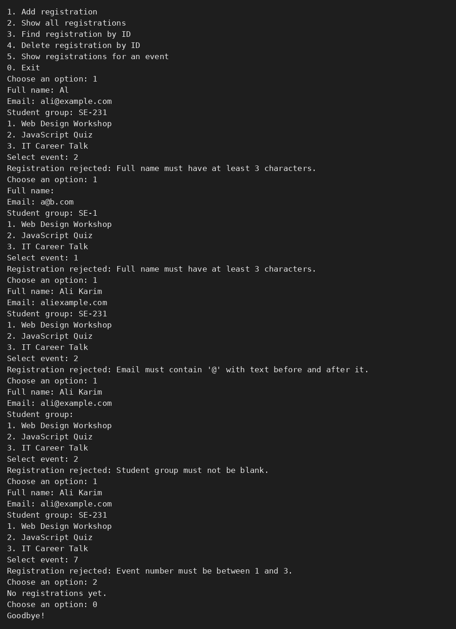
Figure 2. Validation errors: name "Al", blank name, email without @, blank group, event number outside 1–3; no object was added (list stays empty).
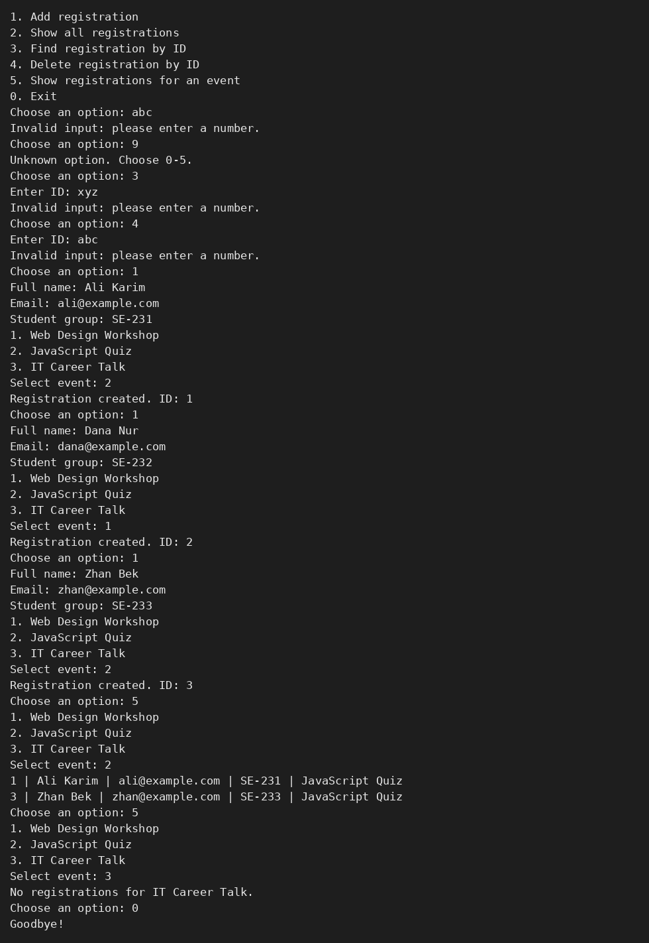
Figure 3. Non-numeric menu option and ID handled; unknown option 9; filter by event; delete and continue.
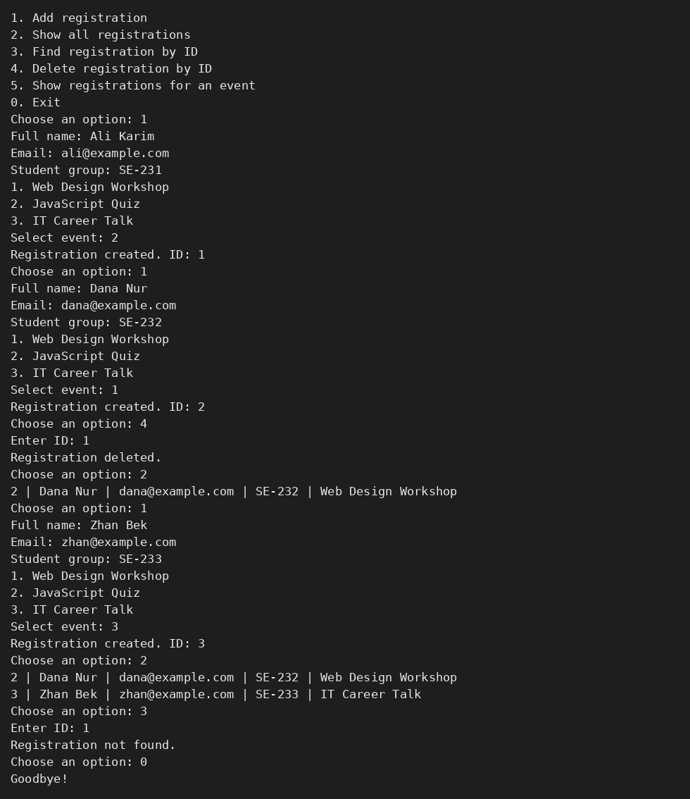
Figure 4. Deleting ID 1 and adding a new record: the new ID is 3, so the deleted ID is not reused. Exit with 0.

4. Test results
Test | Result | Status
Display an empty list | "No registrations yet." – program continues | Passed (Fig. 1, 2)
Add two valid registrations | Both shown with IDs 1 and 2 | Passed (Fig. 1)
Name "Al" or spaces | Rejected, nothing added | Passed (Fig. 2)
Email without @ / blank group | Rejected with message | Passed (Fig. 2)
Letters instead of menu number / ID | "Please enter a number", program continues | Passed (Fig. 3)
Event outside 1–3 | Rejected, not stored | Passed (Fig. 2)
Existing and missing ID | Record shown / "Registration not found." | Passed (Fig. 1)
Filter by event | Only matching records | Passed (Fig. 1, 3)
Delete, then add | Record removed, ID not reused (new ID 3) | Passed (Fig. 4)
Choose 0 | "Goodbye!", program exits normally | Passed

5. Conclusion
In this work I created a Java console application that stores registrations as objects in an ArrayList. I applied encapsulation with private fields and public getters, and separated responsibilities: Registration owns the record data, RegistrationManager owns the list and the rules, and Main handles keyboard input. All fields are validated before an object is stored, and NumberFormatException is handled so the program does not crash. A separate counter guarantees that IDs are unique and never reused after deletion. All required test cases passed.

