TradePilot
Autonomous Trade Finance for SMEs — built on Arc and USDC
Submission — The Stablecoins Commerce Stack Challenge

Short Description
TradePilot turns an SME invoice into a programmable, milestone-based USDC escrow. An AI agent reads the invoice, proposes an order/shipment/delivery payment plan, and — once a human approves — drives real settlement through Circle's Developer-Controlled Wallets and a custom escrow contract deployed on Arc. Every completed trade builds a verifiable SME Credit Passport.

Track
Best SME Trade Finance & Working Capital Workflow (Invoices, Escrow, Settlement)

Email associated with Circle Developer Account
maksutovdesign@icloud.com

Circle Products Used on Arc
- USDC — primary settlement and escrow asset
- Circle Wallets (Developer-Controlled) — embedded wallet for the SME buyer, created via the live Circle API

Functional MVP
Both frontend and backend are deployed and live, wired to a real PostgreSQL database, a real Circle developer-controlled wallet, and a smart contract deployed on Arc Testnet — not a mock or local-only demo.
- Live application (frontend + backend): https://web-psi-rose-15.vercel.app
- API: https://api-sigma-hazel-15.vercel.app
- GitHub repository: https://github.com/maksutovdesign/tradepilot
- Deployed & verified escrow contract on Arc Testnet: 0xc46673b16c94d2898c59aeaa0fd588f2af13792f
A full create → fund → confirm → release cycle has already been executed against this contract live on Arc Testnet (5 onchain transactions, including a full TradeCompleted event). Transaction hashes and links are documented in docs/demo.md in the repository.

Architecture Diagram
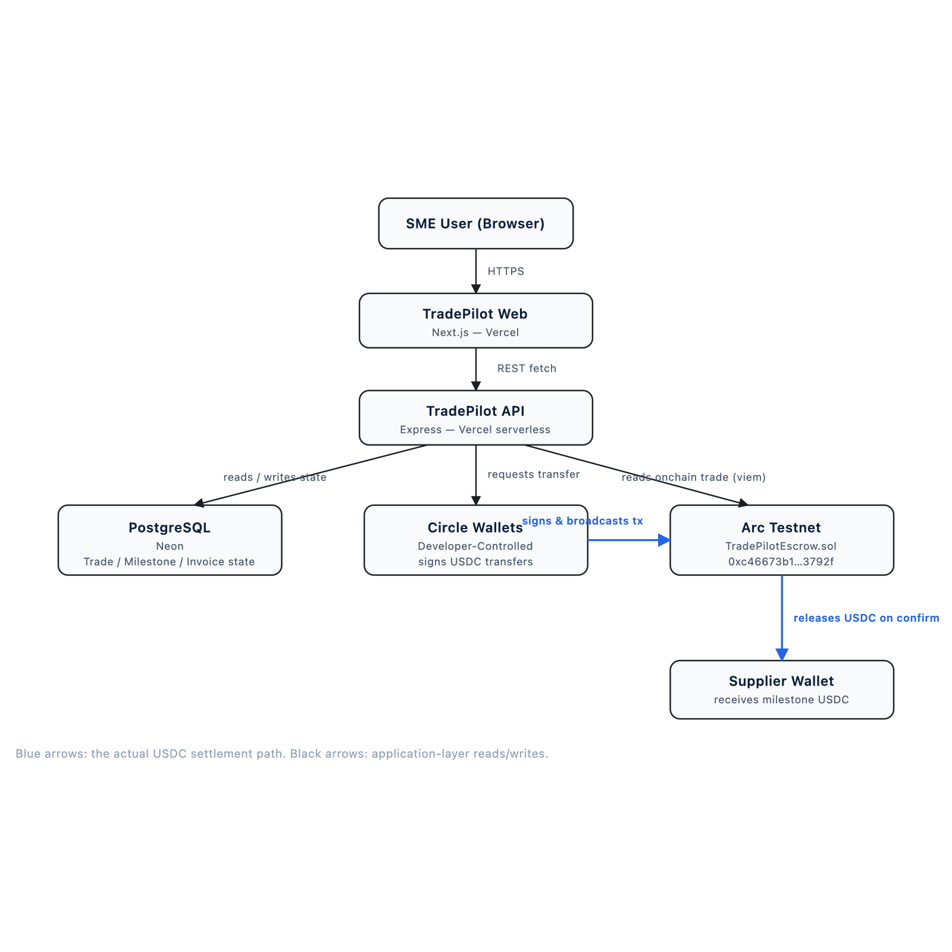
System architecture: browser → Next.js web → Express API → Postgres / Circle Wallets / Arc escrow contract → supplier wallet.
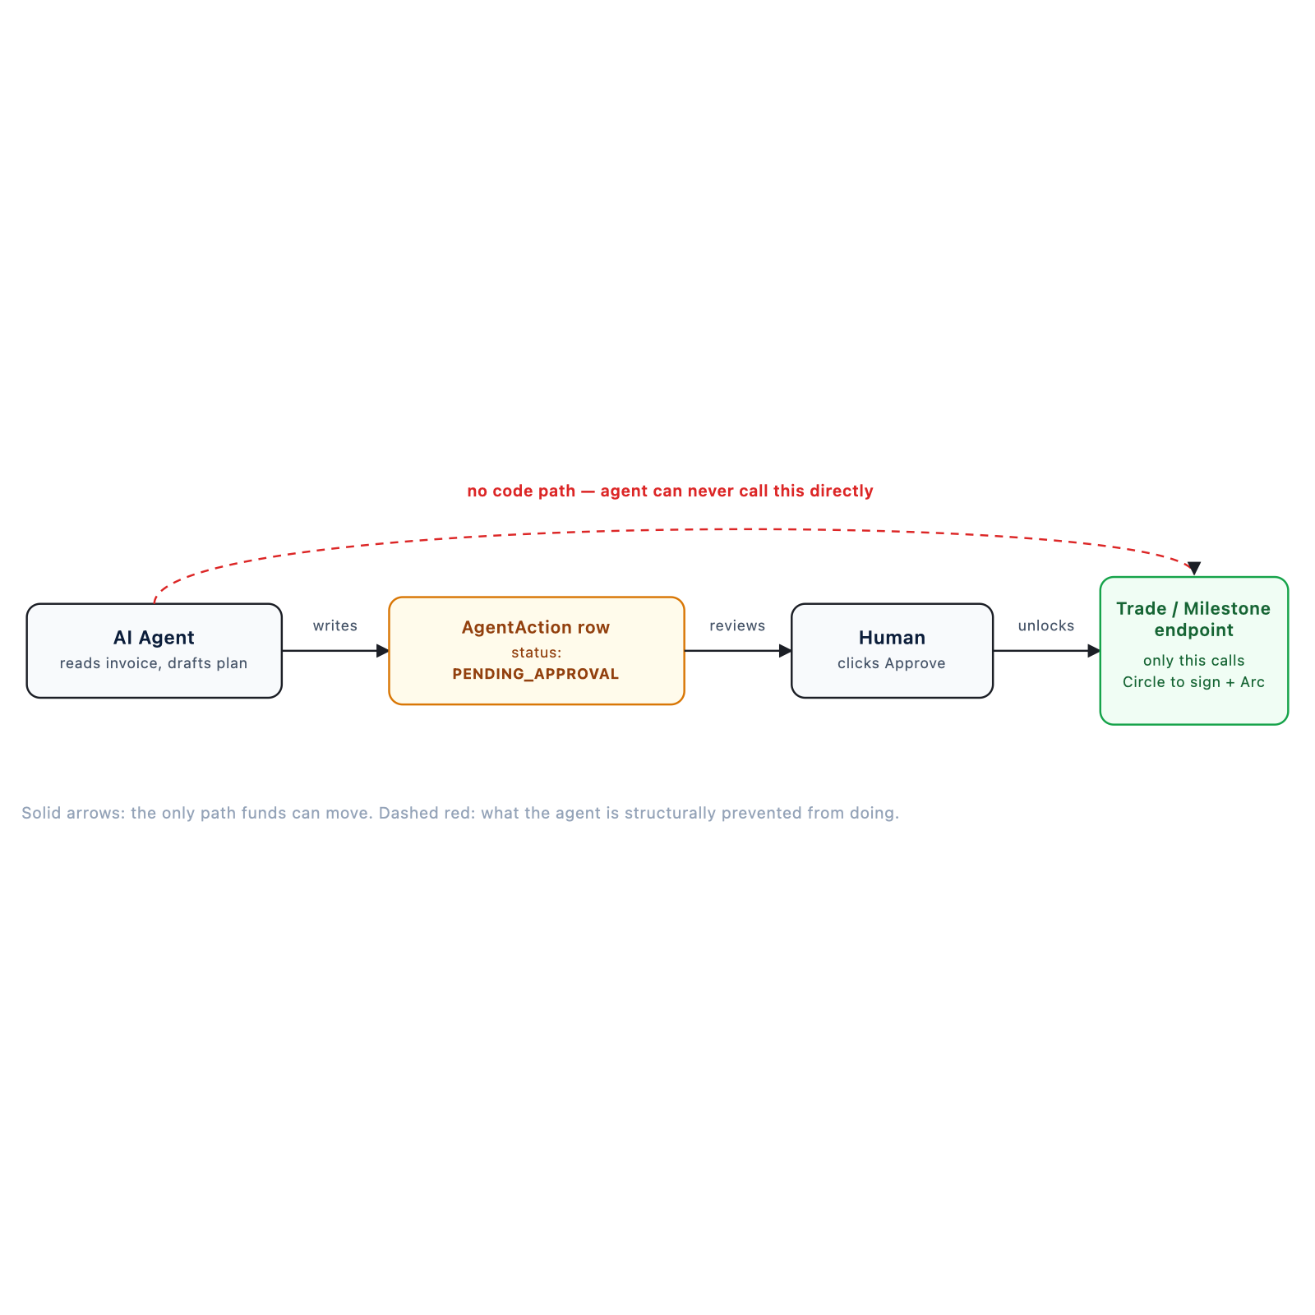
Agent trust boundary: the AI agent can only write a PENDING_APPROVAL row — it has no code path to sign a transaction. Only a human-approved request reaches Circle and Arc.

Video Demo
Submitted separately via the “Product Demo Video Link” field. The video walks through the full vertical slice: upload invoice → AI extracts terms → AI recommends milestone escrow → fund escrow on Arc → confirm + release milestones in USDC → Credit Passport updates — using the live application and real onchain transactions.

Documentation
Full setup instructions, environment variables, and a walkthrough of every Circle integration point (entity secret registration, developer-controlled wallet creation, USDC transfers) are in the GitHub repository:
github.com/maksutovdesign/tradepilot
- README.md — setup + live demo links
- docs/architecture.md — full data flow and agent trust boundary
- docs/smart-contract.md — TradePilotEscrow.sol design, tests, deployment
- docs/circle-integration.md — Circle product feedback (also reproduced below)
- docs/agent.md — AI agent design and trust boundary
- docs/demo.md — demo script + live transaction hashes

Circle Product Feedback

Why we chose these products for your use case
Trade finance for SMEs needs two things banks are bad at: fast, predictable settlement, and a UX where the buyer never has to think about private keys. Developer-controlled wallets let TradePilot hold and move USDC on the company's behalf while a policy layer (AI proposes, human approves) decides when a transfer is allowed to happen. Arc's USDC-denominated fees make milestone amounts predictable, which matters when a $30,000 shipment milestone can't be eaten into by gas volatility.

What worked well during development
The developer-controlled wallet model maps directly onto our trust boundary: the AI agent proposes, a human approves, and only then does a wallet-level call happen — we didn't have to build our own key-custody layer to get that separation. USDC's fixed 6-decimal precision made milestone-split math (30/40/30) exact, with no rounding surprises across onchain and database state.

What could be improved
The entity-secret ciphertext step (fetch public key → RSA-encrypt → attach to every signing call) is correct but easy to get subtly wrong on a first integration. We also hit a snag where our Circle Console account arrived with an entity secret already auto-registered during onboarding, with no visible way to recover or rotate it without the original recovery file — a clearer first-run flow (or an explicit “save this file now” warning) would help.

Recommendations
A reference architecture specifically for “AI agent proposes, backend executes” flows — including where spending limits and policy checks should live relative to the entity secret and wallet APIs — would make the agentic-commerce pattern much faster to get right, since every team building on developer-controlled wallets seems to reinvent that trust boundary independently.

