
Maksuturva/eMaksut
Payment Gateway Module
Magento 1.5-1.9

Revision 125

Table of Contents
1 Changes 3
2 System requirements 4
3 Limitations and notes 4
4 Package contents 5
5 Installation 6
5.1 Package installation 6
5.2 Language customization 7
5.3 Magento setup 7
6 Configuration 8
6.1 Enable the module 9
6.2 Sandbox mode 9
6.3 Key Version 10
6.4 Communication encoding 10
6.5 Emaksut 10
6.6 Seller ID 10
6.7 Secret key 10
6.8 Communication URL 10
6.9 Allow Magento to send order confirmation emails 11
6.10 Changing payment id numbering format 11
7 Administration 13
7.1 Order status 13
7.2 delayed payments 13
7.3 Manually verifying payments 15
7.4 Payment amount changes when additional invoicing fees 16
8 Testing the installation 17
8.1 Sandbox testing 17
8.2 Testing in Maksuturva test environment 18
9 Paying through Maksuturva payment gateway 18

Changes

Date | Module revision | Description
16.04.12 | 101 | Initial release.
13.07.12 | 108 | Handling of multibyte characters fixed. Previous module versions may run into hash calculation problems with some characters and character encodings.
13.11.12 | 108c | Fixed the handling of seller cost changes when eg. invoicing fees are added to the price. That is: seller costs sent from webstore != seller costs returned from Maksuturva service.
07.03.13 | 121 | Fixes to handling of product name and description (use other one if the other is blank), hash calculation problems with multibyte characters and handling of other currencies than euro.  Also now the module creates invoices to orders and marks them as paid. Error message is more informative now, in case of connection errors while verifying payments.
12.09.13 | 122 | Bugfixes in payment verification and invoice saving. Previously invoices (even if registered as paid) did not affect the order's total amount.
24.10.13 | 123 | - Products' article number (SKU) and short description are now passed on to Maksuturva service.  - Prices are passed on as net prices + VAT (previously gross prices + VAT) for minimizing rounding errors.  - Added support for Magento configurable products. Configurable product rows now sent as in a single row (previously in two rows: parent and child row).  - Added minimal support for Magento bundled product. All bundled products are set as ”tailored product” which, in general, buyers are not allowed to return.  - Updated documentation with instructions for changing the used order ID type.
05.03.14 | 124 | - Added support for allowing Magento to send order confirmation emails to buyer and seller after a succesful payment. See section 6.9 for details.  - Payment ID numbering was changed to use long numbering format. NOTE: after upgrading the module to revision 124 from earlier versions, the payment status verification does not work for orders that are made with previous module revision. See section 6.10 for details.
08.10.14 | 125 | Bugfix: Optional parameters (e.g. pre-selected payment method, buyer's identification code) are now included in the hash calculation when available (currently not available, though, but enabling is possible in further development - see _construct -method in MaksuturvaGatewayImplementation.php and Maksuturva Payment interface description).  Documentation updated

System requirements
The Maksuturva Payment Gateway module for Magento was tested on and requires the following set of applications in order to fully work:
Requirement | Supported versions
Magento | - 1.5.x, 1.6.x, 1.7.x, 1.8.1.x, 1.9.x
PHP | - 4.x  - 5.x
PHP cURL Module | - Any
PHP mbstring module | - n/a

There is no guarantee that the module is fully functional in any other environment which hasn't such requirements.

Limitations and notes
The following limitations have been found in this revision of the payment module or in the web store software in question:
- No reported flaws or notable limitations

Package contents
This guide assumes that all the package files were correctly downloaded by the user. The following folder structure is presented by the module when uncompressed:
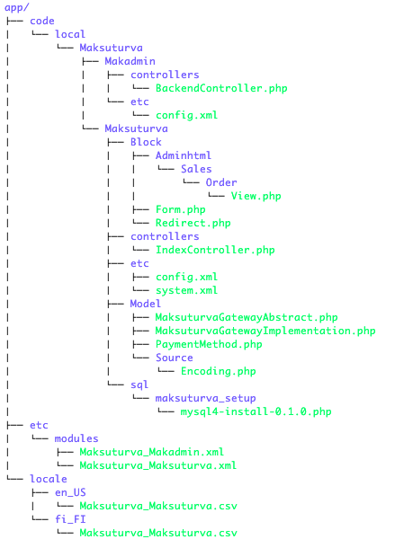Illustration 1: Tree structure of package contents
File | Description
app/code/local/Maksuturva/Makadmin/controllers/BackendController.php | Contain the action used to verify payments from the admin interface.
app/code/local/Maksuturva/Makadmin/etc/config.xml | Configure the payment verification module
app/code/local/Maksuturva/Maksuturva/Block/Adminhtml/Sales/Order/View.php | Add the 'Verify payment' button to orders on admin interface.
app/code/local/Maksuturva/Maksuturva/Block/Form.php | Print the module title on checkout page.
app/code/local/Maksuturva/Maksuturva/Block/Redirect.php | Print the redirect page with data to be sent to Maksuturva gateway.
app/code/local/Maksuturva/Maksuturva/controllers/IndexController.php | Controller with actions to redirect the user to Maksuturva and receive responses.
app/code/local/Maksuturva/Maksuturva/etc/config.xml | Module configurations, routes and setup default values
app/code/local/Maksuturva/Maksuturva/etx/system.xml | Configuration file that contains admin interface setup fields.
app/code/local/Maksuturva/Maksuturva/Model/MaksuturvaGatewayAbstract.php | Base class used to wrap Maksuturva's features.
app/code/local/Maksuturva/Maksuturva/Model/MaksuturvaGatewayImplementation.php | Implementation of base maksuturva's class
app/code/local/Maksuturva/Maksuturva/Model/PaymentMethod.php | Main class of Maksuturva payment method.
app/code/local/Maksuturva/Maksuturva/Model/Source/Encoding.php | Source that enable selection between UTF-8 and ISO-8859-1 on the admin interface.
app/code/local/Maksuturva/Maksuturva/sql/mysql4-install-0.1.0.php | Database installation file, currently not used.
app/etc/modules/Maksuturva_Makadmin.xml | Configuration file to load the administrative portion of Maksuturva payment module (Status query)
app/etc/modules/Maksuturva_Maksuturva.xml | Configuration file to load the Maksuturva payment module
app/locale/en_US/Maksuturva_Maksuturva.xml | Translation file for US english
app/locale/fi_FI/Maksuturva_Maksuturva.xml | Translation file for Finnish

Installation
Prior to any change in your environment, it is strongly recommended that a backup of the entire existing Magento installation is performed.

Package installation
The first step of installation involves to copy the package structure with its contents into a valid Magento installation directory. The simplest way of performing such operation is through copying the catalog folder from the maksuturva package into the installation Maksuturva directory. It is important to notice that a merge operation needs to be done, instead of replacing the entire directory.
Another option is to copy the package contents individually into their destination directories, creating such directories when they do not exist.

Language customization
It is possible to customize the language and messages used in the module. The customization takes effect by changing the text entries located in the files app/locale/en_US/Maksuturva_Maksuturva.csv or
app/locale/fi_FI/Maksuturva_Maksuturva.csv

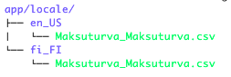
To add support to an existing installed language, open the destination language directory (app/locale/), then create the local folder es_ES, where spanish is taken as example, copy the Maksuturva_Maksuturva.csv from the english locale (app/locale/en_US/Maksuturva_Maksuturva.csv) to the new folder. Finally, open the Maksuturva_Maksuturva.csv file in edit mode and perform the translations and customizations.

Magento setup
When the files are copied into the destination directory, open the administrative panel of your Magento installation and go to the System menu and then access the Configuration option. The Illustration 2 shows the path to open the configuration page.
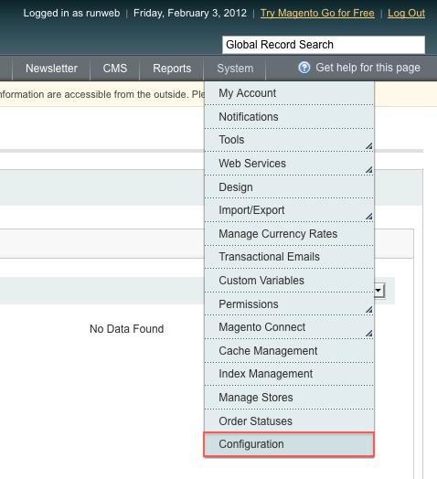Illustration 2: Open the configuration page
On the configuration page, select the Advanced option from the bottom of the menu on the left, as shown in Illustration 3.
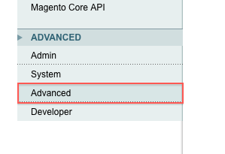Illustration 3: Advanced menu
On the advanced page, under “Disable Modules Output” you should see two modules as shown in Illustration 4.
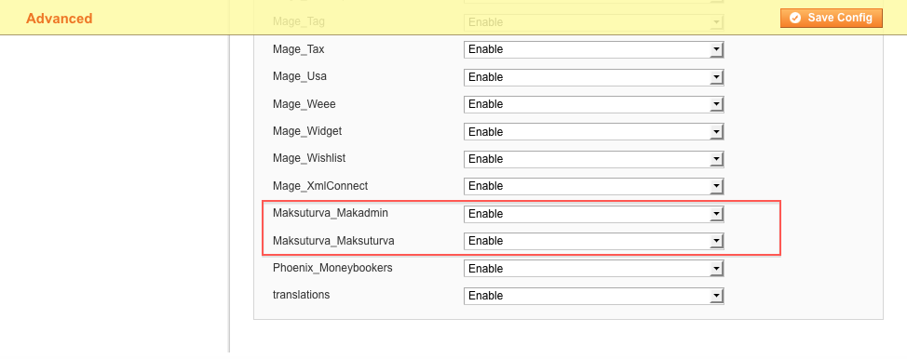Illustration 4: Modules listing
If the modules are not displayed, click the “Save Config” button and it should update the list, displaying the modules.

Configuration
The configuration section for Maksuturva's module is reached by accessing the System > Configuration menu and then select “Payment methods” item from the left menu, as shown in Illustration 5. The parameters and their possible configurations are presented in Illustration 6.

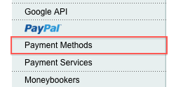Illustration 5: Payment methods menu
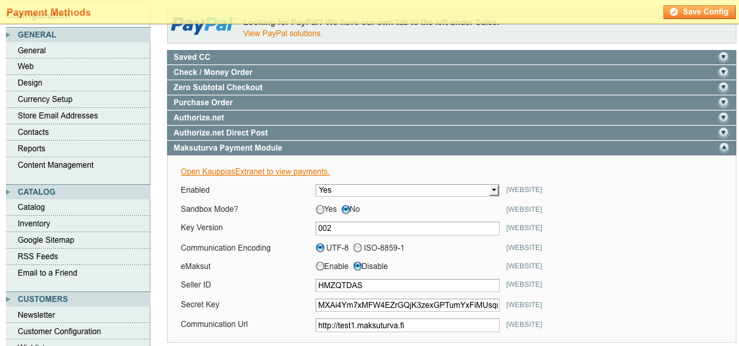Illustration 6: Maksuturva payment method configuration options

All the configuration entries are detailed below. Remember to save the changes after your actions.

Enable the module
The first configuration entry defines if the module should be activated for usage in payments for customers. When set to “Yes” it will be used. When set to “No”, it will not.

Sandbox mode
It is possible to set the module in sandbox test mode through activating the Sandbox mode. When this option is selected, default test parameters (Seller ID and Secret key) will be used in your store payments. Purchases made during sandbox will be directed to sandbox test page to verify information module is forwarding to Maksuturva as well as responses from Maksuturva service to Magento.
When set to “No”, the production mode will be used. If Maksuturva production service credentials and communication URL parameters are used real commercial transactions will be performed when payments are done. Using Maksuturva test credentials and test environment URL makes possible to test the full payment process without actual money transactions.
Note that the default installation value for this configuration entry is “Yes”.

Key Version
This parameter is also provided by Maksuturva. Check your secret key version and input this value into the configuration field. Please note that this key must not be shared with any person, since it allows many operations to be done in your Maksuturva account.

Communication encoding
There are two possible character encodings that are accepted by Maksuturva. Even if you are using a different encoding the module will attempt to convert the data from your Magento encoding to the encoding set on this configuration. You might need to test which of them works better for your encoding by using the sandbox mode. The possible values are 'ISO-8859-1' and 'UTF-8' and they are selected from radio button options. The default value for this setting is 'UTF-8'.
Wrong encoding will fail the hash verficiation of the payment message sent to Maksuturva service.

Emaksut
This configuration option enables payments to be done using eMaksut's service, instead of using Maksuturva's one. Activate this option only if your payment service is an eMaksut service.

Seller ID
Open your Maksuturva account and check your seller ID in account details. The seller id is your identifier, used in every transaction inside your store. Copy the value and paste it in this field.
When used for testing in Maksuturva test environment use your test environment seller id.
When used in sandbox mode, general test account is used and the value filled in this option will be ignored.

Secret key
Together with the Seller ID, the secret key is also provided by Maksuturva. Check your secret key and input this value into the configuration field. Please note that this key must not be shared with any person, since it allows many operations to be done in your Maksuturva account.
When used for testing in Maksuturva test environment use your test environment secret key.
When used in sandbox mode, general test account is used and the value filled in this option will be ignored.

Communication URL
This configures which URL the payment and query status operations will send the data to Maksuturva. The default value 'https://www.maksuturva.fi' refers to Maksuturva production environment.
The communication URL for Maksuturva test environment is 'http://test1.maksuturva.fi' (note, that transfer protocol for test environment is http, not https).

Allow Magento to send order confirmation emails
By default Magento does not send order conrfirmation emails to customers when an external payment service outside of Magento is used. Since Maksuturva payment module revision 124 Magento order confirmation emails are sent if sales emails are enabled. The feature of sending confirmation emails from Magento is independent on possible confirmation emails sent from Maksuturva- / eMaksut-service.
In Magento sending order confirmation emails can be enabled and disabled in: System → Configuration → Sales → Sales Emails → Order (see Illustration 7). Email templates can be modified in System → Transactional Emails.
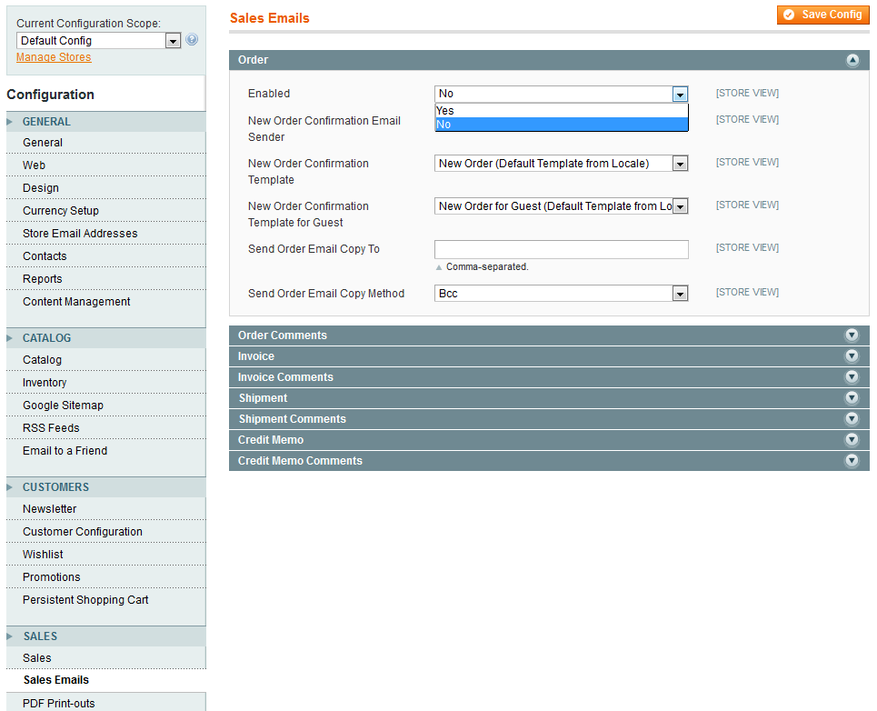Illustration 7: Enabling and disabling Magento's order confirmation emails

Changing payment id numbering format
Maksuturva service requires unique payment ids for every payment. Order numbering can use short (e.g. 227) or long (eg. 100000227) format for Maksuturva payment id. The short order numbering was used before but was changed to long format since Maksuturva payment gateway module revision 124 as this is more common in Magento.
However, if one wishes module to continue using short numbering format , it can be done by altering the code in app/code/local/Maksuturva/Maksuturva/Model/MaksuturvaGatewayImplementation.php
In rows 180 – 182 change the highlighted text with the following new values:
current numbering (long format):
"pmt_id" => $order->getIncrementId(),
"pmt_orderid" => $order->getIncrementId(),
"pmt_reference" => ($order->getIncrementId() + 100),

previous numbering (short format):
"pmt_id" => $order->getEntityId(),
"pmt_orderid" => $order->getEntityId(),
"pmt_reference" => ($order->getEntityId() + 100),

One should keep in mind, that after the change in the numbering format, the payment verification function (see 7.2 delayed payments) can not verify payments that are made with the previous settings.

Administration

Order status
When a customer has confirmed order and is transferred to Maksuturva payment service, Magento sets the order as ”pending”.
When the customer returns to Magento and Maksuturva confirmes the payment, an invoice is created and set as paid and the order's amounts are updated. The order status is now set as ”processing”.
Magento updates order status as ”complete” when the order is fully paid and shipped.

delayed payments
The Maksuturva Gateway Payment module allows customers to perform delayed payments, meaning that a constant verification of payment status is needed. For that purpose, there is a button “Verify Order” on the view page of each order. The Illustration 8 show how to access the order list. Then you must click the “view” link on the order you wish to verify, as shown on Illustration 8.

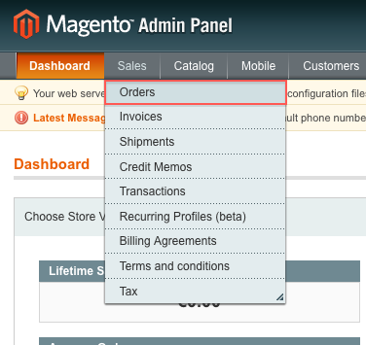Illustration 8: Access order list
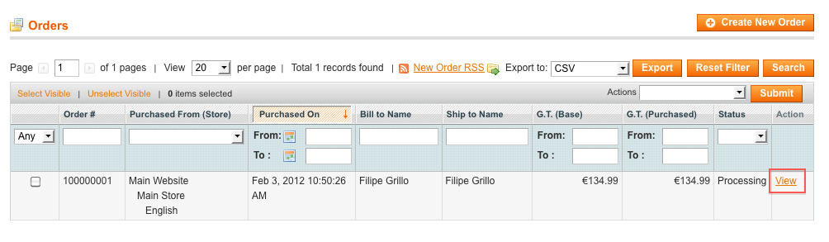Illustration 9: Magento order list

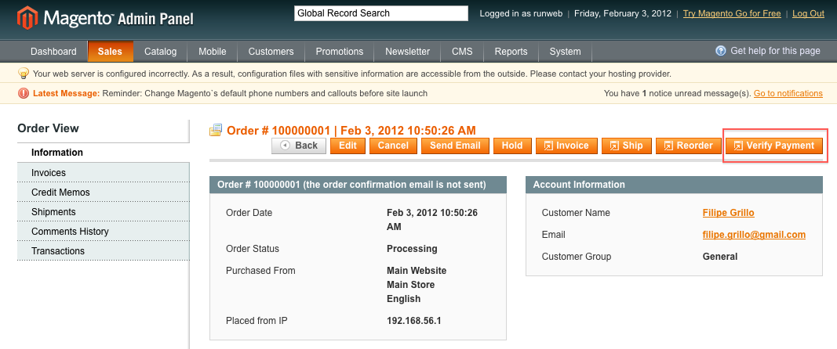Illustration 10: Order view page with order details and verify payment button
When the “Verify Payment” is clicked, the system will request a status update from Maksuturva gateway. If the payment is confirmed and invoice is created and the order total amounts updated. A message is also displayed on top of the page and in in the ”Comments History” box (illustrations 11 and 12).
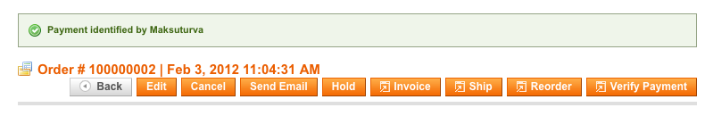Illustration 11: Pending payment verification result
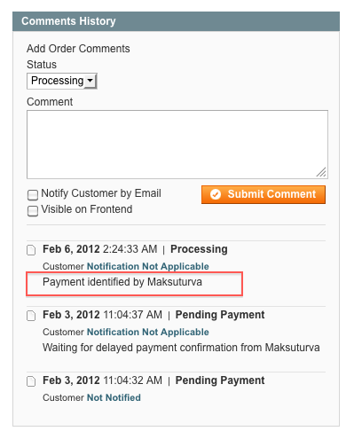Illustration 12: Order comment history

Manually verifying payments
Besides the automatic pending status verification, another possibility is to open your Maksuturva account from within the Maksuturva module configuration panel. The link “Open KauppiasExtranet to view payments” is highlighted in Illustration 13 .
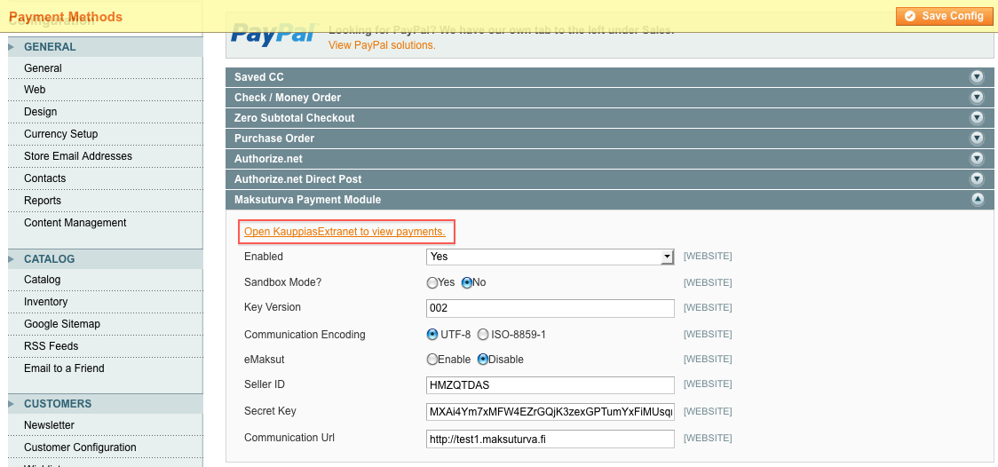Illustration 13: Link to view payments in KauppiasExtranet

Payment amount changes when additional invoicing fees
If the buyer chooses to use a payment method with additional costs (eg. invoicing fees), Maksuturva Payment Service adds them to the total price for the buyer to pay instantly or through invoice.
In the web store the seller costs (shipping and invoicing costs) will not be updated, but store admin can see the price change in the order's comment history following the Payment confirmed -message (see Illustration 14).
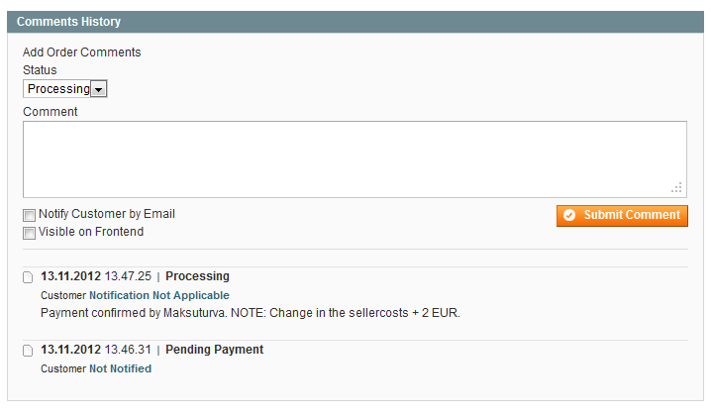Illustration 14: Order's comment history can be found at the bottom of the order view page. In this case the additional costs have been 2,00 € and the actual price the buyer has paid is 2,00 € more than what Magento says as total amount.

Testing the installation
It is strongly encouraged that the Maksuturva payment module is thoroughly tested before taking it into use in on production web store. It is essential to verify that customer and product information, prices, taxes and discount as well as payment message verifying hash are transmitted correctly to Maksuturva.

Sandbox testing
First, one should validate payment messages by general a.k.a sandbox testing by activating Sandbox mode (see chapter 6.2 Sandbox mode). Activating the Sandbox mode, the module will use default test credentials and all confirmed orders are directed to a Sandbox test page where one can see the sent payment message data. Also all possible errors in data are presented.
The payment module calculates a cheksum / hash from the payment data and webstore secret key combination. Secret key itself is never sent. When Maksuturva service receives the payment message it verifies the autenticity by doing the same calculation and comparing the two checksums.
If Sandbox test page reports errors in hash, the following checks are recommended:
- all the message data on the Sandbox test page are accurate and match the ones that have been sent. No extra spaces or symbols are added or removed and no symbol is changed to something else neither.
- Check that the selected encoding is accurate and change it if required (see chapter 6.4 Communication encoding).
- Check if product information (e.g. name, description) includes problematic special symbols (see chapter 3 Limitations and notes).
- If the product information is copied from word processing software (Office Word etc.) copied text might include markings (header, bulletpoint and emphasis markings etc.) which – even if they are not visible – cause errors in hash calculation. In these cases the product information data should be verified by copying it to more simple text editor (e.g. Notepad) which removes all possible invisible symbols and then copied back to PrestaShop replacing previous product information content.
Sandbox test page also shows links to responses to webstore (see Illustration 15). By selecting appropriate link, one can verify the information that buyer and store administration see when payment is e.g. accepted or canceled.

Illustration 15: Return options in Maksuturva Sandbox test page

Testing in Maksuturva test environment
When Sandbox mode is disabled, module acts as in production mode and order confimation directs buyer to Maksuturva payment page. If actual Maksuturva credentials are used real money transactions will occur.
If communication URL is set to refer to Maksuturva test environment it is possible to try the full online bank payment and invoice payment process without using actual money. Test environment uses different credentials than Maksuturva production environment and test environment service needs to be ordered separately from the actual Maksuturva service. More information about testing is available on Maksuturva web site www.maksuturva.fi.

In order to test the Maksuturva Payment Gateway module, open your configuration section, as shown in section 6 Configuration), set the Sandbox mode to “Yes” and save your changes. Follow the steps below to test a purchase.

Paying through Maksuturva payment gateway
Step 1 - Log in as a customer and perform a purchase of a random item, selecting Maksuturva as the payment option during the checkout (see Illustration 16).
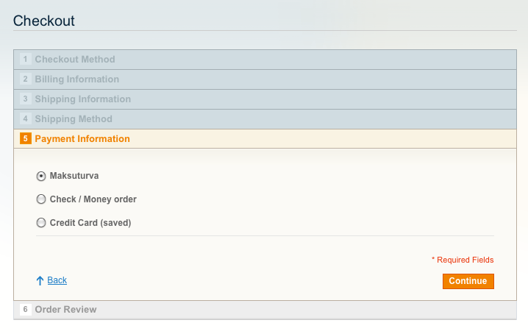Illustration 16: Step 1 - Select maksuturva
Step 2 – Confirm the order.
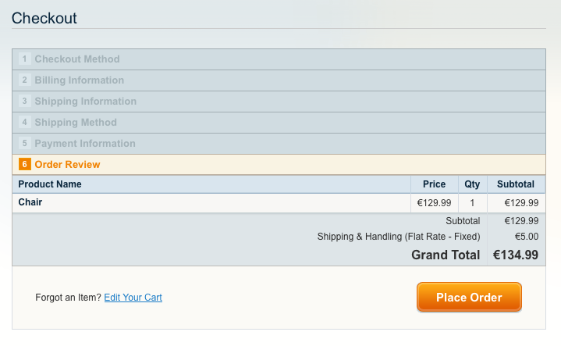Illustration 17: Step 2 - Confirm the order
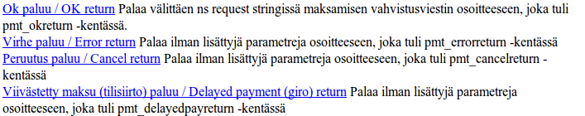Illustration 18: Step 3 - Select simulation action
Step 3 – If using Sandbox mode verify payment by clicking “OK”. If using Maksuturva test or production environment, choose the payment method from the available options and complete the payment process.
Step 4 – Now the payment was confirmed. Buyer sees the order confirmation page (see Illustration 19) and store administration the new confirmed order.

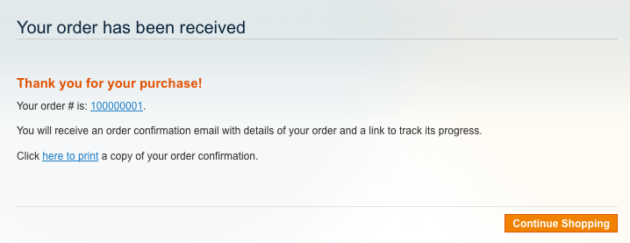Illustration 19: Step 4 - Simulation result

