

Maksuturva/eMaksut
Payment Gateway Module
OsCommerce 2.2-2.3

Revision 122

Table of Contents
1 Changes 3
2 System requirements 4
3 Limitations and notes 4
4 Package contents 5
5 Installation 6
5.1 Package installation 6
5.2 Language customization 6
5.3 OsCommerce setup 6
6 Configuration 8
6.1 Enable the module 9
6.2 Sort order 9
6.3 Seller ID 9
6.4 Secret key 9
6.5 Payment due date 9
6.6Communication URL 9
6.7 Communication encoding 9
6.8 Sandbox mode 9
6.9 eMaksut 10
7 Administration 10
7.1 Delayed payments 10
7.2 Manually verifying payments 12
8 Testing the installation 13

Changes

Date | Module revision | Description
10.04.12 | 97 | Initial document version.
13.04.12 | 99 | Minor fix: If delivery address is empty, buyer address is now used.
16.04.12 | 101 | Minor fix: Better handling of delivery address.
09.07.12 | 106 | Better handling of product description.  Handling of multibyte characters and differenc char encodings fixed.
19.07.12 | 110 | Known bug: Multibyte characters fail in hash calculation in some cases.
13.11.12 | 110c | Fixed the handling of seller costs (shipping, handling and payment costs) when for example invoicing fee is added to the seller costs in the Maksuturva Payment Service.
15.03.13 | 121 | Fixes to handling product name and description (use other one if the other is blank). Also some changes in the common code. No effect on functionalities in this implementation.
08.06.15 | 122 | - fixed payment message errors when product name or description had quotation marks or line endings  - fixed error with too long product names  - fixed hash calculation errors when order had optional data such as payer identification code or pre-selected payment method  - fixed error message that is shown to the customer when Maksuturva returnes an error (or e.g. when testing error return from the sandbox page)  - product article number (product model number in osCommerce) included in the payment message when provided

System requirements
The Maksuturva Payment Gateway module for OsCommerce was tested on and requires the following set of applications in order to fully work:
Requirement | Supported versions
OsCommerce | - 2.2.x  - 2.3.x
PHP | - 4.x  - 5.x
PHP cURL Module | - Any
PHP mbstring module | - n/a

There is no guarantee that the module is fully functional in any other environment which hasn't such requirements.

Limitations and notes
The following limitations have been found in this revision of the payment module or in the web store software in question:
- Unsolved hash calculation errors reported in cases where product names include special or hidden multibyte characters copied e.g. from word processing software.
- Does not send user locale value to Maksuturva.
- Shipping costs gross prices are are forwarded correctly, but the tax is claimed to be 0 %. Does not affect into shipping costs with no tax, product rows nor the total sum of the order.
- Euro is the only allowed currency for payments. Attempts to buy using another currency result first warning messages and finally an error.
- If in Maksuturva payment page the buyer chooses a payment method with additional billing fees, the additional fees will not be stored for the web store admin to see. Actual paid sum can be checked from the KauppiasExtranet. (The possibility of additional billing fees depends on your service contract with Maksuturva).
- Please note that osCommerce does not show interrupted, failed or cancelled payments. In unclear situations check list of succesful payments from Maksuturva's KauppiasExtranet

Package contents
This guide assumes that all the package files were correctly downloaded by the user. The following folder structure is presented by the module when uncompressed:
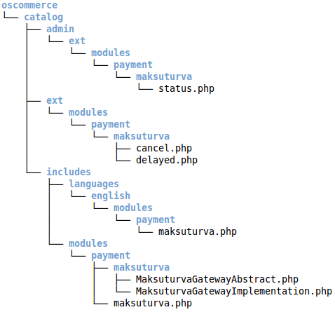Illustration 1: Tree structure of package contents
File | Description
oscommerce/catalog/admin/ext/modules/payment/  maksuturva/status.php | Administrative tool for verifying pending payments.
oscommerce/catalog/ext/modules/payment/  maksuturva/cancel.php | Callback url used to cancel a payment (when in maksuturva).
oscommerce/catalog/ext/modules/payment/  maksuturva/delayed.php | Callback url to inform OsCommerce that a giro (delayed) payment was performed.
oscommerce/catalog/includes/languages/  english/modules/payment/maksuturva.php | English language file for module, containing all the messages.
oscommerce/catalog/includes/modules/payment/  maksuturva/MaksuturvaGatewayAbstract.php | Base class used to wrap Maksuturva's features.
oscommerce/catalog/includes/modules/payment/  maksuturva/MaksuturvaGatewayImplementation.php | Implementation of base maksuturva's class based on OsCommerce
oscommerce/catalog/includes/modules/payment/  maksuturva.php | The main payment gateway file, called from checkout and administration areas.

Installation
Prior to any change in your environment, it is strongly recommended that a backup of the entire existing OsCommerce installation is performed.

Package installation
The first step of installation involves to copy the package structure with its contents into a valid OsCommerce installation directory. The simplest way of performing such operation is through copying the catalog folder from the maksuturva package into the installation OsCommerce directory. It is important to notice that a merge operation needs to be done, instead of replacing the entire directory.
Another option is to copy the package contents individually into their destination directories, creating such directories when they do not exist.

Language customization
It is possible to customize the language and messages used in the module. The customization takes effect by changing the text entries located in the file oscommerce/catalog/includes/languages/english/modules/payment/maksuturva.php.
To add support to an existing installed language, open the destination language directory (/oscommerce/catalog/includes/languages/english/, where english is taken as example) and create the following tree structure, if it doesn't exist:
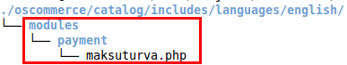
Then, copy the maksuturva.php file from the current language directory to the destination language directory. Finally, open the maksuturva.php file in edit mode and perform the translations and customizations.

OsCommerce setup
When the files are copied into the destination directory, open the administrative panel of your OsCommerce installation and go to the payment modules section. The Illustration 2 shows the path to open the installation panel.
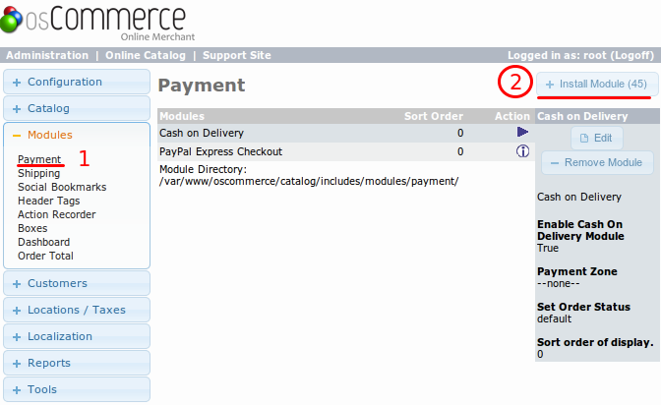Illustration 2: Open the install payment module page
In the installation page, select Maksuturva and click “Install Module”, as shown in Illustration 3.
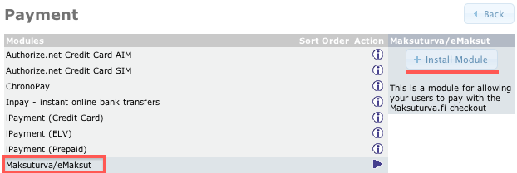Illustration 3: Module installation
The module is now shown as installed, and the configuration can be performed.

Configuration
The configuration section for Maksuturva's module is reached by accessing the installed payment modules, as shown in Illustration 2. The parameters and their possible configurations are presented in Illustration 4.

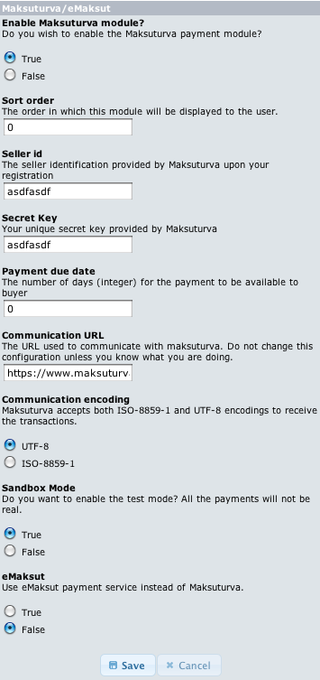Illustration 4: Configuration parameters
All the configuration entries are detailed below. Remember to save the changes after your actions.

Enable the module
The first configuration entry defines if the module should be activated for usage in payments for customers. When set to “True” it will be used. When set to “False”, it will not.

Sort order
Every payment gateway module has a classification which tells the order of listing to the store customers. Supposing you have more than one gateway installed, the lowest order will be printed on top of selections, giving the module more importance as a checkout option. The possible values are any integer equal or greater than zero.

Seller ID
Open your Maksuturva account and check your seller ID in account details. The seller id is your identifier, used in every transaction inside your store. Copy the value and paste it in this field. When using sandbox mode, the value filled in this option will not be used, since the test account will be activated.

Secret key
Together with the Seller ID, the secret key is also provided by Maksuturva. Check your secret key and input this value into the configuration field. Please note that this key must not be shared with any person, since it allows many operations to be done in your Maksuturva account.

Payment due date
The due date tells maksuturva the number of days that the payment will be available to be done by the customer. The possible values are integers equal or greater than zero. When using zero, the payment due date will be the same day of the purchase (the current day). Use the default value zero.

Communication URL
This configures which URL the payment and query status operations will send the data to maksuturva. The default value is 'https://www.maksuturva.fi'. The default value will be the address you need on 99,9% of the cases, so only change this parameter if you know exactly what you are doing.

Communication encoding
There are two possible character encodings that are accepted by Maksuturva. Even if you are using a different encoding the module will attempt to convert the data from your osCommerce encoding to the encoding set on this configuration. You might need to test which of them works better for your encoding by using the sandbox mode. The possible values are 'ISO-8859-1' and 'UTF-8' and they are selected from radio button options. The default value for this setting is 'UTF-8'.

Sandbox mode
It is possible to set the module in test mode through turning the Sandbox mode to “True”. When this option is selected, default test parameters (Seller ID and Secret key) will be used in your store payments, meaning that no money will be spent when paying the orders. This is a great tool to test the operation of your store and training employees.
When set to “False”, the production mode will be used and real commercial transactions will be performed when payments are done. Note that the default installation value for this configuration entry is “True”.

eMaksut
This configuration option enables payments to be done using eMaksut's service, instead of using Maksuturva's one.

Administration

Delayed payments
The Maksuturva Gateway Payment module allows customers to perform delayed payments, meaning that a constant verification of payment status is needed. For that purpose, an administrative tool is presented within the module summary, accessed in the administrative section in “Modules” → “Payment” → “Maksuturva”. The link to verify the pending payments is highlighted in red in Illustration 5.
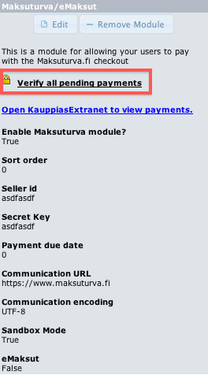Illustration 5: The verification tool
When clicked, a new window will open and the verification process will start. Depending on the number of pending payments, the verification can take a while to complete. When done, a summary of the status changes will be presented, with links to the orders on the left column and the message from Maksuturva on the right column. It is possible to change order status and communicate the customer using the links provided by this tool.

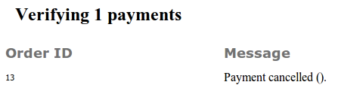Illustration 6: Pending payments verification result

Manually verifying payments
Besides the automatic pending status verification, another possibility is to open your Maksuturva account from within the OsCommerce panel. The link “Open KauppiasExtranet to view payments” is highlighted in Illustration 7.
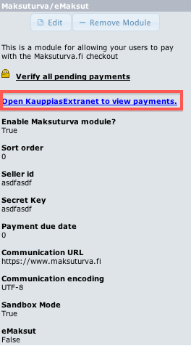Illustration 7: View payments in KauppiasExtranet

Testing the installation
In order to test the Maksuturva Payment Gateway module, open your configuration section, as shown in section 5 – Illustration 7, set the Sandbox mode to “True” and save your changes. Follow the steps below to test a purchase.
Step 1 - Log in as a customer and perform a purchase of a random item, selecting Maksuturva as the payment option during the checkout (see Illustration 5).
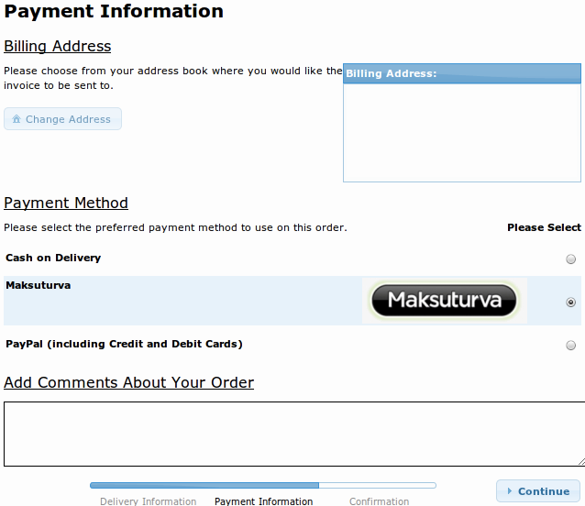Illustration 8: Step 1 - Select maksuturva

Step 2 – Confirm the order.
Illustration 9: Step 2 - Confirm the order
Step 3 – In Maksuturva test environment, click “Ok return”, simulating a payment done successfully.
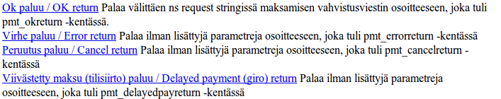Illustration 10: Step 3 - Select simulation action
Step 4 – Now the payment was confirmed and the store administrator will be able to check the update when viewing the order. The other actions in Step 3 can be selected (“Error return”, “Cancel return” and “Delay return”) for testing purposes.

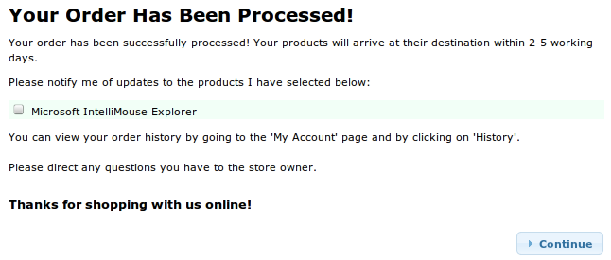Illustration 11: Step 4 - Simulation result

