
Maksuturva/eMaksut
Payment Gateway Module
PrestaShop 1.4.x

Revision 120

Table of Contents
1 Changes 3
2 System requirements 4
3 Limitations and notes 4
4 Package contents 5
5 Installation 6
5.1 Package installation 6
5.2 PrestaShop setup 6
6 Configuration 8
6.1 Seller ID 8
6.2 Secret key 8
6.3 Secret key version 8
6.4 Communication encoding 9
6.5 eMaksut 9
6.6 Sandbox mode 9
6.7Communication URL 9
7 Language customization 10
8 Administration 11
8.1 Delayed payments 11
9 Testing the installation 12

Changes

Date | Module revision | Description
16.04.12 | 101 | Initial release.
13.07.12 | 108 | Handling of multibyte characters fixed. Previous module versions may run into hash calculation problems with some characters or character encodings.
17.07.12 | 110 | The module is now compatible beginning with Prestashop version 1.4.3
15.03.13 | 120 | Fixes to handling product name and description (use other one if the other is blank). Also some changes in the common code. No effect on functionalities in this implementation.

System requirements
The Maksuturva Payment Gateway module for PrestaShop was tested on and requires the following set of applications in order to fully work:
Requirement | Supported versions
PrestaShop | - 1.4.3. - 1.4.9.x
PHP | - 4.x  - 5.x
PHP cURL Module | - Any
PHP mbstring module | - n/a

There is no guarantee that the module is fully functional in any other environment which hasn't such requirements.

Limitations and notes
The following limitations have been found in this revision of the payment module or in the web store software in question:
- No quotation marks allowed in product names. Quotation marks in product names cause error in hash calculation.
- No additional billing fees are allowed to be added in Maksuturva payment page. If the shipping-, billing- or handling prices are changed during the payment in Maksuturva service, the buyer receives an error and the order will not be saved in the store.

Package contents
This guide assumes that all the package files were correctly downloaded by the user. The following folder structure is presented by the module when uncompressed:
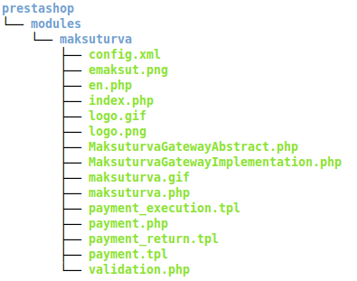Illustration 1: Tree structure of package contents

File | Description
prestashop/modules/maksuturva/validation.php | Callback url used to verify a payment (ok, error, cancel or giro payment).
prestashop/modules/maksuturva/  MaksuturvaGatewayAbstract.php | Base class used to wrap Maksuturva's features.
prestashop/modules/maksuturva/  MaksuturvaGatewayImplementation.php | Implementation of base maksuturva's class based on OsCommerce
prestashop/modules/maksuturva/maksuturva.php | The main payment gateway file, called from checkout and administration areas.
prestashop/modules/maksuturva/config.xml | Module general information.
prestashop/modules/maksuturva/index.php | Module access restriction.
prestashop/modules/maksuturva/payment.php | Payment preparation process, with form generation and presentation.
prestashop/modules/maksuturva/payment.tpl | Payment button template.
prestashop/modules/maksuturva/payment_execution.tpl | Payment form template (with hidden fields which comprise the products and store credentials).
prestashop/modules/maksuturva/payment_return.tpl | Success or error message templates for when coming back from the payment in Maksuturva.
prestashop/modules/maksuturva/en.php | Empty language file.
prestashop/modules/maksuturva/emaksut.png  prestashop/modules/maksuturva/logo.gif  prestashop/modules/maksuturva/logo.png  prestashop/modules/maksuturva/maksuturva.gif | Image files used by the module.

Installation
Prior to any change in your environment, it is strongly recommended that a backup of the entire existing PrestaShop installation is performed.

Package installation
The first step of installation involves to copy the package structure with its contents into a valid PrestaShop installation directory. The simplest way of performing such operation is through copying the module folder from the maksuturva package into the installation PrestaShop directory. It is important to notice that a merge operation needs to be done, instead of replacing the entire directory.
Another option is to copy the package contents individually into their destination directories, creating such directories when they do not exist.

PrestaShop setup
When the files are copied into the destination directory, open the administrative panel of your PrestaShop installation and go to the payment modules section. The Illustration 2 shows the path to open the installation panel.
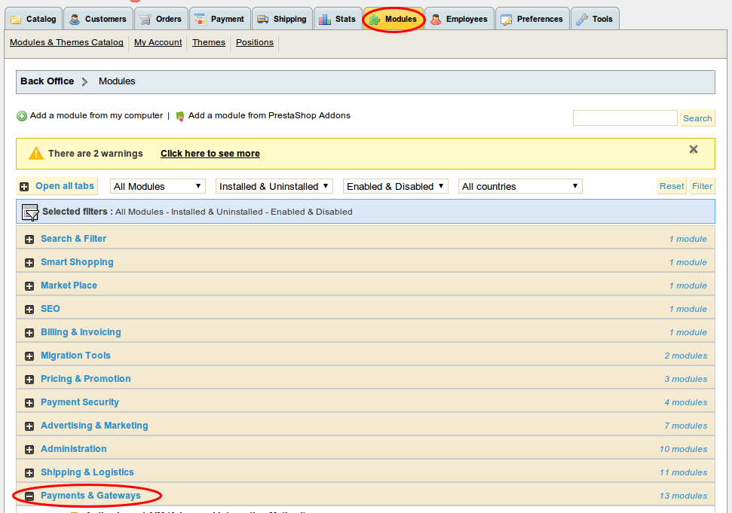Illustration 2: Open the install payment module page
In the installation page, select Maksuturva and click “Install”, as shown below.
Illustration 3: Module installation – before and after
The module is now shown as installed, and the configuration can be performed.

Configuration
The configuration section for Maksuturva's module is reached by accessing the installed payment modules, as shown in the setup section. The parameters and their possible configurations are presented in Illustration 4.

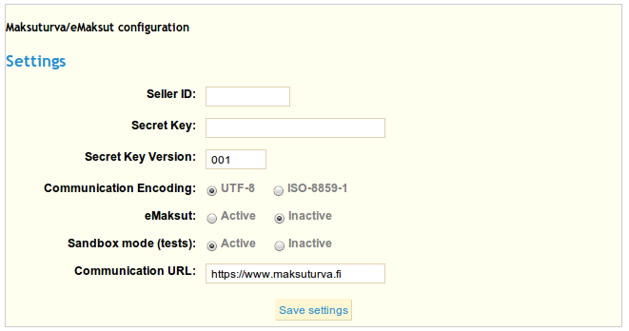Illustration 4: Configuration parameters

All the configuration entries are detailed below. Remember to save the changes after your actions.

Seller ID
Open your Maksuturva account and check your seller ID in account details. The seller id is your identifier, used in every transaction inside your store. Copy the value and paste it in this field. When using sandbox mode, the value filled in this option will not be used, since the test account will be activated.

Secret key
Together with the Seller ID, the secret key is also provided by Maksuturva. Check your secret key and input this value into the configuration field. Please note that this key must not be shared with any person, since it allows many operations to be done in your Maksuturva account.

Secret key version
This parameter is also provided by Maksuturva. Check your secret key version and input this value into the configuration field. Please note that this key must not be shared with any person, since it allows many operations to be done in your Maksuturva account.

Communication encoding
There are two possible character encodings that are accepted by Maksuturva. Even if you are using a different encoding the module will attempt to convert the data from your osCommerce encoding to the encoding set on this configuration. You might need to test which of them works better for your encoding by using the sandbox mode. The possible values are 'ISO-8859-1' and 'UTF-8' and they are selected from radio button options. The default value for this setting is 'UTF-8'.

eMaksut
This configuration option enables payments to be done using eMaksut's service, instead of using Maksuturva's one.

Sandbox mode
It is possible to set the module in test mode through turning the Sandbox mode to “True”. When this option is selected, default test parameters (Seller ID and Secret key) will be used in your store payments, meaning that no money will be spent when paying the orders. This is a great tool to test the operation of your store and training employees.
When set to “False”, the production mode will be used and real commercial transactions will be performed when payments are done. Note that the default installation value for this configuration entry is “True”.

Communication URL
This configures which URL the payment and query status operations will send the data to maksuturva. The default value is 'https://www.maksuturva.fi'. The default value will be the address you need on 99,9% of the cases, so only change this parameter if you know exactly what you are doing.

Language customization
It is possible to customize the language and messages used in the module. The customization takes effect by changing the text entries using the administrative tool, accessed by the administrative menu “Tools” → “Translations” → “Module Translations”.
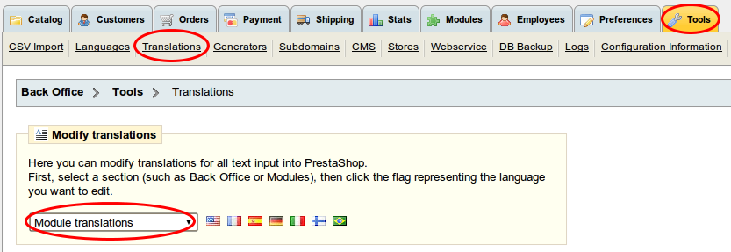Illustration 5: Accessing the translation menu
Look for the section “Module: maksuturva”, and apply all the changes for the selected language.

Administration

Delayed payments
The Maksuturva Gateway Payment module allows customers to perform delayed payments, meaning that a constant verification of payment status is needed. For that purpose, an order which is pending can be automatically verified by opening the order itself. The order is accessed through “Orders” → (filter) “Pending confirmation from Maksuturva” → (click) The desired pending order.
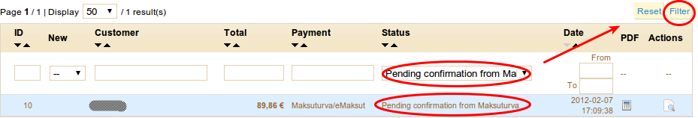Illustration 6: Opening a pending order
When clicked, a new window will open and the verification process will start. When done, a summary of the status changes will be presented with the message from Maksuturva. The order status is automatically updated.
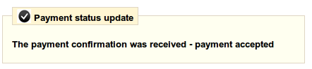Illustration 7: Pending payments verification result

Testing the installation
In order to test the Maksuturva Payment Gateway module, open your configuration section, as shown in section 5, set the Sandbox mode to “True” and save your changes. Follow the steps below to test a purchase.
Step 1 - Log in as a customer and perform a purchase of a random item, selecting Maksuturva as the payment option during the checkout.
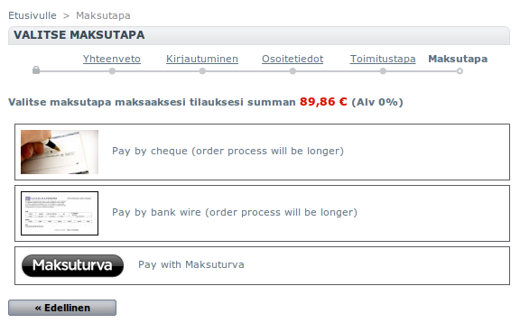Illustration 8: Step 1 - Select maksuturva

Step 2 – Confirm the order.
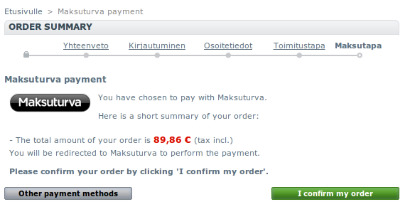Illustration 9: Step 2 - Confirm the order
Step 3 – In Maksuturva test environment, click “Delay return”, simulating a giro payment.
Step 4 – Now the payment was confirmed and the store administrator will be able to check the update when viewing the order. The other actions in Step 3 can be selected (“Ok return”, “Error return”, “Cancel return”) for testing purposes.

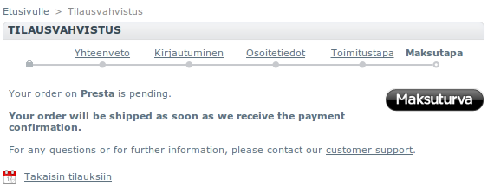Illustration 10: Step 4 - Simulation result

