

Svea Payments

Payment Gateway Manual
for
WooCommerce platform

version 2.7.6
Table of Contents
1 Version history 3
2 Service requirements 3
3 System requirements 3
3.1 Supported 3rd party plugins 3
4 Installation 4
4.1 Installing the Plugin 4
4.2 Upgrading the existing plugin 5
5 Configuration 6
5.1 Enable / Disable 7
5.2 Enable Block mode support 7
5.3 Redirect to Svea’s Payment Method Selection Page 8
5.4 Redirect to Svea’s Payment Method Title 8
5.5 Customer message 8
5.6 Payment handling fees 8
5.7 Payment handling fee tax class 8
5.8 Gateway URL 8
5.9 Seller Id, Secret Key and Secret key version 8
5.10 Payment Prefix 8
5.11 Send delivery confirmation on status change to status 9
5.12 Send delivery confirmation only for specific payment methods 9
5.13 Part Payment widget 10
6 Payment checkout view 11
6.1 Redirect to Svea Payments 11
6.2 Block mode theme view 11
6.3 Collated payment method view 13
6.4 Separate payment methods 14
7 Language customization 15
8 Testing the installation 15
8.1 Testing in Svea Payments test environment 15
9 Administration 16
9.1 Payment verification 16
9.2 Refunds 16
10 About HPOS 17
11 Package contents 18

Version history
Changelog: CHANGELOG.md
Release history: Releases · maksuturva/woocommerce_payment_module (github.com)

Service requirements
The plugin requires an activated Svea Payments payment service to work in production.
For testing purposes, you can order test credentials to Svea Payments test environment. For more details, see the Testing section at http://docs.sveapayments.fi.
Without an active Svea Payments (test environment or production environment) account, you can test the plugin using the Sandbox test mode. See more about testing in section 8.

System requirements
The Svea Payments Payment Gateway plugin for WooCommerce was tested on and required the following set of applications to work fully:
Requirement | Supported versions
WooCommerce | - 9.x, 10.x, 11.x
WordPress | - 6.x
PHP | - 7.x, 8.x

We have added WooCommerce blocks mode support in version 2.7.0. See chapter 5.2

Supported 3rd party plugins
Following 3rd party plugins are supported:
- PW WooCommerce Gift Cards
- WooCommerce Gift Cards
- YITH WooCommerce Gift Cards
- WooCommerce Extra Shipping Options

Installation
Before any change in your environment, we strongly recommend that you back up the entire existing WordPress and WooCommerce installation.
Also, see notes regarding WooCommerce HPOS mode, section 11 About HPOS

Installing the Plugin
- Download the latest zip release package from: https://github.com/maksuturva/woocommerce_payment_module/releases/latest
- On the WordPress plugins page, select Add New (Lisää uusi) and then Upload Plugin (Lataa lisäosa).
Choose the downloaded zip release package file and select Install Now (Asenna nyt).
Note! If you receive this error when uploading the zip package, you need to change your server php.ini settings to allow 6M file size at least.
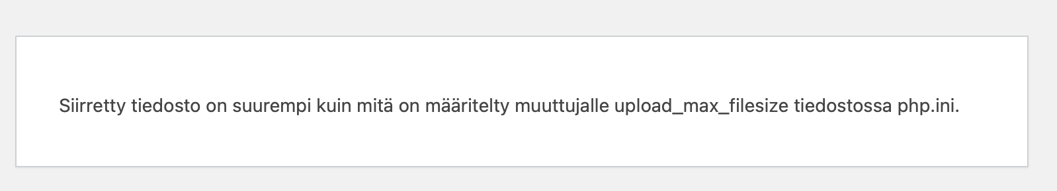
For more information, how to install WordPress plugins other ways, see: https://wordpress.com/support/plugins/install-a-plugin/#install-a-plugin-with-a-zip-file
- Choose Activate (Aktivoi) the plugin.
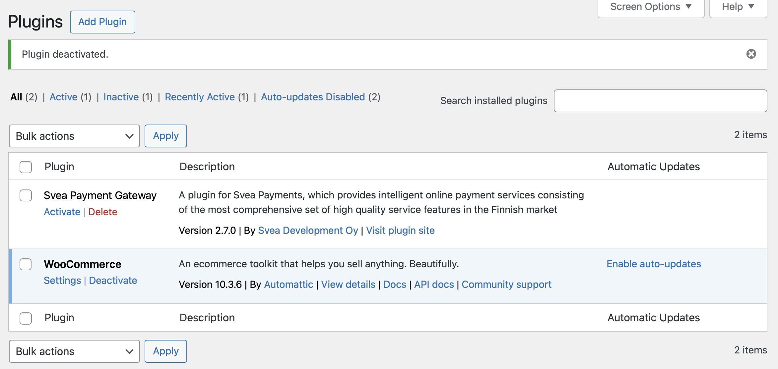

- Select Settings and configure the plugin as described in Configuration 6 -section in this guide.
- Go to WooCommerce / Settings / Payments, and enable Svea payment methods you want to use. See chapter Payment method views
- Continue with configuring the plugin, see chapter 6 Installation.

Upgrading the existing plugin
It's wise to take back up of your database and files. The configuration and payment information are saved on the webstore database.
Check the current version of the Svea Payment Gateway plugin.
- If it’s older than 2.4.0 it’s recommended that you Deactivate and Delete the older module first as the package structure was different in earlier versions and straightforward upgrade is not supported.
- If the current version is 2.4.0 and above, when uploading the release package, WooCommerce will notice that you have the plugin installed already and it will upgrade the current version to a new one.
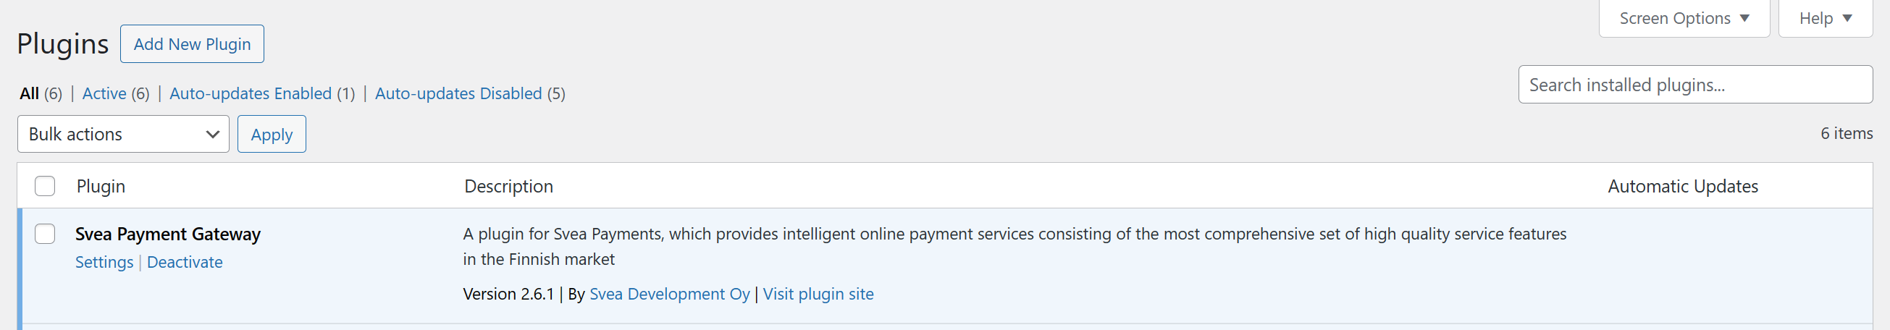
To continue the plugin upgrade, use the Installation process described in the Chapter 5.1.
The configuration will be migrated automatically in the upgrading process.

Configuration
Before you can use the Svea Payments in your WooCommerce store, you need to do some configurations on the plugin's Settings page.
You can access the settings through WordPress plugins list and Settings. Remember to Save changes.
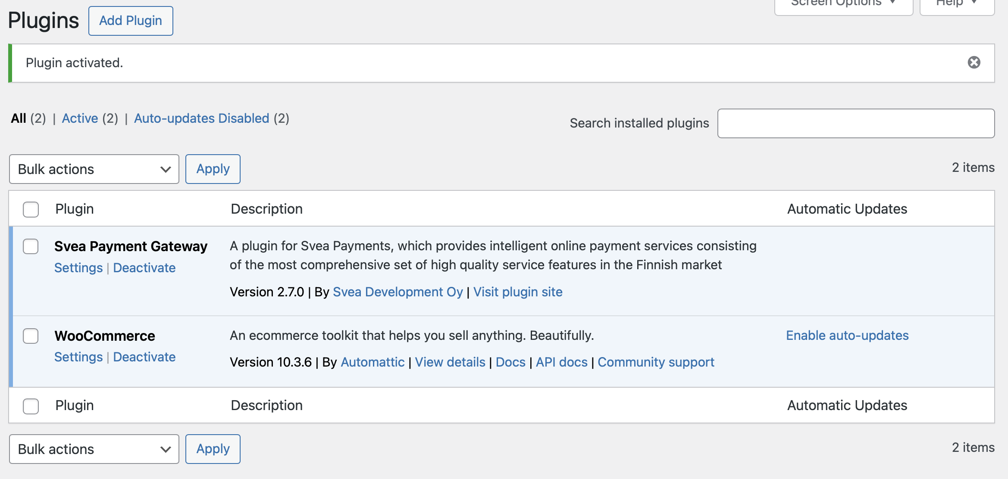
Also, check your WooCommerce tax settings, for example:
- Settings / General / Enable taxes: enable tax calculation
- Settings / General / Currency options: only euro is supported
- Settings / Tax / Prices entered with tax: Yes
- Settings / Tax / Display prices in the shop: Including tax
- Settings / Tax / Display prices during cart and checkout: Including tax
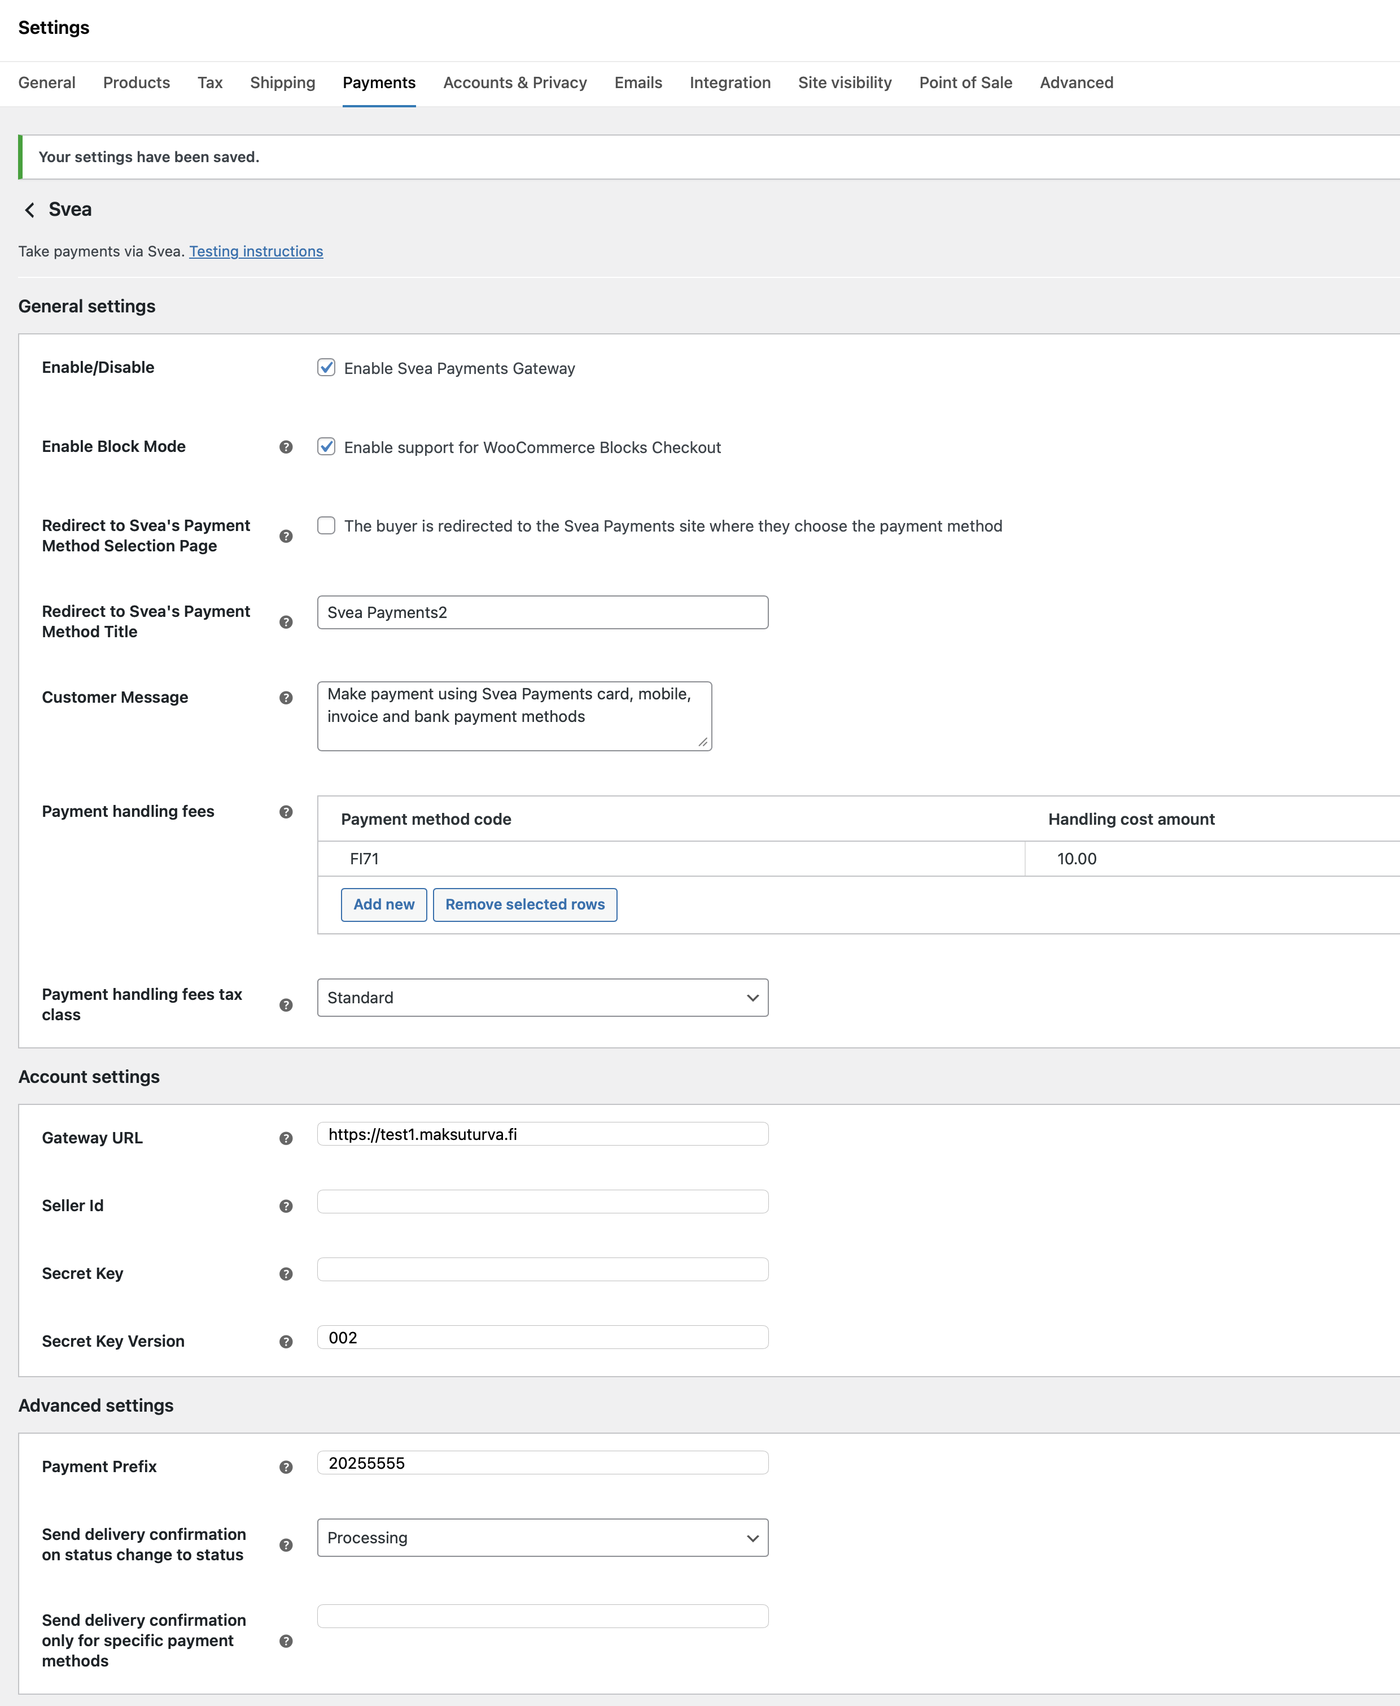

Enable / Disable
Checking this checkbox activates Svea Payments as a payment option for your customers in the checkout process.

Enable Block mode support
Enable this if you are using WooCommerce Block Mode supported theme. Use this, if you use block mode cart & checkout pages in the page editor instead of old short codes. Otherwise, you don’t see any payment methods on checkout page.

Redirect to Svea’s Payment Method Selection Page
Use this option, if you want to use the payment method selection page on the Svea Payment’s web pages instead of WooCommerce Checkout payment selection on the checkout page.
See Chapter 6.1 for more.

Redirect to Svea’s Payment Method Title
Title for the payment gateway when using redirect to Svea Payment page. Shown on the checkout page. Defaults to Svea Payments.

Customer message
Description of the payment gateway. This message is shown below the payment gateway.

Payment handling fees
Optionally, you can specify extra fees per payment method.
You can remove payment fees by selecting the table row and select Remove selected rows.

Payment handling fee tax class
If you have specified handling extra fees, select the fee tax class here.

Gateway URL
Svea Payments production environment (where the customers can make actual payments) uses an SSL-secured connection in a URL https://www.maksuturva.fi.
If you are testing the service using Svea Payments test environment (where you can walk through the whole payment process without using actual money), the connection uses URL https://test1.maksuturva.fi. Remember to change the URL to refer back to production mode before opening your store to real customers.
Both service environments are separate and have specific service accounts, so you must order the credentials separately.

Seller Id, Secret Key and Secret key version
Svea Payments services use your seller id and a secret key combination to authenticate your webstore.
The secret key is used to sign all payments from your store to Svea Payments, so it is essential to keep the secret key secret. Never send the secret key (or a screenshot picture of it) in an unencrypted email or place it somewhere where an outsider could have access to it.
Your initial secret key's version number is 001. If your secret key has been compromised, you can order a new secret key from Svea Payments. In that case, you need to update the version number to refer to the new secret key you have taken in to use.
Your Seller id and Secret Key are ignored when using the Sandbox mode.

Payment Prefix
Svea Payments service requires unique ids for each payment. Orders with payment id that has already been used are not accepted.
As the payment id is calculated from the order numbers, if you move your Svea Payments account to a new software installation and order numbering starts from the beginning, a conflict in payment id numbers can occur. Adding a unique prefix for payment ids after re-installation of the web store can prevent the collision of the payment id numbers.
By default, the prefix is empty.

Send delivery confirmation on status change to status
If the Delivery Confirmation (Toimitustietojen vahvistaminen) feature is enabled in the Svea Payments service, use this dropdown menu to select the status trigger. This trigger determines when the updated order status and delivery information will be sent to Svea Payments.
By default, the trigger is set to "Completed." This means the delivery information is sent when an order is marked as delivered and the WooCommerce order status is updated to "Completed."
You can initiate this action either by manually updating the order status on the order administration page or by applying a bulk action to update the status of multiple orders simultaneously.

Send delivery confirmation only for specific payment methods
If a comma separated list of the payment method codes is specified, the delivery confirmation (see 6.11) is only sent for these payment methods. For example:
FI01,FI02
Note! If this payment method code list is empty and delivery confirmation is activated, the delivery confirmation is set for all payment methods.

Part Payment widget
The Part Payment widget is available in three distinct styles: full, mini, and button, which are selected via the Widget Layout menu. The widget can be displayed on the WooCommerce product page, cart, or checkout page by configuring its location settings. Additionally, the widget's colors and margins can be modified to suit your needs.
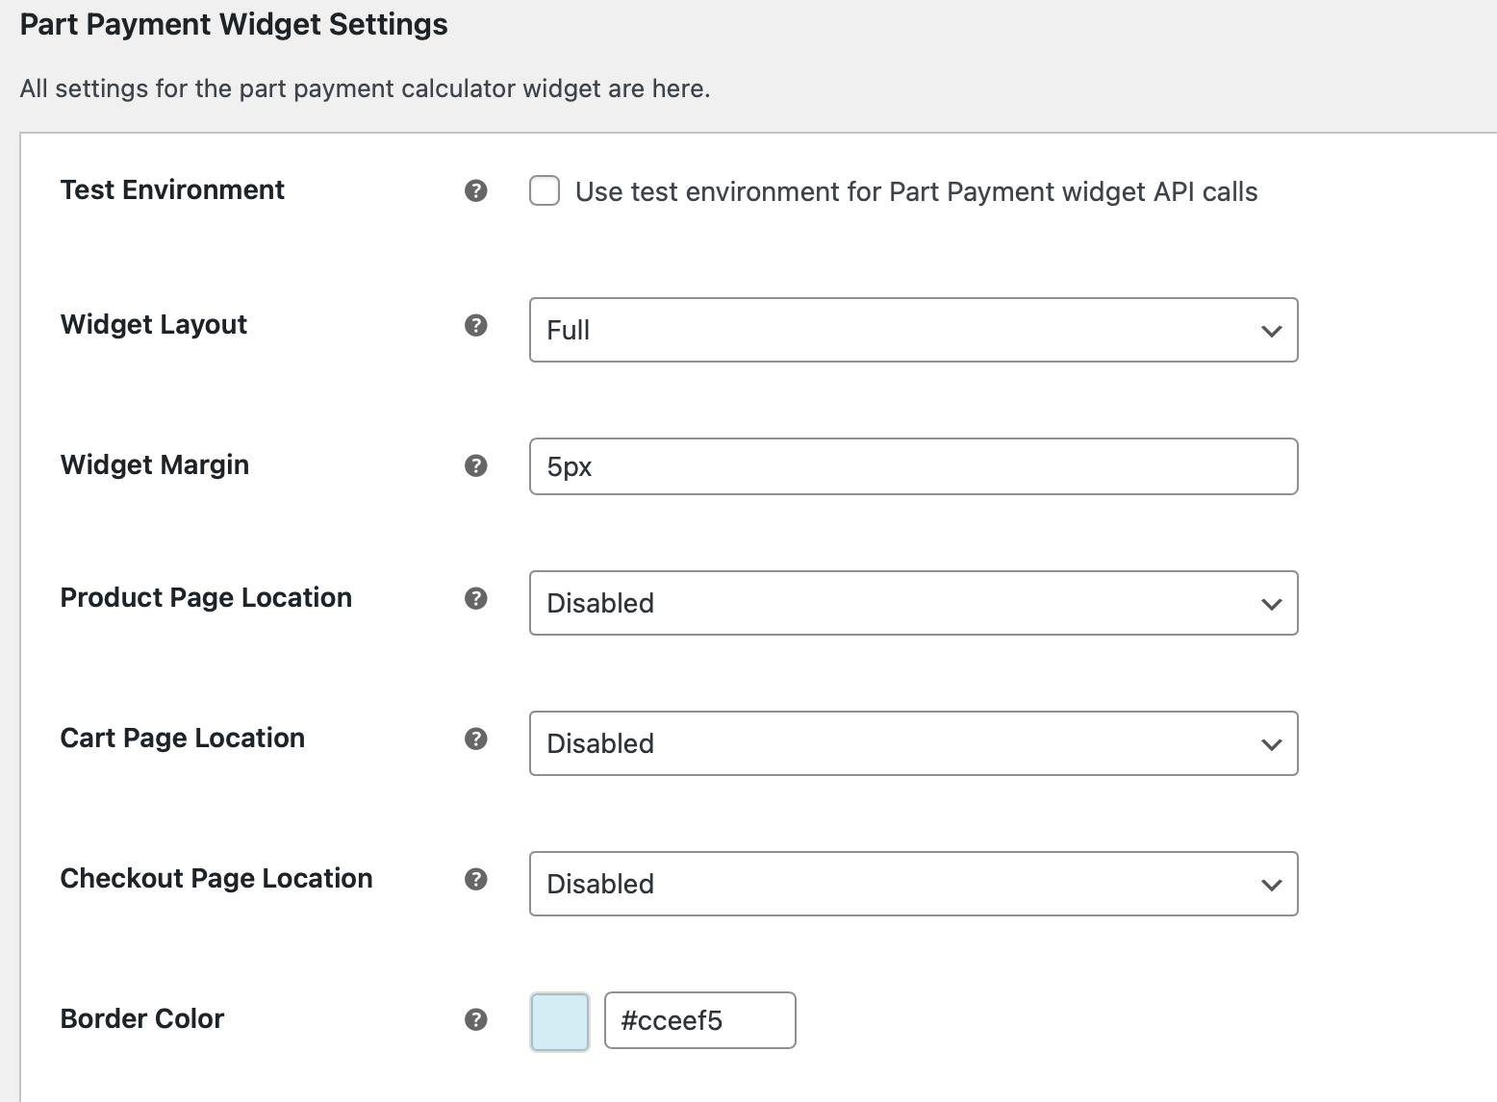
Example of button-style Part Payment Calculator set on the checkout page.
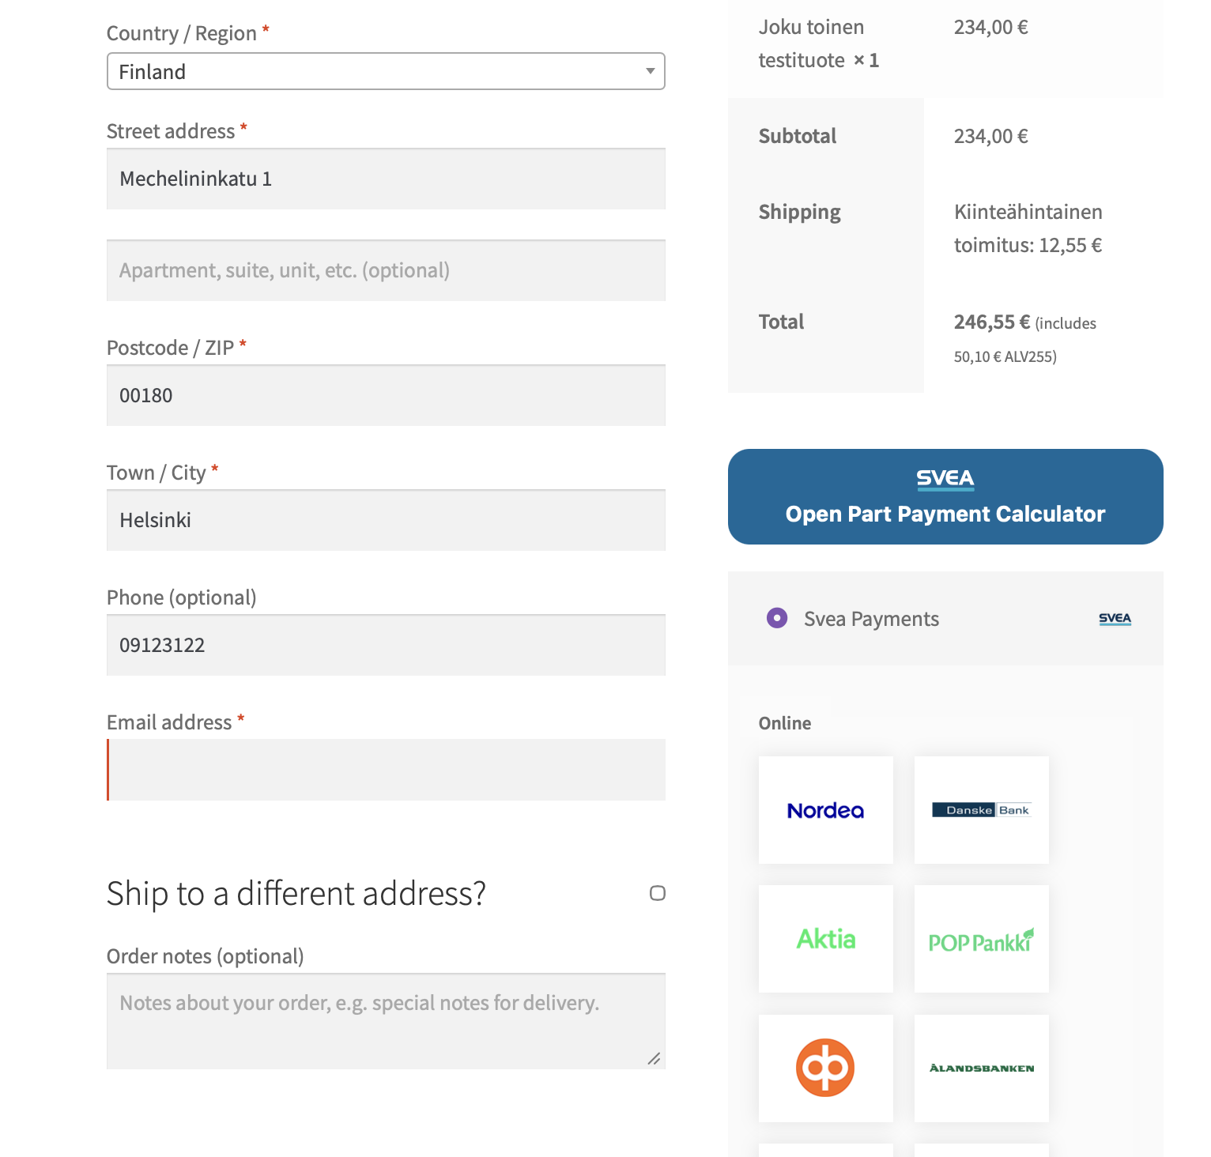

Payment checkout view
The checkout page offers four display configurations for payments:
- Redirect: Users are taken to the Svea Payments portal to select their method.
- Grouped view: A grouped list view of Svea payment methods compatible with WooCommerce Block themes. Use this, if you are using block mode on WordPress pages instead short codes.
- Collated View: A grouped list view of Svea payment methods (does not support Block mode themes).
- Separate Methods: All Svea payment methods listed individually (does not support Block mode themes).

Redirect to Svea Payments
Use this option, if you want to use the payment method selection page on the Svea Payment’s web pages instead of WooCommerce Checkout payment selection on the checkout page.
This option is enabled as follows:
- In WooCommerce payments configuration, enable only Svea – Svea Payments
- In Svea Payments configuration, use setting to enable this feature. See chapter 5.3

Block mode theme view
There is a new block mode cart and checkout view support for payment methods since version 2.7.0.
When using block style checkout page, you only need to:
- In WooCommerce payments configuration, enable only Svea – Svea Payments
- In Svea Payments configuration, locate the Enable Block Mode setting, see chapter 5.2
Enabled (Checked): The Svea payment method will be available in the WooCommerce Checkout Block.
Disabled (Unchecked): The Svea payment method will be hidden from the Checkout Block. Use this if you are using the classic [woocommerce_checkout] shortcode and want to ensure the block integration doesn't interfere.
- Use configuration page to modify payment method group titles, if needed. This configuration can be found in Grouped payment methods section.
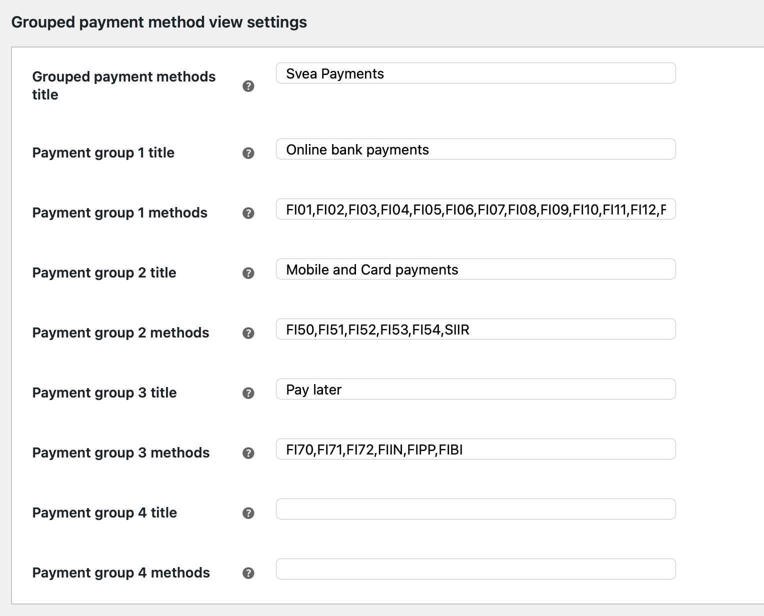
Example layout on the checkout page with payment methods:
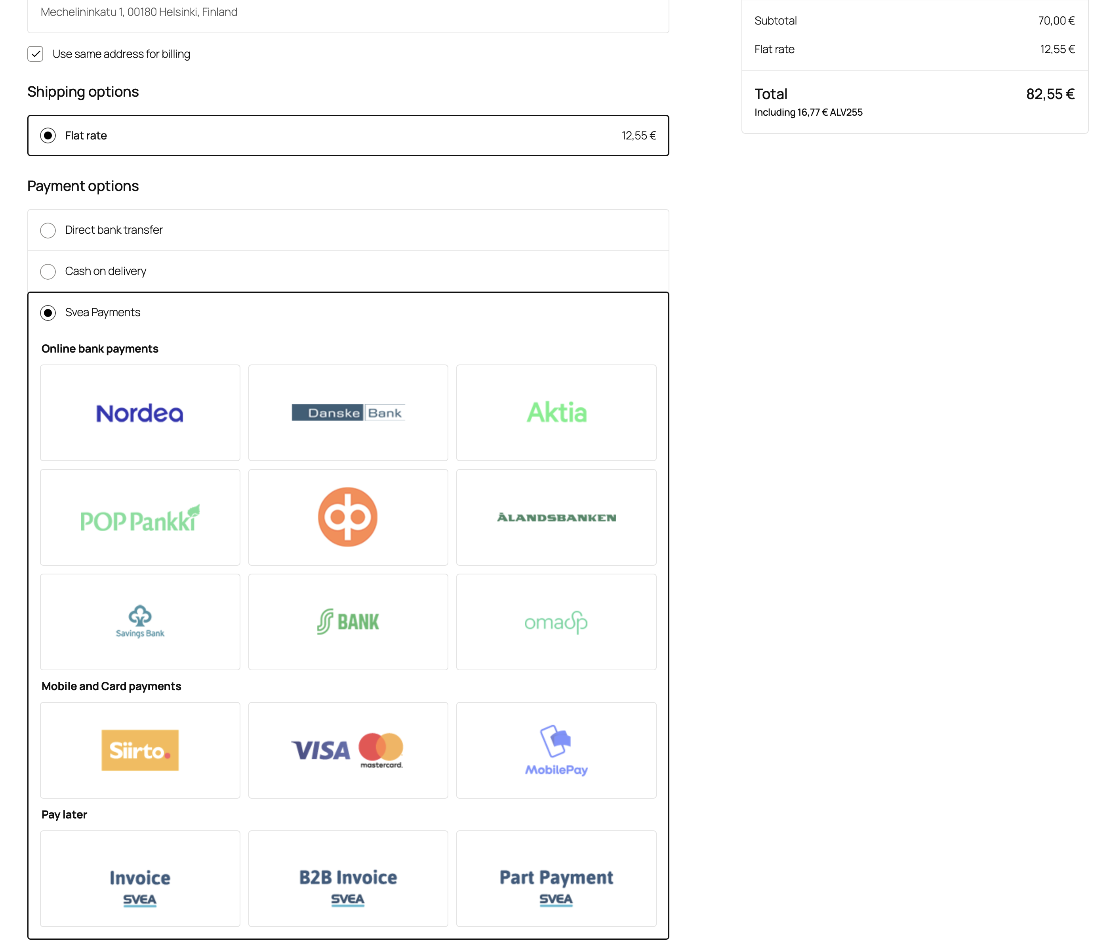

Collated payment method view
When activated, you can edit this method title and assign different subgroups with custom group names and payment methods to it. Additionally, you can use this method in conjunction with other Svea payment methods.
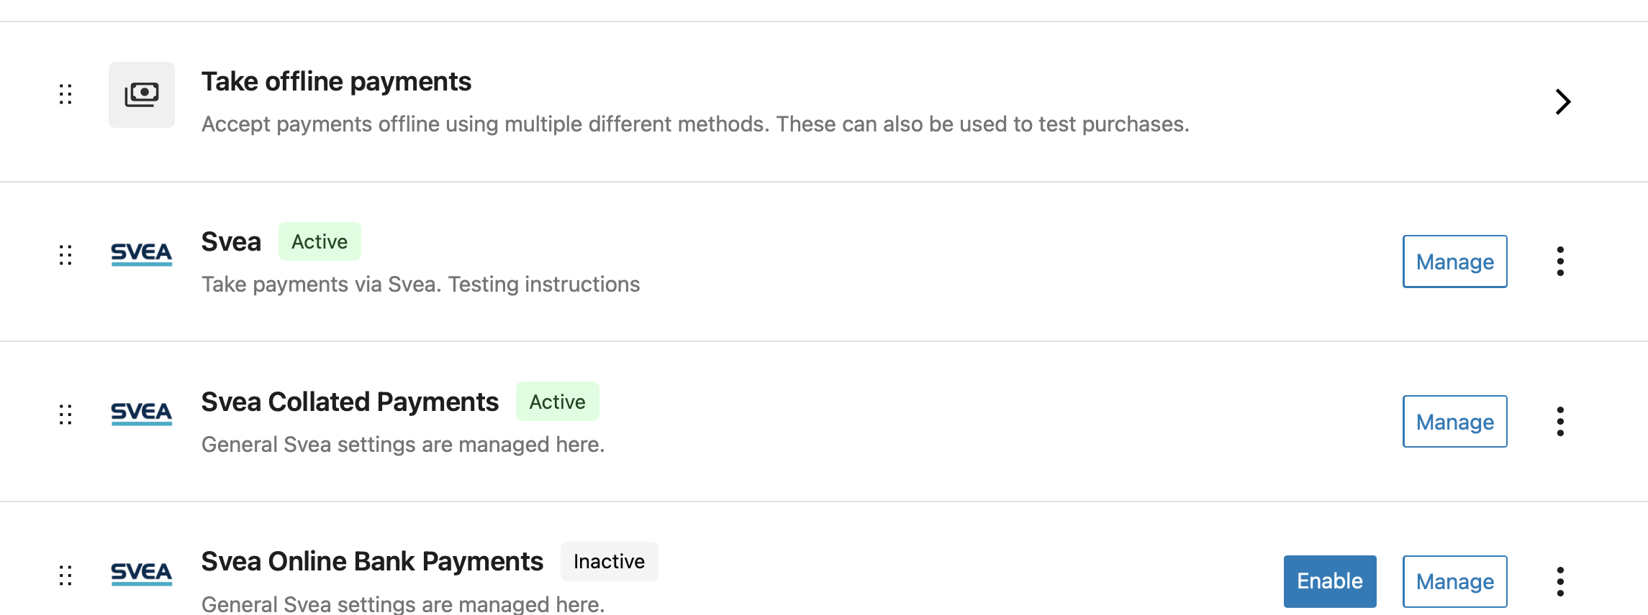
See block mode view configuration in the previous chapter, how to configure collated payment method groups.
Checkout page example:
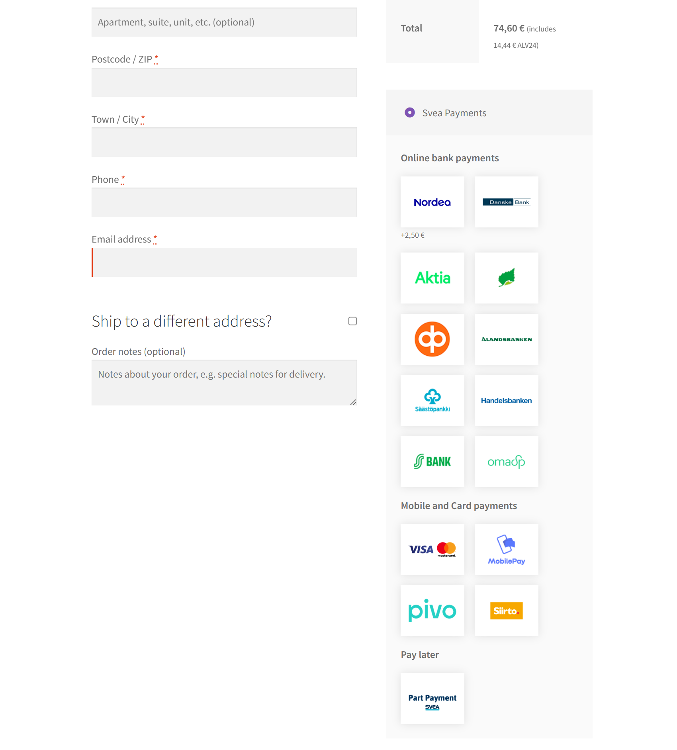

Separate payment methods
If you are using old theme and separate payment methods suit better your needs, you can enable these separately in WooCommerce Payments page:
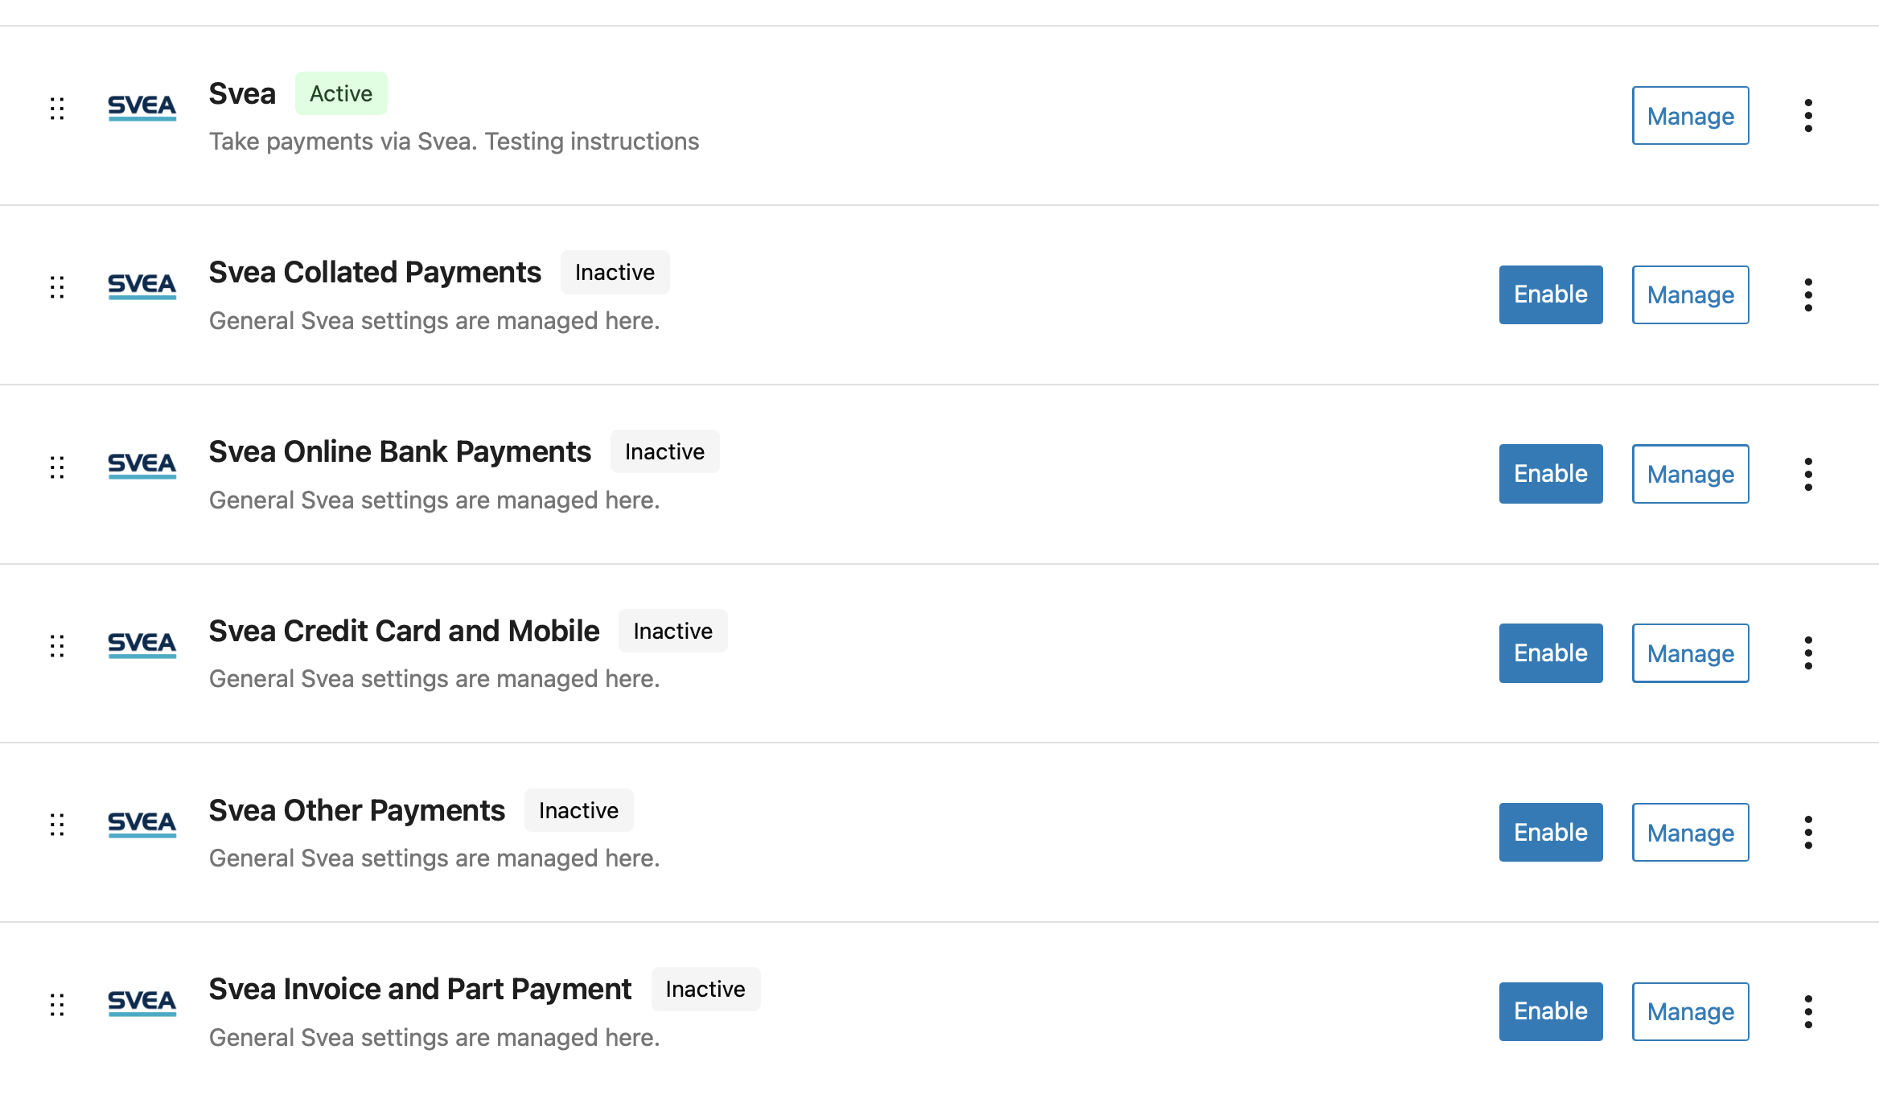
Titles for these methods can be modified in the configuration page, if empty, defaults will be used:
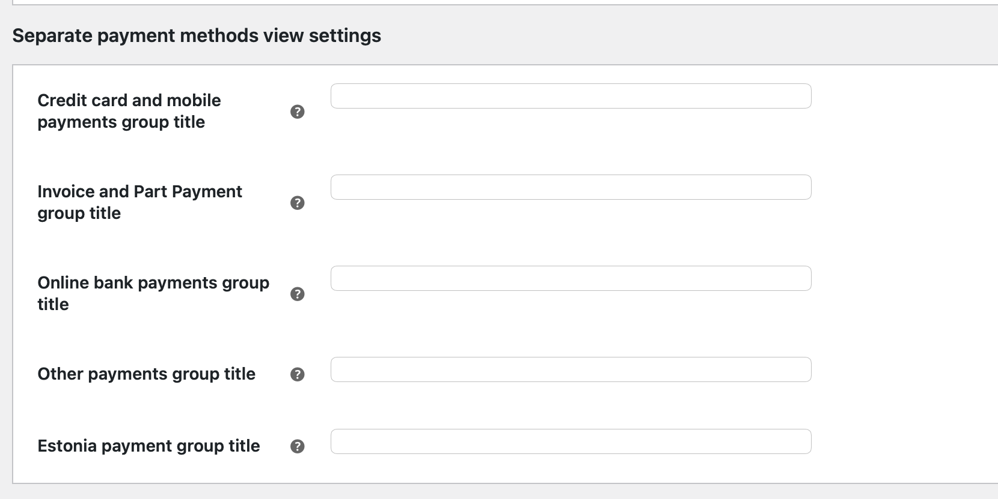

Language customization
Payment Gateway Module can be translated into different languages, and individual texts can be altered by editing .po -files in the languages directory and compiling them as corresponding .mo -files.
One standard tool for this in Windows- and Mac-environments is Poedit (poedit.net). Remember to add the new and altered files to the plugin zip-archive and reinstall the Plugin to WordPress (See section 5).

Testing the installation
It is strongly encouraged that the Svea Payments payment gateway plugin is thoroughly tested before taking it into use in on production web store. It is essential to verify that customer, product information, prices, taxes, and discount and payment message hash calculation is transmitted correctly to Svea Payments.

Testing in Svea Payments test environment
Use Svea Payment test environment (https://test1.maksuturva.fi) to test webstore before production. Set this value to the configuration Gateway URL field.
The test environment uses different credentials than Svea Payments production environment, and test environment service needs to be ordered separately from the existing Svea Payments service. More information about testing is available at http://docs.maksuturva.fi.
After testing the functionality, delete all orders that are made using test environment credentials and set the Gateway URL to https://www.maksuturva.fi . Also change the credentials to match the production environment credentials.

Administration
When a customer chooses to place an order and is redirected to Svea Payments service, the order's status is "pending".
After the payment is completed and the customer returns to the shop from Svea Payments, the status is changed to "processing".
If an error occurs or the customer cancels the payment, customer is returned to the store, and the order status is changed to error or canceled.

Payment verification
The Svea Payments Payment Gateway Plugin automatically verifies payments from Svea Payments and displays the status on the order page.
If the order is still pending after a certain amount of time, it's most likely because the customer has left the payment gateway or closed the browser window in the middle of the payment process. In this case, it's OK for the admin to cancel the order manually.

Refunds
The Svea Payment Gateway Plugin supports refunding the order.
When you press the order page's refund button, after that there is an option for making the refund through Svea.
If the payment is not already settled to the shop, the refund is done automatically after pressing the button.
If the payment is already settled, a message will appear to the order comments with payment details so that the shop can pay the refund back to Svea. Svea can then pay it back to the customer.
If the order has been paid through online banking, the plugin will notify that the refund has to be done directly in Svea Extranet. It is possible to add additional information, such as IBAN, required for refund of online banking payments.

About HPOS
From Svea Payments module version 2.5.0 and above, we support WooCommerce HPOS addition to legacy mode.
HPOS is acronym for WooCommerce High-Performance Order Storage. It’s enabled as default from WooCommerce 8.2 and above. If you have upgraded your webstore from an earlier version, you probably don’t have HPOS enabled yet.
HPOS separates order and payment metadata from older posts-tables to new four tables named:
- _wc_orders
- _wc_order_addresses
- _wc_order_operational_data
- _wc_orders_meta
It’s advised that you use HPOS in compatibility mode. This allows maximum compatibility with all plugins. The settings can be found at WooCommerce Settings / Advanced / Features tab. Preferred settings:
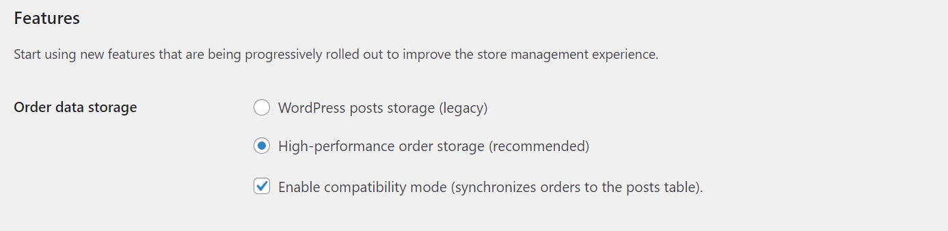
It is important to keep the sync in place until all plugins and custom code are compatible with the new HPOS. Any performance penalties will be temporary, resulting from additional inserts present during the sync.
When you enable HPOS mode first time, the WooCommerce will run a migration job for database to synchronize orders from old structure to new tables.
See more: https://woo.com/document/high-performance-order-storage/

Package contents
This guide assumes that the user correctly downloaded all the package files. Folder structure:
File | Description
CHANGELOG.md | Change log
docs/* | Plugin documentation
includes/* | Class files included by the main plugin class to separate business logic into logical containers
languages/* | Plugin translations
templates/* | Template files used by the module both in the back-end and front-end
src/* | Source files for new block mode supported payment view.
LICENSE | Plugin license file
Svea _logo.png | Svea Payments logo used by WooCommerce
README.md | Readme file
RELEASE.md | Release documentation for GitHub CI

