

Svea Payments

Svea Payments Finland
for WooCommerce

version 3.0.0
Table of Contents
1 Plugin information 3
2 Service requirements 3
3 System requirements 3
3.1 Supported 3rd party plugins 3
4 Installation 4
4.1 Installing the Plugin 4
4.2 Upgrading the existing plugin 5
4.3 Deactivating or removing plugin 5
5 Configuration 6
5.1 Enable / Disable 7
5.2 Enable Block mode support 7
5.3 Redirect to Svea’s Payment Method Selection Page 7
5.4 Redirect to Svea’s Payment Method Title 7
5.5 Customer message 7
5.6 Payment handling fees 7
5.7 Payment handling fee tax class 7
5.8 Gateway URL 7
5.9 Seller Id, Secret Key and Secret key version 7
5.10 Payment Prefix 8
5.11 Send delivery confirmation on status change to status 8
5.12 Send delivery confirmation only for specific payment methods 8
5.13 Part Payment widget 9
6 Selecting payment checkout view 10
6.1 Redirect to Svea Payments 10
6.2 Blocks mode checkout enabled 10
6.3 Collated payment method view 12
6.4 Separate payment methods 13
7 Testing the installation 14
7.1 Testing in Svea Payments test environment 14
8 Administration 15
8.1 Payment verification 15
8.2 Full or partial refund for order 15

Plugin information
Plugin WordPress marketplace location: https://wordpress.org/plugins/svea-payments-finland-for-woocommerce
Changelog: CHANGELOG.md

Service requirements
The plugin requires an activated Svea Payments payment service to work in production. If you don’t have it yet, please contact myynti.payments@svea.fi
For testing purposes, you can order test credentials to Svea Payments test environment. For more details, see the Testing section at http://docs.sveapayments.fi.
See more about testing in section 8.

System requirements
System requirements can be found on plugin page.

Supported 3rd party plugins
Following 3rd party plugins are supported:
- PW WooCommerce Gift Cards
- WooCommerce Gift Cards

Installation
Before any change in your environment, we strongly recommend that you back up the entire existing WordPress and WooCommerce installation.
This plugin works in conjunction with the WooCommerce plugin and provides payment methods for a WooCommerce online store. Install WooCommerce before installing the payment module.

Installing the Plugin
Note! This version is for new installations only. Migration support upgrading from legacy Svea Payments (v2.7.x or older) will be added in future updates.
Prerequisites:
- You have an active merchant account at Svea Payments Oy Finland.
- You have your production Merchant ID and Secret Key ready

- On WordPress plugins page, press Add Plugin button
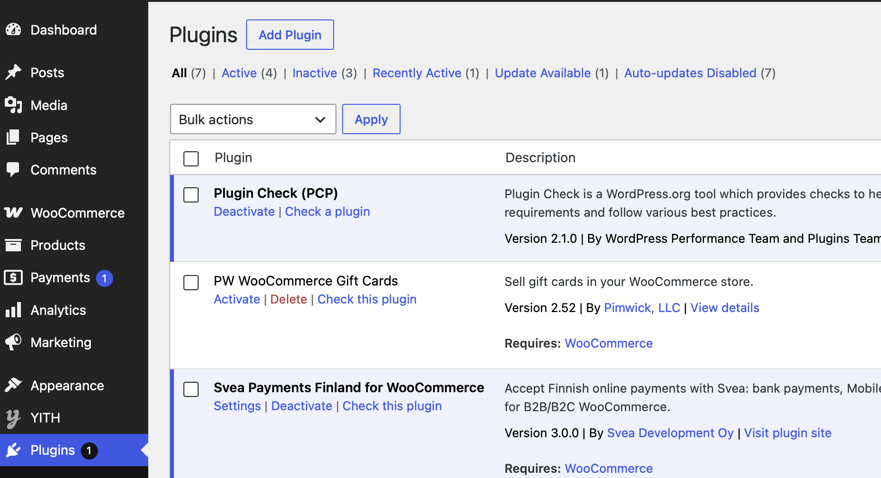
- On Plugins / Add Plugins page, use search text box to find “Svea Payments Finland”
- Press Install Now button and plugin will be installed
- Activate Svea Payments Finland plugin on plugins page by clicking Activate
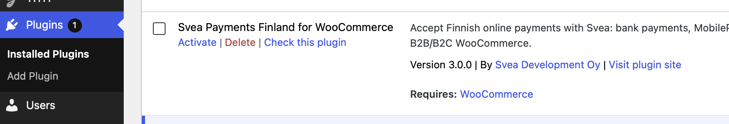

(continues on next page…)
- Click Settings to configure plugin
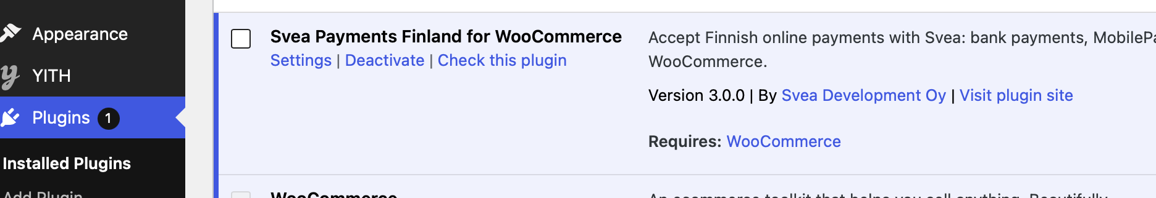
- See chapter Configuration for configuration options.

Upgrading the existing plugin
This plugin is managed by WordPress update mechanism and when new release of plugin is released, you will see a banner below plugin information and option Update Now will updated the plugin to newest version. Example:
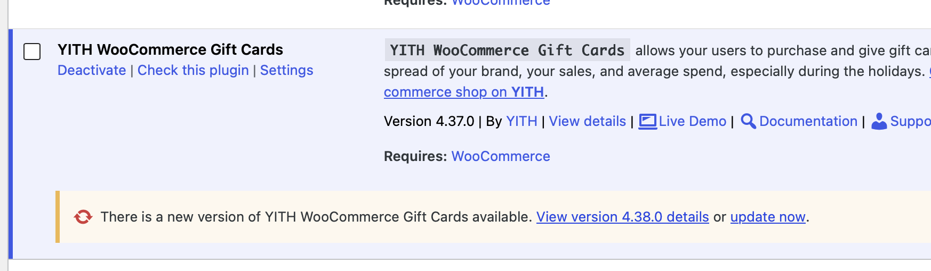

Deactivating or removing plugin
You can use Deactivate option to deactivate plugin temporarily for any good reason.
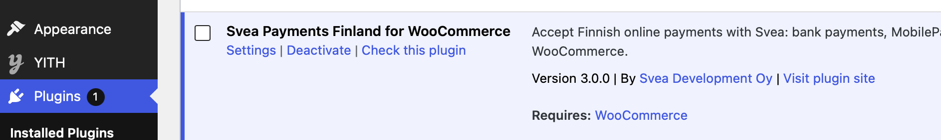
If you want to remove plugin, backup your database first. After deactivating the plugin, use option Delete to delete plugin completely.
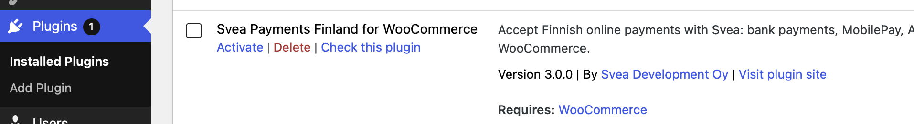

Configuration
Before you can use the Svea Payments Finland plugin in your WooCommerce store, you need to do some configurations on the plugin's Settings page.
You can access the settings through WordPress plugins list and Settings. Remember to Save changes.
Also, check your WooCommerce tax settings, for example:
- Settings / General / Enable taxes: enable tax calculation
- Settings / General / Currency options: only euro is supported
- Settings / Tax / Prices entered with tax: Yes
- Settings / Tax / Display prices in the shop: Including tax
- Settings / Tax / Display prices during cart and checkout: Including tax
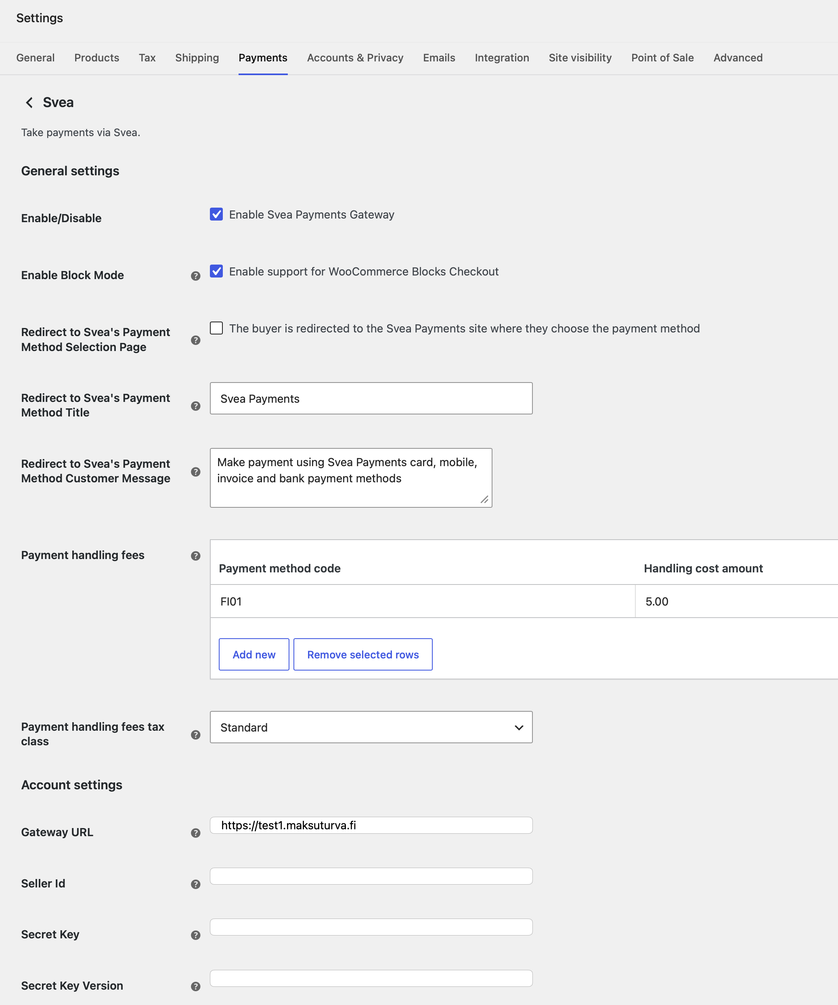

Enable / Disable
Checking this checkbox activates Svea Payments as a payment option for your customers in the checkout process.

Enable Block mode support
Enable this if you are using WooCommerce Block Mode supported theme. Use this, if you use block mode cart & checkout pages in the page editor instead of old short codes. Otherwise, you don’t see any payment methods on checkout page.

Redirect to Svea’s Payment Method Selection Page
Use this option, if you want to use the payment method selection page on the Svea Payment’s web pages instead of WooCommerce Checkout payment selection on the checkout page.
See Chapter 6.1 for more.

Redirect to Svea’s Payment Method Title
Title for the payment gateway when using redirect to Svea Payment page. Shown on the checkout page. Defaults to Svea Payments.

Customer message
Description of the payment gateway. This message is shown below the payment gateway.

Payment handling fees
Optionally, you can specify extra fees per payment method.
You can remove payment fees by selecting the table row and select Remove selected rows.

Payment handling fee tax class
If you have specified handling extra fees, select the fee tax class here.

Gateway URL
Svea Payments production environment (where the customers can make actual payments) uses an SSL-secured connection in a URL https://www.maksuturva.fi.
If you are testing the service using Svea Payments test environment (where you can walk through the whole payment process without using actual money), the connection uses URL https://test1.maksuturva.fi. Remember to change the URL to refer back to production mode before opening your store to real customers.
Both service environments are separate and have specific service accounts, so you must order the credentials separately.

Seller Id, Secret Key and Secret key version
Svea Payments services use your seller id and a secret key combination to authenticate your webstore.
The secret key is used to sign all payments from your store to Svea Payments, so it is essential to keep the secret key secret. Never send the secret key (or a screenshot picture of it) in an unencrypted email or place it somewhere where an outsider could have access to it.
Your initial secret key's version number is 001. If your secret key has been compromised, you can order a new secret key from Svea Payments. In that case, you need to update the version number to refer to the new secret key you have taken in to use.
Your Seller id and Secret Key are ignored when using the Sandbox mode.

Payment Prefix
Svea Payments service requires unique ids for each payment. Orders with payment id that has already been used are not accepted.
As the payment id is calculated from the order numbers, if you move your Svea Payments account to a new software installation and order numbering starts from the beginning, a conflict in payment id numbers can occur. Adding a unique prefix for payment ids after re-installation of the web store can prevent the collision of the payment id numbers.
By default, the prefix is empty.

Send delivery confirmation on status change to status
If the Delivery Confirmation (Toimitustietojen vahvistaminen) feature is enabled in the Svea Payments service, use this dropdown menu to select the status trigger. This trigger determines when the updated order status and delivery information will be sent to Svea Payments.
By default, the trigger is set to "Completed." This means the delivery information is sent when an order is marked as delivered and the WooCommerce order status is updated to "Completed."
You can initiate this action either by manually updating the order status on the order administration page or by applying a bulk action to update the status of multiple orders simultaneously.

Send delivery confirmation only for specific payment methods
If a comma separated list of the payment method codes is specified, the delivery confirmation (see 6.11) is only sent for these payment methods. For example:
FI01,FI02
Note! If this payment method code list is empty and delivery confirmation is activated, the delivery confirmation is set for all payment methods.

Part Payment widget
The Part Payment widget is available in three distinct styles: full, mini, and button, which are selected via the Widget Layout menu. The widget can be displayed on the WooCommerce product page, cart, or checkout page by configuring its location settings. Additionally, the widget's colors and margins can be modified to suit your needs.
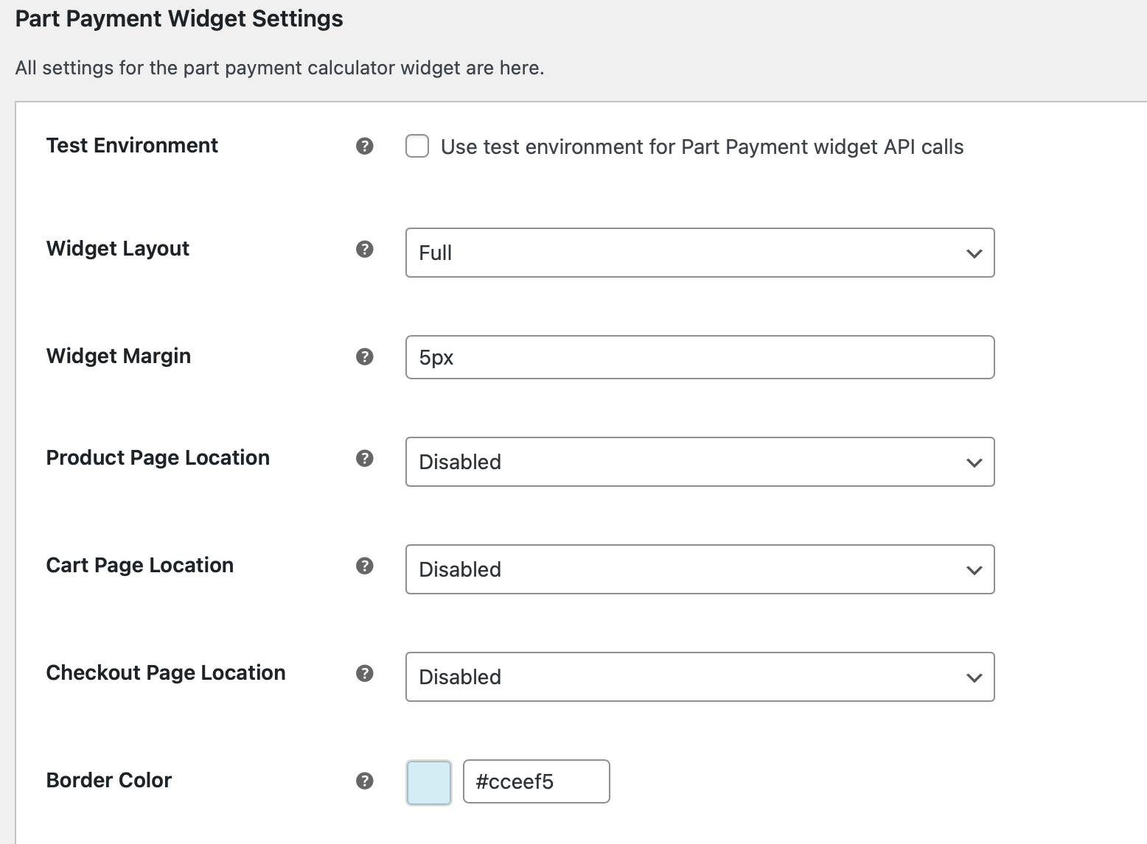
Example of button-style Part Payment Calculator set on the checkout page.
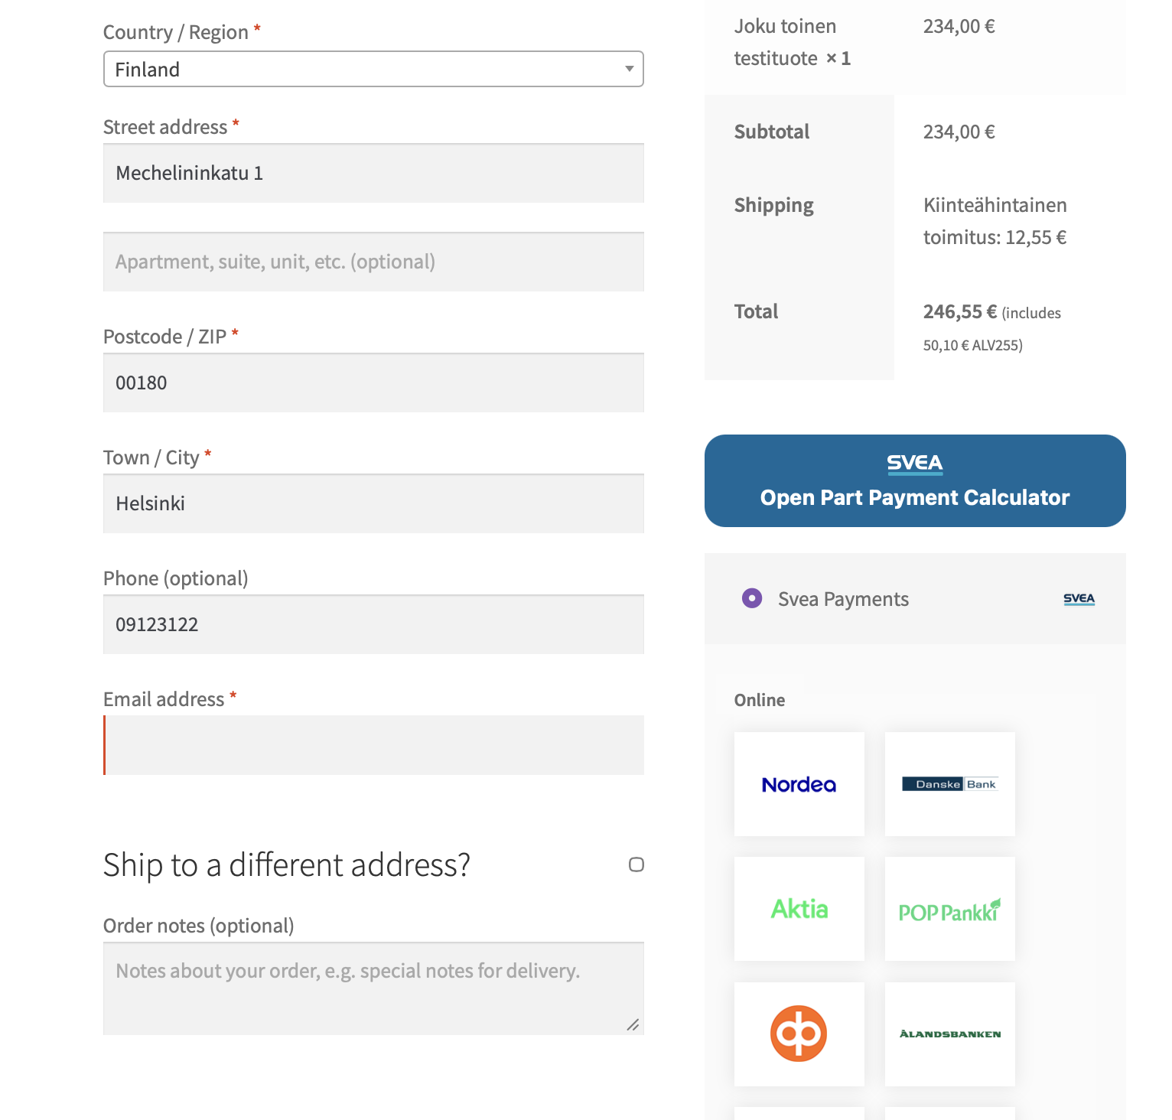

Selecting payment checkout view
The payment plugin offers four layout options for payment methods on the checkout page:
- Redirect: Users are taken to the Svea Payments portal to select their method.
- Blocks mode view: A grouped list view of Svea payment methods compatible with WooCommerce Block themes. Use this, if you are using block mode on WordPress pages instead short codes.
- Collated View: A grouped list view of Svea payment methods (does not support Block mode themes).
- Separate Methods: All Svea payment methods listed individually (does not support Block mode themes).

Redirect to Svea Payments
Use this option, if you want to use the payment method selection page on the Svea Payment’s web pages instead of WooCommerce Checkout payment selection on the checkout page.
This option is enabled as follows:
- In WooCommerce payments configuration, enable only Svea – Svea Payments
- In Svea Payments configuration, use setting to enable this feature. See chapter 5.3

Blocks mode checkout enabled
When using block style checkout page, you only need to:
- In WooCommerce payments configuration, enable only Svea – Svea Payments
- In Svea Payments configuration, locate the Enable Blocks Mode setting, see chapter 5.2
Enabled (Checked): The Svea payment method will be available in the WooCommerce Checkout Block.
Disabled (Unchecked): The Svea payment method will be hidden from the Checkout Block. Use this if you are using the classic [woocommerce_checkout] shortcode and want to ensure the block integration doesn't interfere.
- Use configuration page to modify payment method group titles, if needed. This configuration can be found in Grouped payment methods section.
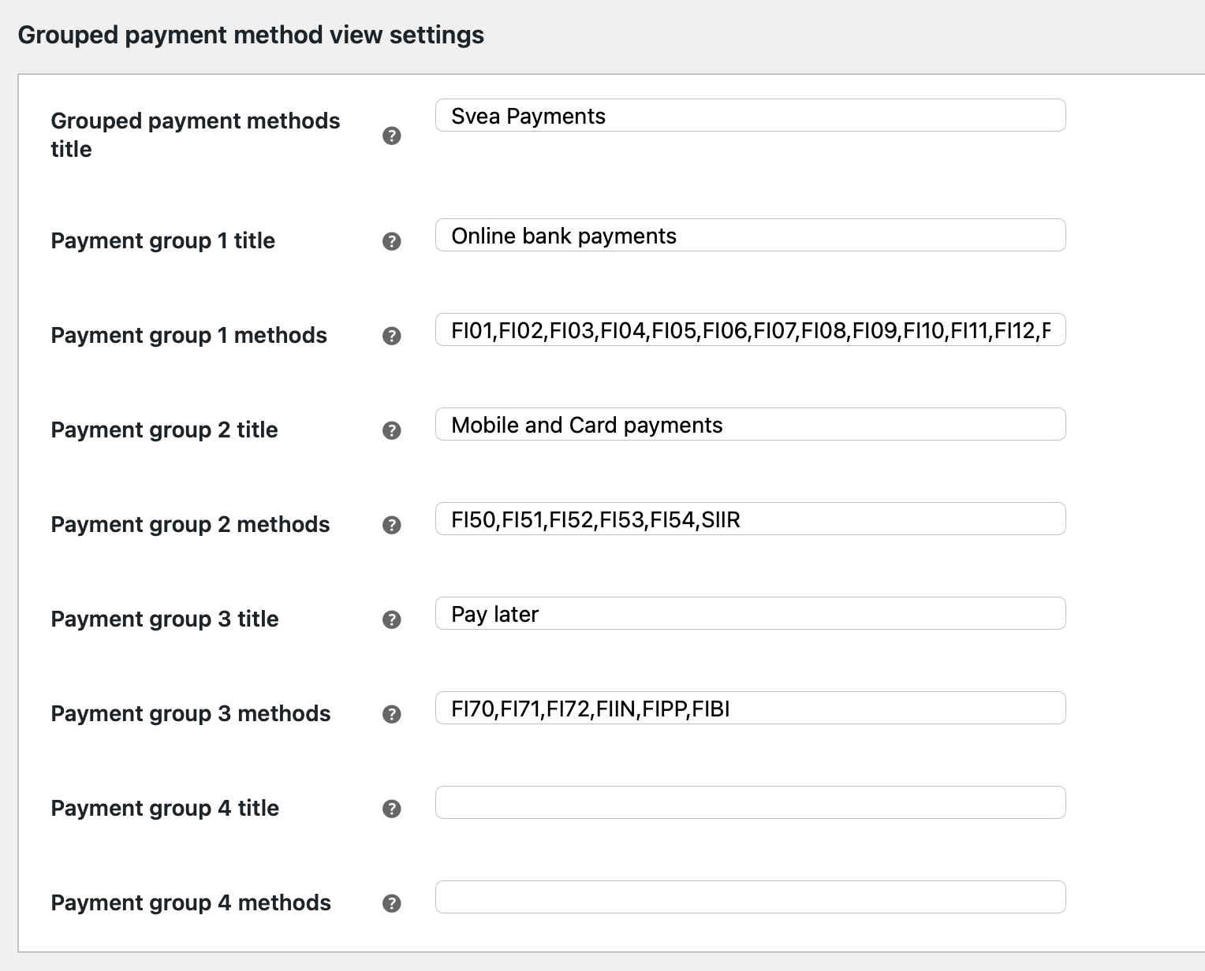
Example layout on the checkout page with payment methods:
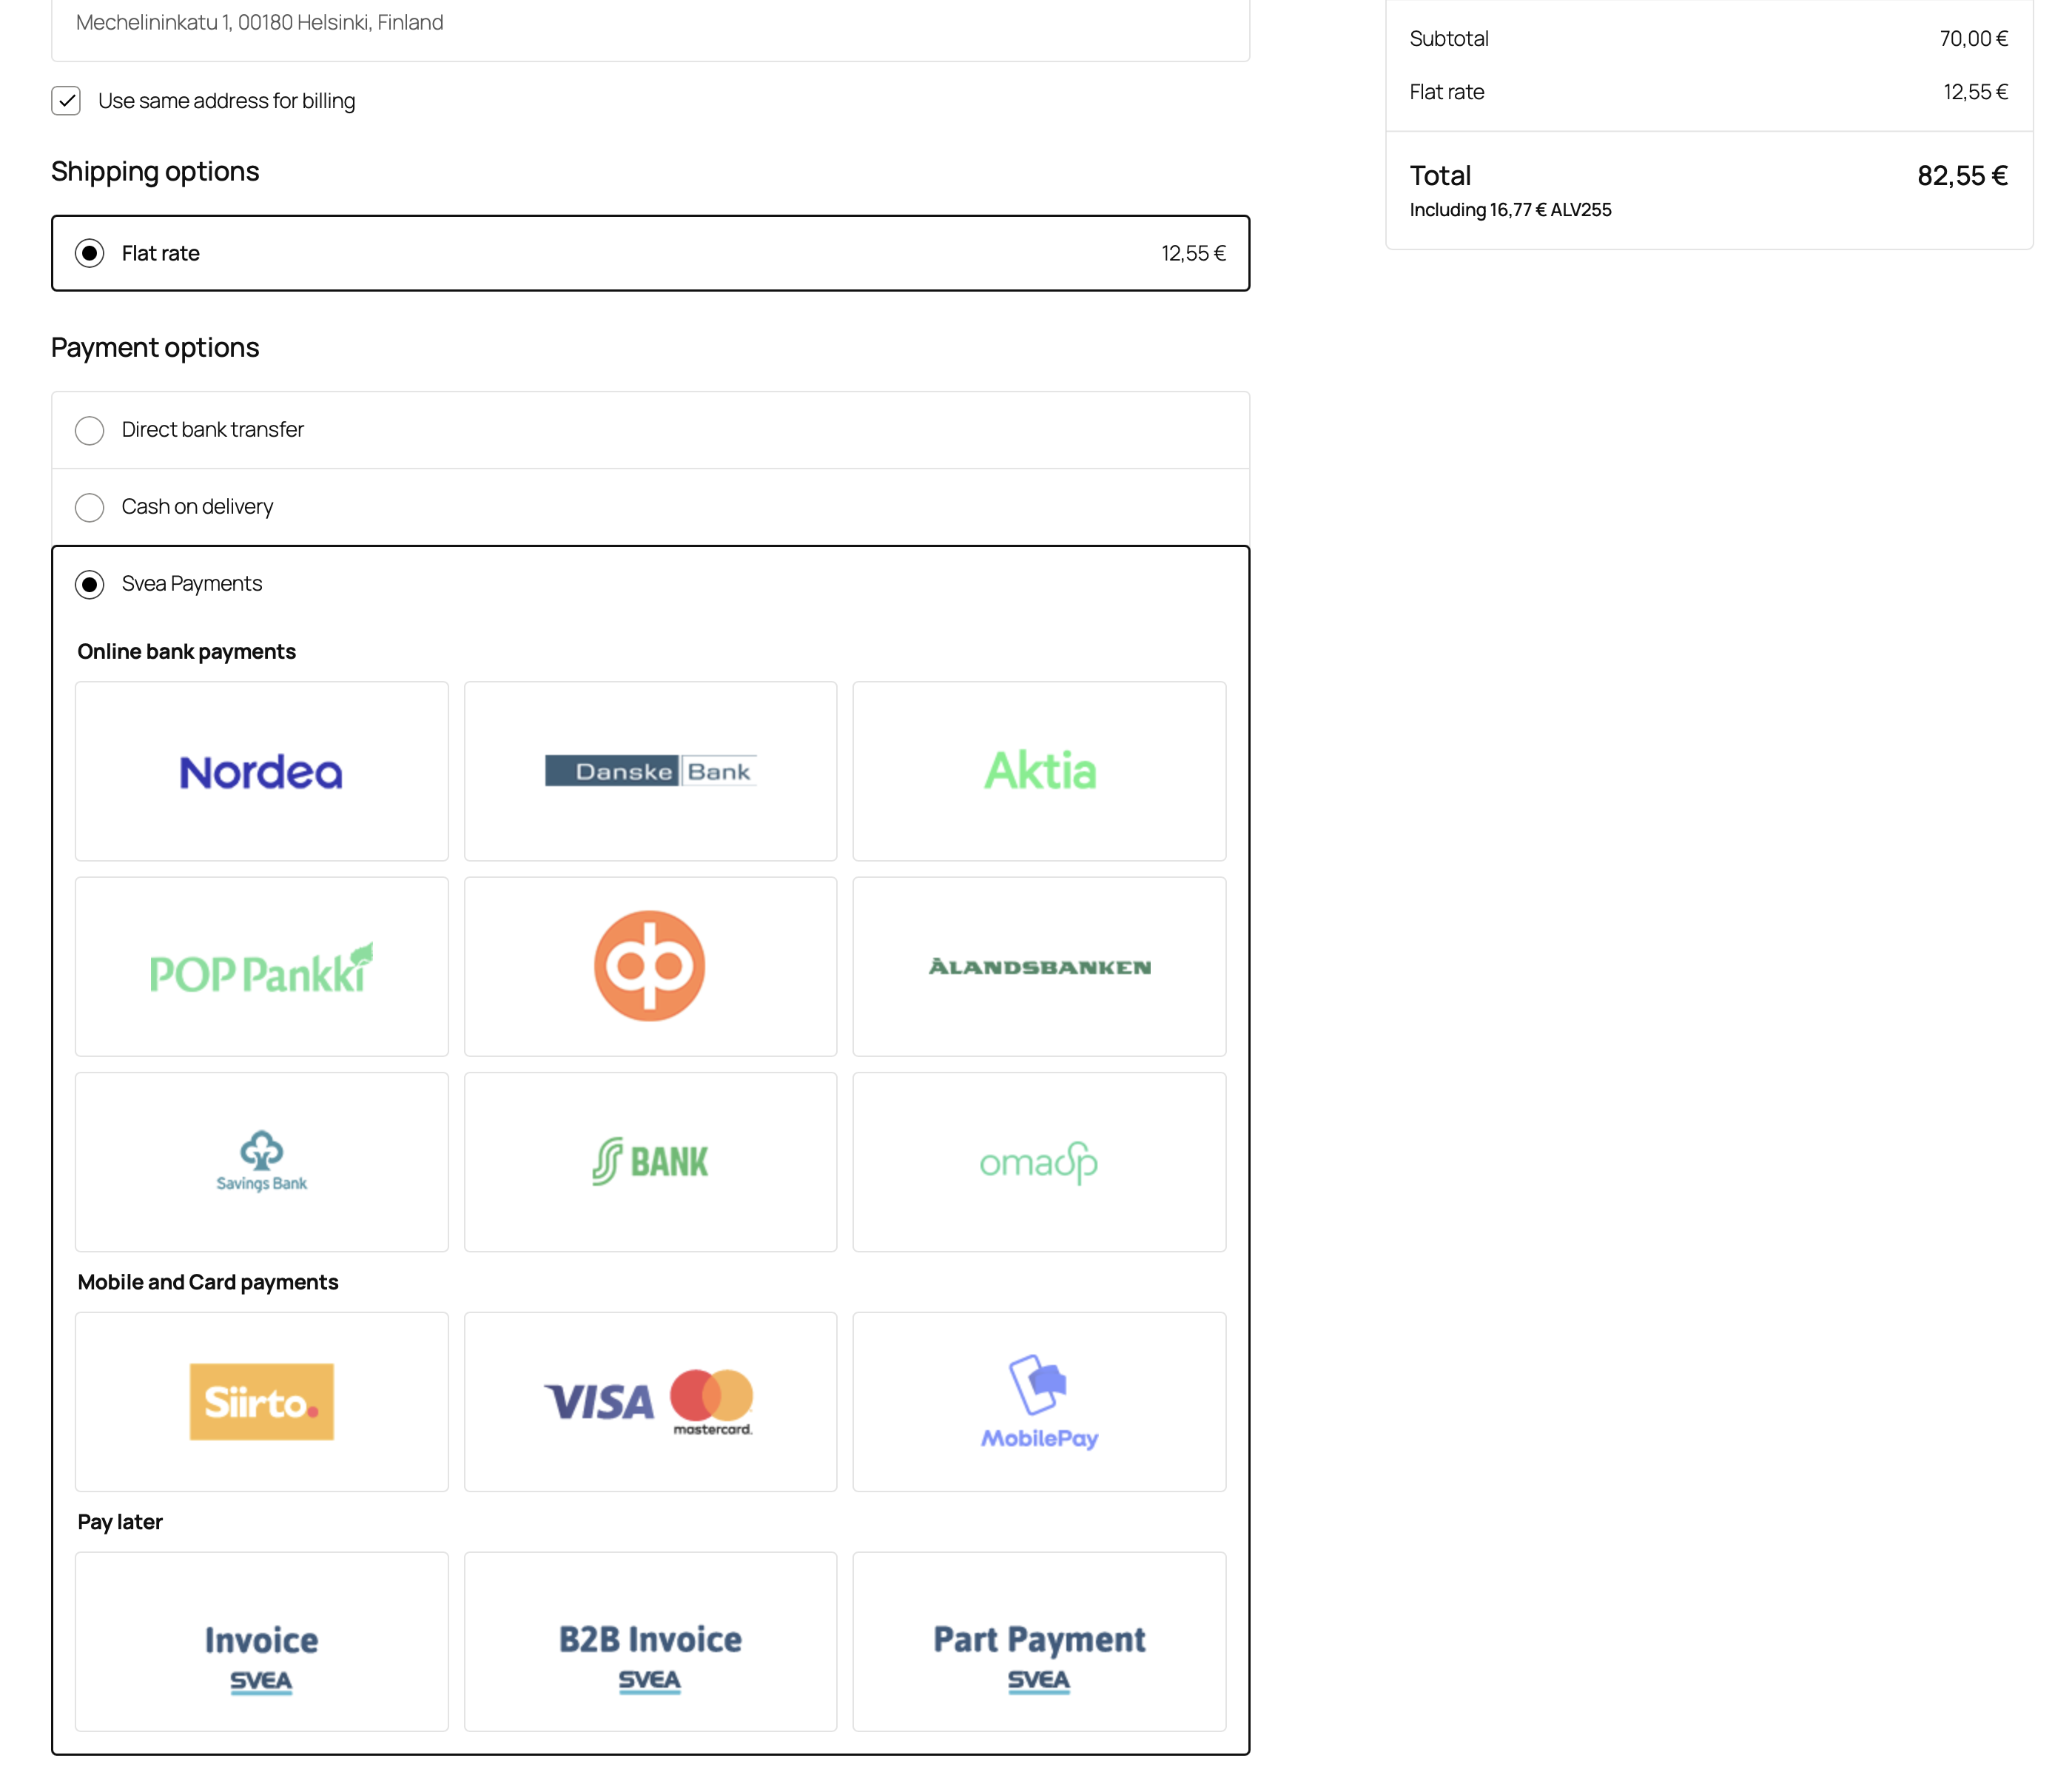

Collated payment method view
When activated, you can edit this method title and assign different subgroups with custom group names and payment methods to it. Additionally, you can use this method in conjunction with other Svea payment methods.
Note! This view option is not supported if you use blocks mode widget on checkout page.
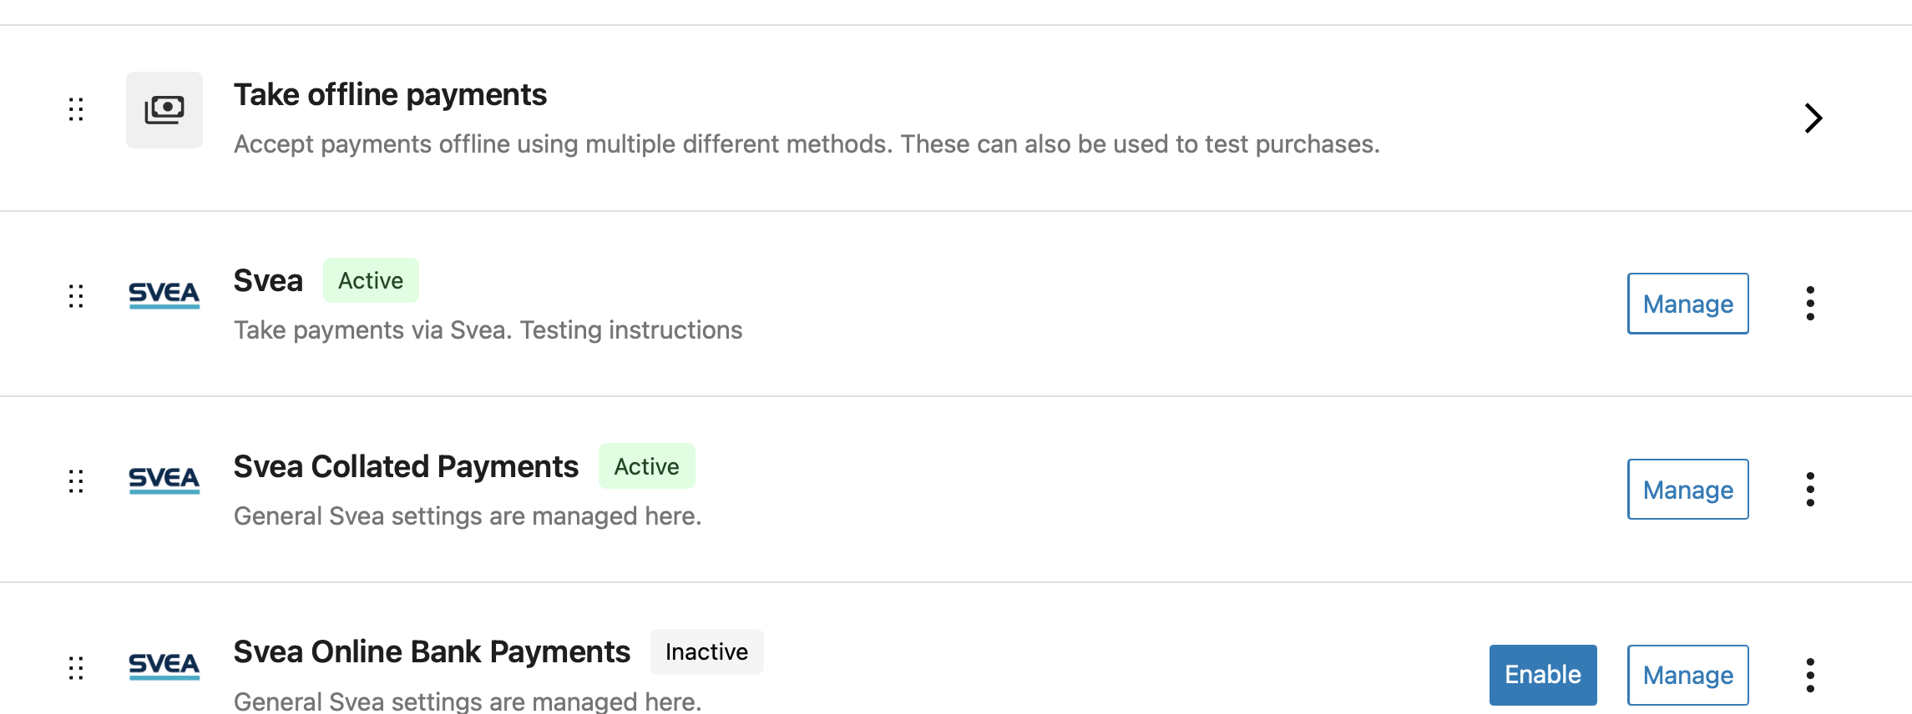
See block mode view configuration in the previous chapter, how to configure collated payment method groups.
Checkout page example:
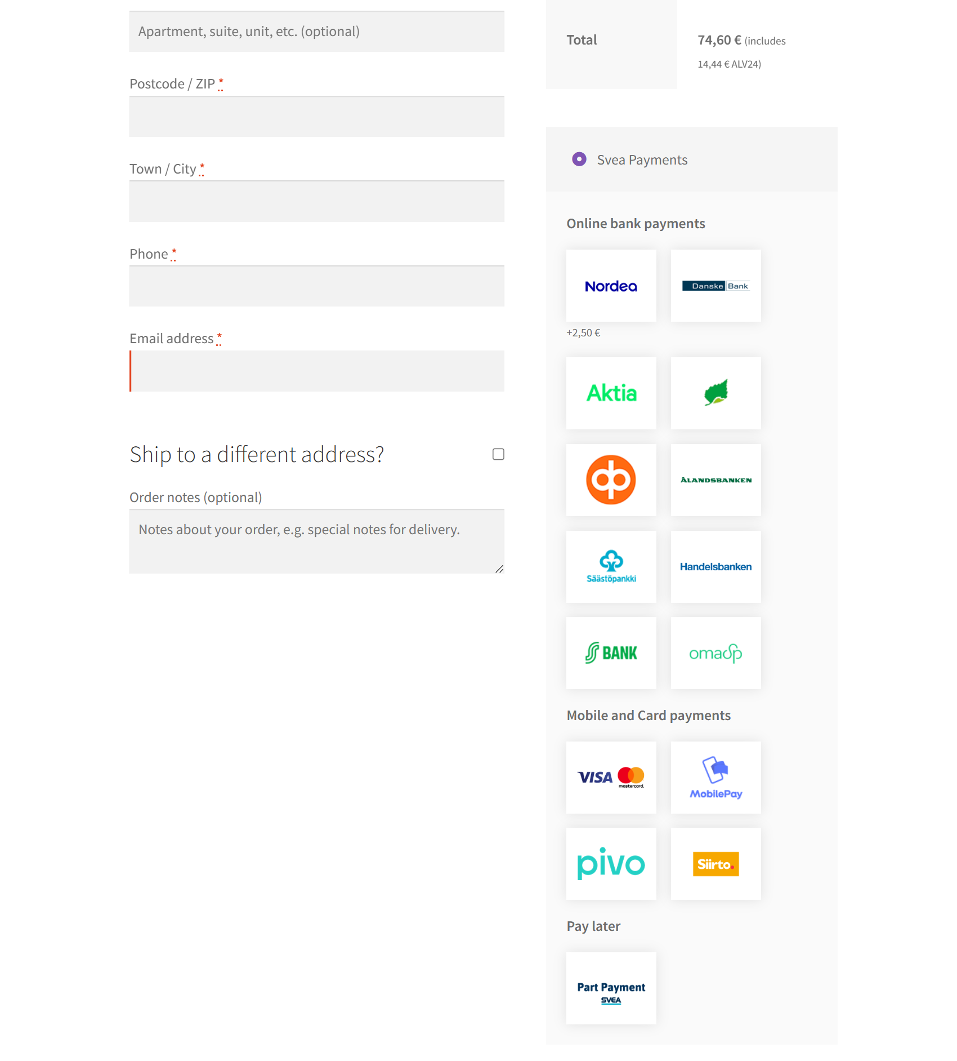

Separate payment methods
Note! This view option is not supported if you use blocks mode widget on checkout page.
If you are using old theme and separate payment methods suit better your needs, you can enable these separately in WooCommerce Payments page:
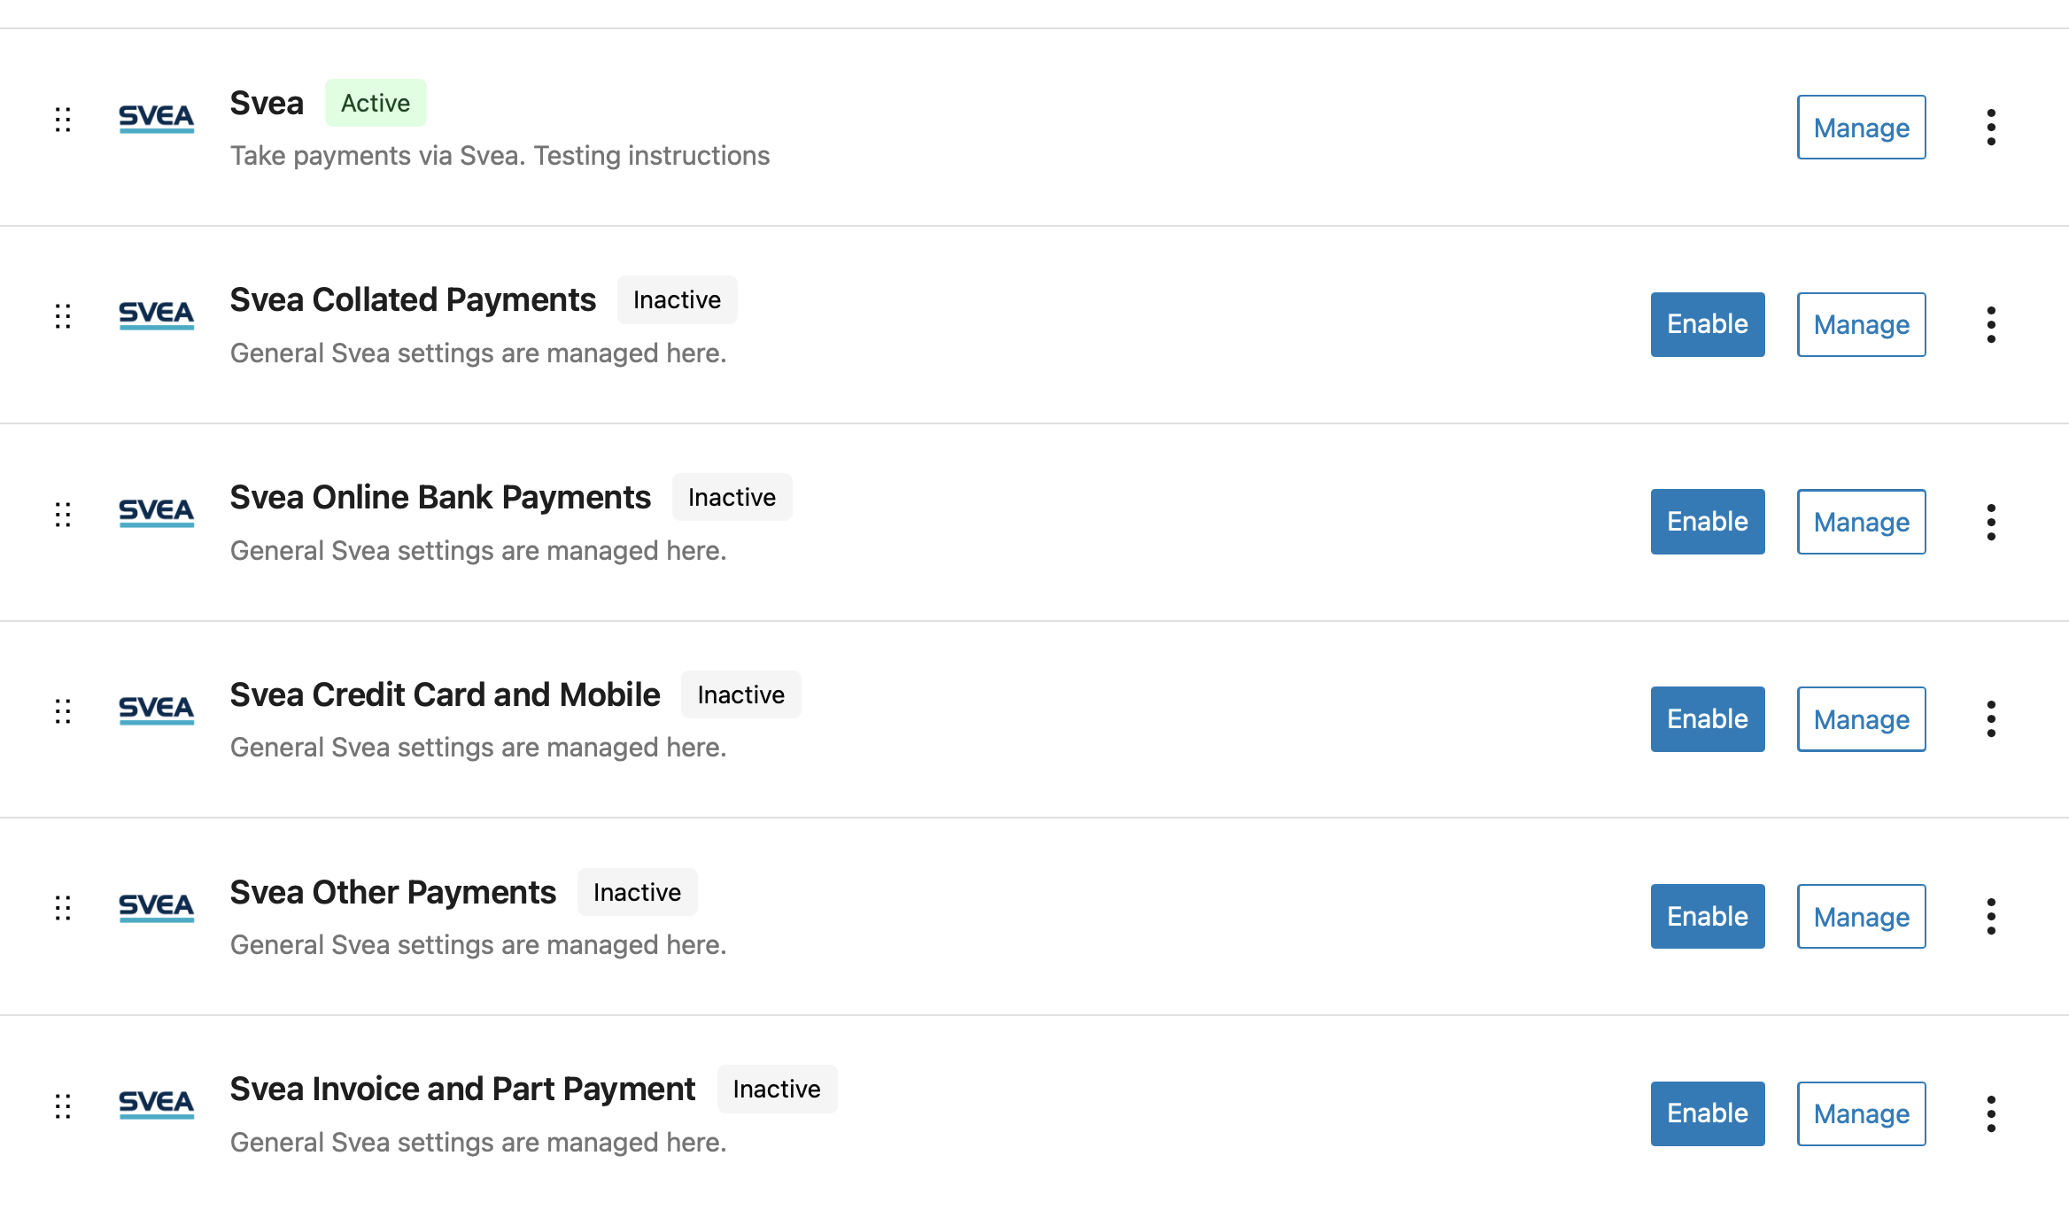
Titles for these methods can be modified in the configuration page, if empty, defaults will be used:
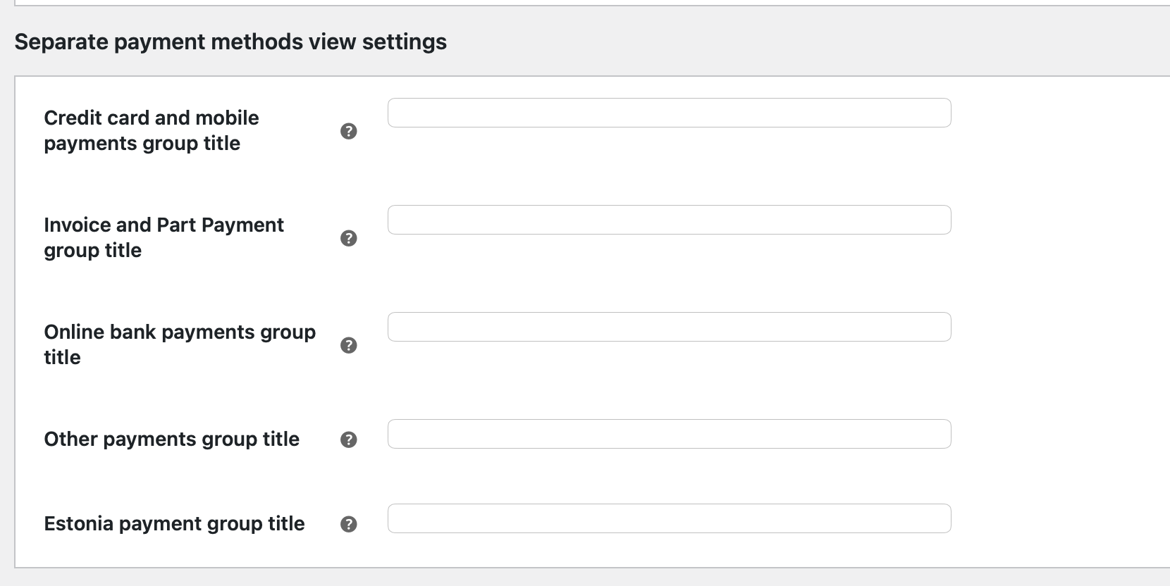

Testing the installation
We strongly recommend thoroughly testing the Svea Payments gateway plugin before deploying it to your production store. You must verify that all customer details, product information, prices, taxes, and discount data transmit correctly to Svea Payments.

Testing in Svea Payments test environment
Use Svea Payment test environment (https://test1.maksuturva.fi) to test webstore before production. Set this value to the configuration Gateway URL field.
The test environment uses different credentials than Svea Payments production environment, and test environment service needs to be ordered separately from the existing Svea Payments service. More information about testing is available at http://docs.maksuturva.fi.
After testing the functionality, delete all orders that are made using test environment credentials and set the Gateway URL to https://www.maksuturva.fi . Also change the credentials to match the production environment credentials.

Administration
When a customer chooses to place an order and is redirected to Svea Payments service, the order's status is "pending".
After the payment is completed and the customer returns to the shop from Svea Payments, the status is changed to "processing".
If an error occurs or the customer cancels the payment, customer is returned to the store, and the order status is changed to error or canceled.

Payment verification
The Svea Payments Payment Gateway Plugin automatically verifies payments from Svea Payments and displays the status on the order page.
If the order is still pending after a certain amount of time, it's most likely because the customer has left the payment gateway or closed the browser window in the middle of the payment process. In this case, it's OK for the admin to cancel the order manually.

Full or partial refund for order
The Svea Payments plugin supports order refunds directly from the WooCommerce order page. When you initiate a refund, you can select the option to process it via Svea. The refund behavior depends on the payment status:
- Unsettled Payments: The refund is processed automatically as soon as you submit the request.
- Settled Payments: If the funds have already been settled to the merchant, the plugin will add a note to the order comments containing the relevant payment details. The merchant must use these details to transfer the refund back to Svea, and Svea will then reimburse the customer.
- Online Banking Payments: The plugin will notify you that these refunds must be processed manually through the Svea Extranet. You can include additional necessary details, such as the customer's IBAN, to complete the transaction.
Refunding:
- Press Refund button
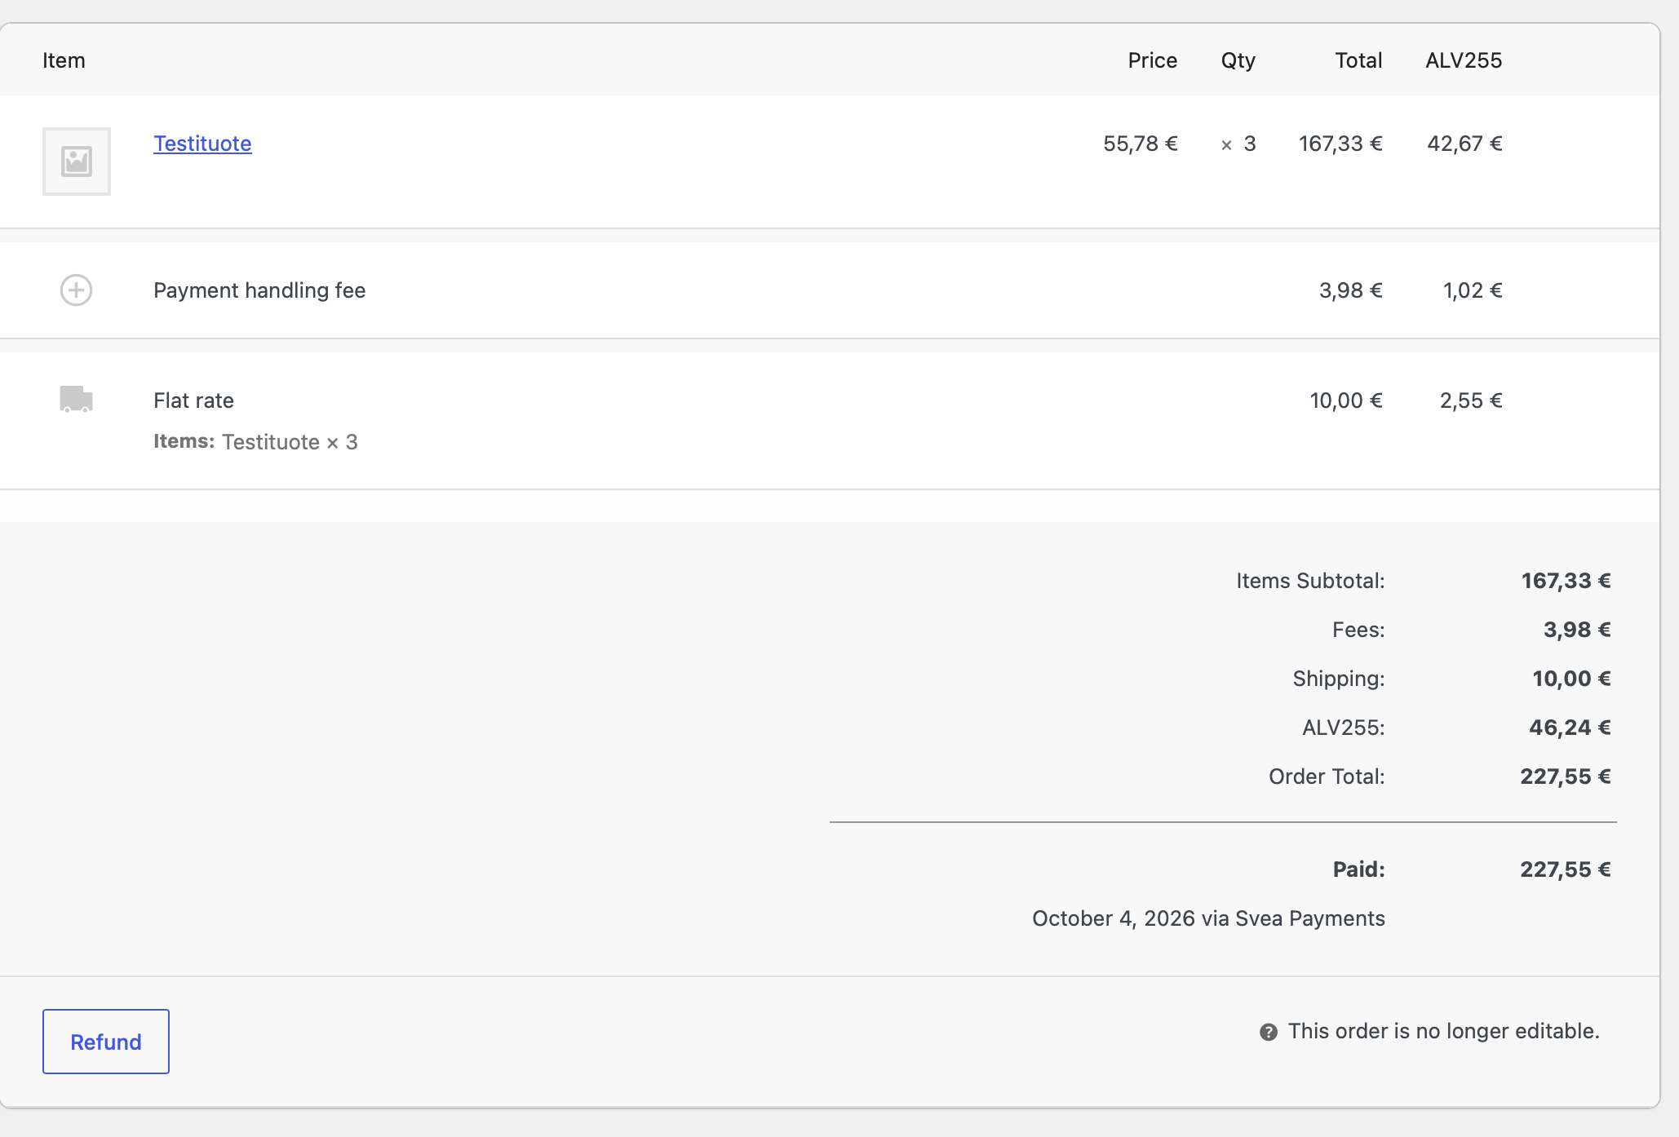
- Press Refund xx eur via Svea button
