Svea Payments

Payment Gateway Manual

for

WooCommerce platform

*version 2.4.0*

**Table of Contents**

1 Changes 3

2 Service requirements 3

3 System requirements 3

4 Package contents 3

5 Installation 4

5.1 Installing the Plugin 4

5.2 Upgrading the existing plugin 5

6 Configuration 6

6.1 Enable / Disable 8

6.2 Title 8

6.3 Customer message 8

6.4 Redirect to Svea’s Payment Method Selection Page 8

6.5 Payment handling fees 8

6.6 Payment handling fee tax class 8

6.7 Seller Id 8

6.8 Secret Key and Secret key version 8

6.9 Gateway URL 8

6.10 Payment Prefix 9

6.11 Send delivery confirmation on status change to status 9

6.12 Send delivery confirmation only for specific payment methods 9

6.13 Svea Payments encoding (deprecated, will be removed soon) 9

6.14 Part Payment widget 10

6.15 Collated payment method view 11

7 Language customization 13

8 Testing the installation 13

8.1 Testing in Svea Payments test environment 13

9 Checkout and payment 14

10 Administration 15

10.1 Payment verification 15

10.2 Refunds 15

# Changes

Changelog: [CHANGELOG.md](https://github.com/maksuturva/woocommerce_payment_module/blob/master/CHANGELOG.md)

Release history: [Releases · maksuturva/woocommerce_payment_module (github.com)](https://github.com/maksuturva/woocommerce_payment_module/releases)

# Service requirements

The plugin requires an activated Svea Payments payment service to work in production.

For testing purposes, you can order test credentials to Svea Payments test environment. For more details, see the Testing section at <http://docs.sveapayments.fi>.

Without an active Svea Payments (test environment or production environment) account, you can test the plugin using the Sandbox test mode. See more about testing in section 8.

# System requirements

The Svea Payments Payment Gateway plugin for WooCommerce was tested on and required the following set of applications to work fully:

|  |  |
| --- | --- |
| **Requirement** | **Supported versions** |
| WooCommerce | * 6.x, 7.x |
| WordPress | * 6.x |
| PHP | * 7.x, 8.x |
| PHP cURL Module | * Any |
| PHP mbstring module | * Any |

There is no guarantee that the plugin is fully functional in any other environment.

# Package contents

This guide assumes that the user correctly downloaded all the package files. Folder structure:

|  |  |
| --- | --- |
| **File** | **Description** |
| CHANGELOG.md | Change log |
| docs/* | Plugin documentation |
| includes/* | Class files included by the main plugin class to separate business logic into logical containers |
| languages/* | Plugin translations |
| templates/* | Template files used by the module both in the back-end and front-end |
| LICENSE | Plugin license file |
| Svea _logo.png | Svea Payments logo used by WooCommerce |
| README.md | Readme file |
| RELEASE.md | Release documentation for GitHub CI |
| wc-maksuturva.php | Main class |
|  |  |

# Installation

Before any change in your environment, we strongly recommend that you back up the entire existing WordPress and WooCommerce installation.

## Installing the Plugin

1. Download the latest zip release package from: <https://github.com/maksuturva/woocommerce_payment_module/releases/latest>
2. On the WordPress plugins page, select Add New (*Lisää uusi)* and then Upload Plugin (*Lataa lisäosa)*.   
     
   Choose the downloaded zip release package file and select Install Now (*Asenna nyt)*.

Note! If you receive this error when uploading the zip package, you need to change your server php.ini settings to allow 6M file size at least.

For more information, how to install WordPress plugins other ways, see: <https://wordpress.com/support/plugins/install-a-plugin/#install-a-plugin-with-a-zip-file>

1. Choose Activate (*Aktivoi) the plugin.*

1. Select Settings and configure the plugin as described in Configuration 6 -section in this guide.
2. Go to WooCommerce / Settings / Payments, and enable Svea payment methods you want to use.

1. Continue with configuring the plugin, see chapter *6 Installation*.

## Upgrading the existing plugin

It's wise to take back up of your database and files.

To upgrade the plugin, use Installation process described in the Chapter 5.1.   
  
The configuration is migrated automatically in the upgrading process, so you can skip chapter 6 configuration step after uploading a new version of the plugin module.

When uploading the release package zip, WooCommerce will notice that you have the plugin installed already and that it will upgrade the current version to new one.

(example image to be updated)

# Configuration

Before you can use the Svea Payments in your WooCommerce store, you need to do some configurations on the plugin's Settings page.

You can access the settings through WordPress plugins list and Settings. Remember to *Save changes*.

Check your WooCommerce tax settings, for example:

* Settings / General / Enable taxes: enable tax calculation
* Settings / General / Currency options: only euro is supported
* Settings / Tax / Prices entered with tax: Yes
* Settings / Tax / Display prices in the shop: Including tax
* Settings / Tax / Display prices during cart and checkout: Including tax

## Enable / Disable

Checking this checkbox activates Svea Payments as a payment option for your customers in the checkout process.

## Title

Title for the payment gateway, shown on the checkout page. Defaults to Svea Payments.

## Customer message

Description of the payment gateway. This message is shown below the payment gateway.

## Redirect to Svea’s Payment Method Selection Page

Use this option, if you want to use the payment method selection page on the Svea Payment’s web pages instead of WooCommerce Checkout payment selection on the checkout page.

## Payment handling fees

Optionally, you can specify extra fees per payment method or set multiple payment methods comma-separated using the same extra fee in this table.

You can remove payment fees by selecting the table row and select *Remove selected rows.*

## Payment handling fee tax class

If you have specified handling extra fees, select the fee tax class here.

## Seller Id

With a Svea Payments service, you'll get a unique seller id.

## Secret Key and Secret key version

Svea Payments services use your seller id and a secret key combination to authenticate your webstore.

The secret key is used to sign all payments from your store to Svea Payments, so it is essential to keep the secret key secret. Never send the secret key (or a screenshot picture of it) in an unencrypted email or place it somewhere where an outsider could have access to it.

Your initial secret key's version number is *001*. If your secret key has been compromised, you can order a new secret key from Svea Payments. In that case, you need to update the version number to refer to the new secret key you have taken in to use.

Your Seller id and Secret Key are ignored when using the Sandbox mode.

## Gateway URL

Svea Payments production environment (where the customers can make actual payments) uses an SSL-secured connection in a URL <https://www.maksuturva.fi>.

If you are testing the service using Svea Payments test environment (where you can walk through the whole payment process without using actual money), the connection uses URL <https://test1.maksuturva.fi>. Remember to change the URL to refer back to production mode before opening your store to real customers.

Both service environments are separate and have specific service accounts, so you must order the credentials separately.

## Payment Prefix

Svea Payments service requires unique ids for each payment. Orders with payment id that has already been used are not accepted.

As the payment id is calculated from the order numbers, if you move your Svea Payments account to a new software installation and order numbering starts from the beginning, a conflict in payment id numbers can occur. Adding a unique prefix for payment ids after re-installation of the web store can prevent the collision of the payment id numbers.

By default, the prefix is empty.

## Send delivery confirmation on status change to status

If you have delivery confirmation (toimitustietojen vahvistaminen) feature option enabled with Svea Payments service, use this dropdown to select status trigger when the updated order status and delivery information will be sent to the Svea Payments.

The default value is Completed. In other words, when the order is marked as delivered and WooCommerce order status is completed.

## Send delivery confirmation only for specific payment methods

If a comma separated list of the payment method codes is specified, the delivery confirmation (see 6.11) is only sent for these payment methos. For example:

FI01,FI02

If this payment method code list is empty and delivery confirmation is activated, the delivery confirmation is set for the all payment methods.

## Svea Payments encoding (deprecated, will be removed soon)

~~Svea Payments accept two possible character encodings. Even if you are using a different encoding, the plugin will attempt to convert the data from your WordPress encoding to the encoding set on this configuration. You might need to test which of them works better for your encoding by using the sandbox-mode. The possible values are 'ISO-8859-1' and 'UTF-8', and they are selected from radio button options.~~

The default and preferred value for this setting are 'UTF-8'.

~~Wrong encoding might cause the hash verification to fail in the Svea Payments service. If you get errors in the Svea Payments service page informing you that the hash value is invalid, you should check if changing the encoding value fixes the problem.~~

## Part Payment widget

Part Payment widget can be added on the WooCommerce catalog *single product page* using this setting.

Below this setting are possible customization parameters for the widget. If no value is set, the part payment widget will use default values in the script.

## Collated payment method view

There is a new WooCommerce payment method named Svea Payments Collated since version 2.4.0.

When activated, you can edit this method title and assign different subgroups with custom group names and payment methods to it. Additionally, you can use this method in conjunction with other Svea payment methods.

Configuration example:

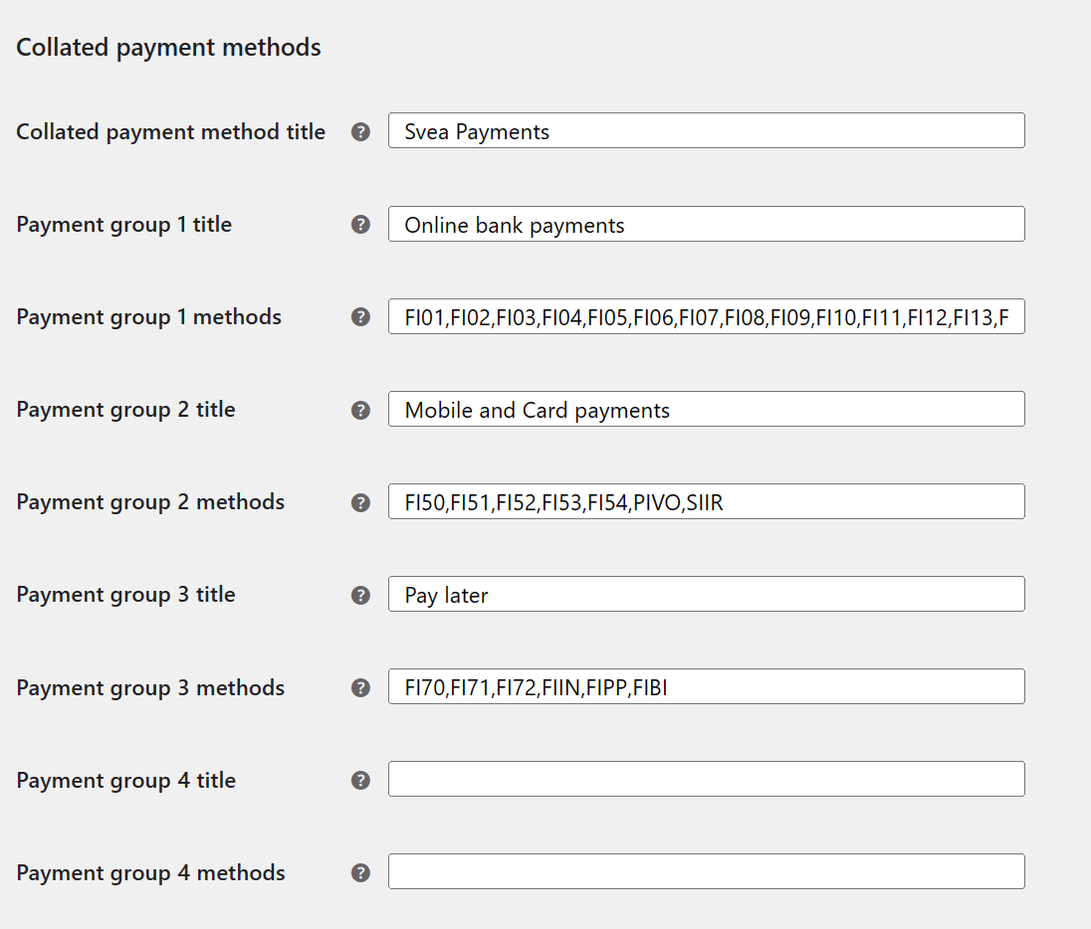

Checkout page example:

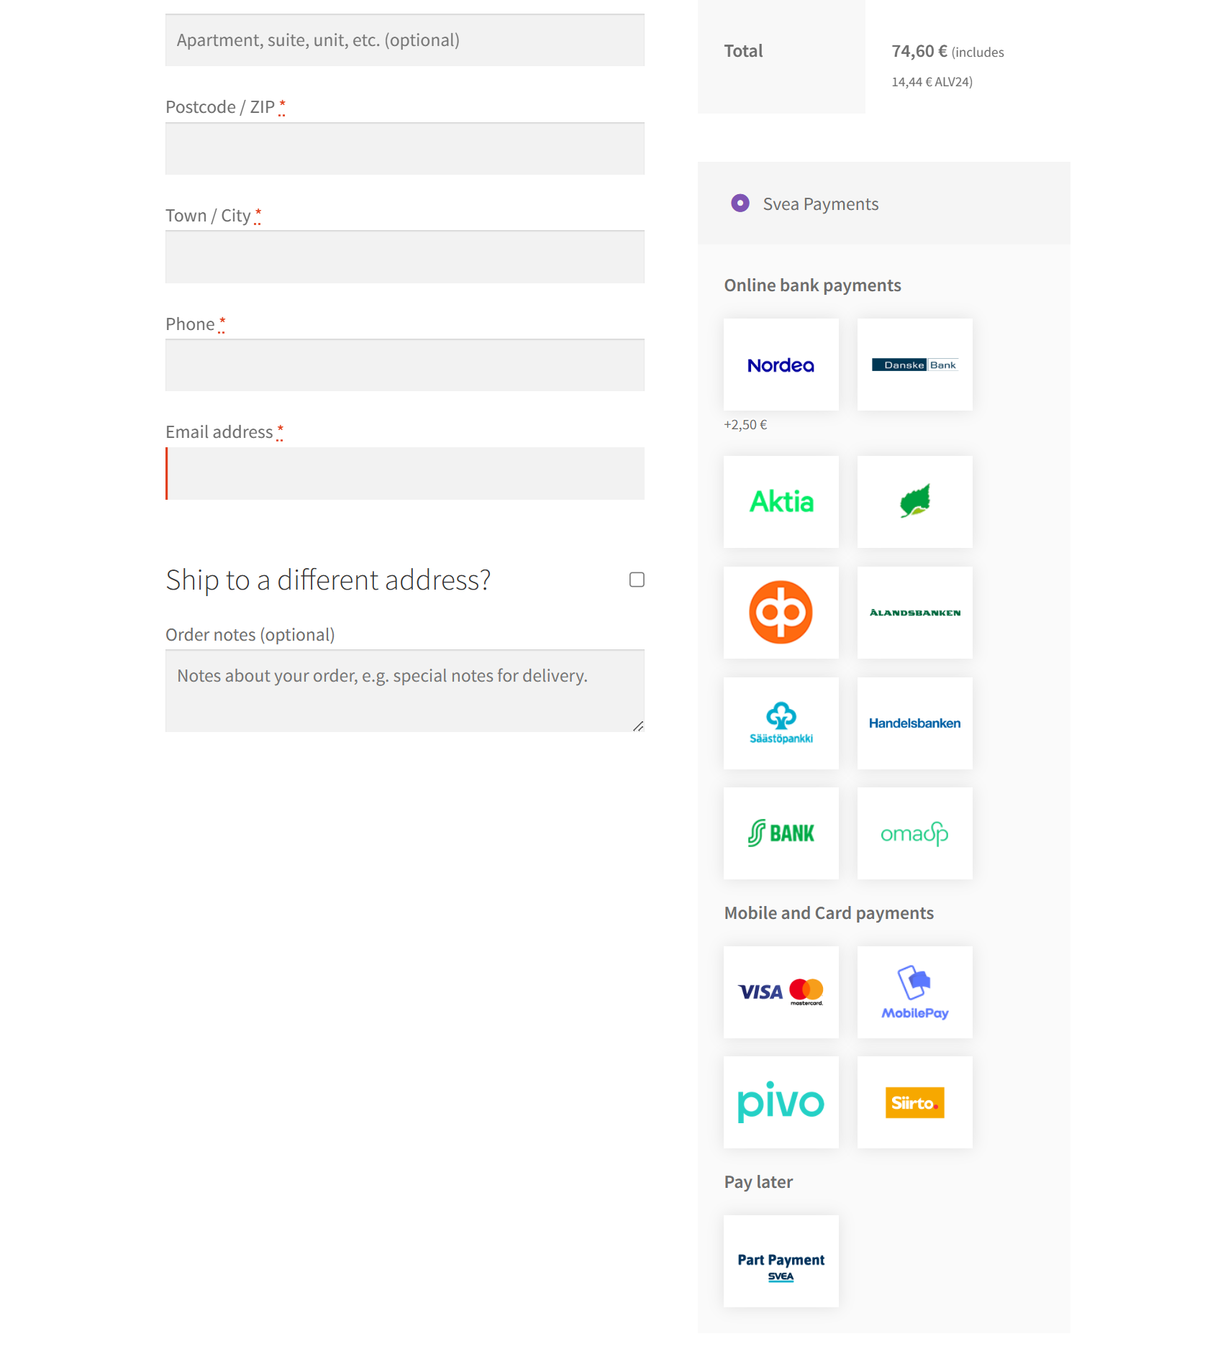

# Language customization

Payment Gateway Module can be translated into different languages, and individual texts can be altered by editing .po -files in the languages directory and compiling them as corresponding .mo -files.

One standard tool for this in Windows- and Mac-environments is Poedit ([poedit.net](http://poedit.net/)). Remember to add the new and altered files to the plugin zip-archive and reinstall the Plugin to WordPress (See section 5).

# Testing the installation

It is strongly encouraged that the Svea Payments payment gateway plugin is thoroughly tested before taking it into use in on production web store. It is essential to verify that customer, product information, prices, taxes, and discount and payment message hash calculation is transmitted correctly to Svea Payments.

## Testing in Svea Payments test environment

Use Svea Payment test environment (<https://test1.maksuturva.fi>) to test webstore before production. Set this value to the configuration Gateway URL field.

The test environment uses different credentials than Svea Payments production environment, and test environment service needs to be ordered separately from the existing Svea Payments service. More information about testing is available at <http://docs.maksuturva.fi>.

After testing the functionality, delete all orders that are made using test environment credentials and set the Gateway URL to <https://www.maksuturva.fi> . Also change the credentials to match the production environment credentials.

# Checkout and payment

At the checkout page, select Svea Payments as the payment method during the checkout. This list can vary related to enabled payment methods in section 5.1, step 5.

If needed, you can reorder the payment methods on the Payment / Payment Methods WooCommerce admin page by using up and down icons.  
  
Also check the example picture of Collated payment methods view in section 6.15.

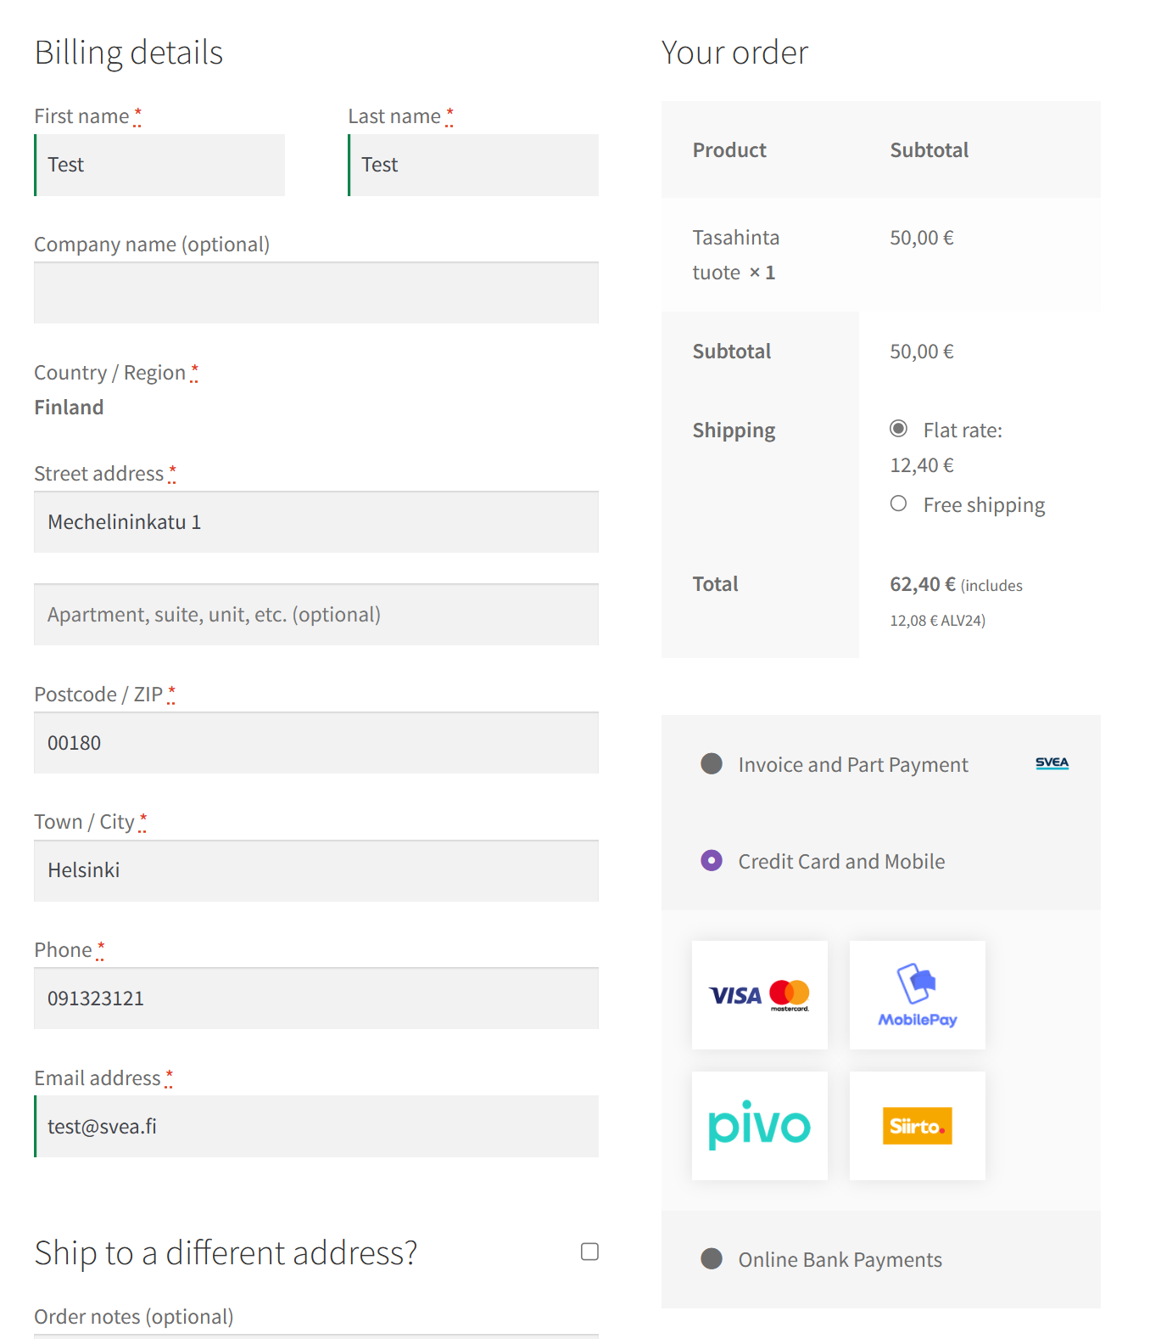

When you fill in your information, select the payment method, and select Place order, you will be redirected to the payments service.

After payment is completed, you will be redirected to the webstore site and see the order confirmation page.

# Administration

When a customer chooses to place an order and is redirected to Svea Payments service, the order's status is "pending".

After the payment is completed and the customer returns to the shop from Svea Payments, the status is changed to "processing".

If an error occurs or the customer cancels the payment, customer is returned to the store, and the order status is changed to error or canceled.

## Payment verification

The Svea Payments Payment Gateway Plugin automatically verifies payments from Svea Payments and displays the status on the order page.

If the order is still pending after a certain amount of time, it's most likely because the customer has left the payment gateway or closed the browser window in the middle of the payment process. In this case, it's OK for the admin to cancel the order manually.

## Refunds

The Svea Payment Gateway Plugin supports refunding the order.

After pressing the order page's refund button, there is an option for making the refund through Svea.

If the payment is not already settled to the shop, the refund is done automatically after pressing the button.

If the payment is already settled, a message will appear to the order comments with payment details so that the shop can pay the refund back to Svea. Svea can then pay it back to the customer.

If the order has been paid through online banking, the plugin will notify that the refund has to be done directly in Svea Extranet. It is possible to add additional information, such as IBAN, required for refund of online banking payments.