www.addictionrecoverycenters.com

Onsite Progress Report

September 2022

|  |  |
| --- | --- |
| Task | Status |
| 25 Pages Title Tag Optimization | Done  The report is shown on the next pages. |
| 25 Pages Meta Tag Optimization | Done  The report is shown on the next pages. |
| Page Speed Check | Speed – 99. |
| W3C Errors Resolve | All fixed. |
| H1, H2 Tags | All fixed. |

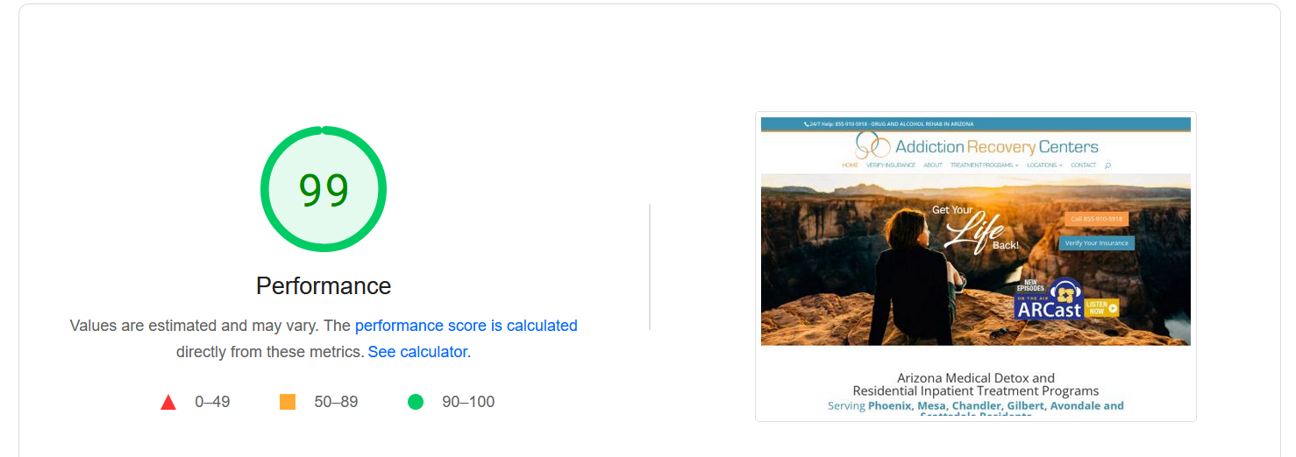

Meta Tags Optimization Report

<https://www.addictionrecoverycenters.com/>

<meta name="description" content="At Addiction Recovery Centers, we’re proud to provide you with exceptional support so you can get through addiction withdrawal."/>

<https://www.addictionrecoverycenters.com/treatment-programs/>

<meta name="description" content="Arizona’s Top Provider of Addiction Treatment for Alcohol and Drug Abuse. For more info please visit us or call us at 1-855-910-5918."/>

<https://www.addictionrecoverycenters.com/medical-detox/>

<meta name="description" content="Our team of compassionate, professional physicians understands how to minimize anxiety and alleviate uncomfortable symptoms that occur during the detox process."/>

<https://www.addictionrecoverycenters.com/treatment-programs/alcohol-addiction/>

<meta name="description" content="We offer a state-of-the-art Medical Detoxification Program that detox patients safely, and effectively."/>

<https://www.addictionrecoverycenters.com/treatment-programs/drug-addiction/>

<meta name="description" content="Our medical treatment is carefully monitored by experienced staff, and our addiction physicians are on call 24/7 in case they need to adjust detox medications to keep patients comfortable."/>

<https://www.addictionrecoverycenters.com/treatment-programs/dual-diagnosis/>

<meta name="description" content="If you feel you or a loved one is struggling with a dual diagnosis, we have the resources to help. Call today! 855-910-5918"/>

<https://www.addictionrecoverycenters.com/treatment-blog/>

<meta name="description" content="Explore our blog for effective communication tips and ideas that you can apply in your personal and professional life."/>

<https://www.addictionrecoverycenters.com/locations/>

<meta name="description" content="Addiction Recovery Center Locations Drug and Alcohol Rehab Centers in Arizona & California."/>

<https://www.addictionrecoverycenters.com/contact/>

<meta name="description" content="If you need any information about drug addiction recovery treatment programs and how to prevent relapse, reach out to Addiction Recovery Centers at 855-910-5918 or send us an email at hope@addictionrecoverycenter.com."/>

<https://www.addictionrecoverycenters.com/articles/drug-rehab-arizona/>

<meta name="description" content="If you are looking for Drug Rehab Arizona then Addiction Recovery Centers is the best place for you."/>

<https://www.addictionrecoverycenters.com/articles/inpatient-drug-rehab-phoenix/>

<meta name="description" content="The inpatient drug rehab in Phoenix allows us to provide you with permanent care, day and night. Our expert team works continually to ensure maximum comfort for the entire duration of the treatment. "/>

<https://www.addictionrecoverycenters.com/articles/drug-rehab-phoenix/>

<meta name="description" content="If you’re looking for practical and comprehensive programs of drug rehab in Phoenix, contact us as soon as you can!"/>

<https://www.addictionrecoverycenters.com/articles/inpatient-drug-rehab-phoenix/>

<meta name="description" content="At Addiction Recovery Centers, we treat people of all ages, races, and social statuses. Everybody deserves a second chance, and we’re the right ones to provide it to you. "/>

<https://www.addictionrecoverycenters.com/what-drug-has-the-most-withdrawal-symptoms/>

<meta name="description" content="If you are looking for help to stop using these substances, seek out Addiction Recovery Centers. Visit addictionrecoverycenters.com or call at 855-910-5918."/>

<https://www.addictionrecoverycenters.com/verify-insurance/>

<meta name="description" content="Addiction Recovery Centers accepts most insurance providers. Give us a call at 855-910-5918 if you have any questions."/>

<https://www.addictionrecoverycenters.com/what-are-the-main-causes-of-addiction/>

<meta name="description" content="We provide individualized planning coupled with supportive, compassionate and respectful care. "/>

<https://www.addictionrecoverycenters.com/what-are-5-ways-to-prevent-addiction/>

<meta name="description" content="We also make each patient’s ability to visualize and work towards a healthy, happy, alcohol or opiate-leave life our top priority."/>

<https://www.addictionrecoverycenters.com/what-do-you-mean-by-alcoholic/>

<meta name="description" content="At Addiction Recovery Centers, we provide the resources you need to recover from alcohol addiction."/>

<https://www.addictionrecoverycenters.com/how-long-do-withdrawal-symptoms-last/>

<meta name="description" content="Our goal is for you to achieve life-long sobriety. Our physician-approved detox protocol is supervised 24/7 by medical professionals who are invested in your recovery."/>

<https://www.addictionrecoverycenters.com/sitemap/>

<meta name="description" content="We offer confidential, convenient, and comfortable transportation services from local airports to our facilities. For more details visit us or call us at

1-855-910-5918."/>

Title Tags Optimization Report

<https://www.addictionrecoverycenters.com/>

<title>Arizona Drug & Alcohol Treatment | Scottsdale Detox | Addiction Recovery Centers</title>

<https://www.addictionrecoverycenters.com/treatment-programs/>

<title>Treatment Programs | Addiction Recovery Centers</title>

<https://www.addictionrecoverycenters.com/medical-detox/>

<title>Medical Detox Arizona Treatment Centers | Addiction Recovery Centers</title>

<https://www.addictionrecoverycenters.com/treatment-programs/alcohol-addiction/>

<title>Alcohol Addiction Treatment Programs Services | Addiction Recovery Centers</title>

<https://www.addictionrecoverycenters.com/treatment-programs/drug-addiction/>

<title>Drug Addiction Treatment Services | Detox Centers Phoenix AZ</title>

<https://www.addictionrecoverycenters.com/treatment-programs/dual-diagnosis/>

<title>Dual Diagnosis | Detox Centers in Scottsdale AZ</title>

<https://www.addictionrecoverycenters.com/treatment-blog/>

<title>Treatment Blog | Addiction Recovery Centers</title>

<https://www.addictionrecoverycenters.com/locations/>

<title>Our Locations | Drug and Alcohol Rehab Centers in Arizona & California</title>

<https://www.addictionrecoverycenters.com/contact/>

<title>Contact Us | Alcohol Detox | Phoenix Drug Rehab Centers</title>

<https://www.addictionrecoverycenters.com/articles/drug-rehab-arizona/>

<title>Drug Rehab Arizona Phoenix | Inpatient Drug Rehab Arizona</title>

<https://www.addictionrecoverycenters.com/articles/inpatient-drug-rehab-phoenix/>

<title>Inpatient Drug Rehab Phoenix | Addiction Recovery Centers</title>

<https://www.addictionrecoverycenters.com/articles/drug-rehab-phoenix/>

<title>Drug Rehab Phoenix AZ | Addiction Recovery Centers</title>

<https://www.addictionrecoverycenters.com/articles/inpatient-drug-rehab-phoenix/>

<title>Inpatient Drug Rehab Phoenix | Addiction Recovery Centers</title>

<https://www.addictionrecoverycenters.com/what-drug-has-the-most-withdrawal-symptoms/>

<title>What Drug Has the Most Withdrawal Symptoms? | Addiction Recovery Centers</title>

<https://www.addictionrecoverycenters.com/verify-insurance/>

<title>Verify Insurance | Addiction Recovery Centers</title>

<https://www.addictionrecoverycenters.com/what-are-the-main-causes-of-addiction/>

<title>What Are the Main Causes of Addiction? | Addiction Recovery Centers</title>

<https://www.addictionrecoverycenters.com/what-are-5-ways-to-prevent-addiction/>

<title>What Are 5 Ways to Prevent Addiction? | Addiction Recovery Centers</title>

<https://www.addictionrecoverycenters.com/what-do-you-mean-by-alcoholic/>

<title>What Do You Mean by Alcoholic? | Addiction Recovery Centers</title>

<https://www.addictionrecoverycenters.com/how-long-do-withdrawal-symptoms-last/>

<title>How Long Do Withdrawal Symptoms Last? | Addiction Recovery Centers</title>

<https://www.addictionrecoverycenters.com/sitemap/>

<title>Sitemap | Cigna Drug & Alcohol Rehab Centers in Phoenix AZ</title>